A new classification scheme for laryngomalacia.
H attya 1 MD
ENT lecturer
1Cairo university, Faculty of medicine, ENT department, Cairo university children’s hospital
Corresponding author and for reprint request: Dr. Hisham M Anwar Attya
Email: hesham_anwar@cu.edu.eg. Drhishamattya1@gmail.com
European archives of otorhinolaryngology

Cronbach's Alpha a measure of the internal consistency of a test or scale; it is expressed as a number between 0 and 1. Internal consistency describes the extent to which all the items in a test measure (questionnaire) the same concept or construct and hence it is connected to the inter-relatedness of the items within the test.
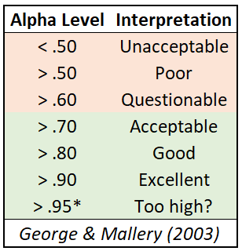

Calculating Cronbach's Alpha for the questionnaire after deleting each question
 | Cronbach's Alpha if Item Deleted
Q1 | 0.708
Q2 | 0.687
Q3 | 0.664
Q4 | 0.702
Q5 | 0.724
Q6 | 0.716
Q7 | 0.690
Q8 | 0.669
Q9 | 0.724
Q10 | 0.659
Q11 | 0.686

