Supplementary materials

Table S1. Search strategy for each database
Database | Search strategy | Number of records
PubMed | ("Tinnitus"[Mesh] OR tinnitus OR "subjective tinnitus" OR "chronic tinnitus")  AND  ("Neuromodulation" OR "Transcranial Magnetic Stimulation" OR "transcranial magnetic stimulation" OR rTMS OR "repetitive transcranial magnetic stimulation" OR "Transcranial Direct Current Stimulation" OR tDCS OR "acoustic neuromodulation" OR "Deep Brain Stimulation"[Mesh] OR "deep brain stimulation" OR DBS) | 571
Scopus | TITLE-ABS-KEY (tinnitus OR "subjective tinnitus" OR "chronic tinnitus")  AND  TITLE-ABS-KEY (neuromodulat* OR "transcranial magnetic stimulation" OR rtms OR "repetitive transcranial magnetic stimulation" OR "transcranial direct current stimulation" OR tdcs  OR "acoustic neuromodulation" OR (acoustic W/3 neuromodulat*) OR "bimodal stimulation" OR (auditory W/3 stimulation) OR "deep brain stimulation" OR dbs) | 1039
Web of science | TS= (tinnitus OR "subjective tinnitus" OR "chronic tinnitus")  AND  TS= (neuromodulation OR "transcranial magnetic stimulation" OR rTMS OR "repetitive transcranial magnetic stimulation" OR "transcranial direct current stimulation" OR tDCS OR "acoustic neuromodulation" OR "deep brain stimulation" OR DBS) | 596
Total |  | 2206

Supplementary Figures

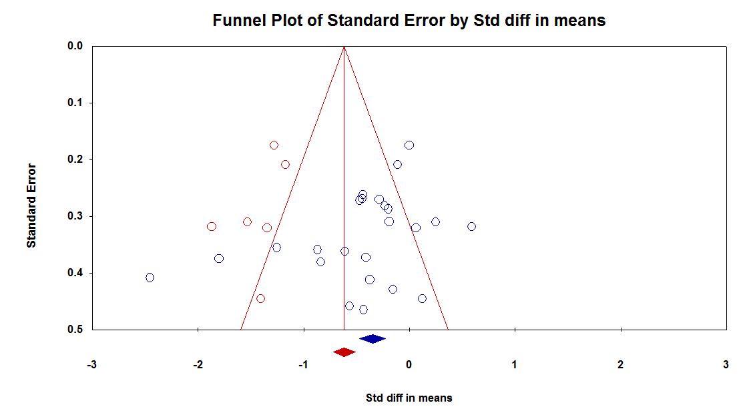
Supplementary Figure S1. Publication bias funnel plot (imputed)

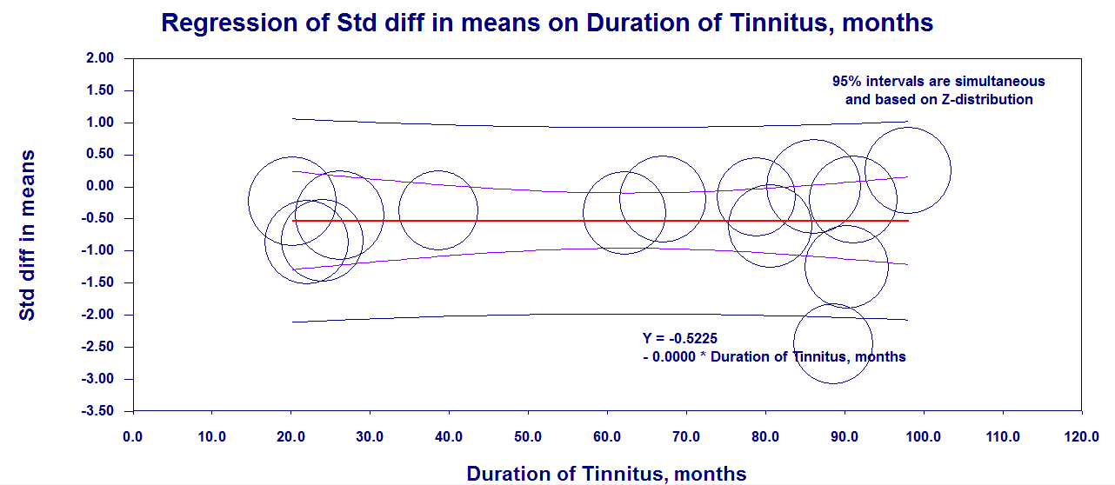
Supplementary Figure S2. Meta regression analysis of association between THI and tinnitus duration

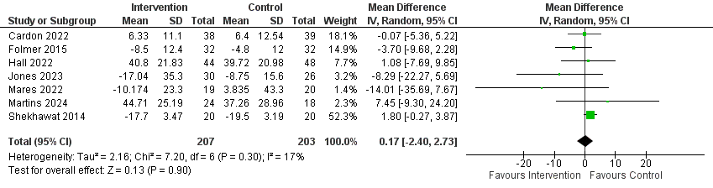
Supplementary Figure S3. Tinnitus Functional Inventory (TFI)

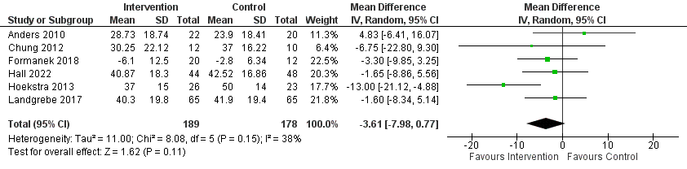

Supplementary Figure S4. Tinnitus Questionnaire

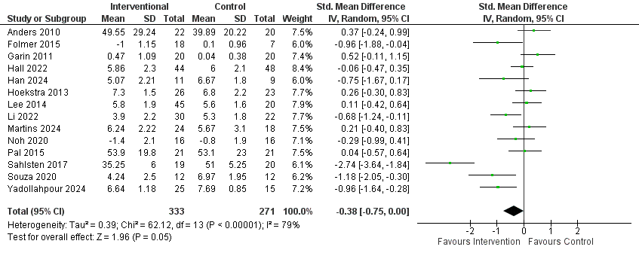

Supplementary Figure S5. VAS loudness

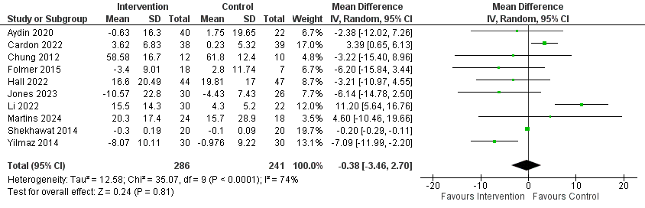
Supplementary Figure S6. Objective Loudness dB

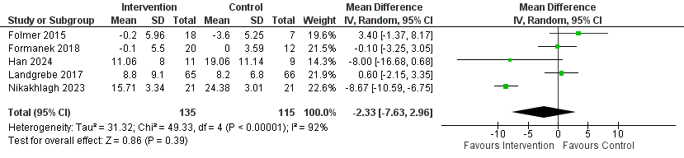
Supplementary Figure S7. Beck Depression Inventory (BDI)

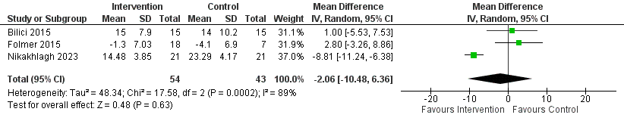
Supplementary Figure S8. Beck Anxiety Inventory (BAI).

