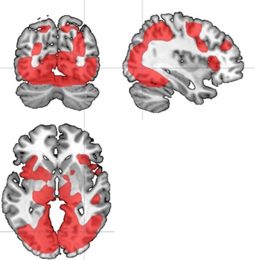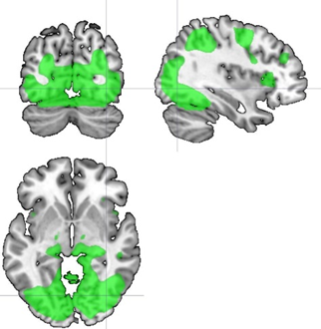

Figure S3. Task activation for angry>baseline (red) and fear>baseline (green).

