The Role of Comorbid Depressive Symptoms on Long-Range Temporal Correlations in Resting EEG in Adults with ADHD

Jue Huang1*, Eike Ahlers2, Holger Bogatsch4, Pierre Böhme5, Thomas Ethofer6,7, Andreas J Fallgatter7, Jürgen Gallinat8, Ulrich Hegerl9, Isabella Heuser2, Knut Hoffmann5, Sarah Kittel-Schneider9,10, Andreas Reif9, Daniel Schöttle8, Stefan Unterecker10, Matti Gärtner2,3†, and Maria Strauß1†
1Department of Psychiatry and Psychotherapy, University of Leipzig, Leipzig, 04103, Germany
2Department of Psychiatry and Psychotherapy, Charité – Universitätsmedizin Berlin, Berlin, 10117, Germany
3MSB Medical School Berlin, Berlin, 14179, Germany
4Clinical Trial Centre Leipzig, Faculty of Medicine, University of Leipzig, Leipzig, 04107, Germany
5Department of Psychiatry Psychotherapy and Preventive Medicine, University Hospital of Bochum, Bochum, 44791, Germany
6Department of Biomedical Magnetic Resonance, University Hospital of Tübingen, Tübingen, 72076, Germany
7Department of Psychiatry and Psychotherapy, Tübingen Center for Mental Health (TüCMH), University of Tübingen, Tübingen, 72076, Germany
8Department of Psychiatry and Psychotherapy, University Medical Center Hamburg-Eppendorf, Hamburg, 20251, Germany
9Department of Psychiatry, Psychotherapy and Psychosomatic Medicine, University Hospital of Frankfurt – Goethe University, Frankfurt am Main, 60528, Germany
10Department of Psychiatry, Psychosomatics and Psychotherapy, University Hospital of Würzburg, Würzburg, 97080, Germany
* Corresponding author. E-Mail: jue.huang@medizin.uni-leipzig.de (ORCID: 0000-0003-1830-9340)
Contributing authors: jue.huang@medizin.uni-leipzig.de; Eike.Ahlers@charite.de; holger.bogatsch@zks.uni-leipzig.de; pierre.boehme@lwl.org; Thomas.Ethofer@med.uni-tuebingen.de; andreas.fallgatter@med.uni-tuebingen.de; j.gallinat@uke.de; ulrich.hegerl@deutsche-depressionshilfe.de; katharina.schmalfeld@charite.de; knut.hoffmann@lwl.org; Kittel_S@ukw.de; andreas.reif@kgu.de; d.schoettle@uke.de; unterecker_s@ukw.de; matti.gaertner@charite.de; Maria.Strauss@medizin.uni-leipzig.de
† These authors contributed equally to this work and share senior authorship

Table S1. Results of one-sample Kolmogorov-Smirnov Test for normality
 |  | df | Test Statistic | Significance
Age |  | 79 | 0.138 | <0.001
CGI-S |  | 79 | 0.411 | <0.001
BDI |  | 79 | 0.149 | <0.001
MADRS |  | 79 | 0.156 | <0.001
CAARS | DSM-G | 79 | 0.141 | <0.001
 | DSM-IA | 79 | 0.196 | <0.001
 | DSM-HYI | 79 | 0.078 | 0.200
 | IA/ME | 79 | 0.164 | <0.001
 | HY/RE | 79 | 0.093 | 0.086
 | IMP/EL | 79 | 0.080 | 0.200
 | SC | 79 | 0.078 | 0.200
 | ADHS-Index | 79 | 0.081 | 0.200
WURS-K |  | 79 | 0.162 | <0.001
QoL |  | 79 | 0.074 | 0.200
IIP |  | 79 | 0.099 | 0.052
Mean delta-LRTC |  | 79 | 0.092 | 0.094
Mean theta-LRTC |  | 79 | 0.095 | 0.075
Mean alpha-LRTC |  | 79 | 0.109 | 0.021
Mean beta-LRTC |  | 79 | 0.120 | 0.007
Bold fonts indicate statistical significance; statistical significance value for these tests was set at 0.05
CGI-S: Severity Scale of the Clinical Global Impression
BDI: Beck Depression Inventory
MADRS: Montgomery-Asberg Depression Rating Scale
CAARS: the Conners’ Adult ADHD Rating Scale
DSM-G, DSM-IA and DSM-HYI: three subscales of CAARS consisting DSM-IV ADHD symptoms
IA/ME: inattention/memory
HY/RE: hyperactivity/restlessness
IMP/EL: impulsivity/ emotional lability
SC: self-concept
WURS-K: German Wender Utah Rating Scale
QoL: quality of life as measured by German Version of the World Health Organization Quality of Life Questionnaire
IIP: interpersonal problems as measured by German Inventory of Interpersonal Problems

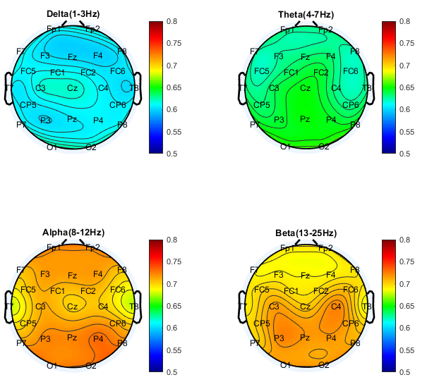
Figure S1. Topographical distributions of LRTC in examined frequency bands in all patients with ADHD.

Table S2. Descriptive statistics to examine presence of baseline LRTC in corresponding EEG frequency band at each electrode site
Electrode site | Delta (1-3Hz) |  | Theta (4-7Hz) |  | Alpha (8-12Hz) |  | Beta (13-25Hz)
Fp1 | 0.62±0.06 |  | 0.63±0.09 |  | 0.73±0.10 |  | 0.70±0.09
Fp2 | 0.62±0.06 |  | 0.63±0.09 |  | 0.73±0.10 |  | 0.70±0.09
F3 | 0.60±0.07 |  | 0.63±0.08 |  | 0.72±0.10 |  | 0.69±0.09
F4 | 0.60±0.07 |  | 0.63±0.09 |  | 0.72±0.10 |  | 0.69±0.09
F7 | 0.62±0.05 |  | 0.63±0.08 |  | 0.71±0.09 |  | 0.69±0.09
F8 | 0.61±0.06 |  | 0.62±0.09 |  | 0.71±0.10 |  | 0.70±0.09
Fz | 0.60±0.07 |  | 0.63±0.10 |  | 0.72±0.10 |  | 0.69±0.10
FC1 | 0.61±0.08 |  | 0.64±0.09 |  | 0.71±0.09 |  | 0.70±0.09
FC2 | 0.61±0.08 |  | 0.64±0.10 |  | 0.71±0.09 |  | 0.70±0.09
FC5 | 0.61±0.06 |  | 0.62±0.07 |  | 0.71±0.09 |  | 0.70±0.10
FC6 | 0.60±0.07 |  | 0.62±0.08 |  | 0.70±0.09 |  | 0.71±0.10
C3 | 0.62±0.07 |  | 0.64±0.09 |  | 0.71±0.09 |  | 0.72±0.09
C4 | 0.61±0.07 |  | 0.63±0.08 |  | 0.71±0.09 |  | 0.73±0.08
T7 | 0.61±0.06 |  | 0.64±0.09 |  | 0.68±0.09 |  | 0.70±0.09
T8 | 0.60±0.05 |  | 0.63±0.09 |  | 0.68±0.08 |  | 0.69±0.08
CP5 | 0.61±0.06 |  | 0.63±0.08 |  | 0.70±0.09 |  | 0.71±0.09
CP6 | 0.61±0.05 |  | 0.63±0.08 |  | 0.72±0.09 |  | 0.72±0.09
P3 | 0.60±0.06 |  | 0.65±0.09 |  | 0.73±0.11 |  | 0.73±0.09
P4 | 0.61±0.06 |  | 0.65±0.08 |  | 0.74±0.10 |  | 0.72±0.09
P7 | 0.61±0.07 |  | 0.65±0.10 |  | 0.72±0.09 |  | 0.70±0.10
P8 | 0.62±0.06 |  | 0.65±0.09 |  | 0.73±0.10 |  | 0.72±0.09
Pz | 0.61±0.06 |  | 0.65±0.10 |  | 0.73±0.10 |  | 0.72±0.09
O1 | 0.63±0.08 |  | 0.66±0.10 |  | 0.73±0.11 |  | 0.72±0.10
O2 | 0.63±0.07 |  | 0.66±0.10 |  | 0.73±0.10 |  | 0.72±0.10
Cz | 0.62±0.08 |  | 0.65±0.10 |  | 0.70±0.09 |  | 0.70±0.09
N=85
Entries are mean ± standard deviation

Table S3. ADHD+ and ADHD- groups did not differ regarding differences between baseline and final visit for CAARS scores.
 |  | Test Statistic | Significance
CAARS | DSM-G | -0.718 | .472
 | DSM-IA | -0.910 | .363
 | DSM-HYI | -0.433 | .665
 | IA/ME | -0.155 | .877
 | HY/RE | -0.576 | .565
 | IMP/EL | -1.183 | .237
 | SC | -0.724 | .469
 | ADHS-Index | -0.427 | .669

