Figure S1 Flow chart
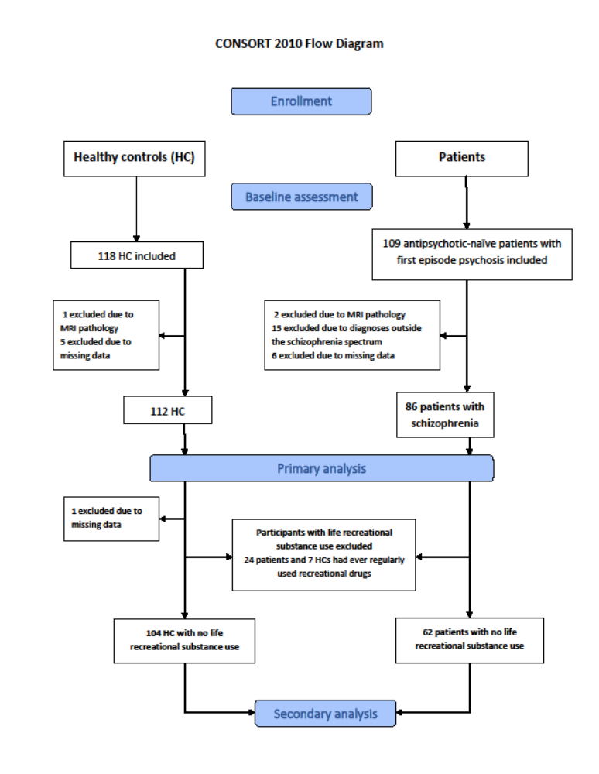
Text S2 Image acquisition
MRI data were acquired using a Philips Achieva 3.0 T whole body MRI scanner (Philips Healthcare, Best, The Netherlands) with a 32-channel SENSE Head Coil (Invivo, Orlando, Florida, USA). Thirty volumes of whole-brain diffusion weighted images were acquired in 30 non-collinear directions (b = 1000 s/mm²) and 5 non-diffusion weighted images (b = 0 s/mm²) using single shot spin-echo echo-planar imaging. Acquisition of all volumes were repeated with opposite phase encoding direction to enable correction for susceptibility distortions using the following parameters: acquisition matrix = 128 × 99, field of view (FOV) = 240 × 240 mm², number of slices = 75, slice thickness = 2.0 mm (no gap), reconstructed voxel dimensions = 1.88 × 1.88 × 2 mm³, TR/TE = 7035/ 68 ms, parallel imaging SENSE factor = 3(AP), flip angle = 90°, total scan duration = 8 min 42 sec.
High-resolution three-dimensional T1-weighted images were acquired using sagittal slices and the following parameters: acquisition matrix = 304 × 299, field of view (FOV) = 240 × 240 mm², number of slices = 200, slice thickness = 0.8 mm, reconstructed voxel dimensions = 0.75 × 0.75 × 0.80 mm³, TR/TE = 10/4.6 ms, inversion time = 964 ms, flip angle = 8º, total scan duration = 10.01 minutes.

Table S3. Image quality metrics

 | TSNR  Mean (SD) | MAXVOX  Mean (SD) | MEANVOX  Mean (SD)
Patients and HCs in the full sample (N=198) | 9.86  (1.09) | 6631  (10240) | 819.11  (687.21)
Roalf et al. (N=147)  “Poor” | 5.52  (0.93) | 14497  (8667) | 2001.50  (1080.20)
Roalf et al. (N=468)  “Good” | 6.9  (0.68) | 7165  (7189) | 830.40  (597.10)
Roalf et al. (N=742)  “Excellent” | 7.37  (0.55) | 1684  (1741) | 378  (164.10)

Table S3 shows mean (SD) of quality metrics on DWI data for the full sample of antipsychotic-naïve patients with first episode schizophrenia and healthy controls, as well as for the quality assessment groups defined by Roalf et al. Three image quality metrics (temporal signal-to-noise ratio (TSNR), maximum voxel intensity outlier count (MAXVOX) and mean voxel intensity outlier count (MEANVOX)) were calculated from each subjects DW image. The measured quality metrics in this study ranged between the ‘good’ and ‘excellent’ quality.
Abbreviations: DWI: diffusion weighted imaging; SD: standard deviation

Text S4 Post hoc DTI analyses of fractional anisotropy (FA)
Image acquisition was identical of the FBA.
Image processing:
The two sets of diffusion weighted scans (acquired in opposite phase-encoding directions) were denoised to reduce random rician noise with overcomplete Local PCA method (Manjón et al. 2013) using MATLAB software (version 2014a). FMRIB diffusion toolbox (part of FSL 5.0.9) (Jenkinson et al. 2012; Smith et al. 2004) was used for further pre-processing, starting with eddy current correction and head motion correction (Jenkinson et al. 2002), followed by a correction of susceptibility distortions (Andersson et al. 2003). For head motion, 3 translational and 3 rotational motion parameters were recorded. Next, data were resampled to 0.93 × 0.93 × 1mm3 resolution using non-local MRI upsampling (Manjón et al. 2010). Non-brain tissue was removed with brain extraction tool (BET) (Smith 2002). FA were calculated using DTIFIT (Jenkinson et al. 2012). FA, data were transformed to standard space and skeletonised using the standard tract- based spatial statistics (TBSS) pipeline (Smith et al. 2006). First, FA data were non-linearly registered using FNIRT (Andersson et al. 2007) onto the standard FMRIB58 FA tem- plate. Next, the nearest maximum FA values of each registered FA image were projected onto a WM skeleton derived from the FMRIB58 template and thresholded at FA > 0.2.

Table S5. Sociodemographic data comparing healthy controls to the substance-free subsample
Variable  Mean (S.D.) / Percent (N) | Patients  (N=62) | controls  (N=104) | Significance  Group effect
Age mean (SD) | 25 (6) | 24 (5) | p=0.33, F=0.95
Gender |  |  | p=0.52, χ²=0.42
Male | 42 % (26) | 47 % (49)
Female | 58 % (36) | 53 % (55)
Parental SES |  |  | p=0.91, χ²=0.19
Low | 15 % (9) | 13 % (13)
Medium | 52 % (31) | 53 % (55)
High | 33 % (20) | 34 % (35)
Handedness |  |  | p=0.12, χ²=4.20
Right | 82 % (51) | 84 % (84)
Left | 7 % (4) | 12 % (12)
Ambidextrous | 11 % (7) | 4 % (4)
DART | 19.5 (8) | 22.4 (6) | p<0.01, F=7.00

Table S5
Significant effect of group is marked in bold.
Abbreviations: DART: Danish version of the National Adult Reading Test; DUI: duration of illness; DUP: duration of untreated psychosis; GAF: The Global Assessment of Functioning; N: number; SES: socio-economic status; SD: standard deviation;

Table S6.
Sociodemographic data comparing the full patient sample to the substance-free subsample
Variable  Mean (S.D.) / Percent (N) | Patients  (N=86) | Substance-free patients  (N=62) | Group effect  comparing NoU vs. substance using patients (N=24)
Age mean (SD) | 25 (6) | 25 (6) | p=0.69, F=0.16
Gender |  |  | p=0.04, χ²=4.24
Male | 49 % (42) | 42 % (26)
Female | 51 % (44) | 58 % (36)
Parental SES |  |  | p=0.15, χ²=3.86
Low | 18 % (15) | 15 % (9)
Medium | 54 % (45) | 52 % (31)
High | 28 % (23) | 33 % (20)
Handedness |  |  | p=0.24, χ²=2.88
Right | 85 % (72) | 82 % (51)
Left | 7 % (6) | 7 % (4)
Ambidextrous | 8 % (7) | 11 % (7)

Table S6
Abbreviations: N: number; SES: socio-economic status; SD: standard deviation
The significant difference on gender when comparing substance using to substance-free patients were 33.3% (N=8) females and 66.7% (N=16) males in the substance using patients versus 58.1% (N=44) females and 41.9% (N=42) males in the substance-free patients.

Table S7. Location and cluster-size of significant correlations
PANSS item | Fixel measure | Correlation | Size  (voxels) | Localization  (X,Y,Z) | White matter tract
PANSS items Psychosis domain
Full sample 86 patients
P6  (Suspiciousness/persecution) | FC  FDC | Positive  Positive | 5909  390  69  16  3205  29 | -3,-24,-36  19,-31,-32  21,-17,-7  -10,-36,-32  -3,-24,-36  -16,-24,56 | CST, bilaterally
Substance-free subsample 62 patients
P1  (Delusions) | FDC | Negative | 392 | -4,-23,-36 | Left CST
P3  (Hallucinatory behavior) | FC | Negative | 172 | -12,-33,27 | Isthmus of CC
P6  (Suspiciousness/persecution) | FC  FDC | Positive  Positive | 10295  274  3870  1109  70 | -3,-24,-36  25,-22,14  -3,-24,-36  18,-20,-9  10,-23,-31 | CST, bilaterally
PANSS items anxio-depressive domain
Full sample 86 patients
G1  (Somatic concern) | FC | Negative | 2446 | 23,-42,4 | Splenium of CC
G3  (Guilt feelings) | FD | Negative | 154  24 | -3,23,0  11,26,0 | Genu of CC
Substance-free subsample 62 patients
G1  (Somatic concern) | FC  FDC | Negative  Negative | 1436  275  152  2129 | 1,-39,15  15,-43,22  27,-50,15  24,-51,4 | Splenium of CC
G3  (Guilt feelings) | FD | Negative | 68 | 3,23,2 | Genu of CC

Figure S8. Correlations between fixel-based measures and psychopathology
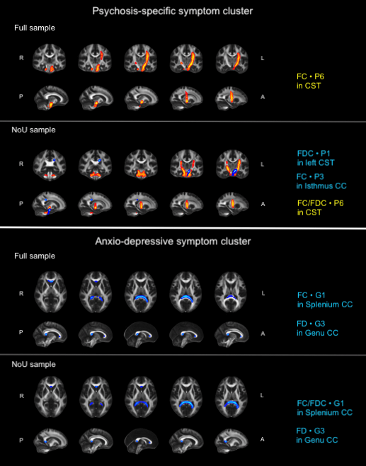
Figure S8. illustrates the localization of the correlations between fibre-based measures and the PANSS-items from the two symptom-clusters, in the full sample and substance-free (NoU) sample, respectively. Blue colours indicate negative correlations, red/yellow colours indicate positive correlations. Images are displayed in radiological directions.
Abbreviations: A: anterior; CC: corpus callosum; CST: corticospinal tract; FC: fibre cross-section; FD: fibre density; FDC: fibre density and cross-section; L: left; P: posterior; R: right

