Supplementary Material

Free-viewing gaze pattern reveals a mood-congruency bias in MDD during an emotional fMRI/eye-tracking task

Rui Sun^{1,2}, Julia Fietz^{1,3}, Mira Erhart,^{1,3}, Dorothee Poehlchen^{1,3}, Lara Henco¹, Tanja M. Brückl¹，BeCOME study team^{1‡}, Michael Czisch¹, Philipp G. Saemann¹, Victor I. Spoormaker^{1*}

Affiliations: ¹ Department of Translational Research in Psychiatry, Max Planck Institute of Psychiatry, Munich, Germany; ² Department of Behavioral and Psychological Science, Zhejiang University, Hangzhou, China; ³International Max Planck Research School for Translational Psychiatry (IMPRS-TP), Max Planck Institute of Psychiatry, Munich, Germany

*Corresponding Author: Victor I. Spoormaker
E-mail address: spoormaker@psych.mpg.de

‡ BeCOME Working Group: Elisabeth B. Binder, Angelika Erhardt, Susanne Lucae, Norma C. Grandi, Tamara Namendorf, Immanuel Elbau, Laura Leuchs, Anna Katharine Brem, Leonhard Schilbach, Sanja Ilić-Ćoćić, Julius Ziebula, Iven-Alex von Mücke-Heim, Yeho Kim and Julius Pape.

Outlines

Part 1: Additional Analysis
S1.1 Group differences in accuracy rates
S1.2 Mood-congruency bias in happy-sad trials
S1.3 Gender effects in mood-congruency bias
S1.4 Group differences in the dwell times and fixation counts

Part 2: Figures
Fig.S1 Flowchart of exclusion of participants for the measurements
Fig. S2 Interaction between group and emotion of target faces in the task-related phase (a) and the free-viewing phase (b)
Fig. S3 Neural correlates of PTRA for emotional faces between the groups (MDD vs. HC) in the task-related phase (a) and the free-viewing phase (b)
Fig. S4 Neural correlates of task-related attentional gaze patterns during the task-related phase in MDD (a) and HC (b)
Fig. S5 Neural correlates of task-related attentional gaze patterns during the free-viewing phase in MDD (a) and HC (b)

Part 3: Tables
Table S1 Demographic information, RTs, and accuracy rates in the behavioral analyses
Table S2 Demographic information and PTRA values in the eye-tracking analyses
Table S3 Demographic information in the fMRI analyses
Table S4 Brain activity in response to emotional faces (vs. geometric forms) in the task-related phase
Table S5 Brain activity in response to emotional faces (vs. geometric forms) in the free-viewing phase
Table S6 Brain activity in response to emotional faces in the free-viewing phase vs. in the task-related phase
Table S7 neural correlates of PTRA (only for emotional faces) in the free-viewing phase vs. in the task-related phase
Table S8 Neural correlates of PTRA between the groups (MDD vs. HC) in the task-related phase
Table S9 Neural correlates of PTRA between the groups (MDD vs. HC) in the free-viewing phase
Table S10 Neural correlates of PTRA (only for emotional faces) for MDD in the task-related phase
Table S11 Neural correlates of PTRA (only for emotional faces) for HC in the task-related phase
Table S12 Neural correlates of PTRA (only for emotional faces) for MDD in the free-viewing phase
Table S13 Neural correlates of PTRA (only for emotional faces) for HC in the free-viewing phase

Part 1: Additional Analysis
S1.1 Group differences in accuracy rates
To test for possible differences in accuracy for different stimulus types, we first conducted a two-factorial ANOVA (factor group, two levels: MDD vs. HC; factor stimulus, two levels: emotional face vs. geometric form). The results showed that there was a significant main effect of stimulus (F _{(1,188)} = 61.95, p < .001, η²_{p} = .27), indicating participants had higher accuracy in shape recognition of geometric forms than facial emotion recognition (t₍₁₈₉₎ = 7.87, p < .001, Cohen’s d = .84). However, the main effect of group and interaction between group and stimulus were not significant (Fs < .84, ps > .36), with accuracy rates for the two groups in both conditions over 90%.
Then, we conducted a two-factorial ANOVA (factor group, two levels: MDD vs. HC; factor emotional pair, two levels: positive-negative vs. negative-negative) to test the group differences for different emotional pairs. The results showed that there was a significant main effect of emotional pair (F _{(1,188)} = 94.72, p < .001, η²_{p} = .13), but again the main effect of group and the interaction between group and emotional pair were not significant (Fs < .41, ps > .52).
Last, we conducted a two-factorial ANOVA (factor group, two levels: MDD vs. HC; factor specific-valenced pair, two levels: happy-sad vs. happy-angry-fearful) for testing the mood-congruency bias from the perspective of accuracy. The results showed that there were no significant main effects of group and specific-valenced pair (Fs < 0.36, ps > .55,), but there was an interaction between group and specific-valenced pair (F _{(1,188)} = 6.59, p = .01, η²_{p} = .04). The post hoc analysis revealed that healthy participants had marginally higher recognition accuracy for happy-sad faces than happy-angry-fearful faces (t₍₁₂₄₎ = 2.68, p = .049), but there was no such significant comparison in MDD, with all accuracy rates above 0.98. Besides, the post hoc analysis did not show any group differences in each type of specific-valenced pair. As this was in the task-related phase, we added this analysis as an effect of potential interest but found little relation to the mood congruency bias in the free-viewing phase.

In summary, the MDD and the HC group had similar accuracy in emotion and shape recognition, with accuracy rates between 90-100%.
S1.2 Mood-congruency bias in happy-sad trials
To test whether a mood-congruency bias could be reflected by variance in preferential attention to sad faces or happy faces between MDD and HC. We conducted a two-factorial ANOVA (factor group, two levels: MDD vs. HC; factor target face, two levels: happy vs. sad) for both phases. Results showed that in the free-viewing phase, the interaction between group and target face is significant (F_{(1, 170)} = 4.37, p = .04, η²_{p} > .02). Post hoc test showed that MDD had less PTRA for happy faces than HC, indicating decreased maintenance on happy faces for MDD than HC (t = 2.63, p = .05, Cohen’s d = .40), supportive of a mood congruency in MDD. However, in the task-related phase, there is no significant interaction or main effect (F_{(1, 170)} < 2.34, p > .13, see Fig. S2).

S1.3 Gender effects in mood-congruency bias
To test for gender differences in the mood-congruency bias, we conducted a three-factorial ANOVA (factor group, two levels: MDD vs. HC; factor gender, two levels: female vs. male; factor specific-valenced pair, two levels: happy-sad vs. happy-angry-fearful) in each phase (the task-related phase or the free-viewing phase), with the proportion of target-related attention (PTRA) as the dependent variable. The results showed that in the task-related phase, there was no significant main effect of gender, no significant interaction between gender and group, no significant interaction between gender and specific-valenced pair, and no significant interaction among all three factors (i.e., group, gender, and specific-valenced pair, Fs < 2.29, ps > 0.13). In the free-viewing phase, there was a trend for a significant interaction among all three factors (F_{(1, 166)} = 3.31, p = 0.07), although the main effect of gender and other interactions with gender weren’t significant (Fs < 2.03, ps > 0.16). For the post hoc analysis of the marginally significant interaction, there were no significant differences in any comparisons (ts < 2.90, ps > 0.11). Therefore, in the task-related or free-viewing phase of emotional processing, we didn’t observe gender differences between and within the MDD and the HC group for the PTRA values in happy-negative trials.
Then we also tested the gender effect in the happy-sad trials with the same condition as in the supplementary material. This analysis focused on testing the mood-congruency attentional bias between positive (happy) faces and negative (sad) faces, which was different from the analysis above (examining between mood-congruent negative (sad) faces and other negative (fearful and angry) faces). We conducted a three-factorial ANOVA (factor group, two levels: MDD vs. HC; factor gender, two levels: female vs. male; factor target face, two levels: happy vs. sad) in each phase, also with PTRA values as the dependent variable. The results showed that in the task-related phase, the main effect of gender, the interaction between gender and target face, and the interaction among three factors (i.e., group, gender, and target face) were not significant (Fs < .42, ps > 0.52), but the interaction between gender and group showed a trend for significance (F_{(1, 166)} = 3.46, p = 0.06, η²_{p} =.002). The post hoc analysis showed that for female participants, the HC group had marginally higher PTRA values than the MDD group (t₍₁₆₈₎ = 2.48, p = .08), indicating that healthy female individuals have more attention to target-related faces than MDD female patients in the task-related phase. However, there were no significant differences in other comparisons of the post hoc analysis (ts < 2.08, ps > .24). In the free-viewing phase, there was no main effect of gender, no interaction between gender and target face, and no interaction between gender and group (Fs< 1.71, ps > 0.19), but the interaction among the three factors was marginally significant (F_{(1, 166)} = 3.06, p = 0.08, η²_{p} =.002). For the post hoc analysis, there were no significant differences in any comparisons (ts < 2.75, ps > .18).
In summary, we didn’t observe any significant interactions among three factors (i.e., group, gender, and specific-valenced pair (or target face)), indicating mood congruency bias cannot be distinguished by gender either for MDD or non-clinical populations in this study. This demonstrated that both female and male patients with MDD had a more attentional bias to mood-congruent faces during the free-viewing, as compared with their counterparts.
S1.4 Group differences in the dwell times and fixation counts
Differences in dwell times and fixation counts between groups may influence mood-congruency attentional bias. To test for possible group differences, we conducted four two-factorial ANOVAs (factor group, two levels: MDD vs. HC; factor specific-valenced pair, two levels: happy-sad vs. happy-angry-fearful) respectively for dwell times and fixation counts in each phase (i.e., the task-related phase or the free-viewing phase).

Dwell times:
The two-factorial ANOVA showed a significant main effect of group for dwell times in the task-related phase (F_{(1,168)} = 4.06, p = .045), indicating that patients with MDD had shorter dwell times on stimuli than healthy controls. However, there was no significant main effect of group in the free-viewing phase (F = .05, p = .83). In addition, there were no interactions between the group and specific-valenced pair in each phase (Fs < 1.95, ps > .16).
To further test the effect of phase, we conducted a three-factorial ANOVA (factor phase, two levels: task-related vs. free-viewing; factor group, two levels: MDD vs. HC; factor specific-valenced pair, two levels: happy-sad vs. happy-angry-fearful). Results showed that the main effect of phase was significant (F_{(1,168)} = 632.15, p < .001, η²_{p} = .74), indicating that participants had shorter dwell times in the task-related phase than the free-viewing phase. The main effect of specific-valenced pair and interaction between phase and specific-valenced pair were significant (Fs > 9.38, ps < .002, η²_{p} > .04). However, the main effect of group and interactions with group were not significant (Fs < 2.26, ps > .13).

Fixation counts:
The two-factorial ANOVA showed there was no significant main effect of group either in the task-related phase (F = .06, p = .80) or in the free-viewing phase (F_{(1,168)} = 1.03, p = .31). In addition, there were no interactions between the group and specific-valenced pair in each phase (Fs > .93, ps > .34).
Similarly, to further test the effect of phase, we conducted a three-factorial ANOVA (factor phase, two levels: task-related vs. free-viewing; factor group, two levels: MDD vs. HC; factor specific-valenced pair, two levels: happy-sad vs. happy-angry-fearful) for fixation counts. Results also showed that the main effect of phase was significant (F_{(1,168)} = 347.52, p < .001, η²_{p} = .61), indicating that participants had fewer fixations in the task-related phase than the free-viewing phase. The main effect of specific-valenced pair and interaction between phase and specific-valenced pair were significant (Fs > 11.91, ps < .001, η²_{p} > .05). However, the main effect of group and interactions with group were not significant (Fs < 1.32, ps > .25).

In summary, the MDD and the healthy group had similar dwell times and fixation counts in the free-viewing phase, which was not affected by the stimulus types. Therefore, mood-congruency attention bias between MDD and HC cannot be accounted for by dwell times or fixation counts on stimuli during the free-viewing phase. However, we observed that healthy participants had more accuracy for happy-sad faces than happy-angry-fearful faces, while there was no such significant comparison in MDD. The accuracy level was dominated mainly by task-related attention before responses, whereas the mood-congruency bias in our eye-tracking analyses was only observed in the free-viewing phase (after responses). Therefore, significant results of accuracy cannot provide further explanation for the mood-congruency attention bias in MDD in our study. In addition, the two groups have similar accuracy for stimuli, demonstrating that the effect of task difficulty did not affect the results of mood-congruency attention bias in MDD.

Part 2: Figures

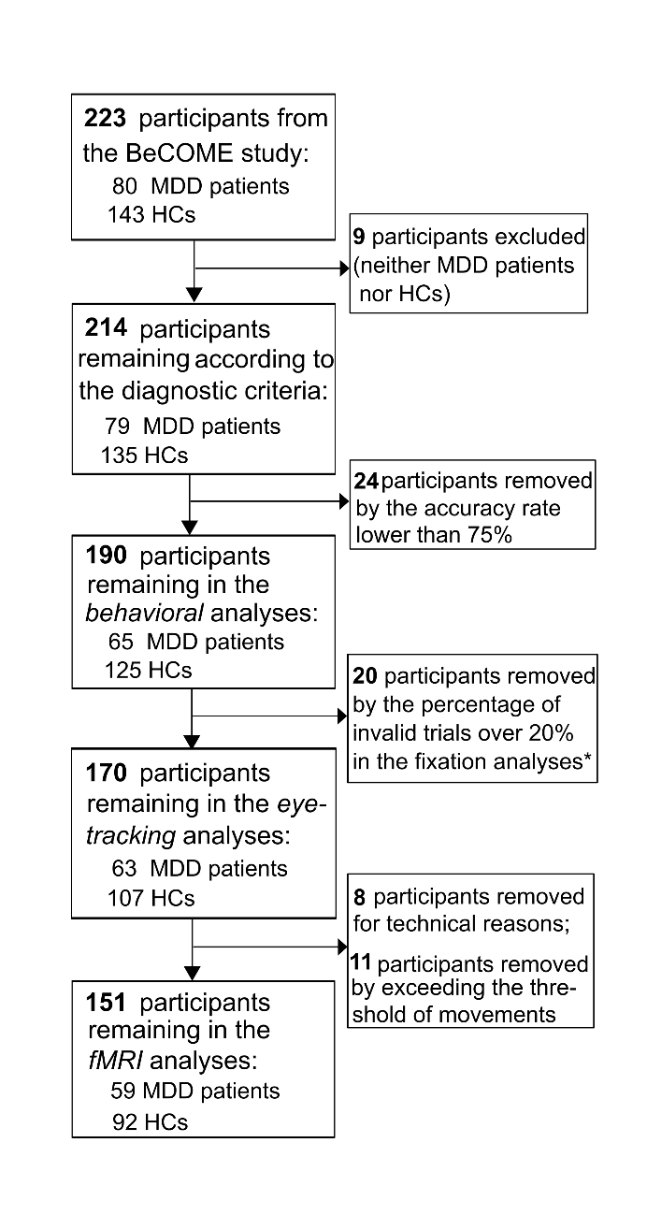
Fig. S1 Flowchart of exclusion of participants for the measurements. The BeCOME study refers to the Biological Classification of Mental Disorders study. MDD and HC refer to major depressive disorder patients and healthy controls, respectively. * the fixation analyses were used to exclude the invalid trials in the eye-tracking analyses; a trial was excluded if more than 25% of fixations were located outside the regions of interest (ROI)

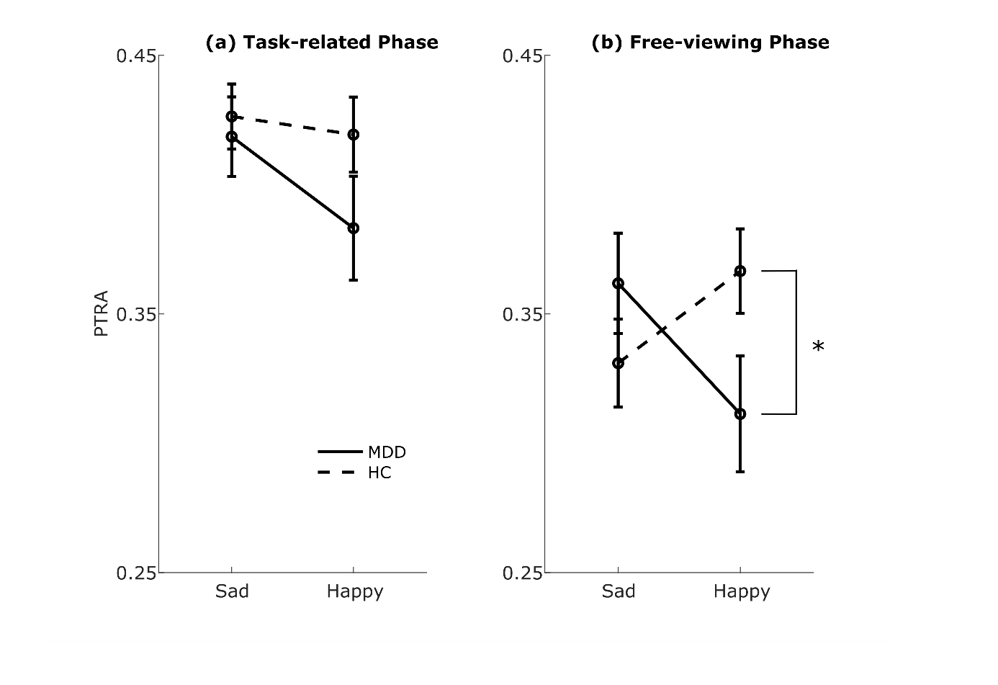
Fig. S2 Interaction between group and target face in the task-related phase (a) and the free-viewing phase (b). MDD patients had lower PTRA for happy faces than HCs in the free-viewing phase, indicating that MDD had decreased attentional maintenance on happy faces, supportive of a mood congruency bias in MDD. However, there was no significant interaction in the task-related phase. PTRA: the proportion of target-related attention; MDD: major depression disorder; HC: healthy control

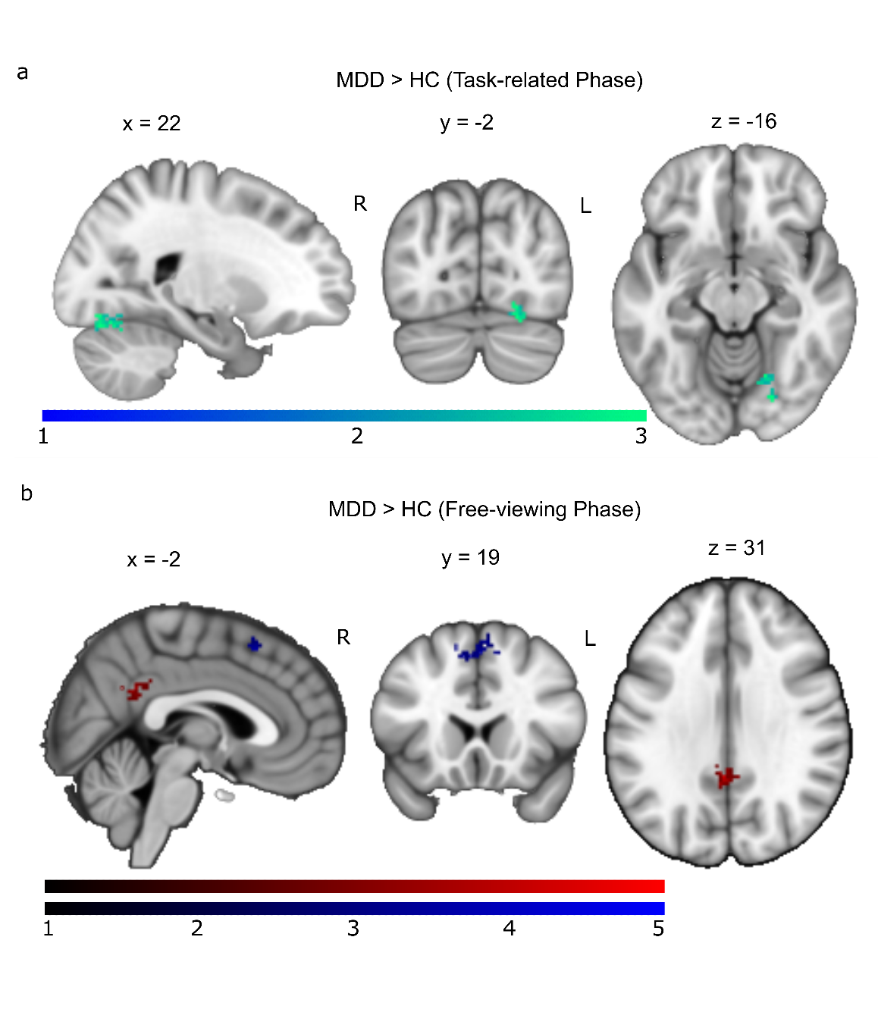
Fig. S3 Neural correlates of PTRA for emotional faces between the groups (MDD vs. HC) in the target-related phase (a) and the free-viewing phase (b). Hot (cold) colors refer to more (less) neural correlates for MDD patients compared to the HCs. The background template is a mean T1-weighted image with DARTEL spatial normalization. L = left, R = right. Color bars indicate T values. p_{cluster.FWE} < .05, with statistical maps collected at uncorrected p < .005 and k > 50

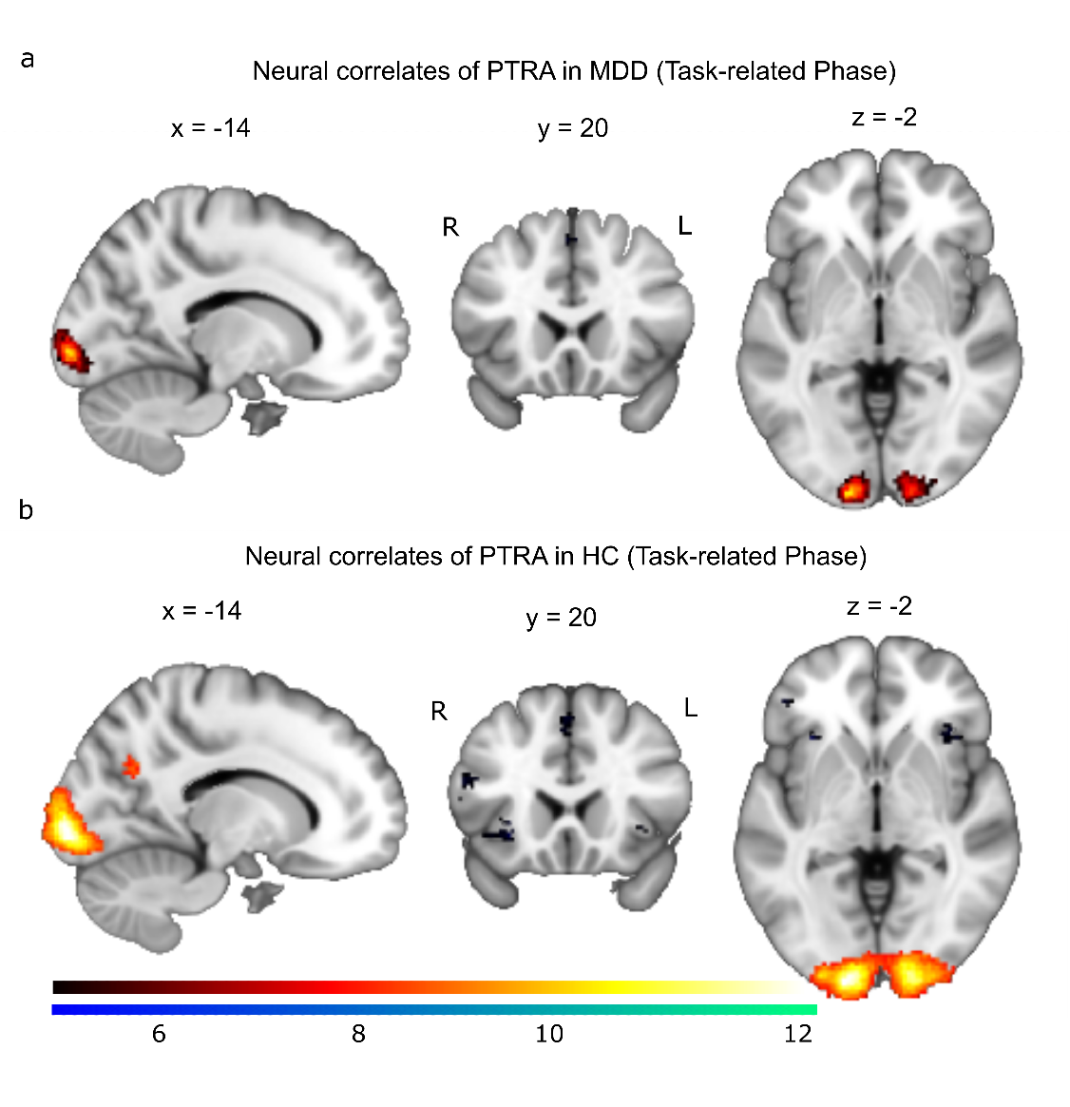
Fig. S4 Neural correlates of task-related attentional gaze patterns during the task-related phase in MDD (a) and HC (b). Hot (cold) colors refer to positive (negative) neural correlates of gaze patterns in emotional face processing. The background template is a mean T1-weighted image with DARTEL spatial normalization. L = left, R = right. Color bars indicate T values. p_{FWE} < .05, k > 30

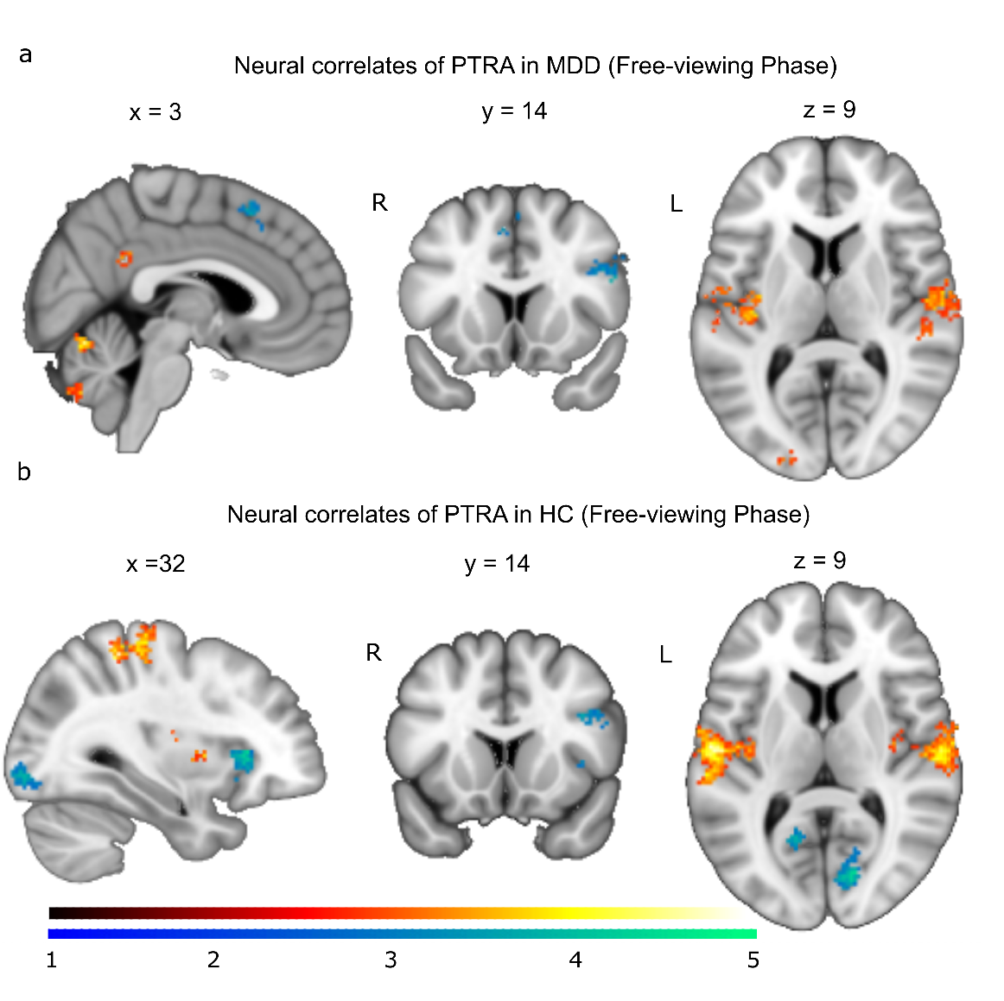
Fig. S5 Neural correlates of task-related attentional gaze patterns during the free-viewing phase in MDD (a) and HC (b). Hot (cold) colors refer to positive (negative) neural correlates of gaze patterns in emotional face processing. The background template is a mean T1-weighted image with DARTEL spatial normalization. L = left, R = right. Color bars indicate T values. p_{cluster.FWE} < .05, with statistical maps collected at uncorrected p < .005 and k > 50

Part 3: Tables
Table S1 Demographic information, RTs, and accuracy rates in the behavioral analyses
 |  | MDD |  |  | HC
n |  | 65 |  |  | 125
% Female |  | 40.0 |  |  | 30.4
 |  | Male | Female |  | Male | Female
Age (years, M±SD) |  | 35.7±14.4 | 34.5±12.6 |  | 31.6±9.7 | 35.4±13.6
 |  | RTs (ms) | Accuracy Rates |  | RTs (ms) | Accuracy Rates
Condition  (M±SD) | Emotional Faces | 2372.2±467.2 | .93±.08 |  | 2334.9±500.7 | .93±.07
Condition  (M±SD) | Geometric Forms | 1118.8±290.7 | .97±.04 |  | 1097.2±250.8 | .99±.03
Condition  (M±SD) | Positive-Negative | 2059.5±428.6 | .96±.07 |  | 2012.0±448.6 | .97±.07
Condition  (M±SD) | Negative-Negative | 2684.9±570.8 | .90±.11 |  | 2657.9±604.0 | .90±.10
Condition  (M±SD) | Happy-Sad* | 1729.5±439.5 | .98±.09 |  | 1627.0±453.8 | 1.00±.05
Condition  (M±SD) | Happy-Angry-Fearful* | 1899.3±461.5 | 1.00±.03 |  | 1859.8±497.5 | .98±.08
Note: MDD and HC refer to major depressive disorder patients and healthy controls; RTs refer to response times; * refers to the face pairs with a happy target (top face); M and SD represent the mean score and standard deviation; ms represent milliseconds.

Table S2 Demographic information and PTRA values in the eye-tracking analyses
 |  | MDD |  |  | HC
n |  | 63 |  |  | 107
% Female |  | 39.7 |  |  | 31.8
 |  | Male | Female |  | Male | Female
Age (years, M±SD) |  | 35.8±14.0 | 33.5±11.9 |  | 32.5±10.3 | 34.8±13.2
 |  | TRP | FVP |  | TRP | FVP
Condition  (PTRA, M±SD) | Emotional Faces | .41±.12 | .32±.11 |  | .42±.13 | .34±.21
Condition  (PTRA, M±SD) | Geometric Forms | .73±.29 | .30±.15 |  | .76±.29 | .34±.17
Condition  (PTRA, M±SD) | Happy-Sad* | .40±.23 | .31±.26 |  | .44±.20 | .36±.22
Condition  (PTRA, M±SD) | Happy-Fearful* | .41±.20 | .40±.21 |  | .41±.20 | .36±.22
Condition  (PTRA, M±SD) | Happy-Angry* | .46±.18 | .40±.21 |  | .43±.19 | .38±.23
Condition  (PTRA, M±SD) | Happy-Angry-Fearful* | .44±.16 | .40±.17 |  | .42±.17 | .38±.18
Note: PTRA refers to the proportion of target-related attention; MDD and HC refer to major depressive disorder patients and healthy controls; TRP and FVP represent the task-related phase and the free-viewing phase, respectively; * refers to the face pairs with a happy target (top face); M and SD refer to the mean score and standard deviation.

Table S3 Demographic information in the fMRI analyses
 | MDD |  |  | HC
n | 59 |  |  | 92
% Female | 43.4 |  |  | 35.9
 | Male | Female |  | Male | Female
Age (years, M±SD) | 34.5±14.1 | 33.3±12.1 |  | 33.8±11.2 | 35.1±12.9
Note: MDD and HC represent major depressive disorder patients and healthy controls; M and SD represent the mean score and standard deviation.

Table S4 Brain activity in response to emotional faces (vs. geometric forms) in the task-related phase
Emotional faces > Geometric forms
 | x | y | z | p_{voxel.FWE} | k
Left inferior occipital gyrus (IOG) | -26 | -96 | -8 | < 10⁻¹⁶ | 8605
Right inferior frontal gyrus (OpIFG) | 42 | 16 | 26 | < 10⁻¹⁶ | 6544
left inferior frontal gyrus (OpIFG) | -54 | 22 | 18 | < 10⁻¹⁶ | 4397
Left superior temporal gyrus (STG) | -54 | -46 | 8 | < 10⁻¹⁶ | 2192
Left amygdala | -18 | -6 | -16 | < 10⁻¹⁶ | 225
Left superior frontal gyrus medial segment (MSFG) | -2 | 32 | 48 | < 10⁻¹⁶ | 1327
Right precuneus | 4 | -64 | 32 | < 10⁻¹⁶ | 609
Right middle frontal gyrus (MFG) | 36 | 62 | 10 | 3.34×10⁻¹¹ | 33
Emotional faces < Geometric forms
 | x | y | z | p_{voxel.FWE} | k
Right superior occipital gyrus (SOG) | 24 | -86 | 18 | < 10⁻¹⁶ | 5980
Left supramarginal gyrus (SMG) | -58 | -28 | 38 | < 10⁻¹⁶ | 12036
Left supplementary motor cortex (SMC) | -4 | -10 | 50 | < 10⁻¹⁶ | 1785
Right anterior insula (AIns) | 42 | 4 | 2 | < 10⁻¹⁶ | 925
Right cerebellum exterior | 12 | -70 | -48 | < 10⁻¹⁶ | 1520
Right inferior temporal gyrus (ITG) | 54 | -58 | -10 | < 10⁻¹⁶ | 296
Left cerebellum exterior | -14 | -66 | -50 | < 10⁻¹⁶ | 184
Right precentral gyrus (PrG) | 30 | -14 | 62 | < 10⁻¹⁶ | 182
Left cerebellum exterior | -24 | -58 | -26 | < 10⁻¹⁶ | 192
Left fusiform gyrus (FuG) | -28 | -52 | -8 | < 10⁻¹⁶ | 151
Right lingual gyrus (LiG) | 16 | -74 | -6 | < 10⁻¹⁶ | 75

Table S5 Brain activity in response to emotional faces (vs. geometric forms) in the free-viewing phase
Emotional faces > Geometric forms
 | x | y | z | p_{voxel.FWE} | k
Right inferior occipital gyrus (IOG) | 30 | -94 | -4 | < 10⁻¹⁶ | 8226
Right inferior frontal gyrus (OpIFG) | 42 | 24 | 22 | < 10⁻¹⁶ | 2355
Right amygdala | 24 | -4 | -16 | < 10⁻¹⁶ | 297
Left amygdala | -28 | -4 | -20 | < 10⁻¹⁶ | 259
Left inferior frontal gyrus (OpIFG) | -56 | 20 | 24 | < 10⁻¹⁶ | 2000
Left middle temporal gyrus (MTG) | -56 | -42 | -42 | < 10⁻¹⁶ | 1022
Right middle temporal gyrus (MTG) | 60 | -46 | -46 | < 10⁻¹⁶ | 861
Right superior temporal gyrus (STG) | 54 | -8 | -14 | < 10⁻¹⁶ | 100
Right medial frontal cortex (MFC) | 4 | 60 | -14 | < 10⁻¹⁶ | 178
Left superior frontal gyrus medial segment (MSFG) | -4 | 54 | 40 | < 10⁻¹⁶ | 520
Right temporal pole (TMP) | 54 | 10 | -24 | 8.35×10⁻¹³ | 40
Right cerebellum | 24 | -80 | -36 | 2.91×10⁻¹¹ | 32
Emotional faces < Geometric forms
 | x | y | z | p_{voxel.FWE} | k
Left superior occipital gyrus (SOG) | -22 | -92 | 20 | < 10⁻¹⁶ | 8990
Left middle cingulate gyrus (MCgG) | -2 | 6 | 40 | < 10⁻¹⁶ | 715
Right fusiform gyrus (FuG) | 24 | -52 | -14 | < 10⁻¹⁶ | 170
Right cerebellum exterior | 16 | -66 | -54 | < 10⁻¹⁶ | 278
Right supramarginal gyrus | 48 | -36 | 54 | < 10⁻¹⁶ | 402
Left cerebellum exterior | -16 | -68 | -56 | 1.02×10⁻¹³ | 45
Right cerebellum exterior | 36 | -46 | -46 | < 10⁻¹⁶ | 224
Left percental gyrus (PrG) | -30 | -14 | 64 | < 10⁻¹⁶ | 146
Right lingual gyrus (LiG) | 14 | -76 | -6 | < 10⁻¹⁶ | 96
Left planum temporal (PT) | -48 | -40 | 18 | 1.05×10⁻¹³ | 45
Right planum polare (PP) | 58 | 0 | -2 | < 10⁻¹⁶ | 258
Left fusiform gyrus (FuG) | -26 | -48 | -10 | < 10⁻¹⁶ | 84
Left cerebellum exterior | 40 | -54 | -46 | < 10⁻¹⁶ | 80

Table S6 Brain activity in response to emotional faces in the free-viewing phase vs. in the task-related phase
Free-viewing phase > Task-related phase
 | x | y | z | p_{voxel.FWE} | k
Right central operculum (CO) | 40 | -16 | 18 | < 10⁻¹⁶ | 16692
Left angular gyrus (AnG) | -44 | -66 | 26 | < 10⁻¹⁶ | 11412
Left cuneus | -6 | -66 | 26 | < 10⁻¹⁶ | 1266
Left hippocampus | -26 | -20 | -20 | < 10⁻¹⁶ | 960
Left middle frontal gyrus (MFG) | -36 | 16 | 52 | < 10⁻¹⁶ | 1240
Left posterior cingulate gyrus (PCgG) | -4 | -38 | 36 | < 10⁻¹⁶ | 544
Right middle frontal gyrus (MFG) | 52 | 44 | 14 | < 10⁻¹⁶ | 566
Right middle frontal gyrus (MFG) | 26 | 22 | 50 | < 10⁻¹⁶ | 625
Left cerebellum exterior | -18 | -46 | -58 | < 10⁻¹⁶ | 147
Left middle frontal gyrus (MFG) | -44 | 54 | -2 | < 10⁻¹⁶ | 110
Right central operculum (CO) | 36 | 4 | 12 | 3.60×10⁻¹¹ | 35
Left posterior orbital gyrus (POrG) | -32 | 34 | 12 | < 10⁻¹⁶ | 83
Right medial orbital gyrus (MOrG) | 22 | 32 | -18 | 1.44×10⁻¹⁵ | 62
Left superior frontal gyrus (SFG) | -8 | 64 | 12 | < 10⁻¹⁶ | 283
Left temporal pole (TMP) | -46 | 8 | -34 | < 10⁻¹⁶ | 93
Right middle temporal gyrus (MTG) | 54 | 0 | -38 | 1.28×10⁻¹⁰ | 32
Left medial frontal cortex (MFC) | -6 | 52 | -10 | 5.47×10⁻¹¹ | 34
Free-viewing phase < Task-related phase
 | x | y | z | p_{voxel.FWE} | k
Left anterior insula (AIns) | -30 | 22 | 0 | < 10⁻¹⁶ | 751
Right anterior insula (AIns) | 32 | 26 | 0 | < 10⁻¹⁶ | 870
Right precentral gyrus (PrG) | 42 | 4 | 30 | < 10⁻¹⁶ | 520
Left cerebellum exterior | -34 | -54 | -32 | < 10⁻¹⁶ | 101
Left cerebellum exterior | 34 | -54 | -30 | < 10⁻¹⁶ | 261
Right lateral ventricle | 28 | -48 | 12 | < 10⁻¹⁶ | 194
Left pallidum | -16 | 6 | 0 | < 10⁻¹⁶ | 89
Left occipital fusiform gyrus (OFuG) | -26 | -78 | -8 | 3.33×10⁻¹⁶ | 66
Left calcarine cortex (Calc) | -16 | -74 | 8 | < 10⁻¹⁶ | 107
Left lateral ventricle | -26 | -50 | 14 | < 10⁻¹⁶ | 104
Right middle frontal gyrus (MFG) | -30 | 38 | 30 | < 10⁻¹⁶ | 82

Table S7 Neural correlates of PTRA (only for emotional faces) in the free-viewing phase vs. in the task-related phase
Free-viewing phase > Task-related phase
 | x | y | z | p_{voxel.FWE} | k
Left inferior frontal gyrus (OpIFG) | -52 | 16 | 24 | < 10⁻¹⁶ | 350
Left triangular part of the inferior frontal gyrus (TrIFG) | -44 | 40 | 0 | < 10⁻¹⁶ | 210
Left supplementary motor cortex (SMC) | -6 | 24 | 44 | < 10⁻¹⁶ | 310
Right cerebellum exterior | 10 | -76 | -26 | < 10⁻¹⁶ | 188
Free-viewing phase < Task-related phase
 | x | y | z | p_{voxel.FWE} | k
Right lingual gyrus (LiG) | 14 | -90 | -6 | < 10⁻¹⁶ | 2894
Left precuneus (PCu) | -12 | -66 | 28 | < 10⁻¹⁶ | 60

Table S8 Neural correlates of PTRA between the groups (MDD vs. HC) in the task-related phase
MDD < HC
 | x | y | z | p_{cluster.FWE *} | k
Right cerebellum exterior | 22 | -76 | 12 | 4.60×10⁻² | 91
Note: * Statistical maps were collected at a threshold of uncorrected p < 0.005, k > 50.

Table S9 Neural correlates of PTRA between the groups (MDD vs. HC) in the free-viewing phase
MDD > HC
 | x | y | z | p_{cluster.FWE *} | k
Left posterior cingulate gyrus (PoCgG) | -2 | -46 | 32 | 1.00×10⁻³ | 100
Left inferior occipital gyrus (IOG) | -18 | -92 | -6 | 3.84×10⁻⁵ | 142
MDD < HC
 | x | y | z | p_{cluster.FWE *} | k
Right supplementary motor cortex (SMC) | 2 | 20 | 52 | 3.30×10⁻² | 63
Note: * Statistical maps were collected at a threshold of uncorrected p < 0.005, k > 50.

Table S10 Neural correlates of PTRA (only for emotional faces) for MDD in the task-related phase
Positive activity
 | x | y | z | p_{voxel.FWE} | k
Middle occipital gyrus (MOG) | -14 | -98 | -2 | < 10⁻¹⁶ | 661
Right calcarine (RC) | 16 | -98 | 0 | < 10⁻¹⁶ | 676
Negative activity
 | x | y | z | p_{voxel.FWE} | k
Left supplementary motor cortex (SMC) | -2 | 20 | 52 | < 10⁻¹⁶ | 96
Left opercular part of inferior frontal gyrus (OpIFG) | -54 | 14 | 16 | 6.67×10⁻¹⁶ | 51

Table S11 Neural correlates of PTRA (only for emotional faces) for HC in the task-related phase
Positive activity
 | x | y | z | p_{voxel.FWE} | k
Middle occipital gyrus (MOG) | -14 | -98 | -2 | < 10⁻¹⁶ | 3231
Right middle cingulate gyrus (MCgG) | 0 | -34 | 32 | < 10⁻¹⁶ | 174
Right precuneus (PCu) | 16 | -60 | -60 | < 10⁻¹⁶ | 67
Left precuneus (PCu) | -16 | -64 | 28 | < 10⁻¹⁶ | 135
Negative activity
 | x | y | z | p_{voxel.FWE} | k
Left supplementary motor cortex (SMC) | -4 | 18 | 50 | < 10⁻¹⁶ | 435
Left insula (Ins) | -32 | 22 | -2 | < 10⁻¹⁶ | 161
Left triangular part of the inferior frontal gyrus (TrIFG) | -38 | 0 | 34 | < 10⁻¹⁶ | 402
Left Middle occipital gyrus (MOG) | -30 | -80 | 22 | < 10⁻¹⁶ | 77
Right insula (Ins) | 34 | 22 | 0 | < 10⁻¹⁶ | 122
Left triangular part of the inferior frontal gyrus (TrIFG) | -44 | 38 | 0 | < 10⁻¹⁶ | 118
Right triangular part of the inferior frontal gyrus (TrIFG) | 58 | 24 | 14 | 9.33×10⁻¹⁴ | 40

Table S12 Neural correlates of PTRA (only for emotional faces) for MDD in the free-viewing phase
Positive activity
 | x | y | z | p_{cluster.FWE *} | k
Vermis 6 | 2 | -68 | -14 | 9.48×10⁻⁵ | 65
Right superior temporal gyrus (STG) | 52 | -10 | 6 | < 10⁻¹⁶ | 354
Left superior temporal gyrus (STG) | -40 | -20 | 12 | < 10⁻¹⁶ | 363
Left posterior cingulate gyrus (PCgG) | -4 | -44 | 30 | 3.64×10⁻⁴ | 56
Vermis 8 | 6 | -72 | -42 | 2.52×10⁻⁸ | 129
Left middle occipital gyrus (MOG) | -20 | -88 | -2 | 2.25×10⁻⁸ | 130
Left angular gyrus (AnG) | -46 | -62 | 32 | 4.95×10⁻⁴ | 54
Negative activity
 | x | y | z | p_{cluster.FWE *} | k
Left inferior occipital gyrus (IOG) | -36 | -88 | -6 | 9.27×10⁻⁴ | 82
Right inferior occipital gyrus (IOG) | 36 | -82 | -8 | 8.46×10⁻⁴ | 50
Left supplementary motor cortex (SMC) | 2 | 16 | 54 | 2.30×10⁻⁴ | 59
Right opercular part of inferior frontal gyrus (OpIFG) | 50 | 14 | 22 | 1.33×10⁻⁷ | 115
Right superior frontal gyrus medial segment (MSFG) | 8 | 24 | 44 | 1.98×10⁻⁴ | 60
Note: * Statistical maps were collected at a threshold of uncorrected p < 0.005, k > 50.

Table S13 Neural correlates of PTRA (only for emotional faces) for HC in the free-viewing phase
Positive activity
 | x | y | z | p_{cluster.FWE *} | k
Right superior temporal gyrus (STG) | 62 | -16 | 16 | < 10⁻¹⁶ | 1088
Left superior temporal gyrus (STG) | -54 | -16 | 12 | < 10⁻¹⁶ | 1031
Right postcentral | 32 | -40 | 56 | < 10⁻¹⁶ | 587
Left Cerebellum | -34 | -54 | -40 | 7.91×10⁻⁴ | 51
Vermis 6 | 2 | -68 | -14 | 9.27×10⁻⁴ | 50
Negative activity
 | x | y | z | p_{cluster.FWE *} | k
Right calcarine cortex (Calc) | 14 | -78 | 8 | 3.94×10⁻¹⁴ | 260
Right insula (Ins) | 34 | 24 | 4 | 1.68×10⁻⁷ | 113
Left calcarine cortex (Calc) | -10 | -58 | 16 | 4.52×10⁻⁸ | 124
Right opercular part of inferior frontal gyrus (OpIFG) | 40 | 10 | 30 | 9.20×10⁻⁸ | 118
Right inferior occipital gyrus (IOG) | 34 | -86 | -10 | 1.42×10⁻⁸ | 134
Left insula (Ins) | -30 | 22 | 4 | 7.94×10⁻⁴ | 51
Left inferior occipital gyrus (IOG) | -32 | -90 | -6 | 6.44×10⁻⁸ | 121
Note: * Statistical maps were collected at a threshold of uncorrected p < 0.005, k > 50.

