Supplementary material
Title: Clinical predictors of suicidal ideation, suicide attempts and suicide death in depressive disorder: a systematic review and meta-analysis
Authors: Pau Riera-Serra, Guillem Navarra-Ventura, Adoración Castro, Margalida Gili, Angie Salazar-Cedillo, Ignacio Ricci-Cabello, Lorenzo Roldán-Espínola, Victoria Coronado-Simsic, Mauro García-Toro, Rocío Gómez-Juanes, Miquel Roca

Corresponding author: Adoración Castro PhD; Research Institute of Health Sciences (IUNICS), University of the Balearic Islands (UIB); Carretera de Valldemossa, km 7.5, 07122 Palma de Mallorca, Balearic Islands, Spain
E-mail: a.castro@uib.es
Phone: +34 971 25 98 88 (ext: 9888)
Journal: European Archives of Psychiatry and Clinical Neuroscience

Table S1. Search strategy: domains and keywords
Domains | Keywords
Depression | Depression  Depressive disorder  Major depression  Dysthymia
Suicide | Suicide  Suicidality  Suicidal behaviour  Suicide attempt  Suicide ideation  Suicide thoughts  Suicide death  Suicide plan  Suicide threat  Self-injury  Self-harm  Self-mutilation  Self-cutting  Self-poisoning  Self-destructive
Study design | Case control study  Cohort study  Cohort analysis  Follow up study  Retrospective  Longitudinal  Longitudinally  Prospective  Prospectively
Filters | Humans  ≥ 18 years old (adults)  English  From 1st January 2001

Table S2. Pubmed (Medline) search strategy: queries and results (searched on October 3, 2022)
N₀ | Queries | Results
#1 | "depression"[MeSH Major Topic] | 66,767
#2 | "depressive disorder"[MeSH Major Topic] | 94,333
#3 | "depress*"[Title/Abstract] | 539,169
#4 | "major depressive disorder"[Title/Abstract] | 29,445
#5 | "MDD"[Title/Abstract] | 17,117
#6 | "major depression"[Title/Abstract] | 25,963
#7 | "dysthymi*"[Title] | 627
#8 | "dysthymia"[Title/Abstract] | 2,286
#9 | "suicide"[MeSH Major Topic] | 52,697
#10 | "self mutilation"[MeSH Major Topic] | 2,270
#11 | "suicid*"[Title/Abstract] | 91,689
#12 | "self injur*"[Title/Abstract] | 6,042
#13 | "self harm*"[Title/Abstract] | 8,078
#14 | "self mutilat*"[Title/Abstract] | 1,889
#15 | "self cut*"[Title/Abstract] | 233
#16 | "self destruct*"[Title/Abstract] | 2,124
#17 | "case control studies"[MeSH Major Topic] | 1,856
#18 | "cohort studies"[MeSH Major Topic] | 4,604
#19 | "retrospective*"[Title/Abstract] | 952,805
#20 | "longitudinal*"[Title/Abstract] | 325,980
#21 | "follow up stud*"[Title/Abstract] | 56,709
#22 | "prospective*"[Title/Abstract] | 827,433
#23 | "cohort stud*"[Title/Abstract] | 292,112
#24 | "case-control*"[Title/Abstract] | 152,204
#25 | #1 OR #2 OR #3 OR #4 OR #5 OR #6 OR #7 OR #8 | 227,858
#26 | #9 OR #10 OR #11 OR #12 OR #13 OR #14 OR #15 OR #16 | 108,404
#27 | #17 OR #18 OR #19 OR #20 OR #21 OR #22 OR #23 OR #24 | 2,208,913
#28 | #25 AND #26 AND #27 | 2,109
#29 | #28 AND ((humans[Filter]) AND (2001/1/1:2022/10/03[pdat]) AND (english[Filter]) AND (alladult[Filter])) | 1,162

Table S3. EMBASE search strategy: queries and results (searched on October 3, 2022)
N₀ | Queries | Results
#1 | 'major depression'/exp | 71329
#2 | 'mdd':ab,ti | 22282
#3 | 'depress*':ab,ti | 357921
#4 | depress*:ti | 208736
#5 | 'major depression':ab,ti | 32439
#6 | 'major depressive disorder':ab,ti | 35125
#7 | dysthymi*:ti | 793
#8 | dysthymia:ab,ti | 2914
#9 | 'suicide'/exp | 63022
#10 | suicid*:ab,ti | 108359
#11 | 'self injur*':ab,ti | 6526
#12 | 'self harm*':ab,ti | 8701
#13 | 'self mutilat*':ab,ti | 2131
#14 | 'self cut*':ab,ti | 291
#15 | 'self destruct*':ab,ti | 2506
#16 | 'automutilation'/exp | 21102
#17 | 'case control study'/exp | 194577
#18 | 'cohort analysis'/exp | 748338
#19 | retrospective*:ab,ti | 1407553
#20 | longitudinal*:ab,ti | 395769
#21 | 'follow-up stud*':ab,ti | 69444
#22 | prospective*:ab,ti | 1180851
#23 | 'cohort stud*':ab,ti | 357168
#24 | 'case-control*':ab,ti | 175709
#25 | 'cohort analy*':ab,ti | 15062
#27 | #1 OR #2 OR #3 OR #4 OR #5 OR #6 OR #7 OR #8 | 412236
#28 | #9 OR #10 OR #11 OR #12 OR #13 OR #14 OR #15 OR #16 | 142282
#29 | #17 OR #18 OR #19 OR #20 OR #21 OR #22 OR #23 OR #24 OR #25 | 3405532
#30 | #26 AND #27 AND #28 AND ([adult]/lim OR [aged]/lim) AND [humans]/lim AND [english]/lim AND [embase]/lim AND [2001-2022]/py | 3411

Table S4. PsychINFO search strategy: queries and results (searched on October 3, 2022)
N₀ | Queries | Results
#1 | DE major depression | 142408
#2 | DE depression | 51159
#3 | MA depressive disorder | 60319
#4 | MA depression | 55734
#5 | TI depress* | 127296
#6 | TI "major depressive disorder" OR AB "major depressive disorder" | 23413
#7 | TI "MDD" OR AB "MDD" | 12872
#8 | TI "major depression" OR AB "major depression" | 23643
#9 | TI dysthymi* | 647
#10 | TI dysthymia AND AB dysthymia | 315
#11 | MA suicide | 22490
#12 | DE suicide | 35428
#13 | MA self-injurious behavior | 4120
#14 | DE self-injurious behavior | 7920
#15 | TI suicid* OR AB suicid* | 72523
#16 | TI self-injur* OR AB self-injur* | 3618
#17 | TI self-harm* OR AB self-harm* | 6817
#18 | TI self-mutilat* AND AB self-mutilat* | 458
#19 | TI self-cut* AND AB self-cut* | 73
#20 | TI self-destruct* AND AB self-destruct* | 311
#21 | DE cohort analysis | 1651
#22 | TI "cohort stud*" OR AB "cohort stud*" | 26522
#23 | TI "case-control*" OR AB "case-control*" | 12679
#24 | TI "cohort analy*" OR AB "cohort analy*" | 901
#25 | TI retrospective* OR AB retrospective* | 50214
#26 | TI longitudinal* OR AB longitudinal* | 136781
#27 | TI "follow-up stud*" OR AB "follow-up stud*" | 13518
#28 | TI prospective* OR AB prospective* | 77389
#29 | S1 OR S2 OR S3 OR S4 OR S5 OR S6 OR S7 OR S8 OR S9 ORS 10 | 220919
#30 | S11 OR S12 OR S13 OR S14 OR S15 OR S16 OR S17 OR S18 OR S19 OR S20 | 81913
#31 | S21 OR S22 OR S23 OR S24 OR S25 OR S26 OR S27 OR S28 | 273958
#32 | S29 AND S30 AND S31 | 2349
#33 | S29 AND S30 AND S31  ( Limiters - Publication date: 2001-01-01-2022-10-31; Language: English; Age group: Adulthood (18 yrs & older); Population group: Human). | 1463

Table S5. Cochrane search strategy: queries and results (searched on October 3, 2022)
N₀ | Queries | Results
#1 | MeSH descriptor: [Depression] 1 tree(s) exploded | 14235
#2 | MeSH descriptor: [Depressive Disorder] explode all trees | 13449
#3 | (depress*):ti | 33986
#4 | (“major depressive disorder”):ti OR (“major depressive disorder”):ab | 7866
#5 | (“MDD”):ti OR (“MDD”):ab | 4225
#6 | ("major depression"):ti OR ("major depression"):ab | 5971
#7 | (dysthymi*):ti | 198
#8 | (dysthymia):ti OR (dysthymia):ab | 479
#9 | MeSH descriptor: [Suicide] explode all trees | 1509
#10 | MeSH descriptor: [Self Mutilation] explode all trees | 37
#11 | (suicid*):ti OR (suicid*):ab | 6477
#12 | (self-injur*):ti OR (self-injur*):ab | 517
#13 | (self-harm*):ti OR (self-harm*):ab | 774
#14 | (self-mutilat*):ti OR (self-mutilat*):ab | 34
#15 | (self-cut*):ti OR (self-cut*):ab | 15
#16 | (self-destruct*):ti OR (self-destruct*):ab | 51
#17 | MeSH descriptor: [Case-Control Studies] explode all trees | 15135
#18 | MeSH descriptor: [Cohort Studies] explode all trees | 161158
#19 | ("Case-control*"):ti OR ("Case-control*"):ab | 5117
#20 | ("Cohort stud*"):ti OR ("Cohort stud*"):ab | 0
#21 | ("Cohort analy*"):ti OR ("Cohort analy*"):ab | 0
#22 | (Retrospective*):ti AND (Retrospective*):ab | 1903
#23 | (Longitudinal*):ti OR (Longitudinal*):ab | 20305
#24 | ("Follow-up stud*"):ti OR ("Follow-up stud*"):ab | 0
#25 | (Prospective*):ti OR (Prospective*):ab | 211230
#26 | #1 OR #2 OR #3 OR #4 OR #5 OR #6 OR #7 OR #8 | 45117
#27 | #9 OR #10 OR #11 OR #12 OR #13 OR #14 OR #15 OR #16 | 7177
#28 | #17 OR #18 OR #19 OR #20 OR #21 OR #22 OR #23 OR #24 OR #25 | 318073
#29 | #26 AND #27 AND #28 with Cochrane Library publication date Between Jan 2001 and Oct 2022 | 307

Table S6. OATD search strategy: queries and results (searched on October 3, 2022)
N₀ | Queries | Results
#1 | title: depress* | 14183
#2 | title:("major depressive disorder") OR abstract:("major depressive disorder") | 1528
#3 | title:( “major depression” ) OR abstract:( “major depression” ) | 331925
#4 | title:( dysthym* ) OR abstract: ( dysthym* ) | 149
#5 | title:( Suicid* ) OR abstract:( Suicid* ) | 9435
#6 | title:( self-injur* ) OR abstract:( self-injur* ) | 0
#7 | title:( "self-harm*" ) OR abstract:( "self-harm*" ) | 977
#8 | title:( self-mutilat*) OR abstract:( self-mutilat* ) | 0
#9 | title:( self-cut* ) OR abstract:( self-cut* ) | 0
#10 | title:( "self-destruct*" ) OR abstract:( "self-destruct*" ) | 2
#11 | title:( "case-control*" ) OR abstract:( "case-control*" ) | 5367
#12 | title:( "cohort stud*" ) OR abstract:( "cohort stud*" ) | 0
#13 | title:( "cohort analy*" ) OR abstract:( "cohort analy*" ) | 0
#14 | title:( retrospective* ) OR abstract:( retrospective* ) | 23819
#15 | title:( longitudinal* ) OR abstract:( longitudinal* ) | 53903
#16 | title:( "follow-up stud*" ) OR abstract:( "follow-up stud*") | 0
#17 | title:( prospective* ) OR abstract:( prospective* ) | 29311
#18 | title:("MDD") OR abstract:("MDD") | 1268
#19 | title:("MDD") OR abstract:("MDD") OR (title:( “major depression” ) OR abstract:( “major depression” )) OR (title: depress*) OR (title:( “major depression” ) OR abstract:( “major depression” )) OR (title:( dysthym* ) OR(abstract: ( dysthym* ) ) | 334987
#20 | (title:( Suicid* ) OR abstract:( Suicid* )) OR (title:( "self-injur*" ) OR abstract:( "self-injur*" )) OR (title:( "self-harm*" ) OR abstract:( "self-harm*" )) OR (title:( self-mutilat*) OR abstract:( self-mutilat* )) | 9952
#21 | title:( "Case-control*" ) OR abstract:( "Case-control*" ) OR title:( "Cohort stud*" ) OR abstract:( "Cohort stud*" ) OR title:( "Cohort analy*" ) OR abstract:( "Cohort analy*" ) OR (title:( Retrospective* ) OR abstract:( Retrospective* )) OR (title:( Longitudinal* ) OR abstract:( Longitudinal* )) OR title:( "Follow-up stud*" ) OR abstract:( "Follow-up stud*") OR title:( Prospective* ) OR abstract:( Prospective* ) | 104667
#22 | ((title:("MDD") OR abstract:("MDD")) OR (title:( “major depression” ) OR abstract:( “major depression” )) OR (title: depress*) OR (title:( “major depression” ) OR abstract:( “major depression” )) OR (title:( dysthym*) OR (abstract: ( dysthym* ))) AND ((title:( Suicid* ) OR abstract:( Suicid* )) OR (title:( "self-injur*" ) OR abstract:( "self-injur*" )) OR (title:( "self-harm*" ) OR abstract:( "self-harm*" )) OR (title:( self-mutilat*) OR abstract:( self-mutilat* ))) AND (title:( "Case-control*" ) OR abstract:( "Case-control*" ) OR title:( "Cohort stud*" ) OR abstract:( "Cohort stud*" ) OR title:( "Cohort analy*" ) OR abstract:( "Cohort analy*" ) OR (title:( Retrospective* ) OR abstract:( Retrospective* )) OR (title:( Longitudinal* ) OR abstract:( Longitudinal* )) OR title:( "Follow-up stud*" ) OR abstract:( "Follow-up stud*") OR title:( Prospective* ) OR abstract:( Prospective* )) | 278
#23 | ((title:("MDD") OR abstract:("MDD")) OR (title:( “major depression” ) OR abstract:( “major depression” )) OR (title: depress*) OR (title:( “major depression” ) OR abstract:( “major depression” )) OR (title:( dysthym*) OR(abstract: ( dysthym* ))) AND ((title:( Suicid* ) OR abstract:( Suicid* )) OR (title:( "self-injur*" ) OR abstract:( "self-injur*" )) OR (title:( "self-harm*" ) OR abstract:( "self-harm*" )) OR (title:( self-mutilat*) OR abstract:( self-mutilat* ))) AND (title:( "Case-control*" ) OR abstract:( "Case-control*" ) OR title:( "Cohort stud*" ) OR abstract:( "Cohort stud*" ) OR title:( "Cohort analy*" ) OR abstract:( "Cohort analy*" ) OR (title:( Retrospective* ) OR abstract:( Retrospective* )) OR (title:( Longitudinal* ) OR abstract:( Longitudinal* )) OR title:( "Follow-up stud*" ) OR abstract:( "Follow-up stud*") OR title:( Prospective* ) OR abstract:( Prospective* )) + filter (English) + filter (date: 2001-2022) | 155

Table S7. WoS Science Citation Index search strategy: queries and results (searched on October 3, 2022)
N₀ | Queries | Results
#1 | (TI= “depress*”) AND LA=(English) | 25767
#2 | (TS= “MDD”) AND LA=English | 1670
#3 | (TS= “major depressive disorder”) AND LA= English | 2766
#4 | (TS= “major depression”) AND LA= English | 3653
#5 | (TI= “ dysthymi*”) AND LA= English | 75
#6 | (TS= “ dysthymia”) AND LA= English | 156
#7 | (TS= “suicid*”) AND LA= English | 6165
#8 | (TS= “self-injur*”) AND LA= English | 291
#9 | (TS= “self-harm*”) AND LA= English | 235
#10 | (TS= “ self-mutilat*”) AND LA= English | 69
#11 | (TS= " self-cut*") AND LA= English | 11
#12 | (TS= " self-destruct*") AND LA= English | 270
#13 | (TS= "Case-control*") AND LA= English | 8248
#14 | (TS= "Cohort stud*") AND LA= English | 16426
#15 | (TS= "Cohort analy*") AND LA= English | 977
#16 | (TS= “ Retrospective* “) AND LA= English | 57914
#17 | (TS= “ Longitudinal* “) AND LA= English | 61675
#18 | (TS= “ Prospective* “) AND LA= English | 72337
#19 | (TS= "Follow-up stud*") AND LA= English | 5172
#20 | #6 OR #5 OR #4 OR #3 OR #2 OR #1 | 28278
#21 | #12 OR #11 OR #10 OR #9 OR #8 OR #7 | 6763
#22 | #19 OR #18 OR #17 OR #16 OR #15 OR #14 OR #13 | 204884
#23 | #20 AND #21 AND #22 | 53

Table S8. Opengrey search strategy: queries and results (searched on October 3, 2022)
N₀ | Queries | Results
#1 | depress* | 3176
#2 | suicid* | 999
#3 | depress* AND suicid | 151
#4 | depress* AND suicid* lang:"en" | 26
#5 | (>=2001) | 16

Table S9. Classification of the predictors of suicidality within depression found among the included studiesª
Diagnostic subtype  (n = 5; k = 19)^{b} | Clinical symptoms  (n = 23; k = 31)^{b} | Clinical course  (n = 10; k = 35)^{b} | Clinical assessment scales  (n = 7; k = 28)^{b}
Atypical features (1) | Agitation (1) | Age at diagnosis of MDD (5) | Beck Depression Inventory (BDI) (8)
Dysthymia (1) | Anhedonia (1) | Family history of suicide or suicide attempts (1) | Beck Hopelessness Scale (BHS) (8)
Melancholic subtype (4) | Appetite gain (1) | Number of major depressive episodes (5) | Beck Scale for Suicide Ideation (BSSI) (5)
Psychotic subtype (7) | Decreased appetite (1) | Number of suicide attempts (1) | Hamilton Depression Rating Scale (HDRS) (3)
Severe depression (6) | Depressed mood (1) | Personal history of depression (1) | Hospital Anxiety and Depression Scale, depression subscale (HADS-D) (1)
- | Depression Symptomatology (1) | Personal history of suicide attempt (11) | Inventory of Depressive Symptomatology (IDS) (1)
- | Fatigue (1) | Personal history of suicidal ideation (3) | Montgomery-Åsberg Depression Rating Scale (MADRS) (2)
- | Guilt (2) | Time to full remission (3) | -
- | Hopelessness (2) | Total time in depression (4) | -
- | Hypersomnia (1) | Time since depression diagnosis (1) | -
- | Insomnia (2) | - | -
- | Loss of concentration (1) | - | -
- | Persistent sleep disturbance (1) | - | -
- | Pessimism (1) | - | -
- | Psychomotor disturbance (1) | - | -
- | Psychotic symptoms (2) | - | -
- | Reduced sleep (1) | - | -
- | Retardation (1) | - | -
- | Sexual interest (1) | - | -
- | Sleep complaints (2) | - | -
- | Suicidal ideation (4) | - | -
- | Suicide plans (1) | - | -
- | Weight loss (1) | - | -
ª The number of prediction cases (k) for each predictor are reported in parentheses. Predictors for which we found more than one prediction case (k > 1) were eventually meta-analysed.
^{b} Number of predictors (n) and prediction cases (k) for each predictor category.
- Indicates that no more predictors were found for the predictor category.

Table S10. Pre-operationalization of several predictors prior to the meta-analysis
Generated predictors | Analogous predictors | Relabelled predictors
Severity of depression (15) | Beck Depression Inventory (BDI) (8)  Hamilton Depression Rating Scale (HDRS) (3)  Hospital Anxiety and Depression Scale, depression subscale (HADS-D) (1)  Montgomery-Åsberg Depression Rating Scale (MADRS) (2)  Inventory of Depressive Symptomatology (IDS) (1) | -
Suicidal ideation (7) | Personal history of suicidal ideation (3)  Suicidal ideation (4) | -
Severity of suicidal ideation (5) | - | Beck Scale for Suicide Ideation (BSSI) (5)
Severity of hopelessness (8) | - | Beck Hopelessness Scale (BHS) (8)
Psychotic features (9) | Psychotic subtype (7)  Psychotic symptoms (2) | -
Sleep disturbances (7) | Hypersomnia (1)  Insomnia (2)  Persistent sleep disturbance (1)  Reduced sleep (1)  Sleep complaints (2) | -
ª Number of prediction cases (k) found for each predictor are reported in parentheses.

Table S11. Newcastle-Ottawa quality assessment of the included studies in the systematic review
N₀ | Study | Design | Suicide  outcome | Selection |  |  |  | Comparability | Outcome |  |  | NOS score
 |  |  |  | S1 | S2ª | S3 | S4^{b} | C1 | E/O1 | E/O2^{c} | E/O3^{d}
1 | Aaltonen et al. (2019) | cohorts | death |  | ★ | ★ | ★ | ★★ | ★ | ★ | - | 8
2 | Baryshnikov et al. (2020) | cohorts | ideation | ★ | ★ | ★ | - | ★★ | - | ★ | ★ | 7
3 | Chan et al. (2014) | cohorts | attempt | - | ★ | ★ | - | ★★ | - | ★ | ★ | 6
4.1 | Courtet et al. (2014) | cohorts | ideation | ★ | ★ | ★ | - | ★★ | - | ★ | ★ | 7
4.2 | Courtet et al. (2014) | cohorts | attempt | ★ | ★ | ★ | - | ★★ | - | ★ | - | 6
5 | Galfalvy et al. (2008);  Grunebaum et al. (2004) | cohort | attempt | ★ | ★ | ★ | - | ★★ | - | ★ | ★ | 7
6 | Gladstone et al. (2001) | cohort | death | ★ | ★ | - | - | ★ | ★ | ★ | - | 5
7 | Gronemann et al. (2021);  Kessing (2004) | cohort | death | ★ | ★ | ★ | ★ | ★★ | ★ | ★ | ★ | 9
8.1 | Sokero et al. (2006) | cohort | ideation | ★ | ★ | ★ | - | ★★ | - | ★ | ★ | 7
8.2 | Holma et al. (2010);  Sokero et al. (2005) | cohort | attempt | ★ | ★ | ★ | - | ★★ | - | ★ | ★ | 7
9 | Kim et al. (2012) | case-control | death | - | ★ | ★ | ★ | ★★ | ★ | ★ | ★ | 8
10 | Leadholm et al. (2014) | cohort | death | ★ | ★ | ★ | ★ | ★★ | ★ | - | - | 7
11 | Manning et al. (2021) | cohort | ideation | ★ | ★ | ★ | - | ★★ | ★ | ★ | ★ | 8
12 | McGirr et al. (2007);  McGirr et al. (2008) | case-control | death | ★ | ★ | - | - | ★ | ★ | ★ | ★ | 6
13 | Nikel et al. (2006) | cohort | attempt | ★ | ★ | - | - | ★ | - | ★ | ★ | 5
14 | Nobile et al. (2022) | cohort | attempt | ★ | ★ | - | - | ★★ | ★ | ★ | ★ | 7
15.1 | Qiu et al. (2017) | cohort | ideation | ★ | ★ | ★ | - | - | - | ★ | ★ | 5
15.2 | Qiu et al. (2017) | cohort | attempt | ★ | ★ | ★ | - | - | - | ★ | ★ | 5
16 | Reutfors et al. (2021) | case-control | death | ★ | ★ | ★ | - | ★★ | ★ | ★ | ★ | 8
17 | Riihimäki et al. (2014) | cohort | attempt | ★ | ★ | ★ | - | ★★ | - | ★ | ★ | 7
18 | Rönnqvist et al. (2021) | cohort | death | ★ | ★ | ★ | - | ★★ | ★ | ★ | - | 7
19 | Schneider et al. (2001) | cohort | death | ★ | ★ | ★ | - | - | - | ★ | ★ | 5
NOS: Newcastle-Otawa Scale
S1: In cohort studies: “Representativeness of the exposed cohort”; In case-control studies: “Is the case definition adequate?”
S2: In cohort studies: “Selection of the non-exposed cohort”; In case-control studies: “Representativeness of the cases”.
S3: In cohort studies: “Ascertainment of exposure”; In case-control studies: “Selection of controls”.
S4: In cohort studies: “Demonstration that outcome of interest was not present at start of study”; In case-control studies: “Definition of controls”.
C1: In cohort studies: “Comparability of cohorts on the basis of the design or analysis”; In case-control studies: “Comparability of cases and controls on the basis of the design or analysis”.
E/O1: In cohort studies: “Assessment of outcome”; In case-control studies: “Ascertainment of exposure”.
E/O2: In cohort studies: “Was follow-up long enough for outcomes to occur”; In case-control studies: “Same method of ascertainment for cases and controls”.
E/O3: In cohort studies: “Adequacy of follow up cohorts”; In case-control studies: “Non-response rate”.
ª S2 criterion was always evaluated positively in cohort studies since the exposure factors under study (i.e., clinical predictors of suicidality) were always assessed at baseline from a single clinical population.
^{b} S4 criterion was scored positively when no more than 10% of study participants had a history of the suicidal outcomes at baseline.
^{c} In cohorts studies the item of the NOS “Outcome” dimension (“Was the follow-up long enough for outcomes to occur”) was considered adequate when follow-up for suicidal ideation was at least 1 month, for suicide attempts was at least 6 months and for suicidal completers was at least 12 months.
^{d} In cohorts studies the item of the NOS “Outcome” dimension ( “Adequacy of the follow-up of cohorts”) was deemed adequate when subjects lost to follow-up were ≤ 30%.

Table S12. Meta-analysis of hazard ratios for depression-related predictors of suicide attempts and suicide death
Outcome | Clinical Predictors | Study (year) | HR (95 % CI) | Weight | wHR (95 % CI) | Heterogeneity
Suicide  attempts | History of suicide attempt | Galfalvy et al. (2008) | 5.14 (2.27 – 11.65) | 54.83 % | 4.79 (2.61 – 8.77)  P < 0.001 | I² = 0 %  χ² = 0.06; P = 0.800
Suicide  attempts | History of suicide attempt | Holma et al. (2010) | 4.39 (1.78 – 10.80) | 45.17 % | 4.79 (2.61 – 8.77)  P < 0.001 | I² = 0 %  χ² = 0.06; P = 0.800
Suicide  attempts | Severity of depression | Galfalvy et al. (2008) | 1.01 (0.97 – 1.05) | 99.06 % | 1.03 (0.98 – 1.08)  P = 0.219 | I² = 0 %  χ² = 0.04; P = 0.851
Suicide  attempts | Severity of depression | Nobile et al. (2022) | 1.08 (0.66 – 1.77) | 0.94 % | 1.03 (0.98 – 1.08)  P = 0.219 | I² = 0 %  χ² = 0.04; P = 0.851
Suicide  attempts | Severity of suicidal ideation | Galfalvy et al. (2008) | 1.06 (1.03 – 1.09) | 55.33 % | 1.59 (0.66 – 3.86)  P = 0.304 | I² = 89.30 %  χ² = 9.33; P = 0.002
Suicide  attempts | Severity of suicidal ideation | Nobile et al. (2022) | 2.63 (1.36 – 4.36) | 44.67 % | 1.59 (0.66 – 3.86)  P = 0.304 | I² = 89.30 %  χ² = 9.33; P = 0.002
Suicide death | Severity of depression | Aaltonen et al. (2019) | 1.19 (1.08 – 1.30) | 85.91 % | 1.21 (1.11 – 1.32)  P < 0.001 | I² = 0 %  χ² = 1.94; P = 0.379
Suicide death | Severity of depression | Gronemann et al. (2021) | 1.52 (1.07 – 2.15) | 5.98 % | 1.21 (1.11 – 1.32)  P < 0.001 | I² = 0 %  χ² = 1.94; P = 0.379
Suicide death | Severity of depression | Ronnqvist et al. (2021) | 1.28 (0.95 – 1.73) | 8.11 % | 1.21 (1.11 – 1.32)  P < 0.001 | I² = 0 %  χ² = 1.94; P = 0.379
Suicide death | Psychotic  features | Aaltonen et al. (2019) | 1.38 (1.24 – 1.53) | 93.09 % | 1.36 (1.22 – 1.51)  P < 0.001 | I² = 0 %  χ² = 0.66; P = 0.416
Suicide death | Psychotic  features | Ronnqvist et al. (2021) | 1.16 (0.78 – 1.72) | 6.91 % | 1.36 (1.22 – 1.51)  P < 0.001 | I² = 0 %  χ² = 0.66; P = 0.416
HR: Hazard Ratio; wHR: weighted Hazard Ratio.

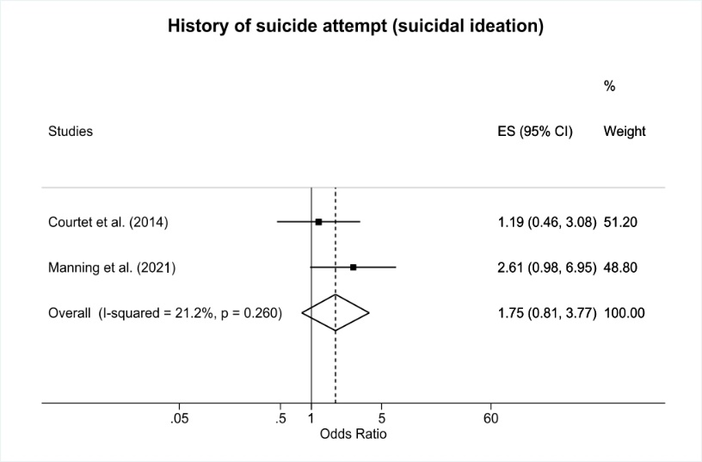
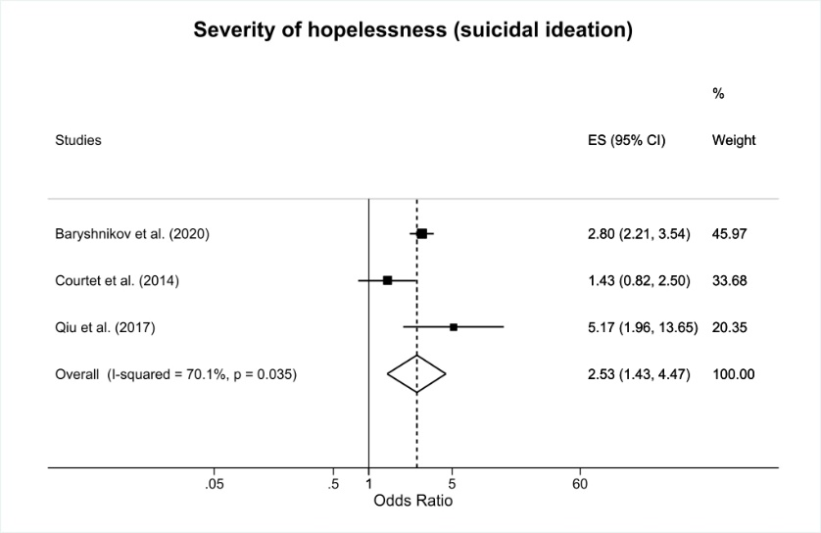
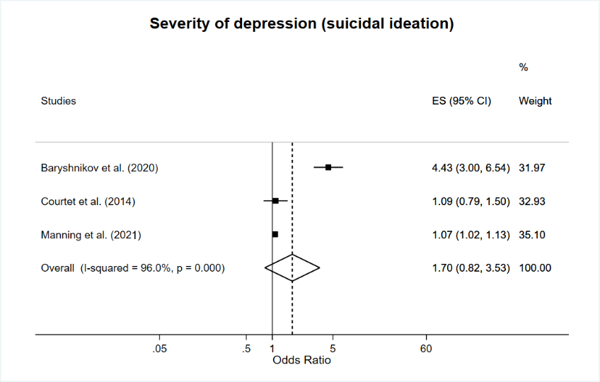

Figure S1. Forest plots for suicidal ideation predictors in adults with depression
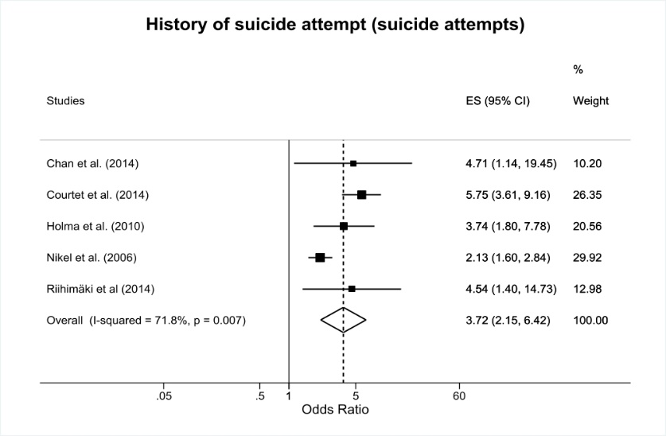
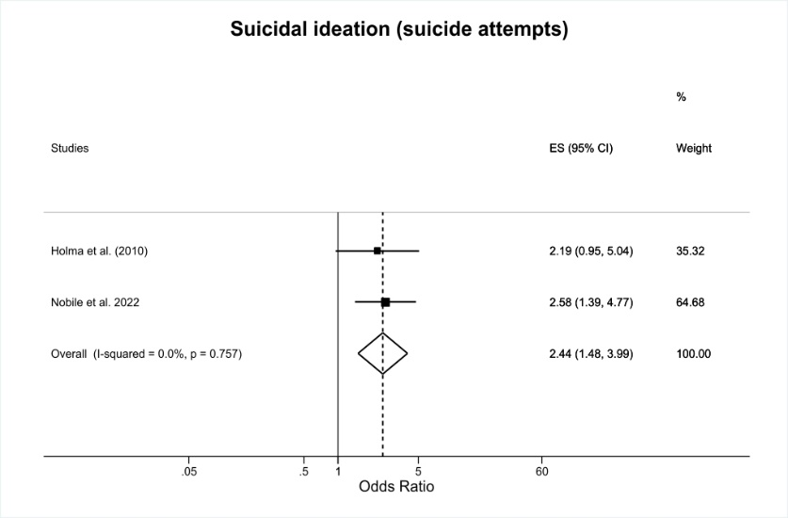
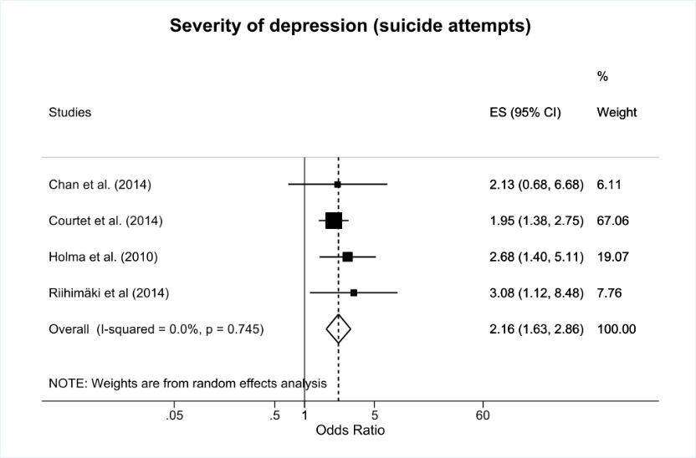
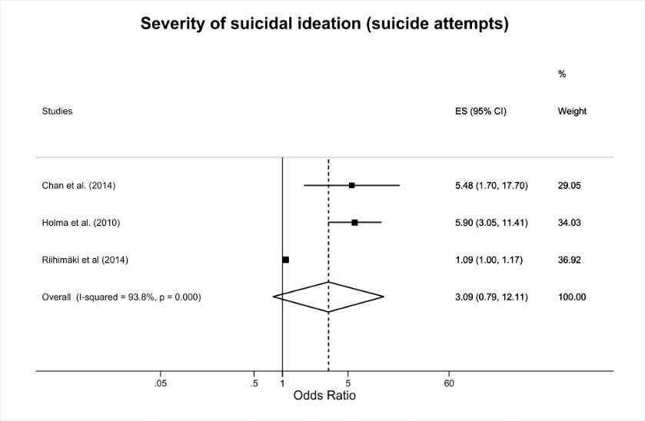
Figure S2. Forest plots for suicide attempts predictors in adults with depression

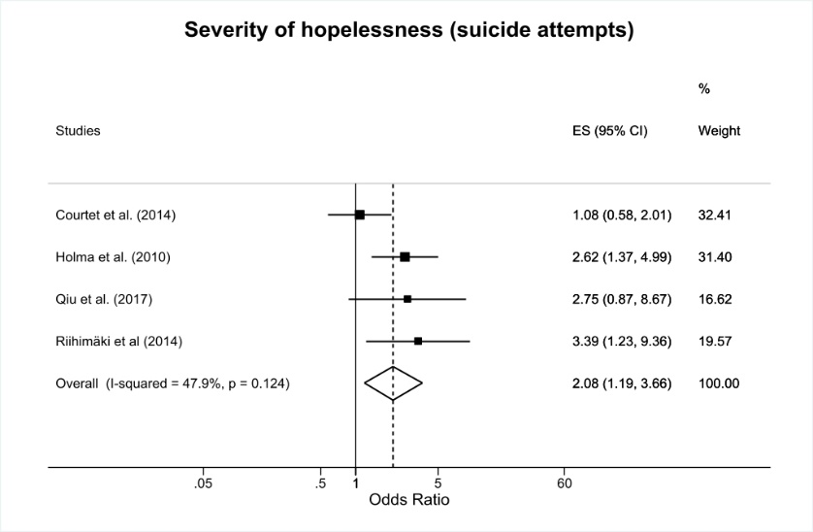
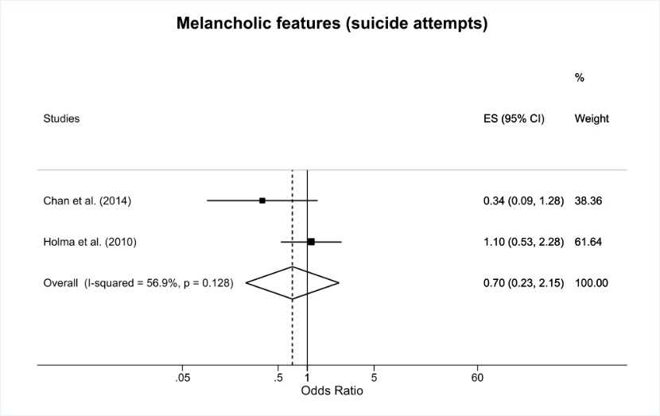
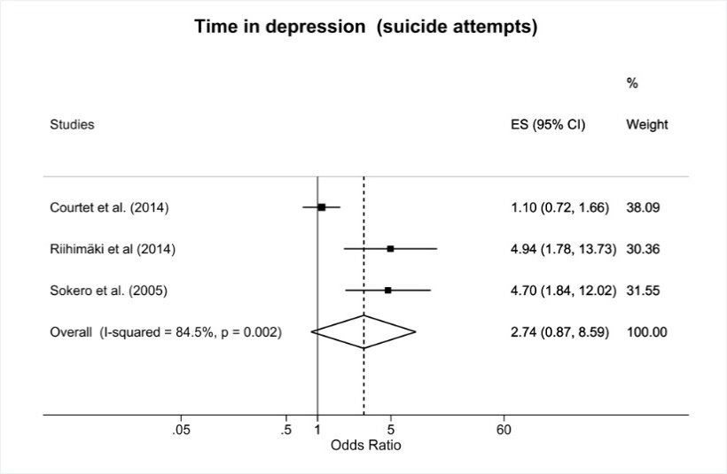
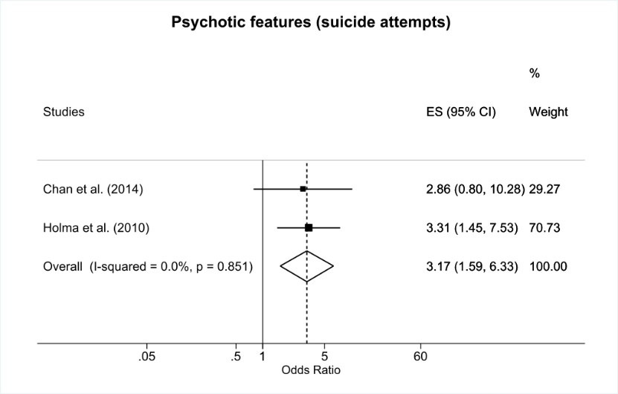
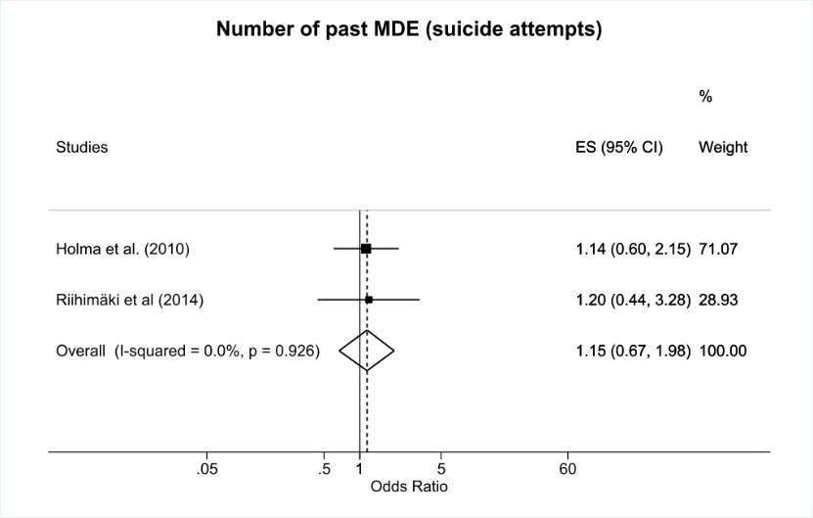
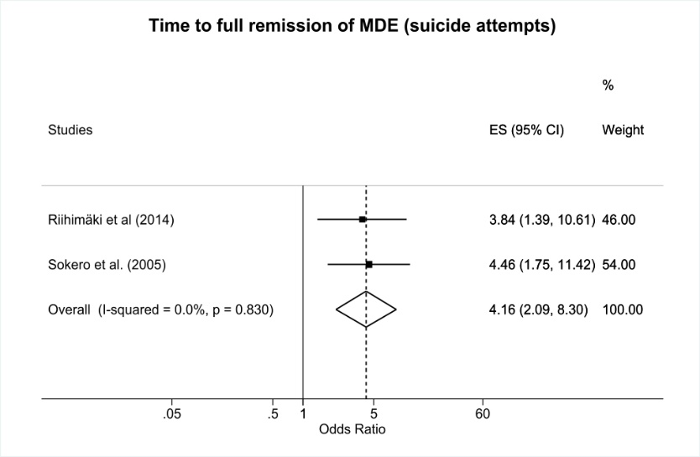
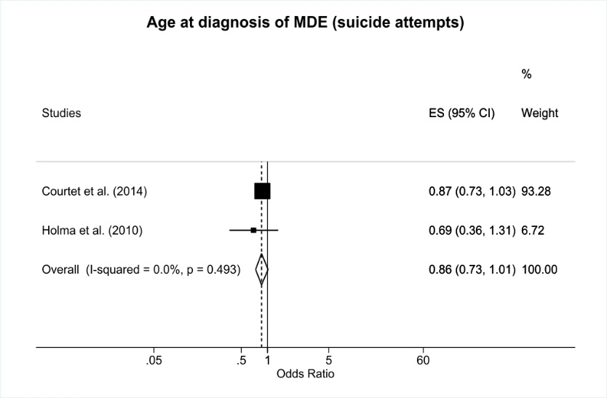

Figure S2. (continued)
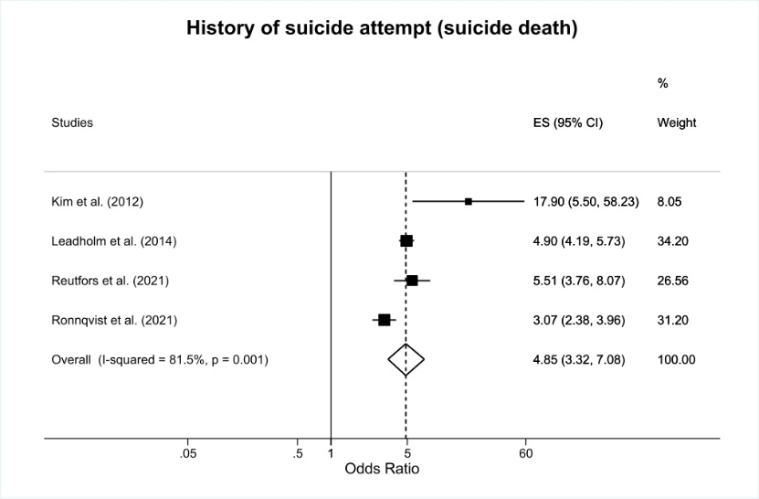
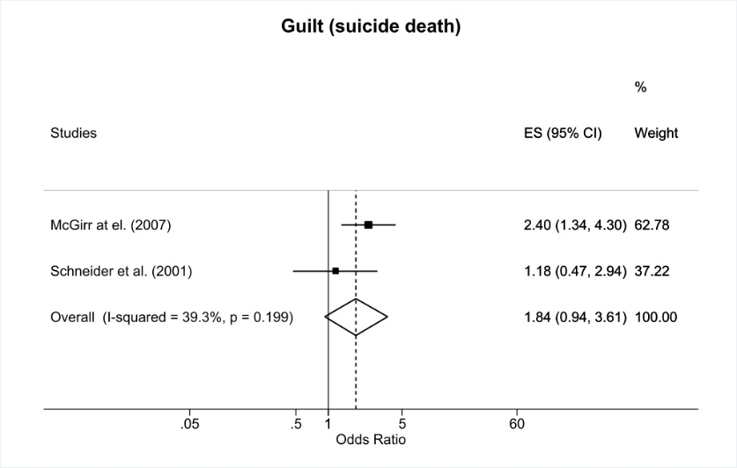
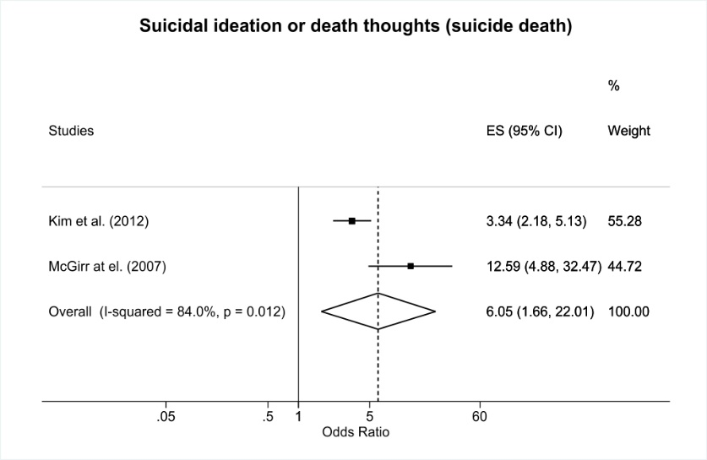
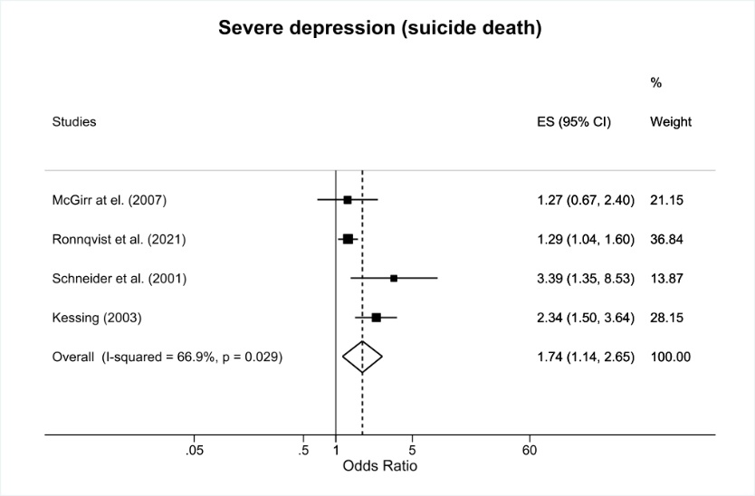
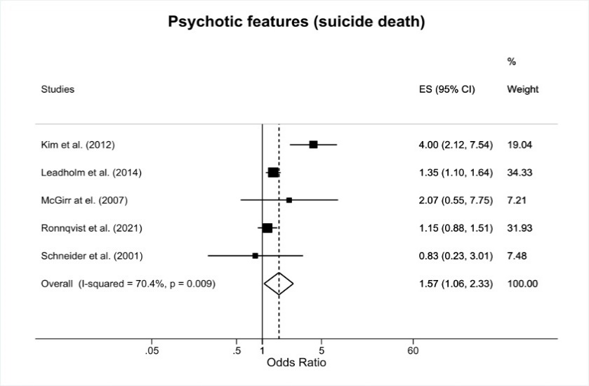
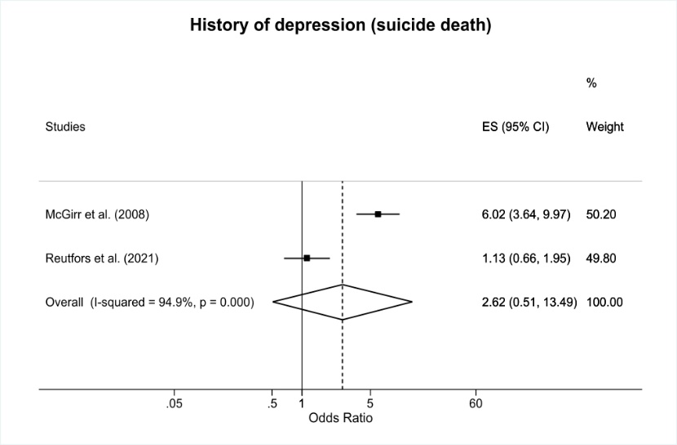
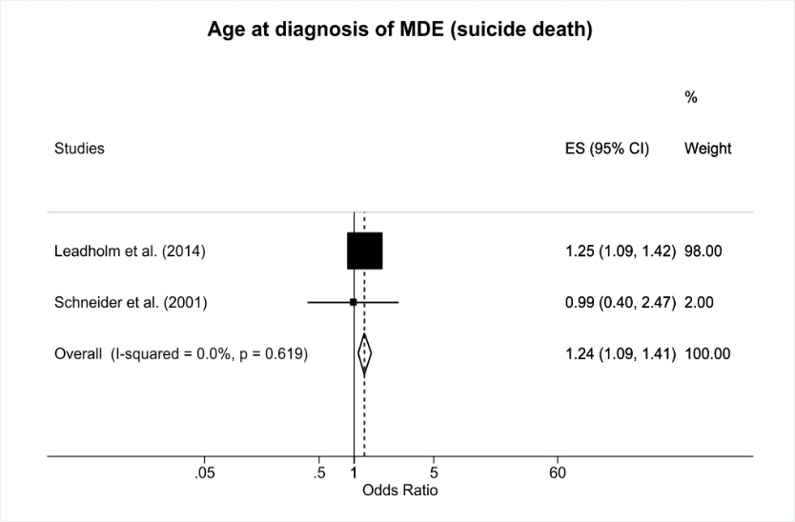
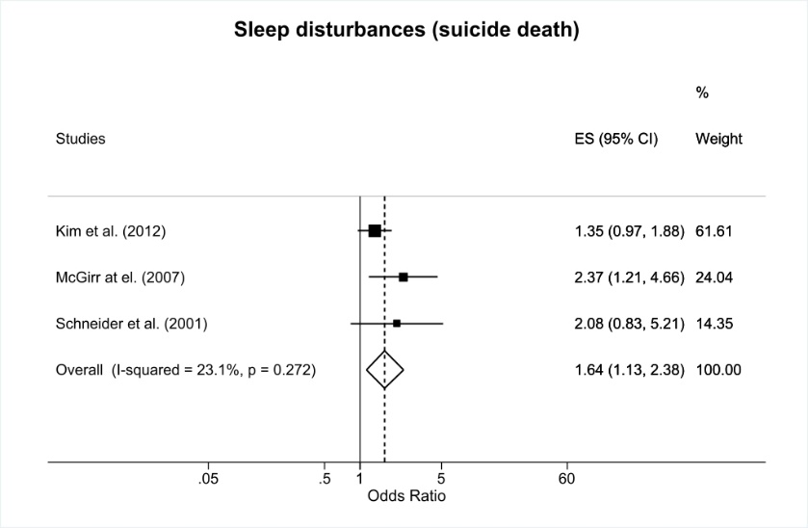
Figure S3. Forest plots for suicide death predictors in adults with depression

