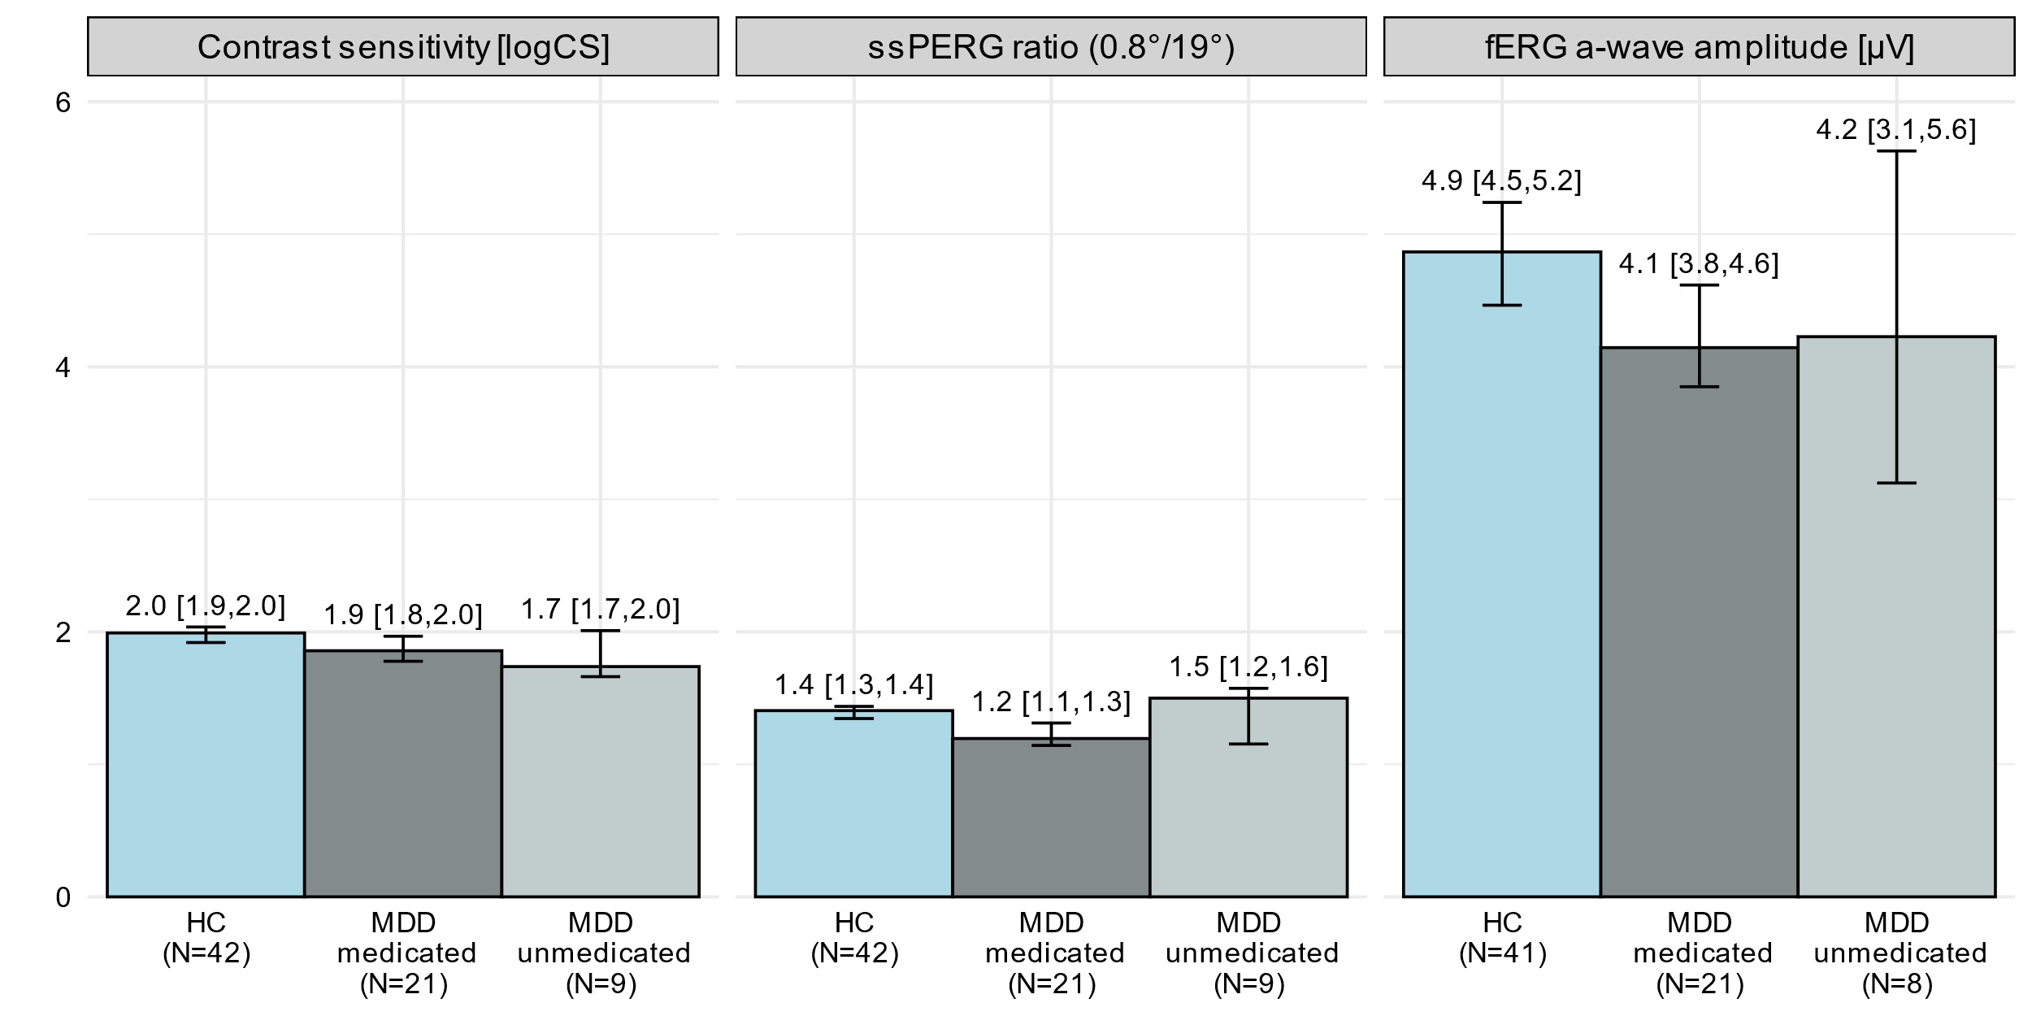
Supplementary Figure 1: Contrast sensitivity as logCS_{Weber}, ssPERG-ratio and the fERG a-wave amplitude in µV for medicated, unmedicated MDD patients and HCs. Bar heights indicate medians, error bars the bootstrapped (10,000 replicates) 95% confidence intervals (CI). Additionally, medians and CIs (in brackets) are annotated in the bar chart.
CI 95% confidence interval; fERG flash Electroretinogram; HC healthy controls; logCS_{Weber} logarithmic Weber contrast sensitivity; MDD patients with major depressive disorder; N number of observations; ssPERG steady-state pattern electroretinogram

Supplementary Table 1: Descriptive statistics for medicated and unmedicated MDD patients and HCs. The median, the bootstrapped (10,000 replicates) 95% confidence intervals (CI) and the proportional differences in medians between the MDD groups and the HC group (“vs. HC”) are depicted for the ssPERG ratio, the contrast sensitivity, and the a-wave amplitude from the fERG. Additionally, a selection of demographic parameters for the MDD subgroups and the HC group are summarized (counts and proportion in % for factorial, median and 1st and 3rd quartiles for numerical data).
BDI-II Beck Depression Inventory II; CI 95% confidence interval; F32.2 severe depressive episode without psychotic symptoms (ICD-10); F33.2 recurrent depressive disorder, current episode severe without psychotic symptoms (ICD-10); fERG flash Electroretinogram; HC healthy controls; ICD-10 International Statistical Classification of Diseases and Related Health Problems version 10; logCS_{Weber} logarithmic Weber contrast sensitivity; MDD patients with major depressive disorder; MADRS Montgomery-Åsberg Depression Rating Scale; N number of observations; ssPERG steady-state pattern Electroretinogram; ⁺ 1 missing data set.
Test | HC  (N=42) | MDD medicated  (N=21) |  | MDD unmedicated  (N=9)
Test | median [CI] | median [95% CI]; | vs. HC | median [95% CI]; | vs. HC
Contrast sensitivity [logCS_{Weber}] | 2.0 [1.9, 2.0] | 1.9 [1.8, 2.0]; | −0.1 | 1.7 [1.7, 2.0]; | −0.3
ssPERG ratio (0.8°/19°) | 1.4 [1.3, 1.4] | 1.2 [1.1, 1.3]; | −15% | 1.5 [1.2, 1.6]; | +6.7%
fERG a-wave amplitude [µV] | 4.9 [4.5, 5.2]⁺ | 4.1 [3.8, 4.6]; | −14.8% | 4.2 [3.1, 5.6]⁺; | −13.1%
Demographical parameter
Sex: female | 29/42 (69%) | 14/21 (67%) |  | 7/9 (78%)
Sex: male | 13/42 (31%) | 7/21 (33%) |  | 2/9 (22%)
Age in years | 30 (23,35) | 34 (26, 39) |  | 22 (20, 29)
ICD-10 Diagnosis: F32.2 | − | 11/21 (52%) |  | 5/9 (56%)
ICD-10 Diagnosis: F33.2 | − | 10/21 (48%) |  | 4/9 (44%)
Medication duration [days] | − | 7 (4, 11) |  | −
BDI-II | 2 (0,4) | 26 (21, 36)⁺ |  | 31 (25, 40)
MADRS | − | 36 (35, 38)⁺ |  | 40 (36, 40)

