Supplementary material

Table S1. Detailed correlations among different anxiety dimensions
 |  | STAI-T | STAI-S | OPQ | OCQ | HYPV | SPSRQ-SP | SPSRQ-SR | IUS
STAI-S | Pearson correlation  Sig. (bilateral) | 0.431  0.000
OPQ | Pearson correlation  Sig. (bilateral) | 0.366  0.000 | 0.360  0.000
OCQ | Pearson correlation  Sig. (bilateral) | 0.196  0.013 | 0.266  0.001 | 0.348  0.000
HYPV | Pearson correlation  Sig. (bilateral) | 0.359  0.000 | 0.477  0.000 | 0.325  0.000 | 0.179  0.024
SPSRQ-SP | Pearson correlation  Sig. (bilateral) | 0.529  0.000 | 0.431  0.000 | 0.493  0.000 | 0.370  0.000 | 0.451  0.000
SPSRQ-SR | Pearson correlation  Sig. (bilateral) | 0.172  0.030 | 0.44  0.585 | 0.295  0.000 | 0.116  0.145 | 0.301  0.000 | 0.212  0.007
IUS | Pearson correlation  Sig. (bilateral) | 0.504  0.000 | 0.427  0.000 | 0.459  0.000 | 0.345  0.000 | 0.462  0.000 | 0.594  0.000 | 0.296  0.000
PSWQ | Pearson correlation  Sig. (bilateral) | 0.601  0.000 | 0.498  0.000 | 0.406  0.000 | 0.274  0.001 | 0.527  0.000 | 0.594  0.000 | 0.152  0.057 | 0.652  0.000

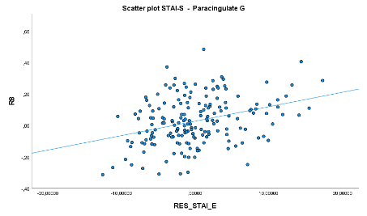
Figure S1. Scatter plots of representative results in Fig. 2 of the manuscript showing positive correlations between bilateral paracingulate gyrus and DRN and between superior frontal gyrus and NCS and right SNc associated with STAI-S covaried by the effect of the STAI-T; and negative correlations between DRN and bilateral paracingulate gyrus and between left SNc and right frontal pole associated with STAI-T covaried by the effect of the STAI-S.
a) STAI-S: positive correlation

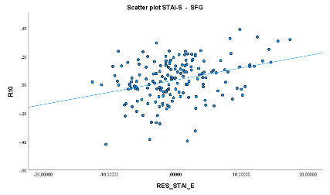
b) STAI-S: positive correlation
Brainstem seed | MNI coordinates |  |  | k | p_{FWE-corr} | t-statistic | Pearson correlation coefficient (r) | Anatomic location
Brainstem seed | x | y | z
DRN (5HT) | +04 | +32 | +32 | 399 | 0.002 | 5.03 | 0.35 | Paracingulate Gyrus
Brainstem seed | MNI coordinates |  |  | k | p_{FWE-corr} | t-statistic | Pearson correlation coefficient (r) | Anatomic location
Brainstem seed | x | y | z
NCS (5HT) | -22 | +30 | +38 | 201 | 0.048 | 3.91 | 0.28 | L Superior Frontal Gyrus

Brainstem seed | MNI coordinates |  |  | k | p_{FWE-corr} | t-statistic | Pearson correlation coefficient (r) | Anatomic location
Brainstem seed | x | y | z
R SNc (DA) | -02 | +16 | +64 | 244 | 0.013 | 4.81 | 0.34 | L Superior Frontal Gyrus

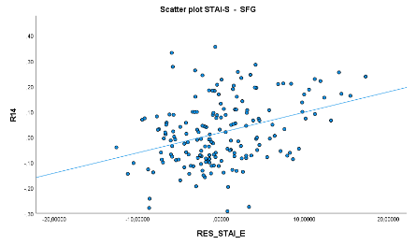
c) STAI-S: positive correlation

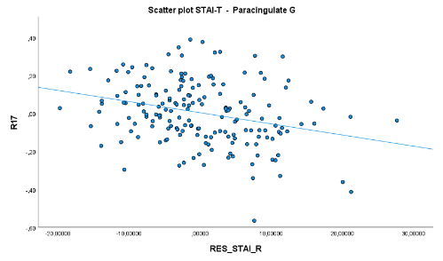
d) STAI-T: negative correlation
Brainstem seed | MNI coordinates |  |  | k | p_{FWE-corr} | t-statistic | Pearson correlation coefficient (r) | Anatomic location
Brainstem seed | x | y | z
DRN (5HT) | +04 | +22 | +38 | 455 | 0.001 | 4.54 | -0.32 | Paracingulate Gyrus

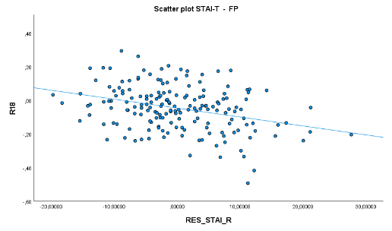

e) STAI-T: negative correlation
Brainstem seed | MNI coordinates |  |  | k | p_{FWE-corr} | t-statistic | Pearson correlation coefficient (r) | Anatomic location
Brainstem seed | x | y | z
L SNc (DA) | +34 | +38 | +28 | 273 | 0.009 | 4.82 | -0.34 | R Frontal Pole

Figure S2. Scatter plots of the results in Fig. 3 of the manuscript showing the consistency of the negative correlation between bilateral frontal pole regions and LC across associations with OPQ, HYPV, SPSRQ-SP, and PSWQ scores.
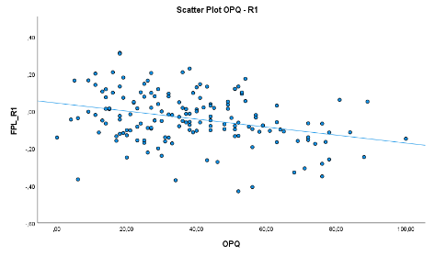
- OPQ: negative correlation

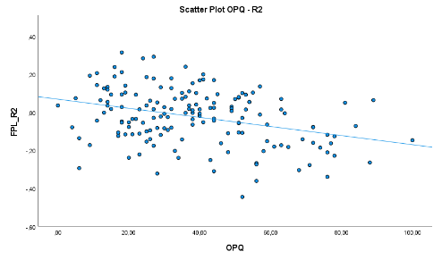

- OPQ: negative correlations
Brainstem seed | MNI coordinates |  |  | k | p_{FWE-corr} | t-statistic | Pearson correlation coefficient (r) | Anatomic location
Brainstem seed | x | y | z
R LC (NE) | -46 | 44 | 18 | 225 | 0.016 | 4.24 | -0.32 | L Frontal Pole *¹

Brainstem seed | MNI coordinates |  |  | k | p_{FWE-corr} | t-statistic | Pearson correlation coefficient (r) | Anatomic location
Brainstem seed | x | y | z
R LC (NE) | -46 | 42 | 18 | 179 | 0.041 | 4.55 | -0.34 | L Frontal Pole *¹

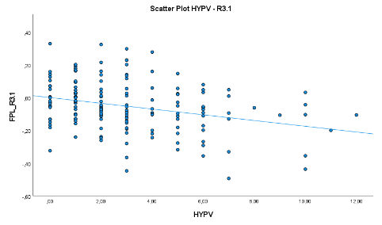
- HYPV: negative correlation

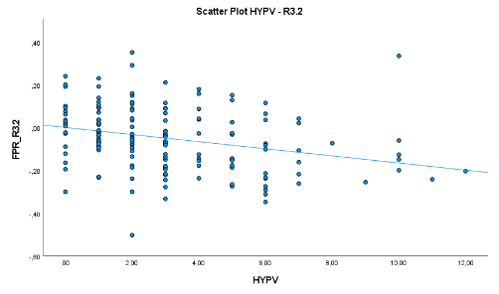
d) HYPV: negative correlation
Brainstem seed | MNI coordinates |  |  | k | p_{FWE-corr} | t-statistic | Pearson correlation coefficient (r) | Anatomic location
Brainstem seed | x | y | z
R LC (NE) | -34 | 56 | 26 | 255 | 0.009 | 3.96 | -0.30 | L Frontal Pole *¹
Brainstem seed | MNI coordinates |  |  | k | p_{FWE-corr} | t-statistic | Pearson correlation coefficient (r) | Anatomic location
Brainstem seed | x | y | z
R LC (NE) | 38 | 60 | 18 | 203 | 0.025 | 3.87 | -0.29 | R Frontal Pole *¹

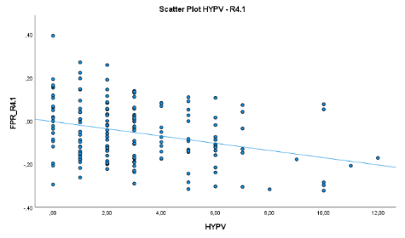
e) HYPV: negative correlation

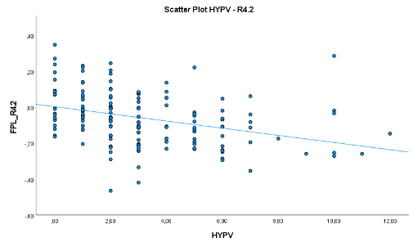

f) HYPV: negative correlation
Brainstem seed | MNI coordinates |  |  | k | p_{FWE-corr} | t-statistic | Pearson correlation coefficient (r) | Anatomic location
Brainstem seed | x | y | z
L LC (NE) | 36 | 58 | 18 | 343 | 0.002 | 4.78 | -0.36 | R Frontal Pole *¹
Brainstem seed | MNI coordinates |  |  | k | p_{FWE-corr} | t-statistic | Pearson correlation coefficient (r) | Anatomic location
Brainstem seed | x | y | z
L LC (NE) | -36 | 46 | 22 | 291 | 0.004 | 4.13 | -0.31 | L Frontal Pole *¹

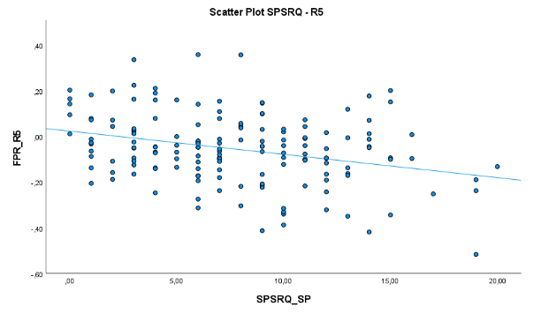
g) SPSRQ-SP: negative correlation
Brainstem seed | MNI coordinates |  |  | k | p_{FWE-corr} | t-statistic | Pearson correlation coefficient (r) | Anatomic location
Brainstem seed | x | y | z
R LC (NE) | -32 | 56 | 26 | 242 | 0.011 | 4.06 | -0.31 | L Frontal Pole *¹

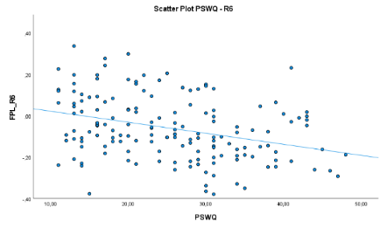
h) PSWQ: negative correlation

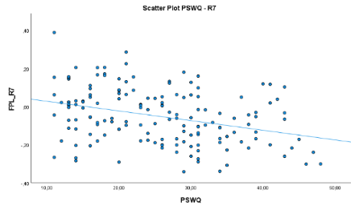
i) PSWQ: negative correlation
Brainstem seed | MNI coordinates |  |  | k | p_{FWE-corr} | t-statistic | Pearson correlation coefficient (r) | Anatomic location
Brainstem seed | x | y | z
R LC (NE) | -34 | 42 | 32 | 483 | 0.001 | 4.38 | -0.33 | L Frontal Pole *¹
Brainstem seed | MNI coordinates |  |  | k | p_{FWE-corr} | t-statistic | Pearson correlation coefficient (r) | Anatomic location
Brainstem seed | x | y | z
L LC (NE) | -34 | 44 | 24 | 244 | 0.024 | 4.45 | -0.34 | L Frontal Pole *¹

Figure S3. Scatter plots of the results in Fig. 4 of the manuscript showing the consistency of the positive correlation between the middle temporal gyrus, particularly its temporooccipital segment, and the right SNc across associations with HYPV and SPSRQ-SP scores.
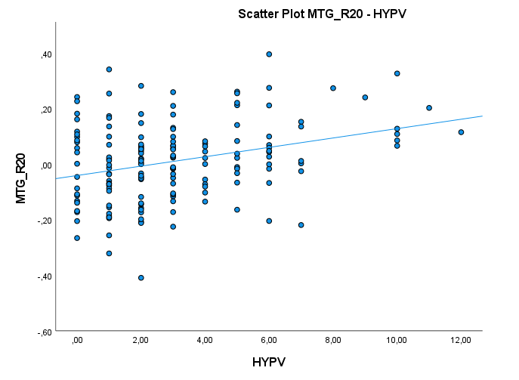
a) HYPV: positive correlation
Brainstem seed | MNI coordinates |  |  | k | p_{FWE-corr} | t-statistic | Pearson correlation coefficient (r) | Anatomic location
Brainstem seed | x | y | z
R SNc (DA) | 50 | -30 | 02 | 226 | 0.016 | 4.08 | 0.31 | R Middle Temporal gyrus, temporooccipital part *²

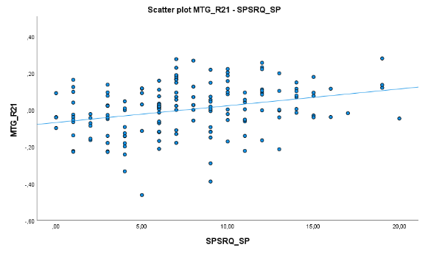
b) SPSRQ-SP: positive correlation
Brainstem seed | MNI coordinates |  |  | k | p_{FWE-corr} | t-statistic | Pearson correlation coefficient (r) | Anatomic location
Brainstem seed | x | y | z
R SNc (DA) | 48 | -46 | 06 | 267 | 0.007 | 4.09 | 0.31 | R Middle Temporal gyrus, temporooccipital part *²

