Table S1 – Kaplan-Meier survival analysis results: comparison on 2-year outcome incidence rates between the two FEP subgroups.

FEP  subgroup |  | 1-cumulative proportion surviving at the time |  |  | Mean (in months) for 2-year service disengagement rate
 |  | Estimate |  | SE | Estimate |  |  | SE | 95% CI
 |  |  |  |  |  |  |  |  | Lower bound |  | Upper bound
FEP+  FEP-  (Overall) |  | .230  .281  - |  | .029  .027  - | 20.990  20.007  20.417 |  |  | .408  .414  .296 | 20.191  19.195  19.837 |  | 21.790  20.819  20.998
2-year Log Rank (Mantel-Cox) |  |  |  |  | Χ² |  |  | df | p
 |  |  |  |  | 1.823 |  |  | 1 | .177
FEP  subgroup |  | 1-cumulative proportion surviving at the time |  |  | Mean (in months) for 2-year new hospitalization rate
 |  | Estimate |  | SE | Estimate |  |  | SE | 95% CI
 |  |  |  |  |  |  |  |  | Lower bound |  | Upper bound
FEP+  FEP-  (Overall) |  | .292  .265  - |  | .034  .029  - | 21.497  21.581  21.545 |  |  | .360  .308  .233 | 20.792  20.977  21.088 |  | 22.203  22.185  22.002
2-year Log Rank (Mantel-Cox) |  |  |  |  | Χ² |  |  | df | p
 |  |  |  |  | .282 |  |  | 1 | .595
FEP  subgroup | 1-cumulative proportion surviving at the time |  |  |  |  | Mean (in months) for 2-year attempted suicide rate
FEP  subgroup | Estimate |  | SE |  |  | Estimate | SE |  |  | 95% CI
 |  |  |  |  |  |  |  |  |  | Lower bound |  | Upper bound
FEP+  FEP-  (Overall) | .065  .038  - |  | .018  .012  - |  |  | 23.294  23.661  23.503 | .216  .134  .117 |  |  | 22.871  23.399  23.273 |  | 23.717  23.924  23.734
2-year Log Rank (Mantel-Cox) |  |  |  |  |  | Χ² | df |  |  | p
 |  |  |  |  |  | 1.801 | 1 |  |  | .180
Note. FEP = First Episode Psychosis; FEP+ = FEP participants with past specialist contact; FEP- = FEP participants without past specialist contact; SE = Standard Error; 95% CI = 95% Confidence Intervals; Log Rank = Logarithm Rank Test; = Chi-Squared test; df = degrees of freedom; p = statistical value.

Figure S1 – Kaplan-Meier survival analysis results: survival functions on 2-year outcome incidence rates between the two FEP subgroups across the follow-up.

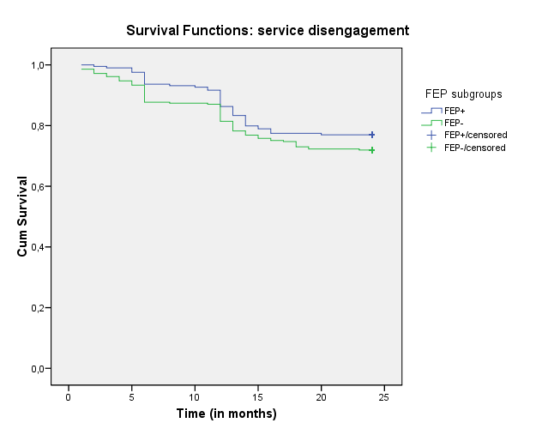

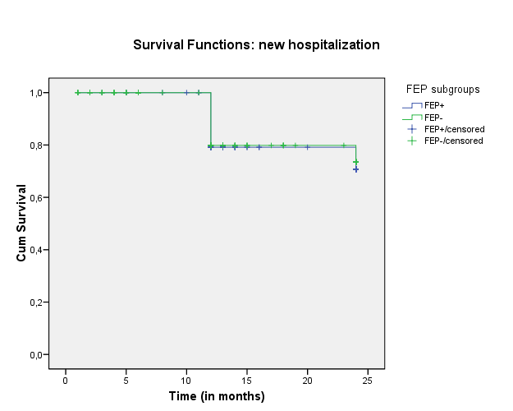

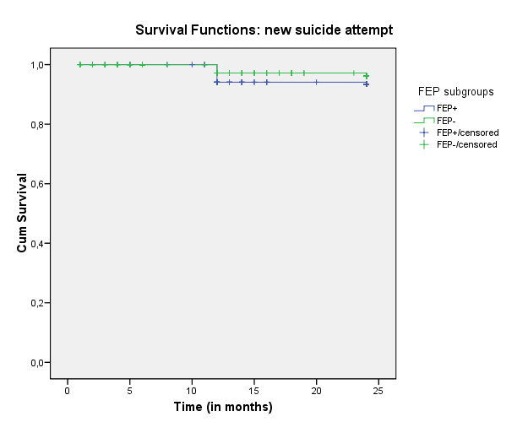

Note. FEP = First Episode Psychosis; FEP+ = FEP participants with past specialist contact; FEP- = FEP participants without past specialist contact.

Table S2 – Treated incidence of FEP patients referred to the Pr-EP program across the recruitment period (2013-2021) (n = 489).

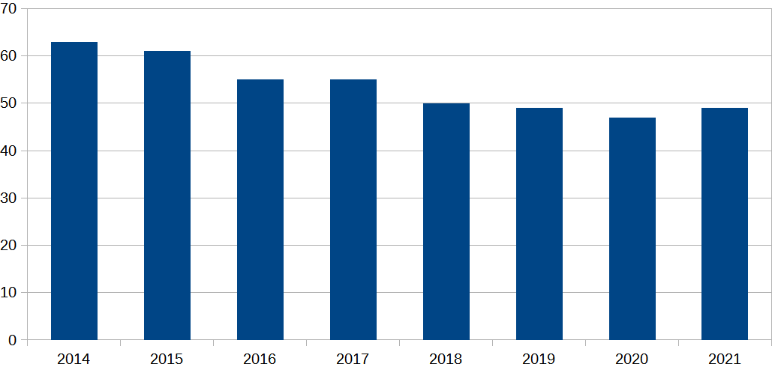
Note - FEP = First Episode Psychosis; Pr-EP = Parma-Early Psychosis.

