Supplementary material
European Archives of Psychiatry and Clinical Neuroscience
COMPARATIVE EFFICACY AND ACCEPTABILITY OF ANXIOLYTIC DRUGS FOR THE TREATMENT OF ANXIETY DISORDERS: A SYSTEMATIC REVIEW AND NETWORK META-ANALYSIS
Thomas J. Müller^{1,2,*}, Arnaud Künzi³, Ellen Heitlinger⁴, Bernd Krämer^{5,6}, Roland von Känel⁷, Josef Hättenschwiler⁸, Matthias Hilpert⁹, Christian Imboden^{10,2}, Edith Holsboer-Trachsler¹¹, Martin Hatzinger¹², Siegfried Kasper^{13,14,15}, Borwin Bandelow¹⁶, Erich Seifritz¹⁷
¹Private Clinic Meiringen, 3860 Meiringen, Switzerland
²University Hospital of Psychiatry and Psychotherapy, University of Bern, Bern, Switzerland.
³Department of Clinical Research, University of Bern, Switzerland.
⁴H+O communications Ltd., 8041 Zurich, Switzerland.
⁵Section for Experimental Psychopathology and Neuroimaging, Department of General Psychiatry, Heidelberg University Hospital, Heidelberg, Germany.
⁶Centre for Translational Research in Systems Neuroscience and Psychiatry, Department of Psychiatry and Psychotherapy, University Medical Center Göttingen, Göttingen, Germany.
⁷Department of Consultation-Liaison-Psychiatry and Psychosomatic Medicine, University Hospital Zurich, University of Zurich, Zurich, Switzerland.
⁸Centre for Anxiety and Depression Treatment Zurich, Zurich, Switzerland.
⁹Psychiatric Services of the Canton Aargau, Windisch, Switzerland.
¹⁰Private Clinic Wyss, Münchenbuchsee, Switzerland.
¹¹Gesundheitszentrum St. Johann, University of Basel, Basel, Switzerland.
¹²Psychiatric Services Solothurn and University of Basel, Solothurn, Switzerland.
¹³Department of Psychiatry and Psychotherapy, Medical University of Vienna, Vienna, Austria.
¹⁴Comprehensive Center for Clinical Neurosciences and Mental Health, Medical University of Vienna, Vienna, Austria.
¹⁵Center for Brain Research, Medical University of Vienna, Vienna, Austria.
¹⁶Department of Psychiatry and Psychotherapy, University Medical Center Göttingen, Germany.
¹⁷Department of Adult Psychiatry and Psychotherapy, Psychiatric Hospital, University of Zurich, Zurich, Switzerland.
*Corresponding author: Professor Thomas J. Müller
Professor of Psychiatry, CMO
Privatklinik Meiringen,
CH - 3860 Meiringen,
Switzerland
Email: thomas.mueller2@unibe.ch
Tel.: +41 33 972 81 11
Fax.: +41 33 972 82 20
ORCID ID: 0000-0001-9315-8138
Table S1. Dosage classification used to select which dosage arm to include in the network-meta-analysis.
Drug | Standard dosage in CH* [mg/day] | Usual daily dosing range**, # | Low dose [mg/day] | Medium dose [mg/day] | High dose [mg/day]
Agomelatine | 25.0 |  | < | 25.0─50.0 | >
Alprazolam | 0.5–4.0 |  | >0.75 | 0.75─1.5 | >1.5
Bromazepam | 1.5–3.0 |  |  | 3.0─12.0 | 18.0
Buspirone |  |  | 10.0 | 20.0─30.0 | 60.0
Clobazam | 10.0 |  | 0.5─15.0 | 20.0─30.0 | 80.0
Clomipramine | 10.0–25.0 |  | 30.0 | 50.0─100.0 | 150.0
Diazepam | 5.0–10.0 |  | 2.5─10.0 | 20.0‒40.0 | 60.0
Duloxetine | 30.0–60.0 | 40.0─120.0 | 30.0 | 60.0─90.0 | 120.0─150.0
Escitalopram | 10.0–20.0 | 10.0–20.0 | 5.0 | 10.0 | 20.0
Fluoxetine | 20.0 | 10.0–80.0 |  | 10.0 | 20.0
Lorazepam | 1.0–2.5 |  | 0.5─1.0 | 2.0–4.0 | >7.5
Metaclazepam |  |  | < | 15.0 | >
Oxazepam | 15.0 |  | 10.0 | 30.0─60.0 | 150.0
Paroxetine | 20.0 | Paxil: 10.0─50.0 | 10.0 | 40.0 | 60.0
Pregabalin | 25.0–300.0 |  | 75.0 | 150.0─450.0 | 600.0
Quetiapin | 25.0–300.0 |  | 12.5 | 50.0─300.0 | 600.0
Sertraline |  | 50.0─200.0 | 25.0 | 50.0 | 200.0
Silexan | 80.0 |  | < | 80.0 | 160.0
Venlafaxine | 37.5–150.0 |  | 37.5─75.0 | 75.0─150.0 | 225.0
Vortioxetine | 5.0–20.0 |  | 5.0 | 10.0 | 20.0
*considered websites: swissmedic.ch; compendium.ch
**Hansen RA et al. (2009). Controlling for drug dose in systematic review and meta-analysis: A case study of the effect of antidepressant Dose. Med Decis Making. (https://www.ncbi.nlm.nih.gov/pmc/articles/PMC2657322/), Table 1.
# The usual dosing range represents doses recommended by FDA-approved product labeling. The upper bound for duloxetine was increased to 120mg/day based on practice patterns and other clinical evidence. The lower bound for some drugs was decreased (e.g., immediate-release bupropion, fluoxetine, and paroxetine) when it was deemed that the FDA-approved range did not capture the full range of doses used in clinical practice and shown to be efficacious in clinical studies.
« < » and « > » symbols without associated numbers: When only a medium dose indication was found, i.e., values below the medium dose are low and those above high, without providing a threshold.
CH, Switzerland; XR, extended-release.

Table S2. Study arms excluded based on selected (medium) dosage classification from Table S1.
Drug | Study ID | Study "Arm" excluded due to comparison of same medication + reason
Silexan | 1 | "Silexan 160mg": other M Silexan arm chosen
Escitalopram | 10  16  20 | "Escitalopram 20mg": other M Escitalopram arm chosen  "Escitalopram 5mg, 20mg ": other M Escitalopram arm chosen  "Escitalopram 5mg, 20mg": other M Escitalopram arm chosen
Quetiapine | 15  71  102 | "Quetiapine XR 300mg": other M arm chosen more in the middle of the medium range  "Quetiapine XR 50mg": other M arm chosen more in the middle of the medium range  "Quetiapine XR 50mg, 300mg": other M arm chosen more in the middle of the medium range
Buspirone | 40 | "Buspirone BID 30mg, TID 30mg": No placebo nor non-Buspirone comparator in the study
Vortioxetine | 51 | "Vortioxetine 2.5mg, 5mg": other M arm chosen
Duloxetine | 53 | "Duloxetine 20mg": other M arm chosen
Pregabalin | 59  61  88  89  92  93  95 | "Pregabalin 600mg": other M arm chosen  "Pregabalin 600mg": other M arm chosen  "Pregabalin 300mg, 600mg": other M arm chosen  "Pregabalin 600mg": other M arm chosen  "Pregabalin 300mg, 600mg": other M arm chosen  "Pregabalin 600mg": other M arm chosen  "Pregabalin 200mg, 400mg": other M arm chosen
Venlafaxine* | 114  119  121  123  127  128 | "Venlafaxine ER 37.5mg, 75mg": other M arm chosen  "Venlafaxine fixed dose 75mg, Flexible dose 213.5mg": No placebo nor non-Venlafaxine comparator in the study  "Venlafaxine XR avg 37.5, avg 150mg": other M arm chosen in that is more in the middle of the medium range  "Venlafaxine XR avg 150mg": other M arm chosen  "Venlafaxine XR avg 75mg, avg 225mg": other M arm chosen  "Venlafaxine XR avg 150mg": other M arm chosen
*normal range is 75-150mg. In order not to systematically choose the lighter or heavier treatment, retained arm was alternatingly 75 then 150 when encountered. Main results were robust to whichever arm was selected.
H, High; ID, identification number; M, Medium; L, Low. ID.
Table S3. Listing of included studies by network
Publication ID | Publication | HAM-A | Discontinuation | AE-caused discontinuation | Adverse events | AE of light severity | AE of moderate severity | DOI
1 | Kasper (2014) | X | X | X | X |  |  | 10.1017/S1461145714000017
2 | Kasper (2015) | X | X | X | X | X |  | 10.1016/j.euroneuro.2015.12.002
3 | Kasper (2010) | X | X | X | X | X | X | 10.1097/YIC.0b013e32833b3242
4 | Kasper (2015) | X | X | X | X | X | X | 10.1016/j.euroneuro.2015.07.024
5 | Woelk (2010) | X | X | X | X | X |  | 10.1016/j.phymed.2009.10.006
7 | Lenze (2009) |  | X | X | X |  |  | 10.1001/jama.2008.977
8 | Davidson (2004) | X |  | X |  |  |  | 10.1002/da.10146
9 | Stein (2018) | X | X | X | X | X |  | 10.1016/j.euroneuro.2018.05.006
10 | Asakura (2016) |  | X | X | X | X | X | 10.1185/03007995.2016.1146663
11 | Stein (2014) |  | X | X | X | X | X | 10.4088/JCP.13m08433
12 | Kasper (2005) |  |  |  |  | X | X | 10.1192/bjp.186.3.222
13 | Bose (2008) |  | X | X |  | X | X | 10.1002/da.20355
15 | Merideth (2012) |  | X | X |  | X | X | 10.1097/YIC.0b013e32834d9f49
16 | Baldwin (2006) |  | X | X | X | X | X | 10.1192/bjp.bp.105.012799
17 | Maity (2014) |  |  |  |  |  |  | 10.4103/0253-7613.135959
20 | Lader (2004) |  | X | X | X | X | X | 10.1002/da.20014
21 | Bystritsky (2008)
25 | Bielski (2005) |  |  | X |  | X | X | 10.1080/10401230590932326
26 | Lader (1998) |  | X |  | X | X | X | 10.1007/s002130050731
28 | Laakmann (1998) |  | X |  | X |  |  | 10.1007/s002130050578
29 | Rickels (1982) |  | X | X | X | X | X
30 | Ansseau (1990) |  | X | X | X |  |  | 10.1159/000119464
31 | Cohn (1989) |  | X | X | X | X |  | 10.1185/03007998909115213
32 | Jacobson (1985) |  | X |  | X |  |  | 10.1002/j.1875-9114.1985.tb03430.x
34 | Mokhber (2010) | X |  |  |  |  |  | 10.1111/j.1440-1819.2009.02055.x
35 | Enkelmann (1991) |  | X | X | X |  |  | 10.1007/BF02244440
37 | Strand (1990) | X | X |  | X | X | X
38 | Feighner (1982) |  |  |  | X |  | X
39 | Ross (1987) |  |  | X |  | X |  | 10.1177/070674378703200505
40 | Sramek (1997) |  |  |  |  |  |  | 10.1016/s0149-2918(97)80134-8
41 | Böhm (1990) |  | X |  |  |  |  | 10.1097/00004714-199006001-00008
44 | Kahn (1987) | X |  |  |  |  |  | 10.1097/00004850-198701000-00003
46 | Alaka (2014) | X | X | X |  |  |  | 10.1002/gps.4088
49 | Rynn (2008) |  | X | X | X | X | X | 10.1002/da.20271
50 | Wu (2011) | X | X | X | X | X | X
51 | Mahableshwarkar (2014) | X | X | X | X | X | X | 10.1111/ijcp.12328
53 | Nicolini (2009) | X | X | X |  | X | X | 10.1017/S0033291708003401
54 | Hartford (2007) | X | X | X | X | X | X | 10.1097/YIC.0b013e32807fb1b2
55 | Ball (2015) |  |  |  |  |  |  | 10.1017/S1041610215000381
56a | Silverstone (2001) |  | X | X |  |  | X | 10.4088/jcp.v62n07a04
56b | Silverstone (2002) |  | X | X |  |  | X | 10.4088/jcp.v62n07a05
59 | Pande (2003) |  | X | X |  | X | X | 10.1176/appi.ajp.160.3.533
60 | Herrera-Arellano (2012) |  |  |  |  |  |  | 10.1055/s-0032-1315110
61 | Feltner (2003) | X |  | X | X | X | X | 10.1097/01.jcp.0000084032.22282.ff
65 | Morton (1992) |  |  |  |  |  |  | 10.1055/s-2007-1014402
66 | Ruiz (1983) |  | X | X
67 | Cordingley (1985) |  | X | X | X | X | X | 10.1185/03007998509109625
68 | Möller (2001) | X | X | X |  |  |  | 10.1097/00004714-200102000-00011
71 | Bandelow (2010) |  | X | X |  | X | X | 10.1017/S1461145709990423
72 | Lepola (2004) |  | X | X |  | X | X | 10.4088/jcp.v65n0213
73 | Ball (2005) | X |  |  |  |  |  | 10.4088/jcp.v66n0113
74 | Baldwin (1999) |  | X | X | X | X | X | 10.1192/bjp.175.2.120
75 | Allgulander (2004) |  |  | X | X | X | X | 10.1002/hup.602
76 | Liebowitz (2002) |  | X | X | X | X | X | 10.4088/jcp.v63n0113
78 | Allgulander (1999) |  |  | X |  |  |  | 10.1111/j.1600-0447.1999.tb10845.x
79 | Pollack (2001) |  |  | X |  | X | X | 10.4088/jcp.v62n0508
80 | Stein (1998) |  | X | X |  | X | X | 10.1001/jama.280.8.708
83 | Kim (2006) | X | X | X |  | X | X | 10.1111/j.1440-1819.2006.01512.x
84 | Stein (2002) |  | X | X |  | X |  | 10.4088/jcp.v63n0211
86 | Ravindran (1997) |  | X | X | X | X |  | 10.4088/jcp.v58n0305
87 | Kasper (2009) | X | X | X |  | X | X | 10.1097/yic.0b013e32831d7980
88 | Feltner (2011) |  | X | X | X | X | X | 10.1097/YIC.0b013e32834519bd
89 | Montgomery (2006) | X | X | X |  | X | X | 10.4088/jcp.v67n0511
91 | Montgomery (2008) | X | X | X |  | X | X | 10.1192/bjp.bp.107.037788
92 | Rickels (2005) | X | X | X |  | X | X | 10.1001/archpsyc.62.9.1022
93 | Pande (2004) | X | X | X |  | X | X | 10.1097/01.jcp.0000117423.05703.e7
95 | Pohl (2005) | X | X | X |  | X | X | 10.1097/01.jcp.0000155820.74832.b0
96 | Altamura (2011) | X |  |  | X |  |  | 10.1097/YIC.0b013e3283457d73
99 | Vaishnavi (2007) |  |  |  |  | X |  | 10.1016/j.pnpbp.2007.06.027
102 | Khan (2011) | X |  |  | X | X | X | 10.1097/JCP.0b013e318224864d
103 | Mezhebovsky (2013) | X |  | X | X | X | X | 10.1002/gps.3867
106 | Brawman-Mintzer (2006) | X | X | X |  |  |  | 10.4088/jcp.v67n0603
108 | Allgulander (2004) | X | X | X |  |  |  | 10.1176/appi.ajp.161.9.1642
110 | Liebowitz (2003) | X | X | X |  |  |  | 10.4088/jcp.v64n0708
113 | Liebowitz (2005) |  | X | X | X | X | X | 10.4088/jcp.v66n0213
114 | Boyer (2004) |  |  |  |  |  |  | 10.1016/j.eurpsy.2004.05.010
115 | Nimatoudis (2004) | X |  |  |  | X |  | 10.1097/00004850-200411000-00003
116 | Rickels (2004) |  |  | X | X | X | X | 10.1097/01.jcp.0000138764.31106.60
117a | Montgomery (2002) | X | X | X |  |  |  | 10.1097/00004714-200212000-00005
118 | Lenox-Smith (2003) | X | X |  | X | X | X
119 | Stein (2005) |  |  |  |  | X | X | 10.1007/s00213-004-1957-9
121 | Allgulander (2001) |  | X | X |  | X |  | 10.1192/bjp.179.1.15
122 | Gelenberg (2000) | X | X | X |  | X | X | 10.1001/jama.283.23.3082
123 | Hackett (2003) |  | X | X |  |  |  | 10.1016/s0924-9338(03)00046-4
127 | Rickels (2000) |  | X | X |  | X | X | 10.1176/appi.ajp.157.6.968
128 | Davidson (1999) | X |  |  |  | X |  | 10.4088/jcp.v60n0805
131 | Väisänen (1987) | X | X |  |  | X |  | 10.1111/j.1600-0447.1987.tb02830.x
132 | Elie (1984) | X
134 | Aden (1980) |  | X | X
135 | Chouinard (1982) |  | X |  |  | X |  | 10.1007/BF00464571
136 | Dunner (1986) | X | X | X
137 | Kerry (1983) | X | X
138 | Fontaine (1986) | X | X |  |  | X |  | 10.1111/j.1600-0447.1986.tb06268.x
139 | Fontaine (1983) |  | X |  |  | X | X
141 | Bilone (1988) | X |  |  |  |  |  | 10.1185/03007998809111130
145 | Rickels (1993) |  |  |  |  | X |  | 10.1001/archpsyc.1993.01820230054005
146 | Lapierre (1982) | X | X |  | X
147 | Botter (1980) |  |  |  |  |  |  | 10.1185/03007998009109494
148 | Rickels (1981) |  | X | X |  |  |  | 10.1038/clpt.1981.132
149 | Jacobson (1983) |  | X | X | X | X | X

Table S4. Listing of excluded studies
Publication ID | Publication | Reason | DOI
6 | Kasper (2017) | pooled dataset of publ 001 and 004 | 10.1097/YIC.0000000000000176
14 | Montgomery (2005) | includes a 12 week of open-label treatment phase, also includes SDS score however it is split in work, social and family life | 10.4088/jcp.v66n1009
18 | Goodman (2005) | data is pooled from three separate studies | 10.1016/j.jad.2004.11.011
19 | Stein (2005) | Same study as 18 "The effects of escitalopram on the HAMA have been previously described in detail" | 10.1080/10401230590932335
22 | Demyttenaere (2008) | Review paper "data from eight randomized, 8-week, double-blind, placebo-controlled clinical trials with escitalopram were used." | 10.1097/YIC.0b013e328303ac5f
23 | Allgulander (2007) | SF-36 mental and physical health data combined "this tool measures eight subscales. Four are mental health related and four are physical health related" | 10.1185/030079907X226087
24 | François (2008) | SF-36 mental and physical health data combined "this is a generic instrument providing eight domain scores" | 10.1111/j.1742-1241.2008.01879.x
27 | Petracca (1990)
33 | Olajide (1987) | exclude: all patients received all 3 drugs successively (buspirone, diazepam and placebo)
36 | Lemoine (1996) | exclude: 2 phases and wash-out during study in 2/4 groups
42 | Lenze (2005) | 12/34 patients took 2mg of lorazepam for the period of the study, because they were already on this medication | 10.1176/appi.ajp.162.1.146
43 | Blank (2006) | excluded | 10.4088/jcp.v67n0319
45 | Lemoine (1991) |  | 10.1055/s-2007-1014464
47 | Davidson (2008) | Study with open-label Phase I with Duloxetine; baseline; randomized double-blind Phase II with Duloxetine and placebo | 10.1016/j.euroneuro.2008.05.002
48 | Simon (2010) | Study with open-label Phase I treated with Duloxetine; baseline; randomized double-blind Phase II trated with Duloxetine and placebo
52 | Endicott (2007) | Study composed of three different studies | 10.4088/jcp.v68n0405
57 | Londborg (2000) |  | 10.1016/s0165-0327(99)00195-0
58 | Tiller (1997) | not included -- 2 incomplete studies in 1 publication, not usable
62 | Kasper (2014) |  | 10.1017/S1461145713001557
63 | DelleChiaie (1995) |  | 10.1097/00004714-199502000-00003
64 | Spénard (1988) | not included because of unclear data, only 12 participants | 10.1002/bod.2510090504
69 | Parris (2018) | no end point data available for any of the measures we were looking for | 10.1097/YIC.0000000000000225
70 | Liebowitz (2005) |  | 10.1001/archpsyc.62.2.190
77 | Stein (1999)
81 | Stocchi (2003) | no CGI data; see Study_info_rob2 sheet for exclusion rationale | 10.4088/jcp.v64n0305
82 | Stein (2002) | data pooled from 3 different studies. The article itself lacked data in multiple categories and only had data on cgi scores | 10.1001/archpsyc.59.12.1111
85 | Stein (2006) | Pooled data. Main drug is escitalopram. | 10.1016/j.euroneuro.2005.05.004
90 | Feltner (2008) | Has an open label phase which heavily skews results | 10.1097/YIC.0b013e3282f0f0d7
94 | Griest (2011) | Has an open label phase which heavily skews results | 10.1097/YIC.0b013e3283491fd5
97 | Katzmann (2011) | Has an open label phase in which the HAMA scores drops heavily | 10.1097/YIC.0b013e32833e34d9
98 | Sheehan (2013) |  | 10.1016/j.jad.2013.07.037
100 | Khan (2014)
101 | Khan (2013)
104 | Montgomery (2014) | exclude: pooled, post-hoc analysis of 3 studies | 10.1097/YIC.0000000000000026
105 | Stein (2011) | exclude: pooled, post-hoc analysis of 3 studies | 10.1002/hup.1256
107 | Dahl (2005) | exclude -- same patient population as 108, less comprehensive | 10.1111/j.1600-0447.2005.00529.x
109 | Pollack (2014) | only LSAS | 10.1176/appi.ajp.2013.12101353
111 | Steiner (2005) | exclude -- same patient population as 108 | 10.1002/hup.648
112 | Connor (2006) | exclude: Combination of data from 2 trials | 10.1002/da.20086
117b | Montgomery (2002) | ak: no info available | 10.1097/00004714-200212000-00005
120 | Rickels (2010) | Has 2 phases for double blind trail, would need another column to look enter data for second and third phase | 10.1001/archgenpsychiatry.2010.170
124 | Baldwin (2012) | data pooled from 4 different studies | 10.1016/j.euroneuro.2011.07.005
125 | Meoni (2004) | 5 studies, 2 with long term extensions | 10.1002/da.10141
126 | Lydiard (1999) | not able to retreive PDF | 10.3810/pgm.11.1999.suppl1.3
129 | Feighner (1999) | not able to retreive PDF | 10.3810/pgm.11.1999.suppl1.2
130 | Hadley (2012) | exclude: premedication, taper-off study. In this study other drugs are involved in the two arms | 10.1177/0269881111405360
133 | Freeman (1986) | exclude: This study doesn not take into account any of the interested outcomes
140 | Schuck (1998) | it doesn not analyse any of the outcomes | 10.1111/j.1472-8206.1998.tb00973.x
142 | Fontaine (1984) | excluded: no usable values reportet. + might be the same study population as 139
143 | Dorman (1983) | excluded: withdrawal study
144 | Jacobson (1985) | Same publication as Buspirone 32
150 | Bollu (2010) | excluded: same study population as publication #087 | 10.4321/S0213-61632010000100003

Table S5. Study characteristics, including direct treatment comparisons
 |  |  | N |  | Study length |  | Direct comparisons available
 |  |  | Studies | Patients randomized | Average | Weighted average | HAM-A | Discontinuation | AE Discontinuation | AE | AE - light | AE - moderate
SSRIs | Escitalopram | Placebo | 9 | 2,826 | 12.0 | 12.0 | X | X | X | X | X | X
SSRIs | Paroxetine | Placebo | 13 | 3,771 | 13.2 | 13.3 | X | X | X | X | X | X
SSRIs | Paroxetine | Escitalopram | 3 | 734 | 20.0 | 19.5 |  | X | X | X | X | X
SSRIs | Paroxetine | Quetiapine | 1 | 435 | 10.0 | 10.0 |  | X | X |  | X | X
SSRIs | Paroxetine | Venlafaxine | 1 | 269 | 12.0 | 12.0 | X | X | X | X | X | X
SSRIs | Sertraline | Placebo | 3 | 1,131 | 11.3 | 11.4 | X | X | X
SSRIs | Sertraline | Buspirone | 1 | 46 | 8.0 | 8.0 | X
SSRIs | Sertraline | Paroxetine | 1 | 53 | 8.0 | 8.0 | X
SSRIs | Fluoxetine | Placebo | 2 | 237 | 12.0 | 12.0 |  | X | X |  |  | X
SSRIs | Vortioxetine | Placebo | 1 | 313 | 8.0 | 8.0 | X | X | X | X | X | X
SNRIs | Duloxetine | Placebo | 7 | 2,083 | 10.4 | 10.2 | X | X | X | X | X | X
SNRIs | Duloxetine | Vortioxetine | 1 | 312 | 8.0 | 8.0 | X | X | X
SNRIs | Venlafaxine | Placebo | 21 |  | 14.2 |  | X | X | X | X | X | X
SNRIs | Venlafaxine | Duloxetine | 2 | 653 | 10.0 | 10.0 | X | X | X | X | X | X
SNRIs | Venlafaxine | Escitalopram | 1 | 264 | 8.0 | 8.0 |  | X | X
SNRIs | Venlafaxine | Fluoxetine | 2 | 241 | 12.0 | 12.0 |  | X | X |  |  | X
SNRIs | Venlafaxine | Paroxetine | 3 | 643 | 10.7 | 11.6 | X | X | X | X | X | X
SNRIs | Venlafaxine | Pregabalin | 2 | 456 | 7.0 | 7.1 | X | X | X |  | X | X
Anticonvulsants | Pregabalin | Placebo | 9 | 1,607 | 6.7 | 6.7 | X | X | X | X | X | X
Tricyclics | Buspirone | Placebo | 8 | 970 | 5.4 | 5.3 | X | X | X | X | X | X
Tricyclics | Buspirone | Diazepam | 1 | 118 | 4.0 | 4.0 |  | X | X | X | X | X
Tricyclics | Buspirone | Oxazepam | 1 | 230 | 6.0 | 6.0 | X | X | X | X | X | X
Tricyclics | Buspirone | Venlafaxine | 1 | 200 | 8.0 | 8.0 | X |  |  |  | X
Tricyclics | Clomipramine | Placebo | 1 | 36 | 8.0 | 8.0 | X
Tricyclics | Clomipramine | Paroxetine | 1 | 1,019 | 12.0 | 12.0 |  | X | X | X | X
Benzodiazepines | Lorazepam | Placebo | 4 | 379 | 5.5 | 5.1 | X | X | X | X | X | X
Benzodiazepines | Lorazepam | Alprazolam | 1 | 53 | 4.0 | 4.0 |  | X | X
Benzodiazepines | Lorazepam | Bromazepam | 1 | 40 | 4.0 | 4.0 | X | X | X | X | X | X
Benzodiazepines | Lorazepam | Buspirone | 1 | 115 | 10.0 | 10.0 |  | X |  | X
Benzodiazepines | Lorazepam | Pregabalin | 2 | 275 | 4.0 | 4.0 | X | X | X |  | X | X
Benzodiazepines | Alprazolam | Placebo | 7 | 721 | 5.1 | 4.5 | X | X | X |  | X | X
Benzodiazepines | Alprazolam | Buspirone | 1 | 63 | 6.0 | 6.0 |  | X | X
Benzodiazepines | Alprazolam | Oxazepam | 1 | 60 | 4.0 | 4.0 | X | X |  |  | X
Benzodiazepines | Alprazolam | Pregabalin | 1 | 184 | 4.0 | 4.0 | X | X | X |  | X | X
Benzodiazepines | Bromazepam | Placebo | 2 | 72 | 4.0 | 4.0 | X | X |  |  | X | X
Benzodiazepines | Bromazepam | Lorazepam | 1 | 750 | 2.0 | 2.0 | X | X | X | X | X | X
Benzodiazepines | Diazepam | Placebo | 10 | 1,125 | 5.0 | 5.1 |  | X | X | X | X | X
Benzodiazepines | Diazepam | Alprazolam | 3 | 243 | 4.7 | 4.3 | X | X | X
Benzodiazepines | Diazepam | Bromazepam | 1 | 32 | 4.0 | 4.0 |  | X |  |  | X | X
Benzodiazepines | Diazepam | Buspirone | 4 | 493 | 4.0 | 4.0 |  | X | X | X | X | X
Benzodiazepines | Diazepam | Clobazam | 2 | 199 | 4.0 | 4.0 | X | X | X | X | X | X
Benzodiazepines | Diazepam | Venlafaxine | 1 | 280 | 8.0 | 8.0 |  | X | X
Benzodiazepines | Clobazam | Placebo | 3 | 231 | 3.7 | 3.8 |  | X | X | X | X | X
Benzodiazepines | Clobazam | Buspirone | 1 | 40 | 3.0 | 3.0
Benzodiazepines | Clobazam | Diazepam | 2 | 85 | 4.0 | 4.0 | X | X | X | X | X | X
Benzodiazepines | Metaclazepam | Bromazepam | 1 | 50 | 1.9 | 1.9 | X
Benzodiazepines | Oxazepam | Buspirone | 1 | 26 | 6.0 | 6.0 | X | X | X | X | X | X
Atypical antipsychotics | Quetiapine | Placebo | 6 | 1,830 | 8.5 | 8.7 | X | X | X | X | X | X
Atypical antipsychotics | Quetiapine | Escitalopram | 1 | 432 | 8.0 | 8.0 |  | X | X |  | X | X
Atypical antipsychotics | Agomelatine | Placebo | 1 | 270 | 12.0 | 12.0 |  | X | X | X | X | X
Atypical antipsychotics | Agomelatine | Escitalopram | 2 | 804 | 12.0 | 12.0 | X | X | X | X | X | X
Plant-based | Silexan | Placebo | 4 | 975 | 10.0 | 10.0 | X | X | X | X | X | X
Plant-based | Silexan | Lorazepam | 1 | 77 | 6.0 | 6.0 | X | X | X | X | X
Plant-based | Silexan | Paroxetine | 1 | 272 | 10.0 | 10.0 | X | X | X | X
Multiarm studies and studies without placebo appear in the tally more than once.
AEs, adverse events; HAM-A, Hamilton Anxiety Rating Scale.

Table S6. Study and patient characteristics, including direct treatment comparisons
 |  |  | Unweighted (study averages/proportions) |  |  |  |  |  | Weighted (Patient averages/proportions)
 |  |  | analyzed patients (%) | missing # analyzed patients (%) | mean age | missing age | proportion of females (%) | missing gender | analyzed patients (%) | missing # analyzed patients (%) | mean age | missing age | proportion of females (%) | missing gender
SSRIs | Escitalopram | Placebo | 99.2 | 0.0 | 42.1 | 0.0 | 59.6 | 0.0 | 99.2 | 0.0 | 40.3 | 0.0 | 58.7 | 0.0
SSRIs | Paroxetine | Placebo | 98.6 | 0.0 | 39.0 | 0.0 | 54.1 | 0.0 | 98.6 | 0.0 | 39.1 | 0.0 | 54.2 | 0.0
SSRIs | Paroxetine | Escitalopram | 100.0 | 0.0 | 38.7 | 0.0 | 60.4 | 0.0 | 100.0 | 0.0 | 38.9 | 0.0 | 59.7 | 0.0
SSRIs | Paroxetine | Quetiapine | 98.9 | 0.0 | 42.0 | 0.0 | 64.8 | 0.0 | 98.9 | 0.0 | 42.0 | 0.0 | 64.8 | 0.0
SSRIs | Paroxetine | Venlafaxine | 100.0 | 0.0 | 35.8 | 0.0 | 46.1 | 0.0 | 100.0 | 0.0 | 35.8 | 0.0 | 46.1 | 0.0
SSRIs | Sertraline | Placebo | 98.1 | 0.0 | 38.9 | 0.0 | 50.4 | 0.0 | 98.2 | 0.0 | 38.8 | 0.0 | 49.9 | 0.0
SSRIs | Sertraline | Buspirone | 100.0 | 0.0 | 66.5 | 0.0 | 56.5 | 0.0 | 100.0 | 0.0 | 66.5 | 0.0 | 56.5 | 0.0
SSRIs | Sertraline | Paroxetine | 100.0 | 0.0 | 39.5 | 0.0 | 77.4 | 0.0 | 100.0 | 0.0 | 39.5 | 0.0 | 77.4 | 0.0
SSRIs | Fluoxetine | Placebo | 100.0 | 0.0 | 42.9 | 0.0 | 62.1 | 0.0 | 100.0 | 0.0 | 42.4 | 0.0 | 58.6 | 0.0
SSRIs | Vortioxetine | Placebo | 100.0 | 0.0 | 38.3 | 0.0 | 66.1 | 0.0 | 100.0 | 0.0 | 38.3 | 0.0 | 66.1 | 0.0
SNRIs | Duloxetine | Placebo | 100.1 | 14.3 | 46.0 | 28.6 | 64.3 | 28.6 | 100.1 | 15.7 | 46.1 | 29.7 | 65.0 | 29.7
SNRIs | Duloxetine | Vortioxetine | 100.0 | 0.0 | 39.6 | 0.0 | 69.9 | 0.0 | 100.0 | 0.0 | 39.6 | 0.0 | 69.9 | 0.0
SNRIs | Venlafaxine | Placebo | 97.1 | 14.3 | 41.4 | 14.3 | 54.7 | 14.3 | 96.8 |  | 41.2 |  | 52.9
SNRIs | Venlafaxine | Duloxetine | 100.0 | 50.0 | 40.2 | 50.0 | 63.2 | 50.0 | 100.0 | 50.1 | 40.2 | 50.1 | 63.2 | 50.1
SNRIs | Venlafaxine | Escitalopram | 97.0 | 0.0 | 37.6 | 0.0 | 60.2 | 0.0 | 97.0 | 0.0 | 37.6 | 0.0 | 60.2 | 0.0
SNRIs | Venlafaxine | Fluoxetine | 100.0 | 0.0 | 42.5 | 0.0 | 62.7 | 0.0 | 100.0 | 0.0 | 42.1 | 0.0 | 61.8 | 0.0
SNRIs | Venlafaxine | Paroxetine | 85.7 | 0.0 | 39.6 | 0.0 | 44.0 | 0.0 | 89.0 | 0.0 | 37.9 | 0.0 | 43.1 | 0.0
SNRIs | Venlafaxine | Pregabalin | 100.0 | 0.0 | 43.3 | 0.0 | 55.9 | 0.0 | 100.0 | 0.0 | 43.1 | 0.0 | 55.4 | 0.0
Anticonvulsants | Pregabalin | Placebo | 99.9 | 0.0 | 43.0 | 11.1 | 54.8 | 11.1 | 99.9 | 0.0 | 45.4 | 10.8 | 57.3 | 10.8
Tricyclics | Buspirone | Placebo | 97.8 | 0.0 | 39.7 | 12.5 | 64.6 | 25.0 | 96.9 | 0.0 | 39.4 | 6.4 | 69.6 | 8.6
Tricyclics | Buspirone | Diazepam | 84.7 | 0.0 | 38.7 | 0.0 | 65.3 | 0.0 | 84.7 | 0.0 | 38.7 | 0.0 | 65.3 | 0.0
Tricyclics | Buspirone | Oxazepam | 100.0 | 0.0 | 45.0 | 0.0 | 78.3 | 0.0 | 100.0 | 0.0 | 45.0 | 0.0 | 78.3 | 0.0
Tricyclics | Buspirone | Venlafaxine | 90.0 | 0.0 | 37.5 | 0.0 | 51.5 | 0.0 | 90.0 | 0.0 | 37.5 | 0.0 | 51.5 | 0.0
Tricyclics | Clomipramine | Placebo | 83.3 | 0.0 |  | 100.0 |  | 100.0 | 83.3 | 0.0 |  | 100.0 |  | 100.0
Tricyclics | Clomipramine | Paroxetine | 98.3 | 0.0 | 42.7 | 0.0 | 72.2 | 0.0 | 98.3 | 0.0 | 42.7 | 0.0 | 72.2 | 0.0
Benzodiazepines | Lorazepam | Placebo | 100.0 | 0.0 | 41.0 | 25.0 | 63.6 | 25.0 | 100.0 | 0.0 | 39.2 | 10.6 | 62.2 | 10.6
Benzodiazepines | Lorazepam | Alprazolam | 100.0 | 0.0 | 36.9 | 0.0 | 67.9 | 0.0 | 100.0 | 0.0 | 36.9 | 0.0 | 67.9 | 0.0
Benzodiazepines | Lorazepam | Bromazepam | 100.0 | 0.0 |  | 100.0 |  | 100.0 | 100.0 | 0.0 |  | 100.0 |  | 100.0
Benzodiazepines | Lorazepam | Buspirone | 100.0 | 0.0 | 50.0 | 0.0 | 63.5 | 0.0 | 100.0 | 0.0 | 50.0 | 0.0 | 63.5 | 0.0
Benzodiazepines | Lorazepam | Pregabalin | 100.0 | 0.0 | 37.2 | 0.0 | 55.6 | 0.0 | 100.0 | 0.0 | 37.2 | 0.0 | 55.6 | 0.0
Benzodiazepines | Alprazolam | Placebo | 100.0 | 28.6 | 37.0 | 42.9 | 68.9 | 42.9 | 100.0 | 50.2 | 38.8 | 58.9 | 66.6 | 58.9
Benzodiazepines | Alprazolam | Buspirone | 100.0 | 0.0 |  | 100.0 |  | 100.0 | 100.0 | 0.0 |  | 100.0 |  | 100.0
Benzodiazepines | Alprazolam | Oxazepam | 100.0 | 0.0 | 35.2 | 0.0 | 56.7 | 0.0 | 100.0 | 0.0 | 35.2 | 0.0 | 56.7 | 0.0
Benzodiazepines | Alprazolam | Pregabalin | 99.5 | 0.0 | 39.0 | 0.0 | 62.0 | 0.0 | 99.5 | 0.0 | 39.0 | 0.0 | 62.0 | 0.0
Benzodiazepines | Bromazepam | Placebo | 100.0 | 50.0 |  | 100.0 |  | 100.0 | 100.0 | 44.4 |  | 100.0 |  | 100.0
Benzodiazepines | Bromazepam | Lorazepam | 100.0 | 0.0 |  | 100.0 | 72.4 | 0.0 | 100.0 | 0.0 |  | 100.0 | 72.4 | 0.0
Benzodiazepines | Diazepam | Placebo | 96.5 | 30.0 | 37.5 | 40.0 | 61.1 | 50.0 | 96.6 | 26.2 | 39.0 | 36.1 | 66.7 | 37.9
Benzodiazepines | Diazepam | Alprazolam | 100.0 | 66.7 | 31.5 | 66.7 | 68.8 | 66.7 | 100.0 | 86.8 | 31.5 | 86.8 | 68.8 | 86.8
Benzodiazepines | Diazepam | Bromazepam |  | 100.0 |  | 100.0 |  | 100.0 |  | 100.0 |  | 100.0 |  | 100.0
Benzodiazepines | Diazepam | Buspirone | 92.7 | 0.0 | 37.9 | 25.0 | 71.0 | 50.0 | 93.3 | 0.0 | 38.1 | 13.4 | 77.0 | 17.2
Benzodiazepines | Diazepam | Clobazam | 86.7 | 50.0 | 38.4 | 50.0 | 40.0 | 50.0 | 86.7 | 54.8 | 38.4 | 54.8 | 40.0 | 54.8
Benzodiazepines | Diazepam | Venlafaxine | 100.0 | 0.0 | 44.7 | 0.0 | 66.0 | 0.0 | 100.0 | 0.0 | 44.7 | 0.0 | 66.0 | 0.0
Benzodiazepines | Clobazam | Placebo | 92.6 | 33.3 | 36.8 | 33.3 | 52.3 | 33.3 | 89.8 | 44.6 | 37.0 | 44.6 | 48.4 | 44.6
Benzodiazepines | Clobazam | Buspirone | 100.0 | 0.0 | 37.3 | 0.0 | 60.0 | 0.0 | 100.0 | 0.0 | 37.3 | 0.0 | 60.0 | 0.0
Benzodiazepines | Clobazam | Diazepam | 100.0 | 0.0 | 38.2 | 0.0 | 58.9 | 0.0 | 100.0 | 0.0 | 38.4 | 0.0 | 58.8 | 0.0
Benzodiazepines | Metaclazepam | Bromazepam | 100.0 | 0.0 |  | 100.0 |  | 100.0 | 100.0 | 0.0 |  | 100.0 |  | 100.0
Benzodiazepines | Oxazepam | Buspirone | 100.0 | 0.0 | 40.2 | 0.0 | 53.8 | 0.0 | 100.0 | 0.0 | 40.2 | 0.0 | 53.8 | 0.0
Atypical antipsychotics | Quetiapine | Placebo | 98.5 | 0.0 | 48.5 | 16.7 | 66.6 | 16.7 | 97.8 | 0.0 | 47.5 | 0.8 | 64.6 | 0.8
Atypical antipsychotics | Quetiapine | Escitalopram | 96.1 | 0.0 | 39.3 | 0.0 | 63.9 | 0.0 | 96.1 | 0.0 | 39.3 | 0.0 | 63.9 | 0.0
Atypical antipsychotics | Agomelatine | Placebo | 100.0 | 0.0 | 43.3 | 0.0 | 73.3 | 0.0 | 100.0 | 0.0 | 43.3 | 0.0 | 73.3 | 0.0
Atypical antipsychotics | Agomelatine | Escitalopram | 100.0 | 0.0 | 41.7 | 0.0 | 70.3 | 0.0 | 100.0 | 0.0 | 41.5 | 0.0 | 69.9 | 0.0
Plant-based | Silexan | Placebo | 99.2 | 0.0 | 46.9 | 0.0 | 75.6 | 0.0 | 99.2 | 0.0 | 46.8 | 0.0 | 76.6 | 0.0
Plant-based | Silexan | Lorazepam |  | 100.0 |  | 100.0 |  | 100.0 |  | 100.0 |  | 100.0 |  | 100.0
Plant-based | Silexan | Paroxetine | 98.2 | 0.0 | 45.8 | 0.0 | 72.4 | 0.0 | 98.2 | 0.0 | 45.8 | 0.0 | 72.4 | 0.0
Denominator: number of randomized patients
For unweighted figures, the statistical unit is the study. For weighted figures, the statistical unit is the patient.

Figure S1. Included and excluded studies based on efficacy and safety outcome measures.
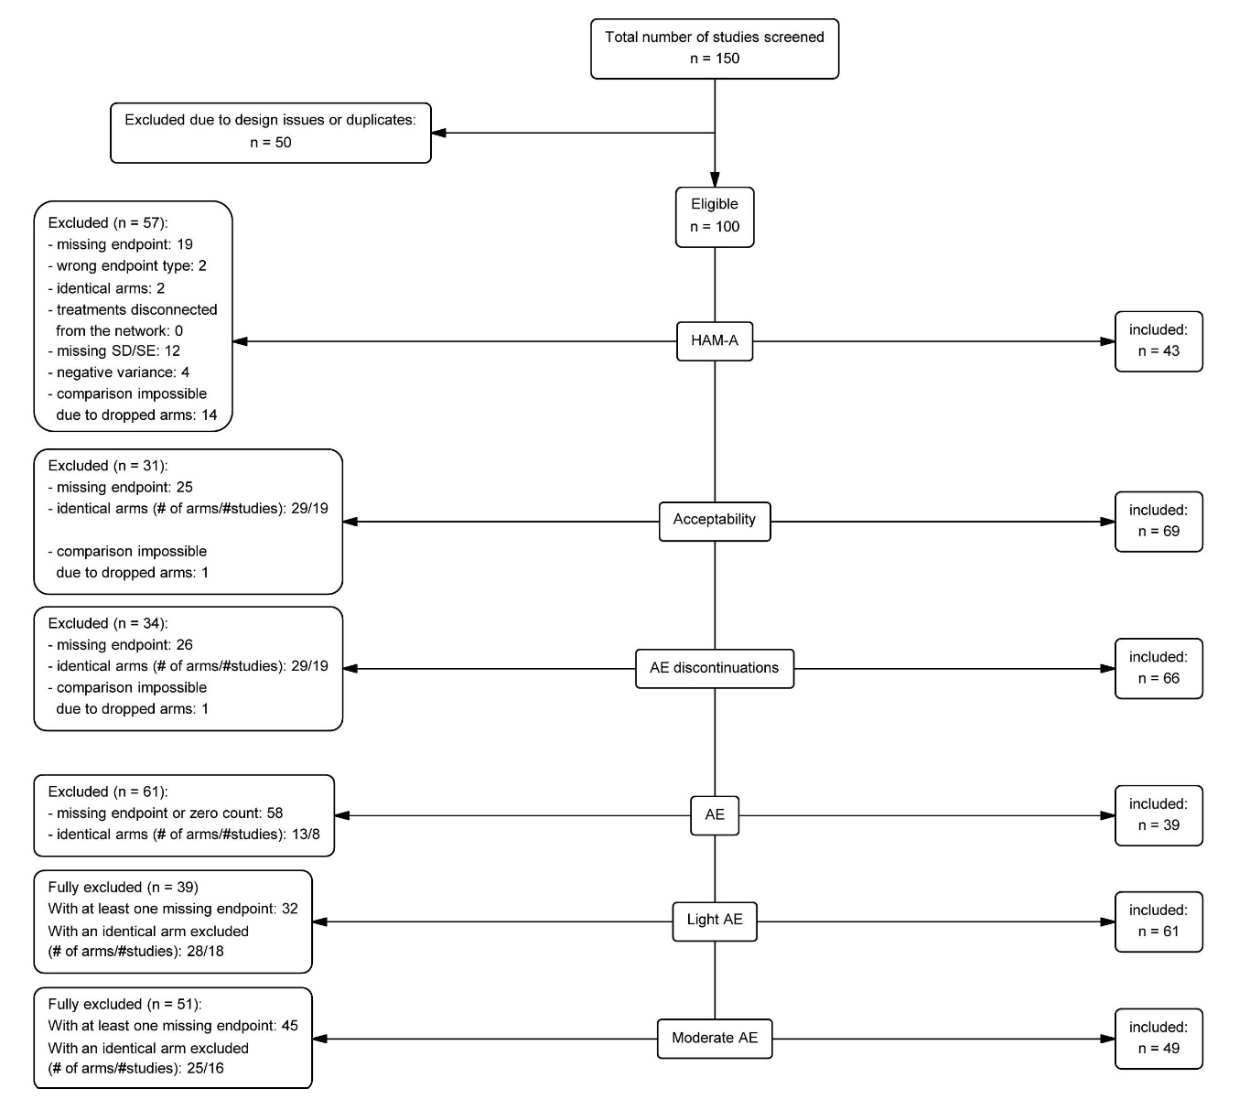
AEs, adverse events; HAM-A, Hamilton Anxiety Rating Scale.
Table S7. Network-level diagnostics for heterogeneity
AEs, adverse events; HAM-A, Hamilton Anxiety Rating Scale.
Metric | HAM-A | All-cause discontinuations | AE-caused discontinuations | AEs | Light AEs | Moderate AEs
tau | 1.33 | 0.21 | 0.259 | 0.078 | 0.208 | 0.241
tau² | 1.77 | 0.044 | 0.067 | 0.006 | 0.043 | 0.058
I² | 62.6% | 43.4% | 23.2% | 46% | 53.6% | 27.7%

Figure S2. Funnel plots – small study bias (ordered by number of randomized patients)
a) HAM-A
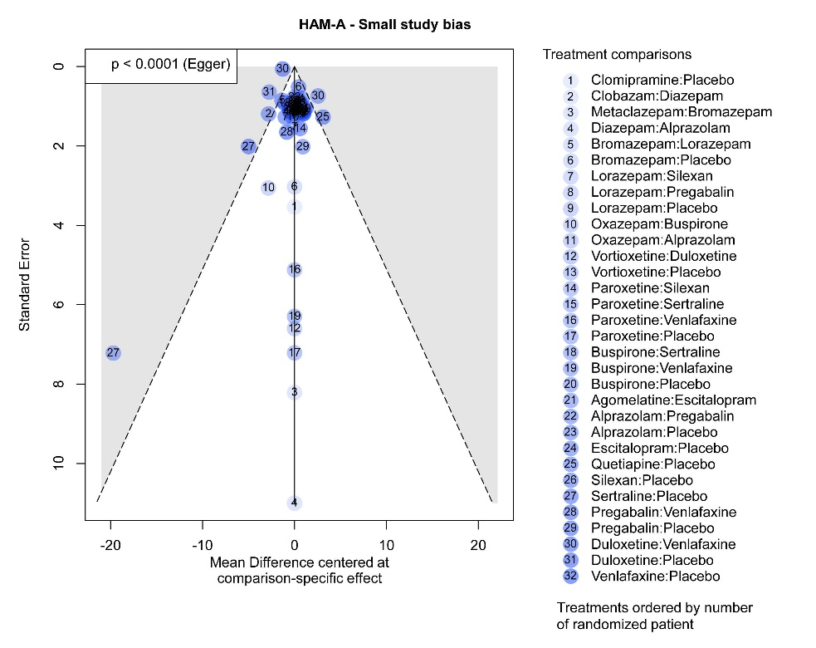
b) HAM-A (zoomed in)
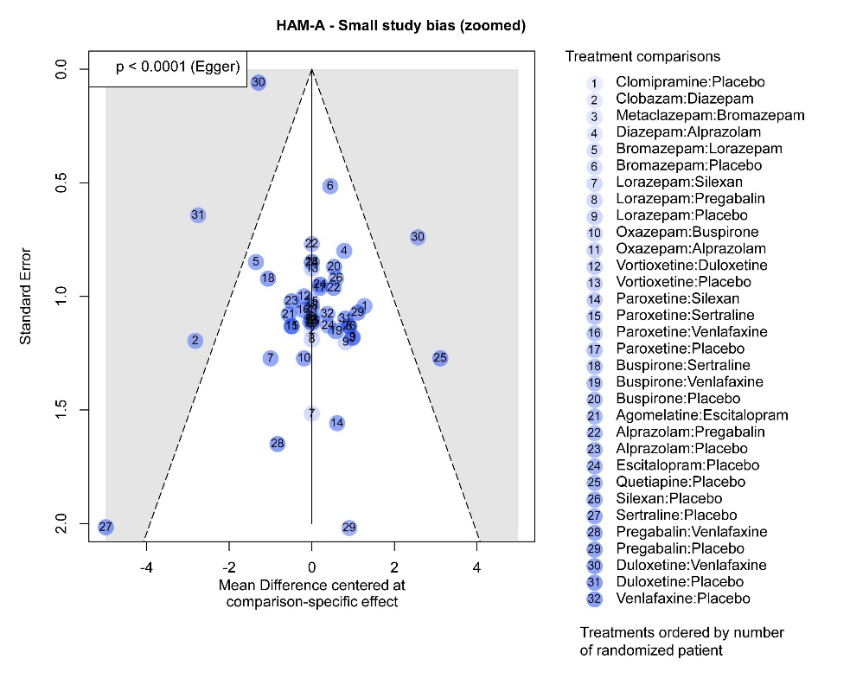
c) All-cause discontinuations
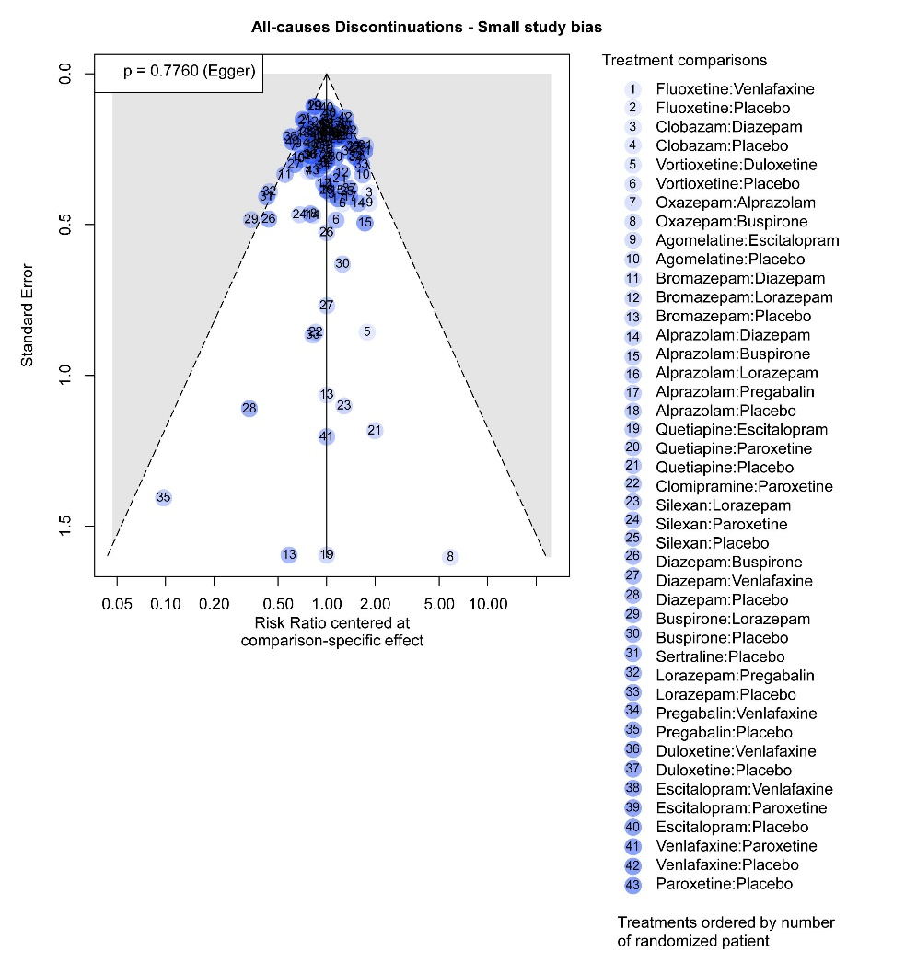
d) All-cause discontinuations (zoomed in)
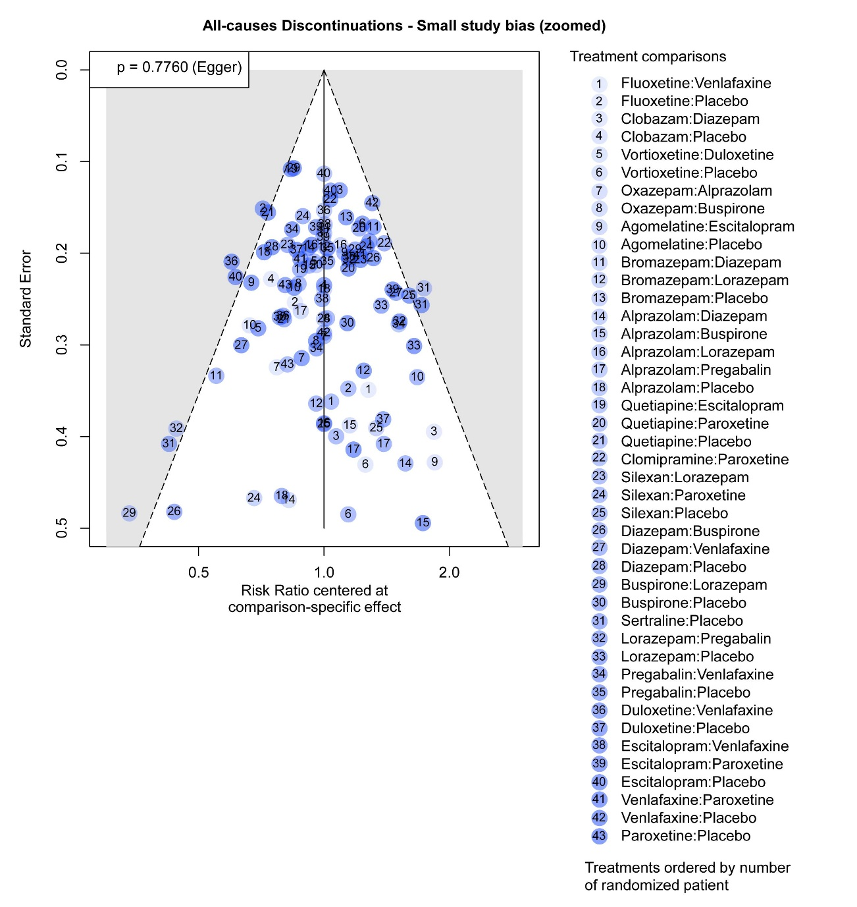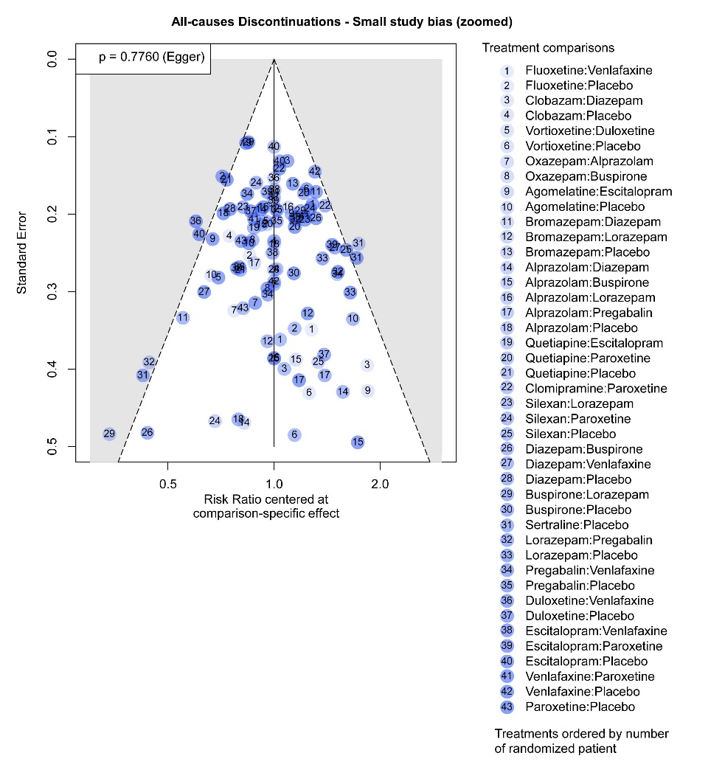
e) AE-caused discontinuations
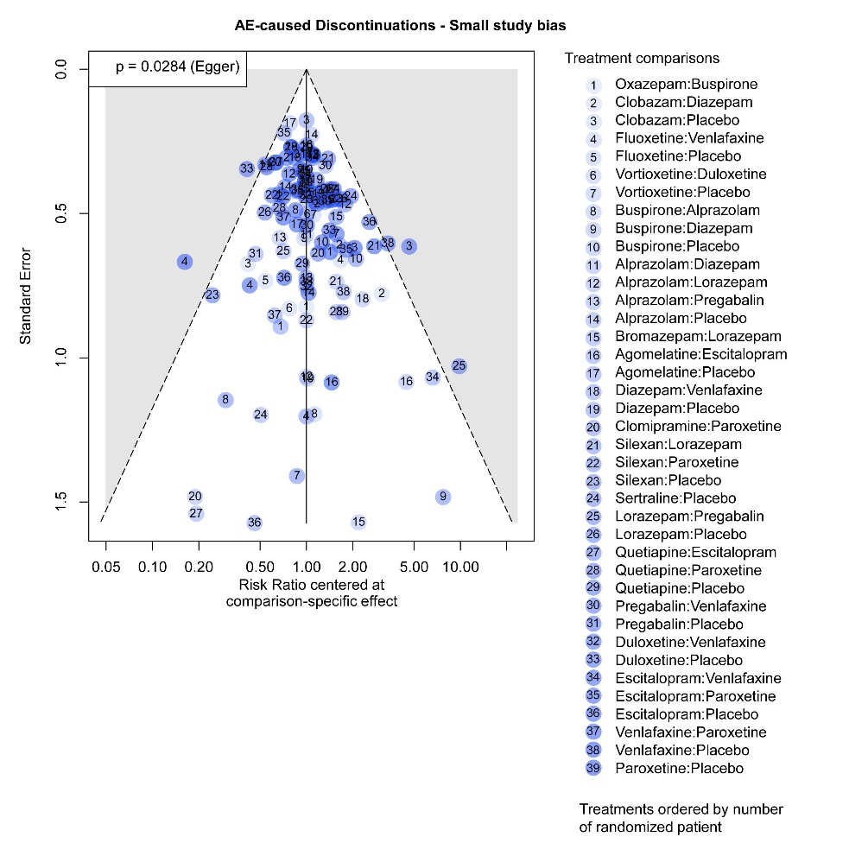
f) AE-caused discontinuations (zoomed in)
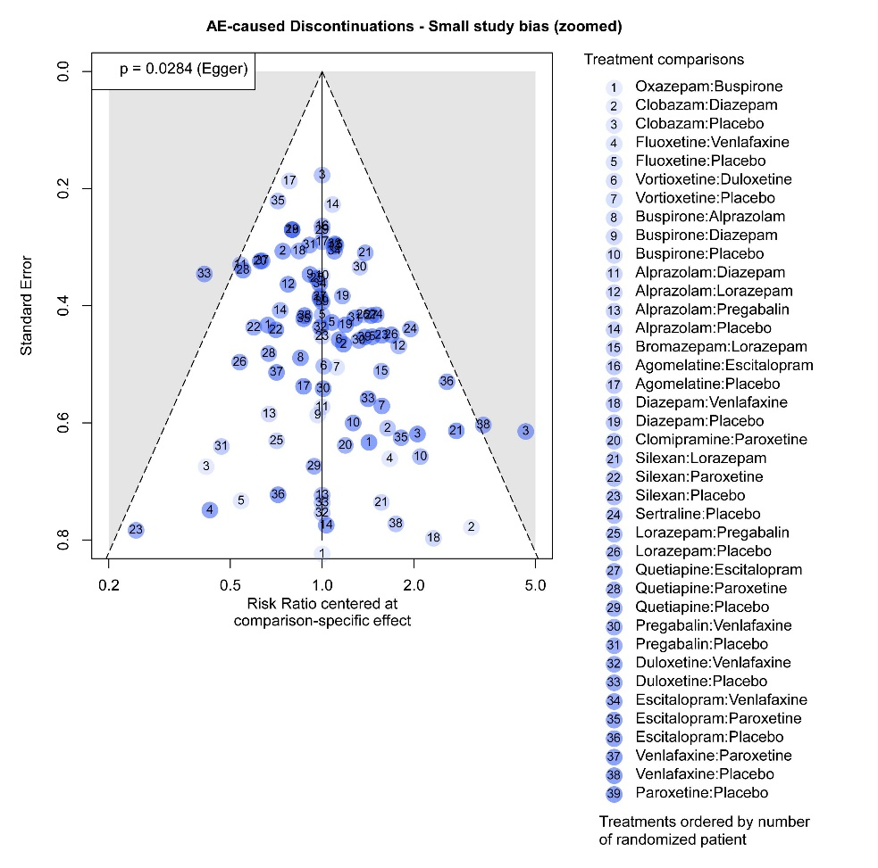
g) AEs
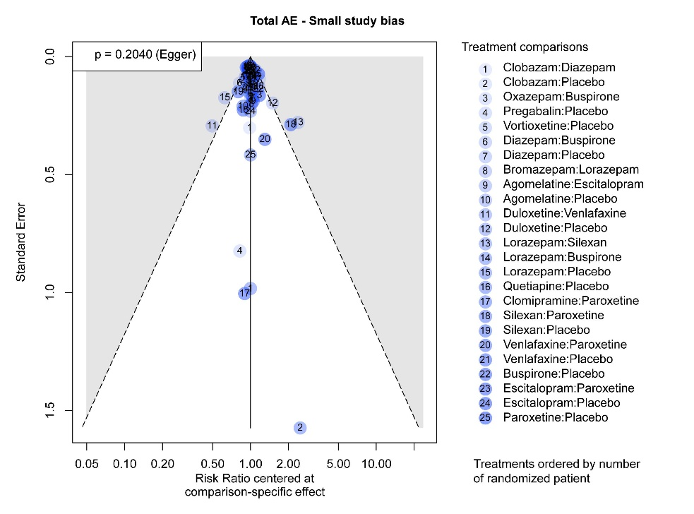
h) AEs (zoomed in)
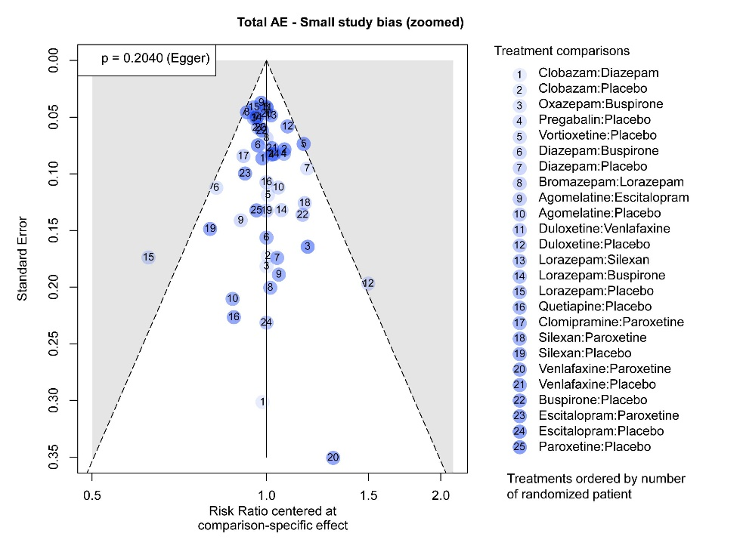
i) Light AEs
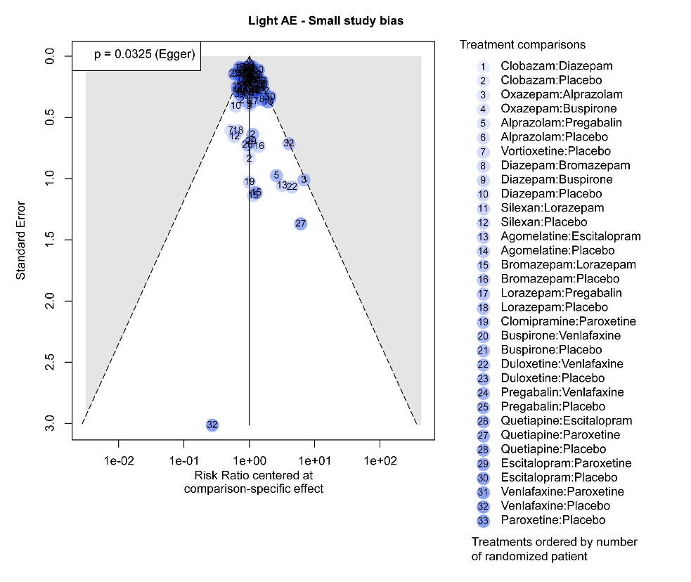
j) Light AEs (zoomed in)
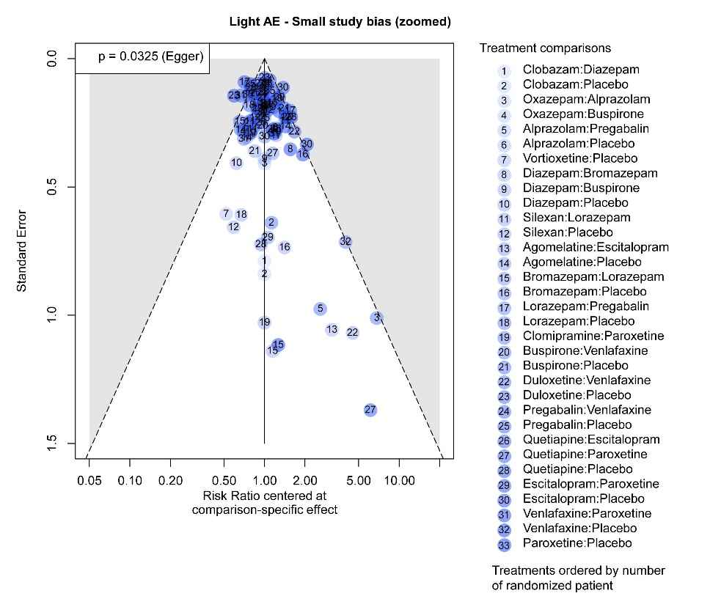
k) Moderate AEs
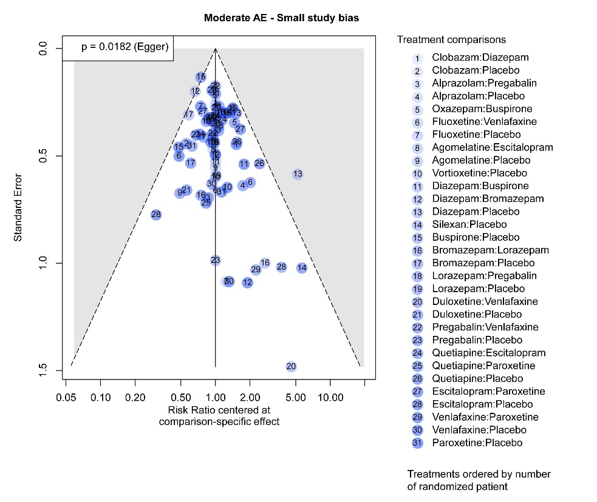
l) Moderate AEs (zoomed in)
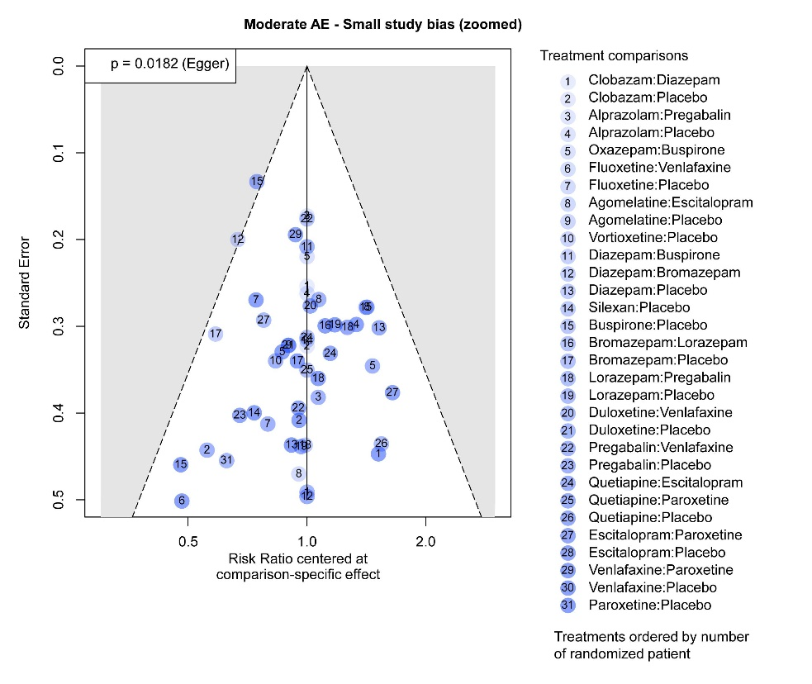
AEs, adverse events; HAM-A, Hamilton Anxiety Rating Scale.

Figures S3. Funnel plots – publication time bias (ordered by median publication date)
a) HAM-A
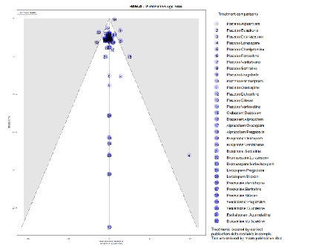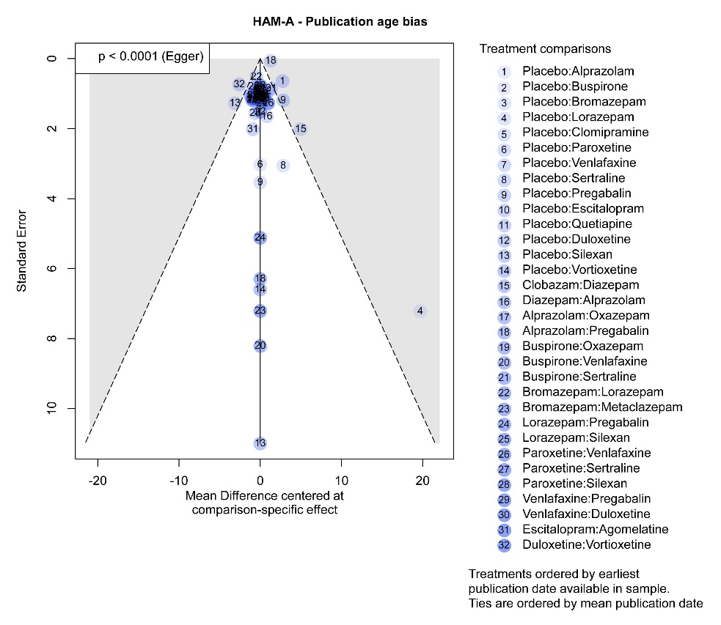
b) HAM-A (zoomed in)
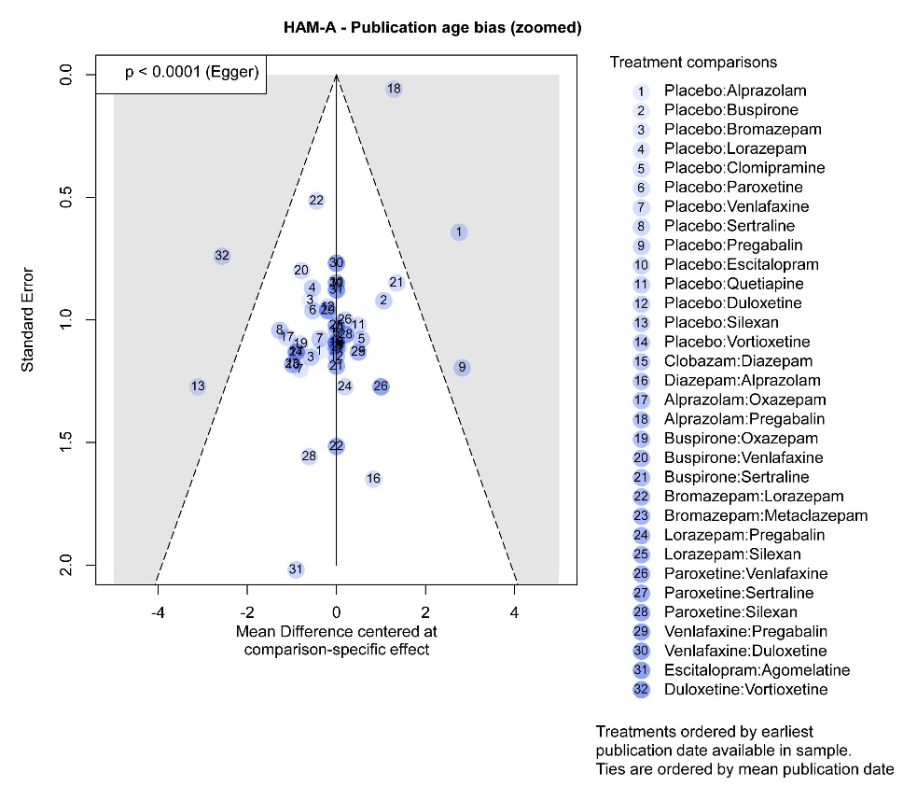
c) All-cause discontinuations
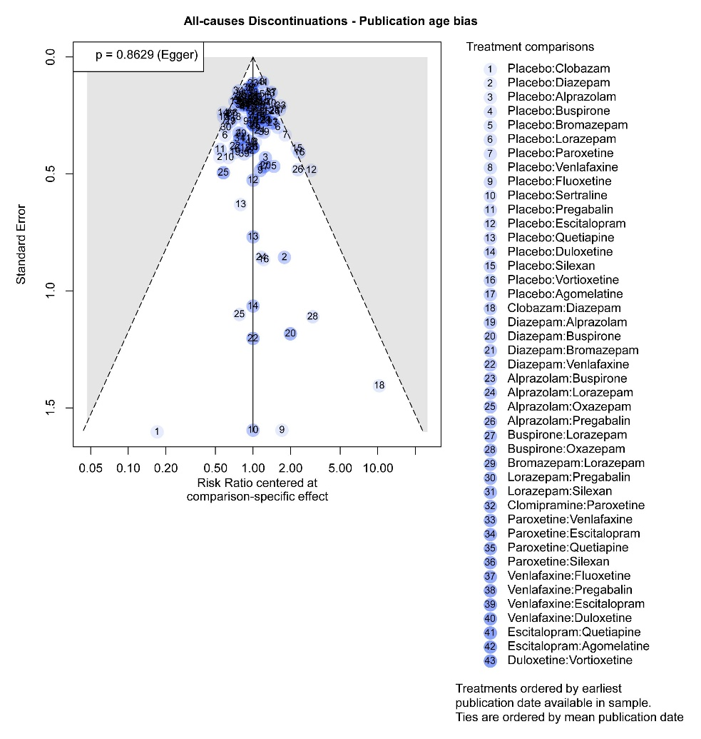
d) All-cause discontinuations (zoomed in)
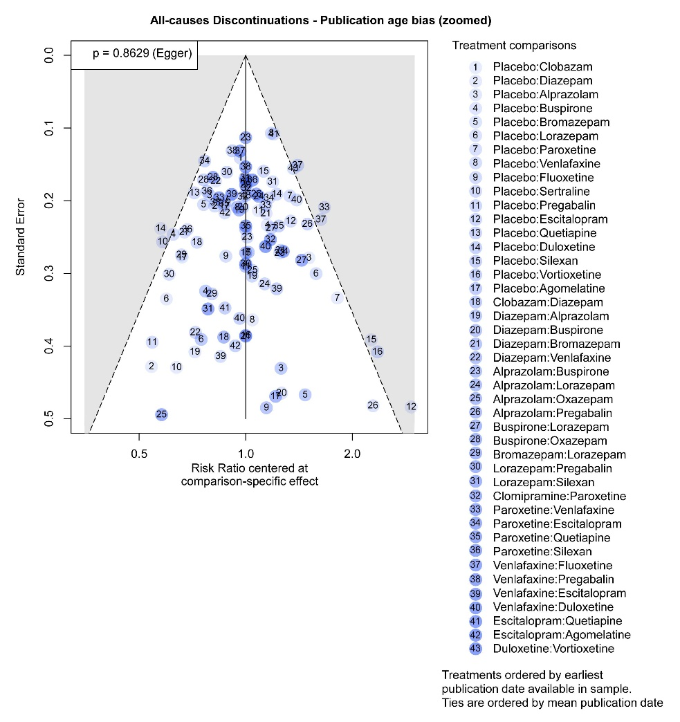
e) AE-caused discontinuations
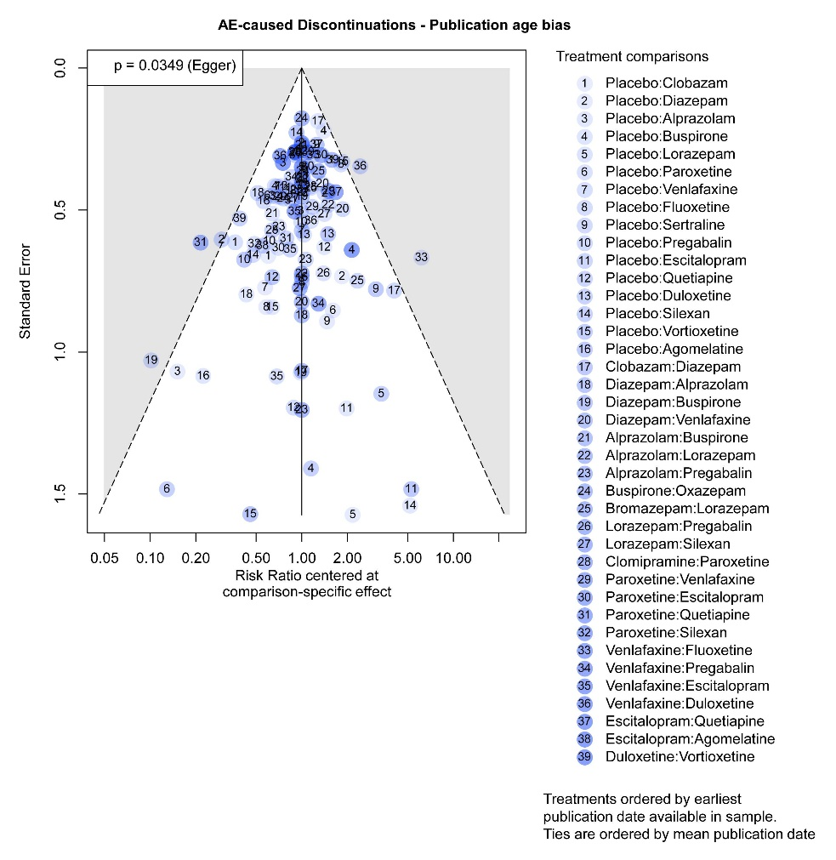
f) AE-caused discontinuations (zoomed in)
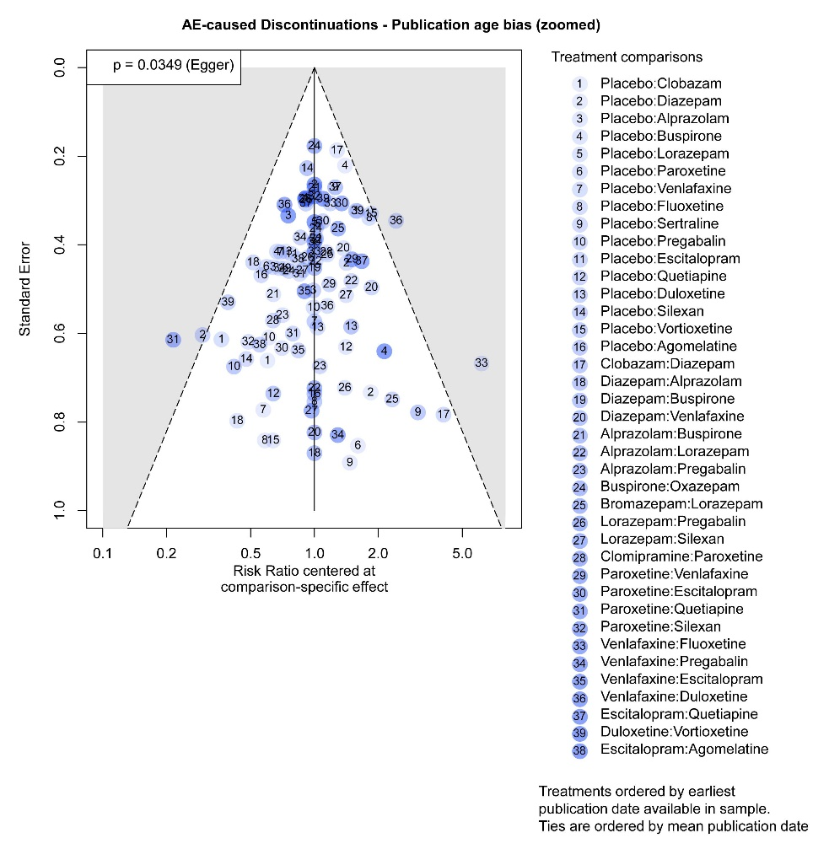
g) AEs
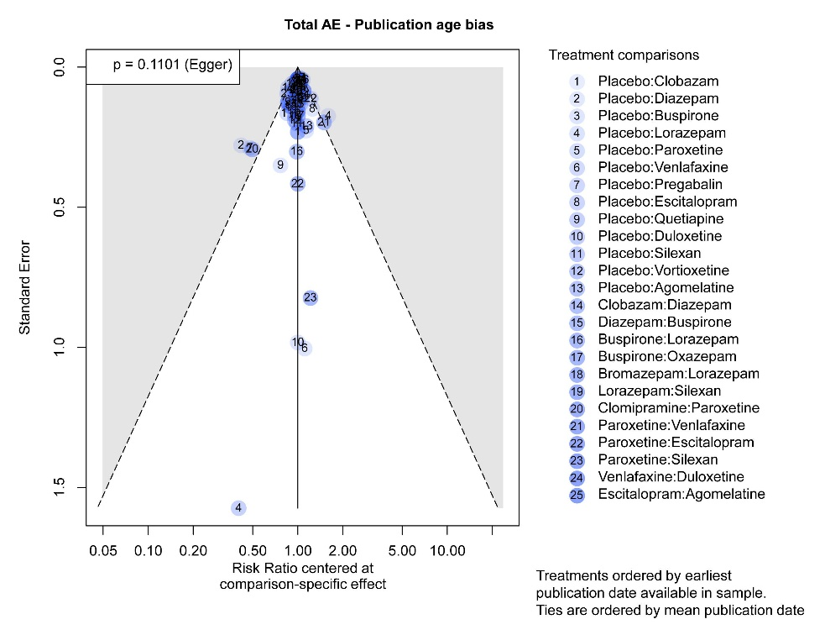
h) AEs (zoomed in)
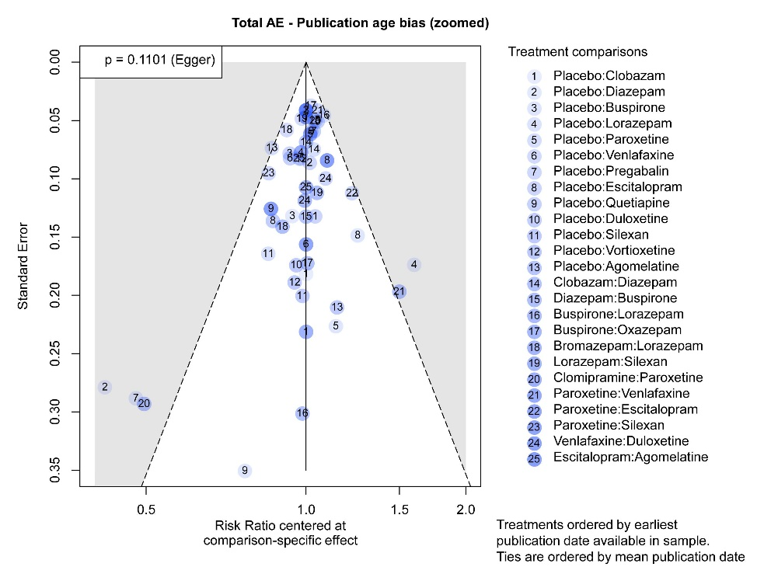
i) Light AEs
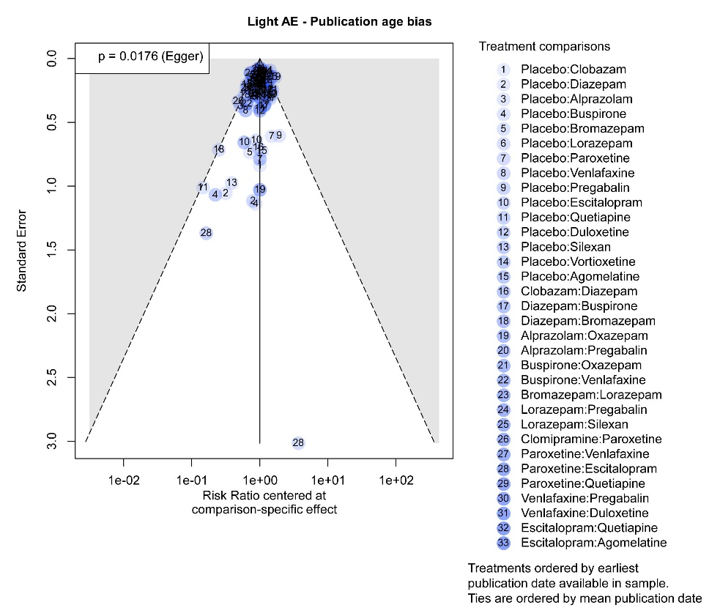
j) Light AEs (zoomed in)
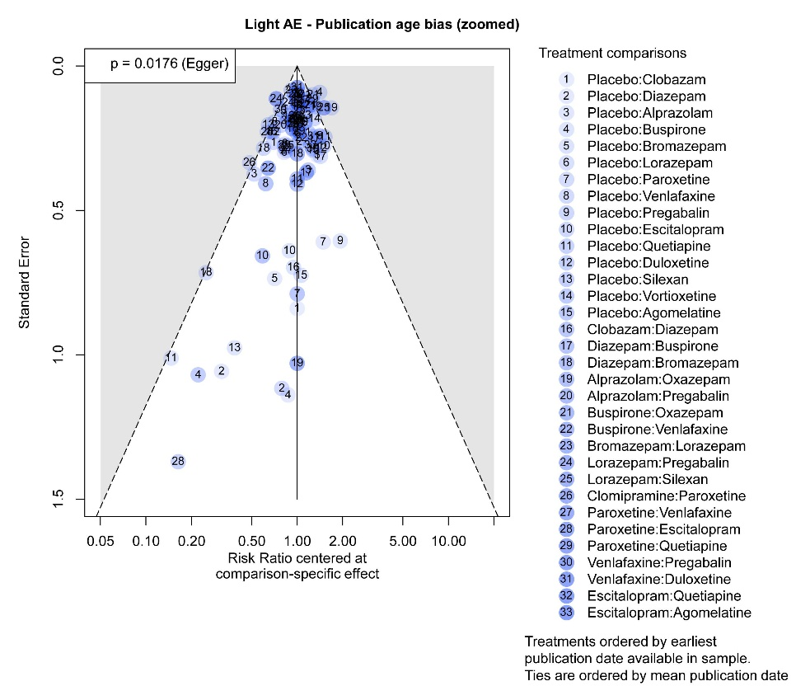
k) Moderate AEs
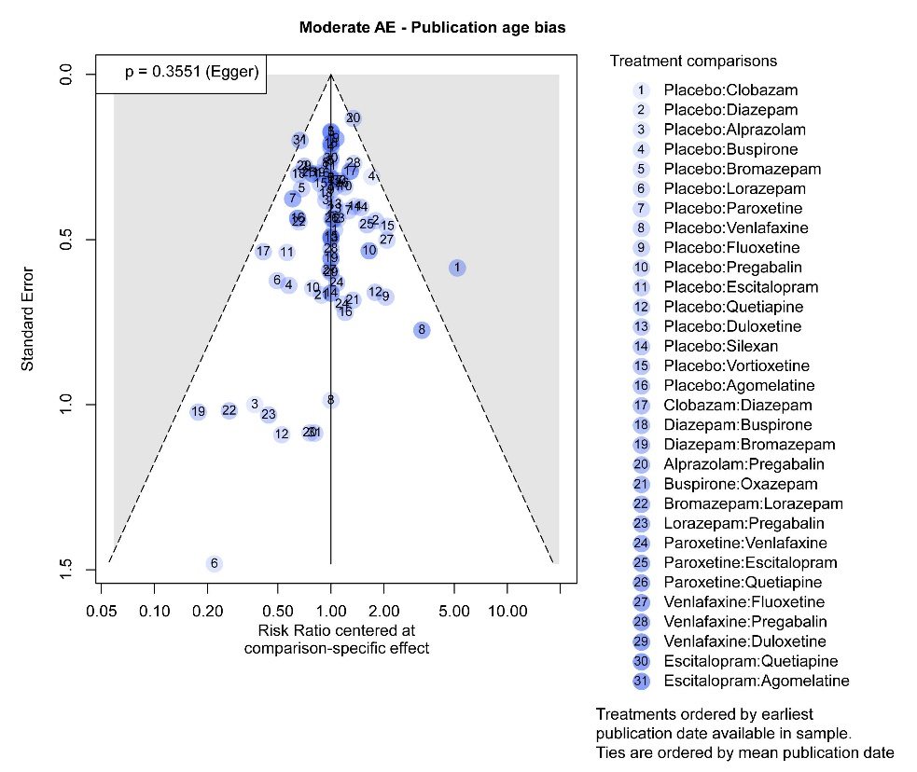
l) Moderate AEs (zoomed in)
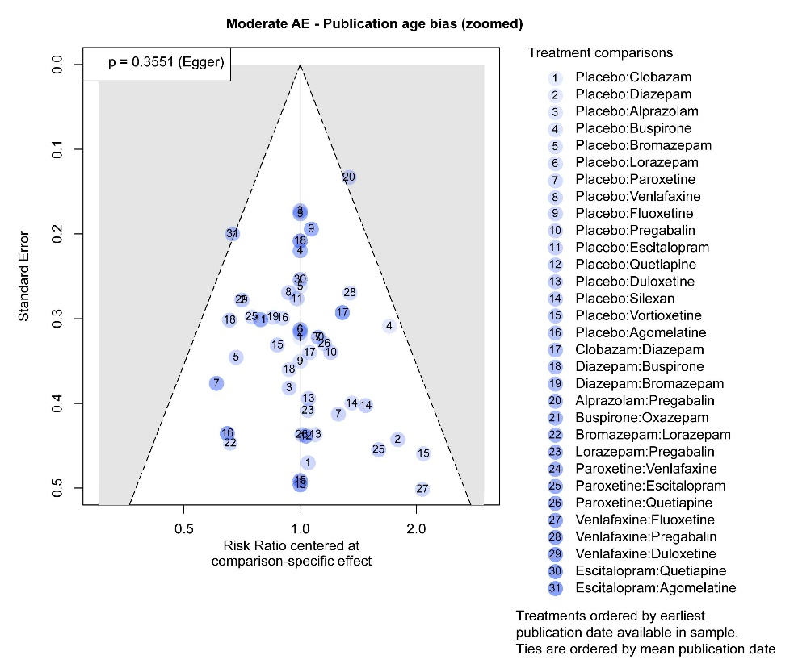
AEs, adverse events; HAM-A, Hamilton Anxiety Rating Scale.

