Table S1. Operative definitions of outcome parameters.

-) Current suicidal ideation = BPRS item 4 score of ≥2.
-) Functional recovery = return to work/school.
-) SOFAS functional remission = SOFAS score of ≥60.
-) HoNOS functional remission = HoNOS item 9, 10, and 11scores of ≤2.
-) PANSS symptomatic remission = PANSS item P1, P2, P3, N1, N4, N6, G5, G9 scores of ≤ 3.
-) Service disengagement = complete lack of contact or untraceable for at least 3 months despite a need of treatment).
-) New suicide attempt = a potentially injurious, self-inflicted behavior without a fatal outcome for which there was (implicit or explicit) evidence of intent to die.

Note. BPRS = Brief Psychiatric Rating Scale; SOFAS = Social and Occupational Functioning Assessment Scale; HoNOS = Health of the Nation Outcome Scale; PANSS = Positive And Negative Syndrome Scale.

Figure S1. Profile plots: mixed ANOVA results on psychopathological and outcome parameters across the 2-year follow-up period in the two CHR-P subgroups.

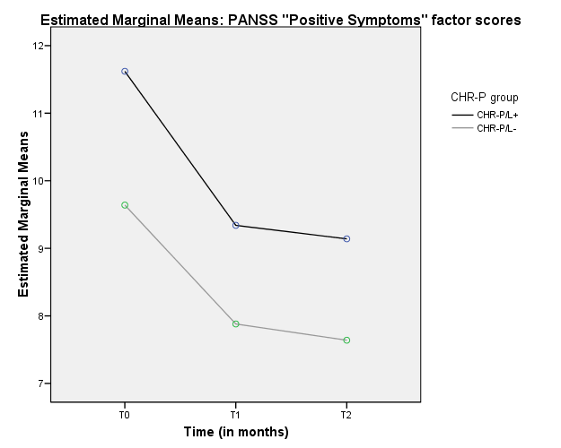

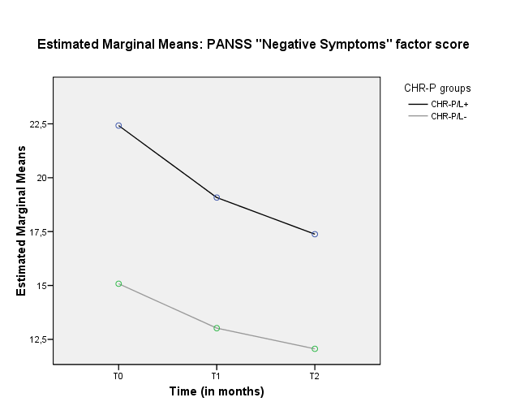

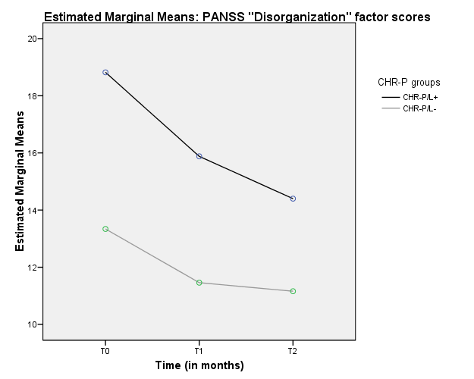

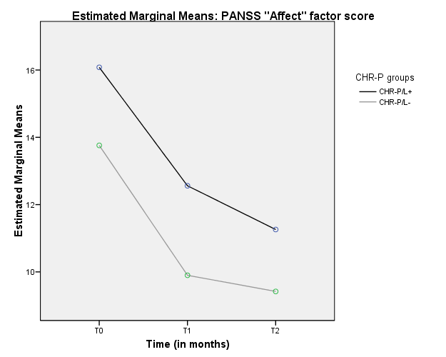

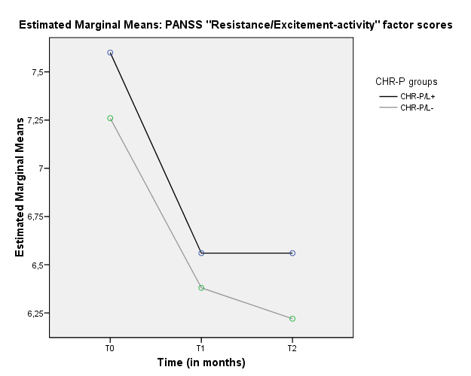

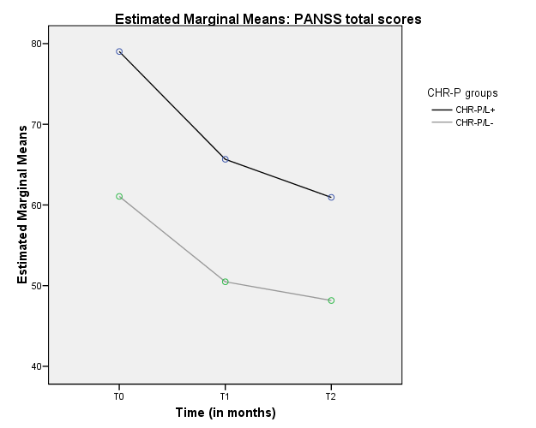

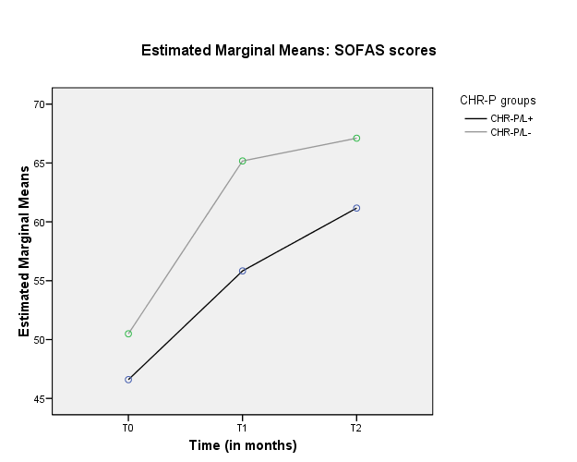

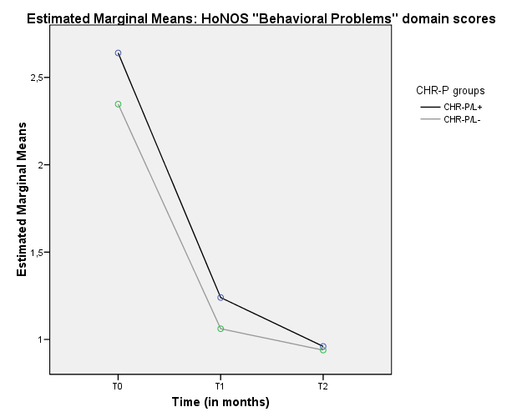

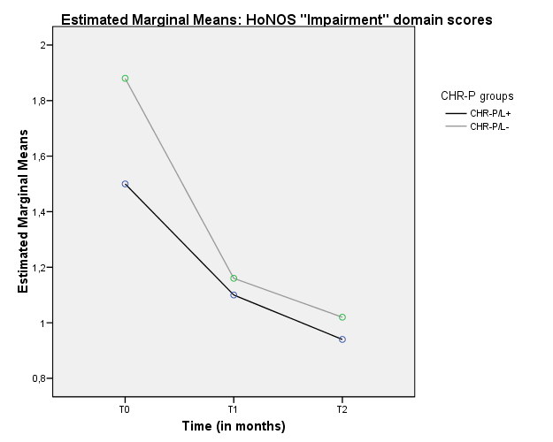

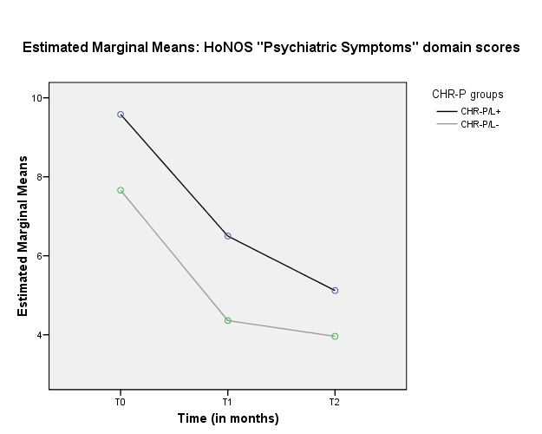

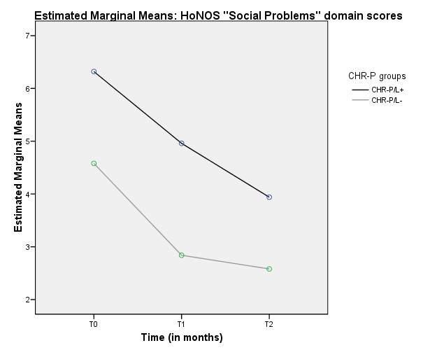

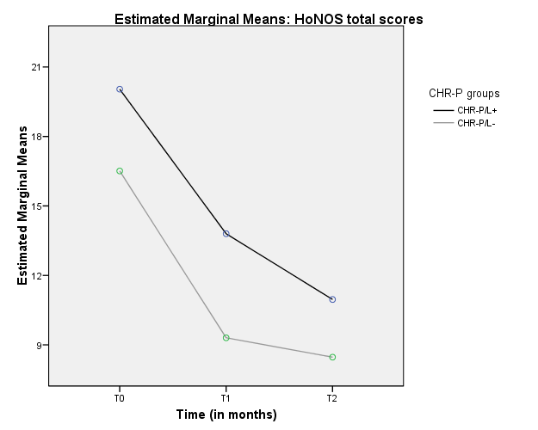

Note. ANOVA = analysis of variance; PANSS = Positive And Negative Syndrome Scale; CHR-P = Clinical High Risk for Psychosis; CHR-P/L+ = CHR-P individuals with language subjective disorder; CHR-P/L- = CHR-P individuals without language subjective disorder; SOFAS = Social and Occupational Functioning Assessment Scale; T0 = baseline assessment; T1 = 1-year assessment time; T2 = 2-year assessment time. As for PANSS and HoNOS scores, lower values indicate symptom/item improvement. As for SOFAS scores, higher values indicate functioning improvement.

Table S2. Kaplan-Meier survival analysis results: comparisons on 2-year time-to-event outcome incidence rate among the two UHR subgroups.

UHR  subgroup | Number of events | cumulative proportion surviving at the time |  | Mean (in months) for 2-year service disengagement incidence rate
UHR  subgroup | Number of events | Estimate | SE | Estimate | SE | 95% CI
 |  |  |  |  |  | Lower bound | Upper bound
UHR/EL+  UHR/EL-  (Overall) | 25  52  77 | 38.5%  49.5%  - | .060  .049  - | 18.923  17.962  18.329 | .831  .633  .505 | 17.295  16.722  17.340 | 20.552  19.202  19.319
Log Rank (Mantel-Cox) |  |  |  | Χ2 | df | p
 |  |  |  | 1.445 | 1 | .229
UHR  subgroup | Number of events | cumulative proportion surviving at the time |  | Mean (in months) for 2-year new hospitalization rate
UHR  subgroup | Number of events | Estimate | SE | Estimate | SE | 95% CI
 |  |  |  |  |  | Lower bound | Upper bound
UHR/L+  UHR/L-  (Overall) | 5  10  15 | 9.5%  11.3%  - | .040  .035  - | 23.186  22.887  23.000 | .439  .373  .275 | 22.326  22.156  22.461 | 24.047  23.617  23.539
Log Rank (Mantel-Cox) |  |  |  | Χ2 | df | p
 |  |  |  | .215 | 1 | .643
UHR  subgroup | Number of events | cumulative proportion surviving at the time |  | Mean (in months) for 2-year new suicide attempt incidence rate
UHR  subgroup | Number of events | Estimate | SE | Estimate | SE | 95% CI
 |  |  |  |  |  | Lower bound | Upper bound
UHR/L+  UHR/L-  (Overall) | 1  5  6 | 2.5%  6.1  - | .025  .028  - | 24.000  23.505  23.692 | .001  .271  .166 | 24.000  22.974  23.366 | 24.000  24.036  24.018
Log Rank (Mantel-Cox) |  |  |  | Χ2 | df | p
 |  |  |  | 1.431 | 1 | .232
UHR  subgroup | Number of events | cumulative proportion surviving at the time |  | Mean (in months) for 2-year psychosis transition rate
UHR  subgroup | Number of events | Estimate | SE | Estimate | SE | 95% CI
 |  |  |  |  |  | Lower bound | Upper bound
UHR/L+  UHR/L-  (Overall) | 7  10  17 | 12.7  12.8%  - | .045  .040  - | 22.780  23.134  23.000 | .510  .332  .274 | 21.780  22.483  22.464 | 23.779  23.785  23.536
Log Rank (Mantel-Cox) |  |  |  | Χ2 | df | p
 |  |  |  | .044 | 1 | .833

Note. UHR = Ultra-High Risk; UHR/EL+ = UHR individuals with expressive language subjective disorder (n=65); UHR/EL- = UHR individuals without language subjective disorder; SE = Standard Error; 95% CI = 95% Confidence Intervals; Log Rank = Logarithm Rank Test; X2= Chi-Square test; df = degrees of freedom; p = statistical value. Significant statistical p values are in bold.

STROBE Statement

 | Item  No |  | Recommendation
Title and abstract | 1 |  | (a) we indicated the study’s design in both the title and the abstract
(b) Provide in the abstract an informative and balanced summary of what was done
and what was found
Introduction
Background/rationale | 2 |  | We clearly explained the scientific background and rationale for our investigation: specifically, the fact that our study addressed a novel topic in the research of psychoses and language disorders.
Objectives | 3 |  | We clearly stated specific objectives of our research at the end of the “Introduction” section.
Methods
Study design | 4 |  | We presented the main elements of study design (observational follow-up study) at the first part of the “Methods” section.
Setting | 5 |  | We specifically described the setting and location (PARMS program within the Parma Department of Mental Health) of our investigation, including periods of recruitment, follow-up, and data collection.
Participants | 6 |  | In the “methods” section (“Participants” paragraph) we gave the eligibility criteria and sources of selection of participants. We also described the methods of follow-up in the “Procedures” paragraph.
Variables | 7 |  | In the “methods” section (“Procedures” and “Statistical Analysis” paragraphs), we  clearly defined all outcomes and predictors. We also gave diagnostic criteria for categorization.
Data sources/ measurement | 8* |  | For each variable of interest, in the “Assessment” paragraph, we detailed methods of assessment (measurement). Moreover, in the “Statistical analysis” paragraph, we described methods of comparability between our subgroup.
Bias | 9 |  | In the “Limitations” paragraph, we addressed potential sources of bias.
Study size | 10 |  | In the “Methods” section, we described how the sample size was recruited.
Quantitative variables | 11 |  | In the Methods” section, we explained qualitative and quantitative variables that were handled in the analyses. Moreover, we described how groupings were selected and why.
Statistical methods | 12 |  | We describe all statistical methods. Specifically, we described the methods we used to examine subgroups. There were no missing data. Finally, we explained data about service disengagement.
Results
Participants | 13 | We reported numbers of individuals at each stage of our follow-up, previously examined for eligibility and subsequently included in the study.
Descriptive data | 14 | We gave characteristics of study participants (i.e., demographic, clinical, social information). Specifically, we indicated number of participants. There were no missing data for the variables of our interest.
Outcome data | 15 | We reported numbers of outcome events and measures over time
Main results | 16 | We gave estimates and their precision (i.e., 95% confidence intervals). When relevant, we considered translating estimates in relative risk.
Discussion
Key results | 18 | We summarized key results with reference to study objectives.
Limitations | 19 | We discussed limitations of the study in a specific paragraph of the “Discussion” section, taking into account sources of potential bias or imprecision.
Interpretation | 20 | We gave a cautious overall interpretation of results considering objectives and limitations, results from similar studies, and other relevant evidence.
Other information

Funding 22 This investigation received no funds or grants.

