Supplementary Table 1. Demographic and clinical characteristics of participants in the intention-to-treat population.
Variable | Total (n = 43) | High (n = 23) | Low (n = 20) | U or $x^{2}$ | p
Age (years) | 39.16 $±$ 15.09 | 38.74 $±$14.81 | 39.65 $±$ 15.76 | 221.5 | 0.84
Sex |  |  |  | 0.47 | 0.55
Male | 17 (39.5%) | 8 (34.8%) | 9 (45.0%)
Female | 26 (60.5%) | 15 (65.2%) | 11 (55.0%)
Prior suicide attempts | 19 (44.2%) | 9 (39.1%) | 10 (50.0%) | 0.51 | 0.55
Psychiatric medication
Benzodiazepine | 25 (58.1%) | 16 (69.6%) | 9 (45.0%) | 2.65 | 0.13
SSRI/SNRI | 32 (74.4%) | 18 (78.3%) | 14 (70.0%) | 0.38 | 0.73
Sedating AD | 12 (27.9%) | 8 (34.8%) | 4 (20.0%) | 1.16 | 0.33
Agomelatine | 7 (16.3%) | 4 (17.4%) | 3 (15.0%) | 0.05 | 1.00
Melatonin | 4 (9.3%) | 2 (8.7%) | 2 (10.0%) | 0.02 | 1.00
Mood stabilizer | 12 (27.9%) | 6 (26.1%) | 6 (30.0%) | 0.08 | 1.00
Atypical AP | 23 (53.5%) | 12 (52.2%) | 11 (55.0%) | 0.03 | 1.00
Others | 23 (53.5%) | 10 (43.5%) | 13 (65.0%) | 1.99 | 0.22
Comorbid disorders | 23 (53.5%) | 14 (60.9%) | 9 (45.0%) | 1.08 | 0.37
Panic disorder | 16 (37.2%) | 8 (34.8%) | 8 (40.0%) | 0.13 | 0.76
Generalized anxiety disorder | 6 (14.0%) | 4 (17.4%) | 2 (10.0%) | 0.49 | 0.67
PTSD | 7 (16.3%) | 5 (21.7%) | 2 (10.0%) | 1.08 | 0.42
Treatment resistant depression | 17 (39.5%) | 9 (39.1%) | 8 (40.0%) | 0.003 | 1.00
Baseline HAM-D | 16.16 $±$ 4.80 | 15.35 $±$ 4.62 | 17.10 $±$ 4.95 | 176.0 | 0.19
Baseline HAM-A | 16.86 $±$ 8.31 | 17.30 $±$ 9.18 | 16.35 $±$ 7.38 | 226.0 | 0.92
Baseline PSQI | 13.26 $±$ 3.53 | 13.26 $±$ 3.31 | 13.25 $±$ 3.86 | 226.5 | 0.93
Note: Data are presented as mean ± standard deviation or n (%). p-values were calculated using Mann-Whitney U test and Fisher's exact test.

Supplementary Table 2. Depression, anxiety, and sleep before and after high-frequency rTMS in the intention-to-treat population.
 | Visit 1 | Visit 2 |  | Visit 3 |  | Visit 4
 | Mean $±$ SD | Mean $±$ SD | tª | Mean $±$ SD | tª | Mean $±$ SD | tª
HAM-D | $$15.35±4.62$$ | $$12.09±5.78$$ | 2.85** | $$10.30±5.77$$ | 4.24*** | $$11.00±7.06$$ | 3.31**
HAM-A | $$17.30±9.18$$ | $$13.48±7.49$$ | 2.16* | $$13.13±8.38$$ | 3.05** | $$13.09±10.45$$ | 2.49*
PSQI | $$13.26±3.31$$ | $$12.65±3.81$$ | 0.97 | $$11.35±4.69$$ | 2.29* | $$11.52±4.83$$ | 2.13*
ªComparison between pre- and post- rTMS was conducted using paired-t tests
*p <0.05, **p <0.01, ***p <0.001
Abbreviations: rTMS, Repetitive transcranial magnetic stimulation; HAM-D, Hamilton depression rating Scale; HAM-A, Hamilton anxiety rating scale; PSQI, Pittsburgh sleep quality index

Supplementary Table 3. Depression, anxiety, and sleep before and after low-frequency rTMS in the intention-to-treat population.
 | Visit 1 | Visit 2 |  | Visit 3 |  | Visit 4
 | Mean $±$ SD | Mean $±$ SD | tª | Mean $±$ SD | tª | Mean $±$ SD | tª
HAM-D | $$17.10±4.95$$ | $$12.20±5.22$$ | 4.25*** | $$10.90±6.30$$ | 5.05*** | $$9.05±6.39$$ | 6.06***
HAM-A | $$16.35±7.38$$ | $$14.15±8.28$$ | 1.82 | $$11.45±8.05$$ | 3.90** | $$11.40±9.25$$ | 2.75*
PSQI | $$13.25±3.86$$ | $$12.80±4.01$$ | 0.83 | $$11.30±3.16$$ | 2.64* | $$10.80±4.64$$ | 3.57**
ªComparison between pre- and post-rTMS was conducted using paired t-tests
*p <0.05, **p <0.01, ***p <0.001
Abbreviations: rTMS, Repetitive transcranial magnetic stimulation; HAM-D, Hamilton depression rating Scale; HAM-A, Hamilton anxiety rating scale; PSQI, Pittsburgh sleep quality index

Supplementary Table 4. Changes from baseline in depression, anxiety, and sleep after HF- and LF-rTMS in the intention-to-treat population.
 | Time | Change from baseline HF-rTMS | Change from baseline LF-rTMS | F
HAM-D | Visit 2 | 3.26 | 4.90 | 1.03
HAM-D | Visit 3 | 5.04 | 6.20 | 0.62
HAM-D | Visit 4 | 4.35 | 8.05 | 4.67*
HAM-A | Visit 2 | 3.83 | 2.20 | 0.45
HAM-A | Visit 3 | 4.17 | 4.90 | 0.23
HAM-A | Visit 4 | 4.22 | 4.95 | 0.21
PSQI | Visit 2 | 0.61 | 0.45 | 0.02
PSQI | Visit 3 | 1.91 | 1.95 | 0.09
PSQI | Visit 4 | 1.74 | 2.45 | 0.99
ANCOVA was performed controlling for age, sex, and comorbid disorders
*p <0.05, **p <0.01, ***p <0.001
Abbreviations: HF, High-frequency; LF, Low-frequency; rTMS, Repetitive transcranial magnetic stimulation; HAM-D, Hamilton depression rating scale; HAM-A, Hamilton anxiety rating scale; PSQI, Pittsburgh sleep quality index

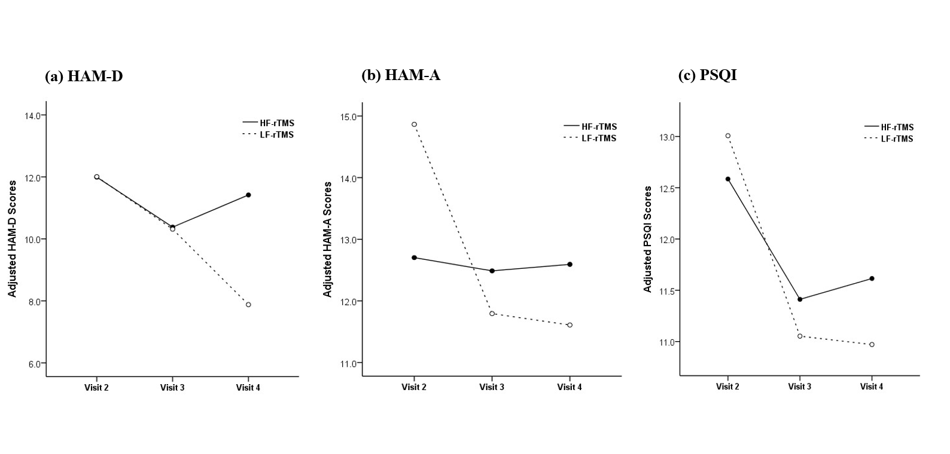
Supplementary Fig. 1. Adjusted mean scores of (a) HAM-D, (b) HAM-A, and (c) PSQI across follow-up visits for HF-rTMS and LF-rTMS groups. Values were adjusted for age, sex, baseline scores, and comorbid disorders.

Abbreviations: HF, High-frequency; LF, Low-frequency; rTMS, Repetitive transcranial magnetic stimulation; HAM-D, Hamilton depression rating scale; HAM-A, Hamilton anxiety rating scale; PSQI, Pittsburgh sleep quality index

