eTable 1. Associations of sleep variables with incident psychiatric disease after excluding the first two years follow-up.
Sleep variable |  | HR (95% CI)
Sleep duration | <7 h | 1.41 (1.07-1.84)
Sleep duration | ≥7, ≤8 h | 1.0 (reference)
Sleep duration | >8 h | 1.39 (1.12-1.71)
Difficulties falling asleep | No | 1.0 (reference)
Difficulties falling asleep | Yes | 1.77 (1.34-2.35)
Repeated awakenings | No | 1.0 (reference)
Repeated awakenings | Yes | 1.43 (1.09-1.87)
Premature awakening | No | 1.0 (reference)
Premature awakening | Yes | 1.46 (1.13-1.89)
Snoring | No | 1.0 (reference)
Snoring | Yes | 1.08 (0.77-1.50)
Apnea | No | 1.0 (reference)
Apnea | Yes | 1.42 (0.86-2.33)
Difficulties awakening | No | 1.0 (reference)
Difficulties awakening | Yes | 1.57 (1.16-2.12)
Non-refreshing sleep | No | 1.0 (reference)
Non-refreshing sleep | Yes | 1.47 (1.18-1.84)
Insufficient sleep | No | 1.0 (reference)
Insufficient sleep | Yes | 1.35 (1.04-1.75)
Persistent fatigue | No | 1.0 (reference)
Persistent fatigue | Yes | 1.72 (1.39-2.13)
Physical exhaustion | No | 1.0 (reference)
Physical exhaustion | Yes | 1.78 (1.40-2.26)
Mental fatigue | No | 1.0 (reference)
Mental fatigue | Yes | 1.90 (1.53-2.36)
Adjusted for age, sex, education, smoking status, physical activity, body mass index, hypnotic use, average sleep duration, and comorbidities (cancer, psychiatric illness, cardiovascular disease); model for sleep duration was not adjusted for average sleep duration.
eTable 2. Associations of sleep variables with incident psychiatric disease in age-specific groups.
 |  | HR (95% CI)
Sleep variable |  | <40 years | 40-60 years | ≥60 years
Sleep duration | <7 h | 1.34 (0.84-2.10) | 1.26 (0.94-1.69) | 1.35 (0.82-2.18)
Sleep duration | 7-8 h | 1.0 (reference) | 1.0 (reference) | 1.0 (reference)
Sleep duration | >8 h | 1.38 (0.98-1.97) | 1.38 (1.09-1.74) | 1.47 (1.04-2.11)
Difficulties falling asleep | No | 1.0 (reference) | 1.0 (reference) | 1.0 (reference)
Difficulties falling asleep | Yes | 2.20 (1.39-3.37) | 1.36 (0.97-1.87) | 1.82 (1.12-2.85)
Repeated awakenings | No | 1.0 (reference) | 1.0 (reference) | 1.0 (reference)
Repeated awakenings | Yes | 1.38 (0.81-2.22) | 1.61 (1.21-2.11) | 1.55 (0.99-2.33)
Premature awakening | No | 1.0 (reference) | 1.0 (reference) | 1.0 (reference)
Premature awakening | Yes | 1.27 (0.81-1.93) | 2.02 (1.56-2.59) | 1.65 (1.02-2.55)
Snoring | No | 1.0 (reference) | 1.0 (reference) | 1.0 (reference)
Snoring | Yes | 1.20 (0.58-2.23) | 1.32 (0.94-1.83) | 1.24 (0.77-1.92)
Apnea | No | 1.0 (reference) | 1.0 (reference) | 1.0 (reference)
Apnea | Yes | 2.98 (1.23-6.13) | 1.32 (0.71-2.24) | 1.74 (0.90-3.08)
Difficulties awakening | No | 1.0 (reference) | 1.0 (reference) | 1.0 (reference)
Difficulties awakening | Yes | 2.08 (1.43-2.98) | 1.38 (0.96-1.92) | 0.81 (0.25-1.93)
Non-refreshing sleep | No | 1.0 (reference) | 1.0 (reference) | 1.0 (reference)
Non-refreshing sleep | Yes | 1.54 (1.10-2.13) | 1.89 (1.49-2.38) | 1.15 (0.70-1.80)
Insufficient sleep | No | 1.0 (reference) | 1.0 (reference) | 1.0 (reference)
Insufficient sleep | Yes | 1.49 (1.01-2.16) | 1.57 (1.20-2.04) | 1.50 (0.87-2.44)
Persistent fatigue | No | 1.0 (reference) | 1.0 (reference) | 1.0 (reference)
Persistent fatigue | Yes | 1.71 (1.22-2.38) | 1.97 (1.57-2.46) | 1.52 (1.00-2.24)
Physical exhaustion | No | 1.0 (reference) | 1.0 (reference) | 1.0 (reference)
Physical exhaustion | Yes | 1.72 (1.18-2.46) | 2.04 (1.58-2.62) | 1.69 (1.04-2.63)
Mental fatigue | No | 1.0 (reference) | 1.0 (reference) | 1.0 (reference)
Mental fatigue | Yes | 1.80 (1.28-2.50) | 2.27 (1.82-2.84) | 1.97 (1.27-2.95)
Adjusted for age, sex, education, smoking status, physical activity, body mass index, hypnotic use, average sleep duration, and comorbidities (cancer, psychiatric illness, cardiovascular disease); model for sleep duration was not adjusted for average sleep duration.
eTable 3. Associations of sleep variables with incident psychiatric disease: multi-adjusted for sleep variables.
Sleep variable |  | HR (95% CI)
Sleep duration | <7 h | 1.10 (0.80-1.53)
Sleep duration | 7-8 h | 1.0 (reference)
Sleep duration | >8 h | 1.34 (1.14-1.58)
Difficulties falling asleep | No | 1.0 (reference)
Difficulties falling asleep | Yes | 1.08 (0.82-1.43)
Repeated awakenings | No | 1.0 (reference)
Repeated awakenings | Yes | 0.96 (0.73-1.27)
Premature awakening | No | 1.0 (reference)
Premature awakening | Yes | 1.25 (0.96-1.62)
Snoring | No | 1.0 (reference)
Snoring | Yes | 1.00 (0.74-1.35)
Apnea | No | 1.0 (reference)
Apnea | Yes | 1.42 (0.93-2.19)
Difficulties awakening | No | 1.0 (reference)
Difficulties awakening | Yes | 1.18 (0.90-1.55)
Non-refreshing sleep | No | 1.0 (reference)
Non-refreshing sleep | Yes | 1.00 (0.77-1.28)
Insufficient sleep | No | 1.0 (reference)
Insufficient sleep | Yes | 1.07 (0.83-1.36)
Persistent fatigue | No | 1.0 (reference)
Persistent fatigue | Yes | 1.13 (0.88-1.44)
Physical exhaustion | No | 1.0 (reference)
Physical exhaustion | Yes | 1.20 (0.95-1.52)
Mental fatigue | No | 1.0 (reference)
Mental fatigue | Yes | 1.66 (1.33-2.09)
Adjusted for age, sex, education, smoking status, physical activity, body mass index, hypnotic use, average sleep duration, comorbidities (cancer, neurology disease, cardiovascular disease), and all sleep variables in the table.

eTable 4. β coefficient and 95% confidence interval (CI) of sleep-related symptom trajectories before and after psychiatric diagnosis.
Sleep-related symptom | β coefficient (95% CI) | P-value
Sleep duration
Slope before year 0 for psychiatry-free subjects | -0.086 (-0.097, -0.075) | <.0001
Slope before year 0 for incident psychiatry subjects | -0.056 (-0.074, -0.038) | <.0001
Difference in slope before year 0 | 0.030 (0.015, 0.045) | <.0001
Slope after year 0 for incident psychiatry subjects | -0.073 (-0.104, -0.041) | <.0001
Difference in slope before and after year 0 | -0.017 (-0.053, 0.020) | 0.366
Difficulties falling asleep
Slope before year 0 for psychiatry-free subjects | 0.024 (0.008, 0.040) | 0.003
Slope before year 0 for incident psychiatry subjects | 0.088 (0.063, 0.114) | <.0001
Difference in slope before year 0 | 0.065 (0.043, 0.086) | <.0001
Slope after year 0 for incident psychiatry subjects | -0.017 (-0.060, 0.027) | 0.458
Difference in slope before and after year 0 | -0.105 (-0.156, -0.054) | <.0001
Repeated awakenings
Slope before year 0 for psychiatry-free subjects | 0.072 (0.055, 0.089) | <.0001
Slope before year 0 for incident psychiatry subjects | 0.130 (0.102, 0.157) | <.0001
Difference in slope before year 0 | 0.058 (0.034, 0.081) | <.0001
Slope after year 0 for incident psychiatry subjects | 0.009 (-0.032, 0.051) | 0.658
Difference in slope before and after year 0 | -0.120 (-0.171, -0.069) | <.0001
Premature awakening
Slope before year 0 for psychiatry-free subjects | 0.072 (0.054, 0.090) | <.0001
Slope before year 0 for incident psychiatry subjects | 0.121 (0.092, 0.151) | <.0001
Difference in slope before year 0 | 0.049 (0.025, 0.074) | <.0001
Slope after year 0 for incident psychiatry subjects | 0.014 (-0.032, 0.060) | 0.545
Difference in slope before and after year 0 | -0.107 (-0.162, -0.052) | 0.000
Snoring
Slope before year 0 for psychiatry-free subjects | 0.077 (0.059, 0.094) | <.0001
Slope before year 0 for incident psychiatry subjects | 0.092 (0.063, 0.121) | <.0001
Difference in slope before year 0 | 0.016 (-0.009, 0.040) | 0.217
Slope after year 0 for incident psychiatry subjects | 0.040 (-0.003, 0.082) | 0.067
Difference in slope before and after year 0 | -0.052 (-0.104, -0.001) | 0.047
Apnea
Slope before year 0 for psychiatry-free subjects | 0.031 (0.019, 0.044) | <.0001
Slope before year 0 for incident psychiatry subjects | 0.033 (0.013, 0.054) | 0.002
Difference in slope before year 0 | 0.002 (-0.016, 0.019) | 0.839
Slope after year 0 for incident psychiatry subjects | -0.011 (-0.037, 0.016) | 0.427
Difference in slope before and after year 0 | -0.044 (-0.077, -0.011) | 0.010
Difficulties awakening
Slope before year 0 for psychiatry-free subjects | 0.002 (-0.013, 0.018) | 0.765
Slope before year 0 for incident psychiatry subjects | 0.040 (0.016, 0.065) | 0.001
Difference in slope before year 0 | 0.038 (0.017, 0.059) | 0.000
Slope after year 0 for incident psychiatry subjects | -0.008 (-0.048, 0.032) | 0.706
Difference in slope before and after year 0 | -0.048 (-0.095, -0.001) | 0.046
Non-refreshing sleep
Slope before year 0 for psychiatry-free subjects | 0.025 (0.008, 0.043) | 0.005
Slope before year 0 for incident psychiatry subjects | 0.082 (0.053, 0.111) | <.0001
Difference in slope before year 0 | 0.057 (0.033, 0.081) | <.0001
Slope after year 0 for incident psychiatry subjects | -0.043 (-0.085, -0.002) | 0.041
Difference in slope before and after year 0 | -0.125 (-0.176, -0.075) | <.0001
Insufficient sleep
Slope before year 0 for psychiatry-free subjects | 0.023 (0.011, 0.036) | 0.000
Slope before year 0 for incident psychiatry subjects | 0.030 (0.010, 0.051) | 0.003
Difference in slope before year 0 | 0.007 (-0.010, 0.024) | 0.418
Slope after year 0 for incident psychiatry subjects | -0.013 (-0.041, 0.016) | 0.375
Difference in slope before and after year 0 | -0.043 (-0.078, -0.009) | 0.015
Persistent fatigue
Slope before year 0 for psychiatry-free subjects | -0.023 (-0.040, -0.006) | 0.009
Slope before year 0 for incident psychiatry subjects | 0.048 (0.014, 0.082) | 0.006
Difference in slope before year 0 | 0.071 (0.041, 0.101) | <.0001
Slope after year 0 for incident psychiatry subjects | -0.110 (-0.155, -0.065) | <.0001
Difference in slope before and after year 0 | -0.157 (-0.215, -0.099) | <.0001
Physical exhaustion
Slope before year 0 for psychiatry-free subjects | -0.049 (-0.065, -0.034) | <.0001
Slope before year 0 for incident psychiatry subjects | -0.009 (-0.039, 0.022) | 0.566
Difference in slope before year 0 | 0.041 (0.014, 0.068) | 0.003
Slope after year 0 for incident psychiatry subjects | -0.112 (-0.158, -0.067) | <.0001
Difference in slope before and after year 0 | -0.104 (-0.160, -0.047) | 0.000
Mental fatigue
Slope before year 0 for psychiatry-free subjects | 0.042 (0.025, 0.060) | <.0001
Slope before year 0 for incident psychiatry subjects | 0.132 (0.098, 0.165) | <.0001
Difference in slope before year 0 | 0.089 (0.059, 0.119) | <.0001
Slope after year 0 for incident psychiatry subjects | -0.040 (-0.089, 0.010) | 0.115
Difference in slope before and after year 0 | -0.171 (-0.233, -0.109) | <.0001
Year 0 was defined as the year of diagnosis for cases or the end of follow-up for those without psychiatry disease. Models were adjusted for age at time 0, sex, and education.
eTable 5. Differences in sleep variables with 95% confidence intervals (CI) between individuals who developed psychiatric disease and those who remained unaffected during the eight years preceding diagnosis.
 | Difficulties falling asleep |  |  | Repeated awakenings |  |  |  | Premature awakening |  |  |  | Snoring
Year | Mean difference (95% CI) | P-value | Mean difference (95% CI) |  | P-value | Mean difference (95% CI) |  |  | P-value | Mean difference (95% CI) |  |  | P-value
-8 | 0.24 (0.04, 0.43) | 0.005 | 0.14 (-0.07, 0.35) |  | 0.122 | 0.06 (-0.15, 0.27) |  |  | 0.509 | 0.17 (-0.06, 0.39) |  |  | 0.095
-7 | 0.3 (0.13, 0.48) | <.0001 | 0.20 (0.01, 0.39) |  | 0.018 | 0.11 (-0.08, 0.30) |  |  | 0.195 | 0.18 (-0.03, 0.39) |  |  | 0.049
-6 | 0.37 (0.21, 0.53) | <.0001 | 0.25 (0.08, 0.43) |  | 0.001 | 0.16 (-0.01, 0.33) |  |  | 0.038 | 0.20 (0.01, 0.38) |  |  | 0.020
-5 | 0.43 (0.28, 0.58) | <.0001 | 0.31 (0.16, 0.47) |  | <.0001 | 0.21 (0.05, 0.36) |  |  | 0.002 | 0.21 (0.04, 0.38) |  |  | 0.007
-4 | 0.50 (0.36, 0.63) | <.0001 | 0.37 (0.22, 0.52) |  | <.0001 | 0.26 (0.12, 0.40) |  |  | <.0001 | 0.23 (0.07, 0.39) |  |  | 0.002
-3 | 0.56 (0.43, 0.69) | <.0001 | 0.43 (0.29, 0.57) |  | <.0001 | 0.31 (0.17, 0.44) |  |  | <.0001 | 0.24 (0.09, 0.40) |  |  | 0.001
-2 | 0.63 (0.5, 0.76) | <.0001 | 0.48 (0.34, 0.62) |  | <.0001 | 0.36 (0.22, 0.49) |  |  | <.0001 | 0.26 (0.11, 0.41) |  |  | 0.000
-1 | 0.69 (0.56, 0.82) | <.0001 | 0.54 (0.40, 0.69) |  | <.0001 | 0.41 (0.27, 0.54) |  |  | <.0001 | 0.27 (0.12, 0.43) |  |  | 0.000
0 | 0.75 (0.61, 0.9) | <.0001 | 0.60 (0.45, 0.75) |  | <.0001 | 0.45 (0.31, 0.60) |  |  | <.0001 | 0.29 (0.13, 0.45) |  |  | 0.000
 | Apnoea |  | Difficulties awakening |  |  |  | Non-refreshing sleep |  |  |  | Insufficient sleep
Year | Mean difference (95% CI) | P-value | Mean difference (95% CI) |  | P-value | Mean difference (95% CI) |  |  | P-value | Mean difference (95% CI) |  |  | P-value
-8 | 0.18 (0.02, 0.35) | 0.010 | 0.14 (-0.04, 0.33) |  | 0.074 | 0.19 (-0.02, 0.4) |  |  | 0.037 | 0.18 (0.03, 0.33) |  |  | 0.006
-7 | 0.19 (0.04, 0.33) | 0.005 | 0.18 (0.01, 0.35) |  | 0.014 | 0.25 (0.06, 0.44) |  |  | 0.003 | 0.19 (0.05, 0.32) |  |  | 0.002
-6 | 0.19 (0.05, 0.32) | 0.002 | 0.22 (0.07, 0.37) |  | 0.001 | 0.30 (0.13, 0.48) |  |  | <.0001 | 0.19 (0.07, 0.32) |  |  | 0.000
-5 | 0.19 (0.07, 0.31) | 0.001 | 0.26 (0.12, 0.40) |  | <.0001 | 0.36 (0.20, 0.52) |  |  | <.0001 | 0.20 (0.09, 0.31) |  |  | <.0001
-4 | 0.19 (0.08, 0.31) | 0.001 | 0.30 (0.17, 0.42) |  | <.0001 | 0.42 (0.27, 0.56) |  |  | <.0001 | 0.21 (0.10, 0.31) |  |  | <.0001
-3 | 0.19 (0.08, 0.30) | 0.000 | 0.33 (0.21, 0.46) |  | <.0001 | 0.47 (0.34, 0.61) |  |  | <.0001 | 0.22 (0.12, 0.31) |  |  | <.0001
-2 | 0.19 (0.09, 0.30) | 0.000 | 0.37 (0.25, 0.49) |  | <.0001 | 0.53 (0.39, 0.67) |  |  | <.0001 | 0.22 (0.13, 0.32) |  |  | <.0001
-1 | 0.20 (0.09, 0.30) | 0.000 | 0.41 (0.29, 0.53) |  | <.0001 | 0.59 (0.45, 0.73) |  |  | <.0001 | 0.23 (0.13, 0.33) |  |  | <.0001
0 | 0.20 (0.08, 0.31) | 0.000 | 0.45 (0.32, 0.58) |  | <.0001 | 0.64 (0.49, 0.8) |  |  | <.0001 | 0.24 (0.13, 0.34) |  |  | <.0001
 | Persistent fatigue |  | Physical exhaustion |  |  | Mental fatigue |  |  |  | Sleep duration
Year | Mean difference (95% CI) | P-value | Mean difference (95% CI) |  | P-value | Mean difference (95% CI) |  |  | P-value | Mean difference (95% CI) |  |  | P-value
-8 | 0.42 (0.15, 0.69) | 0.000 | 0.34 (0.11, 0.57) |  | 0.001 | 0.32 (0.05, 0.58) |  |  | 0.005 | 0.03 (-0.11, 0.17) |  |  | 0.656
-7 | 0.49 (0.25, 0.73) | <.0001 | 0.38 (0.17, 0.59) |  | <.0001 | 0.41 (0.17, 0.64) |  |  | <.0001 | 0.06 (-0.07, 0.19) |  |  | 0.322
-6 | 0.56 (0.35, 0.78) | <.0001 | 0.42 (0.24, 0.60) |  | <.0001 | 0.50 (0.29, 0.70) |  |  | <.0001 | 0.09 (-0.03, 0.21) |  |  | 0.101
-5 | 0.63 (0.44, 0.83) | <.0001 | 0.46 (0.30, 0.62) |  | <.0001 | 0.58 (0.4, 0.77) |  |  | <.0001 | 0.12 (0.01, 0.23) |  |  | 0.017
-4 | 0.70 (0.53, 0.88) | <.0001 | 0.50 (0.36, 0.64) |  | <.0001 | 0.67 (0.51, 0.84) |  |  | <.0001 | 0.15 (0.05, 0.25) |  |  | 0.001
-3 | 0.78 (0.61, 0.94) | <.0001 | 0.54 (0.41, 0.67) |  | <.0001 | 0.76 (0.61, 0.92) |  |  | <.0001 | 0.18 (0.08, 0.28) |  |  | <.0001
-2 | 0.85 (0.69, 1.00) | <.0001 | 0.58 (0.46, 0.71) |  | <.0001 | 0.85 (0.7, 1.00) |  |  | <.0001 | 0.21 (0.11, 0.30) |  |  | <.0001
-1 | 0.92 (0.76, 1.08) | <.0001 | 0.62 (0.50, 0.75) |  | <.0001 | 0.94 (0.79, 1.09) |  |  | <.0001 | 0.24 (0.14, 0.34) |  |  | <.0001
0 | 0.99 (0.82, 1.16) | <.0001 | 0.66 (0.53, 0.80) |  | <.0001 | 1.03 (0.87, 1.2) |  |  | <.0001 | 0.27 (0.17, 0.37) |  |  | <.0001
Differences in sleep variables were calculated as the mean value in participants with incident psychiatry disease minus that in those who remained free of psychiatry disease. Positive values indicate longer sleep duration or more severe nighttime or daytime symptoms in participants who later developed psychiatry diseases. Estimates were adjusted for age at time 0, sex, and education.
eTable 6. β coefficient and 95% confidence interval (CI) of sleep timing trajectories before and after diagnosis of psychiatry disease.
Sleep timing | β coefficient (95% CI) | P-value
Workday bedtime
Slope before year 0 for neurology-free subjects | -0.096 (-0.106, -0.086) | <.0001
Slope before year 0 for incident neurology subjects | -0.087 (-0.103, -0.071) | <.0001
Difference in slope before year 0 | 0.009 (-0.004, 0.023) | 0.187
Slope after year 0 for incident neurology subjects | -0.074 (-0.104, -0.044) | <.0001
Difference in slope before and after year 0 | 0.013 (-0.021, 0.047) | 0.460
Workday wake-up time
Slope before year 0 for neurology-free subjects | -0.195 (-0.214, -0.176) | <.0001
Slope before year 0 for incident neurology subjects | -0.165 (-0.196, -0.135) | <.0001
Difference in slope before year 0 | 0.029 (0.004, 0.055) | 0.023
Slope after year 0 for incident neurology subjects | -0.146 (-0.194, -0.098) | <.0001
Difference in slope before and after year 0 | 0.019 (-0.039, 0.077) | 0.516
Free day bedtime
Slope before year 0 for neurology-free subjects | -0.092 (-0.103, -0.082) | <.0001
Slope before year 0 for incident neurology subjects | -0.079 (-0.097, -0.062) | <.0001
Difference in slope before year 0 | 0.013 (-0.001, 0.028) | 0.075
Slope after year 0 for incident neurology subjects | -0.087 (-0.118, -0.057) | <.0001
Difference in slope before and after year 0 | -0.008 (-0.043, 0.027) | 0.641
Free day wake-up time
Slope before year 0 for neurology-free subjects | -0.070 (-0.087, -0.053) | <.0001
Slope before year 0 for incident neurology subjects | -0.034 (-0.062, -0.007) | 0.015
Difference in slope before year 0 | 0.036 (0.013, 0.059) | 0.003
Slope after year 0 for incident neurology subjects | -0.044 (-0.087, -0.001) | 0.047
Difference in slope before and after year 0 | -0.009 (-0.062, 0.043) | 0.727
Social jetlag
Slope before year 0 for neurology-free subjects | 0.080 (0.069, 0.091) | <.0001
Slope before year 0 for incident neurology subjects | 0.073 (0.056, 0.091) | <.0001
Difference in slope before year 0 | -0.007 (-0.021, 0.008) | 0.382
Slope after year 0 for incident neurology subjects | 0.063 (0.028, 0.097) | 0.000
Difference in slope before and after year 0 | -0.011 (-0.049, 0.028) | 0.590
Year 0 was defined as the year of diagnosis for cases or the end of follow-up for those without psychiatry disease. Models were adjusted for age at time 0, sex, and education.
eFigure 1. Flow chart of study population

29,651 participants included in the SLOSH since 2010
25,038 participants with sleep data and free of psychiatric disease
Excluding 2781 participants with prevalent psychiatric disease
Excluding 1832 participants without any sleep data

eFigure 2. Associations between average sleep duration and risk of psychiatric disease, multi-adjusted model
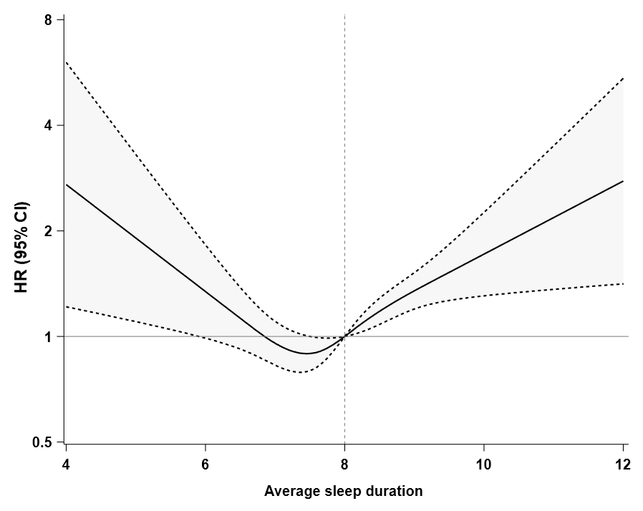
Model adjusted for age, sex, education, smoking status, physical activity, body mass index, hypnotic use, average sleep duration, and comorbidities, p for overall <0.001, p for non-linear=0.0007.
eFigure 3. Associations between social jetlag and risk of psychiatric disease, basic- and multi-adjusted model.

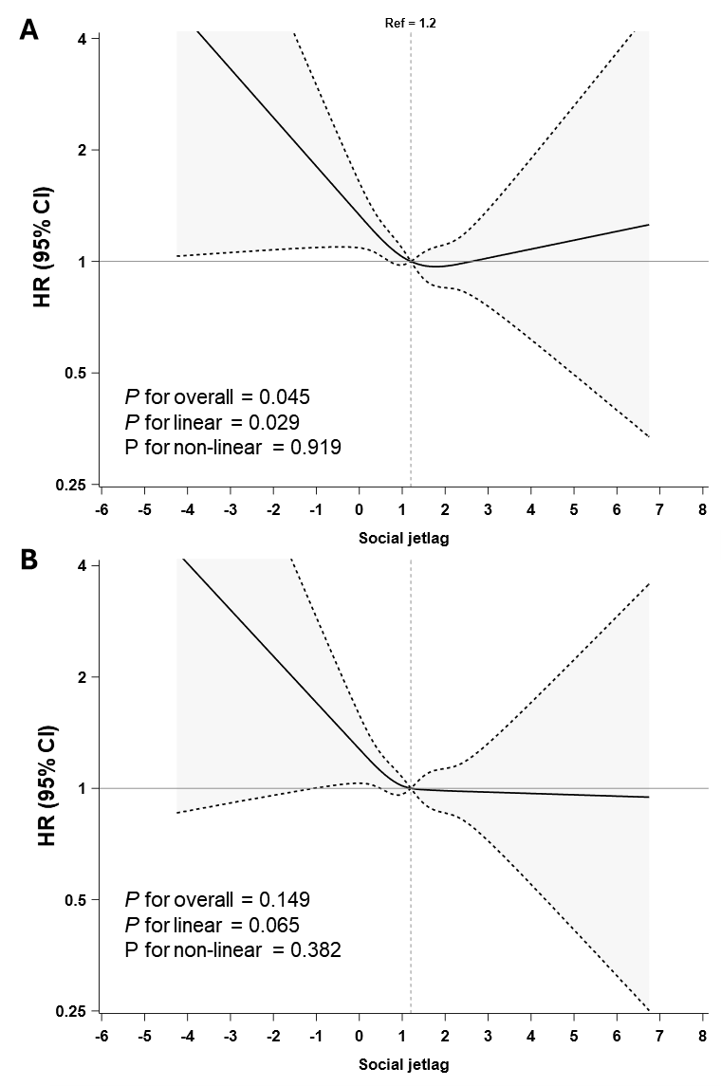
Social jetlag was defined as the difference between the midpoint of sleep on free days and workdays. Hazards ratios with 95% confidence intervals were calculated using Cox regression models with restricted cubic splines. Basic-adjusted model (A) included age, sex, and education. Multi-adjusted model (B) included age, sex, education, smoking status, physical activity, body mass index, hypnotic use, and comorbidities.

eFigure 4. Trajectories of sleep timing on workdays and free days before and after psychiatric diagnosis, by psychiatry disease status.
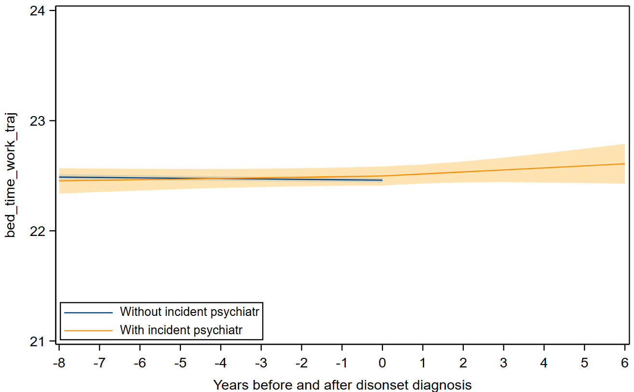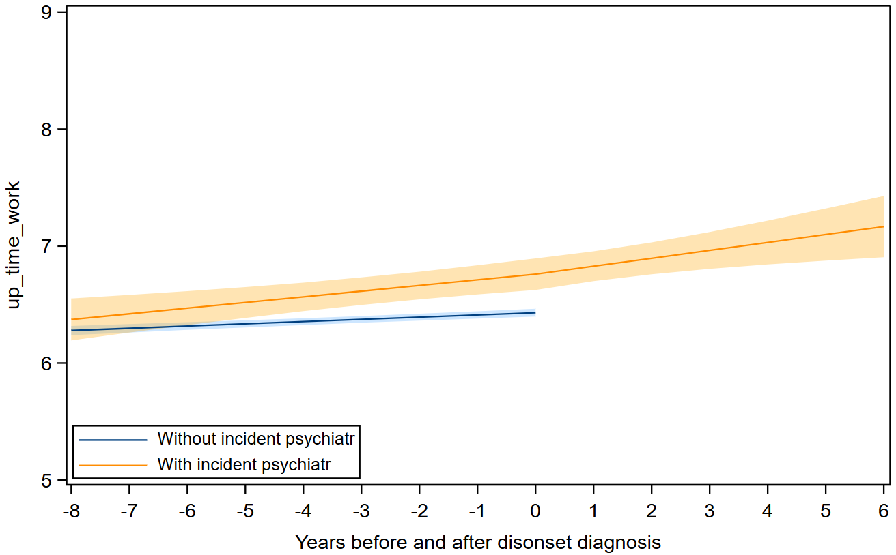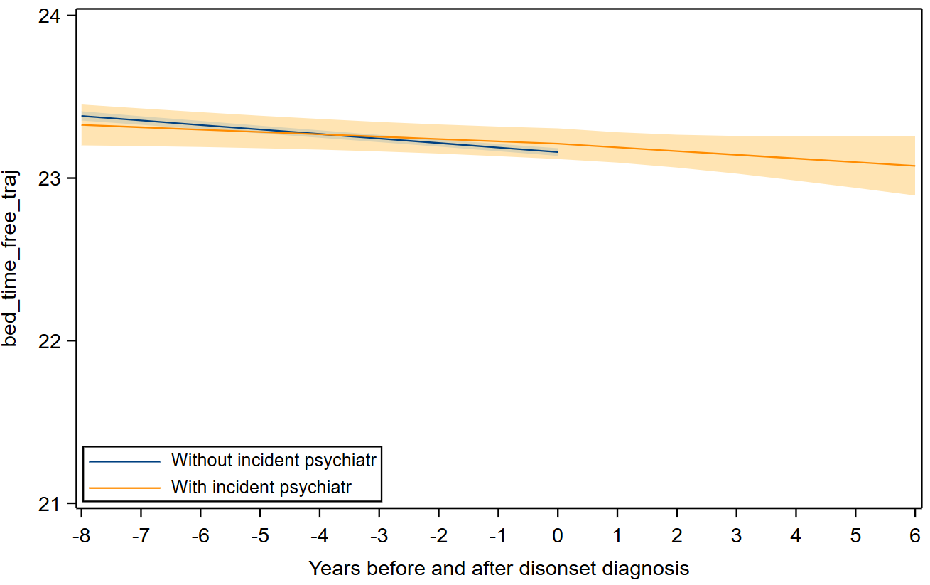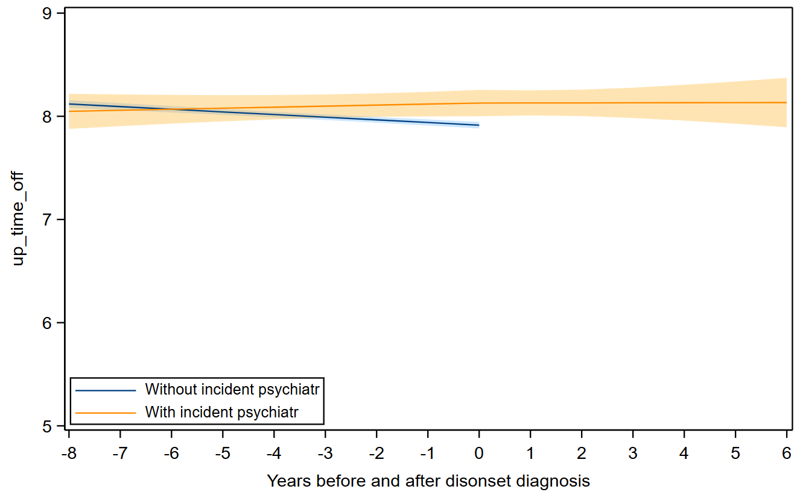
Mean trajectories (solid lines) and 95% confidence intervals (shaded areas) for bed timing and wake-up timing on workdays were predicted by linear mixed-effect models, adjusted for age at time 0, sex, and education. The retrospective timeline captures the eight years prior to psychiatry disease diagnosis or end of follow-up. The prospective timeline captures the six years after the diagnosis. Details about coefficients are presented in eTable 5.

eFigure 5. Trajectories of social jet lag before and after psychiatric diagnosis, by psychiatry disease status.

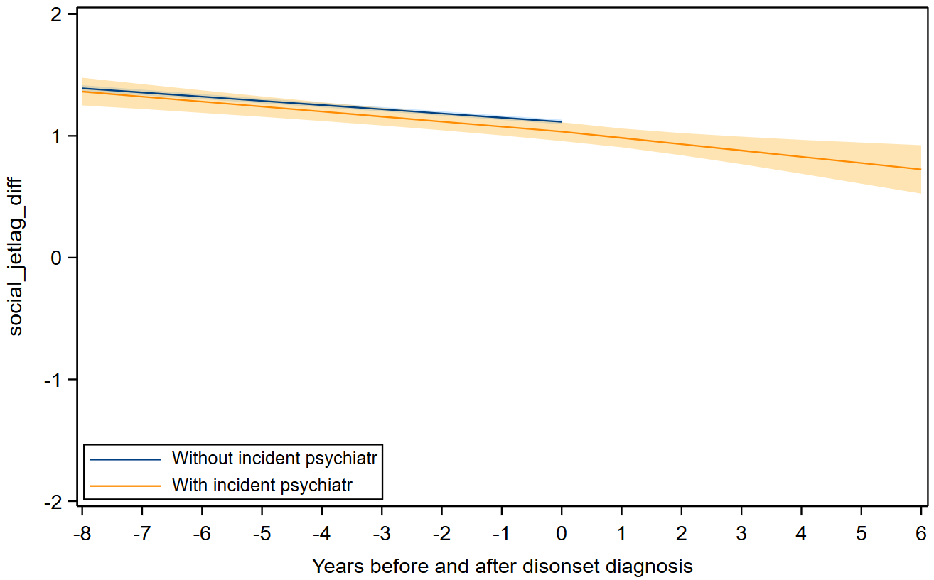
Mean trajectories (solid lines) and 95% confidence intervals (shaded areas) for bed timing and wake-up timing on workdays were predicted by linear mixed-effect models, adjusted for age at time 0, sex, and education. The retrospective timeline captures the eight years prior to psychiatry disease diagnosis or end of follow-up. The prospective timeline captures the six years after the diagnosis. Details about coefficients are presented in eTable 5.

