Electronic cigarette advertising impacts adversely on smoking behaviour within a London student cohort: a cross-sectional structured survey
Online Supplementary File
Ratneswaran C^{1,2,3}, Steier J^{2,3}, Reed K³, Khong TK¹

Figure E1: E-cigarette advertising used within the study, which were currently being used at the time. References are included under the advert, if not within them.

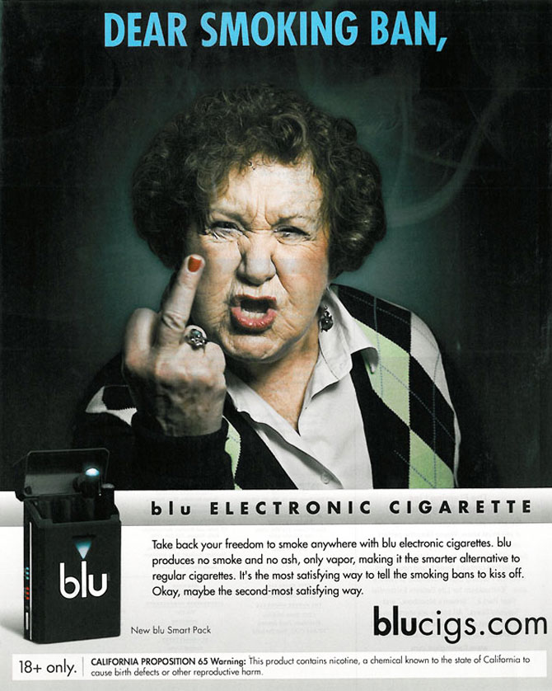

Leolite.com
LeoLite e-cigarette manufacturers


Govype.com
Vype e-cigarette




Njoy.com
E-cigarette manufacturers

Blucigs.com
E-cigarette manufacturers

Figure E2: Awareness of smoking associated consequences: Smokers vs non-smokers (%yes)

Figure E3: Awareness of smoking associated consequences: Vapers vs non-vapers (%yes)

