Supplementary Materials

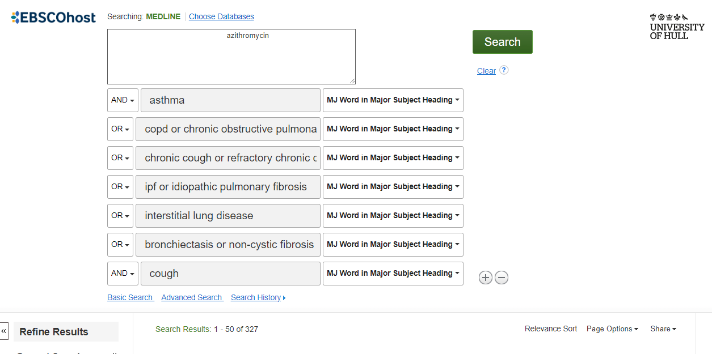
Supplementary Figure 1 – Search strategy and results for MEDLINE database

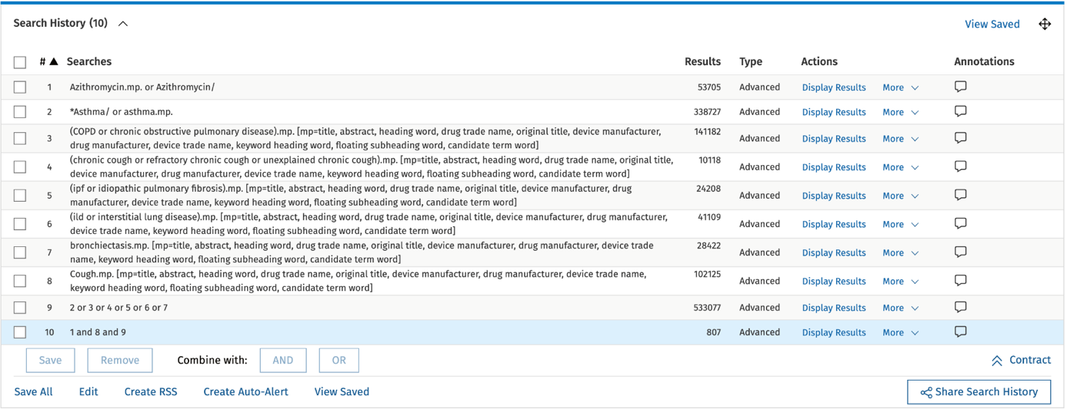
Supplementary Figure 2 – Search strategy and results for EMBASE database

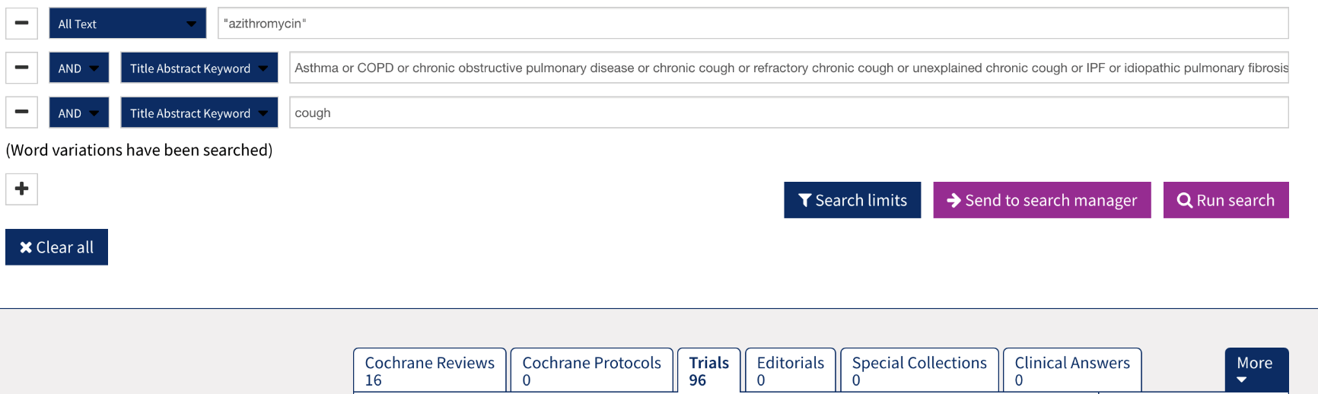

Supplementary Figure 3 – Search strategy and results for CENTRAL database

1 | azithromycin
2 | AND Asthma
3 | OR COPD OR Chronic Obstructive Pulmonary Disease
4 | OR Chronic Cough OR Refractory Chronic Cough
5 | OR IPF OR Idiopathic Pulmonary Fibrosis
6 | OR Interstitial Lung Disease
7 | Or Bronchiectasis OR Non-cystic fibrosis bronchiectasis
8 | AND Cough | 327

1 | azithromycin | 53705
2 | Asthma | 338727
3 | (COPD OR Chronic Obstructive Pulmonary Disease) .mp | 141182
4 | (Chronic Cough OR Refractory Chronic Cough Or Unexplained Chronic Cough) .mp | 10118
5 | ( IPF OR Idiopathic Pulmonary Fibrosis) .mp | 24208
6 | (Interstitial Lung Disease OR ILD) .mp | 41109
7 | Bronchiectasis .mp | 28422
8 | Cough | 102125
9 | 2 OR 3 OR 4 OR 5 OR 6 OR 7 | 533077
10 | 1 AND 8 AND 9 | 807
Supplementary Table 1 – Search strategy and results for MEDLINE database

Supplementary Table 2 – Search strategy and results for EMBASE database

1 | azithromycin
2 | AND Asthma
3 | OR COPD OR Chronic Obstructive Pulmonary Disease
4 | OR Chronic Cough OR Refractory Chronic Cough
5 | OR IPF OR Idiopathic Pulmonary Fibrosis
6 | OR Interstitial Lung Disease OR ILD
7 | Or Bronchiectasis OR Non-cystic fibrosis bronchiectasis
8 | AND Cough | 96

Supplementary Table 3 – Search strategy and results for CENTRAL database

Supplementary Table 4 – ROBINS-I risk of bias assessment for Fraser et al.

ROBINS-I tool (Stage II): For each study

Specify a target randomized trial specific to the study
Design | Non-comparative
Participants | 21
Experimental intervention | 21
Comparator | 0

Is your aim for this study…?
X | to assess the effect of assignment to intervention
 | to assess the effect of starting and adhering to intervention

Specify the outcome
Specify which outcome is being assessed for risk of bias (typically from among those earmarked for the Summary of Findings table). Specify whether this is a proposed benefit or harm of intervention.
24 hour cough count, cough severity VAS, Leicester Cough Questionnaire

Specify the numerical result being assessed
In case of multiple alternative analyses being presented, specify the numeric result (e.g. RR = 1.52 (95% CI 0.83 to 2.77) and/or a reference (e.g. to a table, figure or paragraph) that uniquely defines the result being assessed.
24 hour cough count = 228 vs 81, p=0.002; LCQ 15.96 vs 19.02 p=0.006; Cough Severity VAS = 30.5 vs 19.0 p=0.009

Preliminary consideration of co-interventions
Complete a row for each important co-intervention (i) listed in the review protocol; and (ii) relevant to the setting of this particular study, or which the study authors identified as important.

“Important” co-interventions are those for which, in the context of this study, adjustment is expected to lead to a clinically important change in the estimated effect of the intervention.
(i) Co-interventions listed in the review protocol
Co-intervention | Is there evidence that controlling for this co-intervention was unnecessary (e.g. because it was not administered)? | Is presence of this co-intervention likely to favour outcomes in the experimental intervention or the comparator
Oral Corticosteroids | No | No information
Inhaled Corticosteroids | No | No information
 |  | Favour experimental / Favour comparator / No information
 |  | Favour experimental / Favour comparator / No information

Risk of bias assessment
Responses underlined in green are potential markers for low risk of bias, and responses in red are potential markers for a risk of bias. Where questions relate only to sign posts to other questions, no formatting is used.
 | Signalling questions | Description | Response options
 | 1.1 Is there potential for confounding of the effect of intervention in this study?  If N/PN to 1.1: the study can be considered to be at low risk of bias due to confounding and no further signalling questions need be considered |  | Y
 | If Y/PY to 1.1: determine whether there is a need to assess time-varying confounding:
 | 1.2. Was the analysis based on splitting participants’ follow up time according to intervention received?  If N/PN, answer questions relating to baseline confounding (1.4 to 1.6)  If Y/PY, go to question 1.3. |  | N
 | 1.3. Were intervention discontinuations or switches likely to be related to factors that are prognostic for the outcome?  If N/PN, answer questions relating to baseline confounding (1.4 to 1.6)  If Y/PY, answer questions relating to both baseline and time-varying confounding (1.7 and 1.8) |  | N

 | Questions relating to baseline confounding only
 | 1.4. Did the authors use an appropriate analysis method that controlled for all the important confounding domains? |  | Y
 | 1.5. If Y/PY to 1.4: Were confounding domains that were controlled for measured validly and reliably by the variables available in this study? |  | NA
 | 1.6. Did the authors control for any post-intervention variables that could have been affected by the intervention? |  | NI
 | Questions relating to baseline and time-varying confounding
 | 1.7. Did the authors use an appropriate analysis method that controlled for all the important confounding domains and for time-varying confounding? |  | Y
 | 1.8. If Y/PY to 1.7: Were confounding domains that were controlled for measured validly and reliably by the variables available in this study? |  | N
 | Risk of bias judgement |  | Serious
 | Optional: What is the predicted direction of bias due to confounding? |  | Favours experimental

Bias in selection of participants into the study
 | 2.1. Was selection of participants into the study (or into the analysis) based on participant characteristics observed after the start of intervention?  If N/PN to 2.1: go to 2.4 |  | Y
2.2. If Y/PY to 2.1: Were the post-intervention variables that influenced selection likely to be associated with intervention?
2.3 If Y/PY to 2.2: Were the post-intervention variables that influenced selection likely to be influenced by the outcome or a cause of the outcome?
 | 2.4. Do start of follow-up and start of intervention coincide for most participants? |  | Y
 | 2.5. If Y/PY to 2.2 and 2.3, or N/PN to 2.4: Were adjustment techniques used that are likely to correct for the presence of selection biases? |  | N
 | Risk of bias judgement |  | Moderate
 | Optional: What is the predicted direction of bias due to selection of participants into the study? |  | Favours experimental

Bias in classification of interventions
 | 3.1 Were intervention groups clearly defined? |  | Y
 | 3.2 Was the information used to define intervention groups recorded at the start of the intervention? |  | N
 | 3.3 Could classification of intervention status have been affected by knowledge of the outcome or risk of the outcome? |  | Y
 | Risk of bias judgement |  | Serious
 | Optional: What is the predicted direction of bias due to classification of interventions? |  | Favours experimental

Bias due to deviations from intended interventions
 | If your aim for this study is to assess the effect of assignment to intervention, answer questions 4.1 and 4.2
 | 4.1. Were there deviations from the intended intervention beyond what would be expected in usual practice? |  | N
 | 4.2. If Y/PY to 4.1: Were these deviations from intended intervention unbalanced between groups and likely to have affected the outcome?
 | If your aim for this study is to assess the effect of starting and adhering to intervention, answer questions 4.3 to 4.6
 | 4.3. Were important co-interventions balanced across intervention groups?
 | 4.4. Was the intervention implemented successfully for most participants?
 | 4.5. Did study participants adhere to the assigned intervention regimen?
 | 4.6. If N/PN to 4.3, 4.4 or 4.5: Was an appropriate analysis used to estimate the effect of starting and adhering to the intervention?
 | Risk of bias judgement |  | Moderate
 | Optional: What is the predicted direction of bias due to deviations from the intended interventions? |  | Favours Experiemental

Bias due to missing data
 | 5.1 Were outcome data available for all, or nearly all, participants? |  | Y
 | 5.2 Were participants excluded due to missing data on intervention status? |  | N
 | 5.3 Were participants excluded due to missing data on other variables needed for the analysis? |  | N
 | 5.4 If PN/N to 5.1, or Y/PY to 5.2 or 5.3: Are the proportion of participants and reasons for missing data similar across interventions?
 | 5.5 If PN/N to 5.1, or Y/PY to 5.2 or 5.3: Is there evidence that results were robust to the presence of missing data?
 | Risk of bias judgement |  | Low
 | Optional: What is the predicted direction of bias due to missing data? |  | Unpredictable

Bias in measurement of outcomes
 | 6.1 Could the outcome measure have been influenced by knowledge of the intervention received? |  | Y =
 | 6.2 Were outcome assessors aware of the intervention received by study participants? |  | Y =
 | 6.3 Were the methods of outcome assessment comparable across intervention groups? |  | Y
 | 6.4 Were any systematic errors in measurement of the outcome related to intervention received? |  | N
 | Risk of bias judgement |  | Serious
 | Optional: What is the predicted direction of bias due to measurement of outcomes? |  | Favours experimental

Bias in selection of the reported result
 | Is the reported effect estimate likely to be selected, on the basis of the results, from...
 | 7.1. ... multiple outcome measurements within the outcome domain? |  | Y
 | 7.2 ... multiple analyses of the intervention-outcome relationship? |  | PY
 | 7.3 ... different subgroups? |  | PY
 | Risk of bias judgement |  | Serious
 | Optional: What is the predicted direction of bias due to selection of the reported result? |  | Favours experimental

Overall bias
 | Risk of bias judgement |  | Serious
 | Optional: What is the overall predicted direction of bias for this outcome? |  | Favours experimental

This work is licensed under a Creative Commons Attribution-NonCommercial-NoDerivatives 4.0 International License.

Supplementary Table 5 – ROBINS-I risk of bias assessment for Martin et al.

ROBINS-I tool (Stage II): For each study

Specify a target randomized trial specific to the study
Design | Noncomparative
Participants | 30
Experimental intervention | Azithromycin
Comparator | n/a

Is your aim for this study…?
X | to assess the effect of assignment to intervention
 | to assess the effect of starting and adhering to intervention

Specify the outcome
Specify which outcome is being assessed for risk of bias (typically from among those earmarked for the Summary of Findings table). Specify whether this is a proposed benefit or harm of intervention.
Leicester Cough Questionnaire

Specify the numerical result being assessed
In case of multiple alternative analyses being presented, specify the numeric result (e.g. RR = 1.52 (95% CI 0.83 to 2.77) and/or a reference (e.g. to a table, figure or paragraph) that uniquely defines the result being assessed.
11.5 vs 17.8 p<0.001

Preliminary consideration of co-interventions
Complete a row for each important co-intervention (i) listed in the review protocol; and (ii) relevant to the setting of this particular study, or which the study authors identified as important.

“Important” co-interventions are those for which, in the context of this study, adjustment is expected to lead to a clinically important change in the estimated effect of the intervention.
(i) Co-interventions listed in the review protocol
Co-intervention | Is there evidence that controlling for this co-intervention was unnecessary (e.g. because it was not administered)? | Is presence of this co-intervention likely to favour outcomes in the experimental intervention or the comparator
Inhaled corticodsteroids | No | No information
 |  | Favour experimental / Favour comparator / No information
 |  | Favour experimental / Favour comparator / No information
 |  | Favour experimental / Favour comparator / No information

Risk of bias assessment
Responses underlined in green are potential markers for low risk of bias, and responses in red are potential markers for a risk of bias. Where questions relate only to sign posts to other questions, no formatting is used.
 | Signalling questions | Description | Response options
Bias due to confounding
 | 1.1 Is there potential for confounding of the effect of intervention in this study?  If N/PN to 1.1: the study can be considered to be at low risk of bias due to confounding and no further signalling questions need be considered |  | YY
 | If Y/PY to 1.1: determine whether there is a need to assess time-varying confounding:
 | 1.2. Was the analysis based on splitting participants’ follow up time according to intervention received?  If N/PN, answer questions relating to baseline confounding (1.4 to 1.6)  If Y/PY, go to question 1.3. |  | Y
 | 1.3. Were intervention discontinuations or switches likely to be related to factors that are prognostic for the outcome?  If N/PN, answer questions relating to baseline confounding (1.4 to 1.6)  If Y/PY, answer questions relating to both baseline and time-varying confounding (1.7 and 1.8) |  | Y

 | Questions relating to baseline confounding only
 | 1.4. Did the authors use an appropriate analysis method that controlled for all the important confounding domains? |  | N
 | 1.5. If Y/PY to 1.4: Were confounding domains that were controlled for measured validly and reliably by the variables available in this study? |  | PN
 | 1.6. Did the authors control for any post-intervention variables that could have been affected by the intervention? |  | N
 | Questions relating to baseline and time-varying confounding
 | 1.7. Did the authors use an appropriate analysis method that controlled for all the important confounding domains and for time-varying confounding? |  | PN
 | 1.8. If Y/PY to 1.7: Were confounding domains that were controlled for measured validly and reliably by the variables available in this study?
 | Risk of bias judgement |  | Serious
 | Optional: What is the predicted direction of bias due to confounding? |  | Favours experimental

Bias in selection of participants into the study
 | 2.1. Was selection of participants into the study (or into the analysis) based on participant characteristics observed after the start of intervention?  If N/PN to 2.1: go to 2.4 |  | Y  Y  Y
2.2. If Y/PY to 2.1: Were the post-intervention variables that influenced selection likely to be associated with intervention?
2.3 If Y/PY to 2.2: Were the post-intervention variables that influenced selection likely to be influenced by the outcome or a cause of the outcome?
 | 2.4. Do start of follow-up and start of intervention coincide for most participants? |  | Y
 | 2.5. If Y/PY to 2.2 and 2.3, or N/PN to 2.4: Were adjustment techniques used that are likely to correct for the presence of selection biases? |  | N
 | Risk of bias judgement |  | Serious
 | Optional: What is the predicted direction of bias due to selection of participants into the study? |  | Favours experimental

Bias in classification of interventions
 | 3.1 Were intervention groups clearly defined? |  | Y
 | 3.2 Was the information used to define intervention groups recorded at the start of the intervention? |  | Y
 | 3.3 Could classification of intervention status have been affected by knowledge of the outcome or risk of the outcome? |  | Y
 | Risk of bias judgement |  | Serious
 | Optional: What is the predicted direction of bias due to classification of interventions? |  | Favours Experimental

Bias due to deviations from intended interventions
 | If your aim for this study is to assess the effect of assignment to intervention, answer questions 4.1 and 4.2
 | 4.1. Were there deviations from the intended intervention beyond what would be expected in usual practice? |  | Y
 | 4.2. If Y/PY to 4.1: Were these deviations from intended intervention unbalanced between groups and likely to have affected the outcome? |  | PY
 | If your aim for this study is to assess the effect of starting and adhering to intervention, answer questions 4.3 to 4.6
 | 4.3. Were important co-interventions balanced across intervention groups? |  | Y
 | 4.4. Was the intervention implemented successfully for most participants? |  | Y
 | 4.5. Did study participants adhere to the assigned intervention regimen? |  | PY
 | 4.6. If N/PN to 4.3, 4.4 or 4.5: Was an appropriate analysis used to estimate the effect of starting and adhering to the intervention?
 | Risk of bias judgement |  | Serious
 | Optional: What is the predicted direction of bias due to deviations from the intended interventions? |  | Favours Experimental

Bias due to missing data
 | 5.1 Were outcome data available for all, or nearly all, participants? |  | Y
 | 5.2 Were participants excluded due to missing data on intervention status? |  | N
 | 5.3 Were participants excluded due to missing data on other variables needed for the analysis? |  | N
 | 5.4 If PN/N to 5.1, or Y/PY to 5.2 or 5.3: Are the proportion of participants and reasons for missing data similar across interventions? |  | Y
 | 5.5 If PN/N to 5.1, or Y/PY to 5.2 or 5.3: Is there evidence that results were robust to the presence of missing data? |  | Y
 | Risk of bias judgement |  | Low
 | Optional: What is the predicted direction of bias due to missing data? |  | / Unpredictable

Bias in measurement of outcomes
 | 6.1 Could the outcome measure have been influenced by knowledge of the intervention received? |  | Y
 | 6.2 Were outcome assessors aware of the intervention received by study participants? |  | Y
 | 6.3 Were the methods of outcome assessment comparable across intervention groups? |  | Y
 | 6.4 Were any systematic errors in measurement of the outcome related to intervention received? |  | PN
 | Risk of bias judgement |  | Serious
 | Optional: What is the predicted direction of bias due to measurement of outcomes? |  | Favours experimental

Bias in selection of the reported result
 | Is the reported effect estimate likely to be selected, on the basis of the results, from...
 | 7.1. ... multiple outcome measurements within the outcome domain? |  | PY
 | 7.2 ... multiple analyses of the intervention-outcome relationship? |  | PY
 | 7.3 ... different subgroups? |  | N
 | Risk of bias judgement |  | Serious
 | Optional: What is the predicted direction of bias due to selection of the reported result? |  | Favours Experiemental

Overall bias
 | Risk of bias judgement |  | Seriout
 | Optional: What is the overall predicted direction of bias for this outcome? |  | Favours experimental

This work is licensed under a Creative Commons Attribution-NonCommercial-NoDerivatives 4.0 International License.

