Longitudinal cough frequency monitoring in persistent coughers:
Daily Variability and Predictability

Kian Fan Chung¹*, Carlos Chaccour^{2, 3, 4} , Lola Jover⁵ , Mindaugas Galvosas⁵,
Woo-jung Song⁶, Matthew Rudd^{5, 7}, Peter Small^{5, 8}
¹National Heart and Lung Institute, Imperial College London, London, UK.
² ISGlobal, Barcelona Institute for Global Health, Barcelona, Spain;
³ Clinica Universidad de Navarra, Pamplona, Spain
⁴ Centro de Investigación Biomédica en Red de Enfermedades Infecciosas, Madrid, Spain
⁵ Hyfe, Wilmington, DE, USA;
⁶ Department of Allergy and Clinical Immunology, Asan Medical Center, University of Ulsan College of Medicine, Seoul, South Korea
⁷ University of the South, Sewanee, TN, USA
⁸ University of Washington, Department of Global Health, Seattle, WA, USA and Hyfe

Supplementary data
Supplementary Figure S1
Supplementary Figure S2
Supplementary figure S1:
Flow diagram for inclusion of study subjects from initial pool of users

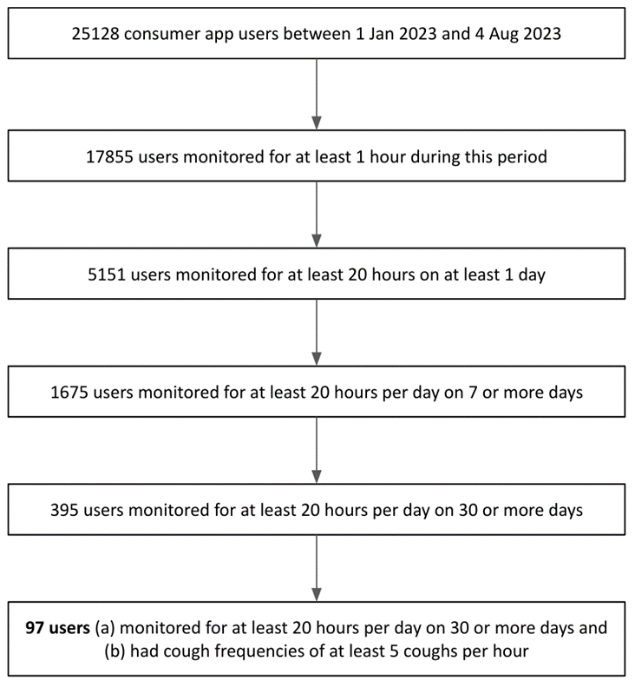

Supplementary Figure S2:

Daily cough frequency time series for all 97 subjects ordered by cough frequency predictability as documented in Figures 1, 2 and 3, from the more predictable to the less predictable. The y axis is coughs per hour and the x-axis represents 30 successive days.

