High Serum IgE is Associated with Risk of Severe Exacerbations among Non-eosinophilic Bronchiectasis
Ting-Wei Kao¹, Ya-Hui Wang², Chia-Ling Chang³, Chau-Chyun Sheu^{4,5}, Ping-Huai Wang⁶, Meng-Heng Hsieh^{7,8}, Wu-Huei Hsu^{9,10,11}, Ming-Tsung Chen¹², Wei-Fan Ou¹³, Yu-Feng Wei^{14,15}, Tsung-Ming Yang¹⁶, Chou-Chin Lan¹⁷, Cheng-Yi Wang^{18,†}, Chih-Bin Lin^{19,20}, Ming-Shian Lin²¹, Yao-Tung Wang^{22,23}, Ching-Hsiung Lin^{24,25,26}, Shih-Feng Liu^{27,28,29}, Meng-Hsuan Cheng^{4,30}, Yen-Fu Chen^{31,32}, Wen-Chien Cheng^{9,11}, Chung-Kan Peng^{12,33}, Ming-Cheng Chan^{34,35}, Ching-Yi Chen³⁶, Lun-Yu Jao²⁰, Chi-Jui Chen¹⁹, Shih-Pin Chen^{22,23}, Yi-Hsuan Tsai^{27,37}, Shih-Lung Cheng⁶, Horng-Chyuan Lin^{7,8,38}, Jung-Yien Chien¹, Hao-Chien Wang^{1,38}; Taiwan Bronchiectasis Research Collaboration (TBARC)
¹ Department of Internal Medicine, National Taiwan University Hospital, National Taiwan University College of Medicine, Taipei, Taiwan
² Medical Research Center, Cardinal Tien Hospital and School of Medicine, College of Medicine, Fu Jen Catholic University, New Taipei City, Taiwan
³ Department of Internal Medicine, National Taiwan University Hospital Hsin-Chu branch, HsinChu, Taiwan
⁴ Division of Pulmonary and Critical Care Medicine, Department of Internal Medicine, Kaohsiung Medical University Hospital, Kaohsiung, Taiwan
⁵ Department of Internal Medicine, School of Medicine, College of Medicine, Kaohsiung Medical University, Kaohsiung, Taiwan
⁶ Division of Thoracic Medicine, Far Eastern Memorial Hospital, New Taipei City, Taiwan
⁷ Department of Thoracic Medicine, Chang Gung Memorial Hospital, Linkou, Taoyuan, Taiwan
⁸ College of Medicine Chang Gung University, Taoyuan, Taiwan
⁹ Division of Pulmonary and Critical Care Medicine, Department of Internal Medicine, China Medical University Hospital, Taichung, Taiwan
¹⁰ Critical Medical Center, China Medical University Hospital, Taichung, Taiwan
¹¹ School of Medicine, College of Medicine, China Medical University, Taichung, Taiwan
¹² Division of Pulmonary and Critical Care Medicine, Department of Internal Medicine, Tri-Service General Hospital, National Defense Medical University, Taipei, Taiwan
¹³ Division of Chest Medicine, Department of Internal Medicine, Taichung Veterans General Hospital, Taichung, Taiwan
¹⁴ School of Medicine for International Students, College of Medicine, I-Shou University, Kaohsiung, Taiwan
¹⁵ Department of Internal Medicine, E-Da Cancer Hospital, I-Shou University, Kaohsiung, Taiwan
¹⁶ Division of Pulmonary and Critical Care Medicine, Chiayi Chang Gung Memorial Hospital, Chiayi, Taiwan
¹⁷ Division of Pulmonary Medicine, Department of Internal Medicine, Taipei Tzu Chi Hospital, Buddhist Tzu Chi Medical Foundation, New Taipei City, Taiwan
¹⁸ Department of Internal Medicine, Cardinal Tien Hospital and School of Medicine, College of Medicine, Fu Jen Catholic University, New Taipei City, Taiwan
¹⁹ Division of Pulmonary Medicine, Department of Internal Medicine, Hualien Tzu Chi Hospital, Buddhist Tzu Chi Medical Foundation, Hualien, Taiwan
²⁰ School of Medicine, Tzu-Chi University, Hualien, Taiwan
²¹ Division of Pulmonary Medicine, Department of Internal Medicine, Chia-Yi Chrisitian Hospital, Chiayi, Taiwan
²² Division of Pulmonary Medicine, Department of Internal Medicine, Chung Shan Medical University Hospital, Taichung, Taiwan
²³ School of Medicine, Chung Shan Medical University, Taichung, Taiwan
²⁴ Department of Internal Medicine, Division of Chest Medicine, Changhua Christian Hospital, Changhua, Taiwan
²⁵ Institute of Genomics and Bioinformatics, National Chung Hsing University, Taichung, Taiwan
²⁶ Ph.D. Program in Translational Medicine, National Chung Hsing University, Taichung, Taiwan
²⁷ Division of Pulmonary & Critical Care Medicine, Department of Internal Medicine, Kaohsiung Chang Gung Memorial Hospital, Kaohsiung, Taiwan
²⁸ Department of Respiratory Therapy, Kaohsiung Chang Gung Memorial Hospital, Kaohsiung, Taiwan
²⁹ College of Medicine, Chang Gung University, Taoyuan, Taiwan
³⁰ Department of Respiratory Therapy, College of Medicine, Kaohsiung Medical University, Kaohsiung, Taiwan
³¹ Department of Internal Medicine, National Taiwan University Hospital, Yunlin Branch, Douliu, Taiwan
³² Thoracic Medicine Center, National Taiwan University Hospital, Yunlin Branch, Douliu, Taiwan
³³ Department of Medicine, Hualien Armed Forces General Hospital, Hualien, Taiwan
³⁴ Department of Critical Care Medicine, Taichung Veterans General Hospital, Taichung, Taiwan
³⁵ School of Post Baccalaureate Medicine, College of Medicine, National Chung Hsing University, Taichung, Taiwan
³⁶ Department of Internal Medicine, E-Da Hospital, I-Shou University, Kaohsiung, Taiwan
³⁷ Department of Pulmonary Medicine, Lee's Clinic, Pingtung, Taiwan
³⁸ Department of Respiratory Therapy, Chang Gung Memorial Hospital, Linkou, Taoyuan, Taiwan
³⁹ Department of Medicine, National Taiwan University Cancer Center, National Taiwan University College of Medicine, Taipei, Taiwan
† Correspondence: Cheng-Yi Wang (cywang@mospital.com)
Contents
Supplementary Table 1. Immunoglobulin E level and eosinophil count in smokers or non-smokers page 5
Supplementary Table 2. Results of pulmonary function testing in high-eosinophil and low-eosinophil groups stratified by IgE level page 6
Supplementary Table 3. Odds ratio of acute exacerbation requiring hospitalization and (B) all-cause mortality in high-eosinophil and low-eosinophil group page 7
Supplementary Table 4. Univariate and multivariate logistic regression analysis for severe acute exacerbation requiring admission in one year after excluding patients administrated with biologics page 8
Supplementary Figure 1. Distribution of eosinophil count in respective to IgE level. page 9
Supplementary Figure 2. Radiographic patterns. Shown are the distribution of lobar involvement, proportion of tree-in-bud pattern, total lobes involved, and modified Reiff score in (A) high-eosinophil and (B) low-eosinophil cohort stratified by IgE level. page 10

Supplementary Table 1. Immunoglobulin E level and eosinophil count in smokers or non-smokers
 | Smoker (N=171) | Non-smoker (N=408) | P
Immunoglobulin E (IU/mL) | 156.3±301.3 | 168.9±339.8 | 0.67
Eosinophil (/uL) | 189.5±0.49 | 173.0±0.50 | < 0.001

Supplementary Table 2. Results of pulmonary function testing in high-eosinophil and low-eosinophil groups stratified by IgE level
 | Entire cohort (N=480) | High-eosinophil group |  |  |  |  | Low-eosinophil group
 | Entire cohort (N=480) | All  (N=66) | IgE ≤ 100 IU/mL (N=40) | 100< IgE ≤ 500 IU/mL (N=14) | IgE > 500 IU/mL  (N=12) | P | All  (N=414) | IgE ≤ 100 IU/mL (N=287) | 100< IgE ≤ 500 IU/mL (N=92) | IgE > 500 IU/mL  (N=35) | P
FEV₁ (L) | 1.54±0.65 | 1.61±0.64 | 1.63±0.66 | 1.62±0.54 | 1.51±0.70 | 0.84 | 1.53±0.65 | 1.53±0.64 | 1.51±0.67 | 1.52±0.69 | 0.94
FEV₁ (%) | 69.6±22.7 | 69.3±23.2 | 70.8±23.7 | 67.9±19.6 | 65.6±26.5 | 0.77 | 69.6±22.7 | 70.3±23.4 | 68.8±19.9 | 66.5±24.1 | 0.60
FVC (L) | 2.15±0.81 | 2.24±0.72 | 2.31±0.77 | 2.23±0.68 | 2.03±0.60 | 0.50 | 2.14±0.83 | 2.14±0.81 | 2.15±0.87 | 2.09±0.86 | 0.93
FVC (%) | 76.6±21.5 | 75.7±21.7 | 79.7±19.9 | 67.5±25.9 | 71.9±20.4 | 0.16 | 76.7±21.5 | 77.1±21.1 | 76.8±22.0 | 73.7±23.7 | 0.68
FEV₁/FVC | 72.7±13.5 | 71.9±13.5 | 71.2±13.6 | 73.1±11.6 | 72.8±16.1 | 0.88 | 72.8±13.5 | 73.4±13.5 | 71.0±13.6 | 73.1±13.2 | 0.32
TLC (L) | 4.82±1.32 | 5.01±1.22 | 5.32±1.21 | 4.84±1.07 | 4.33±1.21 | 0.23 | 4.78±1.34 | 4.90±1.38 | 4.51±1.28 | 4.56±0.98 | 0.33
TLC (%) | 93.7±21.2 | 96.2±22.2 | 96.8±18.4 | 110.4±32.0 | 82.6±17.4 | 0.11 | 93.1±21.1 | 95.3±20.7 | 87.0±21.9 | 91.9±19.8 | 0.17
DLCO (%) | 96.2±40.5 | 88.4±31.5 | 99.9±12.3 | 74.0±22.6 | 73.5±46.5 | 0.27 | 98.1±42.3 | 100.9±47.7 | 85.5±19.6 | 106.0±7.6 | 0.45
FEV₁, forced expiratory volume in one second; FVC, forced vital capacity; IgE, immunoglobulin E; TLC, total lung capacity; DLCO, diffusion capacity of carbon monoxide
Supplementary Table 3. Odds ratio of acute exacerbation requiring hospitalization and (B) all-cause mortality in high-eosinophil and low-eosinophil group
 | Any acute exacerbation admission in one year |  |  | All-cause mortality in one year
 | IgE ≤ 100 IU/mL | 100 < IgE ≤ 500 IU/mL | IgE > 500 IU/mL | IgE ≤ 100 IU/mL | 100 < IgE ≤ 500 IU/mL | IgE > 500 IU/mL
Entire cohort | 0.699 (0.424-1.151) | 0.716 (0.380-1.347) | 3.203 (1.685,6.087) | 0.661 (0.184-2.371) | 0.916 (0.192-4.369) | 2.486 (0.514-12.01)
High-eos cohort | 0.625 (0.215-1.815) | 0.706 (0.215-2.319) | 5.353 (0.658-43.56) | 0.519 (0.069-3.879) | 1.489 (0.145-15.32) | 1.769 (0.171-18.36)
Low-eos cohort | 0.679 (0.218-2.111) | 0.462 (0.140-2.939) | 3.592 (0.947-13.62) | 0.856 (0.155-4.727) | 0.710 (0.082-6.145) | 2.297 (0.262-20.16)
Eos, absolute eosinophil count; IgE, immunoglobulin E
Supplementary Table 4. Univariate and multivariate logistic regression analysis for severe acute exacerbation requiring admission in one year after excluding patients administrated with biologics
 | Univariate analysis |  | Multivariate analysis
 | Odds ratio | P | Odds ratio | P
Age (age) | 0.992 (0.972-1.011) | 0.40 | 1.071 (1.027-1.117) | 0.001
Male | 1.340 (0.826-2.173) | 0.24 | 0.555 (0.158-1.948) | 0.36
Body mass index (kg/m²) | 1.032 (0.972-1.095) | 0.30 | 0.933 (0.829-1.050) | 0.25
Smoking | 1.271 (0.762-2.121) | 0.36 | 0.791 (0.218-2.869) | 0.72
Asthma | 1.311 (0.802-2.142) | 0.28 | 1.230 (0.498-3.037) | 0.65
Chronic obstructive pulmonary disease | 1.750 (1.051-2.914) | 0.03 | 1.993 (0.735-5.410) | 0.18
ICS/LABA | 1.504 (0.903-2.505) | 0.12 | 2.371 (0.960-5.854) | 0.06
Absolute eosinophil count (/uL) | 1.017 (1.013-1.021) | < 0.001 | 1.021 (1.016-1.027) | < 0.001
Immunoglobulin E > 500 IU/mL | 3.341 (1.721-6.488) | < 0.001 | 7.158 (2.243-22.85) | 0.001
ICS, inhaled corticosteroid; LABA, long-acting beta-adrenoceptor agonists
Supplementary Figure 1. Distribution of eosinophil count in respective to IgE level. IgE, immunoglobulin E
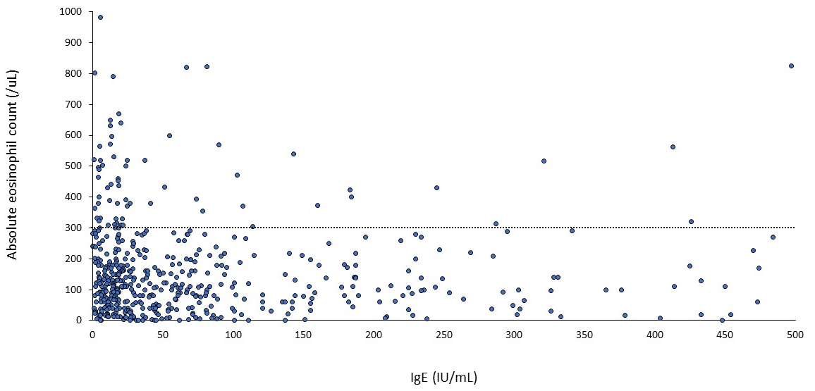

Supplementary Figure 2. Radiographic patterns. Shown are the distribution of lobar involvement, proportion of tree-in-bud pattern, total lobes involved, and modified Reiff score in (A) high-eosinophil and (B) low-eosinophil cohort stratified by IgE level. IgE, immunoglobulin E
