From long-lived batholith construction to giant porphyry copper deposit formation: petrological and zircon chemical evolution of the Quellaveco District, Southern Peru

Chetan L. Nathwani, Adam T. Simmons, Simon J. E. Large, Jamie J. Wilkinson,
Yannick Buret, Christian Ihlenfeld

Supplementary Material 1

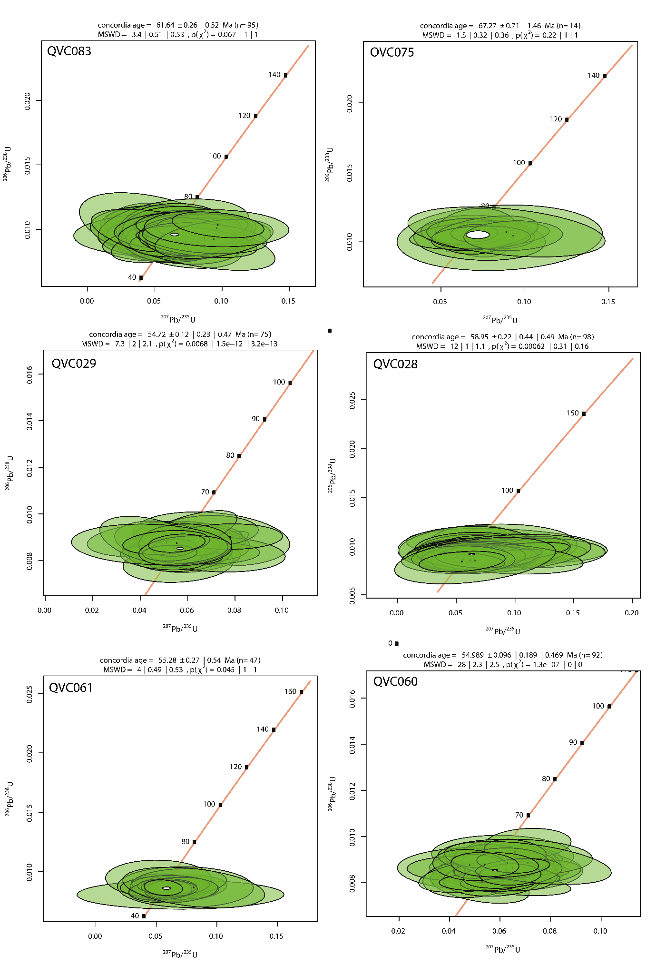
- Geochronology – Concordia plots and ranked weighted mean plots
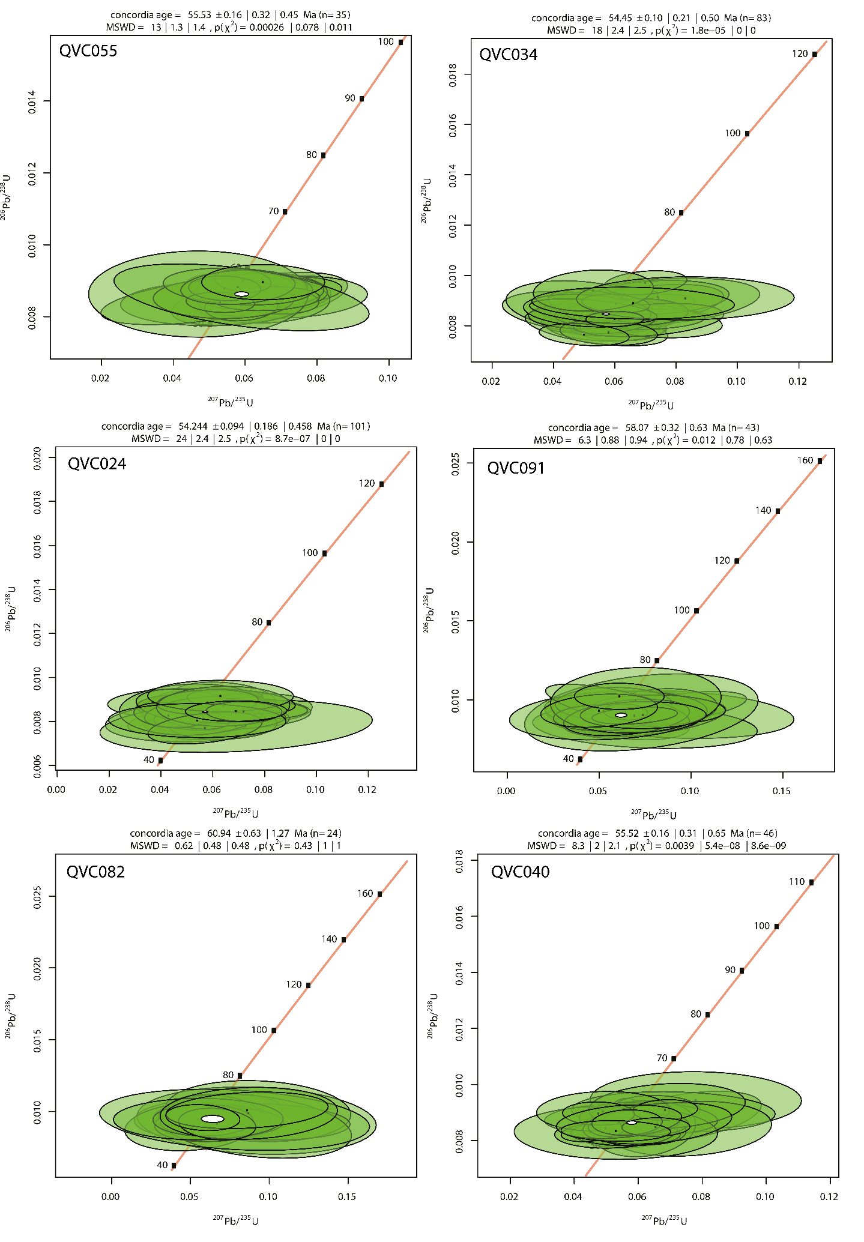
Figure S1: Concordia diagrams for LA-ICP-MS U-Pb data (Vermeesch 2018)
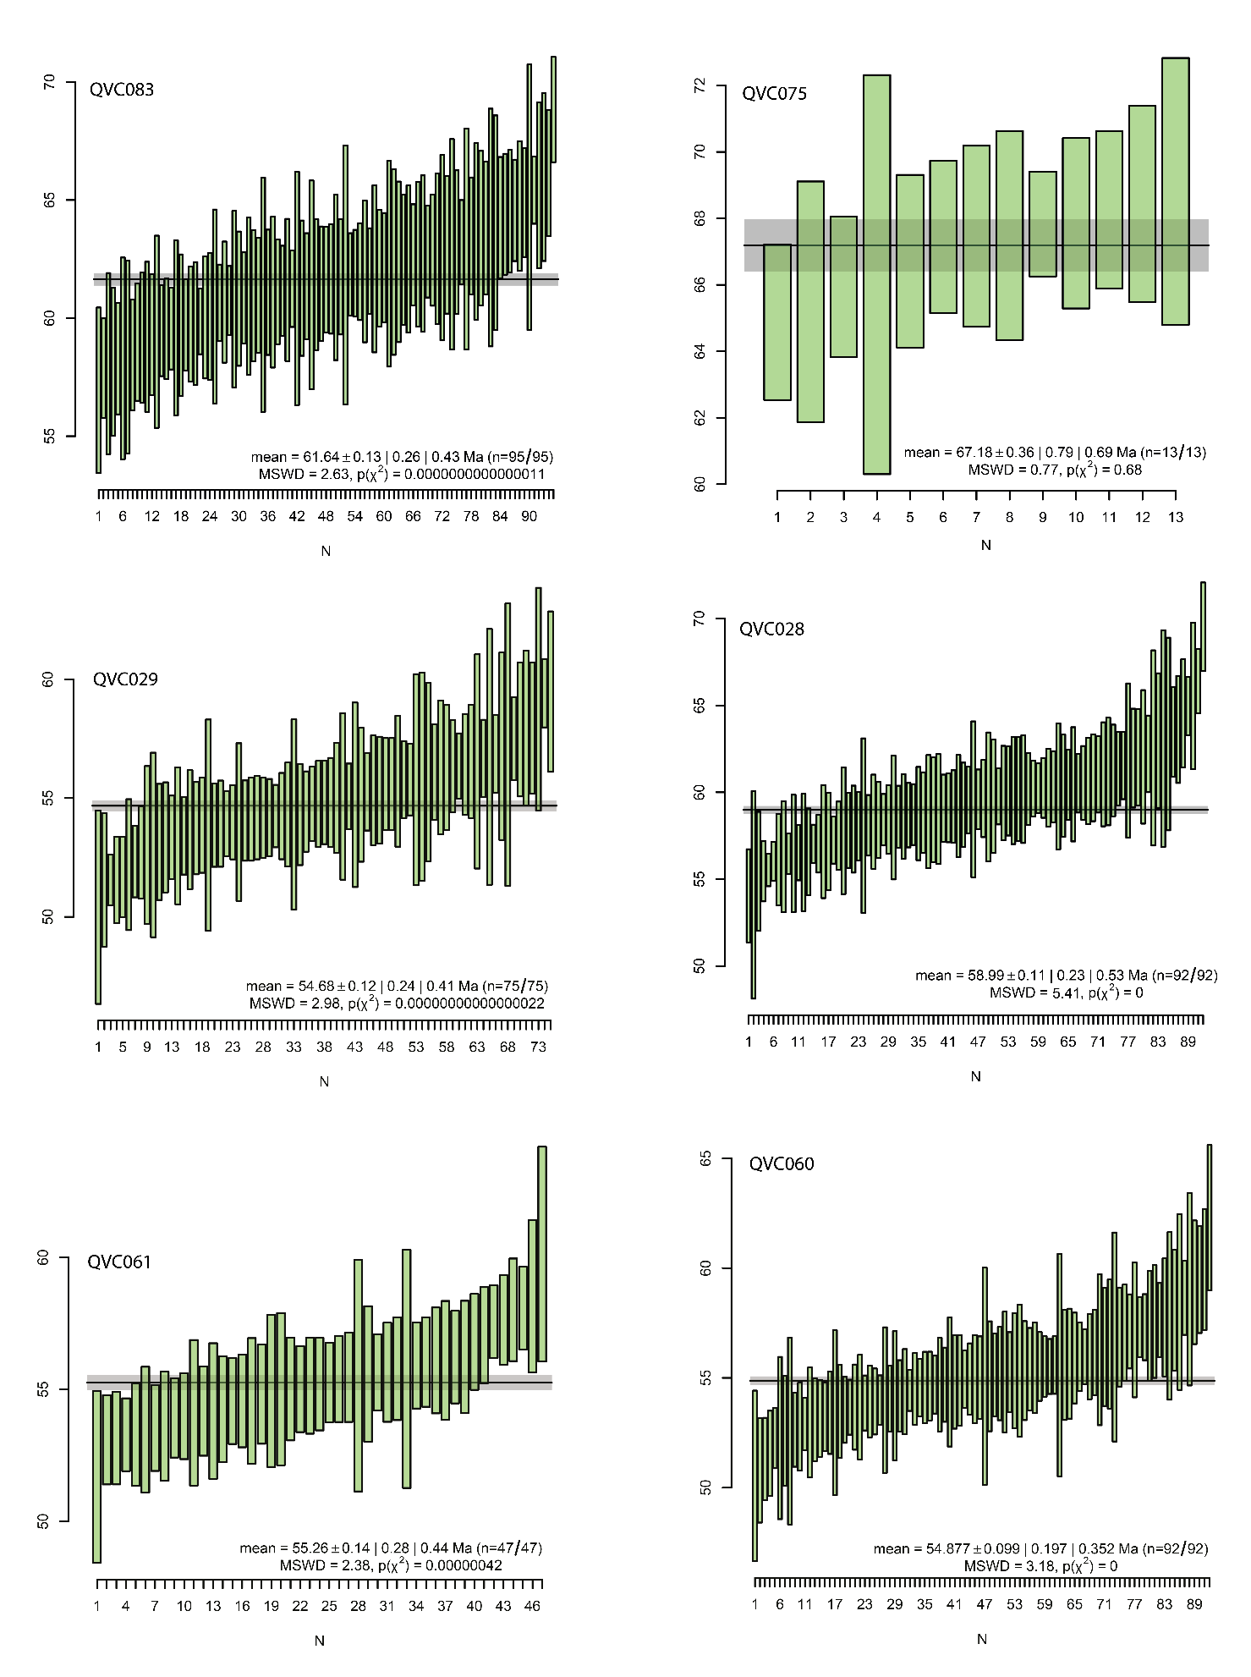
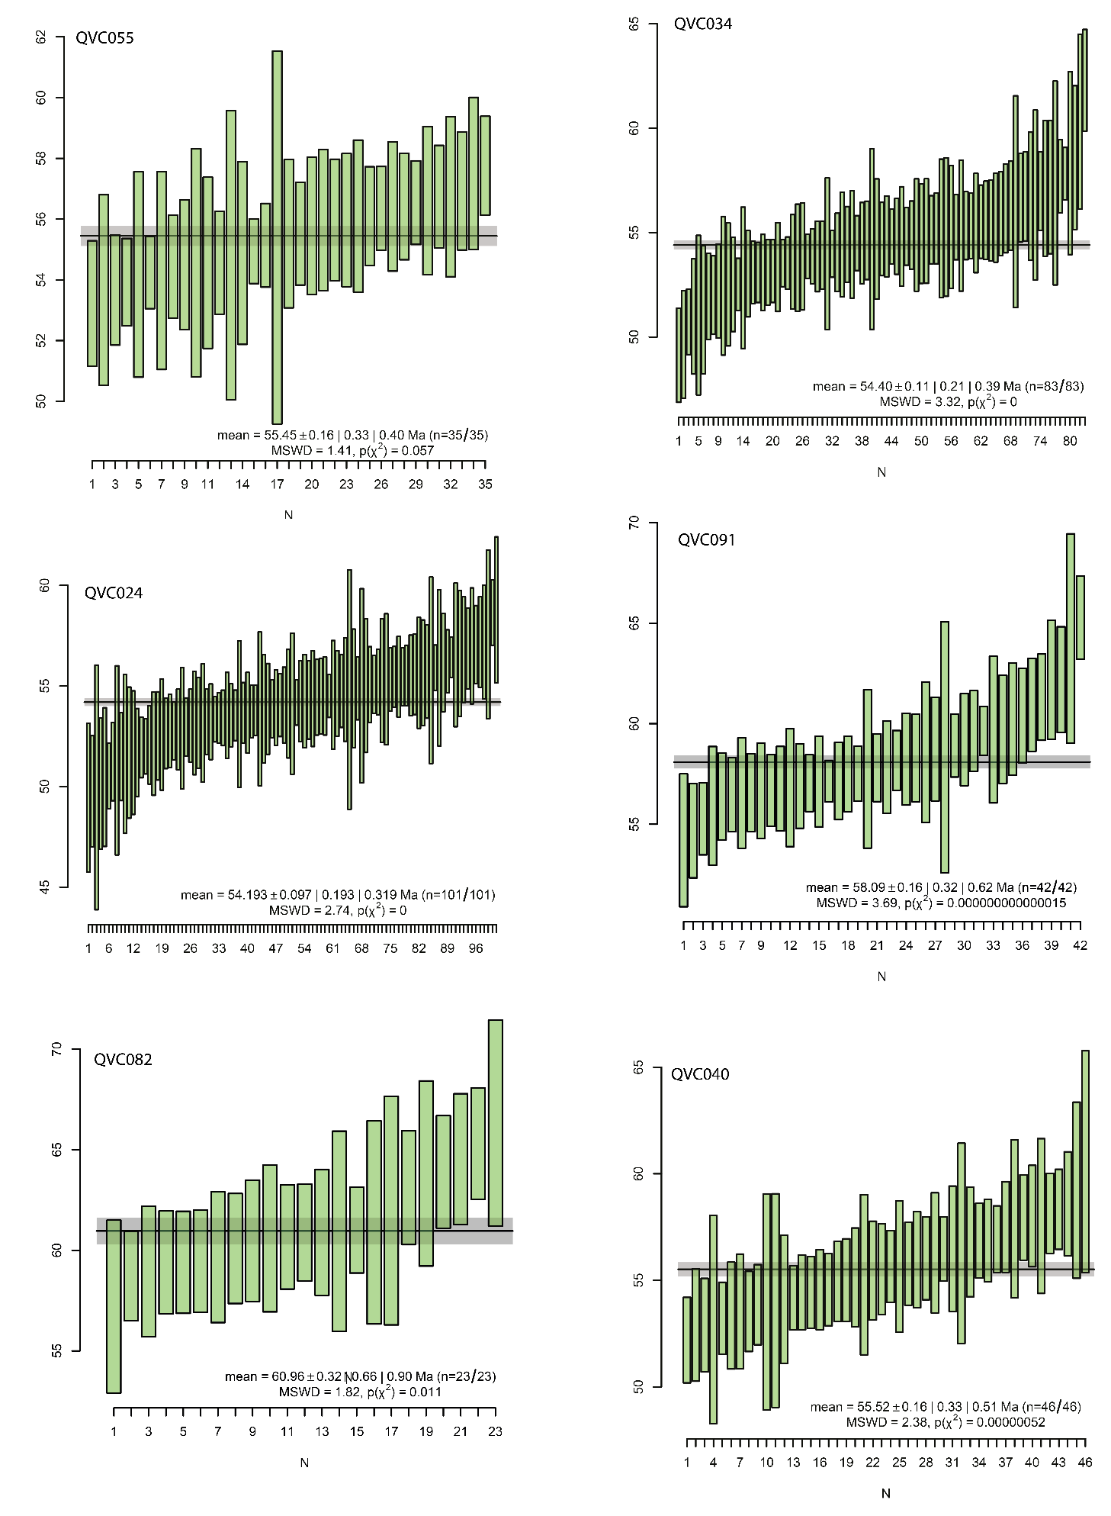
Figure S2: Ranked weighted mean diagrams for LA-ICP-MS U-Pb data

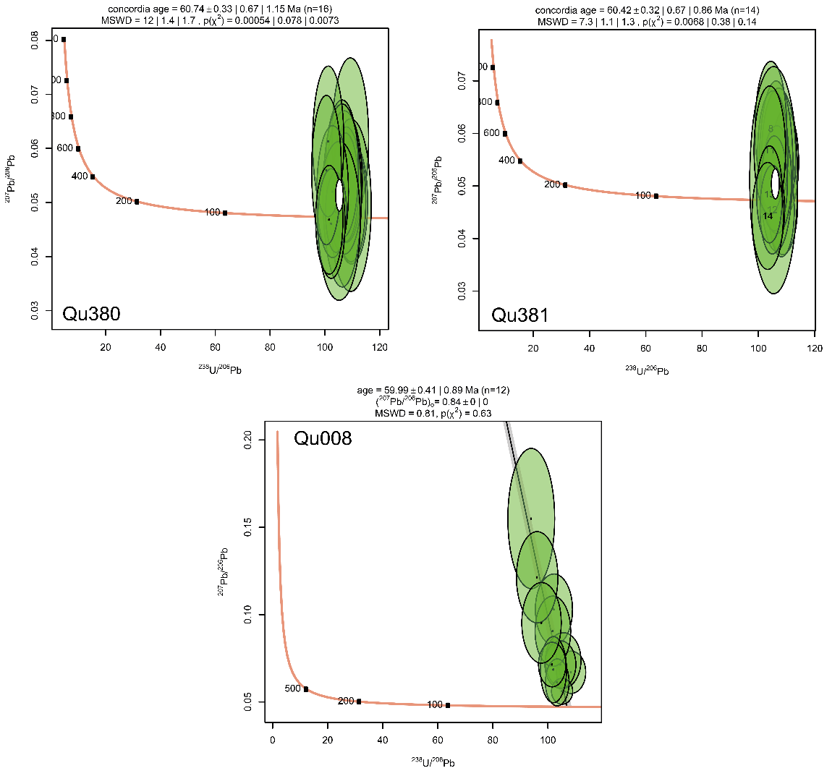
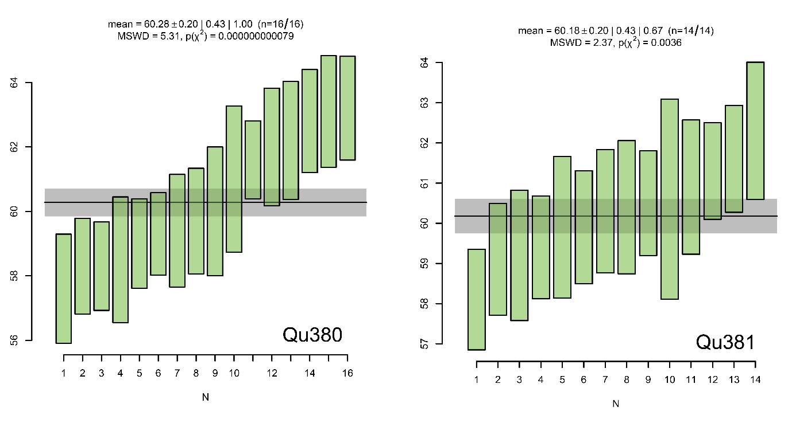
Figure S3: Terra-Wasserburg diagrams for SHRIMP-RG U-Pb data. NB a discordant age was used for Qu008.

Figure S4: Ranked weighted mean diagrams for SHRIMP-RG U-Pb data for Qu380 and Qu381
- SHRIMP-RG Analytical Technique
Three samples were dated by Sensitive High Resolution Ion Microprobe-Reverse Geometry (SHRIMP-RG) at the United States Geological Survey (USGS)-Stanford University facility. Zircons were separated at the Pacific Centre for Isotopic and Geochemical Research (PCIGR) in the Department of Earth and Ocean Sciences, University of British Columbia (UBC). Zircons concentrated by standard heavy mineral separation processes and handpicked for final purity, were mounted on double stick tape on glass slides in 1 x 6 mm rows, cast in epoxy, ground and polished to a 1 micron finish on a 25 mm diameter by 4 mm thick disc. All grains were imaged with cathodoluminescence on a JEOL 5600 SEM to identify internal structure, inclusions and physical defects. The mounted grains were washed with a saturated EDTA solution and thoroughly rinsed in distilled water, dried in a vacuum oven, and coated with Au. Mounts sat in a loading chamber at high pressure (10⁻⁷ torr) for several hours before being moved into the source chamber of the SHRIMP-RG.
Secondary ions were generated from the target spot with an O₂⁻ primary ion beam varying from 4-6 nA. The primary ion beam typically produces a spot with a diameter of 20-40 microns and a depth of 1-2 microns for an analysis time of 9-12 minutes. The acquisition routine began with the high mass normalizing species (⁹⁰Zr₂¹⁶O⁺), followed by ²⁰⁴Pb⁺, a background measured at 0.050 mass units above ²⁰⁴Pb⁺, ²⁰⁶Pb⁺, ²⁰⁷Pb⁺, ²⁰⁸Pb⁺, ²³⁸U⁺, ²³²Th¹⁶O⁺ and ²³⁸U¹⁶O⁺ and ²³²Th⁺. Peak centering on both ubiquitous species and on guide peaks adjacent to low-abundance or interference-prone species were used to eliminate any potential effects of magnet drift or peak wandering. The number of scans through the mass sequence and counting times on each peak were varied according to the sample age and the U and Th concentrations to improve counting statistics and age precision. Measurements were made at mass resolutions of M/ΔM =~8500 (10% peak height), which eliminates all interfering molecular species.
Dates were standardized against R33 (419 Ma, quartz diorite of Braintree complex, Vermont; Black et al, 2004). Data reduction for geochronology follows the methods described by Williams (1997), and Ireland & Williams (2003), and uses IsoplotR (Vermeesch 2018). Average count rates of each element of interest are ratioed to the appropriate high mass normalizing species (⁹⁰Zr₂¹⁶O⁺) to account for any primary current drift, and the derived ratios for the unknowns are compared to an average of those for the standards to determine concentrations. The data were plotted on Terra-Wasserburg plots where discordant dates (e.g. Pb loss) were excluded, with the exception of one sample (Qu-008) were few concordant dates were returned, hence a discordia date was determined (Fig. S3 and Fig. 4).
- Overdispersion of dates
For some samples, the mean square of weighted deviation (MSWD) is significantly greater than 1. An MSWD >> 1 indicates that data are overdispersed based on the uncertainties. This can either be the result of underestimating the uncertainty on each data point, or due to geological reasons such as protracted zircon crystallisation or mixing of multiple populations of dates. On the weighted mean plots (Fig. S2), there is no clear evidence of multiple age populations. The dispersion of the data (the spread in dates that could be account to geological reasons) typically ranges from 1-2 Myr which is greater than which would be expected for a single population of zircon crystals.
In order to investigate the effect that underestimating uncertainty may have on our results, we developed a model to inflate the dates by a constant uncertainty value until the MSWD reached an acceptable value. This additional uncertainty is then used to re-calculate the weighted mean date and standard error. This was done for four samples with high MSWD (Table S8) and new weighted mean dates and errors did not deviate outside of the originally reported dates and uncertainties. This is because systematically changing the error on each measurement will not greatly affect the weighted mean or standard error.
Table S8: Recalculated weighted mean dates for four samples where each date has been inflated to give an acceptable MSWD
Sample | Weighted mean | 2σ abs | + 2% external uncertainty | MSWD | Dispersion (Myr) | Expected MSWD | Required added uncertainty (2σ) | New weighted mean | 2σ abs
QVC028 | 58.99 | 0.23 | 1.2 | 5.41 | 2.20 | 1.29 | 1.75 | 59.20 | 0.48
QVC029 | 54.68 | 0.24 | 1.12 | 2.98 | 1.34 | 1.33 | 1.6 | 54.69 | 0.35
QVC034 | 54.40 | 0.21 | 1.11 | 3.32 | 1.78 | 1.30 | 2.9 | 54.62 | 0.39
QVC040 | 55.52 | 0.33 | 1.16 | 2.38 | 1.10 | 1.46 | 1.06 | 55.23 | 0.49

- Comparison of the analytical techniques
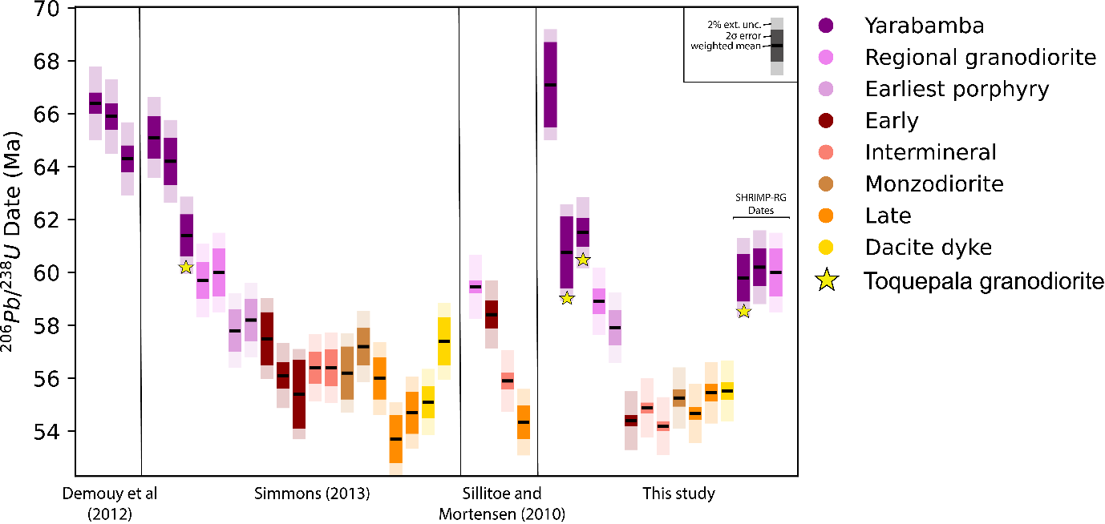

Figure S5. Bar plot comparing zircon U-Pb weighted mean dates for the Quellaveco District from this study compared to other studies – Demouy et al. (2012) – LA-ICP-MS, Simmons (2013) – SHRIMP-RG and Sillitoe and Mortensen – LA-ICP-MS. The data from Simmons (2013) was collected using the same procedure as the SHRIMP-RG data in this study. Stars indicate analyses of the Yarabamba Batholith that are derived from the granodiorite pluton cropping out in and in the vicinity of Toquepala (Fig. 1) to allow comparison between the techniques – these all overlap within the propagated 2% external uncertainty. Other comparable units (each porphyry intrusion) also overlap with the exception of inconsistency of dates for the Early Porphyry (as seen for the single sampled dated by Sillitoe and Mortensen (2010) which does not overlap with that from this study. As discussed in the text, this is expected to be due to Sillitoe and Mortensen sampling an older intrusive unit – likely the granodiorite porphyry which exists as xenoliths within the early porphyry.
- Assessing the effect of alteration on whole-rock chemical signatures
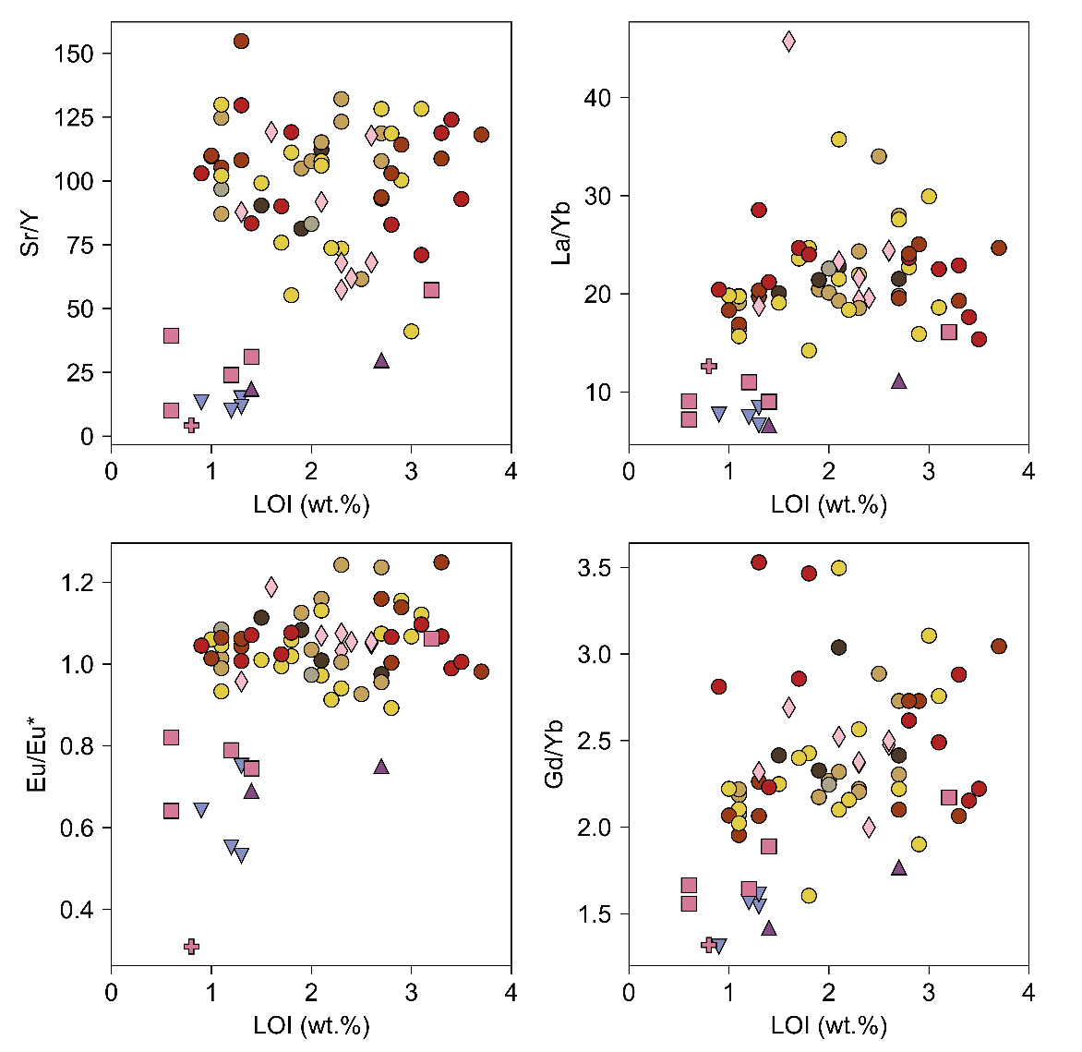
The rocks studied here have undergone varying degrees of hydrothermal alteration, ranging from low temperature chlorite-epidote alteration, to high temperature potassic alteration within the Quellaveco magmatic-hydrothermal system. Therefore, the possibility that hydrothermal alteration may influence the geochemical ratios used in this studied must be evaluated. No clear effect of alteration on Eu/Eu*, La/Yb and Gd/Yb is visible (based on using LOI as a proxy for alteration; Fig. S5). However, with increasing alteration a decrease in Sr/Y is visible because Sr values decrease with increasing LOI. In spite of this, the decrease in Sr/Y for the Quellaveco samples is insufficient to produce the lower Sr/Y values found in the early Yarabamba rocks. Hence while alteration influences Sr/Y values, the effect is minor compared to the difference in Sr/Y produced by petrogenetic processes.
Figure S5. Plots of whole-rock Sr/Y, La/Yb, Eu/Eu* and Gd/Yb vs. loss on ignition (LOI).

- Modelling Eu anomalies in zircon using a Monte Carlo approach
A Monte Carlo approach is adopted to calculate theoretical values for Eu/Eu* as a function of melt Eu/Eu* and melt fO₂. The concentration of an element in zircon can be calculated by:
$C_{zircon}=D_{zircon/melt} ×C_{melt}$ (S1)
Where C_{zircon} and C_{melt} is the concentration of an element in zircon and the melt respectively, and $D_{zircon/melt}$ is the partition coefficient for that element into zircon. For Eu, the partition coefficient (D_{Eu}) can be determined based of the partition coefficient of Eu²⁺ (D_{Eu}²⁺) and Eu³⁺ (D_{Eu}³⁺) and the Eu valence state of the melt ((Eu²⁺/Eu³⁺)_{melt}):
$D_{Eu(min)}= \frac{D_{{Eu}^{3+} }+{((\frac{{Eu}^{2+}}{{Eu}^{3+}})}_{melt}× D_{{Eu}^{2+} })}{{(\frac{{Eu}^{2+}}{{Eu}^{3+}})}_{melt}+1}$ (1)
This equation is simplified for zircon since D_{Eu}²⁺ is approximately equal to 0. The value of D_{Eu}³⁺, D_{Sm} and D_{Gd} (D_{i}) can be calculated using lattice strain theory (Blundy and Wood 1994):
$$D_{i}=D_{0}exp⁡\left(\frac{-4πE_{M}N_{A}{(\frac{r_{0}}{2}(r_{0}-r_{i})}^{2}- \frac{1}{3}{\left(r_{0}-r_{i}\right)}^{3})}{RT}\right)$$
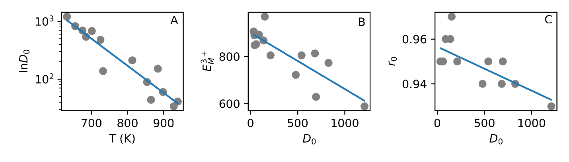
Where D₀ is the partition coefficient for a fictive element with radius r_{o} (radius of the site), N_{A} is Avogadro’s number, E_{M} is the effective Young’s modulus of the site, r_{i} is the radius of i, R is the gas constant and T is temperature. The fit parameters (E_{M}, r₀ and D₀) in the lattice strain equation are compiled from the literature (Claiborne et al. 2018). The values for D_{O} (and less strongly E_{M}) are expected to be sensitive to temperature. Furthermore, increasing concentrations of REE in zircon (i.e. increasing D₀) tends to weaken the structure of zircon (lower E_{M} and lower r₀) allowing parameterisation of these parameters (Claiborne et al. 2018; Burnham 2020). This allows partition coefficients to be calculated in the model as a function
Figure S5: Compilation of fit parameters to the lattice strain equations based on analyses of Claiborne et al. (2018). Equations of lines of best fit are used in the zircon Eu/Eu* model.

of temperature.
The value of (Eu²⁺/Eu³⁺)_{melt} is dependent on temperature, fO₂ and melt composition. Experimental calibration gives the relationship of Eu valence in melts as (Burnham et al., 2015):
$\frac{{Eu}^{3+}}{ΣEu}= \frac{1}{1+ {10}^{-0.25log{fO}_{2}-\frac{6410}{T}-14.2Λ+10.1}}$ (S2)
Where T is temperature in Kelvin and Λ is the optical basicity. For each parameter used in calculations in the model, an array of random uniform distributed values was generated using a determined range in these parameters (Table S9). In each iteration of the Monte Carlo model, the model randomly selects a value for each parameter from these arrays. The simulations were run using an in-house code written in Python (code available as a Jupyter notebook Supplementary Material 3).
Table S9: Ranges of values used for parameters in the Monte Carlo simulation shown in Fig. 11
Parameter | Min | Max | Source
Temperature | 700℃ | 890℃ | Zircon saturation temperatures and pMELTS
Optical Basicity | 0.54 | 0.60 | Experiments from Marxer and Ulmer (2019); Duffey (1993)
Melt composition | 0.1 | 1.2 | Whole-rock compositions (for max) and GEOROC melt inclusions (min)
Oxygen fugacity (fO₂) | FMQ | FMQ+3 | Carmichael (1991)
Partition coefficients | See Fig. S5 |  | Claiborne et al. (2018)

- Relationship between temperature and optical basicity
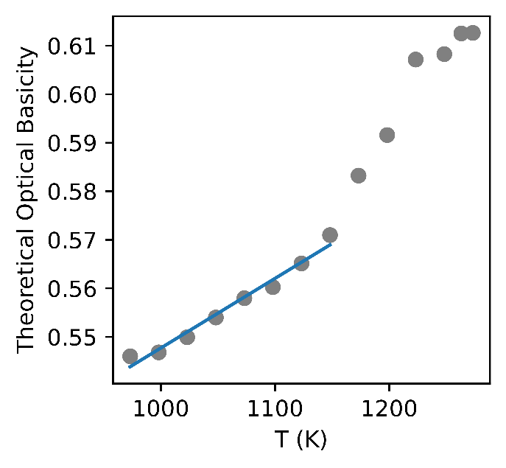
In melts, temperature and optical basicity would be expected to co-vary, since more evolved arc melts generally have lower optical basicity (e.g. Tang et al. 2018). To establish a general relationship, a theoretical optical basicity was calculated (Duffy 1993) for experimental melts appropriate for arc magmas in the shallow crust (Marxer and Ulmer 2019).
Figure S6: Empirical relationship between theoretical optical basicity (Duffey 1993) and melt temperature based on the experiments of Marxer and Ulmer (2019). Regression is fit based on only experimental runs that are within the temperature range appropriate to this model (less than 890°C).
- The effect of other parameters on zircon Eu/Eu*
Our model indicates that there is a strong relationship between melt Eu/Eu* and zircon Eu/Eu*. However, there are other variables that can influence zircon Eu/Eu*, which can be isolated in the model in order to interrogate the magnitude of their influence on natural zircon Eu/Eu*. The model was re-run four times (for temperature, melt Eu/Eu*, fO₂ and optical basicity) where the investigated variable was fully varied and all other variables kept fixed at their mean value (Fig. S7, Table S10).
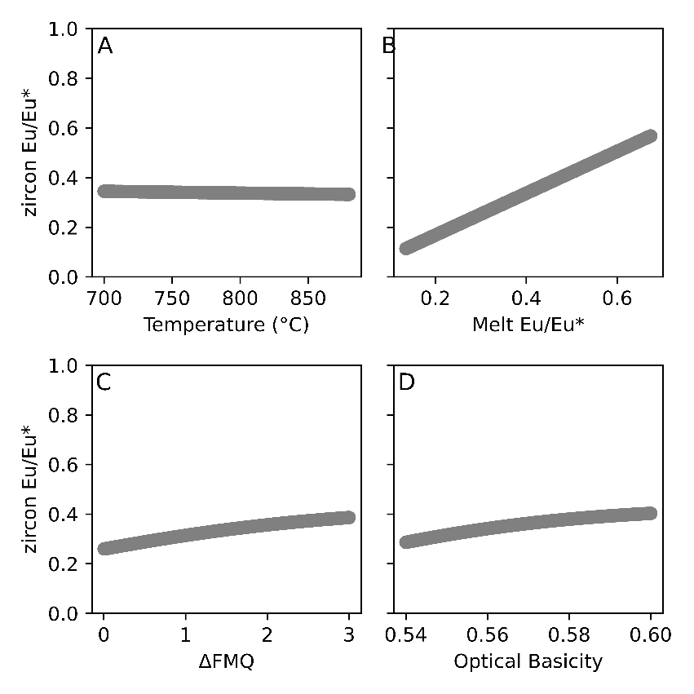
Figure S7. Runs of the model where the effects of (A) Temperature (700-890°C), (B) Melt Eu/Eu* (0.13-0.70) (C) fO₂ (FMQ-FMQ+3) and (D) optical basicity (0.54-0.60) are isolated illustrating their effect on zircon Eu/Eu*. In each model, all other parameters are kept fixed at a mean value.
Table S10: Parameter ranges used for each run in the sensitivity analysis shown in Fig. S7 and on Fig. 11.
Parameter | Min | Max | Source
Temperature | 700℃ | 890℃ | Zircon saturation temperatures and pMELTS
Optical Basicity | 0.54 | 0.60 | Experiments from Marxer and Ulmer (2019); Duffey (1993)
Eu/Eu*_{melt} | 0.13 (5th percentile of modelled melt Eu/Eu* for Yarabamba monzonite) | 0.70 (95th percentile of modelled melt Eu/Eu* for Quellaveco porphyry) | Modelled Eu/Eu*_{melt} for all rocks in this study.
Oxygen fugacity (fO₂) | FMQ | FMQ+3 | Carmichael (1991)

On a log fO₂ vs temperature graph, the slope of the FMQ redox buffer curve and Fe²⁺/Fe³⁺ contours are steeper than the contours of Eu²⁺/Eu³⁺ (Wilke and Behrens 1999), so increasing temperature would cause a decrease in (Eu²⁺/Eu³⁺)_{melt} and therefore more Eu would substitute into zircon. Thermal dilation of the crystal lattice has a large effect on increasing D_{(zircon/melt)} for large misfit ions such as Eu³⁺ (Loucks et al. 2018), meaning that more Eu can substitute into the lattice has low temperature. Running both models whilst keeping other parameters fixed and assessing the effect of temperature on zircon Eu/Eu* shows negligible effect (Fig. S6A). This is because decreasing temperature does not strongly influence the Eu valence state in the melt because lower temperature is coupled with a lower optical basicity (as expected during melt evolution), and these inversely influence the Eu valence of the melt (Equation S5). Furthermore, Sm and Gd would have a similar misfit into the zircon structure and would similarly substitute more into the lattice at lower temperatures, thus temperature would do little to modify Eu concentrations in zircon relative to Sm and Gd. This lack of temperature dependence on zircon Eu/Eu* is consistent with experimental studies that synthesised zircons under a range of temperatures and found no temperature control on zircon Eu/Eu* (Trail et al. 2012).

