SUPPLEMENTARY MATERIAL

Using the elastic properties of zircon-garnet host-inclusion pairs for thermobarometry of the Ultrahigh Pressure Dora-Maira whitescists: problems and perspectives.
Nicola Campomenosi¹, Marco Scambelluri¹, Ross J. Angel², Joerg Hermann³, Mattia L. Mazzucchelli^{4,5}, Boriana Mihailova⁶, Francesca Piccoli³ and Matteo Alvaro⁵
¹Department of Earth Science, Environment & Life, University of Genova, Corso Europa 26, I-16132 Genova, Italy.
²IGG-CNR, Via G. Gradenigo 6, I-35131 Padova, Italy.
³Institute of Geological Sciences, University of Bern, Baltzerstrasse 1+3, CH-3012 Bern, Switzerland
⁴Mainz Institute of Multiscale Modeling & Institute of Geosciences, Johannes-Gutenberg University of Mainz, J. J. Becher-Weg 21, D-55128 Mainz, Germany.
⁵Department of Earth and Environmental Sciences, University of Pavia, Via A. Ferrata 1, I-27100 Pavia, Italy.
⁶Department of Earth Sciences, University of Hamburg, Grindelallee 48, D-20146 Hamburg, Germany.

S.1 Pseudosection modelling of whiteschists

The presence of garnet megablasts in the rock complicates the estimation of the bulk chemistry for pseudosection modelling. In section 3 of the main text, we described how changes in the garnet mode proportion are usually related to differences in the bulk chemistry of the rock. Therefore, the first step is to understand how changes in the bulk chemical composition affect calculated mineral assemblages, garnet chemical composition and mode proportion. The following activity-composition relationships of solid solutions were used for pseudosection modeling: Gt(HP) for garnet, Pheng(HP) for white mica, Carp for carpholite, Ctd(HP) for chloritoid (Holland and Powell, 1998) Bio(HP) for biotite (Holland and Powell 1999), Opx(HP) for orthopyroxene (Powell and Holland, 1999), and Chl(HP) for chlorite (Holland et al. 1998). Quartz, coesite, talc and kyanite have been considered as pure phases. The CORK EoS has been used for the fluid phase (Holland and Powell, 1991). Garnet isopleths and mode abundance have been calculated using the Werami program included in Perple_X.
Figure S1 shows an isobaric T vs X_{bulk} (wt%) diagram with associated modal proportions and chemical compositions of garnet in terms of pyrope molar fraction. The compositional “end-members” for this calculation are the bulk chemistries of SiO₂-rich and SiO₂-poor whiteschists by Gautiez-Putallaz et al. 2016 (expressed in terms of SiO₂ wt% on the x axis see Fig. S1).

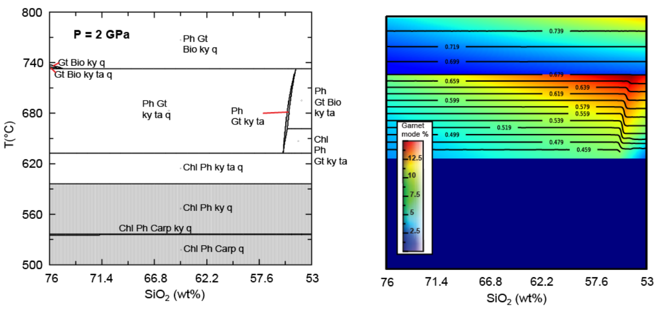
Figure S.1. Isobaric T vs X_{bulk} (wt%) pseudosection of whiteschists. Black thin lines are the garnet isopleths in terms of pyrope mole fraction. The rainbow colours represent the garnet modal abundance as given by the legend. Bulk chemistry for SiO₂ rich whiteschists is: 76 wt% SiO₂, 13 wt% Al₂O₃, 1.75 wt% FeO, 7 wt% MgO, 3 wt% K₂O with water in excess. Bulk chemistry for the SiO₂-poor whiteschists is: 53 wt% SiO₂, 26 wt% Al₂O₃, 3.5 wt% FeO, 14 wt% MgO, 6.6 wt% K₂O with water in excess.

The major effect that SiO₂ wt% variation has on the mineral assemblages is the appearance of biotite solid solution (Bio in Figure S.1) at lower SiO₂ concentration. This is an important feature since we found biotite as an inclusion within the garnet megablasts and never found it within the small garnets that, indeed, belong to the SiO₂-rich whiteschist composition. Furthermore, the abundance of SiO₂ does not influence the chemical composition of garnet (mainly controlled by the Mg/Fe ratio) while it affects garnet mode, being higher for the Si-poor composition (Figure S1).
Therefore, the other important chemical variable that needs to be constrained is MgO/FeO bulk ratio. In this regard, a series of T vs Mg# (i.e. MgO / [FeO + MgO]) diagrams has been computed at different pressures (2, 3 and 4 GPa).
The garnet isopleths do not strongly depend on P and T but mainly on the Mg# and the measured chemical composition of garnet works as a good reference in constraining the Mg# of the reacting bulk rock (Figure S.2).

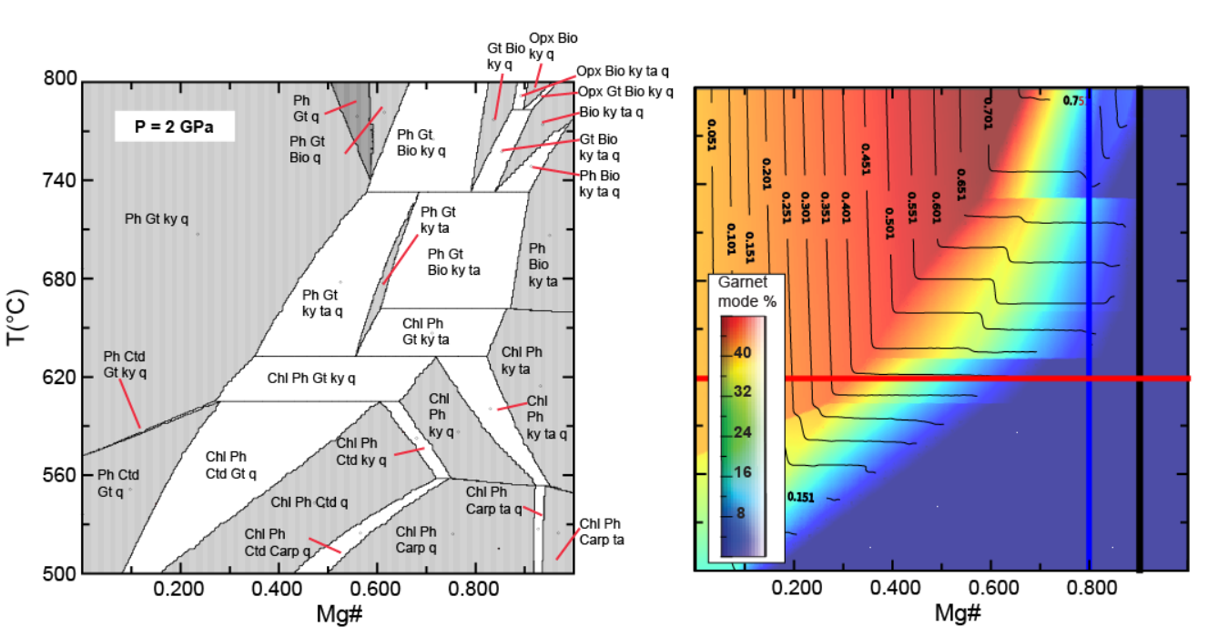
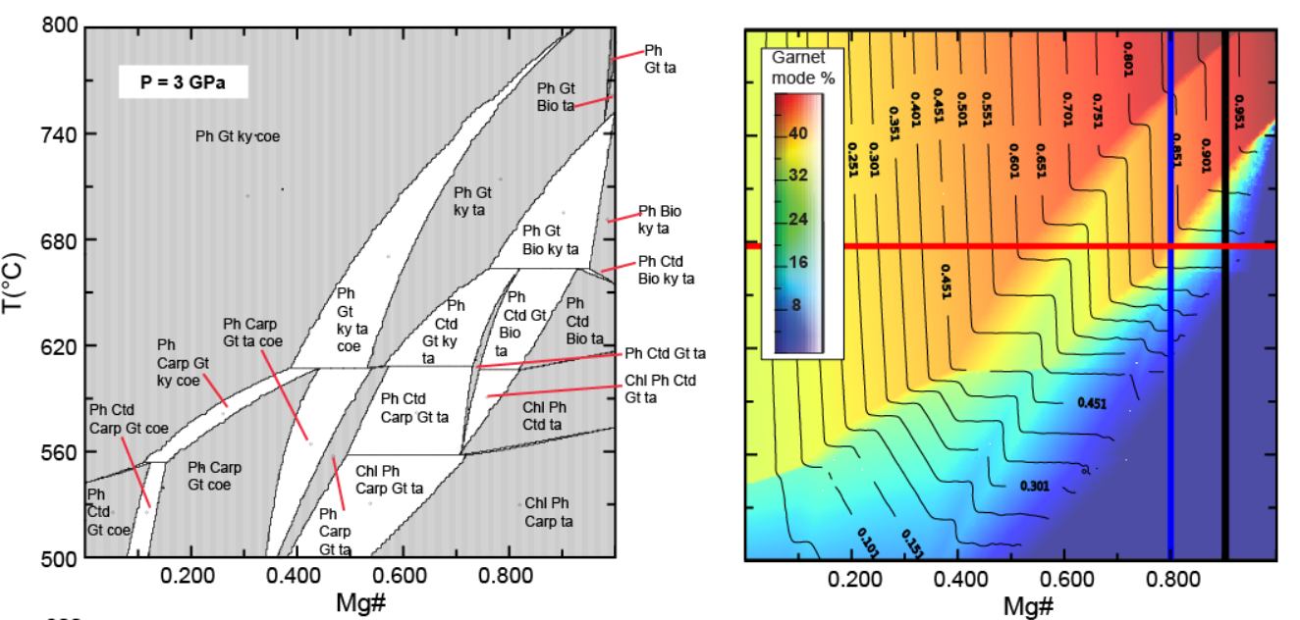
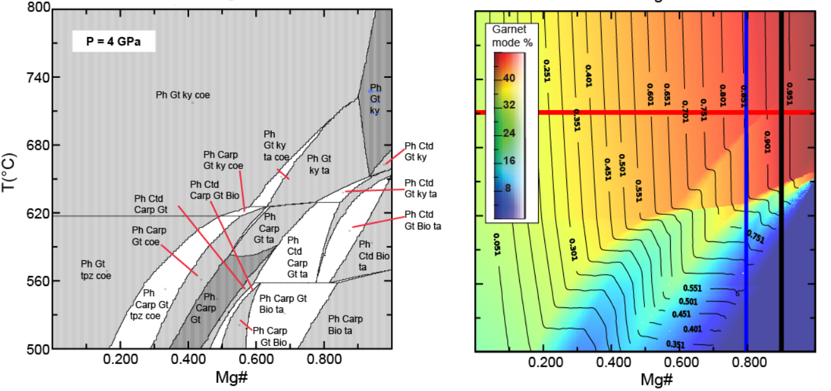
Figure S.2. T vs Mg# pseudosections for SiO₂-poor whiteschists at three different pressures (2, 3 and 4 GPa from top to bottom). Red line in the T vs Mg# pseudosection refer to the temperature values according to the P-T path given by Rubatto and Hermann (2001). Black thin lines are the garnet isopleths in terms of pyrope mole fraction. The rainbow colours represent the garnet modal abundance as given by the legend. The blue thick line refers to the Mg# value given by Gautiez-Putallaz et al. 2016 (0.8) while the black line refers to the present study.

In this study, differently from Gauthiez-Putallaz et al. (2016) that used a Mg# of 0.8 (vertical black line in Figure S.2), our measured garnet chemical composition, in combination with the known P-T path of the Dora Maira rocks (red lines in Figure S.2), are best reproduced with a Mg# of 0.9. Therefore, the bulk chemistry resulting from this analysis and used for the discussion in the main text is:
50 wt% SiO2, 26 wt% Al2O3, 1.5 wt% FeO, 16.5 wt% MgO and 6 wt% K2O with water being considered as in excess.

S.2 Raman spectra processing
Origin Lab-Pro 2018 software package was used for data fitting and evaluation. The collected spectra were baseline corrected for the continuum luminescence background when necessary, temperature-reduced to account for the Bose-Einstein occupation factor (Kuzmany, 2009) and normalized to the acquisition time. Peak positions, full-widths at half maximum (FWHMs), and integrated intensities were determined from fits with pseudo-Voigt functions (PV = (1 – q)·Lorentz + q·Gauss, q is the weight coefficient). The criterion for the maximum number of fitted peaks was ΔI < I/2, where I and ΔI are the calculated magnitude and uncertainty of each peak intensity, respectively.

S.3 FTIR spectroscopy on zircon inclusions and garnet host
FTIR analysis and mapping of the host and the host-inclusion boundary has been carried out to verify and quantify the intra-crystalline water content (OH groups) within the garnet host and the eventual presence of a free fluid (i.e. water) at the host inclusion boundary.
FTIR spectra and maps were acquired at the Institute of Geological Sciences at the Bern University, on double polished sections of 500 microns in thickness. The measurements were performed in transmittance mode, using a Bruker Tensor II spectrometer with a globar infrared source and a KBr beam-splitter, coupled to a Bruker Hyperion 3000 microscope with a dry air-purged sample chamber. The signal was recorded on a Focal Plane Array (FPA) detector composed of 64 x 64 = 4096 liquid nitrogen-cooled MCT elements on a square array. We used a 2 by 2 binning resulting in a spatial resolution of about (6 x 6) μm². The collected spectra were acquired between 900 and 4000 cm⁻¹ with a spectral resolution of 8 cm⁻¹. Data fitting and evaluation follows the same procedure described above for the Raman spectra.
Intra-crystalline water content c in garnet has been estimated using the Beer-Lambert law (e.g. Libowitzky and Rossman, 1997):
$c=\frac{A}{d t ε}$ (S.1)
where $A$ is the integrated intensity of all OH-stretching absorption bands, $d$ is the density of the analysed crystal (for pyrope 3.7 g/cm³), $t$ is thickness of the sample (in cm) and $ε$ represents the integral absorption coefficient of the crystal (for pyrope 6700 mol⁻¹ cm⁻² as given in Reynes et al. 2018 and reference therein).
Figure S.3 shows the absorption bands of intra-crystalline OH groups within garnet. The best fit of the spectra was obtained involving 6 different peaks near to 3601, 3617, 3629, 3642, 3650 and 3660 cm⁻¹. The resulting intra-crystalline OH groups content in the garnet host has been quantified using equation S.1 and yields an average of about 70 µg/g. This amount of intra-crystalline OH groups is small and it is not expected to have any significant effect on the equation of state of the garnet host (Fan et al., 2017).

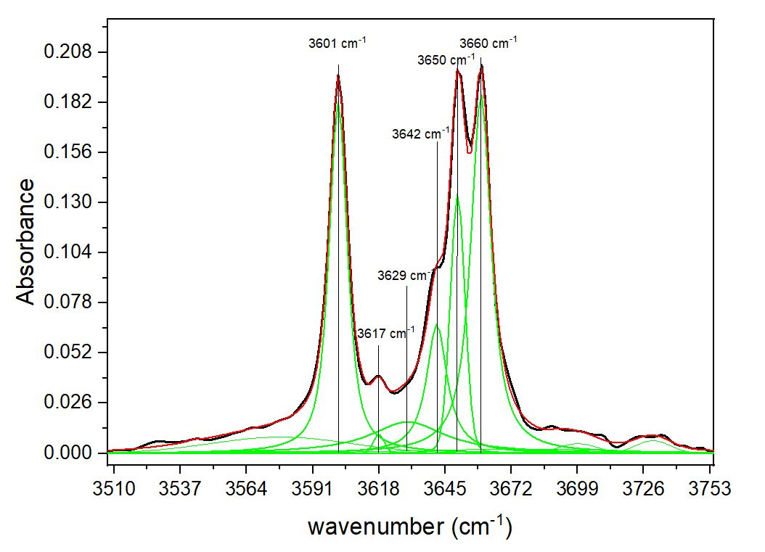
Figure S.3. Representative OH absorption bands from a megablast garnet host. Highlighted and labelled peaks are those used for the quantification of intra-crystalline water content following equation S.1

Figure S.4A shows a representative map collected around a completely buried zircon inclusion within garnet. The colored spots are a transect of measurements shown as stacked spectra in Figure S.4B. The main absorption bands for free water are expected between 3000 and 3600 cm⁻¹. The black spot in Figure S.4A corresponds to a spectrum measured when the beam passed through the inclusion, including the host-inclusion boundary on the top and bottom of the grain. Grey and yellow spots are close to the host-inclusion boundary while the other measurements come only from the host. The corresponding stacked spectra of Figure S4.B shows that OH absorption bands (in analogy with Figure S.3) can be detected only from the garnet host and no extra peaks are evident along the entire transect suggesting the absence of free water at the host-inclusion boundary.
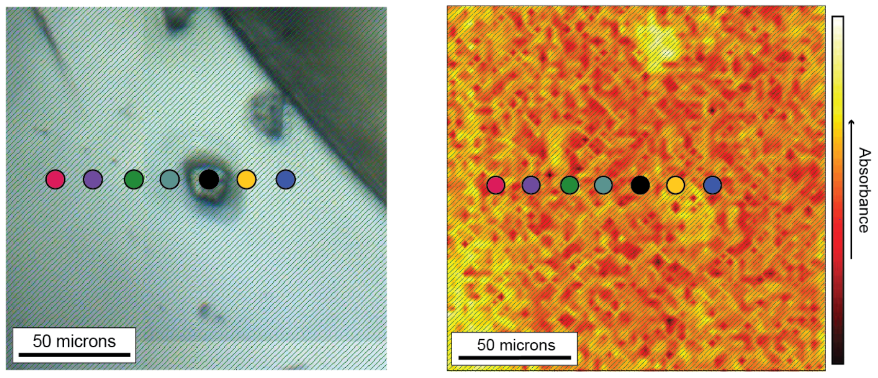A
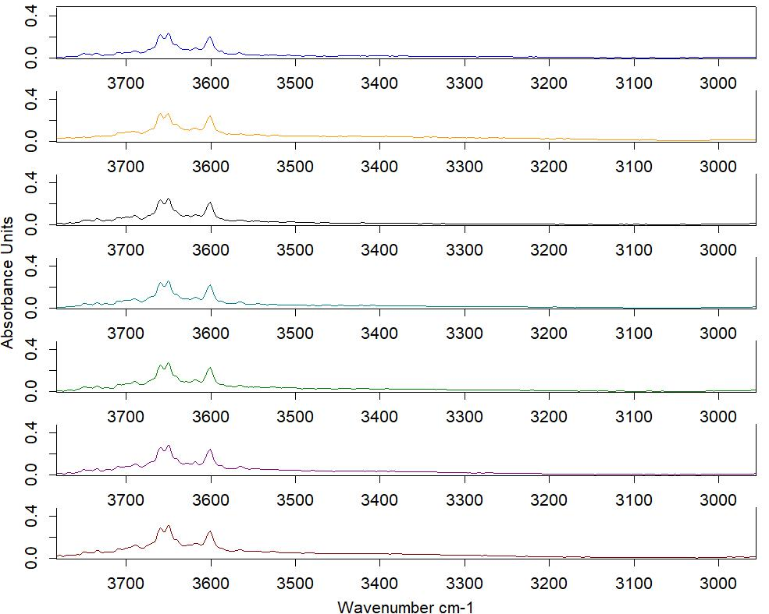B
Figure S.4. (A) Location image and absorbance map of a buried zircon inclusion within a garnet megablast. (B) Stacked spectra of the representative transect of measurements highlighted by the coloured spots reported in (A).

S.4 Chemical composition of garnet neoblasts and zircon inclusion residual pressure
Table S.1 lists representative chemical analyses of three garnet neoblasts. Sample DM17-29 comes from the Gilba locality while samples DM17-8 and DM17-1B come from the Martiniana locality.
Table S.1 Representative microprobe analyses of garnet neoblasts
Sample | DM17-29-1-10 | DM17-29-1-11 | DM17-29-1-2 | DM17-29-1-3 | DM17-8A-4 | DM17-8A-5 | DM17-8A-9 | DM17-8A-10 | DM17-1B-1 | DM17-1B-3 | DM17-1B-10
Notes | Core (G) | Core (G) | Rim (G) | Rim (G) | Core (M) | Core (M) | Rim (M) | Rim (M) | Rim (M) | Mantle (M) | Core (M)
Oxide | wt%
SiO₂ | 43.38 | 43.77 | 44.16 | 43.67 | 44.22 | 43.62 | 44.05 | 43.95 | 43.83 | 43.03 | 43.23
TiO₂ | 0.00 | 0.06 | 0.00 | 0.02 | 0.00 | 0.03 | 0.03 | 0.02 | 0.01 | 0.01 | 0.01
Al₂O₃ | 25.22 | 25.20 | 25.16 | 25.01 | 25.16 | 25.18 | 25.60 | 25.77 | 25.23 | 24.95 | 24.55
Cr₂O₃ | 0.00 | 0.00 | 0.00 | 0.00 | 0.00 | 0.01 | 0.04 | 0.01 | 0.01 | 0.00 | 0.00
Fe₂O₃ | 0.71 | 0.00 | 0.00 | 0.00 | 0.00 | 0.00 | 0.00 | 0.00 | 0.00 | 0.00 | 0.00
FeO | 3.29 | 3.79 | 2.12 | 2.90 | 3.62 | 4.35 | 1.93 | 2.04 | 3.43 | 7.98 | 9.12
MnO | 0.03 | 0.09 | 0.00 | 0.00 | 0.02 | 0.05 | 0.00 | 0.02 | 0.03 | 0.03 | 0.07
MgO | 26.95 | 26.57 | 27.98 | 27.23 | 26.58 | 26.10 | 27.82 | 27.60 | 26.04 | 23.11 | 22.21
CaO | 0.40 | 0.36 | 0.10 | 0.35 | 0.56 | 0.56 | 0.40 | 0.70 | 0.91 | 1.16 | 1.24
Total | 99.98 | 99.84 | 99.52 | 99.18 | 100.16 | 99.90 | 99.87 | 100.11 | 99.49 | 100.27 | 100.43
Si | 2.97 | 3.00 | 3.01 | 3.00 | 3.02 | 2.99 | 2.99 | 2.98 | 3.02 | 3.00 | 3.03
Ti | 0.00 | 0.00 | 0.00 | 0.00 | 0.00 | 0.00 | 0.00 | 0.00 | 0.00 | 0.00 | 0.00
Al | 2.03 | 2.04 | 2.02 | 2.02 | 2.03 | 2.04 | 2.05 | 2.06 | 2.05 | 2.05 | 2.03
Cr | 0.00 | 0.00 | 0.00 | 0.00 | 0.00 | 0.00 | 0.00 | 0.00 | 0.00 | 0.00 | 0.00
Fe³⁺ | 0.04 | 0.00 | 0.00 | 0.00 | 0.00 | 0.00 | 0.00 | 0.00 | 0.00 | 0.00 | 0.00
Fe²⁺ | 0.19 | 0.22 | 0.12 | 0.17 | 0.21 | 0.25 | 0.11 | 0.12 | 0.20 | 0.46 | 0.53
Mn | 0.00 | 0.01 | 0.00 | 0.00 | 0.00 | 0.00 | 0.00 | 0.00 | 0.00 | 0.00 | 0.00
Mg | 2.75 | 2.71 | 2.84 | 2.79 | 2.71 | 2.67 | 2.82 | 2.79 | 2.67 | 2.40 | 2.32
Ca | 0.03 | 0.03 | 0.01 | 0.03 | 0.04 | 0.04 | 0.03 | 0.05 | 0.07 | 0.09 | 0.09
end-memeber | Mol%
Alm | 6.34 | 7.33 | 4.07 | 5.59 | 7.00 | 8.42 | 3.71 | 3.91 | 6.72 | 15.74 | 18.11
Py | 92.61 | 91.60 | 95.69 | 93.55 | 91.58 | 90.09 | 95.31 | 94.33 | 90.94 | 81.27 | 78.60
Gr | 0.97 | 0.89 | 0.25 | 0.86 | 1.39 | 1.39 | 0.98 | 1.72 | 2.28 | 2.93 | 3.15
Sp | 0.06 | 0.18 | 0.00 | 0.00 | 0.04 | 0.10 | 0.00 | 0.04 | 0.06 | 0.06 | 0.14

Figure S.7 shows the normalized REE patterns of samples DM17-29 and DM17-1B. In these two crystals the HREE pattern zonation appears quite evident and similar to the one of garnet megablast DMG4-5 (described in the main text) with flat HREE concentration pattern for the garnet core with a resolved depletion moving toward the garnet rim. No significant Zr vs P concentration trends have been recorded.

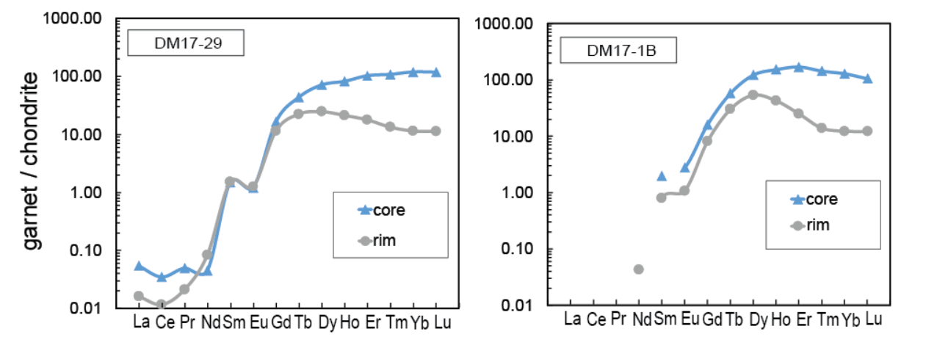
Figure S.7 normalized REE concentration patterns of two garnet neoblasts as function of the different growth domains (i.e. core, mantle and rim).

Figure S.8 displays the ε₃ vs ε₁ diagrams showing the strain state of zircon inclusions found within the garnet neoblasts. In general, it is possible to claim similar average values of inclusion residual pressures (⁓0.6 GPa) and strains with respect to those found for the inclusions within the three garnet megablasts described in the main text.
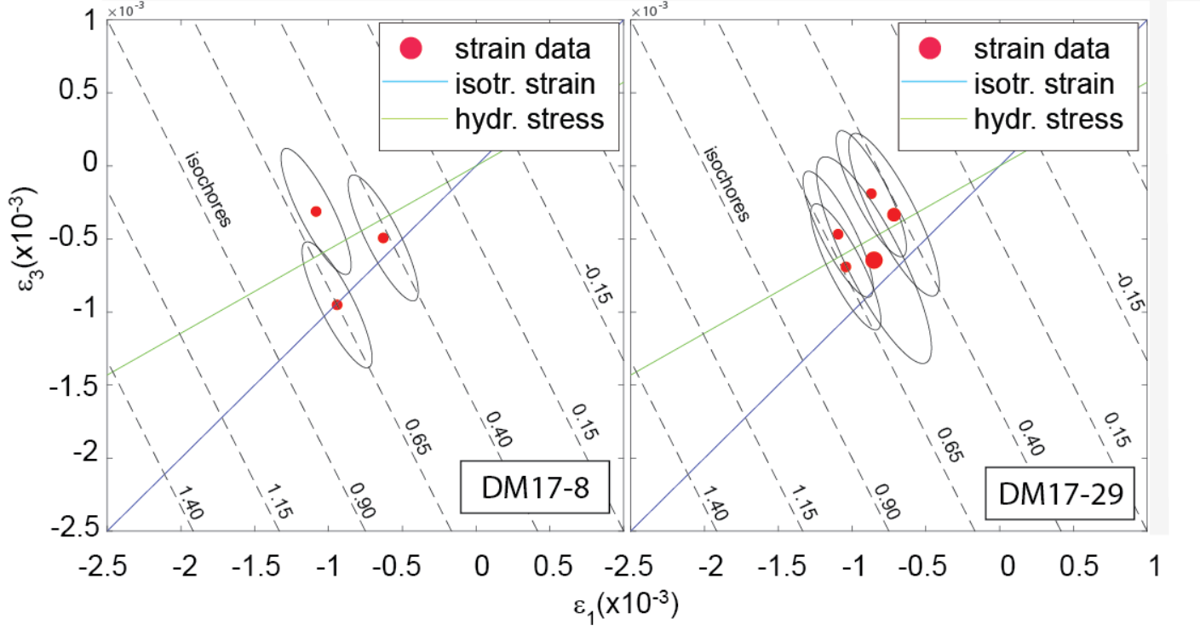
Figure S.8 ε₁ vs ε₃ diagrams showing the strain state of zircon inclusions entrapped within two different garnet neoblasts. The size of the red spots is proportional to the amount of uncertainty (i.e. size of the confidence ellipse). Black dashed lines represent the conditions of equal volume strain (i.e. isochores) over which the corresponding residual pressures are given in GPa as reference.

S.5 Minor and trace element analysis of garnet megablasts

Table S.5.1: minor elements from garnet megablast DM17-35 (listed from core to rim)
S. | P | Ti | V | Cr | Mn | Y | Zr | Hf | Ca
(note) | (ppm) | (ppm) | (ppm) | (ppm) | (ppm) | (ppm) | (ppm) | (ppm) | (ppm)
DM17-35-5A-g4 | 667.7 | 410 | 13.07 | 9.14 | 92.1 | 97.82 | 4.21 | 0.053 | 3869
DM17-35-5A-g5 | 618.2 | 30.6 | 10.1 | 9.54 | 85.4 | 73.35 | 3.56 | 0.074 | 3361
DM17-35-5A-g3 | 695.7 | 49.3 | 12.24 | 10.24 | 95.28 | 88.49 | 4.49 | 0.043 | 3624
DM17-35-5A-g2 | 693.2 | 50.3 | 14.91 | 7.15 | 88.9 | 116.58 | 3.99 | 0.038 | 3740
DM17-35-5A-g7 | 381.1 | 29.1 | 7.58 | 13.22 | 70.03 | 56.96 | 2.18 | 0.022 | 2980
DM17-35-5A-g1 | 745.4 | 80.5 | 15.81 | 6.66 | 115.7 | 149.03 | 4.62 | 0.063 | 4163
DM17-35-5A-g8 | 513 | 12.09 | 4.02 | 7.57 | 181.8 | 55.1 | 1.95 | 0.025 | 3757
DM17-35-5A-g11 | 699.6 | 32.8 | 9.6 | 9.67 | 113.76 | 94.85 | 4 | 0.058 | 3347
DM17-35-3A-g1 | 715.6 | 62.4 | 14.84 | 14.22 | 130 | 33.83 | 8.11 | 0.087 | 2765
DM17-35-3A-g2 | 764.1 | 73.8 | 19.18 | 10.86 | 66.41 | 27.46 | 2.54 | 0.012 | 2772
DM17-35-3A-g10 | 760.9 | 29 | 8.22 | 13.1 | 209.9 | 39.62 | 6.57 | 0.098 | 3187
DM17-35-3A-g3 | 667 | 73.7 | 11.77 | 9.53 | 88.7 | 22.6 | 6.04 | 0.07 | 2432
DM17-35-3A-g9 | 589.6 | 69.1 | 13.37 | 12.77 | 84.97 | 35.92 | 5.73 | 0.067 | 2533
DM17-35-3A-g11 | 579.3 | 50.9 | 12.6 | 9.65 | 91.8 | 74.36 | 4.87 | 0.075 | 3096
DM17-35-3A-g4 | 562.8 | 61.9 | 13.42 | 13.79 | 81.48 | 47.61 | 6.26 | 0.041 | 2671
DM17-35-3A-g6 | 546 | 34.1 | 9.39 | 11.01 | 99.57 | 49.94 | 3.63 | 0.059 | 2685
DM17-35-3A-g5 | 519.5 | 39.3 | 10.41 | 10.26 | 69.95 | 52.57 | 3.34 | 0.048 | 2652
DM17-35-3A-g7 | 661.3 | 31.5 | 9.47 | 10.22 | 91.93 | 64.56 | 4.08 | 0.048 | 3327
DM17-35-1A-g1 | 629.9 | 30 | 8.58 | 9.77 | 111.12 | 91.55 | 3.24 | 0.047 | 3176
DM17-35-1A-g3 | 726.6 | 48.8 | 13.73 | 9.63 | 75.36 | 123.53 | 4.17 | 0.071 | 3796
DM17-35-1A-g4 | 684.8 | 26.7 | 8.39 | 10.55 | 118.02 | 85.47 | 3.46 | 0.026 | 3307
DM17-35-1A-g7 | 611.5 | 36.9 | 10.53 | 11.03 | 129.9 | 92.81 | 3.13 | 0.042 | 3272
DM17-35-1A-g11 | 591.1 | 20.6 | 5.23 | 6.81 | 178.7 | 73.71 | 2.72 | 0.033 | 3373
DM17-35-1A-g6 | 502.1 | 49 | 9.36 | 11.89 | 101.69 | 75.9 | 2.51 | 0.035 | 3123
DM17-35-1A-g8 | 632.6 | 43.6 | 11.81 | 12.31 | 87 | 111.48 | 3.28 | 0.039 | 3626
DM17-35-1A-g10 | 809 | 43.9 | 12.55 | 11.6 | 80.7 | 87.6 | 4.99 | 0.126 | 3333

Table S.5.2: minor elements from garnet megablast DMG4-6 (listed from core to rim)
S. | P | Ti | V | Cr | Mn | Y | Zr | Hf | Ca
(notes) | (ppm) | (ppm) | (ppm) | (ppm) | (ppm) | (ppm) | (ppm) | (ppm) | (ppm)
DMG4-6-g5 | 610.00 | 84.50 | 5.66 | 9.80 | 135.70 | 161.80 | 3.22 | 0.03 | 6820.00
DMG4-6-g6 | 435.40 | 59.30 | 6.44 | 5.66 | 135.80 | 115.60 | 1.49 | 0.02 | 6100.00
DMG4-6-g7 | 513.00 | 91.10 | 5.09 | 18.40 | 135.30 | 122.31 | 2.26 | 0.03 | 6290.00
DMG4-6-g8 | 410.80 | 49.90 | 6.07 | 4.17 | 136.27 | 105.01 | 1.52 | 0.03 | 5890.00
DMG4-6-g9 | 469.10 | 64.40 | 4.08 | 5.42 | 135.80 | 130.74 | 2.13 | 0.04 | 6160.00
DMG4-6-g10 | 470.00 | 65.30 | 4.93 | 5.10 | 136.87 | 130.80 | 1.99 | 0.02 | 6130.00
DMG4-6-g11 | 718.30 | 71.30 | 3.78 | 7.37 | 137.60 | 158.70 | 4.35 | 0.08 | 6130.00
DMG4-6-g12 | 392.20 | 50.70 | 3.28 | 3.19 | 143.30 | 125.77 | 1.25 | 0.03 | 5660.00
DMG4-6-A-g13 | 700.60 | 48.70 | 5.85 | 12.14 | 124.20 | 208.20 | 3.98 | 0.04 | 6050.00
DMG4-6-A-g14 | 433.40 | 45.60 | 4.02 | 3.64 | 132.70 | 113.50 | 1.62 | b.d.l. | 5960.00
DMG4-6-A-g15 | 521.00 | 134.00 | 6.52 | 9.17 | 131.80 | 129.90 | 3.51 | 0.03 | 5770.00
DMG4-6-B-g1 | 682.00 | 410.00 | 7.55 | 8.19 | 153.00 | 214.60 | 3.90 | 0.06 | 6900.00
DMG4-6-B-g2 | 719.70 | 50.50 | 9.01 | 8.75 | 142.10 | 139.70 | 3.80 | 0.07 | 6040.00
DMG4-6-B-g3 | 669.90 | 64.00 | 9.41 | 10.32 | 144.90 | 167.80 | 3.16 | 0.04 | 6492.00
DMG4-6-B-g4 | 702.90 | 86.20 | 8.17 | 8.92 | 137.90 | 140.80 | 3.86 | 0.05 | 6450.00
DMG4-6-B-g5 | 684.50 | 98.60 | 7.25 | 9.81 | 140.30 | 149.90 | 3.56 | 0.04 | 6010.00
DMG4-6-B-g6 | 398.80 | 43.00 | 6.40 | 2.44 | 133.29 | 80.76 | 0.88 | b.d.l. | 4800.00
DMG4-6-B-g7 | 512.90 | 39.10 | 7.83 | 4.02 | 115.05 | 75.96 | 1.62 | 0.03 | 4990.00
DMG4-6-B-g8 | 633.10 | 85.60 | 6.35 | 6.88 | 106.82 | 85.03 | 2.91 | 0.03 | 5260.00
DMG4-6-B-g9 | 727.00 | 94.70 | 8.67 | 10.26 | 104.35 | 109.70 | 3.36 | 0.04 | 5540.00
DMG4-6-B-g10 | 705.70 | 64.90 | 11.03 | 9.28 | 105.58 | 104.60 | 3.04 | 0.03 | 5350.00
DMG4-6-B-g11 | 743.70 | 91.70 | 10.20 | 12.18 | 107.80 | 121.51 | 3.56 | 0.03 | 5470.00
DMG4-6-B-g12 | 738.50 | 81.60 | 12.17 | 11.12 | 110.90 | 131.86 | 3.79 | 0.04 | 5290.00
DMG4-6-B-g13 | 571.30 | 60.90 | 7.17 | 4.06 | 97.20 | 61.24 | 2.45 | 0.04 | 4560.00
DMG4-6-B-g14 | 716.60 | 122.50 | 8.73 | 11.55 | 95.40 | 107.71 | 3.97 | 0.03 | 5240.00
DMG4-6-B-g16 | 509.50 | 41.70 | 5.15 | 10.27 | 77.83 | 60.47 | 2.17 | 0.01 | 4480.00
DMG4-6-B-g17 | 675.90 | 58.20 | 7.39 | 7.31 | 97.52 | 98.68 | 3.46 | 0.03 | 5060.00
DMG4-6-B-g18 | 376.00 | 46.00 | 6.20 | 3.22 | 95.50 | 47.26 | 1.19 | 0.03 | 3910.00

Table S.5.3: minor elements from garnet megablast DM17-13 (listed from core to rim)
sample | P | Ti | V | Cr | Mn | Y | Zr | Hf | Ca
(notes) | (ppm) | (ppm) | (ppm) | (ppm) | (ppm) | (ppm) | (ppm) | (ppm) | (ppm)
DM17-13-A-g1 | 356 | 81.9 | 12.06 | 2.83 | 414.8 | 737.6 | 1.325 | b.d.l. | 4534
DM17-13-A-g2 | 239.1 | 68.7 | 9.15 | 2.69 | 406.3 | 539.6 | 0.675 | b.d.l. | 4028
DM17-13-A-g4 | 325.1 | 91.6 | 10.59 | 3.6 | 378.2 | 639.6 | 1.088 | b.d.l. | 4410
DM17-13-A-g5 | 440.1 | 67.3 | 15.67 | 5.96 | 393.6 | 893.4 | 2.08 | 0.019 | 5096
DM17-13-A-g6 | 329.8 | 82.2 | 10.91 | 4.13 | 393.6 | 650.8 | 1.15 | b.d.l. | 4459
DM17-13-A-g7 | 442.5 | 95.9 | 15.61 | 3.97 | 388.9 | 963.9 | 2.12 | 0.025 | 5306
DM17-13-A-g8 | 479.9 | 147.7 | 14.57 | 6.51 | 363.4 | 1065.2 | 2.44 | 0.028 | 5372
DM17-13-A-g9 | 477.8 | 71.4 | 11.37 | 6.88 | 245.7 | 1247.6 | 2.71 | 0.012 | 5192
DM17-13-A-g10 | 527.8 | 145.2 | 15.84 | 5.3 | 402.6 | 937.2 | 2.95 | b.d.l. | 5916
DM17-13-B-g1 | 578.6 | 143.9 | 15.48 | 8.55 | 326.2 | 805.5 | 3.15 | 0.024 | 6641
DM17-13-B-g2 | 646 | 119.3 | 14.82 | 8.21 | 278.9 | 627.1 | 3.21 | b.d.l. | 7046
DM17-13-B-g3 | 655.2 | b.d.l. | 26.7 | 15 | 286.3 | 491.5 | 3.85 | 0.071 | 6195
DM17-13-B-g4 | 550.9 | 82.8 | 13.46 | 9.27 | 250 | 598.5 | 2.87 | 0.028 | 5754
DM17-13-B-g5 | 702.7 | 104.7 | 14.69 | 7.74 | 242.5 | 402.5 | b.d.l. | 0.0085 | 7328
DM17-13-B-g7 | 338.4 | 65.4 | 11.37 | 11.07 | 212.1 | 241.8 | 3.52 | 0.036 | 8289
DM17-13-B-g8 | 451.9 | 145.1 | 16.12 | 8.79 | 234.4 | 351.9 | 5.78 | 0.079 | 8971
DM17-13-B-g9 | 443.7 | 151 | 16.4 | 10.65 | 260.1 | 429.1 | 4.84 | 0.073 | 9164
DM17-13-B-g10 | 467.8 | 148.7 | 16.66 | 10.81 | 246.3 | 427.1 | 4.73 | 0.065 | 9163
DM17-13-B-g11 | 452.6 | 111.5 | 15.03 | 13.31 | 228.7 | 367.4 | 4.75 | 0.083 | 9205
DM17-13-C-g13 | 470 | 87.4 | 12.15 | 6.18 | 218.6 | 327.8 | 4.24 | 0.096 | 9450
DM17-13-C-g14 | 383 | 74.1 | 10.45 | 14.39 | 279.8 | 206.1 | 3.03 | 0.061 | 8683
DM17-13-C-g15 | 432.2 | 91.3 | 11.07 | 5.46 | 251.2 | 213.6 | 3.64 | 0.054 | 6395
DM17-13-C-g16 | 427.5 | 98.3 | 11.68 | 9.41 | 263.6 | 323.4 | 3.87 | 0.085 | 5850
DM17-13-C-g7 | 406 | 112 | 9.33 | 8.03 | 271.2 | 255 | 5.9 | 0.166 | 8179
DM17-13-C-g6 | 416.7 | 108.2 | 9.93 | 8.69 | 268.5 | 310.5 | 3.57 | 0.073 | 5732
DM17-13-C-g17 | 454.7 | 98.2 | 10.86 | 7.62 | 215.7 | 310.8 | 4.6 | 0.101 | 3979
DM17-13-C-g18 | 649.8 | 96.3 | 10.52 | 7.41 | 200.5 | 306.7 | 6.16 | 0.108 | 6990
DM17-13-C-g19 | 456.7 | 92.5 | 6.84 | 7.23 | 84.57 | 587.9 | 3.09 | 0.043 | 1602
DM17-13-C-g20 | 537.7 | 108 | 8.26 | 4.34 | 22.77 | 469.2 | 5.46 | 0.096 | 744
DM17-13-C-g21 | 575.7 | 155.3 | 11.27 | 7.4 | 15.36 | 170.7 | 8.19 | 0.153 | 2080
DM17-13-C-g22 | 378.3 | 108.4 | 5.54 | 4.57 | 38.87 | 216.8 | 4.36 | 0.076 | 1366
DM17-13-C-g23 | 305 | 66.3 | 5.33 | 10.51 | 30.08 | 324.6 | 2.82 | 0.081 | 1262

Table S.5.4: REE compositional transect in garnet megablast DM17-35 (listed from core to rim)
S. | La | Ce | Pr | Nd | Sm | Eu | Gd | Tb | Dy | Ho | Er | Tm | Yb | Lu
(Notes) | (ppm) | (ppm) | (ppm) | (ppm) | (ppm) | (ppm) | (ppm) | (ppm) | (ppm) | (ppm) | (ppm) | (ppm) | (ppm) | (ppm)
DM17-35-5A-g1 | b.d.l. | b.d.l. | b.d.l. | 0.02 | 0.57 | 0.25 | 9.17 | 3.09 | 23.70 | 5.13 | 15.29 | 2.10 | 13.04 | 1.75
DM17-35-5A-g2 | b.d.l. | b.d.l. | b.d.l. | 0.03 | 0.46 | 0.19 | 7.23 | 2.40 | 18.61 | 3.99 | 13.00 | 1.73 | 11.81 | 1.75
DM17-35-5A-g3 | 0.07 | 0.06 | 0.02 | 0.04 | 0.47 | 0.18 | 6.30 | 1.81 | 14.29 | 3.01 | 9.38 | 1.30 | 8.35 | 1.20
DM17-35-5A-g4 | b.d.l. | b.d.l. | b.d.l. | 0.03 | 0.50 | 0.20 | 6.42 | 1.91 | 15.23 | 3.25 | 9.85 | 1.36 | 9.06 | 1.25
DM17-35-5A-g5 | b.d.l. | 0.01 | b.d.l. | 0.02 | 0.26 | 0.11 | 3.94 | 1.30 | 11.28 | 2.59 | 8.28 | 1.15 | 7.74 | 1.09
DM17-35-5A-g6 | b.d.l. | b.d.l. | b.d.l. | b.d.l. | b.d.l. | b.d.l. | b.d.l. | b.d.l. | b.d.l. | b.d.l. | b.d.l. | b.d.l. | b.d.l. | b.d.l.
DM17-35-5A-g7 | b.d.l. | b.d.l. | b.d.l. | 0.02 | 0.18 | 0.09 | 3.05 | 0.99 | 8.93 | 1.91 | 5.40 | 0.74 | 4.83 | 0.62
DM17-35-5A-g8 | 0.09 | 0.22 | 0.03 | 0.08 | 0.12 | 0.05 | 1.33 | 0.59 | 6.67 | 1.90 | 7.30 | 1.36 | 11.22 | 1.77
DM17-35-5A-g9 | b.d.l. | b.d.l. | b.d.l. | 0.03 | 0.54 | 0.21 | 6.87 | 1.97 | 15.30 | 3.31 | 10.08 | 1.29 | 8.20 | 1.09
DM17-35-5A-g10 | 0.01 | 0.01 | b.d.l. | 0.03 | 0.48 | 0.21 | 6.30 | 1.89 | 13.70 | 2.84 | 8.51 | 1.15 | 7.24 | 0.92
DM17-35-5A-g11 | 0.10 | 0.06 | 0.01 | 0.04 | 0.31 | 0.12 | 5.29 | 1.74 | 15.06 | 3.62 | 11.93 | 1.66 | 12.37 | 1.82
DM17-35-5A-g12 | b.d.l. | 0.01 | b.d.l. | b.d.l. | b.d.l. | b.d.l. | b.d.l. | b.d.l. | b.d.l. | b.d.l. | b.d.l. | b.d.l. | b.d.l. | b.d.l.
DM17-35-3A-g1 | 0.01 | 0.01 | b.d.l. | 0.05 | 0.56 | 0.14 | 2.79 | 0.62 | 4.91 | 1.06 | 3.45 | 0.53 | 3.85 | 0.61
DM17-35-3A-g2 | b.d.l. | b.d.l. | b.d.l. | 0.05 | 0.46 | 0.12 | 2.51 | 0.61 | 4.66 | 0.86 | 2.56 | 0.35 | 2.16 | 0.27
DM17-35-3A-g3 | 0.01 | 0.01 | b.d.l. | 0.06 | 0.45 | 0.11 | 1.79 | 0.46 | 3.42 | 0.73 | 2.21 | 0.29 | 2.09 | 0.27
DM17-35-3A-g4 | b.d.l. | b.d.l. | b.d.l. | 0.04 | 0.53 | 0.12 | 3.18 | 0.90 | 7.36 | 1.49 | 4.90 | 0.72 | 4.68 | 0.62
DM17-35-3A-g5 | 0.01 | 0.01 | b.d.l. | 0.03 | 0.29 | 0.09 | 3.06 | 0.88 | 7.48 | 1.77 | 5.78 | 0.87 | 5.75 | 0.86
DM17-35-3A-g6 | b.d.l. | b.d.l. | b.d.l. | 0.04 | 0.25 | 0.10 | 2.68 | 0.85 | 6.99 | 1.67 | 5.57 | 0.79 | 5.57 | 0.90
DM17-35-3A-g7 | b.d.l. | 0.01 | b.d.l. | 0.02 | 0.30 | 0.10 | 3.57 | 1.14 | 9.56 | 2.25 | 7.14 | 1.06 | 7.05 | 1.02
DM17-35-3A-g8 | b.d.l. | b.d.l. | b.d.l. | 0.02 | 0.30 | 0.10 | 3.00 | 0.85 | 7.69 | 1.70 | 5.49 | 0.79 | 6.47 | 0.95
DM17-35-3A-g9 | b.d.l. | 0.01 | b.d.l. | 0.03 | 0.48 | 0.12 | 2.60 | 0.68 | 5.25 | 1.18 | 3.63 | 0.58 | 3.91 | 0.54
DM17-35-3A-g10 | 0.09 | 0.07 | 0.01 | 0.06 | 0.25 | 0.05 | 1.80 | 0.55 | 4.94 | 1.32 | 4.43 | 0.74 | 6.06 | 1.02
DM17-35-3A-g11 | 0.01 | 0.02 | b.d.l. | 0.02 | 0.44 | 0.12 | 3.83 | 1.23 | 10.61 | 2.54 | 8.30 | 1.18 | 8.06 | 1.12
DM17-35-3A-g12 | b.d.l. | b.d.l. | b.d.l. | 0.01 | 0.32 | 0.09 | 2.38 | 0.66 | 5.99 | 1.55 | 5.54 | 0.77 | 6.24 | 0.91
DM17-35-1A-g1 | 0.01 | 0.02 | b.d.l. | 0.02 | 0.23 | 0.10 | 3.99 | 1.56 | 13.95 | 3.51 | 11.77 | 1.69 | 12.12 | 1.87
DM17-35-1A-g2 | b.d.l. | b.d.l. | b.d.l. | b.d.l. | b.d.l. | b.d.l. | b.d.l. | b.d.l. | b.d.l. | b.d.l. | b.d.l. | b.d.l. | b.d.l. | b.d.l.
DM17-35-1A-g3 | b.d.l. | b.d.l. | b.d.l. | 0.04 | 0.43 | 0.17 | 7.46 | 2.50 | 19.80 | 4.43 | 13.38 | 1.76 | 11.40 | 1.56
DM17-35-1A-g4 | 0.01 | 0.02 | b.d.l. | 0.02 | 0.20 | 0.09 | 4.47 | 1.49 | 13.31 | 3.29 | 10.82 | 1.53 | 10.61 | 1.67
DM17-35-1A-g5 | b.d.l. | b.d.l. | b.d.l. | b.d.l. | b.d.l. | b.d.l. | b.d.l. | b.d.l. | b.d.l. | b.d.l. | b.d.l. | b.d.l. | b.d.l. | b.d.l.
DM17-35-1A-g6 | b.d.l. | b.d.l. | b.d.l. | 0.02 | 0.24 | 0.10 | 3.85 | 1.38 | 12.04 | 2.67 | 8.26 | 1.14 | 7.89 | 1.14
DM17-35-1A-g7 | 0.05 | 0.06 | 0.01 | 0.06 | 0.31 | 0.12 | 4.45 | 1.63 | 14.52 | 3.42 | 10.53 | 1.50 | 10.13 | 1.45
DM17-35-1A-g8 | b.d.l. | b.d.l. | b.d.l. | 0.02 | 0.32 | 0.16 | 5.68 | 1.97 | 17.18 | 3.95 | 12.67 | 1.75 | 11.94 | 1.72
DM17-35-1A-g9 | b.d.l. | b.d.l. | b.d.l. | b.d.l. | b.d.l. | b.d.l. | b.d.l. | b.d.l. | b.d.l. | b.d.l. | b.d.l. | b.d.l. | b.d.l. | b.d.l.
DM17-35-1A-g10 | 0.03 | 0.02 | b.d.l. | 0.03 | 0.29 | 0.13 | 5.39 | 1.72 | 14.49 | 3.19 | 9.21 | 1.28 | 8.53 | 1.23
DM17-35-1A-g11 | 0.02 | 0.06 | 0.01 | 0.05 | 0.21 | 0.08 | 3.23 | 1.14 | 11.28 | 2.79 | 9.39 | 1.31 | 9.06 | 1.31
DM17-35-1A-g12 | b.d.l. | b.d.l. | b.d.l. | 0.04 | 0.41 | 0.16 | 6.32 | 2.11 | 18.79 | 4.26 | 13.42 | 1.82 | 12.35 | 1.71

Table S.5.5: REE compositional transect in garnet megablast DMG4-6 (listed from core to rim)
S. | La | Ce | Pr | Nd | Sm | Eu | Gd | Tb | Dy | Ho | Er | Tm | Yb | Lu
(notes) | (ppm) | (ppm) | (ppm) | (ppm) | (ppm) | (ppm) | (ppm) | (ppm) | (ppm) | (ppm) | (ppm) | (ppm) | (ppm) | (ppm)
DMG4-6-g1 | b.d.l. | b.d.l. | b.d.l. | 0.04 | 0.47 | 0.22 | 8.12 | 3.81 | 37.68 | 8.73 | 27.10 | 3.88 | 26.25 | 3.62
DMG4-6-g2 | b.d.l. | b.d.l. | b.d.l. | 0.01 | 0.38 | 0.17 | 5.68 | 2.44 | 22.43 | 5.19 | 16.09 | 2.31 | 15.13 | 2.07
DMG4-6-g3 | b.d.l. | b.d.l. | b.d.l. | 0.01 | 0.37 | 0.14 | 4.22 | 1.82 | 17.16 | 3.90 | 11.86 | 1.66 | 10.78 | 1.38
DMG4-6-g4 | b.d.l. | b.d.l. | b.d.l. | b.d.l. | 0.38 | 0.18 | 5.56 | 2.21 | 20.10 | 4.72 | 14.63 | 2.07 | 13.48 | 1.83
DMG4-6-g5 | b.d.l. | b.d.l. | b.d.l. | 0.04 | 0.38 | 0.20 | 6.54 | 2.57 | 25.09 | 5.49 | 17.52 | 2.35 | 15.46 | 2.12
DMG4-6-g6 | b.d.l. | b.d.l. | b.d.l. | 0.03 | 0.24 | 0.14 | 4.70 | 1.86 | 17.63 | 3.83 | 11.97 | 1.63 | 10.66 | 1.43
DMG4-6-g7 | b.d.l. | b.d.l. | b.d.l. | 0.02 | 0.38 | 0.16 | 4.80 | 1.98 | 18.79 | 4.13 | 11.82 | 1.58 | 9.87 | 1.23
DMG4-6-g8 | b.d.l. | b.d.l. | b.d.l. | 0.03 | 0.32 | 0.12 | 4.00 | 1.71 | 16.14 | 3.60 | 10.68 | 1.37 | 8.33 | 1.11
DMG4-6-g9 | b.d.l. | 0.00 | b.d.l. | 0.01 | 0.34 | 0.16 | 5.27 | 2.22 | 20.01 | 4.40 | 12.59 | 1.62 | 10.14 | 1.20
DMG4-6-g10 | b.d.l. | b.d.l. | b.d.l. | 0.02 | 0.32 | 0.17 | 5.26 | 2.18 | 20.09 | 4.47 | 12.84 | 1.70 | 10.63 | 1.37
DMG4-6-g11 | b.d.l. | b.d.l. | b.d.l. | b.d.l. | 0.40 | 0.18 | 6.50 | 2.75 | 25.49 | 5.39 | 15.21 | 1.82 | 10.54 | 1.26
DMG4-6-g12 | b.d.l. | b.d.l. | b.d.l. | b.d.l. | 0.27 | 0.14 | 4.61 | 2.18 | 19.51 | 4.14 | 11.18 | 1.37 | 7.78 | 0.90
DMG4-6-A-g13 | b.d.l. | b.d.l. | b.d.l. | 0.02 | 0.39 | 0.18 | 7.18 | 3.41 | 32.76 | 7.35 | 22.18 | 2.83 | 18.48 | 2.39
DMG4-6-A-g14 | b.d.l. | b.d.l. | b.d.l. | 0.01 | 0.26 | 0.13 | 4.58 | 1.87 | 17.01 | 3.81 | 10.89 | 1.40 | 8.93 | 1.08
DMG4-6-A-g15 | 0.01 | 0.01 | b.d.l. | 0.04 | 0.29 | 0.14 | 4.66 | 1.98 | 19.26 | 4.56 | 14.64 | 1.92 | 12.94 | 1.74
DMG4-6-B-g1 | b.d.l. | b.d.l. | b.d.l. | b.d.l. | 0.48 | 0.25 | 8.49 | 4.03 | 35.19 | 7.24 | 19.64 | 2.50 | 14.29 | 1.75
DMG4-6-B-g2 | 0.01 | 0.02 | b.d.l. | 0.04 | 0.32 | 0.17 | 6.22 | 2.80 | 24.16 | 4.76 | 12.36 | 1.47 | 8.68 | 1.02
DMG4-6-B-g3 | 0.09 | 0.07 | 0.02 | 0.10 | 0.43 | 0.19 | 7.15 | 3.22 | 28.28 | 5.76 | 15.13 | 1.86 | 10.57 | 1.32
DMG4-6-B-g4 | 0.10 | 0.08 | 0.02 | 0.09 | 0.44 | 0.20 | 6.55 | 2.97 | 24.54 | 4.64 | 11.64 | 1.41 | 8.25 | 0.99
DMG4-6-B-g5 | b.d.l. | b.d.l. | b.d.l. | b.d.l. | 0.36 | 0.18 | 7.31 | 3.00 | 25.78 | 4.99 | 13.43 | 1.64 | 10.40 | 1.30
DMG4-6-B-g6 | b.d.l. | b.d.l. | b.d.l. | b.d.l. | 0.20 | 0.09 | 3.67 | 1.73 | 14.67 | 2.71 | 6.61 | 0.81 | 4.74 | 0.56
DMG4-6-B-g7 | b.d.l. | b.d.l. | b.d.l. | 0.01 | 0.20 | 0.13 | 4.39 | 1.81 | 14.19 | 2.40 | 6.48 | 0.75 | 5.04 | 0.69
DMG4-6-B-g8 | b.d.l. | b.d.l. | b.d.l. | 0.02 | 0.33 | 0.16 | 5.60 | 2.20 | 15.79 | 2.83 | 7.33 | 0.88 | 5.69 | 0.71
DMG4-6-B-g9 | b.d.l. | b.d.l. | b.d.l. | b.d.l. | 0.41 | 0.21 | 6.64 | 2.57 | 19.70 | 3.72 | 10.30 | 1.38 | 8.25 | 1.14
DMG4-6-B-g10 | b.d.l. | b.d.l. | b.d.l. | 0.02 | 0.37 | 0.16 | 6.31 | 2.42 | 18.52 | 3.70 | 9.81 | 1.29 | 8.43 | 1.12
DMG4-6-B-g11 | b.d.l. | b.d.l. | b.d.l. | 0.02 | 0.45 | 0.21 | 7.05 | 2.86 | 20.95 | 4.13 | 11.08 | 1.40 | 9.10 | 1.25
DMG4-6-B-g12 | b.d.l. | b.d.l. | b.d.l. | 0.02 | 0.37 | 0.18 | 6.51 | 2.76 | 22.90 | 4.62 | 12.77 | 1.67 | 10.31 | 1.38
DMG4-6-B-g13 | b.d.l. | b.d.l. | b.d.l. | 0.02 | 0.30 | 0.14 | 4.41 | 1.51 | 10.93 | 2.05 | 5.62 | 0.69 | 4.04 | 0.55
DMG4-6-B-g14 | b.d.l. | b.d.l. | b.d.l. | 0.02 | 0.42 | 0.22 | 7.22 | 2.57 | 19.34 | 3.67 | 9.93 | 1.30 | 7.70 | 1.09
DMG4-6-B-g15 | 0.01 | 0.01 | b.d.l. | 0.03 | 0.38 | 0.16 | 6.32 | 2.77 | 23.74 | 4.66 | 12.25 | 1.42 | 8.16 | 0.99
DMG4-6-B-g16 | b.d.l. | 0.02 | b.d.l. | 0.01 | 0.29 | 0.12 | 4.10 | 1.58 | 10.99 | 2.03 | 4.94 | 0.64 | 3.75 | 0.49
DMG4-6-B-g17 | b.d.l. | b.d.l. | b.d.l. | 0.03 | 0.31 | 0.14 | 5.75 | 2.27 | 17.58 | 3.38 | 8.71 | 1.03 | 6.07 | 0.79
DMG4-6-B-g18 | b.d.l. | b.d.l. | b.d.l. | 0.01 | 0.24 | 0.11 | 3.08 | 1.23 | 8.52 | 1.54 | 4.34 | 0.57 | 3.59 | 0.50
DMG4-6-B-g19 | b.d.l. | b.d.l. | b.d.l. | 0.01 | 0.35 | 0.15 | 5.74 | 2.37 | 18.29 | 3.40 | 9.52 | 1.30 | 7.78 | 1.04
DMG4-6-B-g20 | b.d.l. | b.d.l. | b.d.l. | 0.03 | 0.47 | 0.21 | 7.09 | 2.65 | 19.46 | 3.65 | 10.25 | 1.33 | 8.50 | 1.16

Table S.5.6: REE compositional transect in garnet megablast DM17-13 (listed from core to rim)
S. | La | Ce | Pr | Nd | Sm | Eu | Gd | Tb | Dy | Ho | Er | Tm | Yb | Lu
(notes) | (ppm) | (ppm) | (ppm) | (ppm) | (ppm) | (ppm) | (ppm) | (ppm) | (ppm) | (ppm) | (ppm) | (ppm) | (ppm) | (ppm)
DM17-13-A-g1 | b.d.l. | b.d.l. | b.d.l. | 0.03 | 0.90 | 0.50 | 17.38 | 7.93 | 87.90 | 25.48 | 97.40 | 15.91 | 115.00 | 16.00
DM17-13-A-g2 | b.d.l. | b.d.l. | b.d.l. | 0.03 | 0.62 | 0.35 | 13.15 | 5.62 | 62.60 | 18.37 | 73.90 | 12.56 | 95.70 | 14.07
DM17-13-A-g4 | 0.01 | 0.02 | 0.01 | 0.06 | 0.86 | 0.47 | 17.66 | 7.52 | 79.40 | 21.95 | 83.10 | 13.44 | 98.00 | 14.32
DM17-13-A-g5 | b.d.l. | b.d.l. | b.d.l. | 0.03 | 1.10 | 0.68 | 25.36 | 10.56 | 110.85 | 30.53 | 117.40 | 19.62 | 152.00 | 23.12
DM17-13-A-g6 | b.d.l. | b.d.l. | b.d.l. | 0.02 | 0.94 | 0.47 | 17.97 | 7.50 | 78.60 | 21.99 | 85.80 | 15.03 | 116.40 | 17.88
DM17-13-A-g7 | b.d.l. | b.d.l. | b.d.l. | 0.06 | 1.32 | 0.69 | 27.09 | 11.43 | 119.70 | 32.91 | 126.70 | 21.29 | 164.30 | 24.27
DM17-13-A-g8 | b.d.l. | b.d.l. | b.d.l. | 0.07 | 1.46 | 0.83 | 31.20 | 12.60 | 133.00 | 36.60 | 140.50 | 24.10 | 185.90 | 28.59
DM17-13-A-g9 | b.d.l. | b.d.l. | b.d.l. | 0.05 | 1.20 | 0.67 | 25.82 | 11.54 | 139.70 | 43.88 | 18b.d.l. | 31.48 | 252.80 | 39.97
DM17-13-A-g10 | b.d.l. | b.d.l. | b.d.l. | 0.05 | 1.15 | 0.66 | 25.58 | 11.13 | 117.10 | 31.51 | 110.70 | 16.94 | 117.70 | 15.88
DM17-13-B-g1 | b.d.l. | b.d.l. | b.d.l. | 0.02 | 0.89 | 0.62 | 23.87 | 10.89 | 105.70 | 26.34 | 86.77 | 12.53 | 86.74 | 11.92
DM17-13-B-g2 | b.d.l. | b.d.l. | b.d.l. | 0.04 | 0.85 | 0.55 | 21.86 | 9.46 | 85.40 | 20.62 | 65.85 | 9.42 | 65.32 | 9.03
DM17-13-B-g3 | b.d.l. | b.d.l. | b.d.l. | 0.02 | 0.67 | 0.41 | 16.72 | 7.34 | 67.96 | 15.96 | 50.10 | 6.79 | 44.22 | 5.73
DM17-13-B-g4 | b.d.l. | b.d.l. | b.d.l. | 0.04 | 0.90 | 0.58 | 21.06 | 8.91 | 82.58 | 19.63 | 63.23 | 8.80 | 58.89 | 7.91
DM17-13-B-g5 | b.d.l. | b.d.l. | b.d.l. | 0.04 | 0.75 | 0.42 | 15.23 | 6.42 | 58.60 | 13.15 | 41.62 | 5.73 | 39.33 | 5.51
DM17-13-B-g7 | b.d.l. | 0.01 | b.d.l. | 0.03 | 0.78 | 0.41 | 13.47 | 4.51 | 36.28 | 7.77 | 23.52 | 3.08 | 19.81 | 2.64
DM17-13-B-g8 | b.d.l. | b.d.l. | b.d.l. | 0.05 | 1.23 | 0.60 | 19.15 | 6.36 | 51.23 | 11.22 | 35.47 | 5.03 | 33.48 | 4.54
DM17-13-B-g9 | b.d.l. | b.d.l. | b.d.l. | 0.06 | 1.18 | 0.65 | 21.59 | 7.39 | 62.11 | 13.76 | 44.24 | 6.30 | 41.64 | 5.53
DM17-13-B-g10 | b.d.l. | b.d.l. | b.d.l. | 0.06 | 1.06 | 0.56 | 19.26 | 7.11 | 60.91 | 13.93 | 44.64 | 6.44 | 43.99 | 5.92
DM17-13-B-g11 | b.d.l. | b.d.l. | b.d.l. | 0.07 | 1.09 | 0.57 | 16.93 | 5.69 | 48.06 | 12.30 | 44.40 | 7.08 | 51.71 | 7.58
DM17-13-B-g13 | b.d.l. | b.d.l. | b.d.l. | 0.07 | 1.31 | 0.63 | 20.55 | 6.95 | 56.61 | 12.29 | 39.80 | 5.43 | 37.07 | 4.84
DM17-13-C-g1 | b.d.l. | b.d.l. | b.d.l. | 0.02 | 0.79 | 0.49 | 16.06 | 6.21 | 54.30 | 13.64 | 49.05 | 7.90 | 57.28 | 7.86
DM17-13-C-g2 | b.d.l. | b.d.l. | b.d.l. | 0.04 | 0.63 | 0.40 | 12.13 | 4.57 | 40.03 | 10.21 | 36.95 | 6.04 | 41.68 | 5.73
DM17-13-C-g3 | b.d.l. | b.d.l. | b.d.l. | 0.03 | 0.77 | 0.43 | 14.63 | 5.62 | 54.71 | 13.99 | 52.56 | 8.54 | 62.11 | 8.84
DM17-13-C-g4 | b.d.l. | b.d.l. | b.d.l. | 0.03 | 0.59 | 0.31 | 9.59 | 4.12 | 40.20 | 10.38 | 39.18 | 6.37 | 46.09 | 6.99
DM17-13-C-g5 | b.d.l. | b.d.l. | b.d.l. | 0.03 | 0.70 | 0.33 | 10.34 | 3.80 | 36.09 | 9.14 | 34.43 | 5.34 | 37.55 | 5.40
DM17-13-C-g6 | b.d.l. | b.d.l. | b.d.l. | 0.04 | 0.73 | 0.39 | 12.93 | 4.67 | 41.47 | 10.08 | 34.84 | 5.22 | 34.77 | 4.64
DM17-13-C-g7 | b.d.l. | b.d.l. | b.d.l. | 0.04 | 0.64 | 0.33 | 9.20 | 4.01 | 36.20 | 8.31 | 28.54 | 4.14 | 28.07 | 3.86
DM17-13-C-g8 | b.d.l. | b.d.l. | b.d.l. | 0.05 | 0.90 | 0.44 | 13.41 | 4.69 | 37.77 | 8.50 | 28.02 | 4.03 | 27.70 | 3.68
DM17-13-C-g9 | b.d.l. | b.d.l. | b.d.l. | 0.04 | 0.78 | 0.45 | 14.28 | 5.08 | 42.96 | 9.35 | 29.03 | 4.07 | 25.93 | 3.29
DM17-13-C-g10 | b.d.l. | b.d.l. | b.d.l. | 0.03 | 0.94 | 0.46 | 14.20 | 5.11 | 41.80 | 9.10 | 28.60 | 4.05 | 26.84 | 3.51
DM17-13-C-g11 | b.d.l. | b.d.l. | b.d.l. | 0.03 | 0.66 | 0.33 | 10.86 | 4.48 | 38.91 | 8.57 | 28.11 | 4.06 | 26.37 | 3.59
DM17-13-C-g12 | b.d.l. | b.d.l. | b.d.l. | 0.05 | 0.88 | 0.49 | 15.50 | 5.46 | 47.22 | 10.32 | 32.75 | 4.52 | 28.76 | 3.64
DM17-13-C-g13 | b.d.l. | b.d.l. | b.d.l. | 0.06 | 0.70 | 0.33 | 11.72 | 4.96 | 46.20 | 10.40 | 35.50 | 5.29 | 38.17 | 5.38
DM17-13-C-g14 | b.d.l. | b.d.l. | b.d.l. | 0.03 | 0.53 | 0.29 | 8.38 | 3.35 | 30.17 | 6.69 | 22.70 | 3.26 | 22.08 | 2.95
DM17-13-C-g15 | b.d.l. | b.d.l. | b.d.l. | 0.02 | 0.55 | 0.35 | 9.96 | 3.44 | 29.84 | 6.93 | 24.47 | 3.56 | 24.86 | 3.36
DM17-13-C-g16 | b.d.l. | b.d.l. | b.d.l. | 0.04 | 0.84 | 0.45 | 14.30 | 5.10 | 43.82 | 10.56 | 35.75 | 5.18 | 35.94 | 4.66
DM17-13-C-g17 | b.d.l. | b.d.l. | b.d.l. | 0.05 | 0.96 | 0.50 | 16.18 | 5.64 | 46.75 | 9.83 | 30.86 | 4.35 | 28.75 | 3.74
DM17-13-C-g18 | b.d.l. | b.d.l. | b.d.l. | b.d.l. | 0.56 | 0.31 | 9.96 | 4.60 | 44.96 | 10.02 | 31.99 | 4.73 | 33.46 | 4.69
DM17-13-C-g19 | b.d.l. | b.d.l. | b.d.l. | 0.03 | 0.67 | 0.39 | 15.86 | 7.85 | 81.20 | 18.93 | 56.40 | 7.31 | 43.75 | 5.57
DM17-13-C-g20 | b.d.l. | b.d.l. | b.d.l. | 0.04 | 0.55 | 0.27 | 10.49 | 5.47 | 61.70 | 15.32 | 45.32 | 5.47 | 30.72 | 3.56
DM17-13-C-g21 | 0.04 | 0.09 | 0.01 | 0.12 | 0.89 | 0.37 | 10.64 | 3.35 | 27.50 | 5.94 | 16.38 | 1.81 | 10.32 | 1.18
DM17-13-C-g22 | b.d.l. | b.d.l. | b.d.l. | 0.06 | 0.64 | 0.30 | 9.23 | 3.38 | 29.85 | 7.50 | 26.54 | 4.13 | 29.96 | 4.37
DM17-13-C-g23 | 0.02 | 0.05 | 0.01 | 0.08 | 0.47 | 0.26 | 8.15 | 3.34 | 35.49 | 11.33 | 47.15 | 7.96 | 60.68 | 9.01

S.6 Minor and trace element analyses of rutile inclusions

Table S.6.1: trace elements composition in rutile inclusions from garnet megablast DM17-35 - part 1(listed from core to rim of the garnet host)
S. | Sc | Zn | Rb | Y | Zr | Nb | Mo | Sn | Sb | Yb | Hf
(notes) | (ppm) | (ppm) | (ppm) | (ppm) | (ppm) | (ppm) | (ppm) | (ppm) | (ppm) | (ppm) | (ppm)
DM17_35_1a_p1 | 4.32 | 4.12 | b.d.l. | 0.21 | 178.51 | 3987.00 | 13.25 | 591.40 | 15.33 | 0.01 | 9.25
DM17_35_1a_p2 | 4.70 | 3.48 | b.d.l. | 0.25 | 178.60 | 4066.00 | 13.02 | 594.00 | 17.77 | 0.01 | 8.92
DM17_35_1a_p3 | 9.00 | 4.15 | 1.19 | 4.80 | 176.30 | 4094.00 | 11.35 | 588.60 | 11.64 | 1.27 | 8.99
DM17_35_1a_p4 | 2.80 | 3.23 | b.d.l. | 0.11 | 244.20 | 2706.00 | 12.62 | 347.50 | 4.01 | b.d.l. | 5.66
DM17_35_1a_p5 | 5.84 | 3.46 | b.d.l. | 0.15 | 219.20 | 3631.00 | 12.96 | 566.10 | 7.79 | b.d.l. | 8.71
DM17_35_1a_p6 | 1.73 | 4.80 | b.d.l. | 0.13 | 233.60 | 2938.00 | 13.26 | 465.50 | 5.31 | b.d.l. | 9.48
DM17_35_1a_p7 | 2.48 | 3.23 | b.d.l. | 0.16 | 188.50 | 3858.00 | 13.21 | 584.80 | 13.91 | b.d.l. | 9.07
DM17_35_1a_p8 | 1.83 | 3.19 | b.d.l. | 0.13 | 201.50 | 3829.00 | 13.61 | 626.90 | 6.48 | b.d.l. | 10.91
DM17_35_1a_p9 | 1.98 | 6.10 | 0.02 | 0.16 | 221.70 | 3450.00 | 13.78 | 630.80 | 11.75 | b.d.l. | 10.91
DM17_35_1a_p10 | 3.06 | 4.49 | 0.03 | 0.14 | 216.60 | 3839.00 | 13.14 | 607.00 | 6.42 | b.d.l. | 9.83
DM17_35_1a_p11 | 4.25 | 3.96 | b.d.l. | 0.14 | 218.60 | 4254.00 | 12.19 | 870.60 | 6.35 | b.d.l. | 10.04
DM17_35_1a_p12 | 5.41 | 3.17 | b.d.l. | 0.13 | 195.60 | 4169.00 | 12.43 | 726.70 | 7.38 | b.d.l. | 9.74
DM17_35_1a_p13 | 1.61 | 3.23 | b.d.l. | 0.13 | 255.70 | 3658.00 | 13.36 | 604.90 | 4.35 | b.d.l. | 8.00
DM17_35_1a_p14 | 2.37 | 3.40 | b.d.l. | 0.17 | 218.50 | 2810.00. | 13.96 | 580.40 | 14.07 | b.d.l. | 10.23
DM17_35_1a_p15 | 2.94 | 3.44 | 0.56 | 1.62 | 217.30 | 2833.00 | 13.76 | 584.10 | 14.87 | 0.27 | 10.21
DM17_35_1a_p16 | 2.18 | 3.19 | b.d.l. | 0.12 | 291.60 | 4394.00 | 12.95 | 846.80 | 2.40 | b.d.l. | 11.95
DM17_35_1a_p17 | 8.04 | 2.97 | b.d.l. | 0.16 | 185.40 | 4133.00 | 12.47 | 624.10 | 8.53 | 0.01 | 9.96
DM17_35_1a_p18 | 4.12 | 3.28 | b.d.l. | 0.13 | 196.00 | 3601.00 | 13.78 | 590.70 | 6.33 | b.d.l. | 10.77
DM17_35_1a_p19 | 5.61 | 3.17 | b.d.l. | 0.14 | 178.30 | 3893.00 | 13.18 | 591.50 | 11.81 | b.d.l. | 9.53
DM17_35_1a_p20 | 3.80 | 3.17 | 1.00 | 0.53 | 181.80 | 4065.00 | 12.74 | 583.50 | 17.89 | 0.02 | 8.74
DM17_35_1a_p21 | 2.27 | 2.75 | b.d.l. | 0.12 | 234.70 | 3312.00 | 13.05 | 600.10 | 5.53 | b.d.l. | 9.28
DM17-35-3A-p1 | 2.29 | 2.94 | b.d.l. | 0.12 | 278.00 | 5339.00 | 11.55 | 149.00 | 4.29 | b.d.l. | 10.37
DM17-35-3A-p3 | 8.88 | 2.25 | b.d.l. | 0.14 | 167.89 | 4085.00 | 12.33 | 582.00 | 19.65 | b.d.l. | 7.77
DM17-35-3A-p4 | 6.79 | 2.33 | b.d.l. | 0.12 | 181.50 | 3877.00 | 13.44 | 550.30 | 7.49 | b.d.l. | 10.22
DM17-35-3A-p5 | 7.54 | 2.24 | b.d.l. | 0.12 | 209.10 | 4642.00 | 12.89 | 885.00 | 6.67 | b.d.l. | 11.06
DM17-35-3A-p10 | 7.79 | 2.05 | b.d.l. | 0.12 | 187.80 | 3530.00 | 13.65 | 548.80 | 8.87 | b.d.l. | 10.36

Table S.6.1: trace elements composition in rutile inclusions from garnet megablast DM17-35 - part 2 (listed from core to rim of the garnet host)
S | Sc | Zn | Rb | Y | Zr | Nb | Mo | Sn | Sb | Yb | Hf
(notes) | (ppm) | (ppm) | (ppm) | (ppm) | (ppm) | (ppm) | (ppm) | (ppm) | (ppm) | (ppm) | (ppm)
DM17-35-3A-p23 | 2.16 | 2.27 | b.d.l. | 0.12 | 181.80 | 3002.00 | 13.49 | 592.50 | 12.99 | b.d.l. | 9.43
DM17-35-3A-p21 | 3.09 | 2.11 | b.d.l. | 0.11 | 245.10 | 3068.00 | 14.31 | 453.30 | 7.72 | b.d.l. | 10.80
DM17-35-3A-p22 | 1.29 | 2.32 | b.d.l. | 0.11 | 246.10 | 2771.00 | 14.65 | 483.70 | 5.35 | b.d.l. | 10.84
DM17-35-3A-p6 | 8.55 | 3.33 | b.d.l. | 0.13 | 207.70 | 4037.00 | 12.57 | 600.40 | 7.90 | b.d.l. | 9.55
DM17-35-3A-p15 | 3.41 | 2.52 | b.d.l. | 0.13 | 288.10 | 4195.00 | 12.45 | 903.60 | 3.05 | b.d.l. | 11.97
DM17-35-3A-p14 | 3.59 | 2.40 | b.d.l. | 0.12 | 294.00 | 4114.00 | 12.86 | 698.00 | 2.07 | b.d.l. | 12.77
DM17-35-3A-p13 | 21.21 | 2.03 | 0.22 | 0.25 | 187.70 | 417.00 | 8.58 | 722.00 | 24.28 | 0.01 | 8.03
DM17-35-3A-p12 | 2.84 | 2.42 | b.d.l. | 0.13 | 210.30 | 3009.00 | 13.80 | 527.40 | 8.86 | b.d.l. | 11.00
DM17-35-3A-p7 | 6.07 | 1.97 | b.d.l. | 0.14 | 177.70 | 4034.00 | 13.03 | 609.20 | 11.15 | b.d.l. | 9.78
DM17-35-3A-p9 | 2.66 | 92.60 | 6.20 | 0.51 | 202.90 | 4440.00 | 13.58 | 637.00 | 19.84 | b.d.l. | 10.22
DM17-35-3A-p16 | 1.36 | 2.08 | 0.05 | 0.11 | 262.00 | 2751.00 | 14.13 | 442.10 | 6.89 | b.d.l. | 9.36
DM17-35-3A-p18 | 1.53 | 1.84 | b.d.l. | 0.12 | 201.40 | 3704.00 | 13.91 | 554.80 | 6.62 | b.d.l. | 11.13
DM17-35-3A-p19 | 2.17 | 2.07 | b.d.l. | 0.11 | 255.20 | 3324.00 | 13.98 | 425.10 | 4.02 | b.d.l. | 8.89
DM17-35-3A-p20 | 4.02 | 4.60 | b.d.l. | 0.15 | 271.70 | 4047.00 | 12.62 | 642.80 | 3.30 | b.d.l. | 12.08
DM17-35-5A-p8 | 2.06 | 1.85 | b.d.l. | 0.12 | 280.60 | 3996.00 | 12.31 | 695.80 | 2.78 | b.d.l. | 11.84
DM17-35-5A-p10 | 2.45 | 1.84 | b.d.l. | 0.11 | 250.20 | 2227.00 | 13.71 | 341.30 | 6.14 | b.d.l. | 5.02
DM17-35-5A-p11 | 2.46 | 2.36 | b.d.l. | 0.30 | 198.50 | 3836.00 | 14.05 | 657.70 | 14.23 | 0.01 | 9.53
DM17-35-5A-p13 | 2.09 | 2.23 | 0.06 | 0.90 | 243.10 | 3647.00 | 14.31 | 628.90 | 5.59 | 0.10 | 11.51
DM17-35-5A-p14 | 5.70 | 1.78 | b.d.l. | 0.13 | 190.40 | 4504.00 | 13.25 | 979.00 | 9.57 | b.d.l. | 9.57
DM17-35-5A-p15 | 4.17 | 1.93 | b.d.l. | 0.14 | 218.40 | 4969.00 | 11.97 | 1383.00 | 8.81 | b.d.l. | 10.19
DM17-35-5A-p16 | 2.14 | 1.77 | b.d.l. | 0.12 | 252.30 | 2782.00 | 13.14 | 376.70 | 3.68 | b.d.l. | 6.81
DM17-35-5A-p17 | 6.22 | 2.30 | b.d.l. | 0.20 | 175.40 | 3722.00 | 13.57 | 616.70 | 10.80 | 0.03 | 9.88
DM17-35-5A-p1 | 5.52 | 2.04 | b.d.l. | 0.13 | 261.90 | 3017.00 | 9.68 | 465.60 | 5.83 | b.d.l. | 9.03
DM17-35-5A-p3 | 2.89 | 1.87 | b.d.l. | 0.24 | 222.90 | 4336.00 | 11.84 | 322.50 | 10.89 | b.d.l. | 6.51
DM17-35-5A-p4 | 2.37 | 1.80 | b.d.l. | 0.13 | 221.40 | 4712.00 | 11.39 | 316.40 | 6.80 | b.d.l. | 6.33
DM17-35-5A-p5 | 4.63 | 2.38 | b.d.l. | 0.13 | 274.00 | 4176.00 | 13.40 | 679.50 | 3.23 | b.d.l. | 12.65
DM17-35-5A-p6 | 2.12 | 2.01 | 2.28 | 0.28 | 251.80 | 3552.00 | 13.26 | 593.60 | 6.28 | b.d.l. | 11.20

Table S.6.2: trace elements composition in rutile inclusions from garnet megablast DMG4-6 (listed from core to rim of the garnet host)
S. | Sc | Zn | Rb | Y | Zr | Nb | Mo | Sn | Sb | Yb | Hf
(notes) | (ppm) | (ppm) | (ppm) | (ppm) | (ppm) | (ppm) | (ppm) | (ppm) | (ppm) | (ppm) | (ppm)
DMG4-6-A-p1 | 22.81 | 2.20 | b.d.l. | 0.15 | 188.00 | 4217.00 | 16.35 | 570.50 | 12.53 | b.d.l. | 8.57
DMG4-6-A-p2 | 7.64 | 3.73 | b.d.l. | 23.66 | 225.80 | 3589.00 | 10.40 | 469.50 | 5.53 | 2.41 | 5.76
DMG4-6-A-p3 | 14.75 | 3.72 | 0.19 | 14.10 | 171.60 | 5308.00 | 20.24 | 831.00 | 19.54 | 0.15 | 8.13
DMG4-6-A-p4 | 3.80 | 3.05 | 1.47 | 0.18 | 276.70 | 4805.00 | 8.47 | 999.00 | 8.91 | b.d.l. | 11.50
DMG4-6-A-p5 | 7.97 | 3.42 | b.d.l. | 0.27 | 178.90 | 4799.00 | 11.52 | 1552.00 | 11.71 | 0.03 | 9.44
DMG4-6-A-p6 | 5.64 | 3.55 | b.d.l. | 0.15 | 184.30 | 5051.00 | 11.79 | 853.00 | 14.93 | b.d.l. | 10.33
DMG4-6-A-p7 | 3.36 | 2.00 | b.d.l. | 0.14 | 257.80 | 4712.00 | 8.21 | 884.00 | 11.13 | b.d.l. | 10.96
DMG4-6-A-p8 | 4.49 | 2.03 | b.d.l. | 0.13 | 189.70 | 3656.00 | 7.60 | 493.20 | 9.47 | b.d.l. | 10.35
DMG4-6-A-p9 | 3.78 | 2.70 | 1.21 | 16.44 | 224.60 | 5167.00 | 9.48 | 1068.00 | 11.65 | 0.59 | 11.21
DMG4-6-A-p10 | 4.21 | 1.91 | b.d.l. | 0.15 | 227.70 | 4447.00 | 9.76 | 872.00 | 12.92 | b.d.l. | 11.13
DMG4-6-A-p11 | 3.14 | 5.27 | b.d.l. | 0.12 | 255.30 | 3857.00 | 7.38 | 467.10 | 10.03 | b.d.l. | 6.82
DMG4-6-A-p12 | 5.98 | 2.88 | b.d.l. | 0.19 | 271.80 | 5522.00 | 9.69 | 892.00 | 28.69 | 0.02 | 12.93
DMG4-6-A-p13 | 5.25 | 2.36 | b.d.l. | 0.13 | 303.10 | 5322.00 | 8.13 | 924.00 | 19.54 | b.d.l. | 13.81
DMG4-6-A-p14 | 4.06 | 2.33 | b.d.l. | 0.14 | 219.10 | 5076.00 | 1b.d.l. | 91b.d.l. | 12.65 | b.d.l. | 11.96
DMG4-6-A-p15 | 3.10 | 1.91 | b.d.l. | 0.14 | 277.40 | 4266.00 | 8.41 | 674.80 | 10.03 | b.d.l. | 9.77
DMG4-6-A-p16 | 2.44 | 2.53 | b.d.l. | 0.12 | 230.70 | 3773.00 | 12.17 | 453.20 | 8.90 | b.d.l. | 10.65
DMG4-6-B-p1 | 2.62 | 6.29 | 0.04 | 0.37 | 289.00 | 8720.00 | 3.38 | 1127.00 | 3.92 | b.d.l. | 8.57
DMG4-6-B-p2 | 2.69 | 2.20 | b.d.l. | 0.13 | 261.70 | 6783.00 | 4.35 | 1345.00 | 5.62 | b.d.l. | 10.99
DMG4-6-B-p3 | 2.54 | 2.12 | b.d.l. | 0.12 | 271.90 | 6007.00 | 4.57 | 1594.00 | 13.38 | b.d.l. | 10.61
DMG4-6-B-p4 | 10.92 | 2.30 | b.d.l. | 0.35 | 199.60 | 4231.00 | 6.20 | 804.00 | 9.23 | b.d.l. | 7.36
DMG4-6-B-p5 | 1.76 | 4.82 | b.d.l. | 0.15 | 245.80 | 3635.00 | 4.93 | 646.00 | 8.95 | b.d.l. | 7.52
DMG4-6-B-p6 | 2.51 | 2.60 | b.d.l. | 0.13 | 218.50 | 3516.00 | 5.74 | 611.60 | 6.36 | b.d.l. | 6.42
DMG4-6-B-p7 | 7.14 | 2.83 | b.d.l. | 5.60 | 250.60 | 5328.00 | 5.88 | 2632.00 | 11.15 | 0.34 | 15.80
DMG4-6-B-p8 | 1.83 | 1.82 | b.d.l. | 0.24 | 210.30 | 3246.00 | 5.38 | 401.00 | 8.29 | b.d.l. | 5.84
DMG4-6-B-p9 | 1.78 | 2.10 | b.d.l. | 0.11 | 268.30 | 3299.00 | 4.07 | 684.70 | 5.19 | b.d.l. | 6.55
DMG4-6-B-p10 | 1.38 | 3.15 | b.d.l. | 0.14 | 174.60 | 3142.00 | 5.28 | 516.00 | 5.33 | b.d.l. | 5.00
DMG4-6-B-p11 | 1.60 | 2.53 | b.d.l. | 0.12 | 184.30 | 3151.00 | 4.67 | 570.30 | 4.85 | b.d.l. | 4.84
DMG4-6-B-p12 | 2.04 | 2.41 | b.d.l. | 0.86 | 265.10 | 4017.00 | 3.44 | 1656.00 | 5.74 | 0.07 | 10.74
DMG4-6-B-p14 | 3.78 | 2.95 | 0.03 | 0.55 | 134.17 | 4295.00 | 10.11 | 476.20 | 7.32 | 0.03 | 4.73
DMG4-6-B-p15 | 4.21 | 2.22 | b.d.l. | 0.20 | 131.80 | 4295.00 | 10.01 | 493.30 | 7.67 | b.d.l. | 4.67
DMG4-6-B-p16 | 4.15 | 11.43 | b.d.l. | 0.19 | 178.40 | 365 | 8.97 | 86 | 11.47 | b.d.l. | 8.53
DMG4-6-B-p17 | 14.71 | 57.30 | 0.52 | b.d.l. | 195.90 | 952 | 10.25 | 417 | 11.25 | 8.40 | 11.68

Table S.6.3 trace elements composition in rutile inclusions from garnet megablast DM17-13 (listed from core to rim of the garnet host)
sample name | Sc | Zn | Rb | Y | Zr | Nb | Mo | Sn | Sb | Yb | Hf
(notes) | (ppm) | (ppm) | (ppm) | (ppm) | (ppm) | (ppm) | (ppm) | (ppm) | (ppm) | (ppm) | (ppm)
DM17-13-C-p2 | 51.98 | 3.41 | 0.13 | 0.51 | 151.30 | 6642.00 | 4.36 | 483.80 | 4.43 | 0.05 | 6.77
DM17-13-C-p3 | 6.88 | 2.43 | b.d.l. | 0.13 | 137.10 | 7660.00 | 4.44 | 638.00 | 2.77 | b.d.l. | 6.35
DM17-13-C-p4 | 19.31 | 2.91 | b.d.l. | 0.13 | 150.50 | 7256.00 | 6.65 | 494.60 | 2.52 | b.d.l. | 6.24
DM17-13-C-p5 | 2.34 | 2.91 | b.d.l. | 0.34 | 148.10 | 7593.00 | 15.42 | 355.80 | 1.51 | 0.02 | 6.97
DM17-13-C-p6 | 7.06 | 2.46 | b.d.l. | 0.13 | 140.50 | 7292.00 | 7.64 | 544.00 | 2.76 | b.d.l. | 6.02
DM17-13-C-p7 | 7.23 | 5.41 | b.d.l. | 0.13 | 171.40 | 8040.00 | 3.24 | 671.00 | 2.60 | b.d.l. | 6.61
DM17-13-C-p8 | 7.88 | 3.08 | b.d.l. | 0.14 | 131.60 | 7381.00 | 5.39 | 592.00 | 3.01 | b.d.l. | 5.68
DM17-13-C-p9 | 12.89 | 2.62 | b.d.l. | 0.14 | 143.20 | 8117.00 | 3.76 | 781.00 | 2.51 | b.d.l. | 6.06
DM17-13-C-p10 | 5.33 | 2.81 | b.d.l. | 0.16 | 140.40 | 8380.00 | 3.03 | 837.00 | 2.44 | 0.01 | 6.54
DM17-13-C-p11 | 5.10 | 3.23 | b.d.l. | 0.13 | 131.70 | 7990.00 | 3.53 | 723.00 | 2.56 | b.d.l. | 5.87
DM17-13-C-p12 | 4.80 | 2.64 | b.d.l. | 0.14 | 150.60 | 7957.00 | 3.86 | 691.00 | 2.31 | b.d.l. | 6.46
DM17-13-C-p13 | 4.77 | 2.11 | 0.05 | 0.31 | 146.10 | 7860.00 | 3.53 | 658.00 | 2.52 | 0.02 | 6.40
DM17-13-C-p14 | 6.40 | 2.37 | b.d.l. | 0.13 | 136.20 | 8986.00 | 2.65 | 868.00 | 2.56 | b.d.l. | 6.88
DM17-13-C-p15 | 6.00 | 2.60 | b.d.l. | 0.12 | 141.90 | 8104.00 | 3.06 | 736.20 | 2.15 | b.d.l. | 6.45
DM17-13-C-p16 | 6.26 | 7.60 | b.d.l. | 0.15 | 132.90 | 7940.00. | 3.64 | 785.00 | 2.64 | b.d.l. | 6.20
DM17-13-C-p17 | 4.89 | 2.69 | b.d.l. | 0.12 | 126.90 | 7244.00 | 4.71 | 529.00 | 2.56 | b.d.l. | 5.85
DM17-13-C-p18 | 5.01 | 2.49 | b.d.l. | 0.12 | 133.60 | 7300.00. | 5.90 | 575.00 | 2.82 | b.d.l. | 5.91
DM17-13-C-p19 | 5.04 | 2.43 | b.d.l. | 0.14 | 144.20 | 7730.00 | 3.70 | 587.00 | 2.35 | b.d.l. | 7.32
DM17-13-C-p20 | 5.08 | 2.62 | b.d.l. | 0.13 | 14b.d.l. | 7870.00. | 3.23 | 583.80 | 2.54 | b.d.l. | 6.05
DM17-13-C-p21 | 6.18 | 13.90 | b.d.l. | 0.28 | 161.60 | 8550.00 | 2.99 | 859.00 | 1.96 | 0.04 | 7.43
DM17-13-C-p22 | 8.19 | 2.64 | b.d.l. | 0.13 | 154.80 | 8011.00 | 4.15 | 727.00 | 2.03 | b.d.l. | 7.07
DM17-13-C-p23 | 7.22 | 3.42 | b.d.l. | 0.19 | 132.80 | 7893.00 | 2.89 | 695.40 | 2.63 | 0.01 | 6.30
DM17-13-C-p24 | 7.14 | 2.76 | b.d.l. | 0.14 | 137.30 | 8350.00 | 2.97 | 753.00 | 2.66 | b.d.l. | 6.50
DM17-13-C-p25 | 7.96 | 2.67 | b.d.l. | 0.14 | 153.60 | 8168.00 | 3.02 | 874.00 | 2.15 | b.d.l. | 7.04
DM17-13-C-p26 | 2.13 | 2.43 | b.d.l. | 0.52 | 150.60 | 7646.00 | 11.74 | 451.10 | 1.54 | 0.03 | 6.90
DM17-13-C-p27 | 2.62 | 2.41 | b.d.l. | 0.20 | 15b.d.l. | 7192.00 | 19.90 | 331.90 | 1.53 | 0.01 | 6.73
DM17-13-C-p28 | 2.00 | 2.67 | 0.03 | 0.21 | 143.10 | 7700.00. | 11.73 | 338.70 | 1.49 | 0.01 | 6.63
DM17-13-C-p29 | 5.06 | 2.39 | b.d.l. | 0.59 | 151.90 | 8088.00 | 3.75 | 379.60 | 2.09 | 0.12 | 7.09
DM17-13-B-p2 | 25.45 | 3.04 | b.d.l. | 0.23 | 145.30 | 7424.00 | 3.43 | 534.00 | 2.61 | 0.02 | 5.90
DM17-13-B-p3 | 18.12 | 3.19 | b.d.l. | 0.14 | 148.70 | 9191.00 | 3.87 | 1289.00 | 2.00 | b.d.l. | 6.62
DM17-13-B-p4 | 6.68 | 2.96 | b.d.l. | 0.15 | 138.50 | 8165.00 | 3.84 | 814.00 | 1.89 | b.d.l. | 6.05
DM17-13-B-p6 | 6.23 | 2.89 | b.d.l. | 0.14 | 150.70 | 8081.00 | 10.49 | 1483.00 | 1.30 | b.d.l. | 6.69
DM17-13-B-p7 | 7.18 | 4.17 | b.d.l. | 0.13 | 144.70 | 9840.00 | 3.75 | 1403.00 | 1.27 | b.d.l. | 6.61
DM17-13-B-p8 | 6.47 | 3.73 | b.d.l. | 0.12 | 152.20 | 13560.00 | 2.41 | 3474.00 | 1.11 | b.d.l. | 7.74
DM17-13-B-p10 | 18.91 | 3.14 | b.d.l. | 0.19 | 151.50 | 8022.00 | 2.88 | 451.10 | 1.89 | 0.01 | 6.40
DM17-13-B-p11 | 11.64 | 2.95 | b.d.l. | 1.65 | 146.70 | 5686.00 | 4.21 | 423.00 | 2.09 | 0.06 | 4.57
DM17-13-B-p12 | 6.98 | 4.50 | b.d.l. | 0.13 | 132.50 | 7840.00 | 2.44 | 499.00 | 1.79 | b.d.l. | 5.52
DM17-13-B-p14 | 9.14 | 8.55 | 1.08 | 0.48 | 138.10 | 4226.00 | 7.15 | 305.90 | 3.25 | 0.02 | 3.22
References
Fan, D., Lu, C., Xu, J., Yan, B., Yang, B., & Chen, J. Effects of water on P-V-T equation of state of pyrope. Physics of the Earth and Planetary Interiors, 267, 9-18 (2017).
Gauthiez-Putallaz, L., Rubatto, D., & Hermann, J. Dating prograde fluid pulses during subduction by in situ U–Pb and oxygen isotope analysis. Contributions to mineralogy and petrology, 171(2), 15 (2016).
Holland, T., & Powell, R. (1991). A compensated-Redlich-Kwong (CORK) equation for volumes and fugacities of CO 2 and H 2 O in the range 1 bar to 50 kbar and 100–1600 C. Contributions to Mineralogy and Petrology, 109(2), 265-273.
Holland, T. J. B., & Powell, R. T. J. B. An internally consistent thermodynamic data set for phases of petrological interest. Journal of metamorphic Geology, 16(3), 309-343 (1998).
Kuzmany, H. Solid-state spectroscopy: an introduction. Springer Science & Business Media (2009).
Libowitzky, E., & Rossman, G. R. An IR absorption calibration for water in minerals. American Mineralogist, 82(11-12), 1111-1115 (1997).
Nimis, P., Alvaro, M., Nestola, F., Angel, R. J., Marquardt, K., Rustioni, G., J. W. Harris & Marone, F. First evidence of hydrous silicic fluid films around solid inclusions in gem-quality diamonds. Lithos, 260, 384-389 (2016).
Powell, R., & Holland, T. Relating formulations of the thermodynamics of mineral solid solutions; activity modeling of pyroxenes, amphiboles, and micas. American Mineralogist, 84(1-2), 1-14 (1999).
Reynes, J., Jollands, M., Hermann, J., & Ireland, T. Experimental constraints on hydrogen diffusion in garnet. Contributions to mineralogy and petrology, 173(9), 69 (2018).

