Isotopic evolution of prehistoric magma sources of Mt. Etna, Sicily: Insights from the Valle Del Bove

Kempton, P.D.*, Spence, A., Downes, H., Blichert-Toft, J., Bryce, J.G.., Hegner, E., Vroon, P.Z.
* Corresponding author. pkempton@ksu.edu (P. Kempton).
Contributions to Mineralogy and Petrology
Online Resources
Figure S1 (a) Plot of CaO/Al₂O₃ v Mg #; (b) plot of K₂O v SiO₂. Data sources and symbols as in Figure 3, main text.
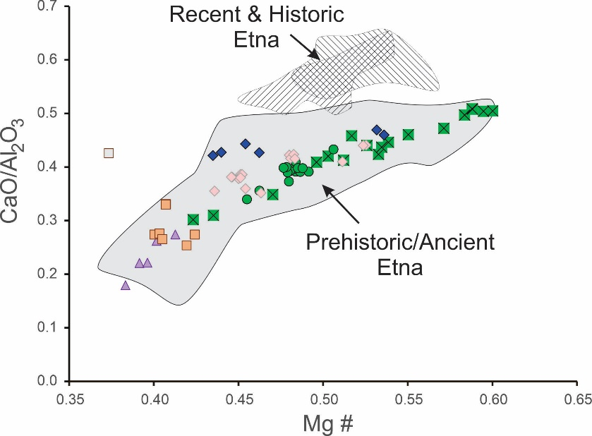
(a)
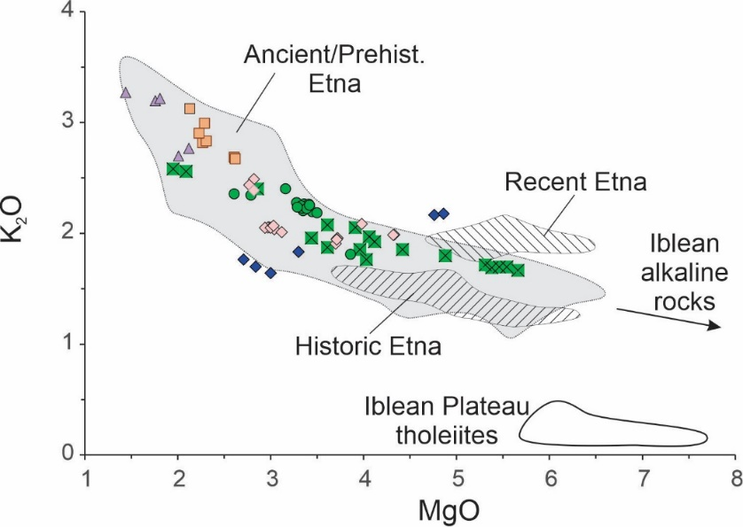
(b)

Figure S2 (a) Samples from the six Valle del Bove units plotted as Differentiation Index (DI, where DI = normative q + or + ab + ne + lc) vs degree of silica saturation / undersaturation, represented here as normative quartz and normative nepheline, respectively. Salifizio-1 samples with no normative quartz or nepheline are transitional, containing normative olivine and hypersthene. (b) Plot of Differentiation Index vs SiO₂ wt. %. Note the two distinct differentiation trends in both diagrams. Lavas from Salifizio-1 and Piano Provenzana become more silica saturated as they become more evolved. Those from Salifizio-2, Cuvigghiuni, Tripodo Member and Mongibello become more silica undersaturated with increasing differentiation.

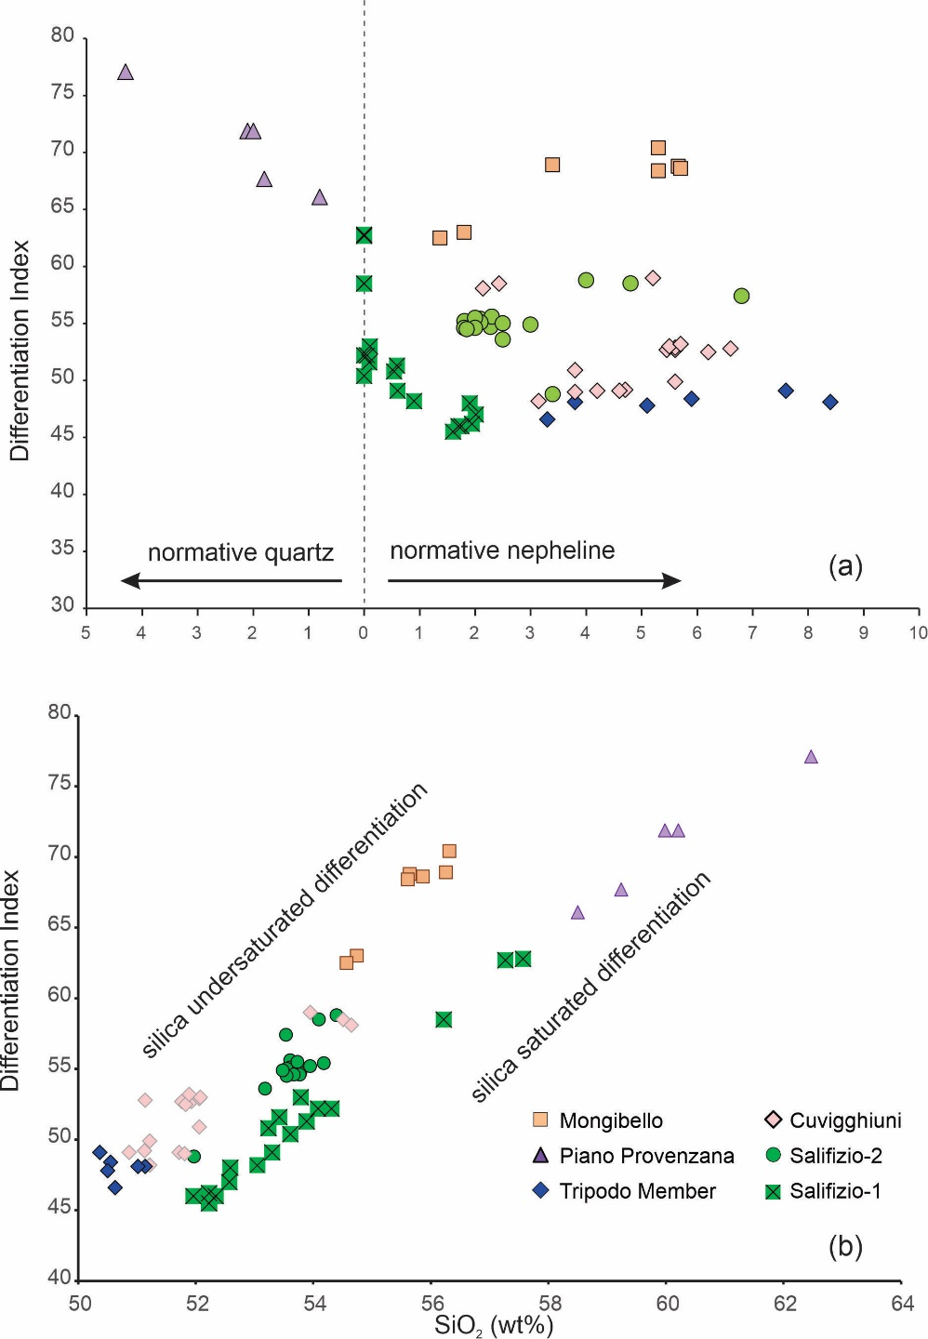

Figure S3 Plot of Differentiation Index versus Th (ppm) for samples from the six Valle del Bove units.
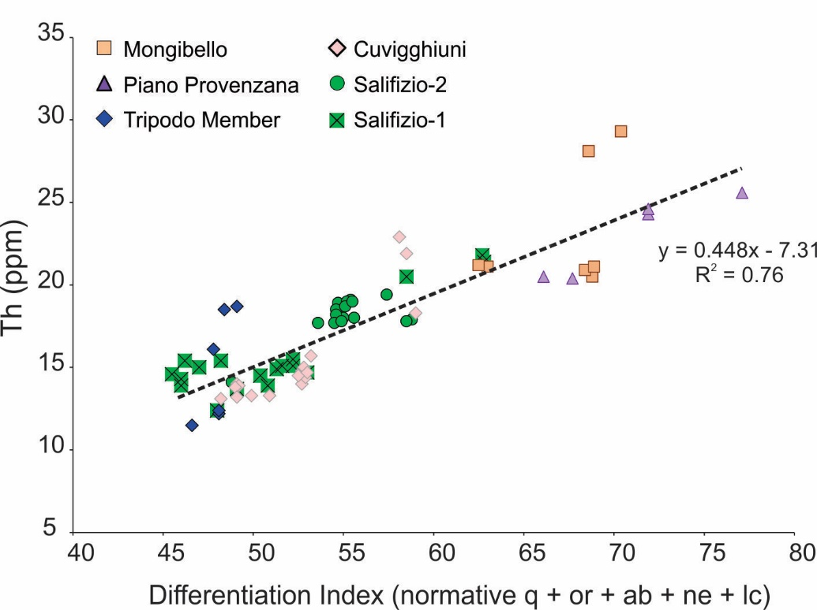

Figure S4. Plot of Na₂O concentrations versus Zr/Nb ratio. Data sources and symbols as in Figure 3 main text.
