Dynamics and timescales of mafic-silicic magma interactions
at Soufrière Hills Volcano, Montserrat

Rosa Didonna^{1*}, Fidel Costa^{2,3}, Heather Handley^{1,4}, Simon Turner¹, Jenni Barclay⁵

¹Department of Earth and Environmental Sciences, Macquarie University, Sydney, NSW, Australia
²Earth Observatory of Singapore, Nanyang Technological University, Singapore
³Asian School of the Environment, Nanyang Technological University, Singapore
⁴Department of Applied Earth Sciences (AES), University of Twente, Enschede, The Netherlands
⁵School of Environmental Science, University of East Anglia, Norwich, UK
*corresponding author: rosa.didonna@mq.edu.au

Supplementary Figure

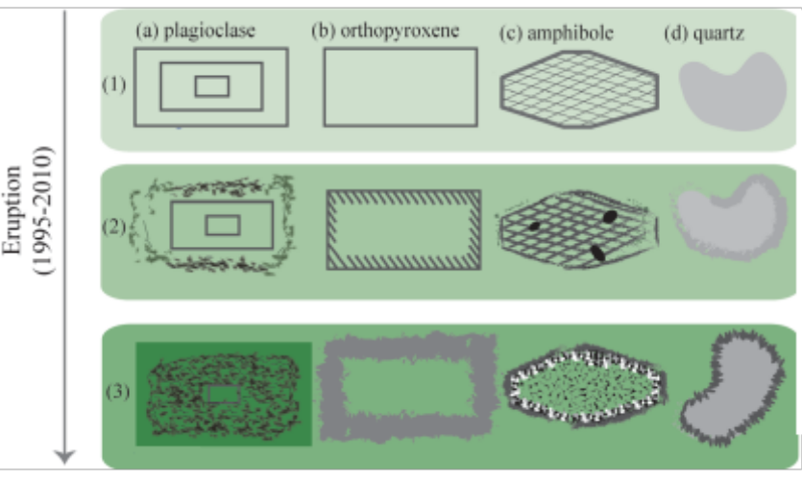

Figure S1 Schematic representation of the sequence of three events that occurred during interaction between the andesite and intruding basalt. (1) Andesite stored at relatively low temperature (850±50°C) and crystallinity of 40-50% (type I plagioclase and intermediate-core type II) (a), orthopyroxene (b), amphibole (c) and quartz (d) formed), with rhyolitic interstitial liquid. (2) Near-liquidus mafic magma intrudes the andesite that was reheated, and crystals began to partially melt. plagioclase dissolved and generated a sieve texture. Amphibole and quartz were dissolved and reacted. (3) After time, the interaction between the two magmas increases and the mafic magma cools down. Some of the crystals from the enclaves were reincorporated in the andesite magma. For more details see the text.

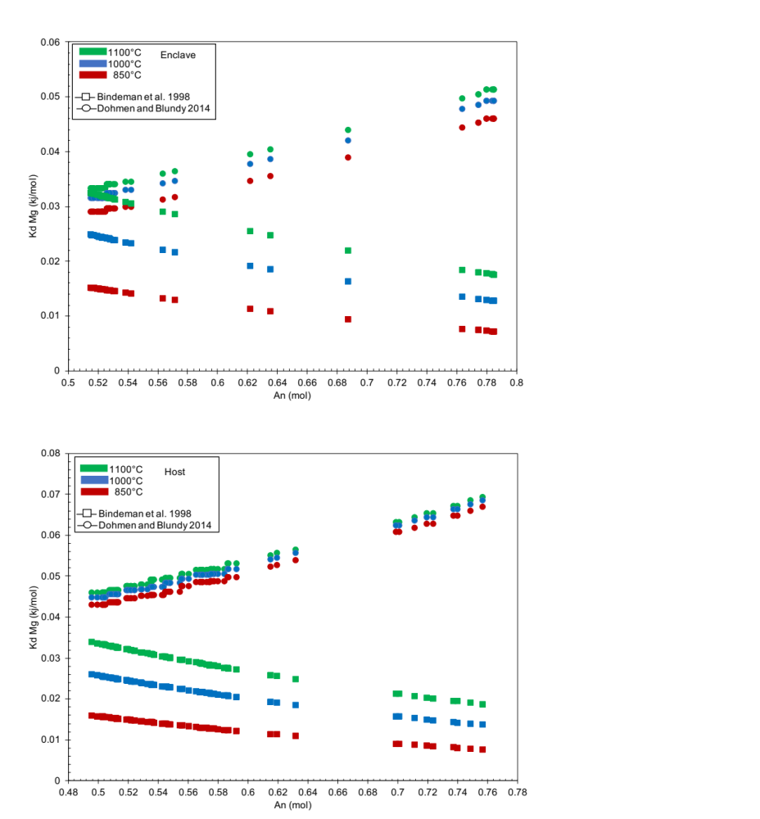
Figure S2 Comparison between partition coefficients (K_{D}) calculated using the equation proposed by Bindeman et al. (1998) (square) and Dohmen and Blundy (2014) (circle), selecting plagioclase phenocrysts found in enclave (a) and host (b).

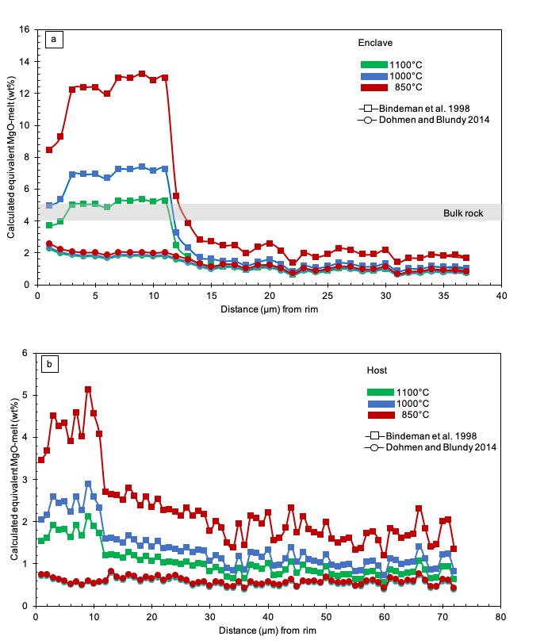

Figure S3 Profiles of calculated equivalent MgO in melt from plagioclase phenocrysts in enclave (a) and host (host). Results are based on K_{D} calculated using equation from Bindeman et al. (1998) (square) and Dohmen and Blundy (2014) (circle).

