Online Resource 1: ShapeCalc
See separate Excel Sheet.

Online Resource 2: ShapeCalc Documentation
ShapeCalc provides 3D (S:I:L) shape estimates for 2D (w-l) sample data. Best estimates are found by comparing the sample w/l distribution with 2618 model w/l distributions covering shapes from 1:1:1 to 1:20:20. The approach taken is analogous to CSDslice, including the binning of the w/l distribution into 25 bins with a width of Δw/l = 0.04. However, ShapeCalc is distinguished by a seven key differences:
- The model w/l distributions for ShapeCalc are derived from CSDCorrections (v 1.61; M. Higgins, personal communication), as they allow a more robust shape differentiation for S≈I (cf. Methods). Furthermore, using the same models for shape estimates and crystal size distribution analysis via CSDCorrections offers superior internal consistency for any CSD work.
- Each model distribution is based on 20000 random sections of a given model shape (CSDslice: 10000 datapoints).
- The database for ShapeCalc includes shapes up to 1:20:20, allowing adequate representation of crystals with extreme aspect ratios, which may be expected in rapidly cooled samples (CSDslice: 1:1:1 - 1:10:10).
- The ShapeCalc data grid offers a higher resolution for 3D intermediate and long dimensions I and L, and it reflects the greater uncertainty on L with a wider spacing (Table S1; Figure S1). The total number of model shapes included in the ShapeCalc database is 2618 (CSDslice: 703).
- The best S:I:L estimate is found by maximising the cumulative goodness of fit (GOF) between sample and model w/l distributions (Fig. S2), calculated as
(1)
$${R_{c}}^{2}=1-\frac{\sum_{j=1}^{25}{\sum_{i=1}^{j}{{(s_{i}-m_{i})}^{2}}}}{\sum_{j=1}^{25}{\sum_{i=1}^{j}{{\left[s_{i}-\frac{(\sum_{i=1}^{n}{s_{i})}}{25}\right]}^{2}}}}$$
where $s_{i}$ is the normalised frequency of crystals in bin$i$ for the sample w/l distribution, and $m_{i}$ is the normalised frequency of crystals in bin$i$ for the model w/l distribution.
The cumulative assessment of the GOF using ${R_{c}}^{2}$ is distinct from$R_{CSDSlice}^{2}$, which assesses the GOF based on the modes of the distribution. However, in natural samples, variations in both mode and tail frequencies are to be expected compared to w/l distributions derived from a perfect model crystal. The ${R_{c}}^{2}$ GOF test parameter accounts for such natural variability, as it is less sensitive to the modal value and variations in individual bins, but rather assesses the overall fit of the w/l distributions. An ${R_{c}}^{2}$ <0.975 indicates a larger discrepancy between sample and model w/l distributions than reasonably expected for a natural sample; such results are highlighted in red by ShapeCalc. In such cases, better results may be achieved by binning the w-l sample dataset (Fig. S2).
- ShapeCalc lists and displays the 300 best-ranked S:I:L estimates, colour coded by ${R_{c}}^{2}$. This threshold was empirically chosen as the limit in variation between sample and model. If desired, the threshold value can be easily changed in the spreadsheet.
- ShapeCalc provides constraints on the uncertainties on the best shape estimate as 1σ standard deviations on S/I and I/L of the 300 best shape estimates. These uncertainties are deliberately conservative to reflect the variability of crystal shapes both between and within crystal populations, as well as generally poor statistical constraints on I/L. Typical standard deviations are ± 0.04-0.11 for S/I, and ± 0.12-0.26 for I/L.

Table S1 Step sizes for I and L used to produce model
w/l distributions

Fig. S1 Grid of model shapes used by ShapeCalc. Every intersection between S/I and S/L tie lines represents a model shape in the ShapeCalc database

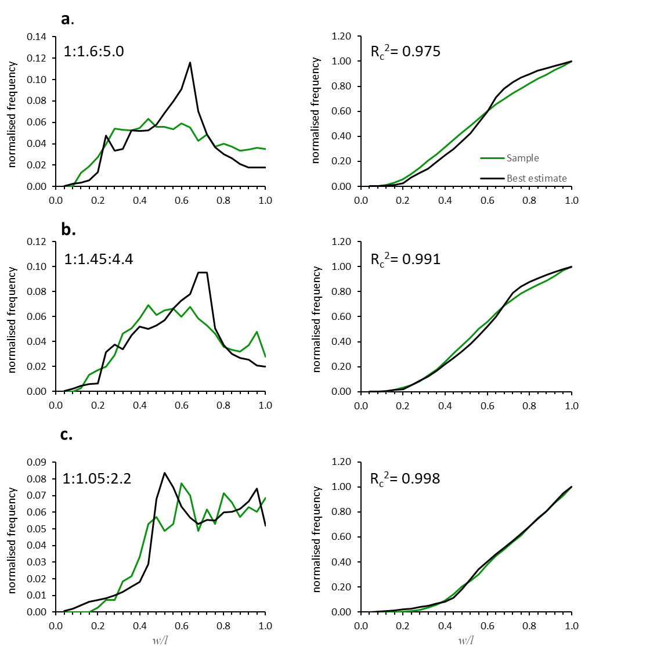
Fig. S2 Normalised and cumulative frequency plots of MSH sample SH131A-2. (a) unbinned dataset The fit between model and sample is at the threshold value of ${R_{c}}^{2}$ = 0.975, indicating that the best estimate may not be an accurate representation of true crystal shapes in the sample. Binning the w-l data into smaller length fractions, e.g., (b) 5-10 µm and (c) 0-5 µm, produces improved ${R_{c}}^{2}$ values indicative of a change in crystal shape with size

Online Resource 3: Textural data and shape estimates
See separate Excel Sheet.

Online Resource 4: Evaluation of measuring technique and statistical effects
Image processing packages such as ImageJ calculate the aspect ratio of a polygon by measuring the width and length of a best-fit ellipse, i.e., an ellipse of equal area, orientation and centroid as the original shape. Combined with thresholding algorithms, which can identify the desired shapes, w-l data can be rapidly extracted from an image. However, as crystals in natural samples are commonly intergrown, automatic thresholding is often not feasible, and even manual outlining of individual crystals can be challenging. Direct line measurements of crystal length and width are more time consuming, but they offer greater conceptual robustness, as it is not necessary to know the complete 2D crystal outline in order to determine l and w accurately. To test whether the method of acquiring w and l affects shape results, we measured plagioclase crystals in six BSE images of sample SH131A-2 using both crystal outlines and direct line measurements. The w-l distributions (n ≈ 600) for both methods are in overall good agreement, the only slight difference being the greater relative abundance of w/l > 0.9 (Fig. S3a).
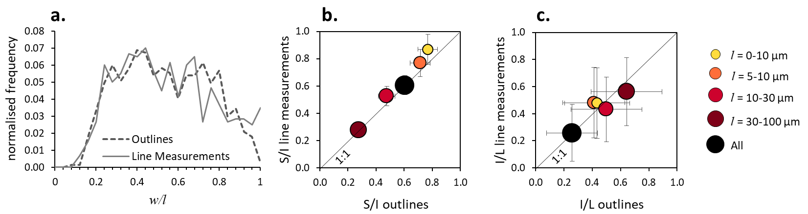Fig. S3 Shape results for ≈600 plagioclase crystals counted using crystal outlines or direct line measurements to obtain length and width data. (a) normalised frequency plot of 2D data. (b) and (c) ShapeCalc 3D best estimates for line measurement data plotted against those for outline data, (b) S/I and (c) I/L
Similarly, processing of the 2D datasets using ShapeCalc yields consistent S:I:L best estimates across length fractions (Fig. S3b & c). Ratios of S/I and I/L show a difference between methods of ≤0.1, which constrain uncertainties on S/I and I/L derived from measurement errors to ± 0.05. These uncertainties are equal to or lower than those related to most ShapeCalc model results, suggesting that both methods of constraining the aspect ratios of 2D crystal intersections are robust and reproducible.
Because of the limited number of crystals counted for the measurement technique test (n = 599), individual size bins contain low numbers of intersection data (n = 33-265). Such small sample sizes may preclude accurate S:I:L estimates, and indeed no S:I:L could be determined for the l = 0-5 μm size fraction (n₀₋₅ = 33) as the data is too spurious. Morgan & Jerram (2006) suggested that a minimum of 250 sections is necessary for accurate S:I:L estimates in natural samples, and that more sections are required for shapes with S≈I due to the cut-section effect (cf. Methods Section). We tested the effect of statistics on 2D w-l data and 3D S:I:L estimates by comparing results of two individual counts of plagioclase in BSE images of SH131A-2 (Fig. S4). The first dataset is the one obtained for the test of the measuring technique (n = 599), with the number of sections per bin varying from 126 to 265. The second dataset is the one used to obtain the S:I:L estimates presented in the main article (n = 2518), with 354-1450 sections per bin.
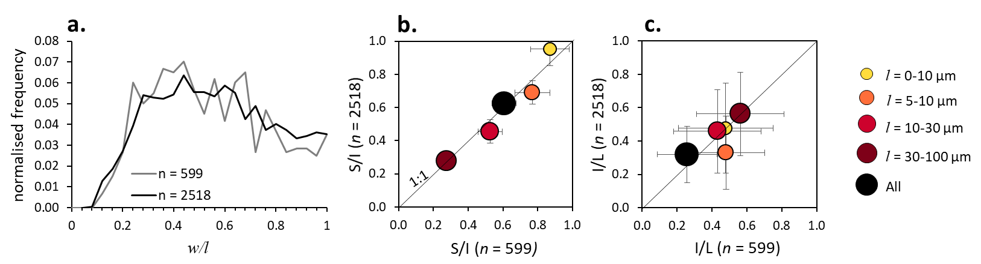
Fig. S4 Shape results for different counting statistics of MSH sample SH131A-2. In a first run, widths and lengths of 599 crystals were measured; in a second run of the same sample, 2518 crystals were measured. (a) normalised frequency plot of 2D data. (b) and (c) ShapeCalc 3D best estimates for the two runs plotted against each other, (b) S/I and (c) I/L
The w-l distributions for the respective complete datasets are broadly consistent (Fig. S4a), and S:I:L estimates show good agreement (Fig. S4b & c), including the bins with the smallest n (l = 30-100 μm). The largest differences between the two datasets are observed for the size fractions with shapes approaching S/I = 1, i.e., the l = 0-10 μm and 5-10 μm fractions (ΔS/I ≤0.08, ΔI/L ≤0.15). It should be noted that even the largest discrepancies related to counting statistics are equal to or smaller than uncertainties related to the modelling performed with ShapeCalc. We conclude that when using ShapeCalc, a minimum number of 200 w/l data points is recommended in order to estimate a 3D shape for an unknown sample; for tabular crystal shapes (S<<I), robust results can be obtained with ~100 2D crystal intersections.

Online Resource 5: Evaluation of binning effects
While a trend towards lower S/I with increasing crystal size is supported by visual assessment of crystal textures (Figs. 1 & 5), it is important to test whether the binning process itself introduces artefacts into 3D shape estimates. The predominance of plagioclase crystals with 2D intersection lengths <10 µm in natural samples (Table 1), most of which show euhedral shapes, strongly suggests that they represent distinct, small crystals rather than simply being edge cuts of larger crystals. The presence of several crystal populations of varying size is therefore evident. However, it needs to be tested whether the observed shape trends could be caused by multiple crystal populations of different size but same morphology. Random sectioning of a crystal will not only produce crystal intersections of variable 2D aspect ratios (w/l), but also of variable lengths l. For example, a crystal population with true 3D dimensions of 10:20:100 μm will produce 2D intersection lengths with a mode of l = 20 μm (i.e., cut perpendicular to L), but there will also be shapes with l between 0 (i.e., cut off a corner) and 100 μm (i.e., cut parallel to L). Similarly, a crystal population with true dimensions of 1:2:10 μm (i.e., same shape but ten times smaller) will produce intersection lengths between 0 and 10 μm. If both the 10:20:100 μm and the 1:2:10 μm crystal population are present in the same medium (i.e., a polydisperse population of equal shape), intersection shapes with l = 0-10 μm could be from either population, and the w/l data for l = 0-10 μm will include both crystal populations. In volcanic rocks, multiple generations of a given mineral phase (and therefore varying true size) are commonly present, which is the basis of all CSD analyses (cf. Marsh, 1988; Cashman & Marsh, 1988). Overlapping w/l distributions could therefore produce artificial shape estimates when binned by l. To test whether the observed systematic trends could be caused by multiple crystal populations of same shape but different size, we produced a hybrid w/l distribution representing four crystal populations of identical shape but scaled to 1/3, 1/9, and 1/18 of the original l. We used the w-l data of sample SH226, which is dominated by crystals with l >10 μm and consistent tabular shape (Table 1); the few crystal intersections with l <10 μm are likely peripheral cuts of the larger tabular crystals. We then created three scaled down duplicates of the unbinned SH226 dataset by dividing w and l by 3, 9, and 18; intersections with l < 1 μm were discarded as these would not be resolved in BSE images. The four w-l datasets were combined into a new hybrid model, which was then binned and processed like the other samples in this study. The results show that while there is minor variability in 2D w/l data (Fig. S5a), the underlying 3D shape is always reproduced within error, irrespective of length fraction modelled (Fig. S5b). Therefore, the variation of crystal shape with size observed for our sample set is not considered an artefact of the binning process.
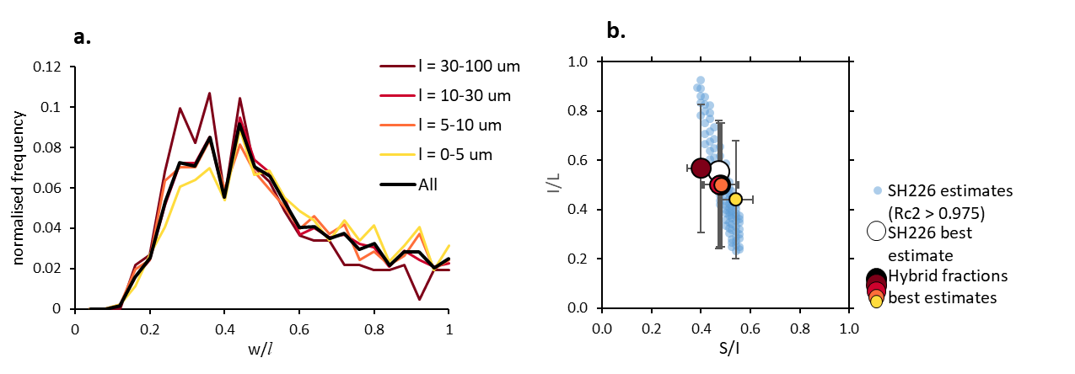
Fig. S5 2D and 3D shape results for a hybrid sample with four crystal populations of identical shape but different sizes, generated from sample SH226. The best shape estimate for the unbinned SH226 dataset is reproduced within error by all length fractions of the polydisperse sample, suggesting that binning of w/l dataets does not introduce artefacts to shape estimates. (a) 2D w/l distributions for individual size fractions of the hybrid sample. (b) Zingg diagram showing 3D estimates for all size fractions of the hybrid sample, as well as shape estimates for the original, unbinned SH226 dataset.

