Supplementary figures:
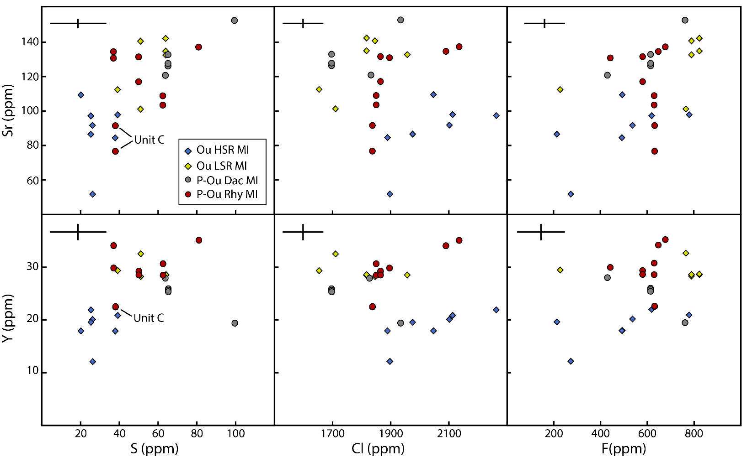
Fig. S1. Selected trace element (ppm) versus sulfur (ppm) and chlorine (ppm) plots for melt inclusions from Oruanui high- and low-silica rhyolite (Ou HSR MI and Ou LSR MI respectively), and post-Oruanui dacite and rhyolite compositions (P-Ou Dac and P-Ou Rhy respectively).
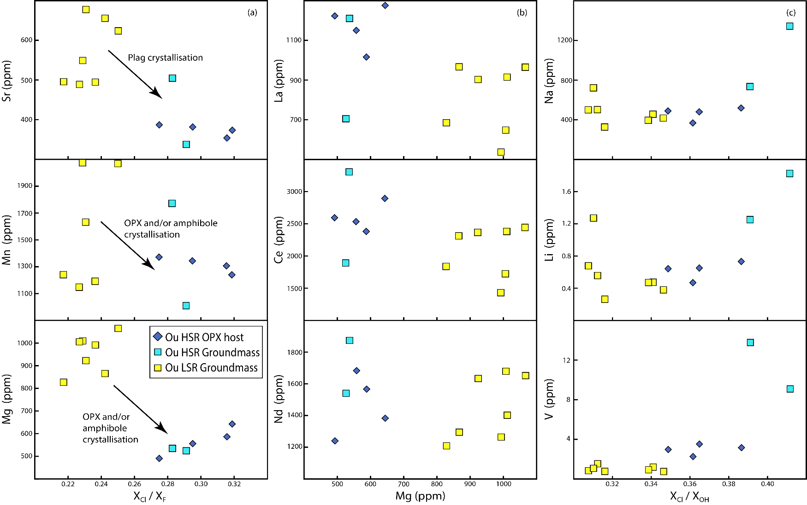
Fig. S2. Trace element (ppm) diagrams for orthopyroxene-hosted apatite inclusions and microphenocryst apatite from Oruanui. a Mole fraction ratio X_{Cl} / X_{F} versus compatible trace elements. b Mg versus incompatible REE. c Mole fraction ratios X_{Cl} / X_{OH} versus selected trace elements showing anomalies in HSR groundmass apatites. All data and standards are presented in Online Resource 1. See text for discussion.

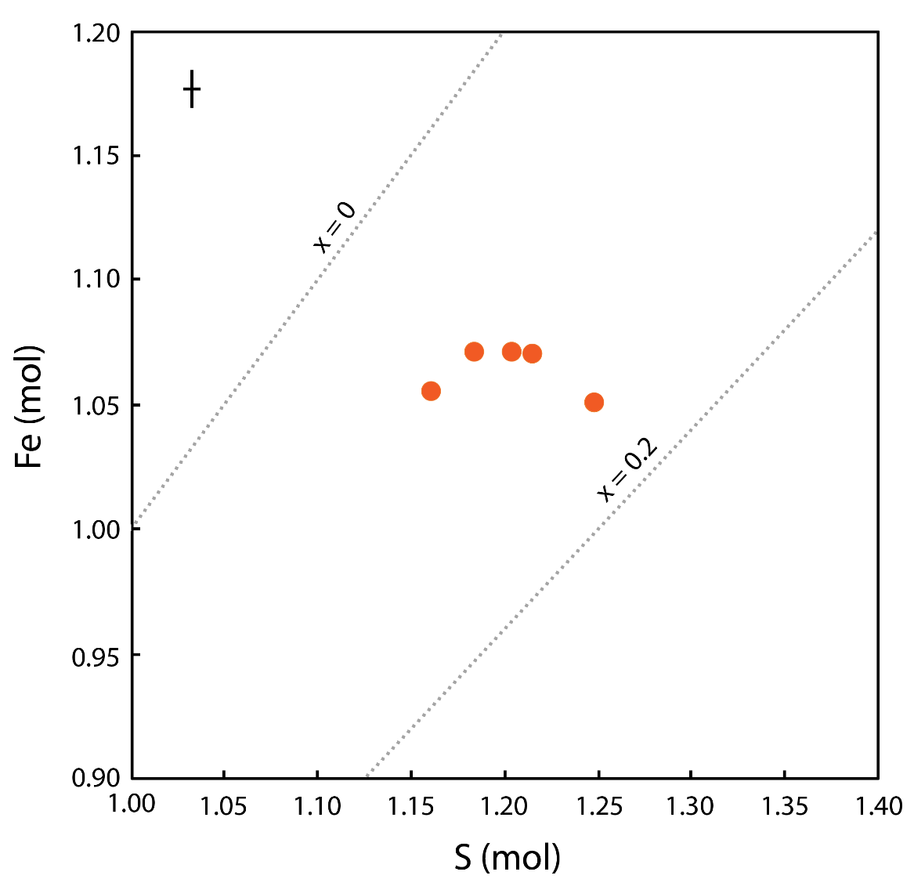
Fig S3. Fe (mol) vs S (mol) for orthopyroxene-hosted pyrrhotite inclusions from units Ψ and Ω. Dotted grey lines indicate the range of acceptable X values for pyrrhotites chemical formula Fe1-xS. The error bar represents the average 2 s.d. based on repeated analyses of Elba Pyrite.

