SUPPLEMENTARY FILE 2 – TIMS METHODS

The compositional diversity and temporal evolution of an active andesitic arc stratovolcano: Tongariro, Taupō Volcanic Zone, New Zealand

Authors: Leo R Pure*, Colin JN Wilson, Bruce LA Charlier, John A Gamble, Dougal B Townsend, Graham S Leonard
Journal: Contributions to Mineralogy and Petrology

Purification and column separation procedures for isotopic analysis
Cation and anion exchange columns were used to separate Sr, Nd and Pb from dissolved samples, following digestions described in the main text. Column chemistry methodologies broadly follow those of Pin et al. (2014), with minor modifications that are summarised below. An illustrated summary of column Sr-Nd-Pb separation is shown in Fig. S.2.1.

Strontium (Sr)
Columns were fashioned from 1 mL EppendorfTM plastic pipette tips that were loaded with a porous polyethylene frit cut with a stainless-steel cork borer. Trial and error experimentation showed that cutting the pipette tips diagonally at their ends below the frit maximised drip rates (done with a stainless steel razor blade cleaned with ethanol and MQ H₂O), as shown for Sr-specTM and TRU-specTM (Triskem International), and AG1-X8TM (Biorad) columns in Fig. S.2.1. These columns were cleaned then stored in a Teflon vat filled with 3% HNO_{3,} and were removed at the time with of use Teflon tweezers, dried with clean-room wipes (3MTM, USA) and placed into a custom-made perspex stand. Flow-rates were checked initially using MQ H₂O to ensure that subsequently loaded resin would be free-draining. This setup procedure also applies to TRU-specTM and AG1-X8TM columns.
About 7 drops of Sr-specTM resin (~0.15 mL) were loaded into these columns and cleaned with two full column volumes (CV) of 6M HCl and MQ H₂O each, in that order. Waste was collected in plastic shot-glasses beneath the dripping columns. This step onwards is summarised in Fig. S.2.1. HCl and MQ H₂O were dispensed from PFA squeezy bottles. The resin was then pre-conditioned with 1 CV 9M HNO₃. The required volume of sample needed for 500 ng Sr, already dissolved in 9M HNO₃ (usually ~0.1 mL for andesite samples in this study, from the same digestion used for Nd separation), was pipetted onto the resin gently, dripped from a 1 mL EppendorfTM pipette down the sides of the column. Successive elution volumes were added, then allowed to drain, before the next elution followed. Elution steps were in volumes 50 µL, 100 µL, 200 µL, 1 mL then another 1 mL. Waste was discarded and the sample was collected into a pre-cleaned 3 mL SavillexTM PFA (USA) beaker with 2 mL MQ H₂O. This was dried down at 100-120 °C, sometimes overnight, within sealed laminar flow cabinets.
Sr-specTM resin used for chemical separation was pre-cleaned according to the following procedure (Charlier et al. 2006). Using a plastic retort stand, a 2 mL BioradTM plastic column with reservoir extension filled with dry Sr-specTM resin was suspended above a waste acid receptacle. The column was repeatedly filled with ~250 mL of acid that dripped through the resin according to the following cycle, after initially wetting the resin with MQ H₂O: (1) MQ H₂O, (2) 6M HCl, (3) 0.05M HNO₃, (4) 0.2M H₂SO₄. This was repeated a total of five times. During cleaning, the funnel was left covered with a sheet of ParafilmTM (Bemis Company, USA).

Neodymium (Nd)
Chemical separation of Nd required two sets of columns: the first with TRU-spec resin (to remove most matrix elements and provide a REE-enriched solution) and the second with LN-spec resin (to provide a purified Nd sample). TRU-spec resin was loaded into columns fashioned from 1 mL Eppendorf tips as described for Sr separation, above. LN-spec columns were constructed with larger 2 ml columns (EichromTM) and calibrated chromatographically, which process is described below. The sequence for Nd separation is as follows.
Sample aliquots for Nd separation were already dissolved in 9M HNO₃ (from the same digestion used for Sr separation) were dried down after the Sr aliquot had been processed. These were then re-dissolved in a mixture of 2M HNO₃ + ascorbic acid that was made by dissolving 2.5 g of crystalline ascorbic acid (Sigma AldrichTM) in 50 mL of 2M HNO₃ within a pre-cleaned PFA centrifuge tube (this volume being sufficient for processing 12 samples through TRU-spec resin). Ascorbic acid is used to reduce the iron to Fe²⁺ from Fe³⁺ because a better separation is achieved when Fe is in a reduced state (Pin et al. 2014). Once a clear solution was obtained, 0.5 mL of the 2M HNO₃ + ascorbic acid mix was added to the dried samples and beaker lids were closed tightly. Most andesitic samples examined in this study turned a murky olive-green/black colour on account of the Fe reduction; some Fe-poor samples (e.g. AGV-2) immediately achieved a transparent olive-green colour. The addition of 2M HNO₃ + ascorbic acid solution to dried samples was done ≤1 hr prior to commencing column separation. Any re-dissolved samples that were originally murky, that became transparent (as AGV-2), were diluted with a further 0.5 mL of 2M HNO₃ + ascorbic acid solution to ensure the Fe remained in its reduced state.
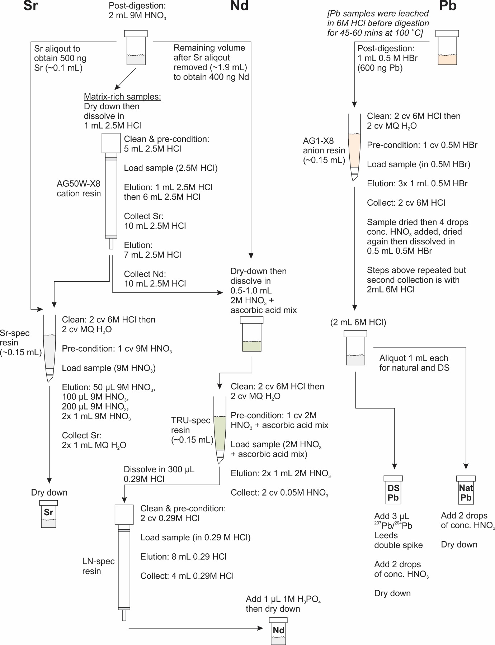
Figure S.2.1. Summary cartoon showing chemical column separation procedures for Sr, Nd and Pb, following the methods of Pin et al. (2014).

TRU-spec resin was loaded into columns fashioned from 1 mL Eppendorf pipette tips (see above), and cleaned with two full CV of 6M HCl and MQ H₂O each, in that order. Waste was collected in plastic shot-glasses beneath the dripping columns. This step onwards is summarised in Fig. S.2.1. The resin was then pre-conditioned with 1 CV 2M HNO₃ + ascorbic acid mixture and the sample was loaded gently from a 1 mL EppendorfTM pipette into the column. Elution volumes were added, then allowed to drain, before the next elution followed. The elution steps were 2x 1 CV 2M HNO₃ (not mixed with ascorbic acid) which was collected as waste then discarded. Samples were collected into pre-cleaned 7 mL SavillexTM PFA (USA) beakers with 2x 1 CV 0.05M HNO₃. This was dried down at 100-120 °C, never overnight, in laminar flow cabinets, then re-dissolved in 300 µL 0.29M HCl in preparation for LN-spec columns (below).
A note on preparing 0.29M HCl: the 0.29M HCl used for dissolving samples and eluting with in LN-spec columns must closely match the concentration of the 0.29M HCl used to calibrate the LN-spec columns originally. This is because the separation of Nd from other REEs follows a chromatographic scheme, and depends on reproducible conditions to maximise the collection of the most Nd-enriched aliquot of eluted HCl, relative to other REEs. Over the course of this study, two batches of 0.29M HCl were made in 2 L PFA bottles. Using density-concentration relationships, the required masses of 6M HCl and MQ H₂O needed to produce 0.292M HCl were calculated. First the densities of 6M HCl and MQ H₂O were measured with a density meter accurate to 0.0001 g/cm³. For the second 0.29M HCl batch, these had densities of ρ = 1.1011 g/cm³ at 19.3 °C (6.230M HCl) and ρ = 0.9993 g/cm³ at 20.4 °C (MQ H₂O). For each batch, the predicted 0.29M HCl density was cross-checked with a density meter and found to be exactly as predicted (ρ = 1.0034 at 20.3 °C) in the first batch (20 Sep 2018) and very similar (ρ = 1.0036 at 20.4 °C) in the second batch (27 Feb 2019), with the small difference considered insignificant in changing the position of the Nd cut in the column elution profile.

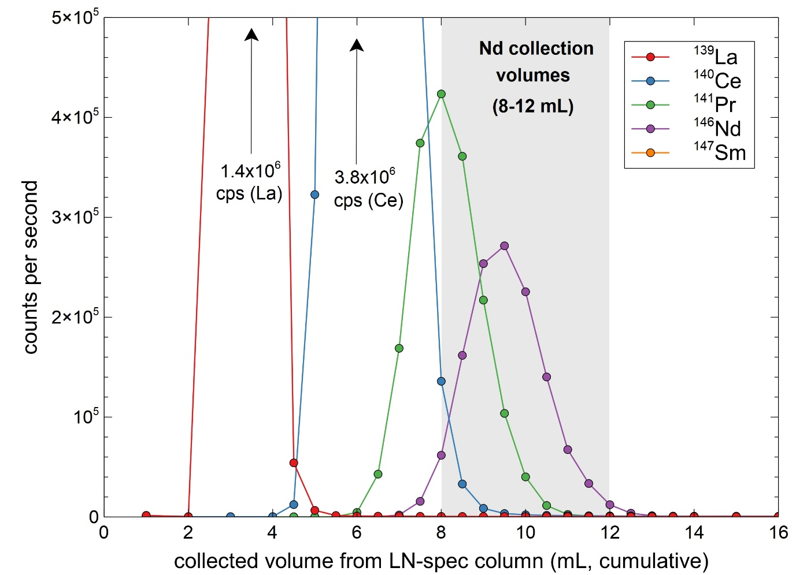
Figure S.2.2. LN-spec column calibration profile for La, Ce, Pr, Nd and Sm as used for batches I2-6 in this study. Calibration was performed on Tongariro andesite sample LP009B which was previously passed through a TRU-spec column then re-taken up in 2 M HNO₃ + ascorbic acid ≤1 hr prior to column pass. Elutions were performed with 0.29M HCl. ¹⁴⁷Sm occurs in low concentrations that obscure its visibility.

The column separation of Nd from other REEs in this study used two sets of LN-spec columns. An older set of columns calibrated by Swallow (2018) were used for Batch I1, which were shorter and contained less resin. This resulted in poorer separation of neighbouring REEs from the Nd and thus greater isobaric interferences with other REEs (principally Ce) during TIMS analysis. To address this, a second set of LN-spec columns were constructed from new resin that was used for batches I2-I6. The new LN-spec columns were cleaned with MQ H₂O and repeated washes with 6M HCl before first ever use. The calibration for this second set of columns was made with an internal standard (andesite sample LP009B) with 0.292M HCl prepared as described above. Column elutions were collected in 1.0 mL increments (0-4 mL; 14-20 mL) and 0.5 mL increments (4-14 mL) and analysed by solution ICP-MS, following procedures described in the main text. Count rates were measured for ¹³⁹La, ¹⁴⁰Ce, ¹⁴¹Pr, ¹⁴⁶Nd and ¹⁴⁷Sm, as shown in Fig. S.2.2. The results of this calibration indicate that the optimal elution volumes to collect for Nd are the 8th, 9th, 10th and 11th millilitres (from zero) (Fig. S.2.2).
LN-spec columns were cleaned immediately after preceding Nd separation with 2 CV 6M HCl, then further cleaned and conditioned with 2 CV 0.29M HCl. Before use, these columns were taken from storage (with 0.29M HCl) and re-conditioned with 2 CV 0.29M HCl before samples were loaded and eluted. Samples were previously dissolved in 300 µL 0.29M HCl, which was loaded gently into the columns with a 1 mL EppendorfTM pipette. The columns were then eluted with 8 mL 0.29M HCl in 1 mL increments, which were allowed to drain before the subsequent elution was added, with these first 8 mL discarded as waste. The subsequent 8th, 9th, 10th and 11th mL 0.29M HCl elutions (from zero) were collected in pre-cleaned 7 mL SavillexTM PFA (USA) beakers, after first adding 1 µL 1M H₃PO₄ to each beaker with a 10 µL EppendorfTM pipette (although it is recommended to use 0.01M H₃PO₄ for any future users of this method) (Figs. S.2.1 and S.2.2). These collections were dried down at 100-120 °C, never overnight, in sealed cabinets. Subsequent cleaning and storage procedures of the LN-spec columns are described above.

Lead (Pb)
Pb separation was performed using the traditional ‘bromide method’ (Strelow and Toerien, 1966) on AG1-X8 resin anion columns (Fig. S.2.1), following techniques that are similar to those described by Kempton (1995). Two elution cycles, with an intermediate collection and dry-down stage, were used to obtain a highly pure Pb separate from digested samples. Sample masses weighed for digestions contained 600 ng Pb, which may be relatively high but was intended to compensate for Pb lost during leaching. Sample powders were leached before beginning digestions, following Baker et al. (2004) and Todd et al. (2015), which was important for removing anthropogenic contamination (from past usage of leaded petrol). Leaching also removes sub-millimetre isotopic heterogeneities that can develop in ~zero-age volcanic rocks between alteration minerals and their coexisting protoliths (e.g. Todd et al. 2015).
Initial attempts to separate Pb failed because of undissolved gel-like material in HBr solutions that were introduced to the columns. Investigations here deduced that the gel-like material inhibits flow through the column and binds to the resin, reducing its capacity to sorb the Pb from the mobile phase during the elution process with HBr. Consequently, Pb is generally lost as elution waste and elements other than Pb are over-represented in final collections, which characteristically poisons the Pb ionisation during TIMS analysis. In the process of identifying this issue, tests were undertaken to ascertain whether poor Pb yields were due to excessive Pb loss during leaching. These experiments analysed the supernatant fluid (6M HCl) that was removed after leaching three samples with between 4.6-14.3 ppm Pb, following leaching in 6M HCl at 100 °C for 45-60 mins. Analyses were made via solution ICP-MS. Results of these experiments are reported in Table S.2.1 and show that leaching removed 16-35 % of Pb in the samples (a basaltic-andesite [LP097], an andesite [LP039] and a dacite [LP234]).

Table S.2.1. Results from Pb leaching tests wherein the Pb lost into the leachate was analysed.
Sample | Pb in powder (ppm) | Powder leached (mg) | Total Pb in powder (ng) | Total Pb in leachate (ng) | % Pb lost as leachate
LP039 | 9.8 | 109.98 | 172 | 1078 | 15.9
LP097 | 4.6 | 94.77 | 154 | 436 | 35.3
LP234 | 14.3 | 99.36 | 417 | 1421 | 29.3

The Pb separation process is summarised as follows. Prior to digesting samples for Pb separation, all samples were leached in 6M HCl for 45-60 mins at 100 °C, with the supernatant discarded. Immediately after leaching, HF + HNO₃ was administered to begin digestions in addition to <300 µL remaining after the leach. These were separate from Sr-Nd digestions. When Pb digestions were completed, samples were dried down to a gel then re-dissolved in 0.5M HBr. These solutions typically contained undissolved gel-like material, and to ensure only pure solutions were used for Pb separation, the HBr solutions were centrifuged for 5 mins in 2.5 mL centrifuge tubes that were pre-rinsed with 1 mL 0.5M HBr. Note that because Pb is highly soluble in 0.5M HBr, it is unnecessary (and undesirable—see below) to include the separated gel-like material during column separation.
Columns fashioned from 1 mL EppendorfTM pipette tips, as for Sr separation (described above), were loaded with 7 drops of AG1-X8TM resin (~0.15 mL) and cleaned with 2x CV of 6M HCl and MQ H₂O each, in that order. Waste was collected in plastic shot-glasses beneath the dripping columns. This step onwards is summarised in Fig. S.2.1. The resin was then pre-conditioned with 1 CV 0.5M HBr. In their respective columns, samples were gently dripped from a 1 mL EppendorfTM pipette down the sides of each column onto the resin bed. Elution volumes were added, then allowed to drain, before the next elution followed. The elution steps were 3x 1 CV 0.5M HBr, then the sample was collected in the original digestion beaker that had been cleaned during the elution process. To clean the 15-22 mL beaker for reuse, all gel-like material was washed out with MQ H₂O and discarded, then the beaker was filled with 3 mL 6M HCl and fluxed at 120 °C for 20 mins. The HCl was then discarded and the beaker was re-rinsed with MQ H₂O, then used to re-collect the sample. Samples were collected with 2x 1 CV 6M HCl, which was dried down at 120-140 °C, then briefly re-dissolved with ~4 drops of conc. HNO₃ to remove HBr and destroy organic compounds derived from the resin. This was dried to a gel then re-dissolved in 0.5-1.0 mL 0.5M HBr. The process from pre-conditioning the columns to collecting samples was repeated in the same columns, with two differences: (1) only 2x (not 3x) 1 CV 0.5M HBr were eluted and (2) collection was with 2x 1 mL (not CV) 6M HCl into a pre-cleaned 2 mL SavillexTM PFA (USA) beaker. From this collection, 1 mL was aliquoted into a separate beaker, after first adding 3 µL of ²⁰⁷Pb/²⁰⁴Pb Leeds double-spike (DS). The amount of added DS was chosen based on tests with NBS982-DS mixtures (see below) that minimised the error magnification during data deconvolution. The spike was added before the dry-down stage to ensure full sample-spike equilibration in the DS aliquot. About 2 drops of conc. HNO₃ were added to both natural and DS aliquots and then dried down at 120-140 °C on separate hotplates in separate cabinets. Note again, beakers used for DS collections were never mixed with beakers used for natural samples.

Matrix-rich samples
A number of samples prepared for Sr and Nd isotope ratio analysis repeatedly failed because column purification did not satisfactorily remove matrix material. Consequently, TIMS analyses failed because of poor ionisation and loss of sample (loads were characterised by ~1 mm tall mounds on loaded filaments). These samples (LP113, LP113GM, LP149, LP149GM) possessed either flat CI-normalised REE profiles or positive Eu anomalies (LP113GM). To achieve successful analyses on these samples, new digested material was prepared and separated in AG50W-X8TM cation columns in order to remove matrix elements. The appropriate collections from these initial pre-concentration columns were then processed as per standard procedures for Sr and Nd separation (as above). A description of the separation process follows.
The (reused) AG50W-X8TM cation columns were cleaned and pre-conditioned with 5 mL 2.5M HCl. Samples were previously dissolved in ~2 mL 2.5M HCl after digestions, and were loaded gently into the column and allowed drain before beginning elutions. The separation on AG50W-X8TM cation columns is a chromatographic process and requires two successive cuts to be collected to give Sr-bearing and Nd-bearing solutions. The AG50W-X8TM columns used in this study were calibrated by Swallow (2018) and the elution process is described as follows. First, the columns were eluted with 1 mL 2.5M HCl, then another 6 mL 2.5M HCl once the first elution had dripped through. During this elution step, the original digestion beaker was rinsed with MQ H₂O then with 6M HCl then MQ H₂O again. Another 10 mL 2.5M HCl was added to the column and collected into the rinsed digestion beaker. This collection was the Sr-bearing aliquot and was subsequently processed according to procedures outlined to obtain Sr described above. After the Sr-bearing collection, a further 7 mL 2.5M HCl was eluted through the columns, which was discarded as waste. A further 10 mL 2.5M HCl was added and collected into a separate, previously-cleaned 15-22 mL Savillex PFA (USA) beaker. This cut contained the Nd fraction and was processed according to the Nd separation procedure described above.

Filament loading procedures
Filament componentry was cleaned after being stripped of previously analysed Re filaments, with components used for spiked versus natural sample analysis dealt with separately here and in all subsequent steps. Filament shields were scrubbed with a fibreglass brush and boiled alongside filament mounts, blank-plates and slit-plates in a Pyrex® (Corning Inc.) beaker filled with MQ H₂O (~1 L) and a cap-full of 30-volumes concentrated H₂O₂. After boiling, the samples were dried in an oven in boats shaped from aluminium foil overnight at 80 °C. New Re filaments were cut to size with ceramic scissors, formed using a filament bending gauge then welded onto the filament mounts using a spot welder. Using a ThermoScientificTM outgasser unit, all filaments were heated to 4 A twice over a 66-minute cycle that was initiated under a 5-6 x10⁻⁷ mbar vacuum. Filaments were stored in plastic boxes inside a desiccator until required.
Inside a laminar flow cabinet, each filament was loaded by first fusing small ~0.3 mm mounds of ParafilmTM (Bemis Company, USA) onto the Re filament wire that was heated with a 0.85 A current passing through it. The specific reagents used for Sr, Nd and Pb samples were administered with 10 µL EppendorfTM pipettes. These reagents were evaporated to dryness at ~0.8 A and then quickly heated with a ~1.5-2.0 A current for 2 seconds to burn off the ParafilmTM. Loading procedures for Sr, Nd and Pb are described as follows.
Sr single filaments (samples and NBS987 standards) were first loaded with 0.7 µL Ta₂F₅, (following Charlier et al. 2006), which is an activator that improves the ionisation efficiency of Sr. The samples obtained after drying Sr column collections were re-dissolved in 1 µL of conc. HNO₃ and loaded onto Ta₂F₅ as it evaporated, and then the activator-sample mix was fully dried together. The NBS987 solution used in this study had a concentration of 901 ng/µL Sr and was loaded in amounts of 1 µL per each standard.
After column separation and drying, Nd samples were dissolved in 1-3 µL of 1M H₃PO₄ for batches I1-I3 and with 0.01M H₃PO₄ for batch I6 and loaded onto double filaments. Note that 0.01M H₃PO₄ produced loads that were 80-90 % smaller than loads with 1M H₃PO₄; smaller loads from 0.01M H₃PO₄ were preferred for analysis. JNdi-1 (551 ng/µL) solution was loaded on filaments in amounts of 1 µL per standard.
Dried samples obtained from chemical separation of Pb (described above) were dissolved in 1 µL silica gel (Gerstenberger and Haase 1997). The gel was loaded onto each single filament then fused and quenched to produce a Pb-Si glass by ramping the filament current from 0.85 A to ~2.0 A over 1-2 seconds. The accuracy of Pb isotope ratio measurements was determined by analysing filaments loaded with NBS981 (for natural Pb) and an optimal mixture of NBS981-Leeds ²⁰⁷Pb/²⁰⁴Pb DS (for DS Pb). Both natural and DS Pb solutions (50 ng/µL) were loaded at a rate of 3 µL per filament, after first loading 1 µL of silica gel and partially drying the gel before adding the NBS981 solution.

TIMS instrumental operating conditions
All samples were analysed on Re filaments from the TIMS source chamber with a vacuum better than 2 x 10⁻⁷ mbar. All analyses were performed with various permutations of the standard nine Faraday cup configuration. For analyses in batches I1-I3, the Faraday collectors were connected to 10¹¹ Ω feedback amplifiers whereas samples in batches I4-I6 were analysed after five 10¹³ Ω feedback amplifiers were installed in exchange for five of the stock 10¹¹ Ω amplifiers during early 2019. After the 10¹³ Ω amplifiers were installed and the instrument was baked out, multiple daily gain calibrations for all amplifiers over subsequent weeks showed an initially rapid re-stabilisation of gain results. Variable gain sensitivities after the upgrade did not affect data comparability because gains were measured daily and all analyses were run with multiple internationally certified reference standards that were later used to externally normalise the analytical results.
Sr isotope measurements were performed on single outgassed Re filaments over 24 cycles of 10 block ratio measurements after a 20 second pre-baseline wait and 120 second baseline. Typical beams on ⁸⁸Sr were 4-6 V, which effectively ensured ⁸⁴Sr beams were at ~40 mV. For Batch I6, cups L1 (mass 84) and C (mass 85: Rb) were assigned to a 10¹³ Ω amplifiers to improve the stability of relatively low beam voltages on ⁸⁴Sr and ⁸⁵Rb which improved analytical precision. Inference corrections for ⁸⁷Rb on ⁸⁷Sr used the measured abundance of ⁸⁵Rb and ⁸⁷Rb/⁸⁵Rb = 0.385707 (Rosman and Taylor 1997). During analysis, Sr isotope data was corrected for instrumental mass fractionation using ⁸⁸Sr/⁸⁶Sr = 8.37521, which is equivalent to ⁸⁶Sr/⁸⁸Sr = 0.1194 using the exponential mass fractionation law (Thirlwall 1991). All sample wheels contained at least three NBS987 standards which were later used to determine external precision and normalise data to allow robust comparisons between analytical batches and published data. Sr blanks were calculated via isotope dilution (ID) using an ⁸⁴Sr-enriched tracer, measured at the end of analytical sessions after all samples were completed.
Nd isotope measurements were performed over 24 cycles of 10 block ratio measurements for batches I1-I3 and 18 cycles for batches I4-I6. For all Nd analyses this was after a 20 second pre-baseline wait and 120 second baseline. Nd isotope analyses use closely spaced opposing double outgassed Re filaments (separated by as little as 100 µm). One filament (evaporation side) was loaded with the sample and the opposing filament (ionisation side) was not loaded. Typical ionisation (unloaded) filament temperatures during analysis were ~1840 °C. Typical beams on ¹⁴⁴Nd were 0.5-3.0 V, which were strongly dependent on the closeness of the filament spacing (stronger beam = closer spacing). Nd isotope data were corrected for instrumental mass fractionation using ¹⁴⁶Nd/¹⁴⁴Nd = 0.7219 (O’Nions et al. 1977) and the exponential law, following Thirlwall (1991). All sample wheels contained at least three JNdi-1 standards (Tanaka et al. 2000) to monitor accuracy and to determine the external precision. Standard-normalised data could then be used for robust comparisons between analytical batches and with published data.
Pb isotope measurements were performed on samples loaded onto single outgassed Re filaments with the double-spike (DS) method, following Thirlwall (2000). Pb natural and double-spike (DS) aliquots were analysed separately on different sample wheels. Except for a single sample (LP103) analysed in Batch I1, all other analyses of natural Pb aliquots were performed with a 10¹³ Ω amplifier assigned to the cup measuring ²⁰⁴Pb (least abundant Pb isotope), which improved analytical precision (batches I4-I5). Natural Pb aliquots were analysed for 24 cycles (Batch I1) or 18 cycles (batches I4-I5) of 10 block ratio measurements. DS Pb aliquots were analysed for 18 cycles (Batch I1) or 12 cycles (batches I4-I5) of 10 block ratio measurements. All measurements were performed after a 20 second pre-baseline wait and 120 second baseline. Measured natural and DS Pb isotope data were deconvolved using a modified Newtown-Raphson inversion (BLA Charlier, pers. comm. 2017) with within-run uncertainties calculated using a 4000-iteration Mote-Carlo regression. All sample wheels contained at least three NBS981 standards (both natural and DS) to determine external reproducibility and to normalise data to allow robust comparisons between analytical batches and with published data.
The ²⁰⁷Pb-²⁰⁴Pb double spike used for this work is an in-house spike that was prepared by RA Cliff (University of Leeds) and calibrated at VUW (nicknamed ‘Leeds DS’). Calibration of the double spike was carried out against NBS982 (‘equal atom lead’) which was prepared gravimetrically from the pure metal form. The isotopic composition of the double spike was determined via inversion of the double spike calculation on mixtures of the DS and NBS982 where the value ²⁰⁸Pb/²⁰⁶Pb = 1.00016 was used (taken from the NIST certificate of analysis for NBS982, available online). The ‘Leeds DS’ was found to have a concentration of 26 ppm total Pb and the isotopic abundances of ²⁰⁴Pb, ²⁰⁶Pb, ²⁰⁷Pb and ²⁰⁸Pb = 29.15%, 6.26%, 57.53% and 7.06% respectively. This double spike mixture is close to an optimal mixture as calculated using a MatlabTM implementation of ‘The Double Spike Toolbox’ (Rudge et al. 2009), and permits deconvolution of DS-natural mixtures with the lowest error magnification term.

Blanks for Sr-Nd-Pb isotope analyses
Blanks were determined for Sr-Nd-Pb isotope ratio analyses with solution ICP-MS and isotope dilution (ID) methods. Blanks analysed by solution ICP-MS did not include loading blanks whereas spiking methods did. ID spikes were sometimes used to determine Sr total procedure blanks (TPB) and a ²⁰²Pb/²⁰⁵Pb DS was sometimes used to determine Pb TPB amounts and isotope ratios. Blank amounts are summarised in Table S.2.2.

Table S.2.2. Sr-Nd-Pb isotope ratio blank amounts for all TIMS samples.
Batch | Element¹ | Blank type² | Sr (pg) | Nd (pg) | Pb (pg) | Blank method | Date | Comment
I1 | Sr | EF | 83.3 |  |  | ICP-MS | 1/08/2018
I1 | Nd | EF |  | 28.0 |  | ICP-MS | 1/08/2018
I1 | Pb | ND |  |  |  |  |  | Only LP103 run in this batch: SRM981 data are accurate and LP009B and LP024 Pb analyses are in excellent agreement with LP103 result from the same stratigraphic unit
I2 | Sr | TPB | 83.9 |  |  | ID TIMS | 17/08/2019
I2 | Nd | EF |  | 13.4 |  | ICP-MS |  | BLA Charlier (pers. comm. 2019)
I3 | Sr | TPB | 37.8 |  |  | ID TIMS | 8/02/2019
I4 | Pb |  |  |  |  |  |  | Assume as for Batch I5 because of done in same period from same resin and materials
I5 | Pb | TPB |  |  | 126.4 | ²⁰²Pb-²⁰⁵Pb DS | 10/07/2019 | From wheel 0540 in ²⁰²Pb/²⁰⁵Pb spreadsheet provided by BLA Charlier (pers. comm. 2019); the isotopic composition is available for this blank
I6 | Sr (normal) | TPB | 15.0 |  |  | ID TIMS | 17/07/2019 | All samples except LP113GM and LP149GM
I6 | Sr  (MQ wash) | EF | 3140 |  |  | ICP-MS | 2/07/2019 | For samples LP113GM and LP149GM
I6 | Nd | EF |  | 400 |  | ICP-MS | 2/07/2019
¹ ‘normal’ and ‘MQ wash’ refer to different sample treatment between most samples versus LP113GM and LP149GM, respectively.
² TPB = total procedure blank which includes loading, EF = full procedure except for filament loading, ND = not determined.

All blanks for Sr-Nd-Pb chemistry were generally excellent, being between 13.4-83.9 pg (Table S.2.2), and can be considered negligible against the amount of sample analysed. However, two samples analysed for Sr were only available as ~1 mg amounts of powder smeared over the inner surfaces of 2 cm x 7 mm glass vials, and were collected with water from an old MQ H₂O squirt bottle, which was evidently less clean than all other reagents used for Sr-Nd-Pb wet chemistry (Table S.2.2). The blank amount for these samples (LP113GM and LP149GM) is ~3140 pg, which for ~1 mg of sample with 230-258 ppm Sr, equates to 1.2-1.4 % of the Sr in the sample. These samples are groundmass separates that have paired whole-rock Sr isotope ratio measurements, which follow the trend observed in other data where blanks were negligible (Fig. 9 of the main text). This provides confidence that the analyses for LP113GM and LP149GM are accurate.

References
Baker J, Peate D, Waight T, Meyzen C (2004) Pb isotopic analysis of standards and samples using a ²⁰⁷Pb/²⁰⁴Pb double spike and thallium to correct for mass bias with a double-focusing MC-ICP-MS. Chem Geol 211:275–303.
Charlier BLA, Ginibre C, Morgan D, Nowell GM, Pearson DG, Davidson JP, Ottley CJ (2006) Methods for the microsampling and high-precision analysis of strontium and rubidium isotopes at single crystal scale for petrological and geochronological applications. Chem Geol 232:114–133.
Gerstenberger H, Haase G (1997). A highly effective emitter substance for mass spectrometric Pb isotope ratio determinations. Chem Geol 136:309–312.
Kempton PD (1995) Common Pb chemical procedures for silicate rocks and minerals, methods of data correction and an assessment of data quality at the NERC Isotope Geosciences Laboratory. NIGL Report 78, 26 pp. NERC Isotope Geoscience Laboratory, Keyworth.
O’Nions RK, Hamilton PJ, Evensen NM (1977) Variations in ¹⁴³Nd/¹⁴⁴Nd and ⁸⁷Sr/⁸⁶Sr ratios in oceanic basalts. Earth Planet Sci Lett 34:13–22.
Pin C, Gannoun A, Dupont A (2014) Rapid, simultaneous separation of Sr, Pb and Nd by extraction chromatography prior to isotope ratios determination by TIMS and MC-ICPMS. J Anal Atom Spectrom 29:1858–1870.
Rudge JF, Reynolds BC, Bourdon B (2009) The double spike toolbox. Chem Geol 256:420–431.
Rosman KJR, Taylor PDP (1997) Isotopic compositions of the elements 1997. Pure Appl Chem 70:217–235.
Strelow FWE, Toerien FVS (1966) Separation of Lead (II), from Bismuth (III), Thallium (III), Cadmium (II), Mercury (II), Gold (III), Platinum (IV), Palladium (II), and other elements by anion exchange chromatography. Anal Chem 38:545–548.
Swallow EJ (2018) Aspects of the petrology and geochemistry of the Huckleberry Ridge Tuff, Yellowstone. Unpubl PhD thesis, Victoria University of Wellington, Wellington, 333 pp.
Tanaka T, Togashi S, Kamioka H, Amakawa H, Kagami H, Hamamoto T, Yuhara M, Orihashi Y, Yoneda S, Shimizu H, Kunimaru T, Takahashi K, Yanagi T, Nakano T, Fujimaki H, Shinjo R, Asahara Y, Tanimizu M, Dragusanu C (2000) Jndi-1: a neodymium isotopic reference in consistency with LaJolla neodymium. Chem Geol 168:279–281.
Thirlwall MF (1991) Long-term reproducibility of multicollector Sr and Nd isotope ratio analysis. Chem Geol 94:85–104.
Thirlwall MF (2000) Inter-laboratory and other errors in Pb isotope analyses investigated using a ²⁰⁷Pb–²⁰⁴Pb double spike. Chem Geol 163:299–322.
Todd E, Stracke A, Scherer EE (2015) Effects of simple acid leaching of crushed and powdered geological materials on high-precision Pb isotope analyses. Geochem Geophys Geosyst 16:2276–2302.

0.292M is specified, despite rounding to 0.29M elsewhere in the text, to be consistent with subsequent densities, stock acid molarities and temperatures.

