Supplementary material
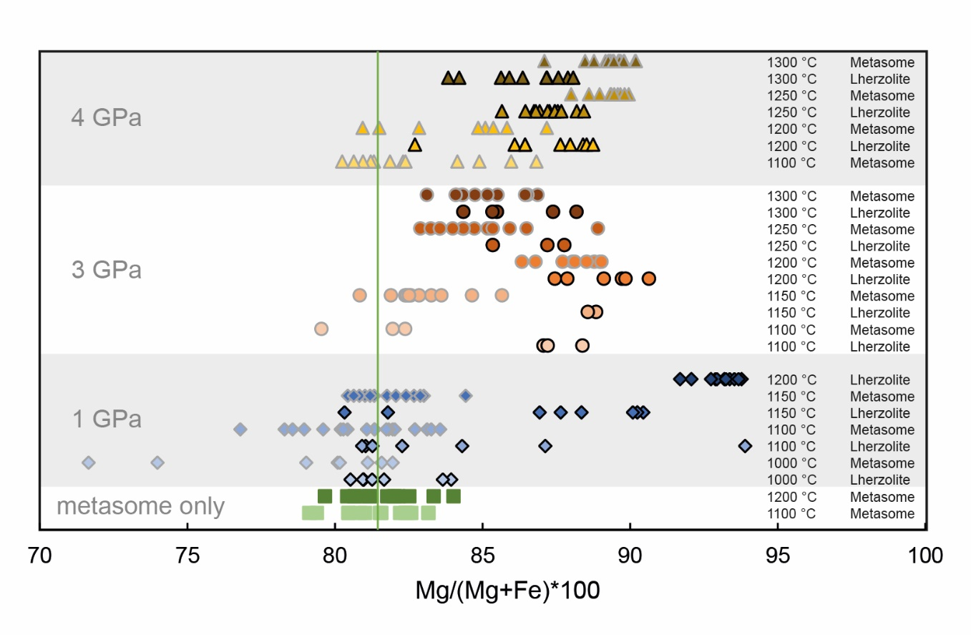
Figure S1: Mg/(Mg+Fe)*100 ratio for olivine The green line shows the average olivine value of the metasome starting material.

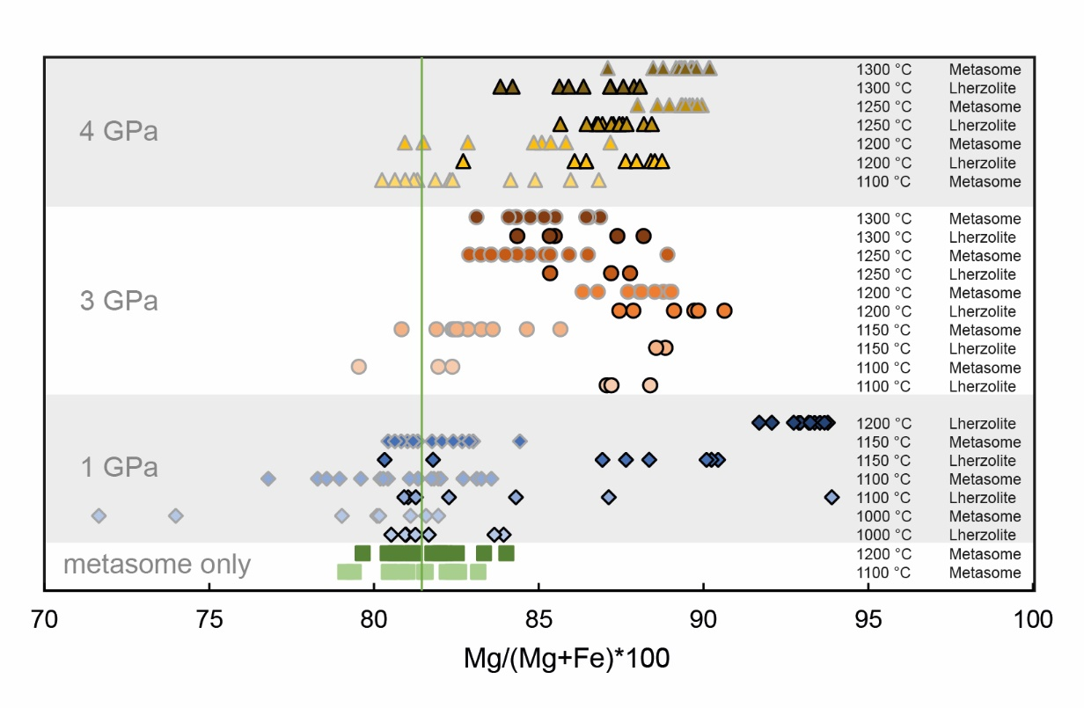
Figure S2: Mg/(Mg+Fe)*100 ratio for clinopyroxene. The green line shows the average clinopyroxene value of the metasome starting material.
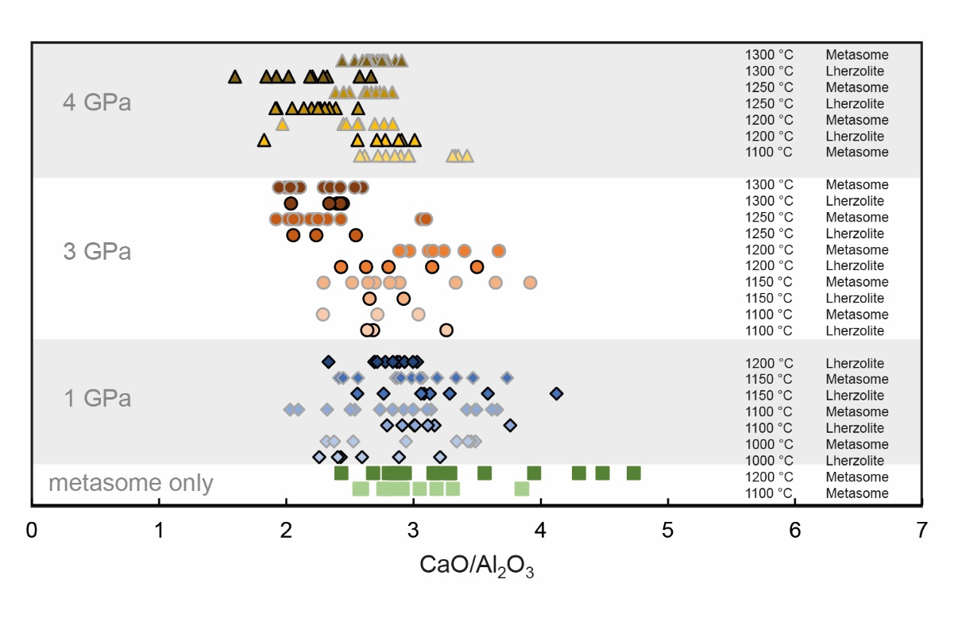
Figure S3: CaO/Al₂O₃ ratios for clinopyroxene in the experiments.

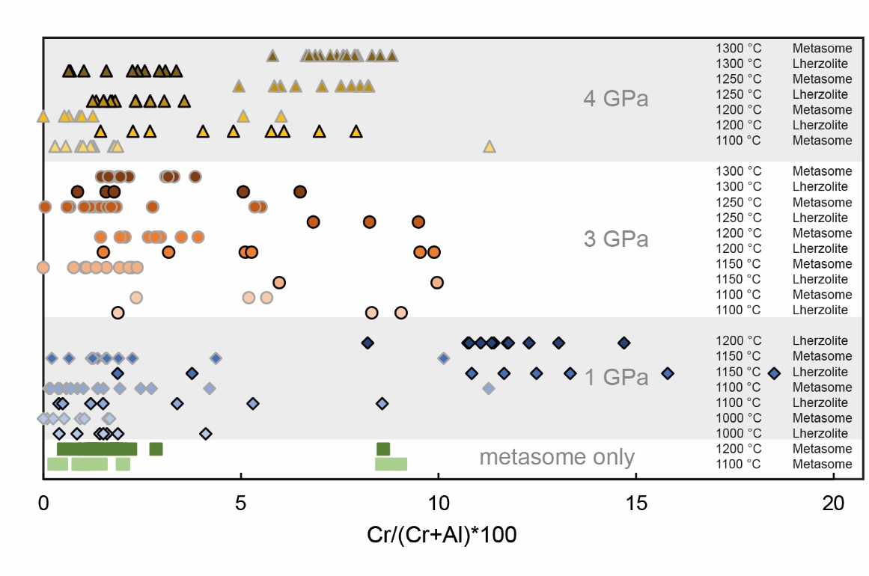
Figure S4: Cr/(Cr+Al)*100 ratio for clinopyroxene.
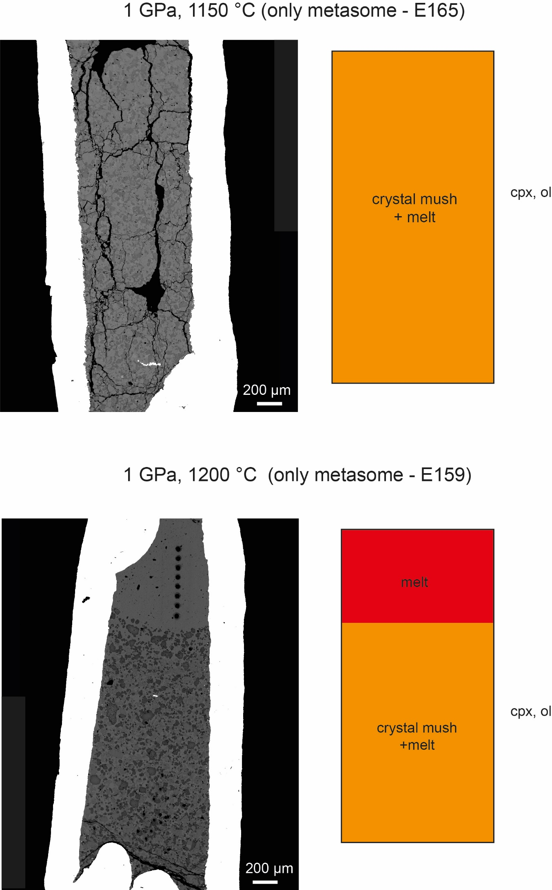
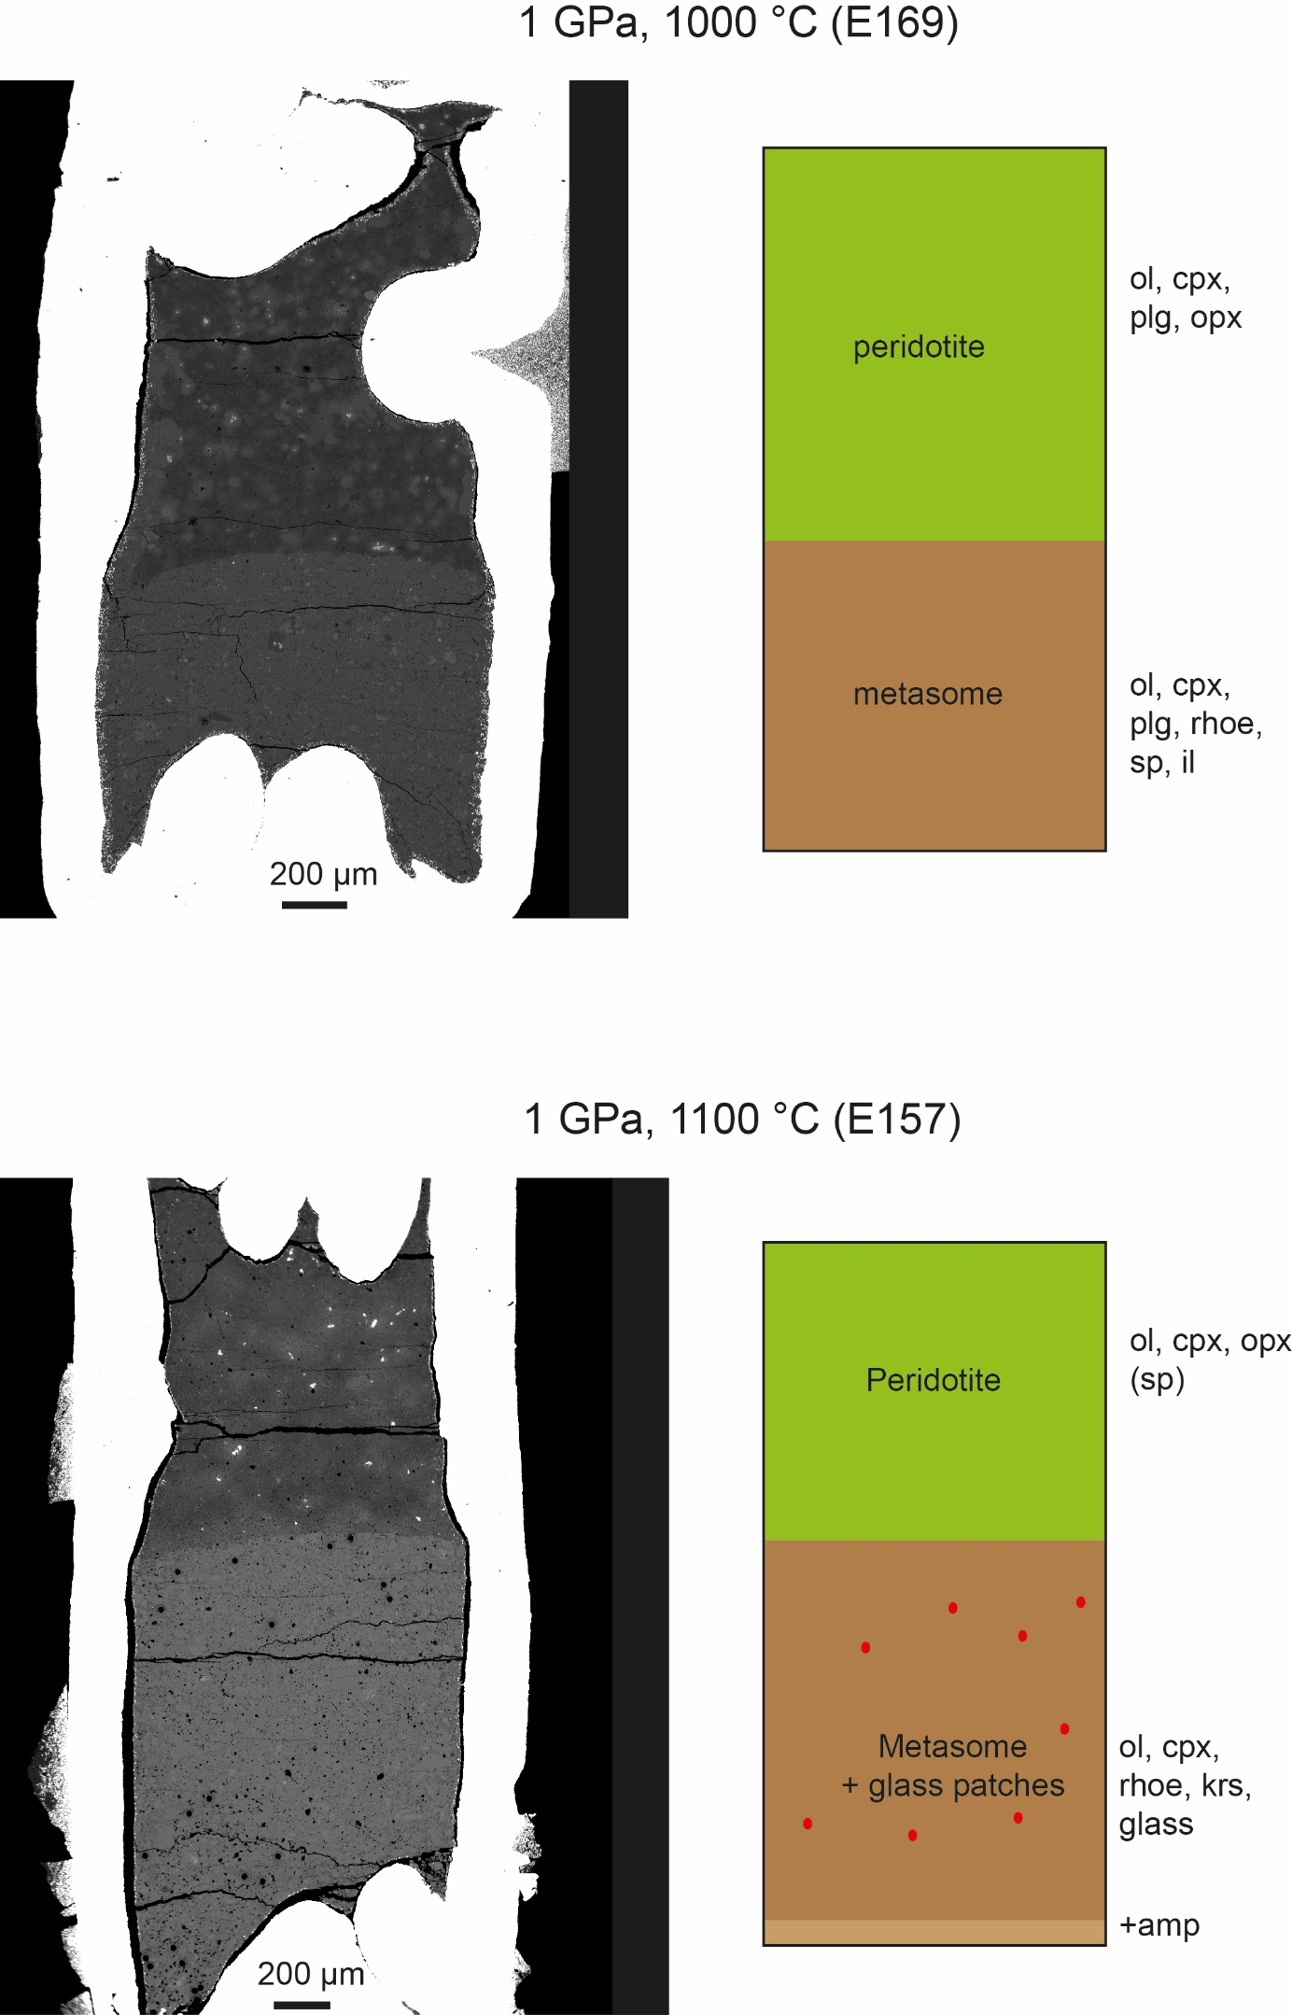
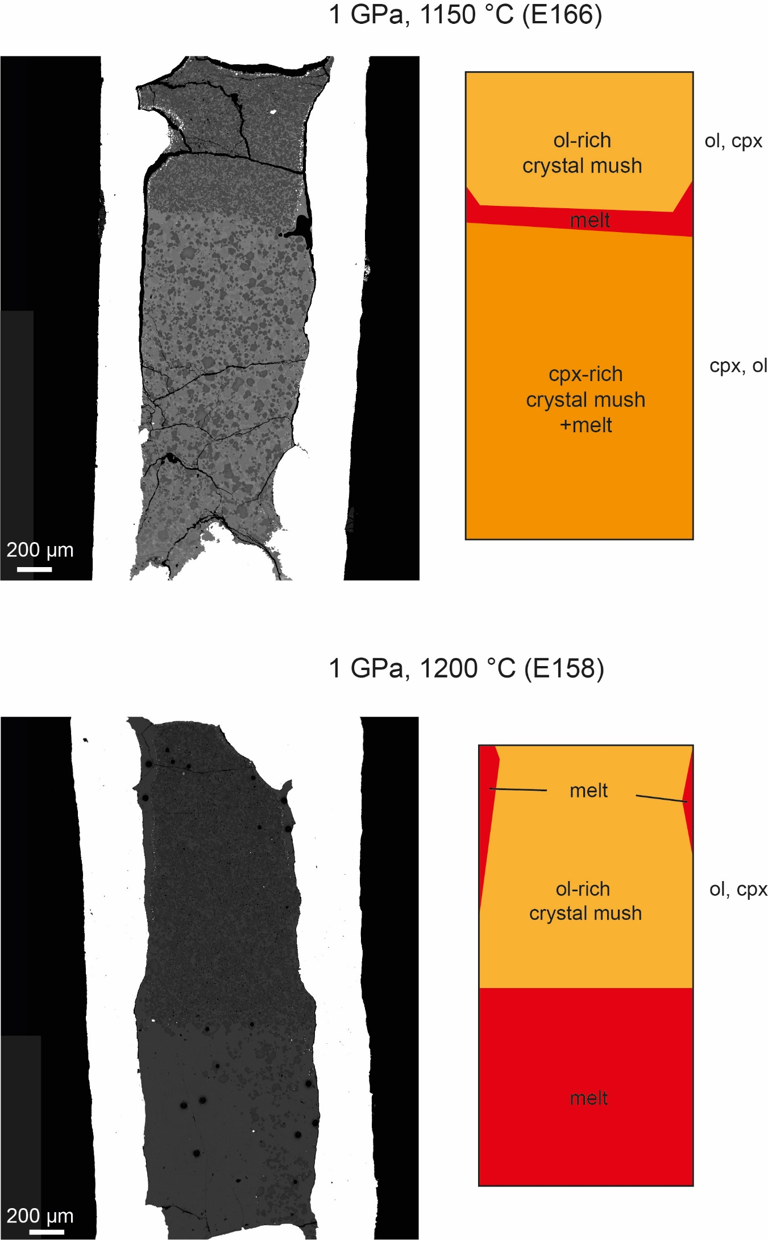
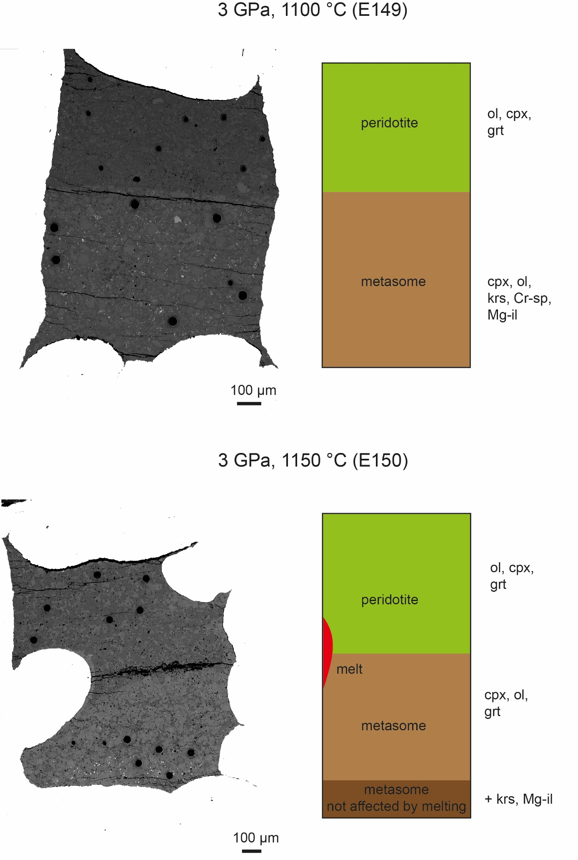
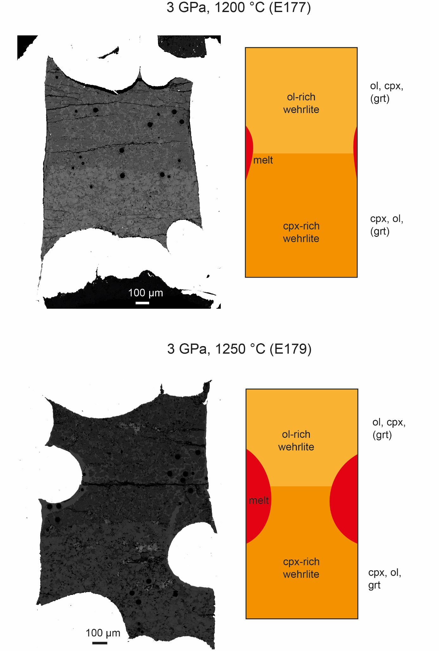
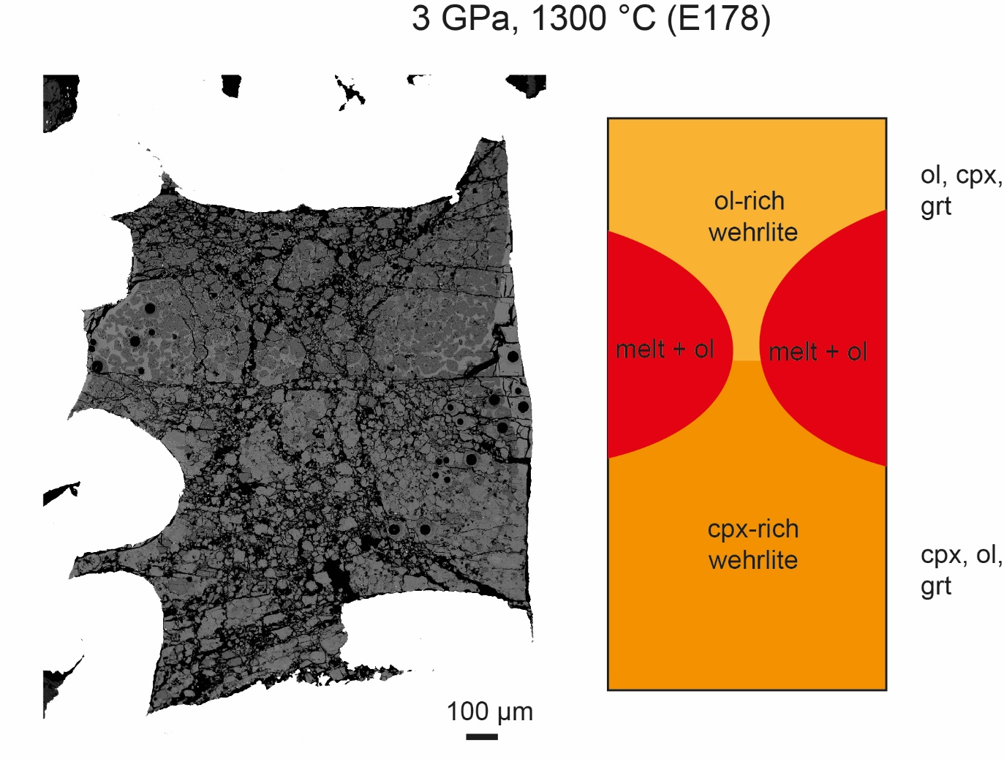
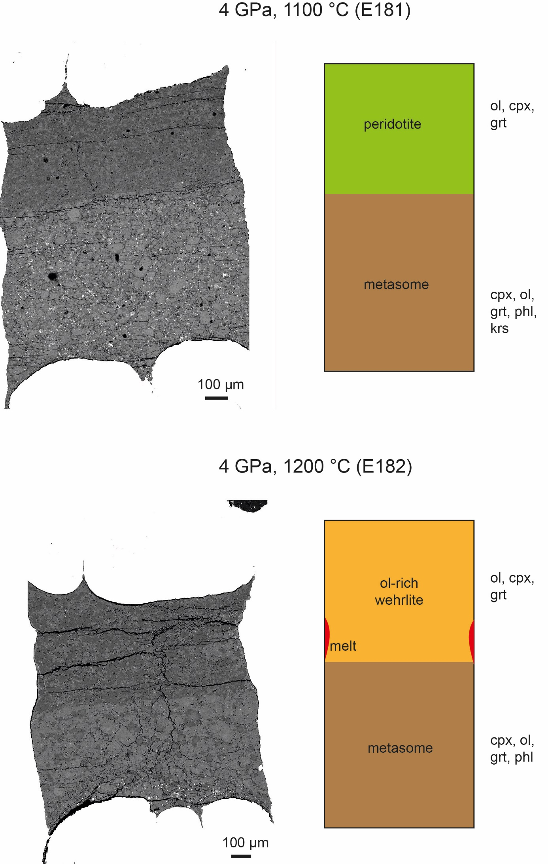
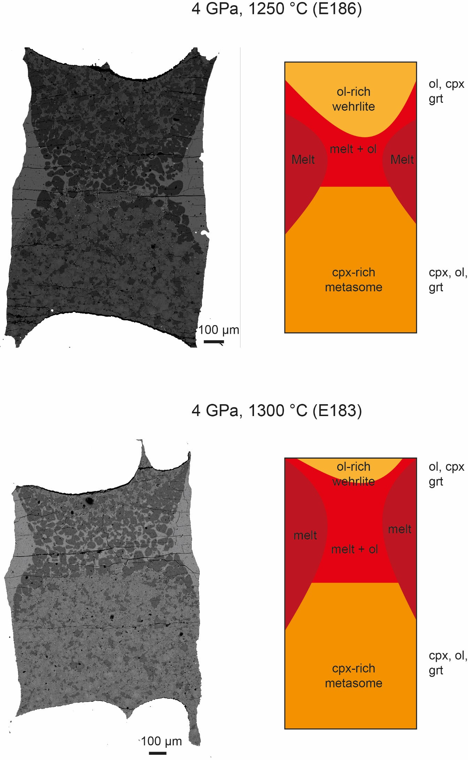
Figure S5: Cross section and SEM images of all experimental runs. Black round holes are from LA-ICPMS analyses. Mineral abbreviations are cpx = clinopyroxene, grt = garnet, il = ilmenite, krs = kaersutite, ol = olivine, phl = phlogopite, plg = plagioclase, rho = rhönite, sp = spinell.

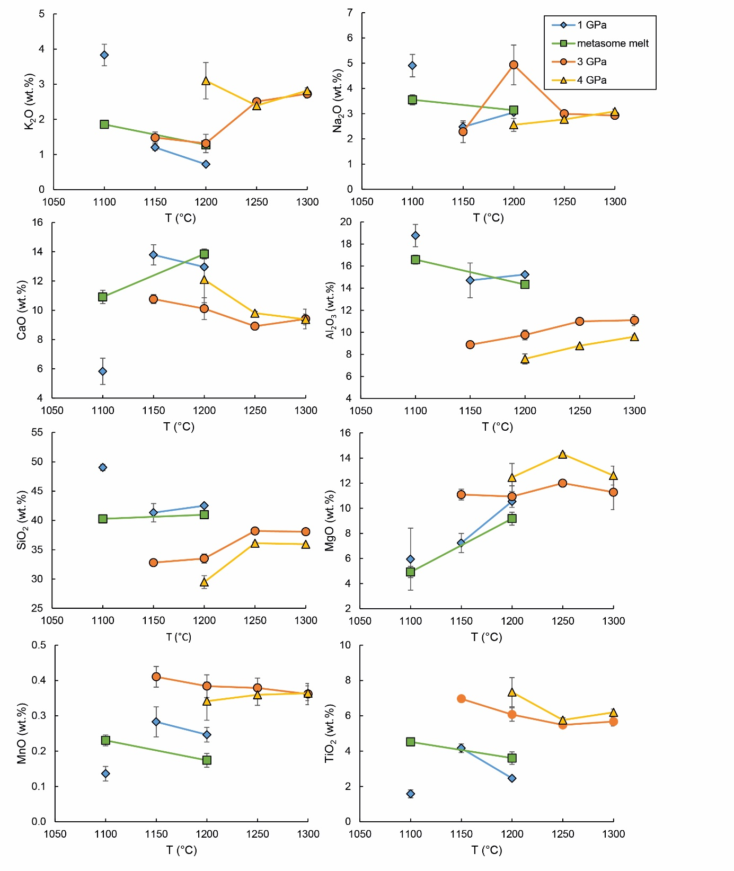
Figure S6: Major and minor element oxide trends vs temperature for experimental glasses.

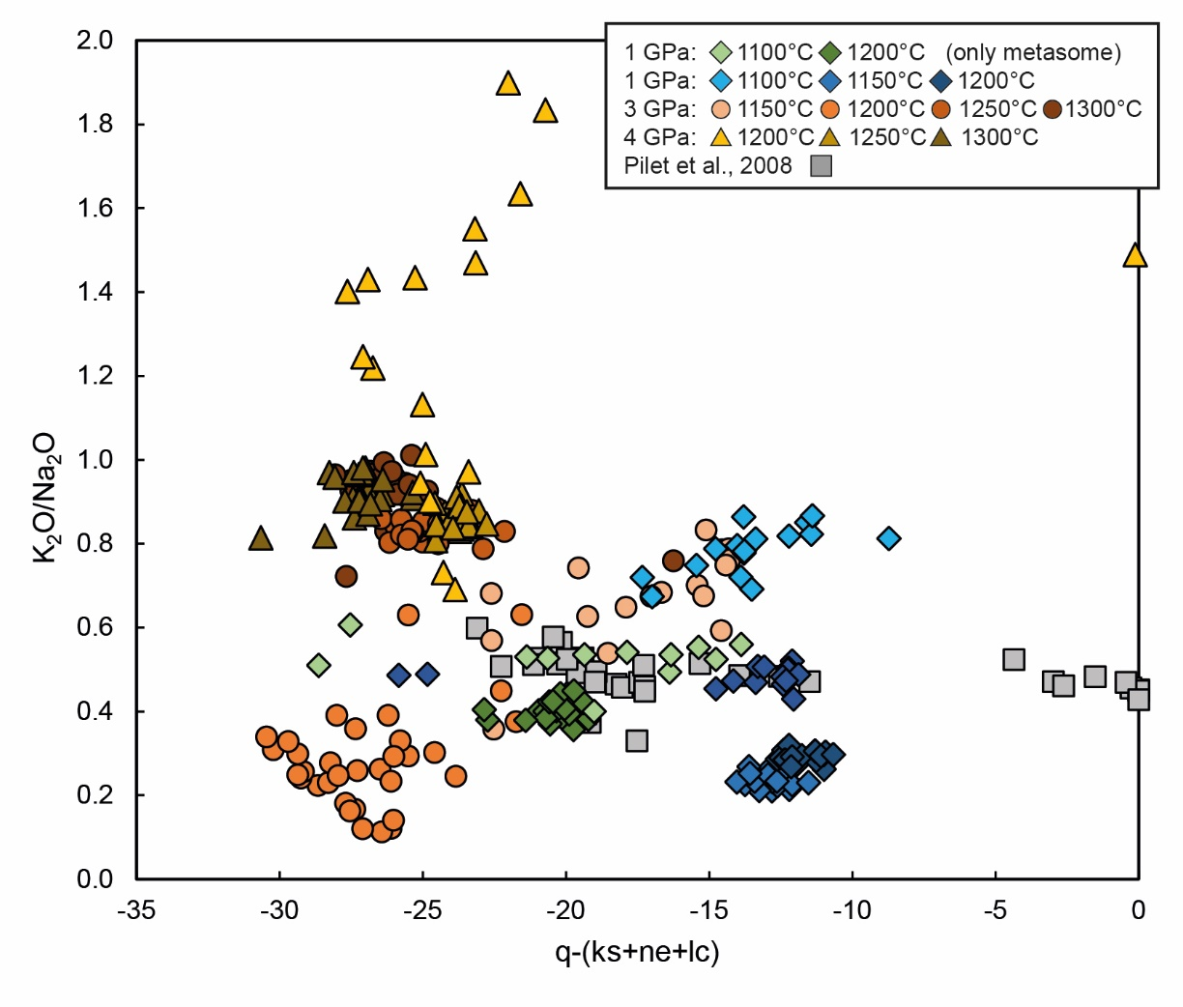
Figure S7: Alkaline oxide ratios (K₂O/Na₂O) vs. parameter Q [normative quartz - (nepheline + leucite + kalsilite)] of experimental melts. All melts are nepheline-normative (parameter Q < 1) and sodic (K₂O/Na₂O < 1). Only E182, the first melt at 4 GPa (1200 °C) is potassic (1 < K₂O/Na₂O < 2).

