Supplementary Materials: Methods

Error propagation for partition coefficients
Partition coefficients (D) between mineral and melt were determined by dividing the concentration (c) of a trace element (a) in the mineral by the concentration of that element in the silicate glass.
- $D_{a}^{minerl-melt}$ = $\frac{c(mineral)}{c(melt)}$

Concentrations were determined by averaging the concentration of n analyzes.
For the error propagation, the average concentration of n analyzes, the standard deviation on the average concentration and the relative standard deviation (RSD) of n analyzes was determined. The RSD was calculated dividing the standard deviation of n analyzes by the average of n measurements of one phase. The propagated relative standard error (pRSE) on the partition coefficients (D) was calculated using the formula:
- $pRSE\%=\sqrt{(RSD_{mineral}^{2}+RSD_{melt}^{2}})*100$
For one experiment at 1200 °C and at atmospheric pressures and an fO₂ of IW–1, we report a combined partition coefficient, which involves four individual partition coefficients of four run products (CHV-E154, 155, 156 and 157) which were all prepared in exactly the same way, run in the same experiment (run Nr. 42, Table 2) and analyzed in the same way. The indivudual partition coefficients and propagated errors are in good agreement, this is why we decided to calculate a combined partition coefficient using the analysed four individual run products. The individual partition coefficients and uncertainties are listed in Supplementary Table S1, S2, and S3.

Equilibrium and fractional crystallization modeling
When we modeled the trace element evolution of the lunar magma ocean, we assume two stages of crystallization, first equilibrium crystallization until about 50 PCS and then fractional crystallization for PCS >50 of crystallization (Elardo et al. 2011; Johnson et al. 2021). Since the ~50% of the cumulate only consist of ol and opx (cf. Supplementary Table S7), in which most trace elements are very incompatible, we investigated different modes of crystallization only for the ~second half of crystallization. To cylculate the first ~50% of equilibrium crystallization, the formula CL/C0 = F([1–K_{D}]+ K_{D})^{–1} was used (Shaw 1970), where CL = the concentration of the trace element of interest in the liquid, C0 = the concentration of the same element in the starting melt, K_{D} = the bulk partition coefficient of the crystallizing phases and F = the melt fraction. Fractional crystallization calculation > 50 PCS employed the following equation: CL/C0 = F^{(D—1)} (Neumann et al. 1954). The hence calculated absolute trace element abundances in the residual melt is further used to assess the cumulate trace element compositions, i.e., in the solid phases coexisting with each residual melt. The D^{mineral-melt} used for modeling can be found in Supplementary Table S6. For silicates (pyroxenes, olivine, plagioclase) the data of this study were used. For spinels, quartz, and apatite, literature data was used (Nash and Crecraft 1985; Prowatke and Klemme 2006; Klemme et al. 2006; Brophy et al. 2011; Dygert et al. 2013; Fedele et al. 2015; Wijbrans et al. 2015; Snape et al. 2022). The evolution modeling for elements like Sc, V, Cr, Mn, Co, and Ni must be regarded with caution, since the availability of trace element partition coefficients for plagioclase and apatite is very limited. We assume that these elements are incompatible in phosphates and apatite fractionation will have a negligible effect on these elements. Partition coefficients for accessory phases were interpolated, where reasonably possible (details in Supplementary Tables S6).
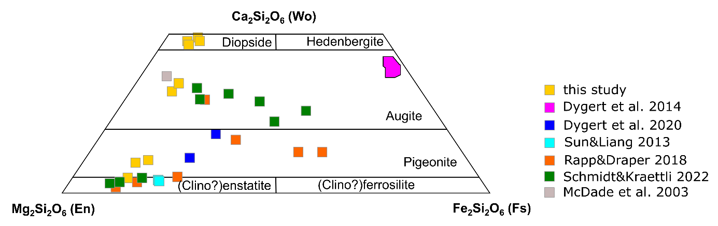
Figure S1 Pseudoternary diagram showing compositions of pyroxene in Wollastonite-Enstatite-Ferrosilite ternary plot. The data of this study are shown, together with pyroxene compositions of experimental studies of McDade et al. (2003), Sun and Liang (2013), and Dygert et al. (2014, 2020). The data of Rapp and Draper (2018) and Schmidt and Kraettli (2022) show pyroxene compositions in the cumulates during fractional crystallization of the lunar magma ocean.

Figure S2 Back scattered electron image of high-pressure experimental run GPC_866 (1.5 GPa) showing idiomorphic unzoned, large clinopyroxene crystals and quenched melt in a graphite capsule

Figure S3 Analyzed clinopyroxene partition coefficients for minerals of this study (D analyzed) as a function of calculated partition coefficients using the parameterization of Sun and Liang (2012) including Mg on the M2 site and Al on the tetrahedral site. Note 1:1 line in red. Calculated partition coefficients are higher, than analyzed ones.
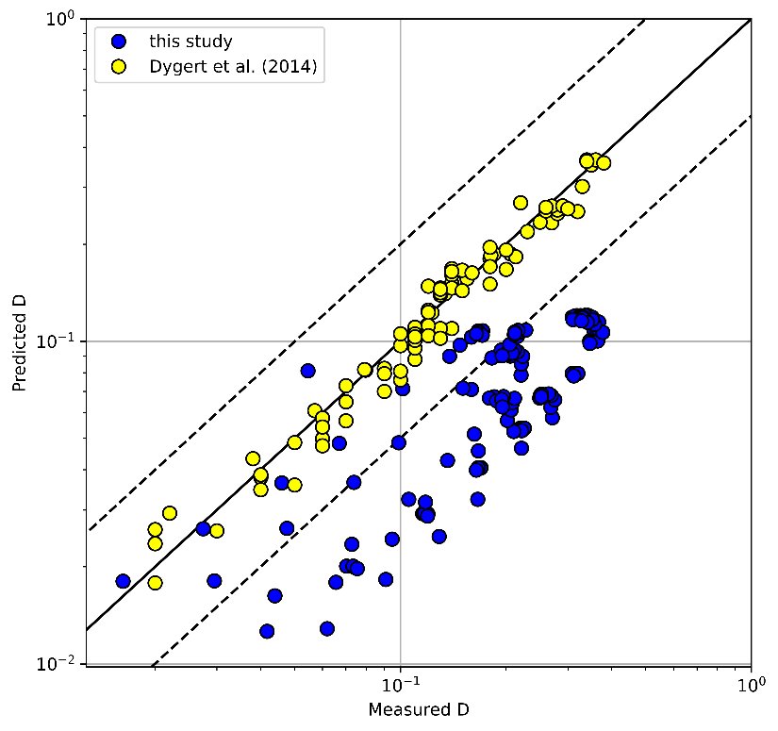
Figure S4 Analyzed REE+Y D^{cpx-melt} of this study (blue) plotted against predicted D^{cpx-melt} based on a model including Al on the clinopyroxene’s tetrahedral site, as developed by Dygert et al. (2014, 2015). The data used for calibrating the model are shown in yellow (cf. Dygert et al. 2014, 2015). The predicted D^{cpx-melt} overestimate compatibility of the data of this study.

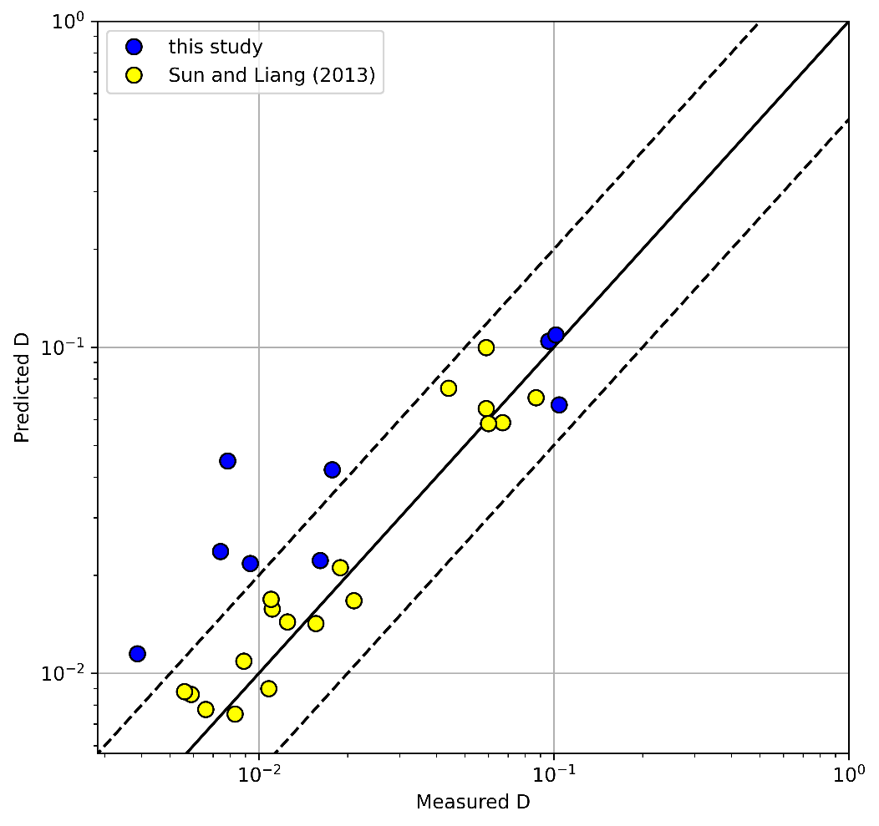
Figure S5 Measured HFSE (Ti, Zr, Hf) D^{opx-melt} of this study (pigeonite CHV-E281/82, orthopyroxene CHV-E421) against predicted D^{px-melt} based on a model including Fe and Mg on the M1 site, Ca and Mg on M2 site, and Al on the tetrahedral site of the pyroxene, as developed by Sun and Liang (2013). The data used for calibrating the model are shown in yellow (Sun and Liang 2013). The predicted D^{px-melt} overestimate compatibility.
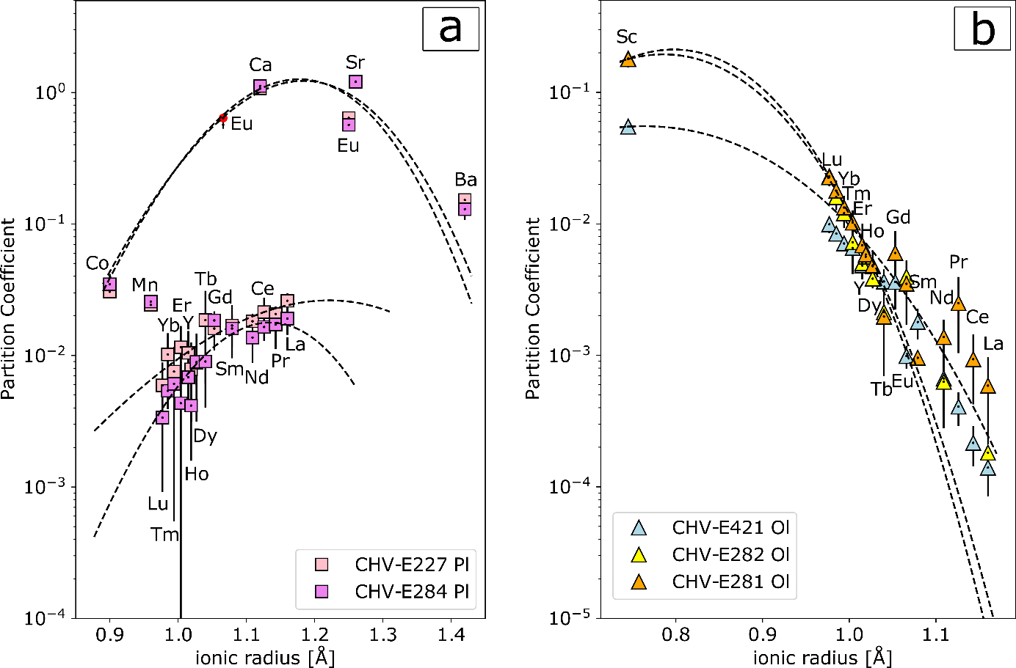
Figure S6 Onuma diagrams for (a) plagioclase 3+ and 2+ ions and (b) for olivine 3+ ions. Note large errors in (a) for 3+ ions resulting from very low abundances of REE in plagioclase, due to low compatibilities. Fit parameters for r₀, D₀, and E can be found in the supplementary tables

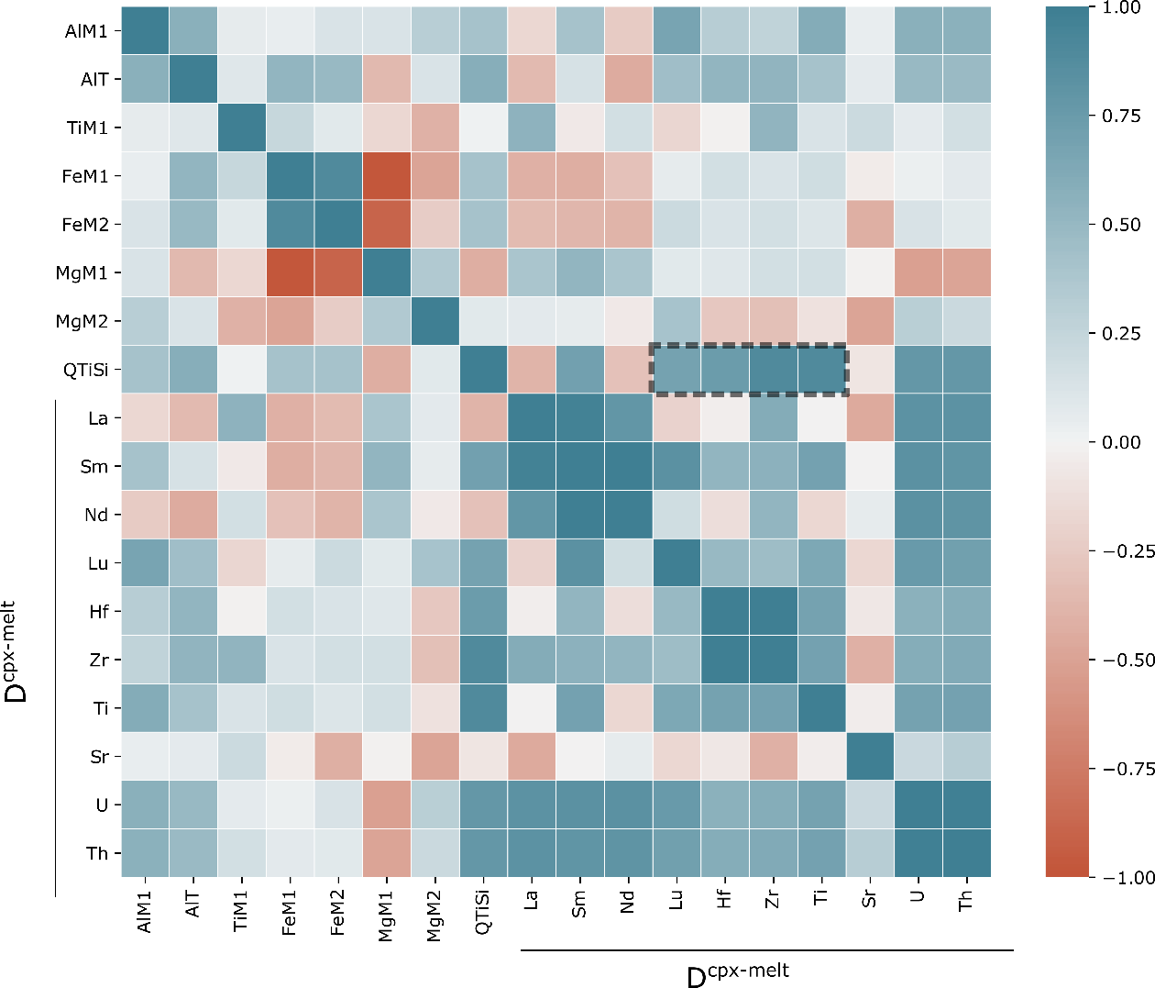
Figure S7 Correlation matrix (Pearson correlation) depicting the linear correlations between the chemical composition of the clinopyroxene (i.e., Al on M1 or the tetrahedral site, Ti on M1, Fe and Mg on M1 or M2, Q_{TiSi} ([TiO₂^{mineral}*SiO₂^{melt}]/[TiO₂^{melt}xSiO₂^{mineral}])) and the D^{cpx-melt} (La, Sm, Nd, Lu, Hf, Zr, Ti, Sr, U, Th). The color scale bar on the right-hand side indicates the correlation: blue indicates a positive correlation (0<R²<1) and brown indicates a negative correlation (1>R²>–1). The white color and the palest blueish and brownish colors indicate no or very weak correlations. Note that the diagonal (top left to bottom right) of deep blue squares are self-correlations. An example for strong correlations is shown in the four dark blue fields (surrounded by a black dotted line), indicating very strong correlations between Q_{TiSi} and D_{HFSE} (Fig. 4 a, b)

References:
Brophy JG, Ota T, Kunihro T, et al (2011) In situ ion-microprobe determination of trace element partition coefficients for hornblende, plagioclase, orthopyroxene, and apatite in equilibrium with natural rhyolitic glass, Little Glass Mountain Rhyolite, California. American Mineralogist 96:1838–1850. https://doi.org/10.2138/am.2011.3857
Dygert N, Draper DS, Rapp JF, et al (2020) Experimental determinations of trace element partitioning between plagioclase, pigeonite, olivine, and lunar basaltic melts and an fO2 dependent model for plagioclase-melt Eu partitioning. Geochim Cosmochim Ac 279:258–280. https://doi.org/10.1016/j.gca.2020.03.037
Dygert N, Liang Y, Hess P (2013) The importance of melt TiO2 in affecting major and trace element partitioning between Fe–Ti oxides and lunar picritic glass melts. Geochim Cosmochim Ac 106:134–151. https://doi.org/10.1016/j.gca.2012.12.005
Dygert N, Liang Y, Sun C, Hess P (2014) An experimental study of trace element partitioning between augite and Fe-rich basalts. Geochim Cosmochim Ac 132:170–186. https://doi.org/10.1016/j.gca.2014.01.042
Dygert N, Liang Y, Sun C, Hess P (2015) Corrigendum to ‘An experimental study of trace element partitioning between augite and Fe-rich basalts’ [Geochim. Cosmochim. Acta 132 (2014) 170–186]. Geochim Cosmochim Ac 149:281–283. https://doi.org/10.1016/j.gca.2014.09.013
Elardo SM, Draper DS, Shearer CK (2011) Lunar Magma Ocean crystallization revisited: Bulk composition, early cumulate mineralogy, and the source regions of the highlands Mg-suite. Geochim Cosmochim Ac 75:3024–3045. https://doi.org/10.1016/j.gca.2011.02.033
Fedele L, Lustrino M, Melluso L, et al (2015) Trace-element partitioning between plagioclase, alkali feldspar, Ti-magnetite, biotite, apatite, and evolved potassic liquids from Campi Flegrei (Southern Italy). American Mineralogist 100:233–249. https://doi.org/10.2138/am-2015-4995
Johnson TE, Morrissey LJ, Nemchin AA, et al (2021) The phases of the Moon: Modelling crystallisation of the lunar magma ocean through equilibrium thermodynamics. Earth Planet Sci Lett 556:116721. https://doi.org/10.1016/j.epsl.2020.116721
Klemme S, Günther D, Hametner K, et al (2006) The partitioning of trace elements between ilmenite, ulvospinel, armalcolite and silicate melts with implications for the early differentiation of the moon. Chem Geol 234:251–263. https://doi.org/10.1016/j.chemgeo.2006.05.005
McDade P, Blundy JD, Wood BJ (2003) Trace element partitioning on the Tinaquillo Lherzolite solidus at 1.5GPa. Phys Earth Planet In 139:129–147. https://doi.org/10.1016/S0031-9201(03)00149-3
Nash WP, Crecraft HR (1985) Partition coefficients for trace elements in silicic magmas. Geochimica et Cosmochimica Acta 49:2309–2322. https://doi.org/10.1016/0016-7037(85)90231-5
Neumann H, Mead J, Vitaliano CJ (1954) Trace element variation during fractional crystallization as calculated from the distribution law. Geochim Cosmochim Ac 6:90–99. https://doi.org/10.1016/0016-7037(54)90018-6
Prowatke S, Klemme S (2006) Trace element partitioning between apatite and silicate melts. Geochim Cosmochim Ac 70:4513–4527
Shaw DM (1970) Trace element fractionation during anatexis. Geochimica et Cosmochimica Acta 34:237–243. https://doi.org/10.1016/0016-7037(70)90009-8
Snape JF, Nemchin AA, Johnson T, et al (2022) Experimental constraints on the long-lived radiogenic isotope evolution of the Moon. Geochim Cosmochim Ac 326:119–148. https://doi.org/10.1016/j.gca.2022.04.008
Sun C, Liang Y (2013) Distribution of REE and HFSE between low-Ca pyroxene and lunar picritic melts around multiple saturation points. Geochim Cosmochim Ac 119:340–358. https://doi.org/10.1016/j.gca.2013.05.036
Wijbrans CH, Klemme S, Berndt J, Vollmer C (2015) Experimental determination of trace element partition coefficients between spinel and silicate melt: the influence of chemical composition and oxygen fugacity. Contrib Mineral Petrol 169:45. https://doi.org/10.1007/s00410-015-1128-5

