Supplemental Material

Sample Preparation:

Nine indium mounts were made containing standards and clinopyroxene phenocrysts from Cook-Austral Islands basalts. Whole rock samples were crushed and sieved, and inclusion-free clinopyroxene grains were picked and then mounted in crystal bond on glass slides. Grains were polished with grit paper from 65 to 13 μm and then finished with 5 μm and 1 μm diamond paste. The crystal bond was dissolved in an acetone bath, freeing the polished grains. Individual polished grains were then washed in a series of baths: clean acetone, ethanol, and deionized water. Grains were then dried for 24 hr at 80 ºC before being mounted in indium.

Indium mount preparation techniques were similar to those outlined in Marshall et al. (2018). The indium was held in 1 inch aluminum rounds with a cylindrical depression of 0.75 inches in diameter at the center. Solid indium was placed in the center of the mounts and heated to 250 °C on a hot plate in order to melt the indium into the mount. To ensure no organic material was incorporated into the mount, temperatures above the melting temperature of indium were used to oxidize any organics. Molten indium oxidizes in contact with air and thus an oxide coat was formed on the surface of the mounts, which was scraped off prior to cooling. Next, the mounts were placed between two plastic sheets and pressed to 5 tons of force using a hydraulic press at the University of Texas at Austin. This ensured that the mounts had a level surface. However, five tons of force may have been excessive and resulted in some deformation of the mounts (each mount widened by a few millimeters). The aluminum sides of these mounts needed to be ground in order to fit into the 1 inch EMPA and SIMS mount holders.

Cleaned grains were picked and loaded onto mounts and pressed into place with a clean glass microscope slide. Once grains and standards were placed, the mounts were pressed with the hydraulic press using the same procedure as before. Lastly, the mounts were lightly polished using a 1 μm diamond suspension and polishing cloth to remove surficial material. The mounts were then sonicated in 18MΩ water and stored in an oven at 80 °C.

EPMA Major Element Analysis:

Each mount was carbon coated prior to major element analysis. Grains were analyzed for major elements using the JEOL JXA-8200 EPMA at the University of Texas at Austin. EMPA analysis were conducted using a 20 nA beam current, 15 kV accelerating voltage, and a 10 μm defocused beam. Count times were 30 to 40 seconds on peak and 15 to 20 seconds off peak. Accuracy and precision based on repeated analysis on the secondary standard NMNH (National Museum of Natural History) Cr-Augite 164905 are given in Table S1. For elements with concentrations greater than 1 wt. %, reproducibility of Cr-Augite 164905 was better than 2%. For elements with concentrations less than 1 wt%, reproducibility ranged from better than % for Cr2O3, 11% for Na2O, MnO, TiO2, and better than 12% for MnO. Averaged analyses of NMNH Cr Augite were accurate within 3% of published values for all elements, except for Cr (5%) and Mn (8%) (Jarosewich et al., 1980). Cr-Augite NMNH 164905 is a true secondary standard for Mounts F, G, H, and I. However, for Mounts A through E, Al was calibrated using Cr-Augite as a primary standard, therefore NMNH Kakanui Hornblende 143965 was used as a secondary standard for this element. Repeated analyses of Kakanui Hornblende were reproducible better than 2% for Al. Furthermore, Cr-Augite was used as the primary standard for Mg, Si, Ca and Fe for Mount A, B, and C. Thus, for these mounts, Kakanui Hornblende was used as the secondary standard for Mg, Si, Ca and Fe. Reproducibility for these elements was also better than 2%. Averaged analyses of NMNH Kakanui Hornblende were within 3% of published values for Al2O3, FeO, CaO, MgO, SiO2.

SIMS H₂O Analysis:

Following major element analysis, phenocrysts were analyzed for H₂O contents using the Cameca IMS 6f Secondary Ion Mass Spectrometer at Arizona State University. Analytical procedures were similar to methods of Tenner et al. (2009) and Marshall et al. (2018). Mounts were left in the SIMS antechamber at 2x10⁻⁸ torr for roughly 24 hours prior to analysis to minimize the background signal. Main chamber pressures ranged from 2.5x10⁻¹⁰ to 4x10⁻¹⁰ torr during analysis and a 10 nA rastered Cs+ beam was used for analysis. Energy filtering was conducted with a 75 V offset. Mass resolving power was approximately 5000, allowing differentiation of ¹⁷O from ¹⁶O¹H. A 20 μm primary beam was rastered across a 40 μm square area. A circular 8 μm diameter beam mask was applied so that only the center of the rastered area was sampled for analyses. Intensities of ¹⁶O¹H, ¹⁸O, ¹⁹F, ²⁸Si, and ³⁵Cl were measured by an electron multiplier. Although a majority of the measured grains are inclusion free, intensities of ¹⁶O¹H and ³⁵Cl over the duration of individual analyses were used to monitor for possible inclusions or contamination that contain much higher H₂O content than the host pyroxene.

The same (or as close as possible) spots were analyzed as for EPMA measurements. Mosenfelder and Rossman (2013b) suggested little to no matrix effects between olivine, orthopyroxene, and clinopyroxene for SIMS H₂O analysis. Therefore, olivine and pyroxene standards provide a good matrix match for our pyroxene phenocryst analyses. Two to three standards and a “blank” were placed at the center of each mount. Standards include PMR 53, JLM 77, CITI7210, 62047708, GRR2334a, GRR16506 (Mosenfelder and Rossman, 2013b and references therein). San Carlos olivine or GRR1017 were used to estimate analytical blanks (Mosenfelder and Rossman, 2013a). Background ¹⁶O¹H-/²⁸Si intensities were determined via the analysis of either San Carlos or GRR1017. GRR1017 is a blank with reported FTIR values that are significantly below background and sample concentrations (Mosenfelder and Rossman, 2013a). Measurements conducted by Edward Marshall via the Thermo Electron Nicolet 6700 FTIR spectrometer at the University of Texas at Austin, show that San Carlos has <3 ppm H2O (Marshall et al., 2018), below detection limits for FTIR and well below measured [H₂O] in the Australs phenocrysts (72-1019 ug/g).

A block of standards was run at the beginning of each analytical sequence, at the end, and between every ~10 sample analyses. Blank background intensities were subtracted from standards and samples within each calibration block. The blank corrected standard intensities were then regressed against their published values. This regression was forced through zero and the resulting regression function was used to calculate sample intensities between each standard block. Any calibration curve that produced an R² value less than 0.90 was subsequently rejected along with the sample analyses associated with that calibration curve.

Several studies of the standard PMR-53 have reported a large range in H₂O concentrations from 202 ppm (Aubaud et al. 2007) to 333 (Mosenfelder and Rossman, 2013b). Therefore, PMR-53 was used as a secondary standard rather than a primary standard for any mounts with three or more standards, not including PMR-53. For these mounts, PMR 53 was analyzed as a secondary standard. All calculated intensities of PMR-53 were then averaged together (291 ppm ± 38 ppm; see Table S3) and was then used in any calibration curve for which use of PRM-53 as a primary standard was necessary.

Measured ¹⁶O¹H/²⁸Si values of primary and secondary for each standard mount and run are reported in Table S2.

Finally, clinopyroxene typically have very low Cl concentrations (Segee-Wright, pers. comm). Therefore, any spot analysis with a measured ³⁵Cl/²⁸Si higher than 1x10⁻⁴ was rejected because such high signals likely reflect micro-inclusions or other contamination not representative of primary clinopyroxene composition. Based on the variance of H₂O measurements for secondary standard PRM-53, analytical uncertainty for cpx [H₂O] is estimated to be ~13% (1SD).

Trace Element Analysis:

Trace element concentrations were measured via Excimer LA-ICP-MS with a New Wave UP-193FX laser system coupled to an Agilent 7500Ce quadrupole at the University of Texas at Austin. Again, the same spots (or as close as possible) were analyzed to maintain consistency across all data sets. All grains were pre-ablated with a 100 μm spot size. Each analysis used a 90 μm spot size at 40% power and 10 Hz repetition rate. A 45 second gas blank was collected before each analysis followed by a 60 second laser dwell time. Ablated material was transported with a He sweep gas flow rate of 750 mL/min and an Ar carrier gas flow of 900 mL/min. NIST 612 (a synthetic glass) was used as a primary standard and BCR 2G (a USGS basalt) was used as a secondary standard. Three spot analyses of NIST-612 and BCR-2G were analyzed at the beginning and end of the sequence, as well as between every hour of analyses. Analyses of BCR-2G were accurate within 6% of published values for all elements other than Ti (8%), Y (8%), and Tb (9%) (see Table S4). Repeated analyses of BCR-2G were reproducible within 5% (1σ) for all elements other than Tm (13%), Lu (11%), and U (6%). Measured and published standard trace element concentrations are reported in Table S4.

Error propagation for melt [H₂O] and [H₂O/Ce] determinations:

The analytical uncertainty on individual cpx [H₂O] measurements is ~13%. Uncertaintly in melt [H₂O] estimates are compounded by uncertainty in cpx/melt K_{d}(H₂O). We used three models (Novella et al., 2014; O’Leary et al.,2010, Wade et al., 2008) to estimate cpx/melt K_{d}(H₂O) based on cpx major element composition. Although calculated K_{d} values are strongly correlated between the three models, we estimate the uncertainty in the K_{d} value as 1 SE of the mean, which averages ~15%. Because thr analytical error and error in K_{d} values are independent from each other, total variance in melt [H₂O] can be approximated through the sum of squares:

(σ^{T})² = (σ¹)² + (σ²)² + …

For the above uncertainties in cpx [H₂O] and cpx/melt K_{d}(H₂O), the total uncertainty in melt [H₂O] is ~20%. Similar error propagation was used to estimate uncertainty in melt REE abundances and H₂O/Ce ratios. Average uncertainty in REE cpx/melt K_{d} estimates varies from ~6% for Yb to ~20% for La and are generally larger than analytical uncertainty in cpx [REE] measurements. Error bars shown in figures are representative for samples spanning the range of measured composions and incorporate both analytical uncertainties and, where appropriate, uncertainty in calculated K_{d} values.

References for compiled MORB and OIB data:

MORB and OIB data presented in figures 4, 6, and 9 are from the following sources: Cabral et al. (2014), Halldorsson et al. (2016), Hanyu et al. (2019), Jackson et al. (2015), Kendrick et al (2017), Le Voyer et al. (2019), Longpre et al. (2017), Peterson et al (2017), Reinhard et al. (2018), Rose-Koga et al. (2017), Saal et al. (2002), Shimizu et al. (2016), Sides et al. (2014).

Supplemental References:

Cabral, RA, MG Jackson, KT Koga, EF Rose‐Koga, EH Hauri, MJ Whitehouse, AA Price, JMD Day, N Shimizu, KA Kelly (2014), Volatile cycling of H2O, CO2, F, and Cl in the HIMU mantle: A new window provided by melt inclusions from oceanic hot spot lavas at Mangaia, Cook Islands. Geochem. Geophys. Geosys., 15, 4445-4467.

Halldórsson, SA, JD Barnes, A Stefánsson, DR Hilton, EH Hauri, EW Marshall (2016), Subducted lithosphere controls halogen enrichments in the Icelan mantle plume source. Geol. 44, 679-682.

Hanyu, T, K Shimizu, T Ushikubo, KI Kimura, Q Chang, M Hamada, M Ito, H Iwamori, I Ishikawa (2019), Tiny droplets of ocean island basalts unveil Earth’s deep chlorine cycle. Nature Comm. 10, DOI: 10.1038/s41467-018-07955-8

Jackson, MG, KT Koga, A Price, JG Konter, AAP Koppers, VA Finlayson, et al. (2015), Deeply dredged submarine HIMU glasses from the Tuvalu Islands, Polynesia: Implications for volatile budgets of recycled oceanic crust. Geochem. Geophys. Geosys., 16, 3210-3234.

Jarosewich, E, JA Nelen, JA Norberg (1980), Reference samples for electron microprobe analysis. Geostand. News., 4, 43-47.

Jochum, KP, M Willbold, I Raczek, B Stoll, K Herwig (2005), Chemical characterization of the USGS reference glasses GSA-1G, GSC-1G, GSD-1G, GSE-1G, BCR-2G, BHVO-2G and BIR-1G using EPMA, ID-TIMS and LA-ICP-MS. Geostand. Geoanal. Res. 29, 285-302.

Kendrick, MA, C Hémond, VS Kamenetsky, L Danyushevsky, CW Devey, T Rodemann, MG Jackson, MR Perfit (2017), Seawater cycled throughout Earth’s mantle in partially serpentinized lithosphere. Nature Geosci. 10, 222-228.

Le Voyer, M, EH Hauri, E Cottrell, KA Kelly, VJM Salters, CH Langmuir, DR Hilton, PH Barry, E Füri (2019), Carbon fluxes and primary magma CO₂ contents along the global mid-ocean ridge system. Geochem. Geophys. Geosys. 20, 1387-1424.

Longpré, MA, J Stix, A Klügel, N Shimizu (2017), Mantle to surface degassing of carbon- and sulfur-rich alkaline magma at El Hierro, Canary Islands. Earth Planet. Sci. Lett. 460, 268-280.

Marshall, EW, JC Lassiter, JD Barnes (2018), On the (mis) behavior of water in the mantle: Controls on nominally anhydrous mineral water content in mantle peridotites. Earth Planet. Sci. Lett, 499, 219-229.

Mosenfelder, J.L., and Rossman, G.R., 2013a, Analysis of hydrogen and fluorine in pyroxenes: II. Orthopyroxene. Amer. Mineral. 98, 1026–1041.

Mosenfelder, J.L., and Rossman, G.R., 2013b, Analysis of hydrogen and fluorine in pyroxenes: II. Clinopyroxene. Amer. Mineral. 98, 1042–1054.

Peterson, ME, AE Saal, MD Kurz, EH Hauri, JS Blusztajn, KS Harpp, R Werner, DJ Geist (2017), Submarine basaltic glasses from the Galapagos Archipelago:L Determining the volatile budget of the mantle plume. J. Petrol. 58, 1419-1450.

Reinhard, AA, MG Jackson, JM Koornneef, EF Rose-Koga, J Blusztajn, JG Konter, KT Koga, PJ Wallace, J Harvey (2018), Sr and Dn isotopic compositions of individual olivine-hosted melt inclusions from Hawai’I and Samoa: Implications for the origin of isotopic heterogeneity in melt inclusions from OIB lavas. Chem. Geol. 495, 36-49.

Rose-Koga, EF, KT Koga, M Moreira, I Vlastelic, MG Jackson, MJ Whitehouse, N Shimizu, N Habib (2017), Geochemical systematics of Pb isotopes, fluorine, and sulfur in melt inclusions from Sao Miguel, Azores. Chem. Geol. 458, 22-37.

Saal, AE, EH Hauri, CH Langmuir, MR Perfit (2002), Vapour undersaturation in primitive mid-ocean-rigde basalt and the volatile content of Earth’s upper mantle. Nature 6906, 451-455.

Shimuzu, K, AE Saal, CE Myers, AN Nagel, EH Hauri, DW Forsyth, VS Kamenetsky, YL Niu (2016), Two-component mantle melting-mixingmodel for the generation of mid-ocean ridge basalts: Implications for the volatile content of the Pacific upper mantle. Geochim. Cosmochim. Acta 176, 44-80.

Sides, I, M Edmonds, J Maclennan, BF Houghton, DA Swanson, MJ Steel-MacInnis (2014), Magma mixing and high fountaining during the 1959 Kilauea Iki eruption, Hawai’i. Earth Planet. Sci. Lett. 400, 102-112.

Tenner, T.J., Hirschmann, M.M., Withers, A.C., and Hervig, R.L., 2009, Hydrogen partitioning between nominally anhydrous upper mantle minerals and melt between 3 and 5 GPa and applications to hydrous peridotite partial melting. Chem. Geol. 262, 42–56.

Supplemental Figure Captions

Figure S1: a) Cpx Mg# vs. Al₂O₃. b) Cpx Mg# vs. [Ce]. Symbols are as in Figure 2.

Figure S2: Cpx Mg# vs cpx [H₂O]. Symbols are as in Figure 2

Figure S3: Cpx La/Sm vs cpx [H₂O]. Symbols are as in Figure 2.

Figure S1:
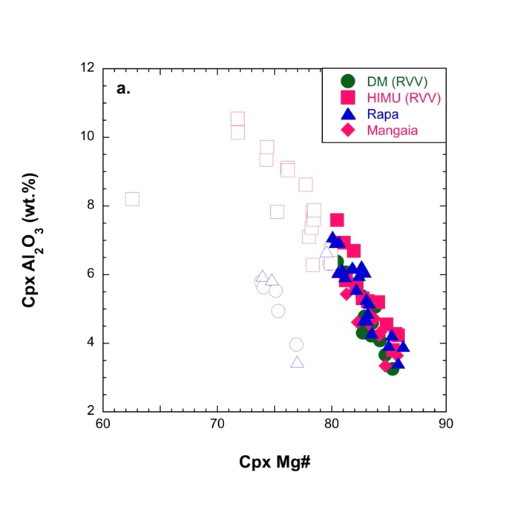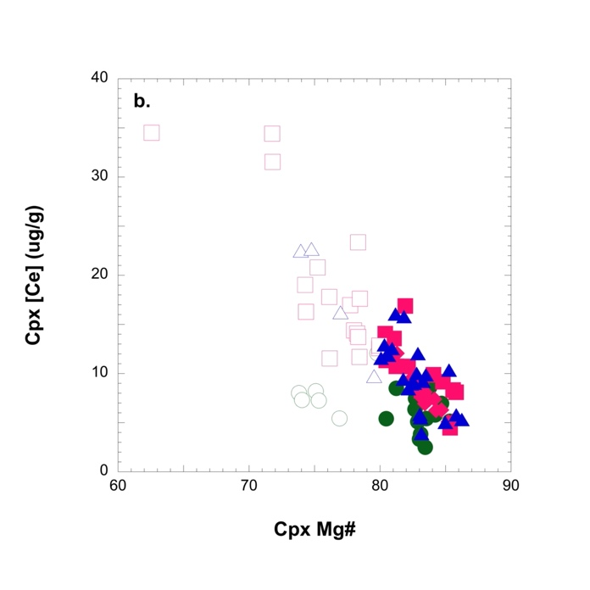

Figure S2:
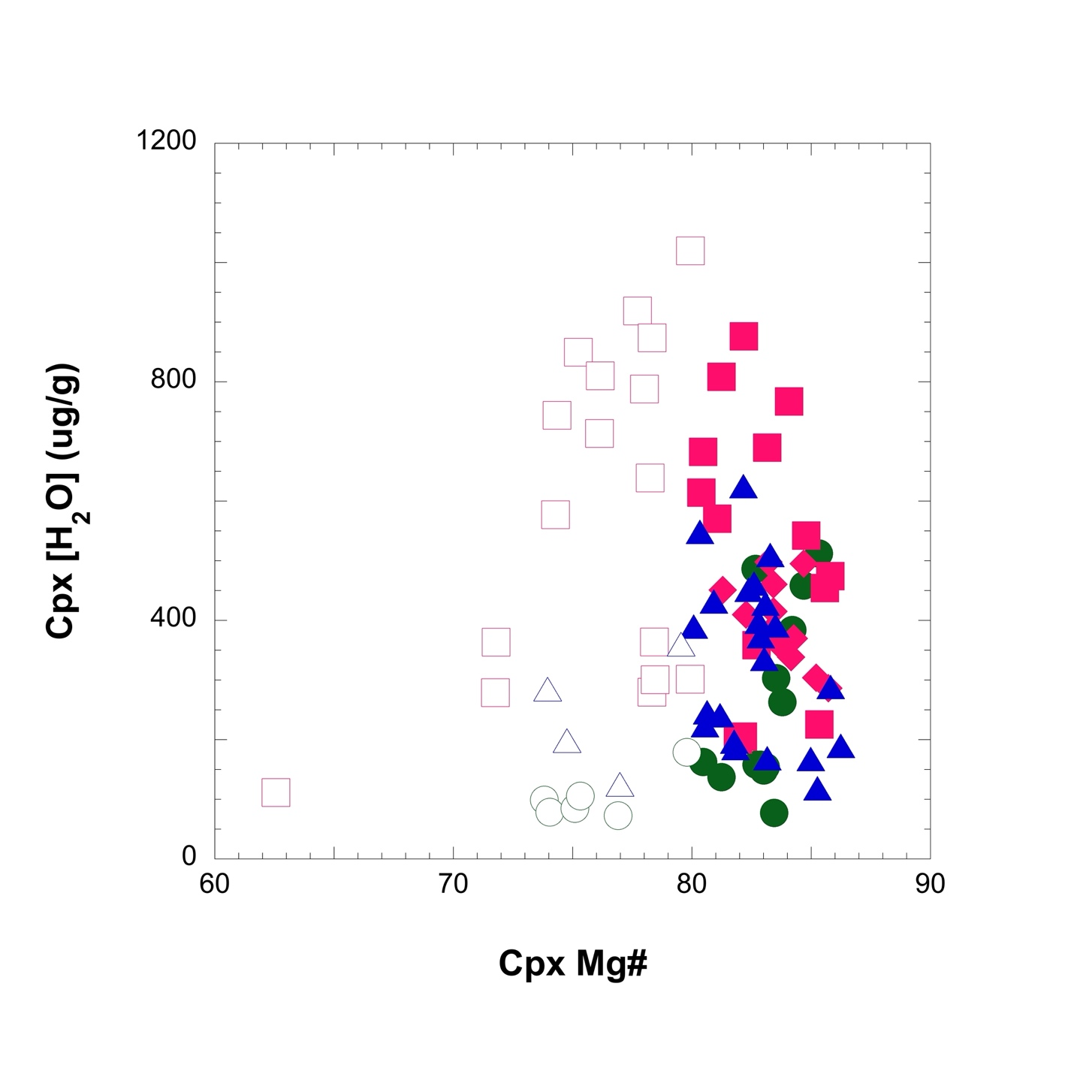

Figure S3:
