Supplementary Material
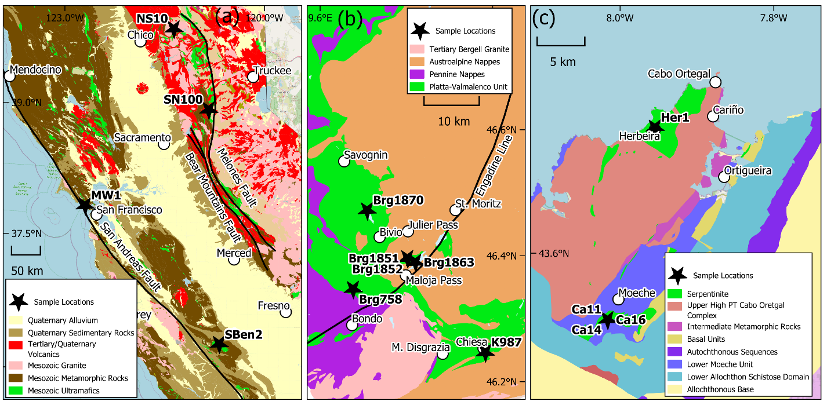
Suppl. Fig. 1. Geologic settings of sample locations. (a) Northern California. This map is based on the California Geological map (https://maps.conservation.ca.gov/cgs/gmc/). (b) Valmalenco-Platta zone in the Central Alps. During the Cretaceous to Tertiary Alpine orogeny, African plates in the southern and eastern Alps (Austroalpine nappes) were overthrust on the European plate in the north (Pennine nappes). Juxtaposed in between is the oceanic Platta Valmalenco unit. This stack of nappes was intruded in Tertiary by the Bergell granite (after Bernoulli and Weissert, 2021). (c) Cabo Ortegal Complex of the Variscan orogen in the Iberian Peninsula in Northern Spain (modified from Albert et al., 2013)

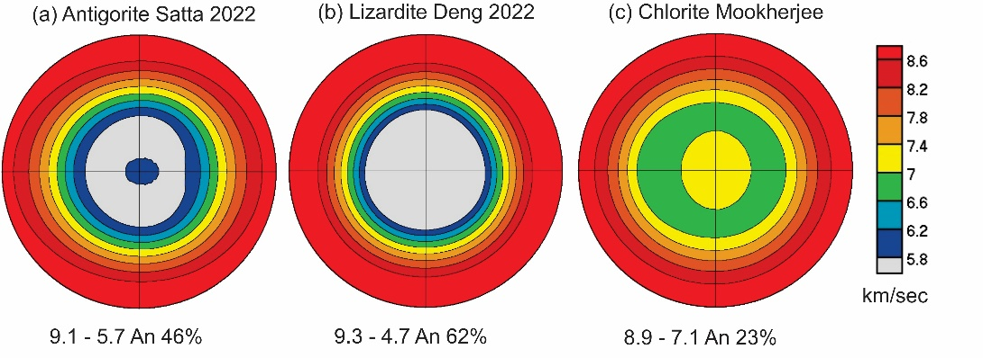
Suppl. Fig. 2. P-wave velocities for single crystals of antigorite, lizardite and chlorite at ambient conditions used for calculating aggregate elastic properties. Equal area projection on silicon tetrahedral sheet plane. At the bottom of the plots are maximum and minimum (in km/s) and anisotropy (%)

Suppl. Table 1. Chemical composition of serpentine and some component minerals based on EDS analyses. Atomic percentages normalized to 100%. . The “dark” and “bright” refer to spot analyses with different grey shades in BSE images (Fig. 9, 10)
Sample | O | Mg | Al | Si | Fe | Ca | Cr
Serpentine
California:
NS10 bulk | 66.02 | 19.16 | 0.42 | 13.37 | 1.03 | 0.00 | 0.00
NS11 surface bright | 64.34 | 19.78 | 0.00 | 14.82 | 1.05 | 0.00 | 0.00
NS11 surface dark | 62.57 | 21.23 | 0.00 | 15.35 | 0.85 | 0.00 | 0.00
SN100 | 62.14 | 21.01 | 1.08 | 14.92 | 0.85 | 0.00 | 0.00
MW1 bright | 62.42 | 20.27 | 1.40 | 13.83 | 2.09 | 0.00 | 0.00
MW1 dark | 61.80 | 21.06 | 0.68 | 15.27 | 1.19 | 0.00 | 0.00
SBen2 bulk | 63.40 | 20.81 | 0.42 | 14.41 | 0.96 | 0.00 | 0.00
SBen2 vein bright | 61.21 | 20.82 | 1.47 | 14.75 | 1.75 | 0.00 | 0.00
SBen2 vein dark | 60.99 | 22.28 | 0.44 | 15.46 | 0.82 | 0.00 | 0.00
Central Alps
Brg758 | 61.57 | 21.37 | 0.00 | 15.65 | 1.42 | 0.00 | 0.00
Brg1851 bright | 62.03 | 21.69 | 0.61 | 14.79 | 0.89 | 0.00 | 0.00
Brg1851 dark | 61.93 | 21.84 | 0.44 | 15.17 | 0.62 | 0.00 | 0.00
Brg1863 | 63.03 | 20.20 | 1.23 | 14.16 | 1.40 | 0.00 | 0.00
Brg1870 bright | 62.67 | 20.53 | 0.46 | 14.56 | 1.80 | 0.00 | 0.00
Brg1870 dark | 62.70 | 20.70 | 0.40 | 15.50 | 0.60 | 0.00 | 0.00
K987 | 63.10 | 21.10 | 0.30 | 14.75 | 0.75 | 0.00 | 0.00
Spain
Ca11 bright | 64.46 | 19.52 | 0.51 | 14.07 | 1.45 | 0.00 | 0.00
Ca11 dark | 64.14 | 19.80 | 0.46 | 14.25 | 1.35 | 0.00 | 0.00
Ca14 bright | 64.71 | 18.04 | 1.69 | 13.76 | 1.80 | 0.00 | 0.00
Ca14 dark | 63.80 | 19.76 | 0.53 | 14.40 | 1.52 | 0.00 | 0.00
Ca16 bulk bright | 62.86 | 20.65 | 0.63 | 14.71 | 1.16 | 0.00 | 0.00
Ca16 bulk dark | 62.10 | 22.01 | 0.28 | 14.83 | 0.79 | 0.00 | 0.00
Ca16 surface bright | 63.46 | 19.83 | 1.13 | 14.00 | 1.58 | 0.00 | 0.00
Ca16 surface dark | 63.20 | 20.04 | 0.85 | 14.48 | 1.44 | 0.40? | 0.00
Her1 bright | 61.43 | 20.83 | 0.00 | 16.20 | 1.51 | 0.00 | 0.00
Her1 dark | 60.33 | 20.83 | 0.68 | 16.82 | 1.34 | 0.00 | 0.00
Chlorite
California
NS10 bulk | 66.68 | 16.95 | 4.32 | 10.84 | 1.21 | 0.00 | 0.00
NS11 surface | 65.46 | 17.44 | 4.65 | 11.41 | 1.05 | 0.00 | 0.00
MW1 | 62.00 | 18.60 | 5.76 | 12.13 | 1.50 | 0.00 | 0.00
MW1 Cr-bearing | 60.90 | 17.85 | 5.10 | 10.60 | 4.45 | 0.00 | 1.20
SBen2 bulk  Central Alps | 66.29 | 17.46 | 3.91 | 11.97 | 0.67 | 0.00 | 0.00
Brg758 Cr-bearing | 62.57 | 19.08 | 4.04 | 11.96 | 1.52 | 0.00 | 0.64
Brg1863 | 62.28 | 18.24 | 5.55 | 12.05 | 1.88 | 0.00 | 0.00
Brg1863 Cr-bearing | 64.55 | 15.85 | 5.60 | 9.15 | 3.20 | 0.00 | 1.50
Andradite
California
NS10 bulk | 65.38 | 2.07 | 0.55 | 14.22 | 7.06 | 10.73 | 0.00
NS11 surface | 61.12 | 0.67 | 0.00 | 14.70 | 9.35 | 14.15 | 0.00
Spain
Ca16 surface | 62.70 | 3.53 | 0.99 | 13.46 | 7.36 | 11.95 | 0.00
Diopside
California
NS11 surface | 59.53 | 10.01 | 0.00 | 20.65 | 0.00 | 9.75 | 0.00
Olivine
Central Alps
K987 | 56.45 | 26.52 | 0.00 | 15.05 | 1.98 | 0.00 | 0.00

Suppl. Table 2 Stiffness tensors of single crystals used for averaging aggregate elastic properties. All values in GPa. Antigorite and chlorite are changed to monoclinic first setting used in the Rietveld analysis. These values are for ambient conditions. Coefficients C₁₅ C₂₅ C₃₄ C₃₅ C₄₆ are zero
C_{ij} | Antigorite Pm:c  (Satta et al. 2022) | Lizardite P31m  (Deng et al. 2022) | Chlorite C2/m:c1  (Mookherjee and Mainprice 2014)
C₁₁ | 85.6 | 215.72 | 135.1
C₁₂ | 21.0 | 74.11 | 21.1
C₁₃ | 18.0 | 8.11 | 34.1
C₁₄ | 0 | 1,54 | 0
C₁₆ | 0.8 | 0 | 0.4
C₂₂ | 191.0 | 215.72 | 197.8
C₂₃ | 60.3 | 8.11 | 60.7
C₂₄ | 0 | -1.54 | 0
C₂₆ | 1.2 | 0 | 3.3
C₃₃ | 209.0 | 59.68 | 202.3
C₃₆ | -1.0 | 0 | 0.2
C₄₄ | 68.1 | 10.63 | 70.3
C₄₅ | -1.9 | 0 | 0.1
C₅₅ | 14.0 | 10.63 | 24.5
C₅₆ | 0 | 1.54 | 0
C₆₆ | 19.9 | 70.50 | 24.4

