Supplementary figures
  - Experimental Differentiation of Kimberlitic to Carbonatitic Melts: Crystallization Sequence and Liquid Line of Descent
Rebecca F. Zech, Max W. Schmidt, Andrea Giuliani

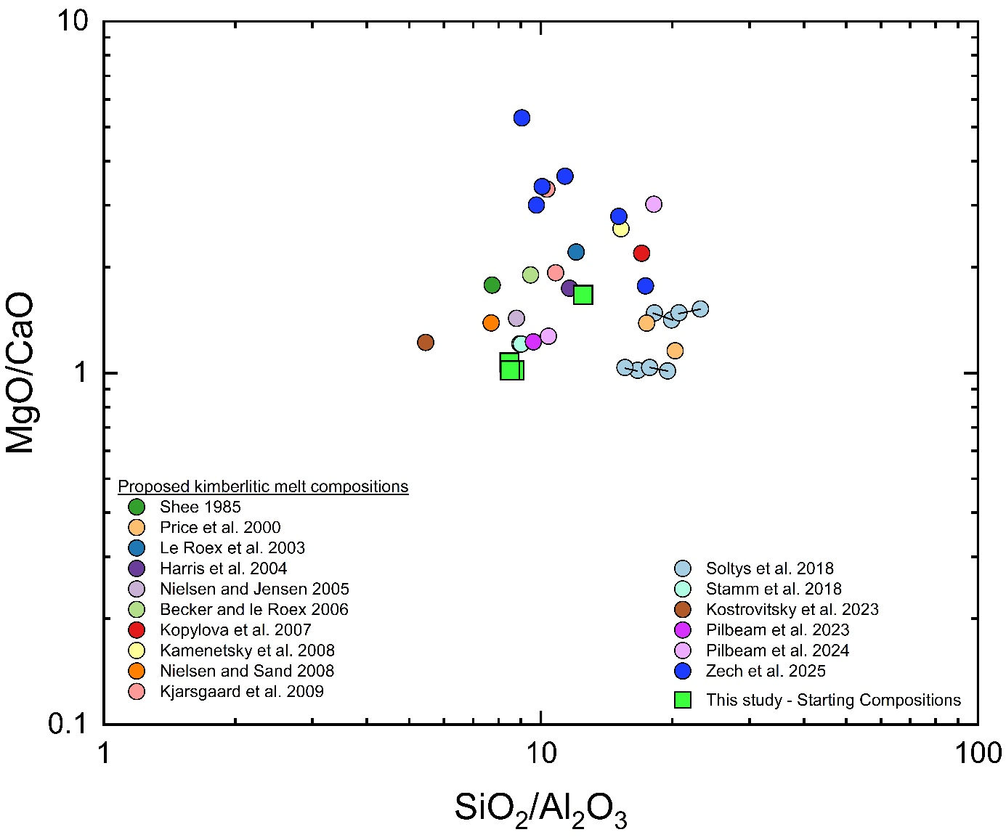
Supplementary Figure S1: MgO/CaO versus SiO₂/Al₂O₃ of proposed kimberlitic melt compositions compared with the starting compositions used in this study. Literature data represent melt estimates reconstructed from natural kimberlite rocks after removal of xenocrystic components (Shee 1985; Price et al. 2000; Le Roex et al. 2003; Harris et al. 2004; Nielsen and Jensen 2005; Becker and le Roex 2006; Kopylova et al. 2007; Kamenetsky et al. 2008; Nielsen and Sand 2008; Kjarsgaard et al. 2009; Soltys et al. 2018; Stamm et al. 2018; Kostrovitsky et al. 2023; Pilbeam et al. 2023, 2024; Zech et al. 2025). Starting compositions from this study (green squares) plot within the range of proposed kimberlitic melts, showing their consistency with previous estimates of primitive kimberlite melt compositions.

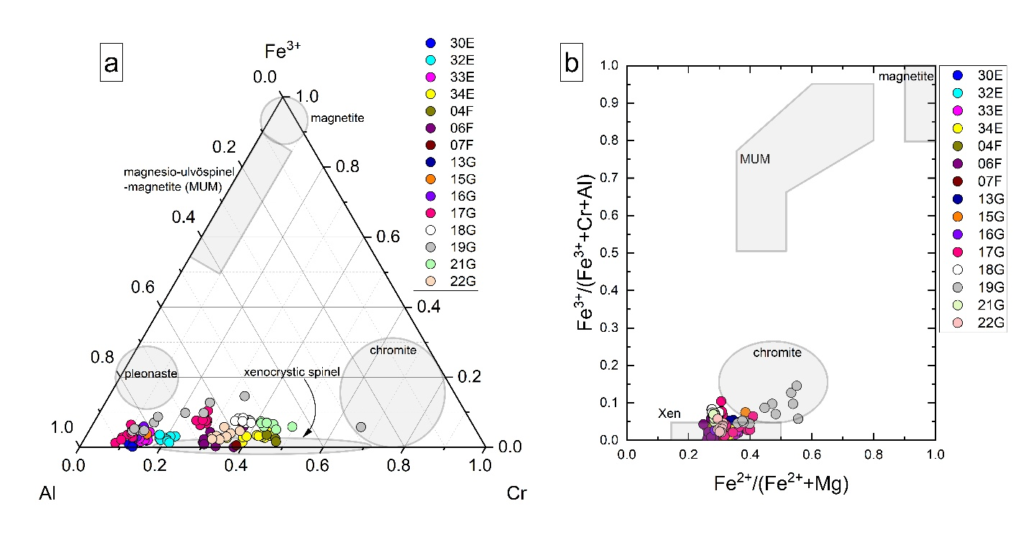
Supplementary Figure S2: (a) Ternary plot of Al, Cr and Fe³⁺, and (b) bivariate plot Mg# (all Fe as Fe²⁺) versus Fe³⁺/(Fe³⁺ + Cr + Al) of experimental spinel compositions. The majority of analyses cluster at low Fe³⁺ contents, consistent with a pleonaste–chromite compositional range. These low-Fe³⁺ spinels are comparable to those reported by Edgar et al. (1988). Shaded fields denote typical compositional ranges of natural spinel group minerals, with the experimental data indicating limited oxidation, likely reflecting more reducing conditions than for spinel crystallization in natural kimberlites.
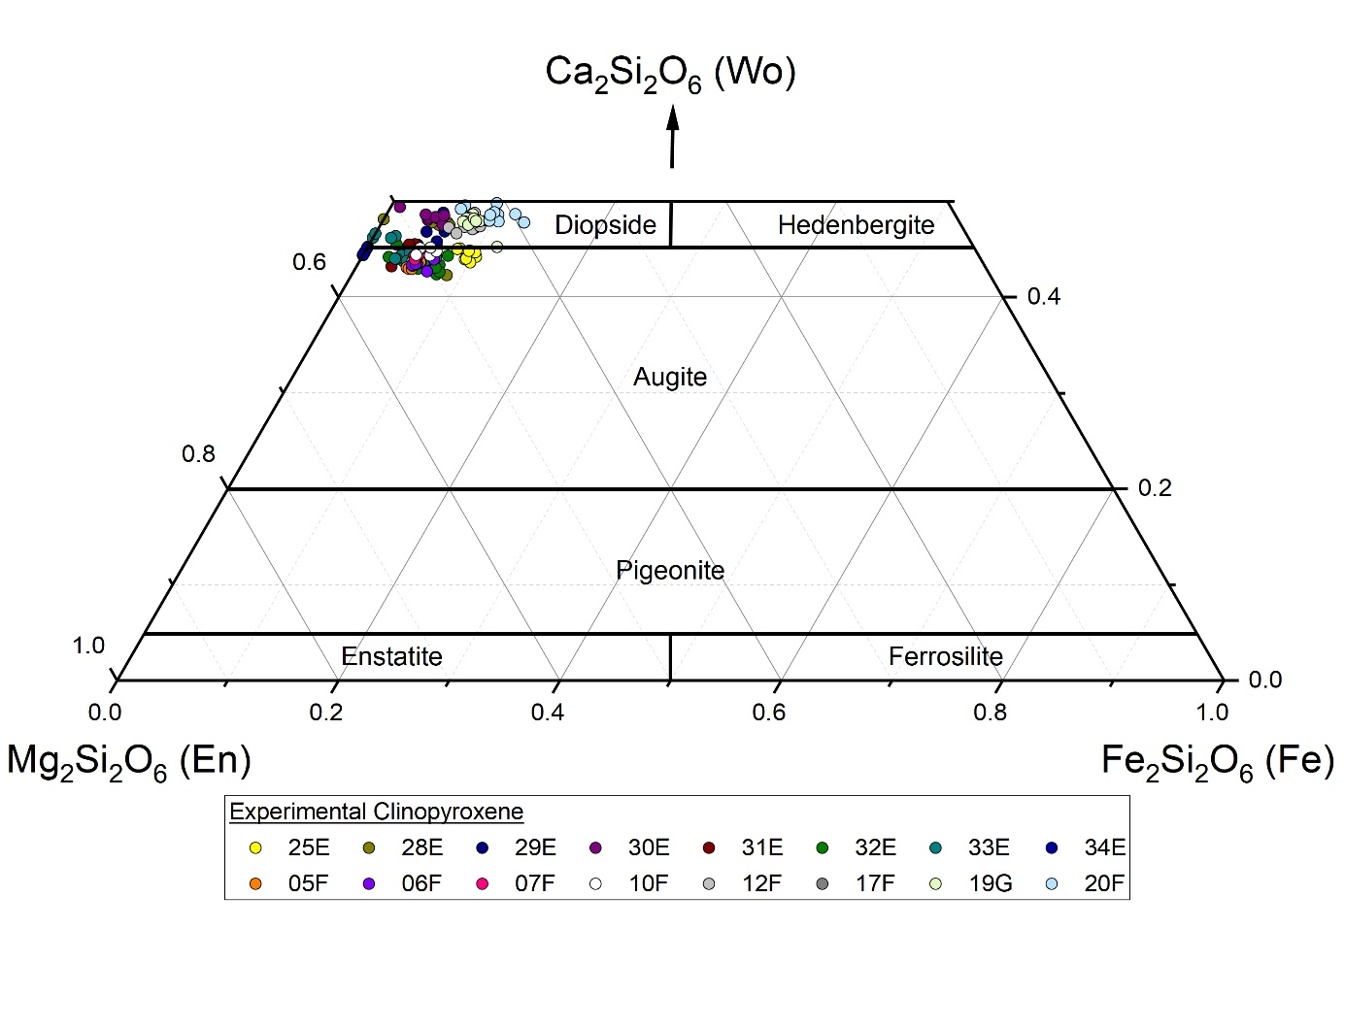Supplementary Figure S3: Ternary plot of experimental clinopyroxene compositions in the system Mg₂Si₂O₆ (enstatite) – Fe₂Si₂O₆ (Ferrosilite) – Ca₂Si₂O₆ (wollastonite). The majority of analyses cluster at diopside to augite, with low Fe³⁺ contents. These compositions are similar to clinopyroxenes in ultramafic lamprophyres.

