Supplementary materials for

Formation of ekanite in “antiskarn” by carbonatitic melt infiltration into charnockitic gneiss, Ampegama, southwestern Highland Complex, Sri Lanka

Geeth Sameera K.A.^{1,2,3} • Christoph A. Hauzenberger⁴ • Rohan Fernando G.W.A.⁵ • Radek Škoda⁶ • Prasanna L. Dharmapriya⁷ • Chutimun Chanmuang N.³ • Lutz Nasdala³

¹ Geological Survey and Mines Bureau, 569, Epitamulla road, Pitakotte, Sri Lanka
² Postgraduate Institute of Science, University of Peradeniya, P. O. Box 25, Peradeniya 20400, Sri Lanka
³ Institut für Mineralogie und Kristallographie, Universität Wien, Josef-Holaubek- Platz 2, 1090 Wien, Austria
⁴ Institute of Earth Sciences-NAWI Graz Geocenter, University of Graz, Universitätsplatz 2, 8010 Graz, Austria
⁵ Department of Physics, Faculty of Natural Sciences, The Open University of Sri Lanka, Nugegoda, Sri Lanka
⁶ Department of Geological Sciences, Faculty of Science, Masaryk University, Kotlářská 267/2, 61137 Brno, Czech Republic
⁷ Department of Geology, Faculty of Science, University of Peradeniya, Peradeniya 20400, Sri Lanka

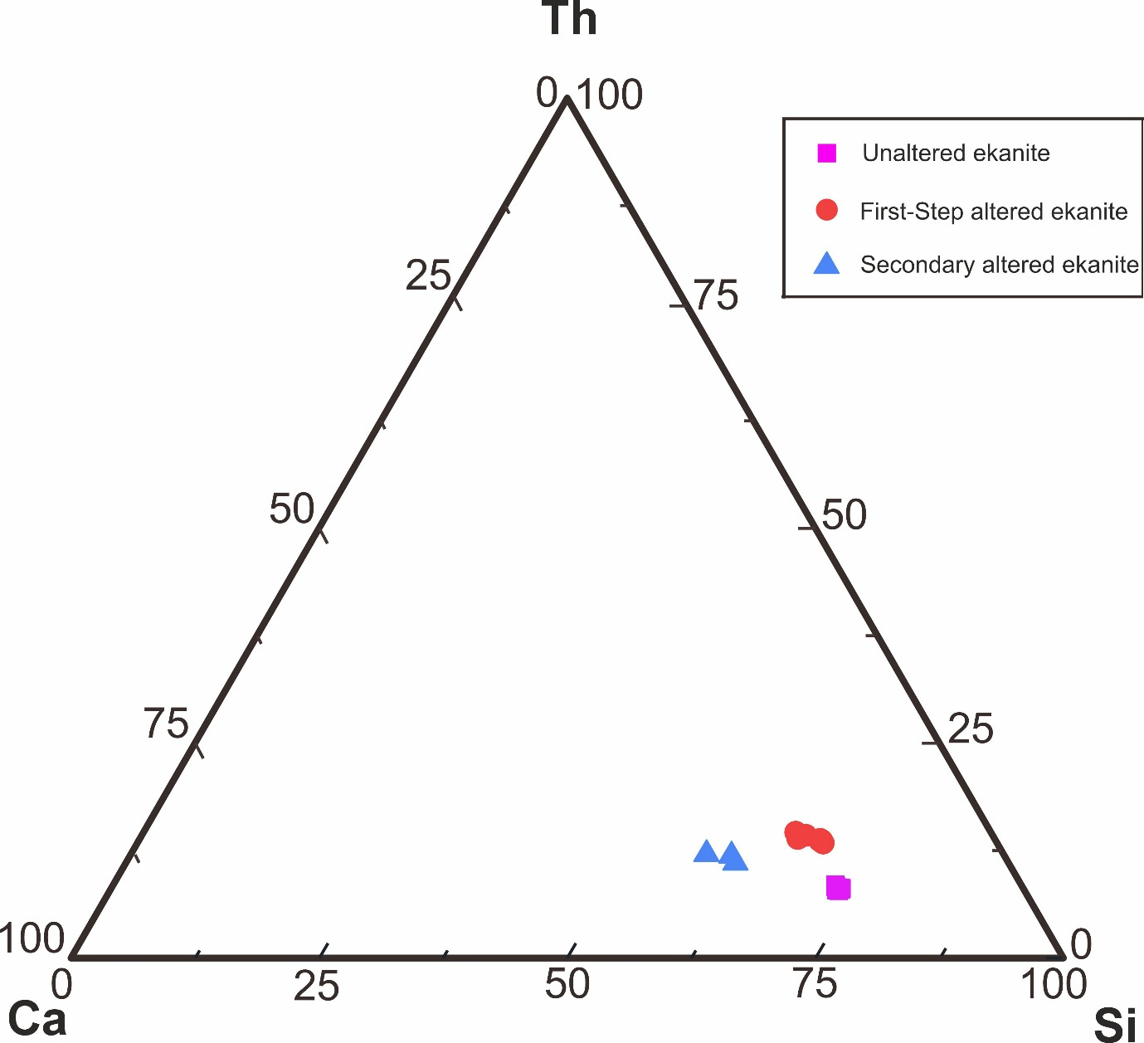
Fig. S1 Ca-Si-Th ternary diagram for the ekanite and its alterations.

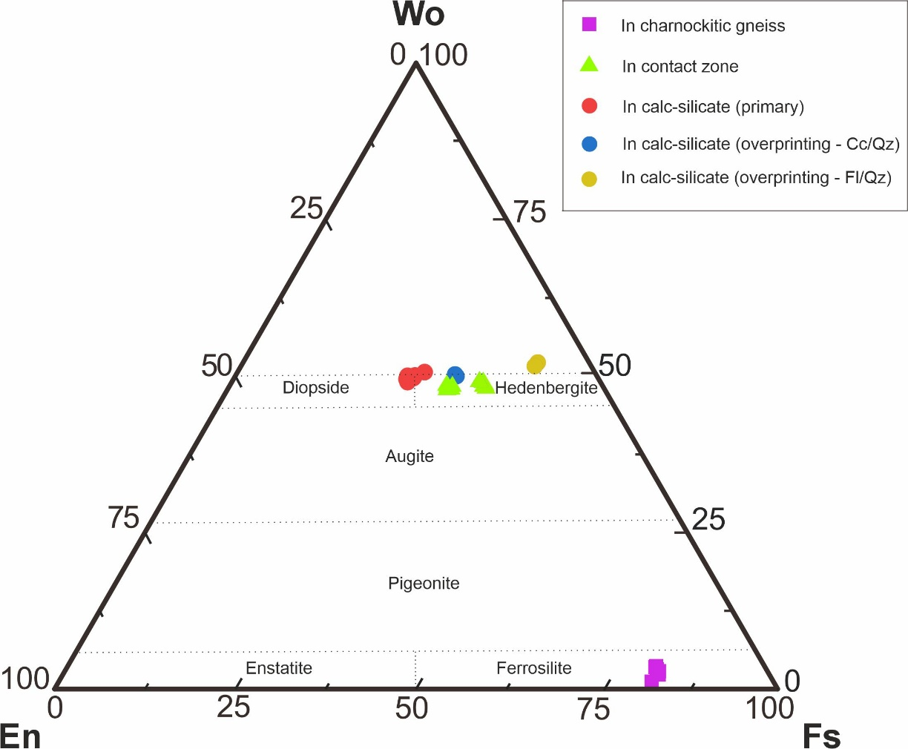

Fig. S2 CaO-MgO-FeO ternary diagram for the pyroxene in charnockitic gneiss, contact zone and calc-silicate rock.

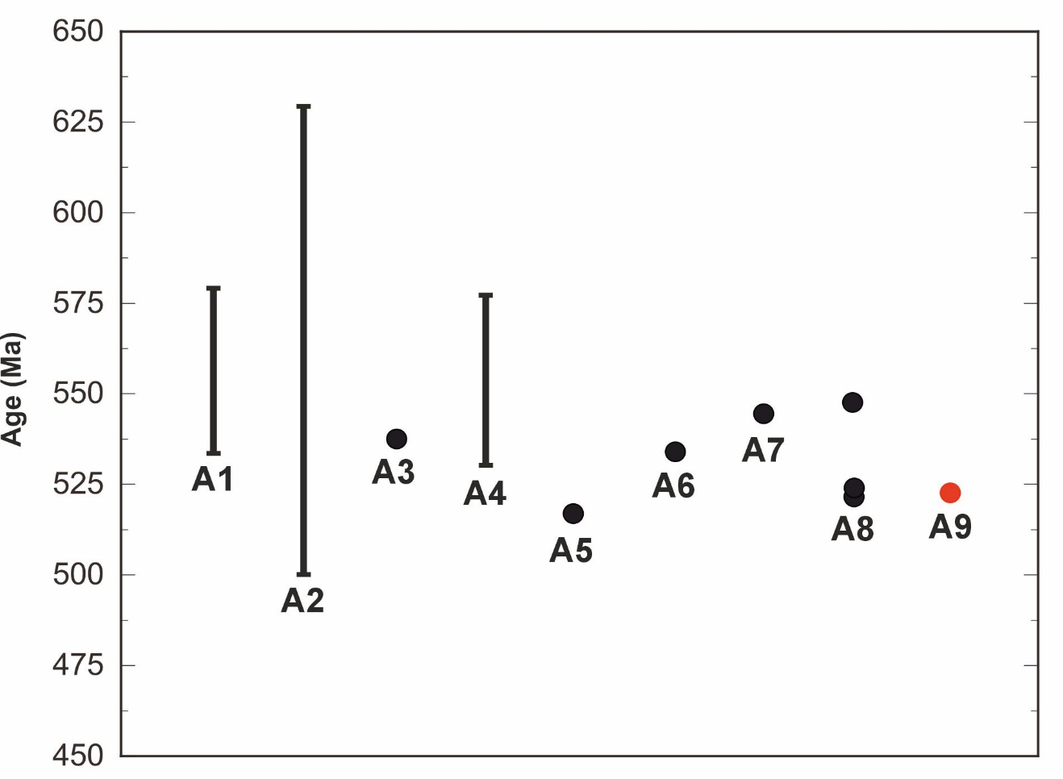
Fig. S3 Time-space plot showing various age data values relevant to high-grade metamorphism and carbonatites within the Highland and Wanni Complexes, Sri Lanka. This plot include data from; A1 - high-grade metamorphism in the Highland Complex (Takamura et al. 2016); A2 - high-grade metamorphism in the Highland Complex (Wanniarachchi et al. 2016); A3 - age of metamorphism in the Highland Complex (Kröner and Williams 1993); A4 - UHT metamorphism in the Highland Complex (Dharmapriya et al. 2015); A5 - cooling event after peak metamorphism of the Highland Complex (Dharmapriya et al. 2017); A6 - crystallization age of Kawisigamuwa carbonatite (Gallhofer et al. 2023); A7 - crystallization age of Eppawala carbonatite (Martin et al. 2024); A8 - titanite, zircon and calcite ages of Balangoda carbonatite showing its crystallization age (Wang et al. 2026); A9 - crystallization age of Ampegama ekanite (this study).

