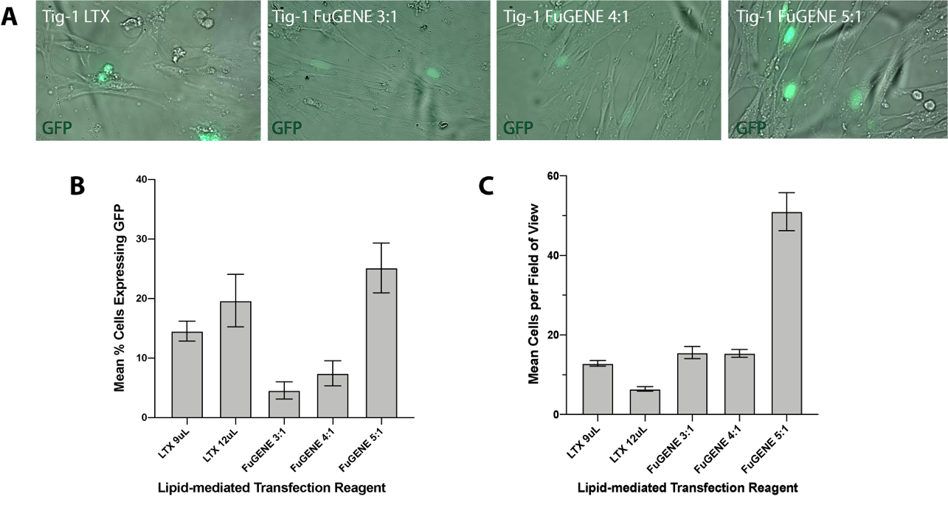

Figure S1. Optimization of lipid-mediated transfection protocol for primary human fibroblasts. A) Representative images of transient transfection of Tig-1 cells with GFP expression vector and (left to right): 9 uL of Lipofectamine LTX reagent, 3:1 ratio of FuGENE HD reagent to GFP vector, 4:1 ratio of FuGENE HD, and 5:1 ratio of FuGENE HD reagent to GFP vector. B) Transfection efficiencies using Lipofectamine LTX or FuGENE HD reagent in scaled concentrations. Mean percentage of cells with GFP expression out of total cells per field of view (± SEM). C) Cell viability of selected reagents and concentrations on transfected Tig-1 cells. Mean number of cells per field of view is shown (± SEM).

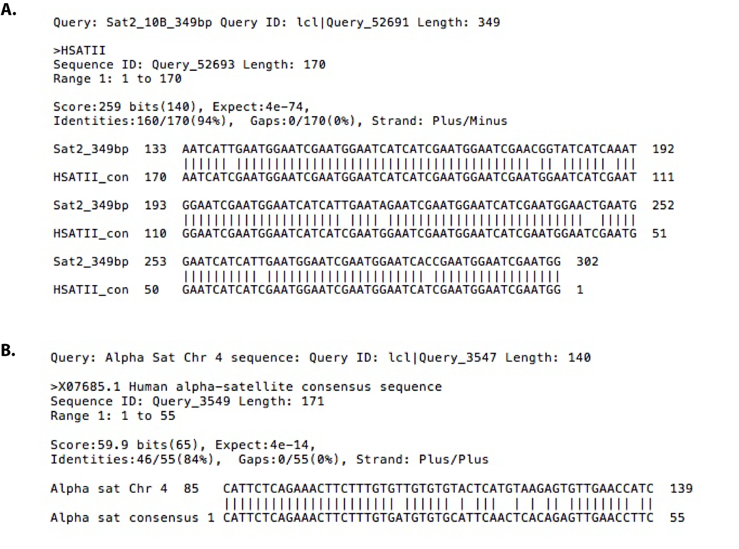

Figure S2. Alignment of chromosome-specific expression clones to satellite consensus sequences. A) Alignment of 349bp Chr7-specific HSATII variant to HSATII Repbase consensus sequence (HSATII_con). Alignment produced by Blast2seq. B) Alignment of 140bp Chr4-specific alpha satellite variant (Genbank M38467.1) to Repbase alpha satellite consensus sequence (Genbank X07685.1)

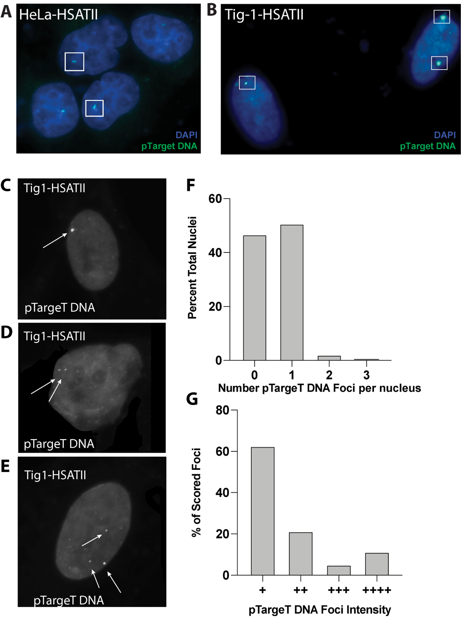

Figure S3. pTargeT vector DNA integration at high efficiency in HSATII transfected Tig-1 cells. A-B) Hybridization of pTarget (empty vector) shows integration into one or two genomic loci per nucleus in both HeLa (A) and Tig-1 (B) nuclei. FISH with labeled pTargeT backbone probe for Tig-1 showing C) Representative HSATII transfected nucleus with one site of integration. D) Representative HSATII transfected nucleus with two sites of integration. E) Representative HSATII transfected nucleus with three sites of integration. F) DNA FISH with the pTargeT backbone shows at least one site of pTargeT integration in 54.69% of HSATII transfected cells (N = 200). Due to incomplete DNA hybridization efficiency, not all nuclei displayed detectable pTargeT DNA signal. G) Relative intensity of scored foci was assigned to the following categories: + (dim), ++ (easily visible), +++ (very bright), or ++++ (extremely bright, saturated pixels). All foci were categorized and imaged using the same exposure time.

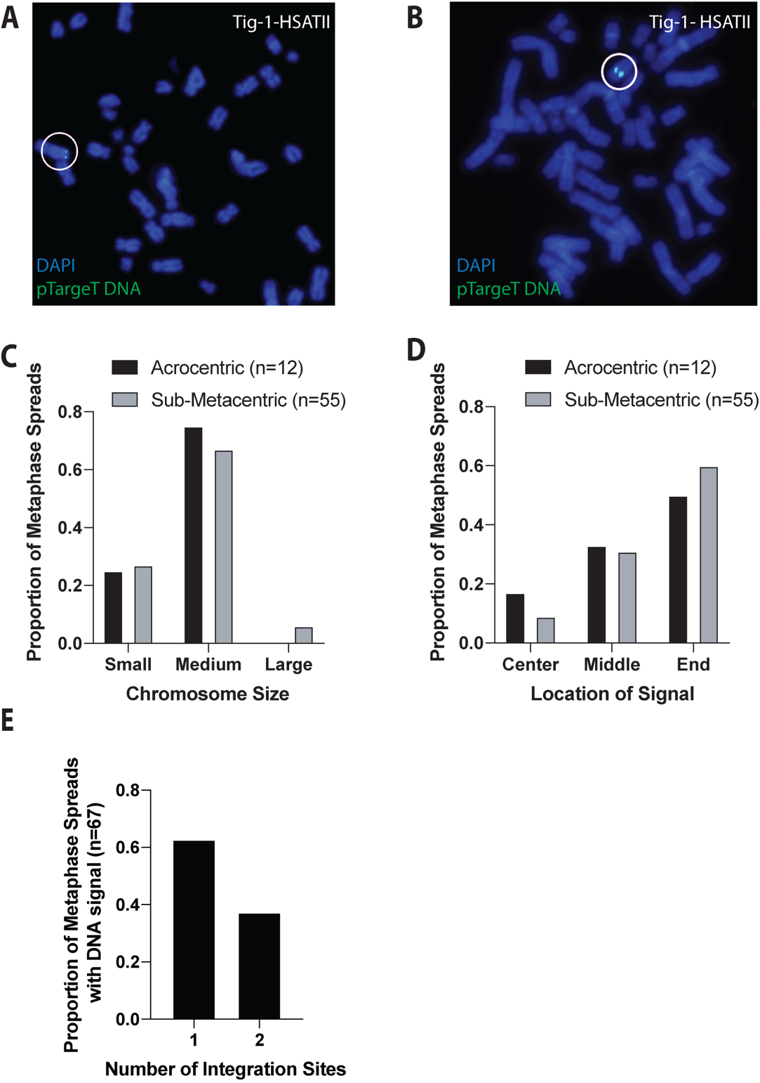
Figure S4. Stable Tig-1 cell lines display random integration of pTargeT vector DNA into Tig-1 chromosomes. A-B) Labeled pTargeT backbone probe detects integration sites of transfection vector containing HSATII DNA construct (green) in both (A) sub-metacentric and (B) acrocentric chromosomes on DAPI-stained metaphase spreads. Integration sites are indicated by circles and have been replicated on sister chromatids. C-D) Categorization of (C) chromosome size and (D) signal location were scored for both sub-metacentric and acrocentric chromosomes and demonstrate random integration on a variety of human chromosomes. Since most human chromosomes are categorized as “medium” size, the higher frequency of integration into medium-sized chromosomes likely reflects a random distribution of integration sites. E) The number of pTargeT vector DNA integration sites on HSATII transfected Tig-1 chromosome spreads was also scored. Data shown is for chromosome spreads with detectable pTargeT DNA hybridization signal.

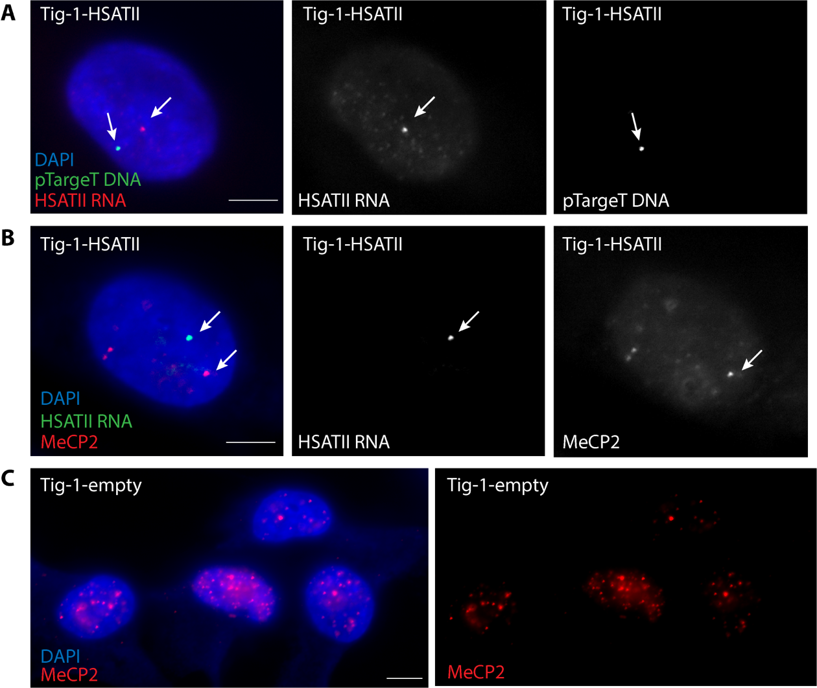

Figure S5. Non-localized pattern of HSATII RNA with pTargeT DNA and MeCP2 in transfected Tig-1 cells. A) In some Tig-1 cells transfected and expressing HSATII RNA, HSATII RNA (red) does not localize adjacent to sites of pTargeT vector integration (green). B) Tig-1 cells transfected and expressing HSATII (green) do not always recruit MeCP2 (red) to HSATII RNA accumulations (HSATII and MeCP2 distinct foci indicated by separate arrows). C) Tig-1 cells transfected with empty vector (pTargeT only) demonstrate MeCP2 nuclear foci (red) in a normal nuclear distribution. Scale bar, 5µm.

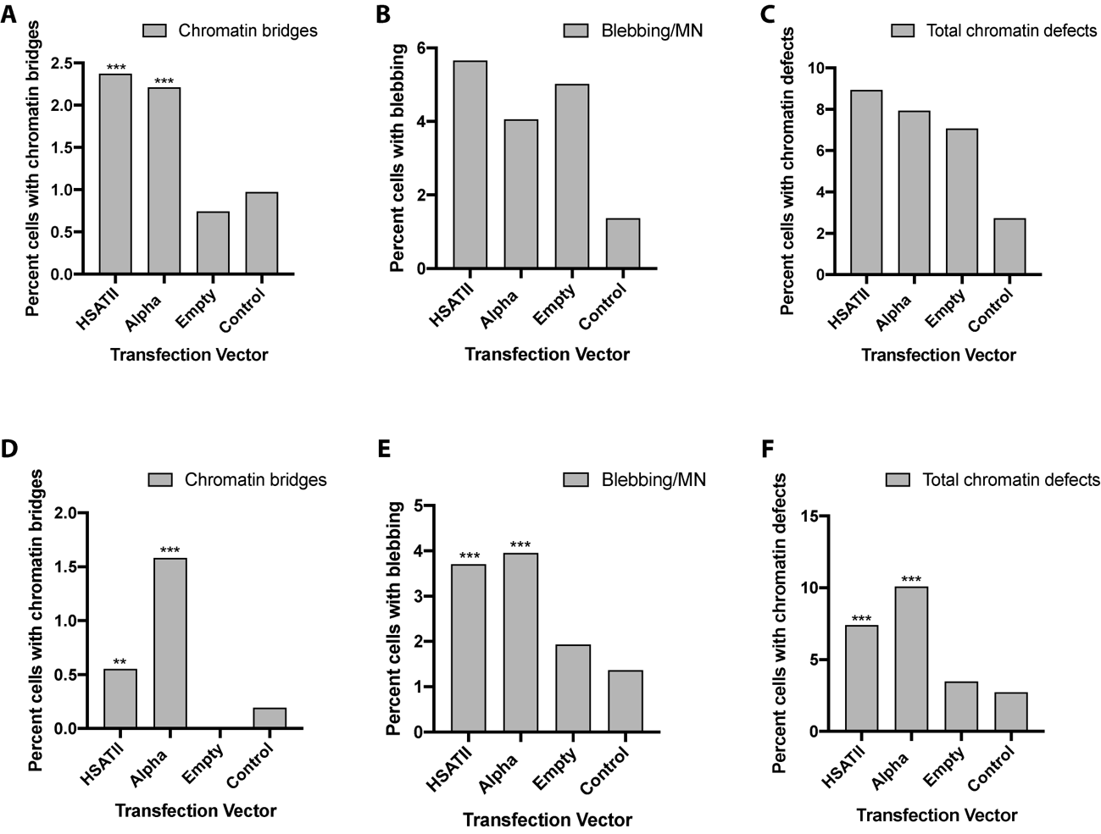

Figure S6. Chromatin defect scoring from replicate HeLa (A-C) and Tig-1 (D-F) transfection experiments. These scoring data reflect independent transfection experiments from those shown in Figure 4. Scoring of control HeLa or HeLa cells transfected with HSATII, a-sat or empty vector displaying percentage of cells with A) chromatin bridges, B) blebbing/MN and C) total chromatin defects out of 500 total cells for each transfection vector used. Percentages of control Tig-1 or Tig-1 cells transfected with HSATII, a-sat or empty vector displaying percentage of cells with D) chromatin bridges, E) blebbing/MN and F) total chromatin defects from 500 total cells per transfection vector. Data in this figure are from independent transfections from those shown in Fig. 4, but scoring and chi-square statistical analysis were performed in an identical manner.

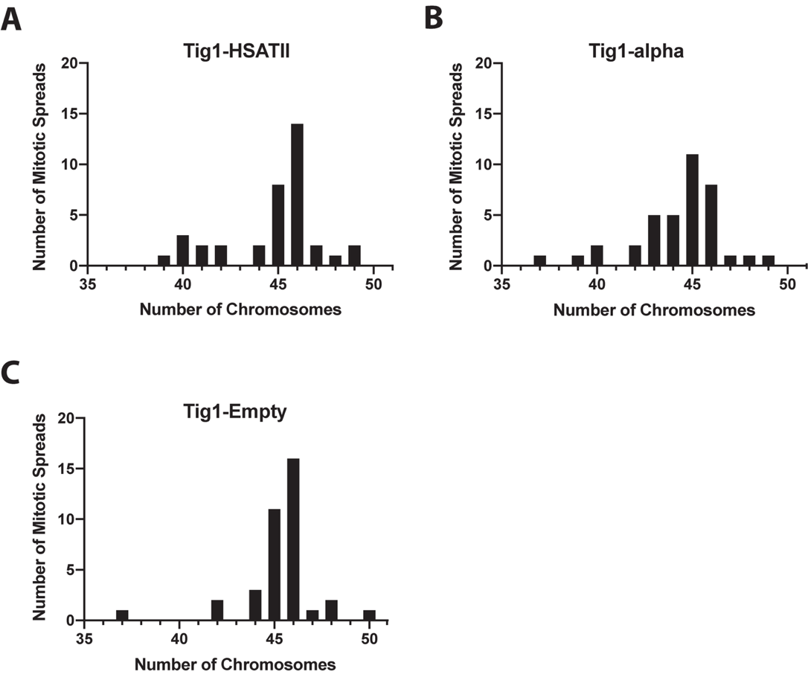

Figure S7. Karyotype analysis of Tig-1 transfected cells. Tig-1 cells were arrested and harvested for mitotic spread analysis 60 days following transfection. A) Number of chromosomes scored in each mitotic spread in HSATII transfected cells (n= 37). B) Number of chromosomes scored in each mitotic spread in alpha-sat transfected cells. C) Number of chromosomes scored in each mitotic spread in empty-vector transfected cells.

