Figure S1: Autosomal STR DNA Profile of one sample showing Amelogenin deletion in Madhya Pradesh Population.
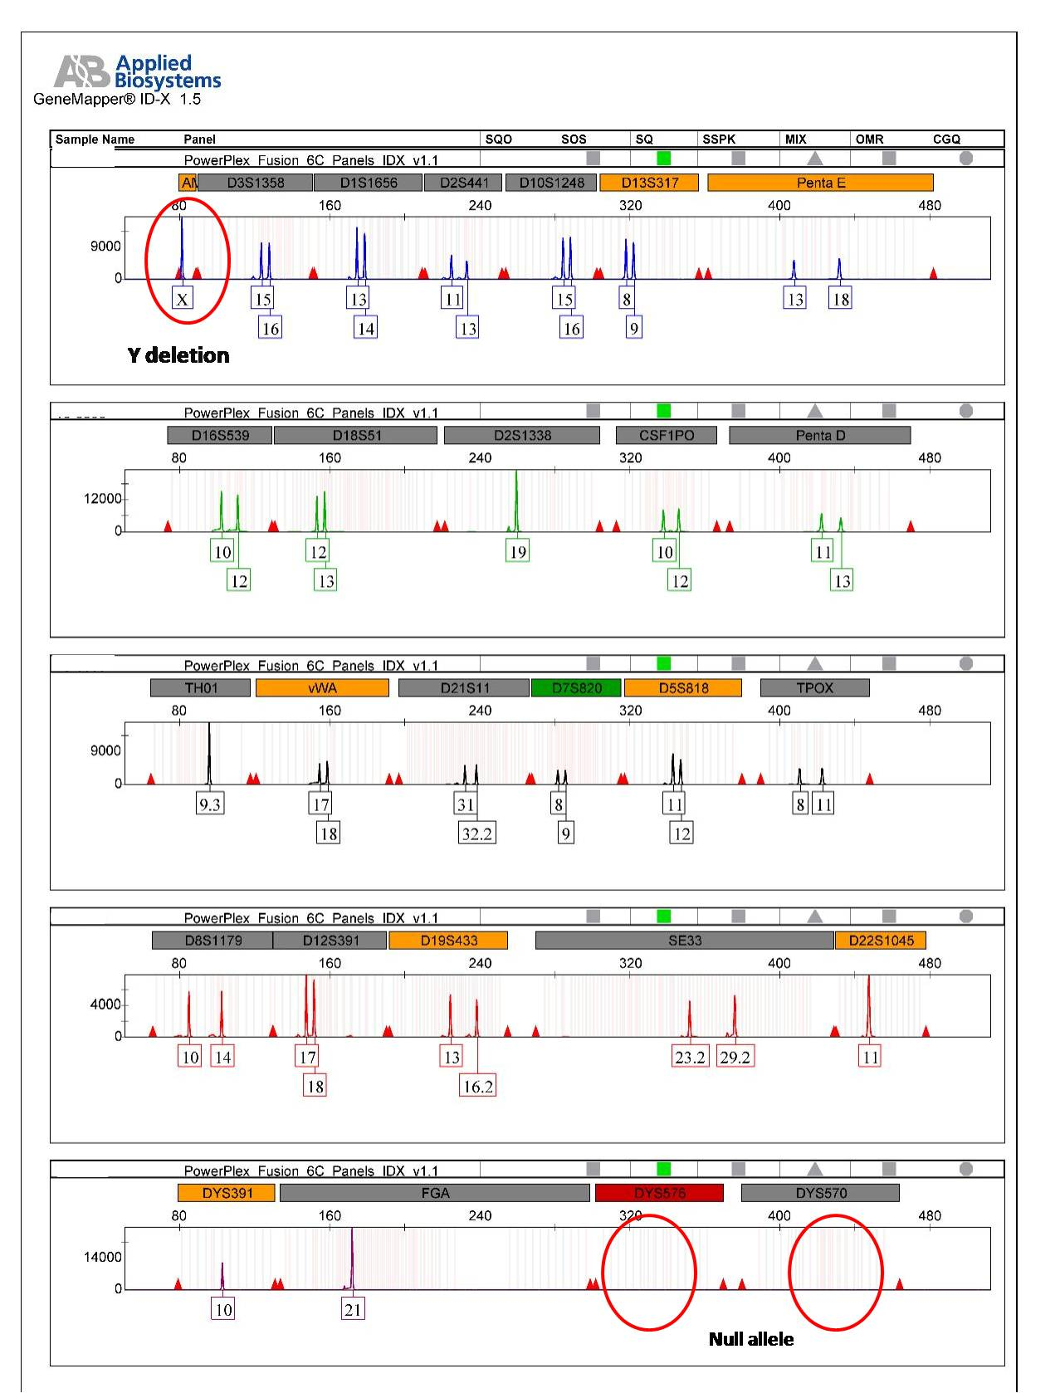

Figure S2. NJ tree comparison of Madhya Pradesh with other reported populations based on autosomal STR data.

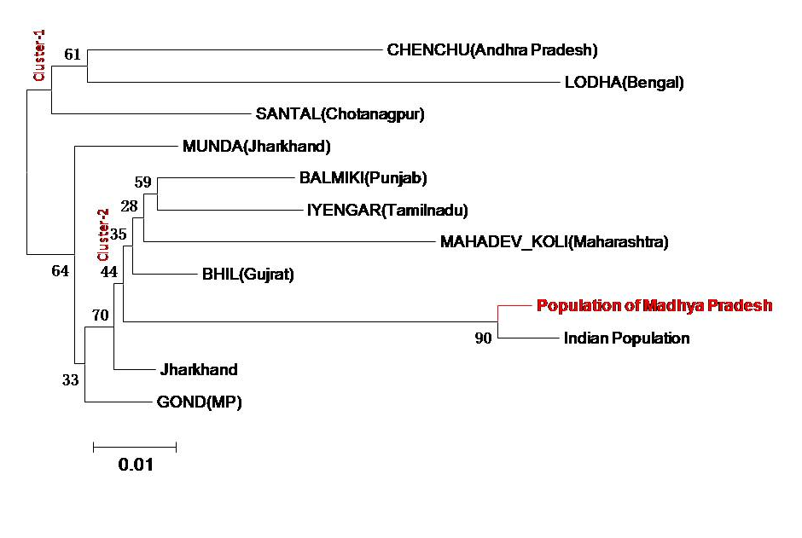

Figure S3. Genetic Diversity of three Y-STR Loci included in PP F6C Multiplex System in Population of Madhya Pradesh.

