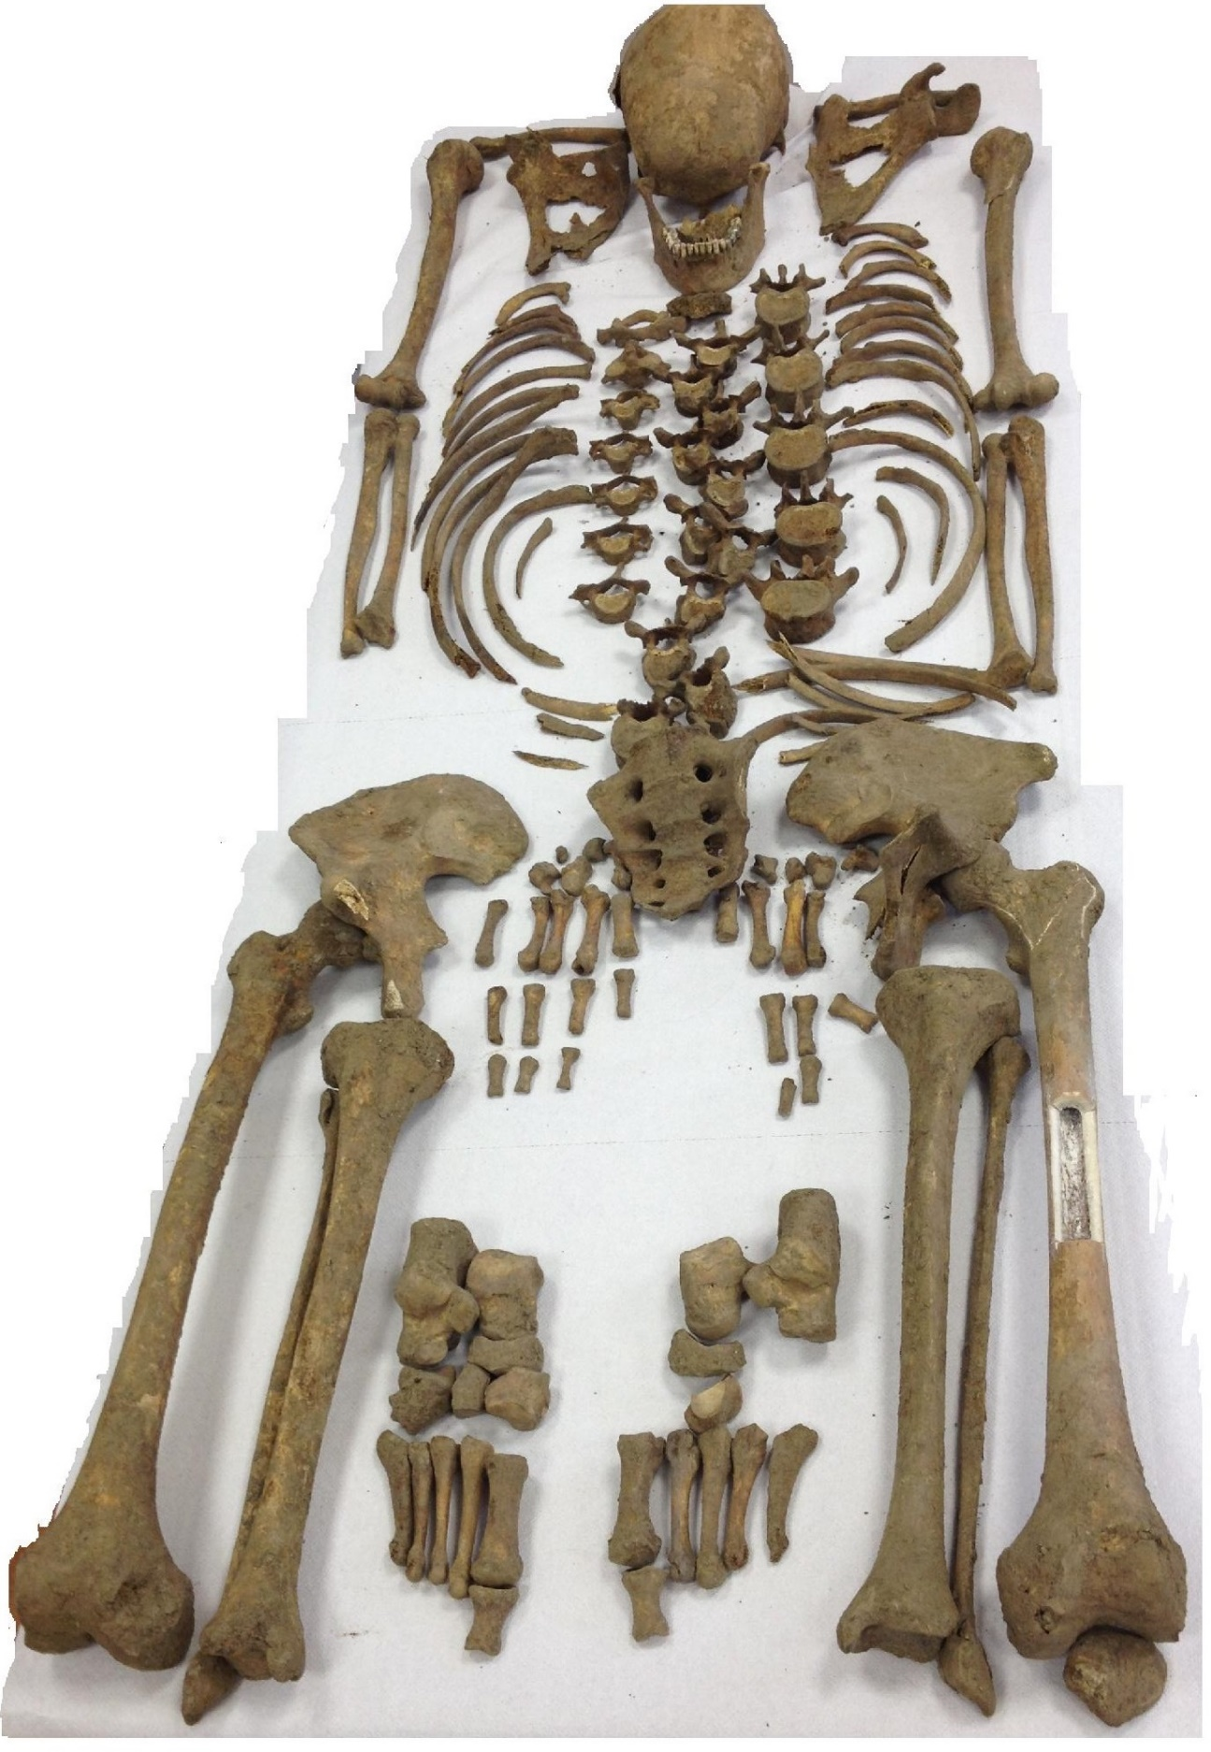
Fig. S2. The exhumated bone remains in anatomical order.
Identification of World War II bone remains found in Ukraine using classical anthropological and mitochondrial DNA results, Eszter Dudás, Éva Susa, Horolma Pamjav, Zoltán Szabolcsi*, University of Pannonia, email: szabzoltan@gmail.com

