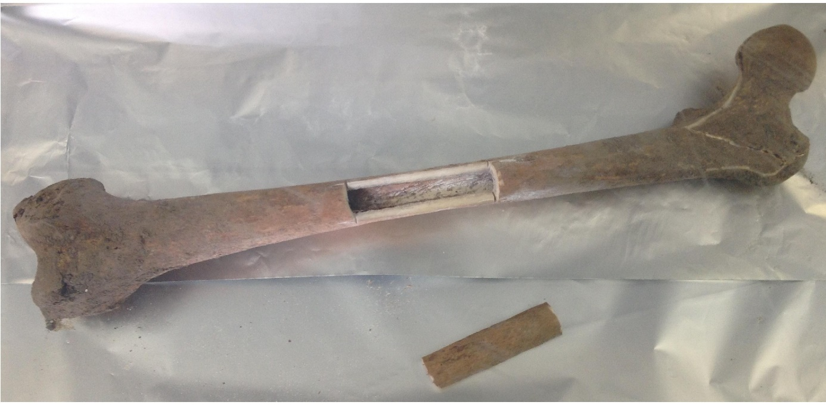
Fig. S3. The post examination leftward femur.
Identification of World War II bone remains found in Ukraine using classical anthropological and mitochondrial DNA results, Eszter Dudás, Éva Susa, Horolma Pamjav, Zoltán Szabolcsi*, University of Pannonia, email: szabzoltan@gmail.com

