Fig 1S. Number of RDX-C4 cases in Bahrain from 2015-2018 (May)

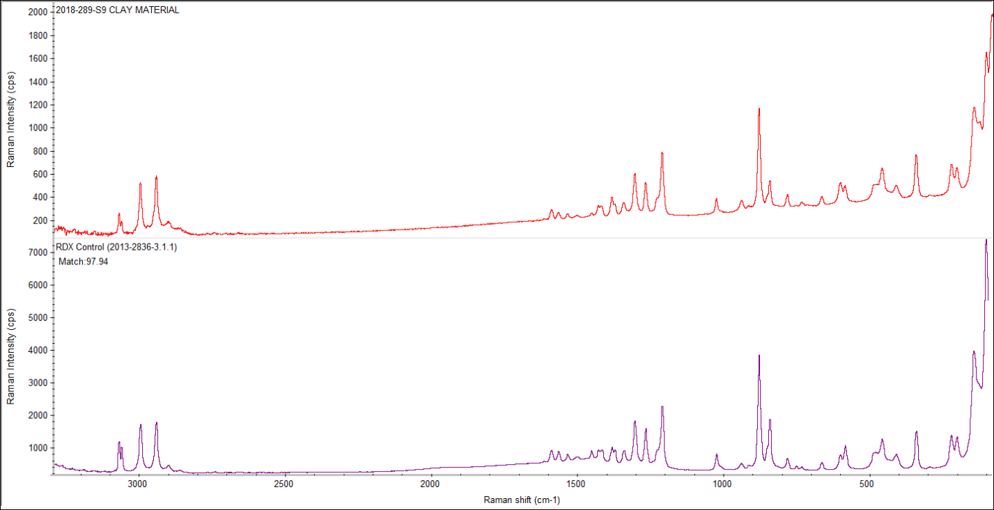
Fig 2S. Chemical analysis of Evidence showing 97.94 match with RDX control using DXR Raman Spectrometer

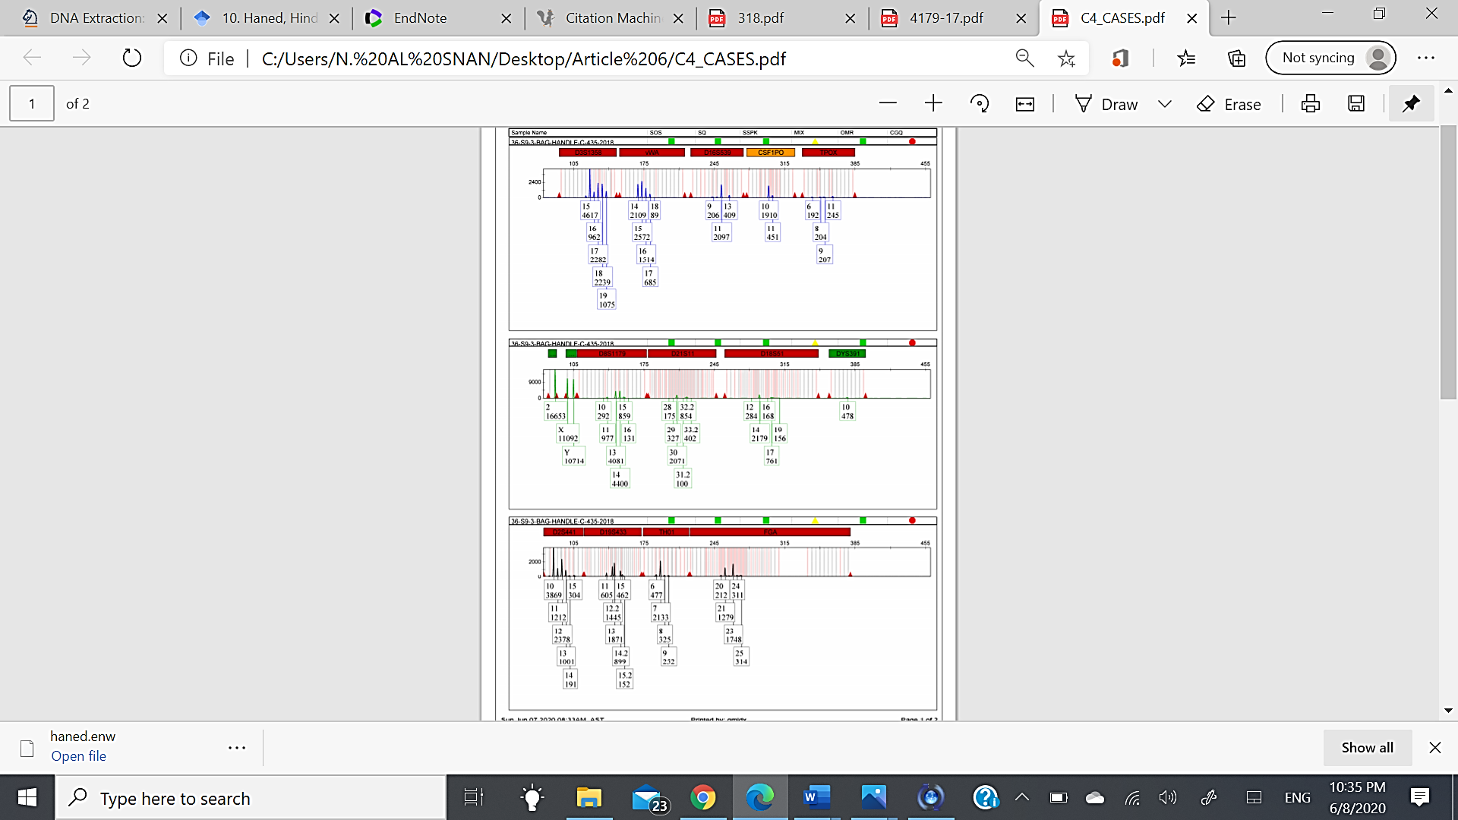
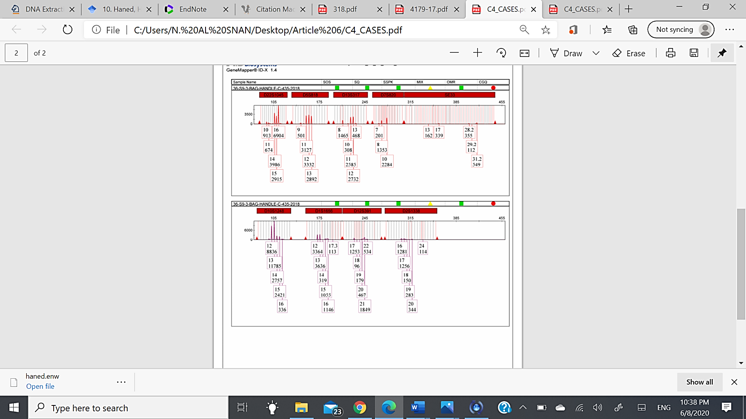
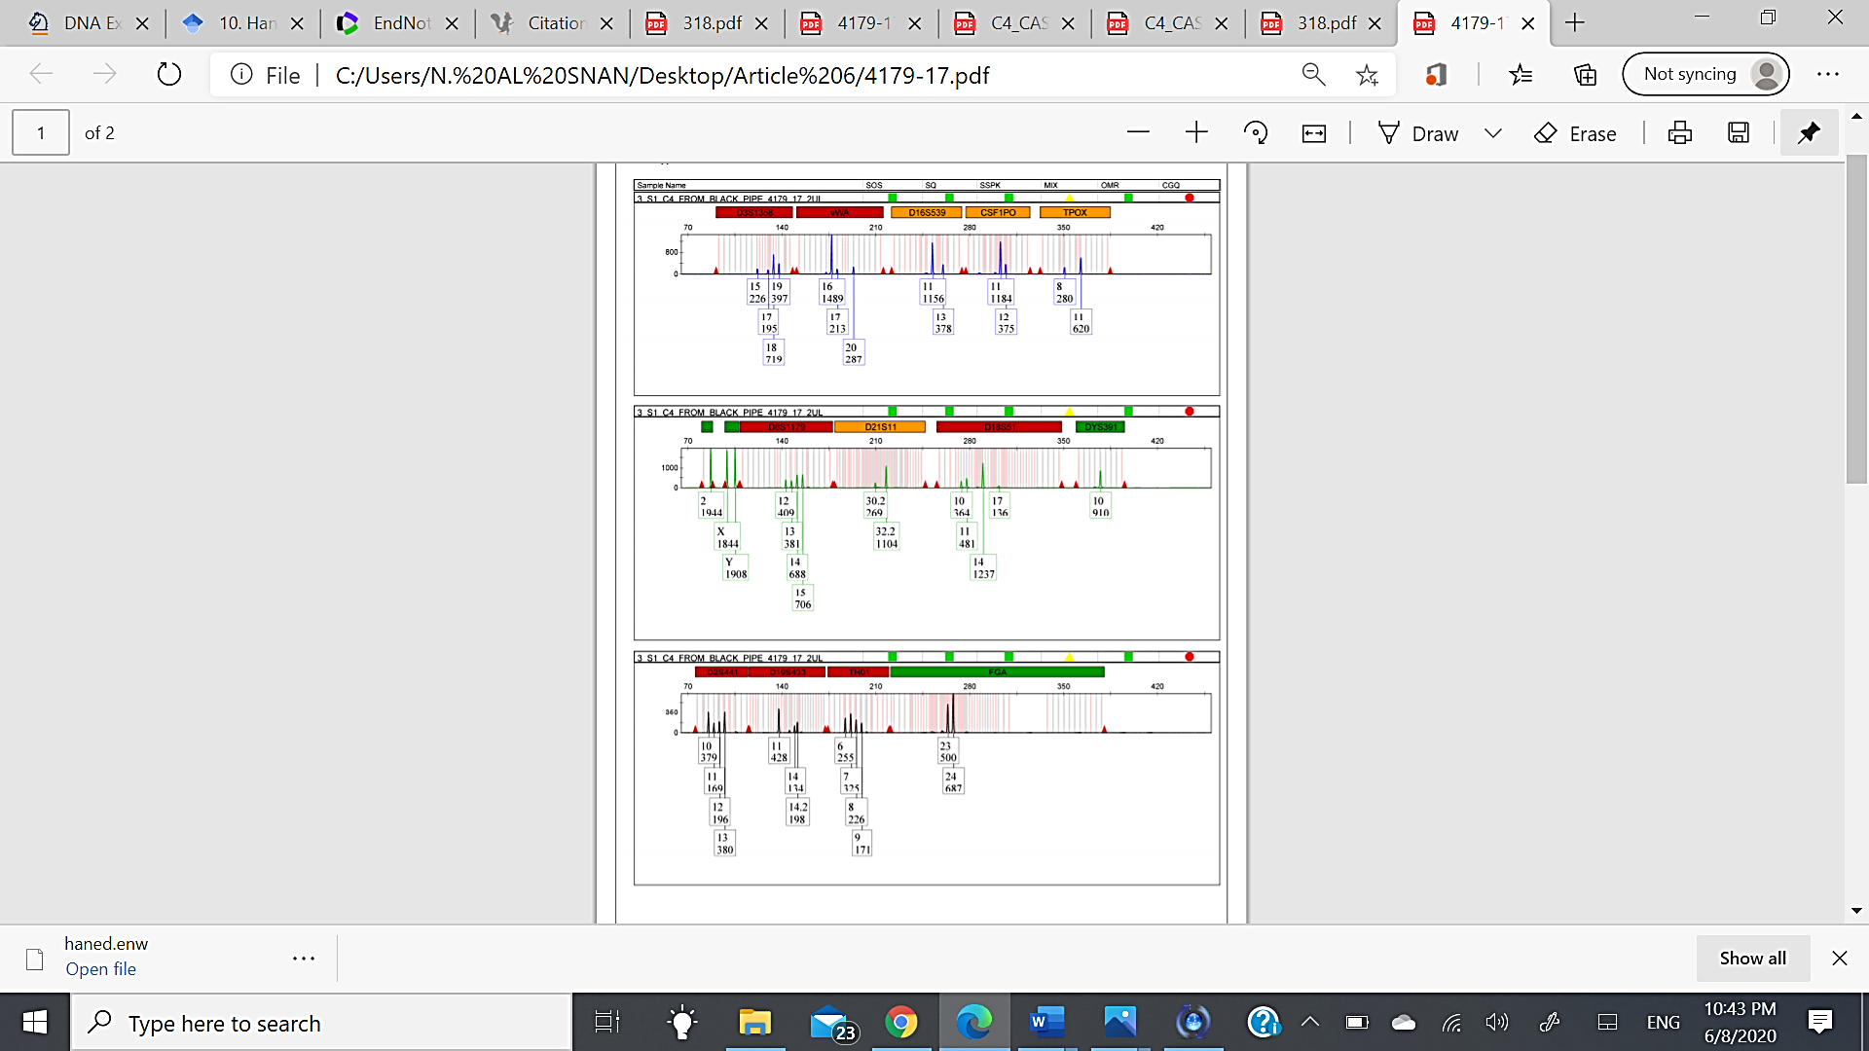
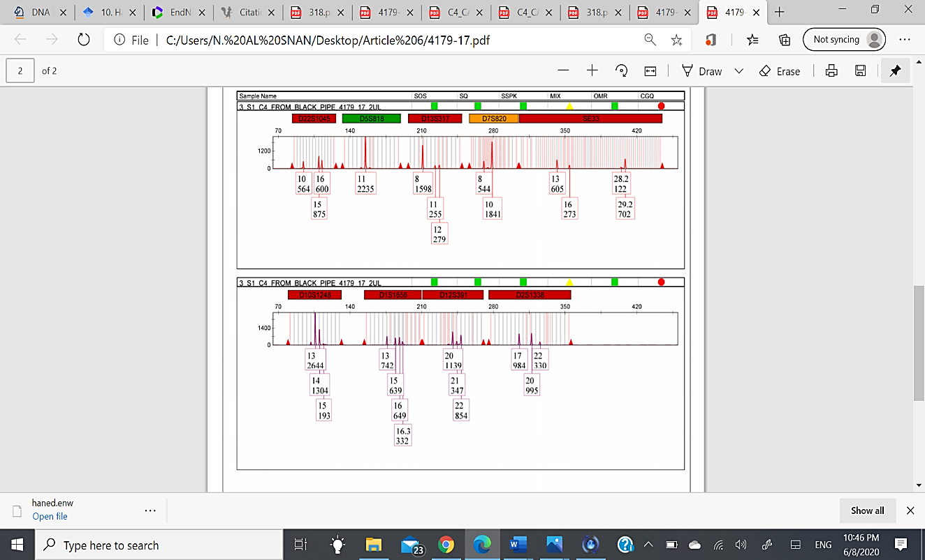
Fig 3S. The results obtained from handles of black bag contaminated with RDX-C4 showed DNA mixtures (0.75ng/µl)
Fig 4S. The results obtained from RDX-C4 inside the black pipe showed DNA mixtures (0.001ng/µl)

Figure 4 Figure 4 The results obtained from RDX-C4 inside the black pipe showed DNA mixtures (0.01ng/µl)

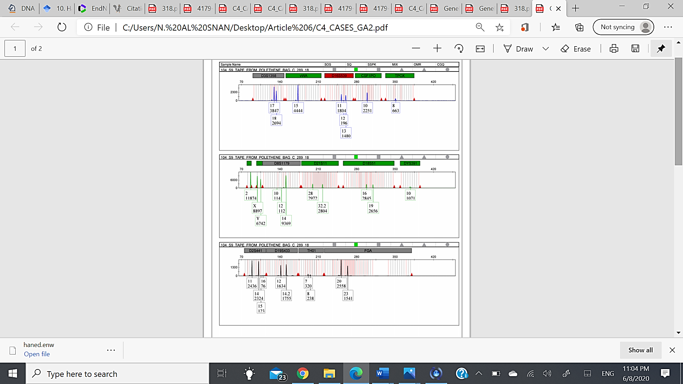
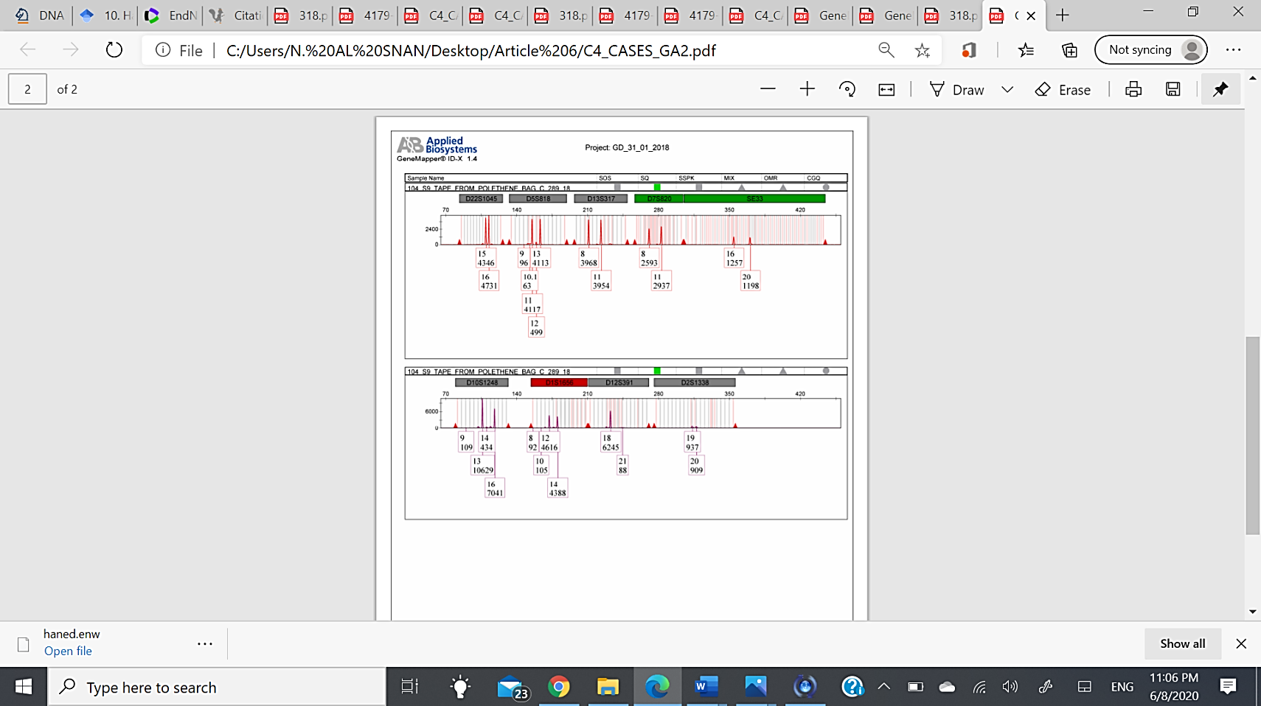
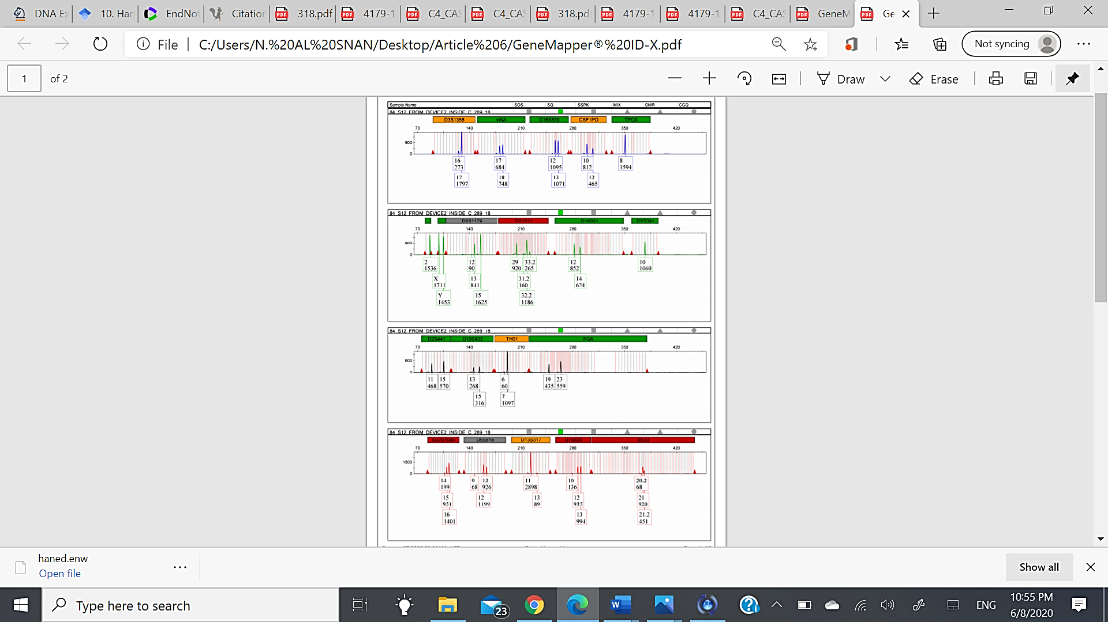
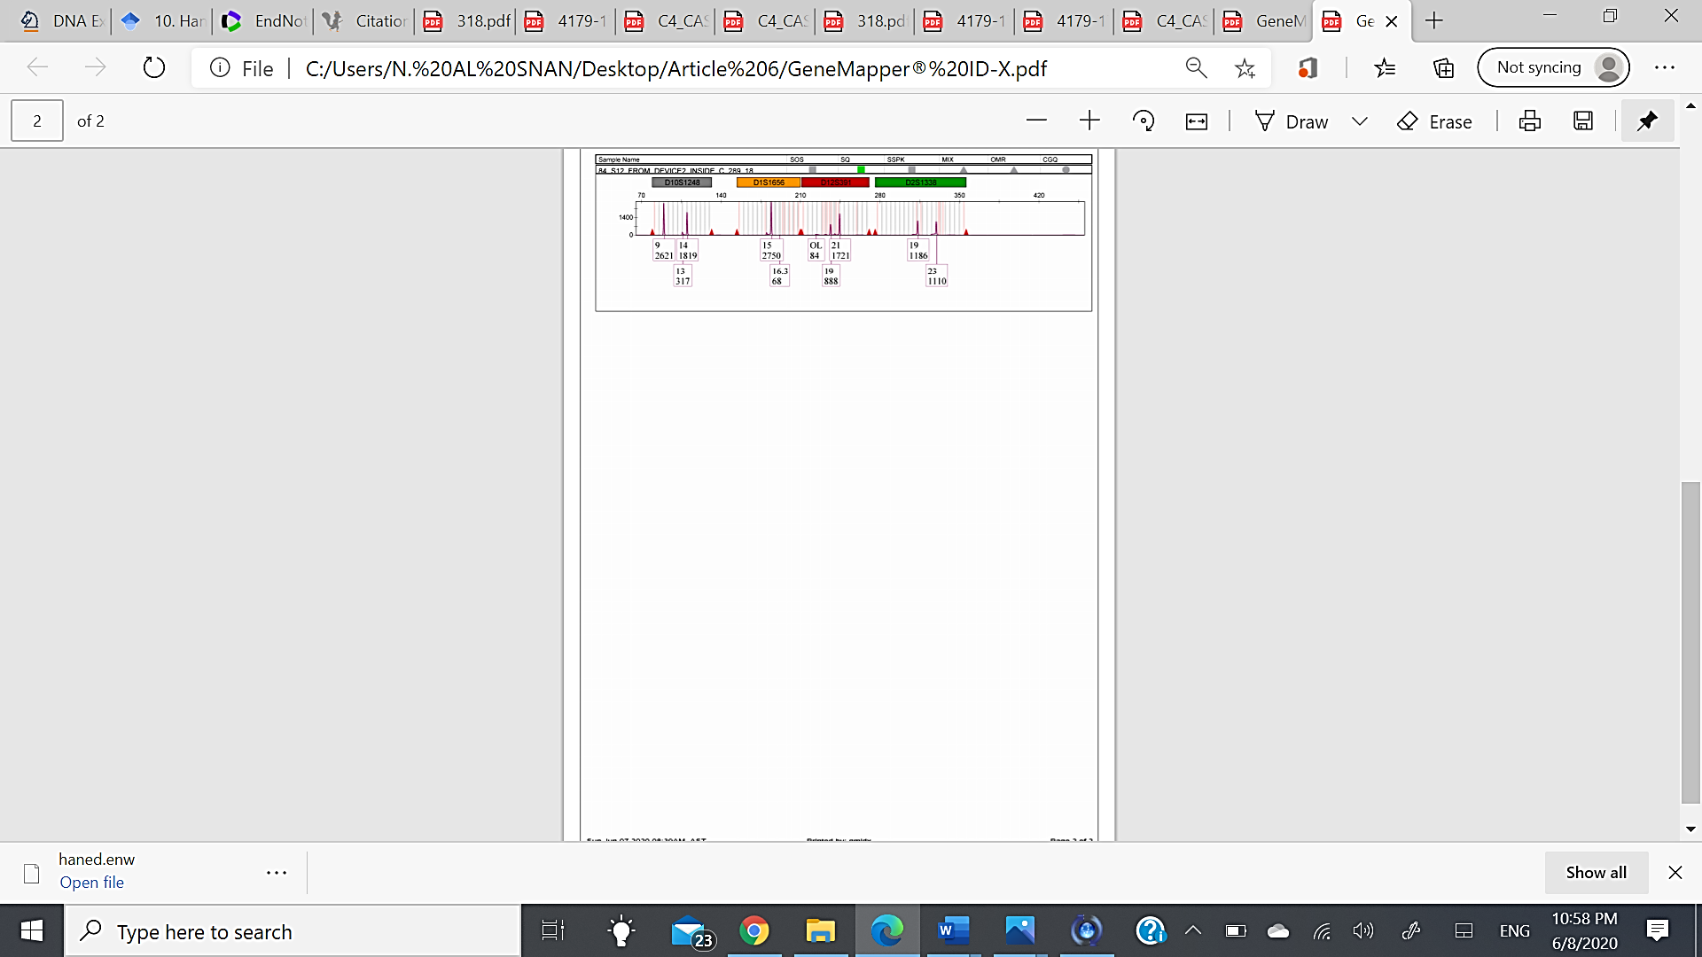
Fig 6S. The results obtained from tape on the Demolition Charge M112 (external surface) contaminated with RDX-C4 showed major contributor of single-source male DNA (0.75ng/µl)
Fig 5S. The results obtained from RDX-C4 inside the magnetic IED showed DNA mixtures (00.01ng/µl)

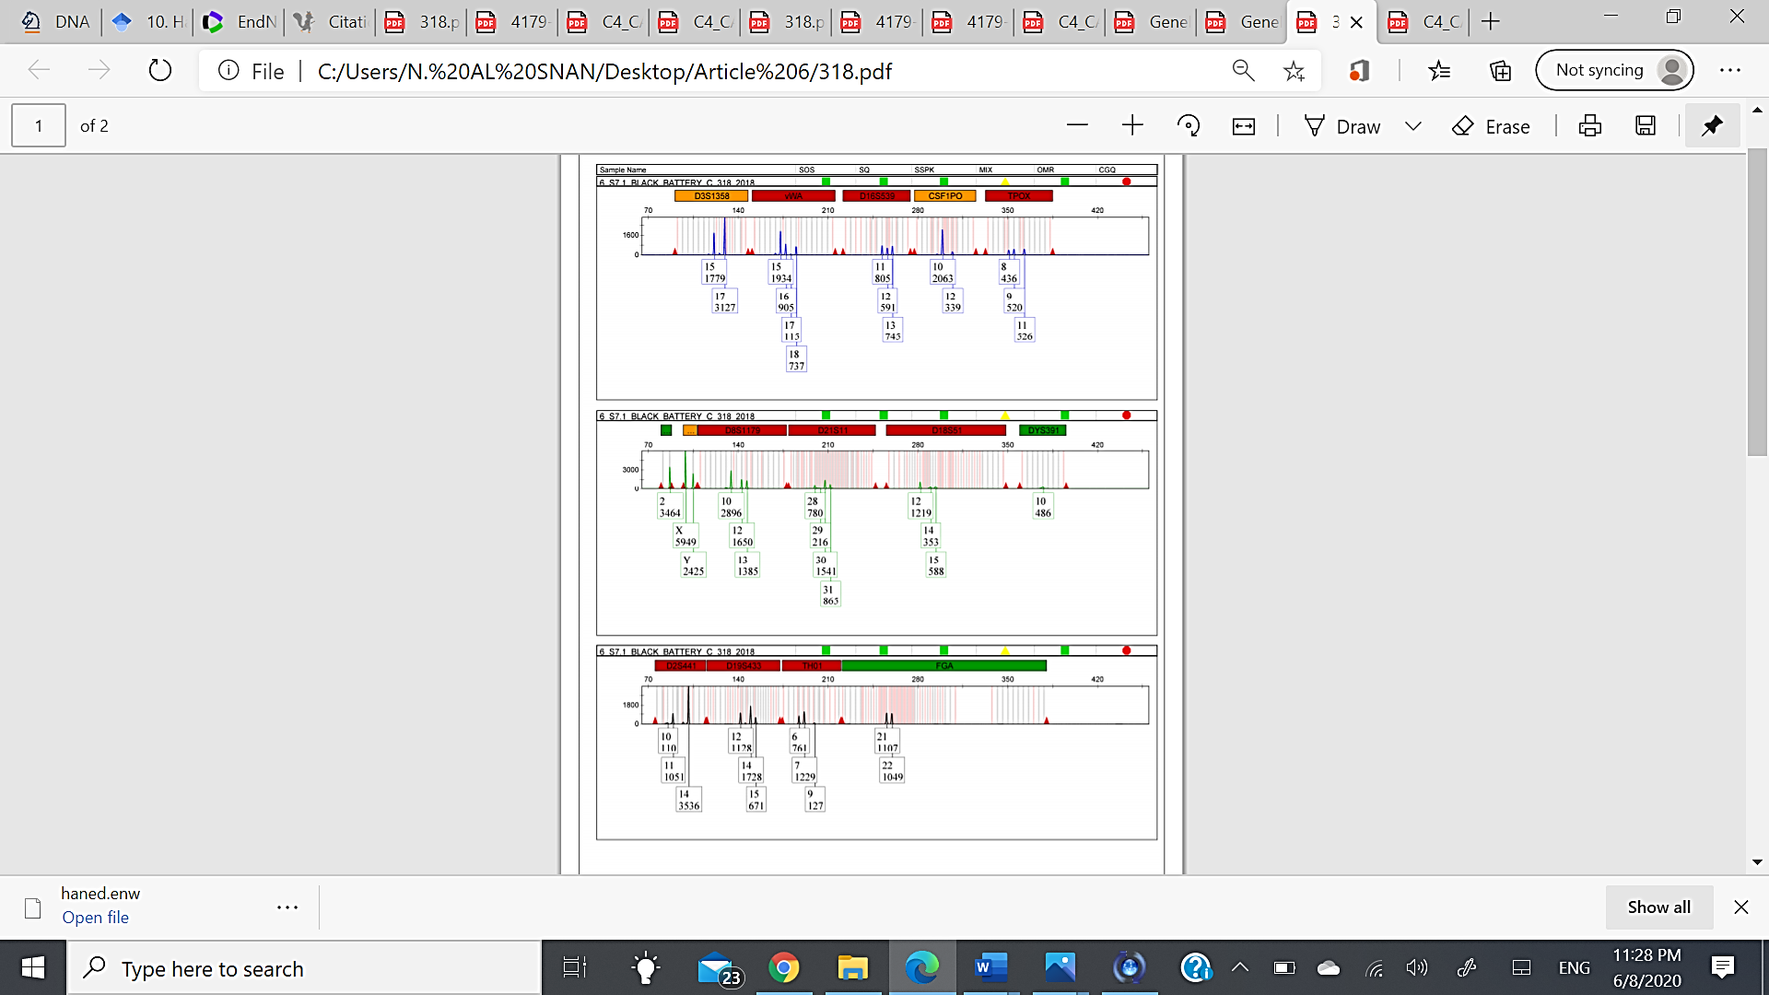
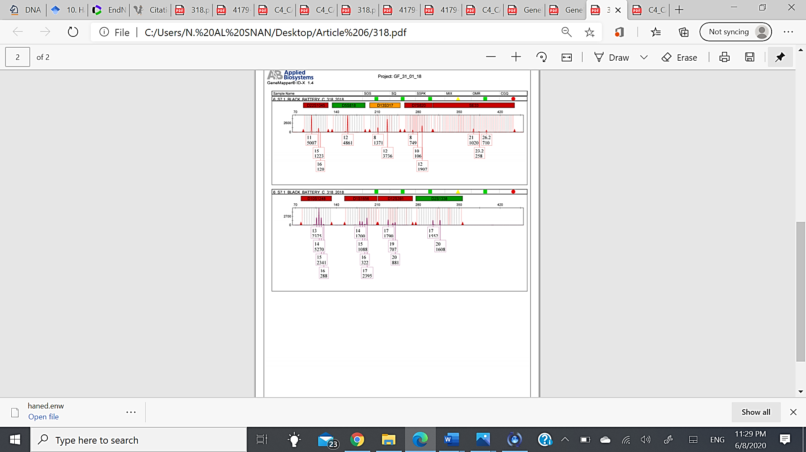
Fig 7S. The results obtained from black battery (external surface) contaminated with RDX-C4 showed DNA mixtures (0.75ng/µl)

