Internal validation study to assess the SeqStudio™ for Human Identification’s performance
International Journal of Legal Medicine
Soldati Giulia¹, Turrina Stefania¹, Saccardo Chiara¹, Ausania Francesco¹, De Leo Domenico¹

¹ Department of Diagnostics and Public Health, Section of Forensic Medicine, Forensic Genetics Lab, University of Verona, Italy

Corresponding author: giulia.soldati_02@univr.it, ORCID iD 0000-0001-7442-8139

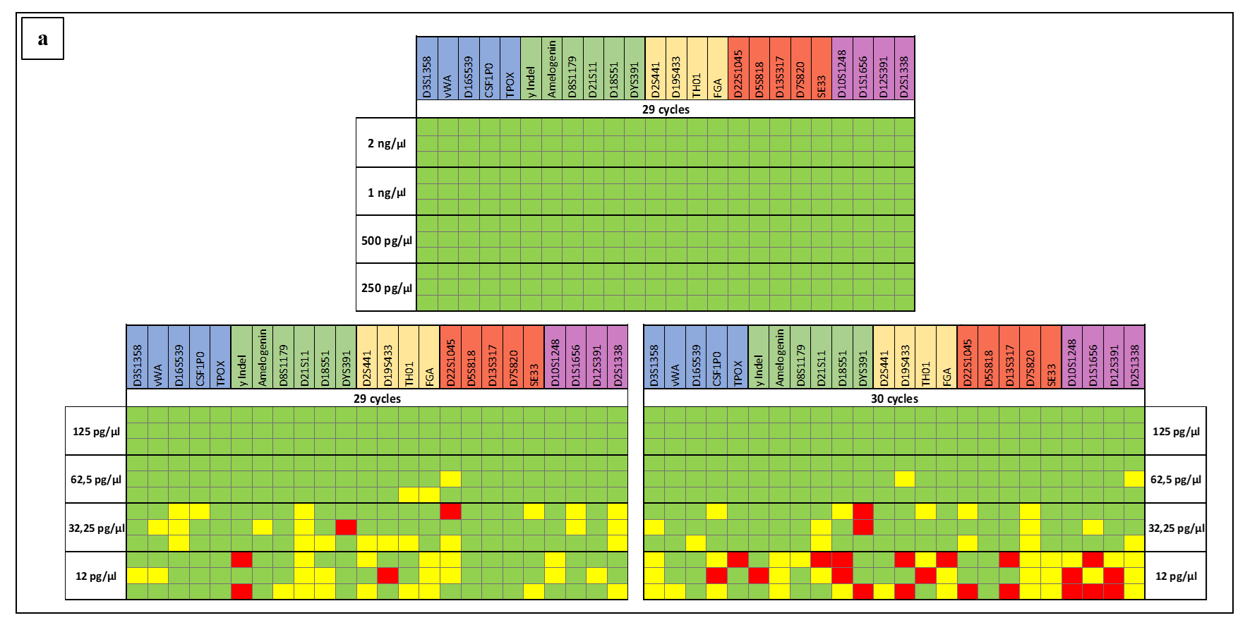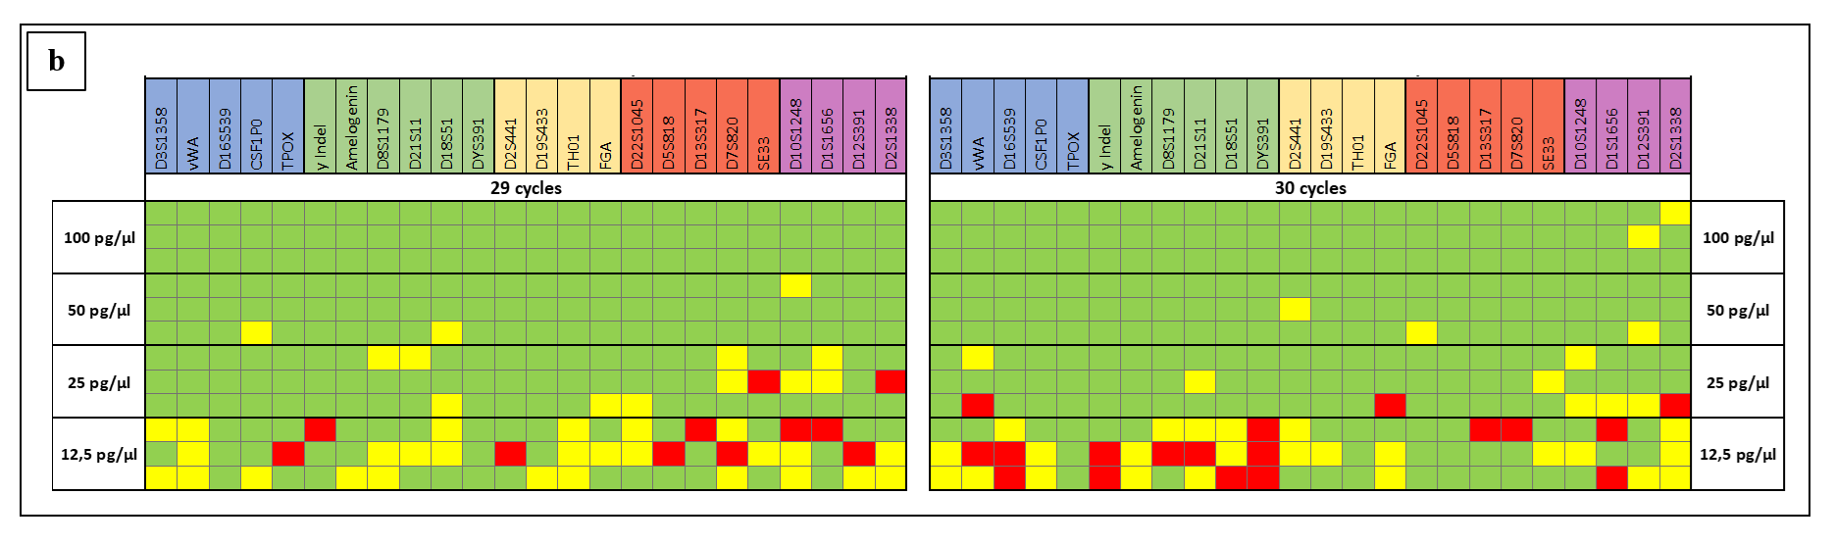
Supplemental figure S1 Sensitivity results for serial dilutions of the two DNA control 007-A/B (a, b). Three replicates of GlobalFiler™ IQC were run over a range of DNA control 007-A/B input amounts (y-axis). Green= properly alleles called; Yellow= only one of the two expected alleles in heterozygous genotype was called; Red= no alleles called

