Supplementary material to:
Henry and Zieger, Self and non-self DNA on hands and sleeve cuffs

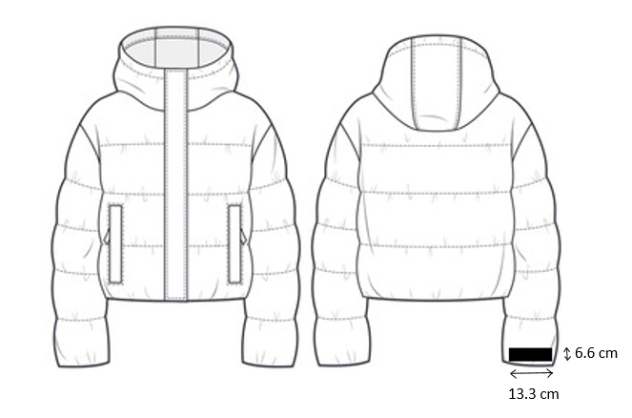
Suppl. Fig. 1. Sampling area on the back side of the right sleeve cuff of the upper garment of the participants

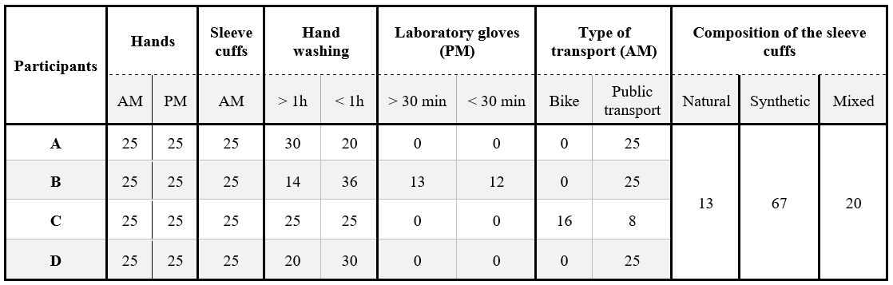
Suppl. Table 1. Summary of the total number of samples for each participant and recorded factors. Sleeve cuffs of different compositions were grouped over all participants.

