Supplemental Figure 1. Menstrual Blood Whole Homogenate Protein Concentrations on Each Day of Menses with Standard Deviations - All Volunteers.

Day 1 N=44; Day 2 N=44; Day 3 N=41; Day 4 N=35; Day 5 N=27

Supplemental Figure 2. Menstrual Blood Whole Homogenate Protein Concentrations during Each Day of Menses with Standard Deviations - 5 Day Menses Samples Only (27 Volunteers) The 5 Day Average is ~11.9 μg/μl.

Supplemental Figure 3. Menstrual Blood Pellet Protein Content During Each Day of Menses with Standard Deviations.
Day 1 N=44; Day 2 N=44; Day 3 N=41; Day 4 N=35; Day 5 N=27

Supplemental Figure 4. Determining CPLC Column Saturation for Menstrual Blood
Most samples with more than 7,500 μg applied protein appear to cluster between 150 and 300 total μg protein recovered, suggesting that saturation occurs at about 7,500 μg applied protein.

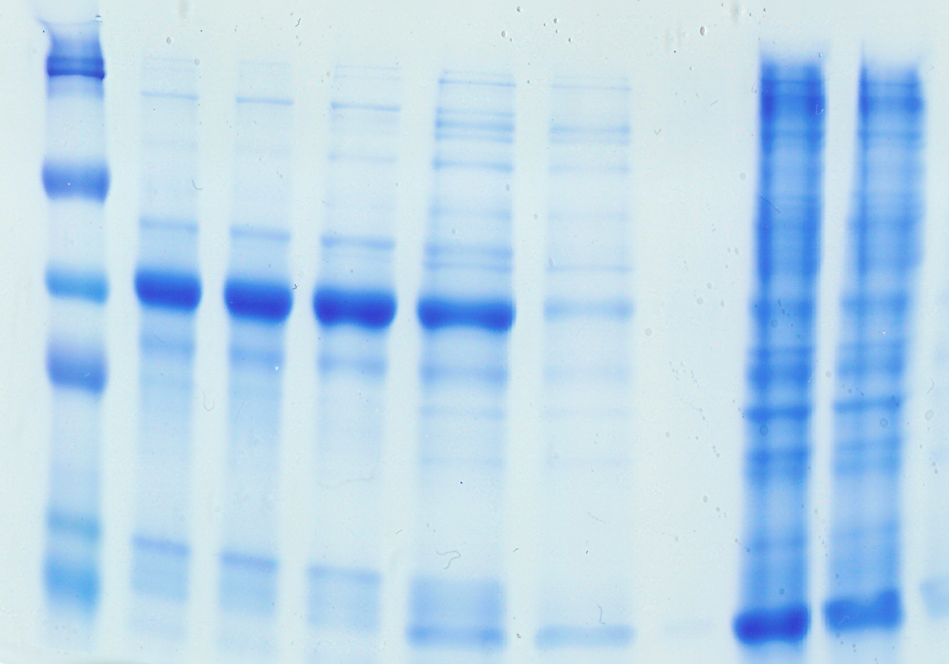
Supplemental Figure 5. SDS PAGE analysis of CPLC processed menstrual blood proteins extracted with PBS and eluted twice with 8M Urea, 2% CHAPS in 5% acetic acid.
M
O
FT
W1
W2*
W3*
W4*
E1
E2
220 KDa
100 KDa
65 KDa
45 KDa
30 KDa
20 KDa
Each lane was loaded with 20 µg of protein except where indicated*. M: Molecular Weight Marker; O: Original PBS extract prior to column loading; FT: Flow Through of loaded sample; W1: Wash 1; W2: Wash 2; W3: Wash 3; W4: Wash 4; E1: Elution 1, 5% acetic acid, 8 M Urea and 2% CHAPS; E2: Repeat of Elution 1 - demonstrating that not all protein was released in the first elution. *Column washes W2-W4 were precipitated in four volumes of ice cold acetone, resuspended in a small volume of SDS PAGE loading buffer and loaded on the gel (no quantitation performed).

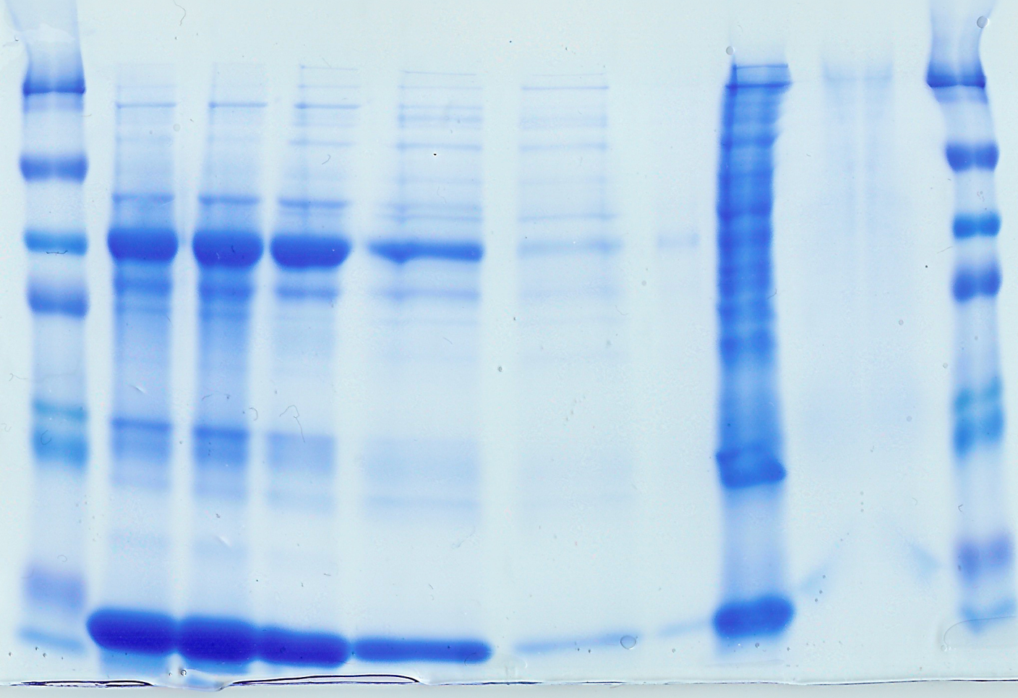
Supplemental Figure 6. SDS PAGE analysis of CPLC processed menstrual blood proteins extracted with PBS and eluted first with 2% SDS and second with 8M Urea, 2% CHAPS in 5% acetic acid.
M
O
FT
W1
W2***
W3*
W4*
E1
E2
M
220 KDa
100 KDa
65 KDa
45 KDa
20 KDa
13 KDa
8 KDa
Each lane was loaded with 20 µg of protein except where indicated*. M: Molecular Weight Marker; O: Original PBS extract prior to column loading; FT: Flow Through of loaded sample; W1: Wash 1; W2: Wash 2; W3: Wash 3; W4: Wash 4; E1: Elution 1, 2% SDS; E2: Elution 2, 5% acetic acid, 8 M Urea and 2% CHAPS (UAC) - demonstrating that nearly all protein is released with 2% SDS. *Column washes W2-W4, ~45 μl of each ~200 μl wash were directly loaded onto the gel.

Supplemental Figure 7. SDS PAGE analysis of CPLC processed menstrual blood proteins extracted with 0.5% NP-40 in PBS and eluted with 2% SDS.
M
O
FT
W1
W2*
W3*
W4*
E
M
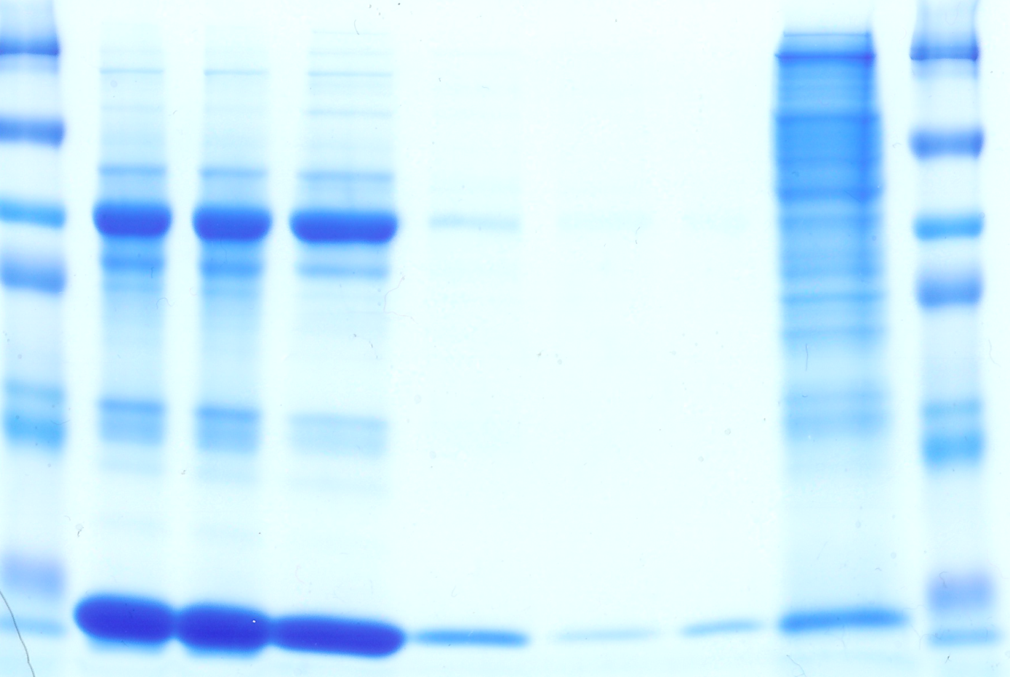
220 KDa
100 KDa
65 KDa
45 KDa
20 KDa
13 KDa
8 KDa
30 KDa
Each lane was loaded with 20 µg of protein except where indicated*. M: Molecular Weight Marker; O: Original PBS extract prior to column loading; FT: Flow Through of loaded sample; W1: Wash 1; W2: Wash 2; W3: Wash 3; W4: Wash 4; E1: Elution 1, 2% SDS. *Column washes W2-W4, ~45 μl of each ~200 μl wash were directly loaded onto the gel.
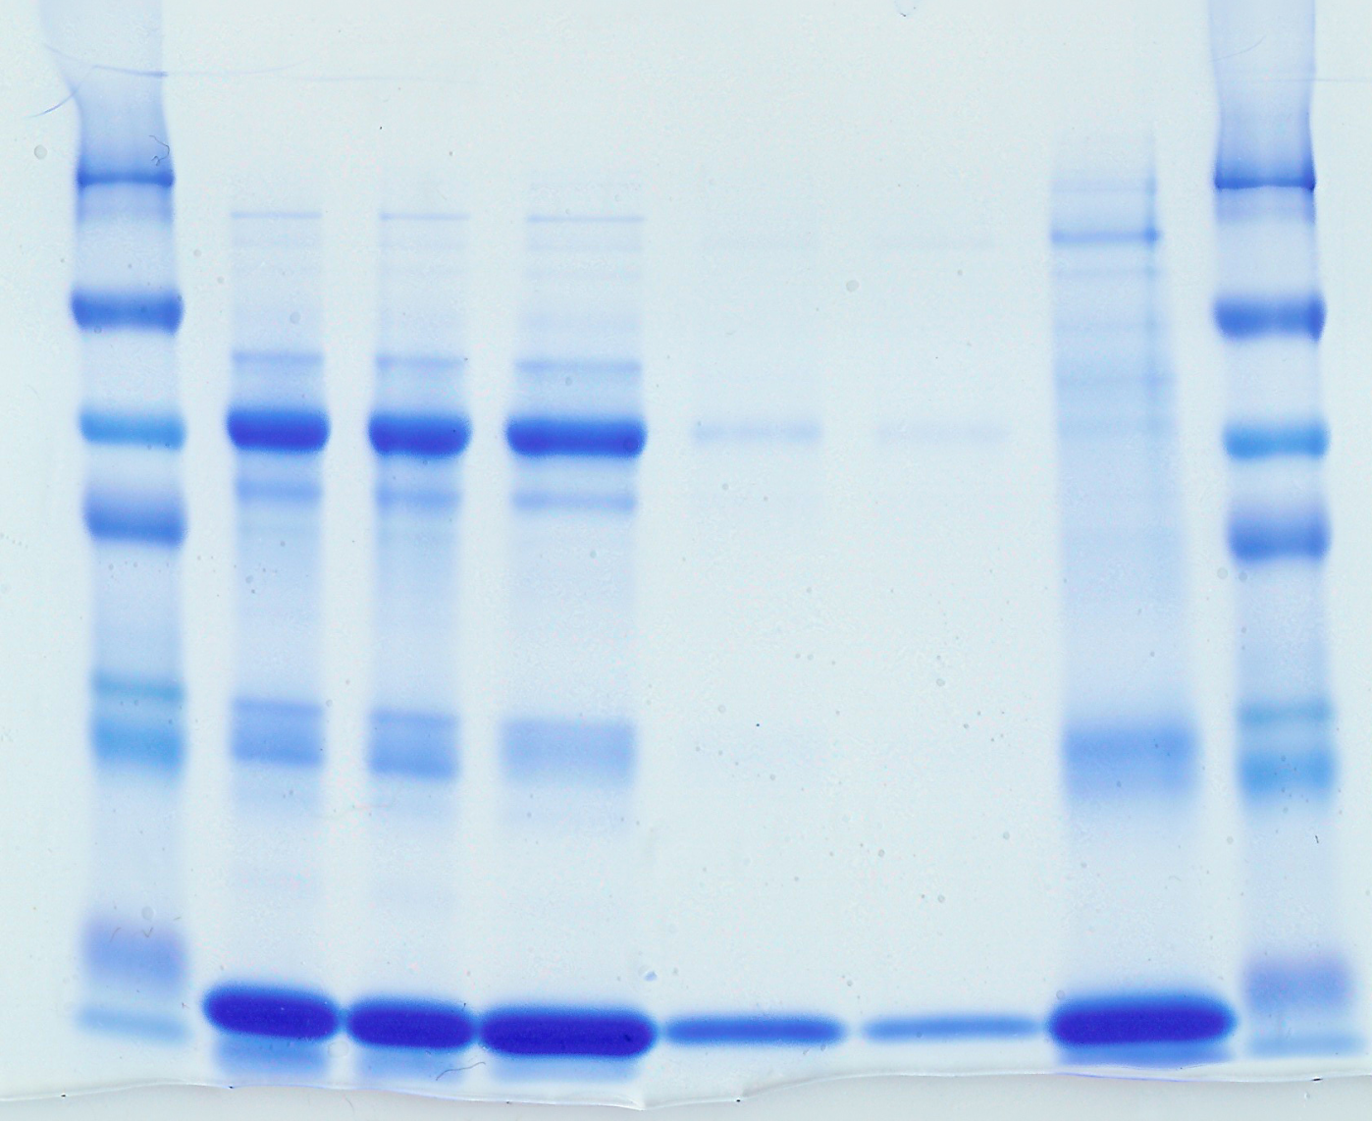
Supplemental Figure 8. SDS PAGE analysis of ProteoMiner processed menstrual blood proteins extracted with 0.1% SDS in PBS, eluted with 2% SDS.
M
O
FT
W1
W2*
W3*
E
M
220 KDa
100 KDa
65 KDa
45 KDa
20 KDa
13 KDa
8 KDa
30 KDa
Each lane was loaded with 20 µg of protein except where indicated*. M: Molecular Weight Marker; O: Original 0.1% SDS in PBS extract prior to column loading; FT: Flow Through of loaded sample; W1: Wash 1; W2: Wash 2; W3: Wash 3; W4: Wash 4; E1: Elution 1, 2% SDS. *Column washes W2 and 3, ~45 μl of each ~200 μl wash were directly loaded onto the gel.
Supplemental Figure 9. Multiplexing Isobaric Barcode Labelled Samples for MS Analysis Analysis
VLVEDDEIMQGFIR

