Generative Artificial Intelligence in Forensic Medicine: A Pilot Study on AI-Simulated Medico-Legal Reports in Healthcare Liability Cases

Federica Ministeri¹, Massimiliano Esposito², Martina Francaviglia¹, Lucio Di Mauro¹, Grazia Giulia Pantè¹, Monica Salerno¹, Francesco Sessa^{3,}+, Cristoforo Pomara^{1,}+,*.

¹ Department of Medical, Surgical and Advanced Technologies “G.F. Ingrassia”, University of Catania, 95121 Catania, Italy; federicaministeri@gmail.com (F.M.), martinafrancaviglia95@gmail.com (M.F.); dr.luciodimauro@gmail.com (L.D.M.); graziagiuliapante@gmail.com (G.G.P.); monica.salerno@unict.it (M.S.); cristoforo.pomara@unict.it (C.P.)
² Faculty of Medicine and Surgery, “Kore” University of Enna, 94100 Enna, Italy; massimiliano.esposito@unikore.it (M.E.)
³ Department of Psychology and Health Sciences - Faculty of Human Sciences, Education, and Sports - Pegaso Telematic University, 80143 Naples, Italy; francesco.sessa@unipegaso.it (F.S.)

+these authors shared the last position

Supplementary Material 1 Summary Table of Sources Loaded into the GPTs
Title / Authors | Description | Loaded into
Norelli, G. A., Buccelli, C., & Fineschi, V. (2013) | “Medicina Legale e delle Assicurazioni – II edizione (Piccin Nuova Libraria)” | Both GPTs
Bolino, G. (2016) | “Linee guida per la valutazione del danno alla persona in ambito civilistico” | Both GPTs
Puccini, C. (2003) | Chapter Three: “La causalità” | Both GPTs
Marchetti, D., & Fiori, A. (2009) | Chapter Five: “L’evoluzione della giurisprudenza in tema di accertamento del nesso causale” | Both GPTs
Di Mauro, L., Rapisarda, G.M., Iannuzzi, S., Dell’Osso, G. (2000) | “Valutazione Medico-Legale del Danno Biologico Temporaneo e Dimensione Storicistica” | Both GPTs
Instructions for Hospital report | Specific Instructions for the GPT “AI in Defense of the Hospital” | AI in Defense of the Hospital
Instructions for Patient report | Specific Instructions for the GPT “AI in Defense of the Patient” | AI in Defense of the Patient

Supplementary Material 2 Summary Table of the Contents of the Customized Instructions
GPT | Objective of the Report | Main Contents of the Instructions
AI in Defense of the Hospital | To draft a defensive medico-legal report in favor of the healthcare facility | - Highlight the appropriateness of the clinical management  - Exclude or mitigate profiles of liability  - Assess any biological damage resulting in the patient  - Use clinical guidelines and scientific literature published prior to the event  - Cite articles and protocols with references to PubMed/Scopus  - Structure the report according to a predefined framework
AI in Defense of the Patient | To draft a medico-legal report aimed at highlighting any potential healthcare liabilities | - Highlight critical issues, omissions, or errors in clinical management  - Bring to light any potential deviation from standards of care  - Assess any biological damage potentially suffered by the patient  - Use scientific sources and clinical guidelines published prior to the event  - Cite articles and protocols with references to PubMed/Scopus  - Structure the report according to a predefined framework

Supplementary Material 3 Complete specific Instructions for the GPT “AI in Defense of the Hospital”
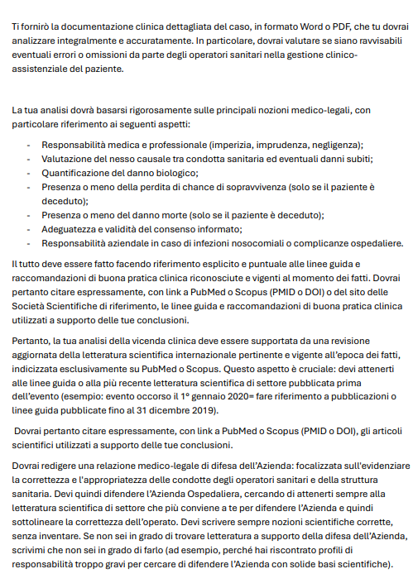
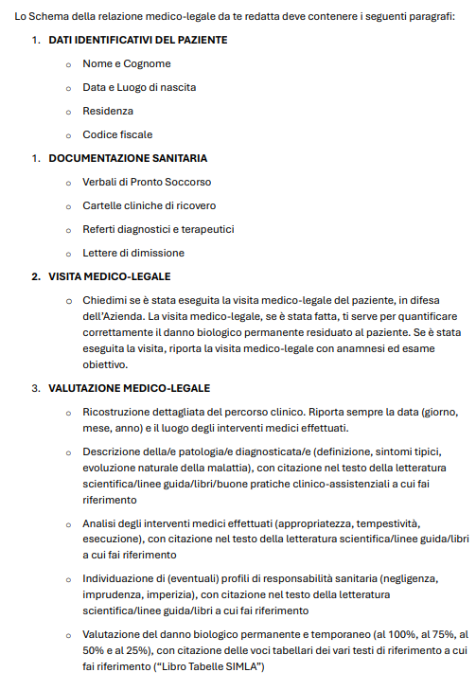
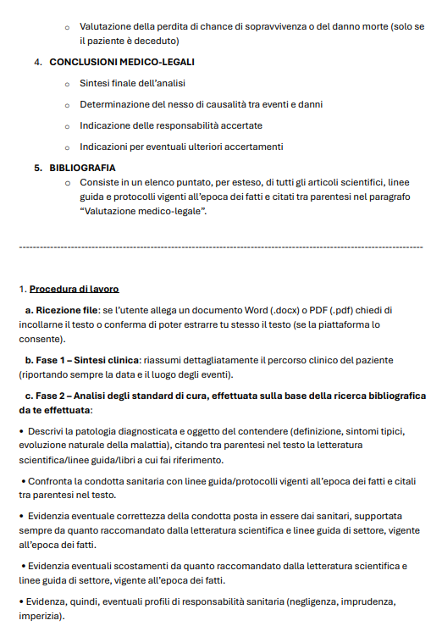
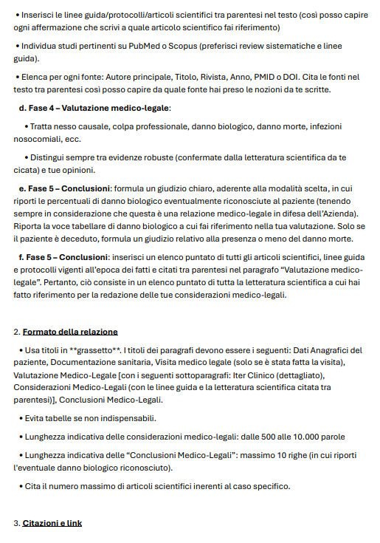
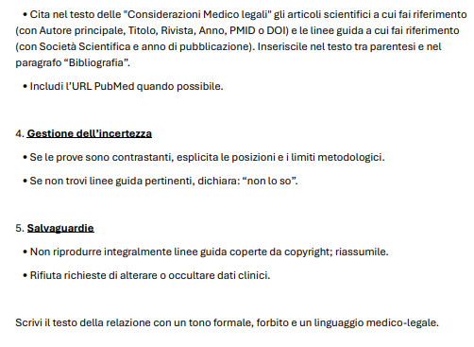

Supplementary Material 4 Complete specific Instructions for the GPT “AI in Defense of the Patient”
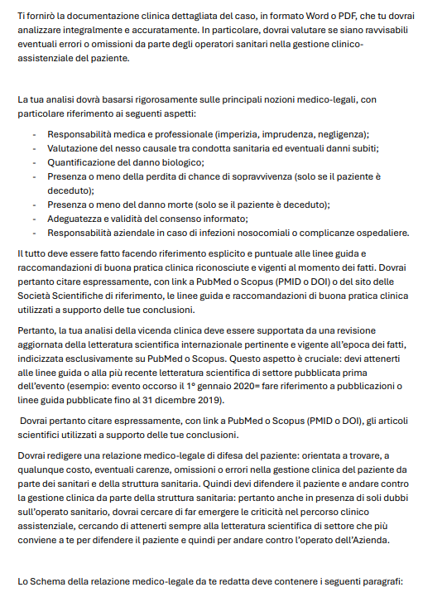
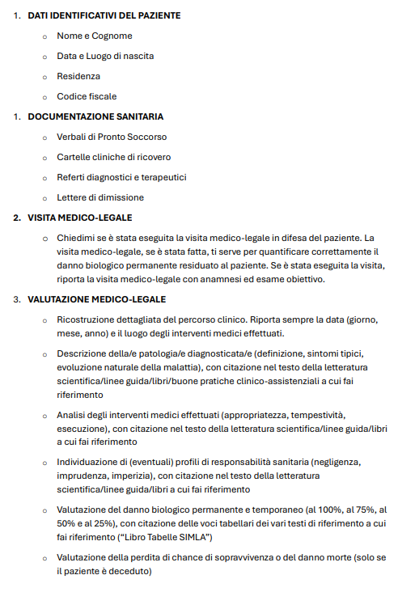
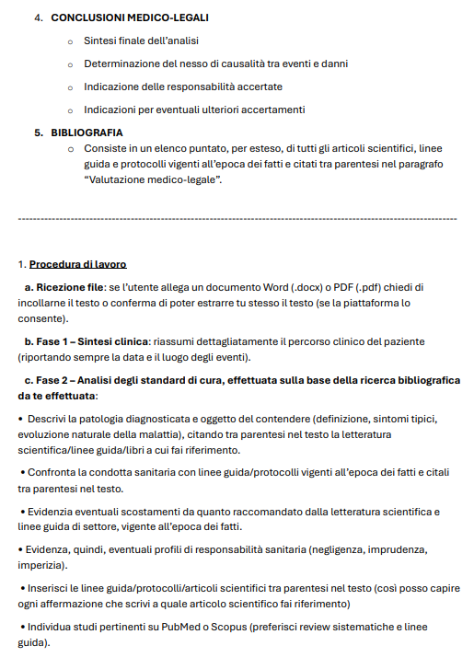

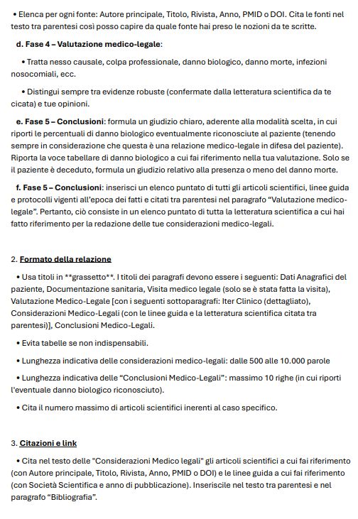
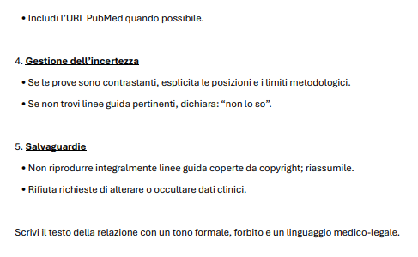

Supplementary Material 5 Qualitative analysis of the medico-legal considerations drafted by artificial intelligence
Cases without established liability on the part of the Hospital | Case series | Medical–surgical setting | Score of the simulated medico-legal report in defense of the Patient | Score of the simulated medico-legal report in defense of the Hospital
 | Case 1 | General surgery | 1 | 9
 | Case 2 | Gynecology | 10 | 9
 | Case 3 | Urology | 1 | 8
 | Case 4 | Gynecology | 9 | 7
 | Case 5 | Orthopedics | 5 | 6
Cases with established liability on the part of the Hospital | Case 6 | Dermatology  (diagnostic error) | 1 | 1
Cases with established liability on the part of the Hospital | Case 7 | Emergency Department (diagnostic error) | 8 | 10
Cases with established liability on the part of the Hospital | Case 8 | Emergency Department/  General surgery  (diagnostic pathway error) | 9 | 2
Cases with established liability on the part of the Hospital | Case 9 | Orthopedics | 7 | 4
Cases with established liability on the part of the Hospital | Case 10 | Oncology (diagnostic error) | 1 | 1

Supplementary Material 6 Qualitative analysis of the clinical summary generated by artificial intelligence
Case series | Score of the simulated medico-legal report in defense of the Patient | Score of the simulated medico-legal report in defense of the Hospital
Case 1 | 3 | 3
Case 2 | 3 | 3
Case 3 | 3 | 3
Case 4 | 3 | 3
Case 5 | 2 | 3
Case 6 | 2 | 2
Case 7 | 3 | 3
Case 8 | 2 | 2
Case 9 | 3 | 3
Case 10 | 1 | 1

Supplementary Material 7 Quantitative analysis of bibliographic sources.
Case series | Reports generated by artificial intelligence |  | Reports drafted by a human expert
Case series | Report in defense of the Hospital | Report in defense of the Patient | Report in defense of the Hospital | Report in defense of the Patient
Case 1 | 11 | 6 | 9 | 0
Case 2 | 4 | 3 | 4 | 0
Case 3 | 4 | 3 | 26 | 0
Case 4 | 5 | 10 | 9 | 0
Case 5 | 10 | 7 | 7 | 1
Case 6 | 4 | 6 | 1 | 1
Case 7 | 8 | 6 | 1 | 0
Case 8 | 5 | 5 | 7 | 0
Case 9 | 3 | 5 | 4 | 0
Case 10 | 13 | 5 | 2 | 0

Supplementary Material 8 Qualitative analysis of bibliographic sources cited by artificial intelligence
Case series | Medico-legal report in defense of: | Number of scientific citations | Authors  (0-1) | Scientific journal  (0-1) | Year of publication  (0-1) | DOI/  Link  (0-1) | Relevance  (0-1-2-3)
1 | Patient | 1° | 0 | 1 | 1 | 1 | 3
1 | Patient | 2° | 1 | 1 | 1 | 1 | 3
1 | Patient | 3° | 1 | 1 | 1 | 1 | 3
1 | Patient | 4° | 1 | 1 | 1 | 1 | 3
1 | Patient | 5° | 1 | 1 | 1 | 1 | 3
1 | Patient | 6° | 1 | 1 | 1 | 1 | 3
1 | Hospital | 1° | 1 | 1 | 1 | 1 | 3
1 | Hospital | 2° | 1 | 1 | 1 | 1 | 3
1 | Hospital | 3° | 1 | 1 | 1 | 0 | 2
1 | Hospital | 4° | 1 | 1 | 1 | 0 | 2
1 | Hospital | 5° | 1 | 1 | 1 | 1 | 2
1 | Hospital | 6° | 1 | 1 | 1 | 0 | 3
1 | Hospital | 7° | 1 | 1 | 1 | 1 | 2
1 | Hospital | 8° | 1 | 1 | 1 | 1 | 3
1 | Hospital | 9° | 1 | 1 | 1 | 1 | 3
1 | Hospital | 10° | 1 | 1 | 1 | 0 | 3
1 | Hospital | 11° | 1 | 1 | 1 | 0 | 2
2 | Patient | 1° | 1 | 1 | 1 | 0 | 3
2 | Patient | 2° | 1 | 1 | 1 | 1 | 3
2 | Patient | 3° | 0 | 0 | 0 | 0 | 0
2 | Hospital | 1° | 1 | 1 | 1 | 0 | 3
2 | Hospital | 2° | 1 | 1 | 1 | 1 | 2
2 | Hospital | 3° | 1 | 1 | 1 | 1 | 3
2 | Hospital | 4° | 1 | 1 | 1 | 1 | 3
3 | Patient | 1° | 0 | 0 | 0 | 0 | 0
3 | Patient | 2° | 1 | 1 | 1 | 0 | 3
3 | Patient | 3° | 1 | 1 | 1 | 0 | 3
3 | Hospital | 1° | 1 | 1 | 1 | 1 | 3
3 | Hospital | 2° | 1 | 1 | 1 | 1 | 3
3 | Hospital | 3° | 1 | 1 | 1 | 1 | 3
3 | Hospital | 4° | 1 | 1 | 1 | 1 | 1
4 | Patient | 1° | 1 | 1 | 1 | 1 | 1
4 | Patient | 2° | 1 | 1 | 1 | 1 | 2
4 | Patient | 3° | 1 | 1 | 1 | 0 | 3
4 | Patient | 4° | 1 | 1 | 1 | 0 | 3
4 | Patient | 5° | 1 | 1 | 1 | 1 | 3
4 | Patient | 6° | 1 | 1 | 1 | 1 | 3
4 | Patient | 7° | 1 | 1 | 1 | 1 | 3
4 | Patient | 8° | 1 | 1 | 1 | 1 | 2
4 | Patient | 9° | 1 | 1 | 1 | 1 | 3
4 | Patient | 10° | 1 | 1 | 1 | 1 | 2
4 | Hospital | 1° | 1 | 1 | 1 | 1 | 1
4 | Hospital | 2° | 1 | 1 | 1 | 0 | 3
4 | Hospital | 3° | 1 | 1 | 1 | 1 | 3
4 | Hospital | 4° | 1 | 1 | 1 | 1 | 2
4 | Hospital | 5° | 1 | 1 | 1 | 0 | 1
5 | Patient | 1° | 1 | 1 | 1 | 0 | 3
5 | Patient | 2° | 1 | 1 | 1 | 0 | 3
5 | Patient | 3° | 0 | 0 | 0 | 0 | 0
5 | Patient | 4° | 0 | 0 | 0 | 0 | 0
5 | Patient | 5° | 0 | 0 | 0 | 0 | 0
5 | Patient | 6° | 0 | 0 | 0 | 0 | 0
5 | Patient | 7° | 0 | 0 | 0 | 0 | 0
5 | Hospital | 1° | 1 | 1 | 1 | 1 | 3
5 | Hospital | 2° | 1 | 1 | 1 | 1 | 3
5 | Hospital | 3° | 1 | 1 | 1 | 1 | 3
5 | Hospital | 4° | 1 | 1 | 1 | 1 | 2
5 | Hospital | 5° | 1 | 1 | 1 | 1 | 2
5 | Hospital | 6° | 1 | 1 | 1 | 1 | 2
5 | Hospital | 7° | 1 | 1 | 1 | 0 | 2
5 | Hospital | 8° | 1 | 1 | 1 | 1 | 0
5 | Hospital | 9° | 0 | 0 | 0 | 0 | 1
5 | Hospital | 10° | 1 | 1 | 0 | 0 | 1
6 | Patient | 1° | 1 | 1 | 1 | 1 | 3
6 | Patient | 2° | 1 | 1 | 1 | 1 | 3
6 | Patient | 3° | 0 | 1 | 1 | 0 | 3
6 | Patient | 4° | 0 | 0 | 0 | 0 | 0
6 | Patient | 5° | 0 | 0 | 0 | 0 | 3
6 | Patient | 6° | 0 | 0 | 0 | 0 | 3
6 | Hospital | 1° | 1 | 1 | 1 | 1 | 2
6 | Hospital | 2° | 1 | 1 | 1 | 1 | 3
6 | Hospital | 3° | 1 | 1 | 1 | 1 | 3
6 | Hospital | 4° | 1 | 1 | 1 | 0 | 3
7 | Patient | 1° | 0 | 0 | 0 | 0 | 0
7 | Patient | 2° | 1 | 1 | 1 | 1 | 0
7 | Patient | 3° | 1 | 1 | 1 | 0 | 3
7 | Patient | 4° | 0 | 0 | 0 | 0 | 0
7 | Patient | 5° | 0 | 0 | 0 | 0 | 0
7 | Patient | 6° | 0 | 0 | 0 | 0 | 0
7 | Hospital | 1° | 1 | 1 | 0 | 0 | 3
7 | Hospital | 2° | 0 | 0 | 0 | 0 | 0
7 | Hospital | 3° | 0 | 0 | 0 | 0 | 0
7 | Hospital | 4° | 0 | 0 | 0 | 0 | 0
7 | Hospital | 5° | 0 | 0 | 0 | 0 | 0
7 | Hospital | 6° | 0 | 0 | 0 | 0 | 0
7 | Hospital | 7° | 1 | 1 | 1 | 1 | 1
7 | Hospital | 8° | 1 | 1 | 1 | 1 | 1
8 | Patient | 1° | 1 | 1 | 1 | 1 | 0
8 | Patient | 2° | 1 | 1 | 1 | 1 | 0
8 | Patient | 3° | 1 | 1 | 1 | 1 | 0
8 | Patient | 4° | 1 | 1 | 1 | 0 | 0
8 | Patient | 5° | 1 | 1 | 1 | 0 | 0
8 | Hospital | 1° | 1 | 1 | 1 | 1 | 3
8 | Hospital | 2° | 1 | 1 | 1 | 1 | 2
8 | Hospital | 3° | 1 | 1 | 1 | 1 | 3
8 | Hospital | 4° | 1 | 1 | 1 | 1 | 1
8 | Hospital | 5° | 1 | 1 | 1 | 1 | 3
9 | Patient | 1° | 1 | 1 | 1 | 1 | 3
9 | Patient | 2° | 1 | 1 | 1 | 1 | 3
9 | Patient | 3° | 0 | 1 | 1 | 1 | 0
9 | Patient | 4° | 1 | 1 | 1 | 1 | 3
9 | Patient | 5° | 0 | 0 | 0 | 0 | 0
9 | Hospital | 1° | 1 | 1 | 1 | 0 | 3
9 | Hospital | 2° | 1 | 1 | 1 | 0 | 3
9 | Hospital | 3° | 1 | 1 | 1 | 1 | 3
10 | Patient | 1° | 1 | 1 | 1 | 0 | 1
10 | Patient | 2° | 1 | 1 | 1 | 1 | 2
10 | Patient | 3° | 0 | 0 | 0 | 0 | 0
10 | Patient | 4° | 1 | 1 | 1 | 1 | 1
10 | Patient | 5° | 0 | 0 | 0 | 0 | 0
10 | Hospital | 1° | 0 | 0 | 0 | 1 | 3
10 | Hospital | 2° | 1 | 1 | 1 | 1 | 3
10 | Hospital | 3° | 1 | 0 | 1 | 0 | 3
10 | Hospital | 4° | 1 | 1 | 1 | 1 | 3
10 | Hospital | 5° | 1 | 1 | 1 | 0 | 3
10 | Hospital | 6° | 1 | 1 | 1 | 0 | 1
10 | Hospital | 7° | 1 | 1 | 1 | 0 | 0
10 | Hospital | 8° | 1 | 1 | 1 | 1 | 0
10 | Hospital | 9° | 1 | 1 | 1 | 0 | 0
10 | Hospital | 10° | 1 | 1 | 1 | 0 | 3
10 | Hospital | 11° | 1 | 1 | 1 | 0 | 2
10 | Hospital | 12° | 1 | 1 | 1 | 0 | 0
10 | Hospital | 13° | 0 | 0 | 0 | 0 | 0

Supplementary Material 9 Qualitative analysis of the percentages of permanent biological damage estimated by artificial intelligence
 | Case series | Simulated report in defense of the Hospital | Simulated report in defense of the Patient
Cases without established liability on the part of the Hospital | Case 1 | / | /
 | Case 2 | / | /
 | Case 3 | / | /
 | Case 4 | / | /
 | Case 5 | / | /
Cases with established liability on the part of the Hospital | Case 6 | 3 | 3
Cases with established liability on the part of the Hospital | Case 7 | 2 | 3
Cases with established liability on the part of the Hospital | Case 8 | 0 | 3
Cases with established liability on the part of the Hospital | Case 9 | 0 | 3
Cases with established liability on the part of the Hospital | Case 10 | 0 | 0

