Gastric emptying times of high-fat, high-carbohydrate and high-protein standard meals using MRI examinations
– a contribution to estimating the time since death

Dena Farivar¹, Birte Hellwig², Anna Holzer¹, Marcel Alexander Drews³, Benedikt Michael Schaarschmidt^{3,4}, Benno Hartung^{1,4}

¹ Institute of Legal Medicine, University Hospital Essen, Essen, Germany
² Institute for Medical Informatics, Biometry and Epidemiology, University Hospital Essen, Essen, Germany
³ Institute for Diagnostic and Interventional Radiology and Neuroradiology, University Hospital Essen, Essen, Germany
⁴ Both authors contributed equally

Corresponding author:
Benno Hartung
Institute of Legal Medicine, University Hospital Essen
Hufelandstraße 55, 45147 Essen, Germany
Benno.Hartung@uk-essen.de

Supplementary Information

Supplementary Table 1 Drinking protocol for each study day and subject

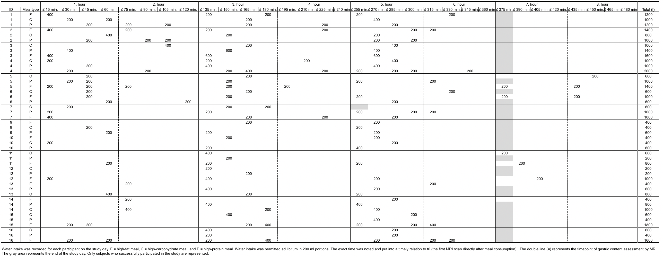
Supplementary Table 1 Drinking protocol for each study day and subject

