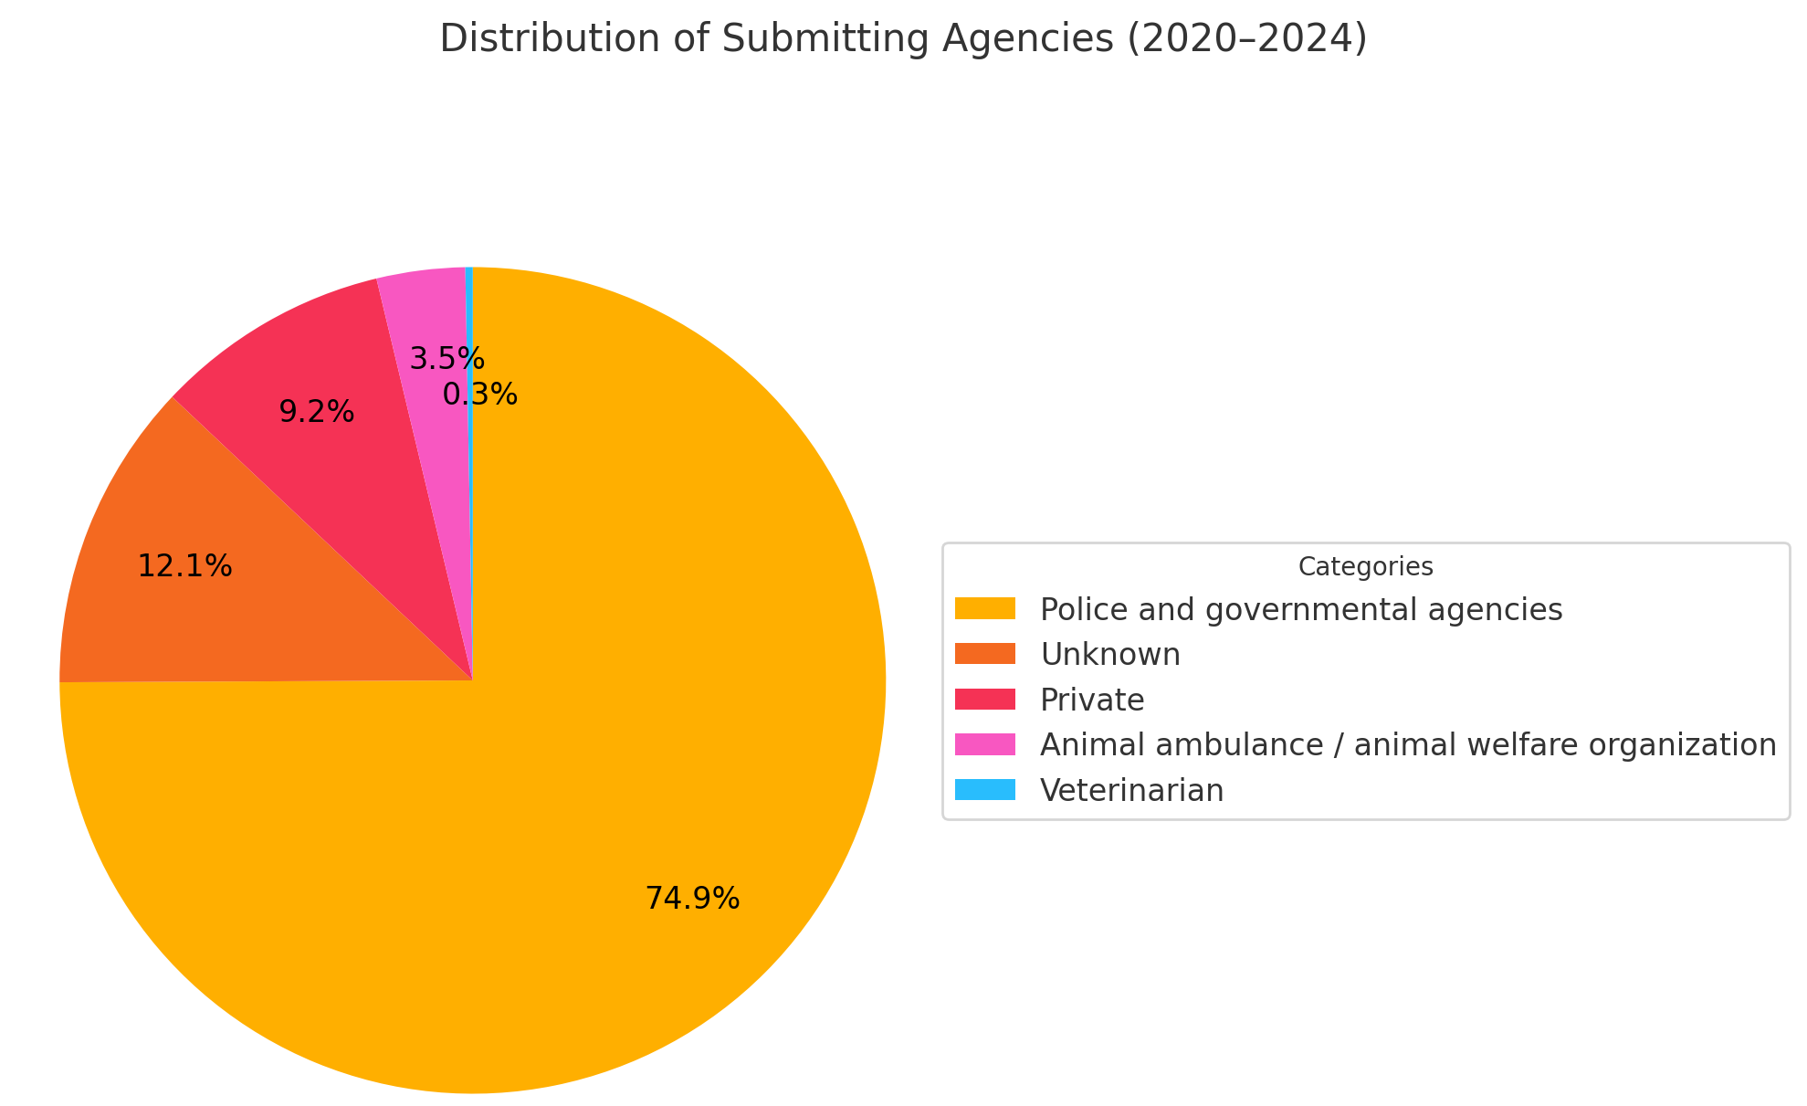
Figure A. A pie chart visualizing the distribution of agencies submitting cases between 2020 and 2024 (N = 346), categorized in the following categories: police and governmental agencies (orange), unknown (dark orange), private (red), animal ambulance / animal welfare organization (pink), and veterinarian (blue).

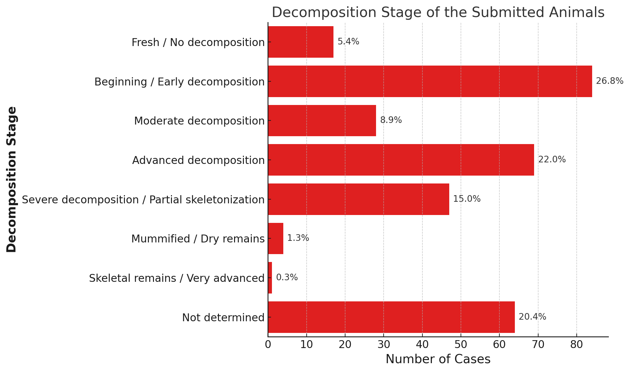
Figure B. A bar chart representing the distribution of decomposition stages of the submitted animals at the time of forensic examination (N = 346). Percentages are given right to the bars.

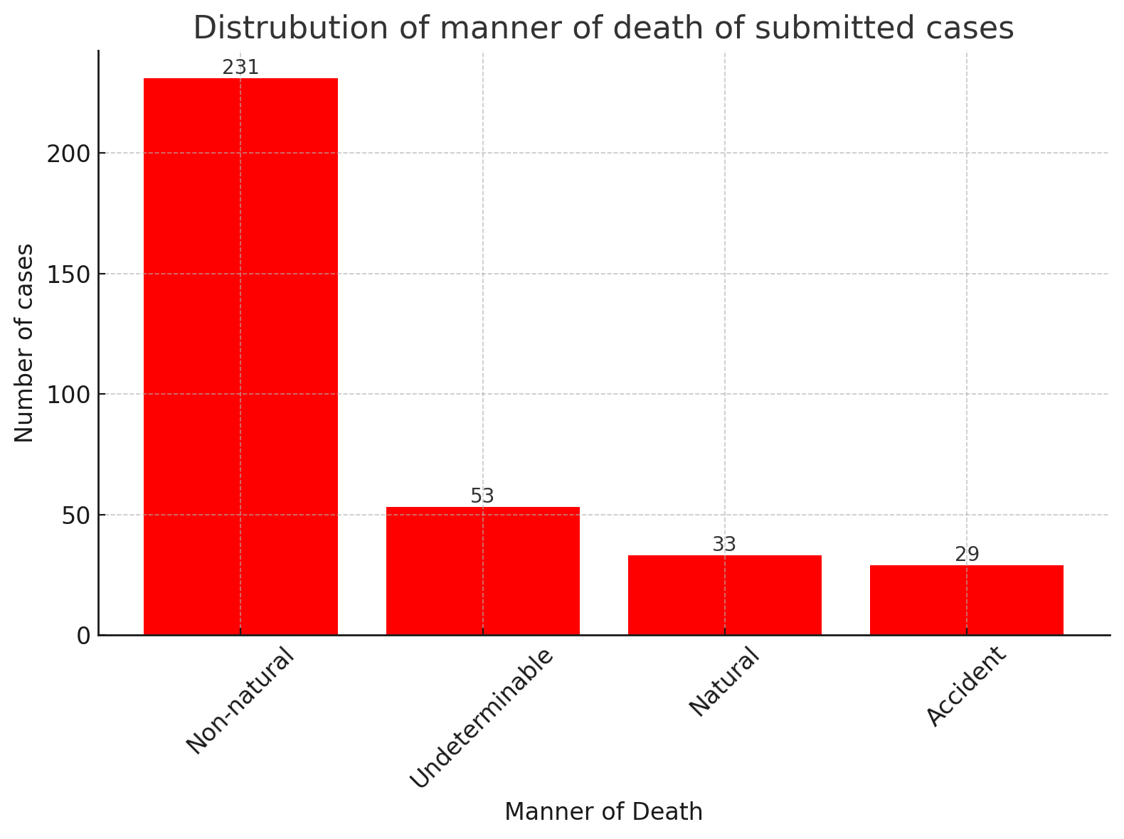
Figure C. Distribution of presumptive manner of death in submitted forensic cases (N = 346).

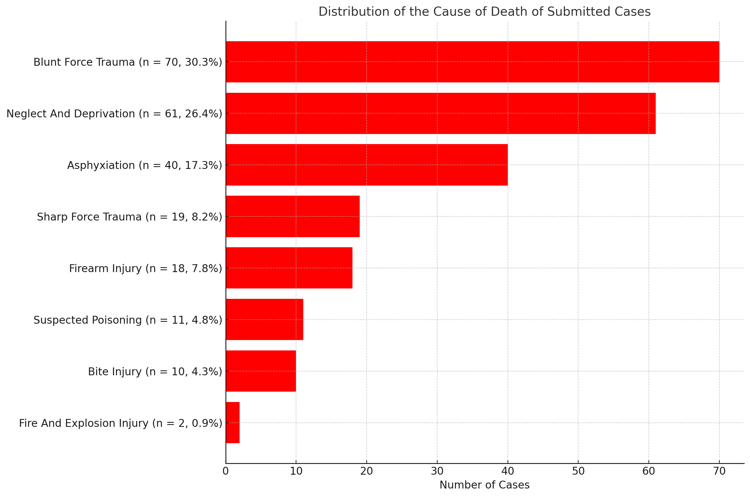
Figure D. Distribution of presumptive cause of death among cases classified as non-natural, with blunt force trauma and neglect/deprivation representing the most common causes (N = 231).

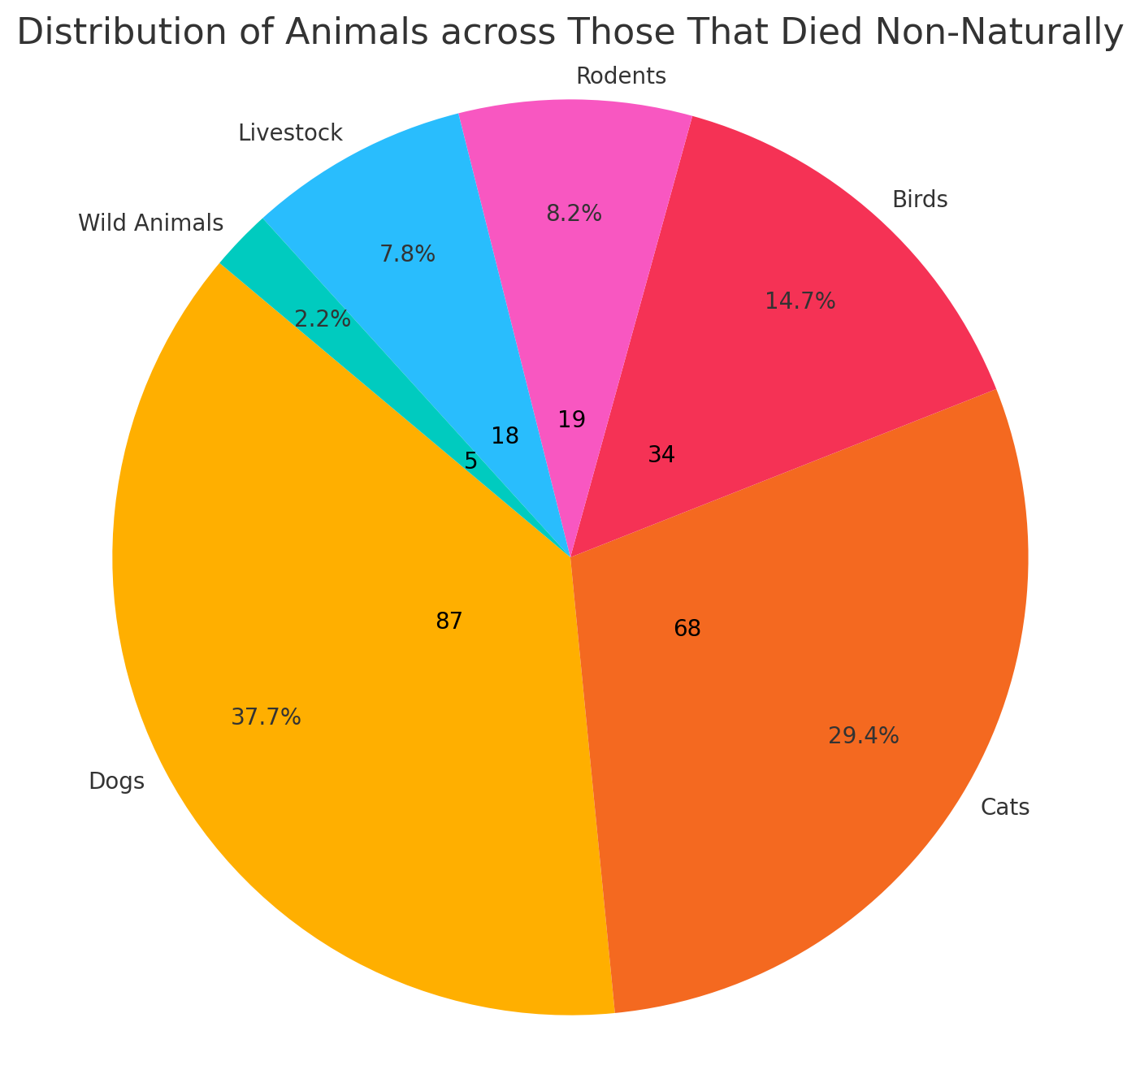
Figure E. A pie chart of the distribution of animals across submitted cases with presumptive a non-natural cause of death (N = 231), categorized in the categories dogs (orange), cats (yellow), birds (red), livestock (blue), rodents (pink) and wild animals (green).

