Supplementary Figures
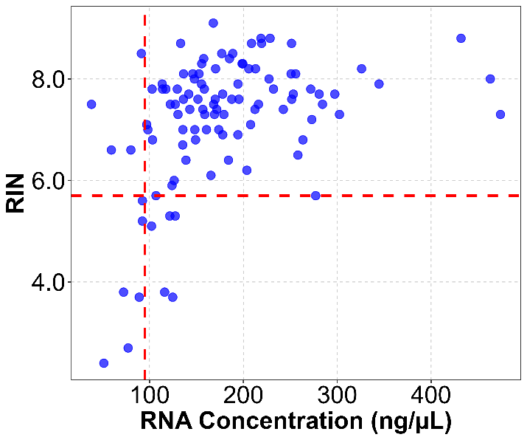
Supplementary Figure 1. Distribution of all samples with valid RNA concentrations and RIN.
The horizontal axis represents RNA concentration and the vertical axis shows the RIN. Red dashed lines indicate the empirically selected inclusion thresholds of 95 ng/µL for RNA concentration and 5.7 for RIN. A total of 88 samples satisfied both criteria and were included in the primary analysis.
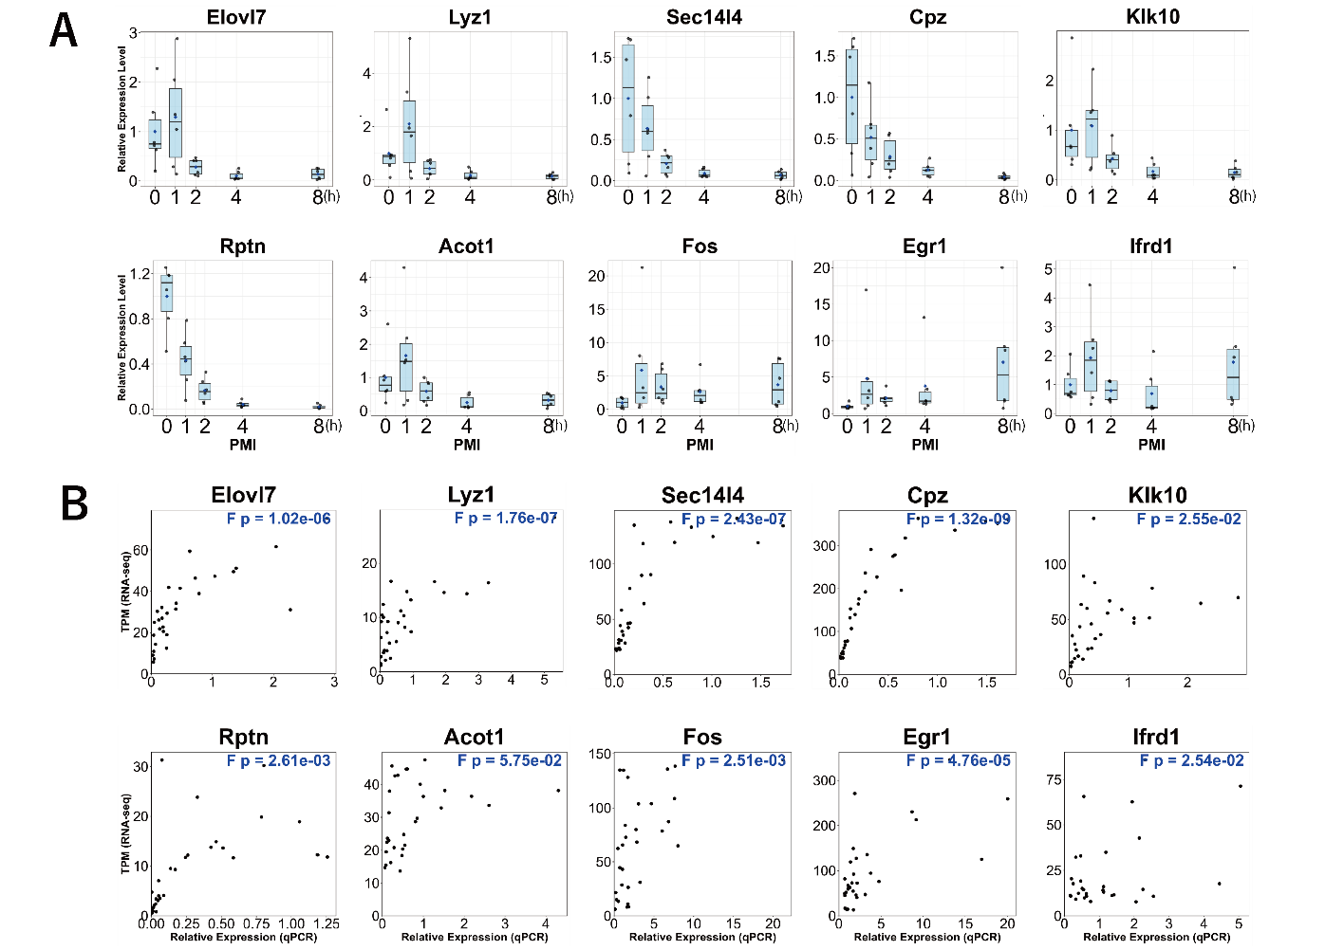
Supplementary Figure 2. Validation of mouse RNA-seq data by quantitative PCR.
A. Boxplots of qPCR data of 10 genes shown in main Figure 1B. The horizontal axes indicate each postmortem interval (PMI; 0, 1, 2, 4 and 8 h), while the vertical axes denote relative expression levels normalized by the expression levels of 18S rRNA. B. Scatterplots showing the correlation between qPCR and RNA-seq data. The horizontal axes indicate relative expression measured by qPCR, while the vertical axes denote TPM calculated after an RNA-seq analysis. The correlation coefficient (R²) is presented in the upper right corner of each panel.
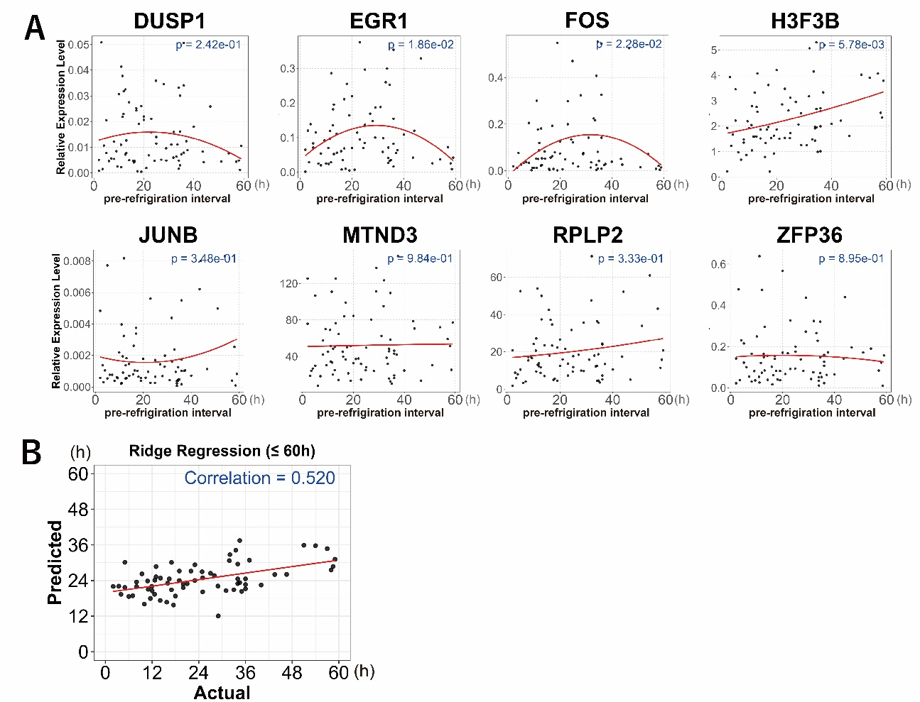
Supplementary Figure 3. RNA expression levels in human postmortem skin with pre-refrigeration interval ≤60 h.
A. RNA expression levels of eight human genes derived from limited individuals with a pre-refrigeration interval of ≤60 h. Horizontal axes indicate the pre-refrigeration interval, while vertical axes show relative expression levels of the genes relative to GAPDH. Each dot represents the value of each individual, and the red lines denote quadratic regression curves. P values are shown in the upper right corner of each plot. B. The regression curve generated from human skin RNA expression data show in A. The red line indicates the fitted linear regression line between the actual and predicted pre-refrigeration interval (correlation coefficient = 0.520).
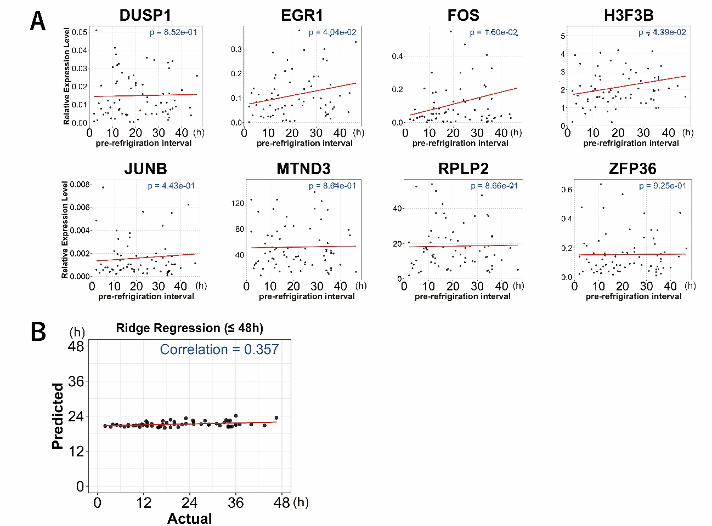
Supplementary Figure 4. RNA expression levels in human postmortem skin with pre-refrigeration interval ≤48 h.
A. RNA expression levels of eight human genes with a pre-refrigeration interval of ≤48 h. Horizontal axes indicate the pre-refrigeration interval, while vertical axes show relative expression levels of the genes relative to GAPDH. Each dot represents the value of each individual, and the red lines denote linear regression curves. P values are shown in the upper right corner of each plot. B. The regression curve generated from human skin RNA expression data show in A. The red line indicates the fitted linear regression line between the actual and predicted pre-refrigeration interval (correlation coefficient = 0.357).
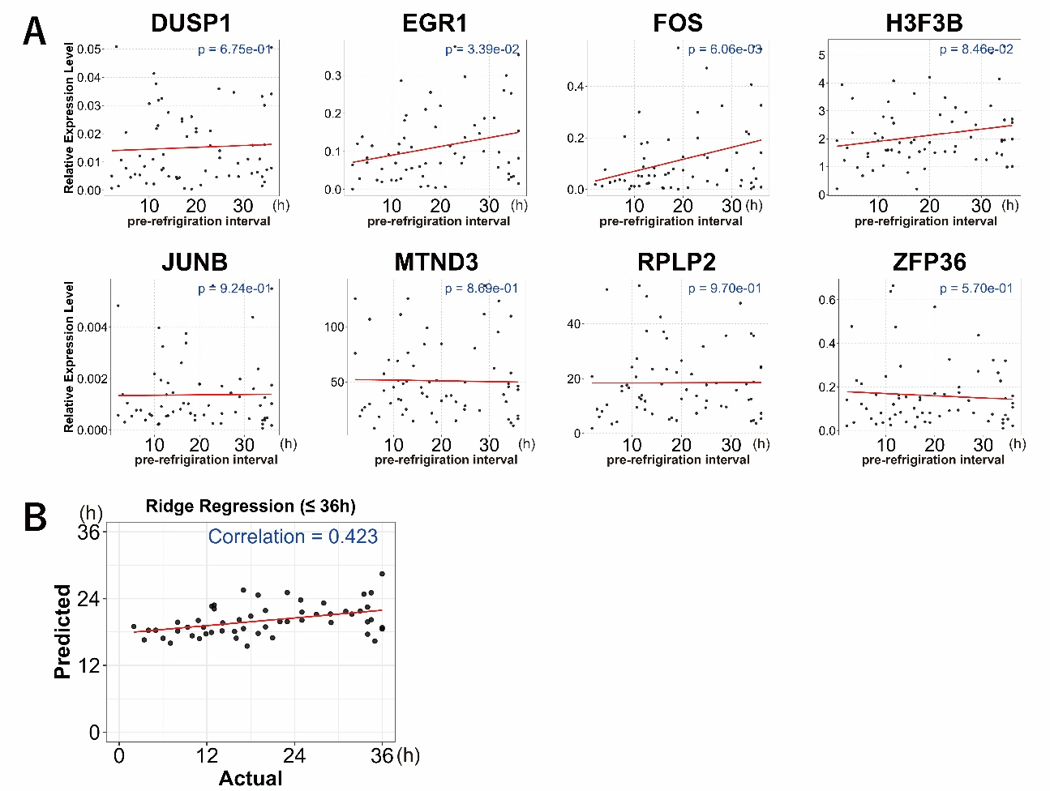
Supplementary Figure 5. RNA expression levels in human postmortem skin with pre-refrigeration interval ≤36 h.
A. RNA expression levels of eight human genes with a pre-refrigeration interval of ≤36 h. Horizontal axes indicate the pre-refrigeration interval, while vertical axes show relative expression levels of the genes relative to GAPDH. Each dot represents the value of each individual, and the red lines denote linear regression curves. P values are shown in the upper right corner of each plot. B. The regression curve generated from human skin RNA expression data show in A. The red line indicates the fitted linear regression line between the actual and predicted pre-refrigeration interval (correlation coefficient = 0.423).
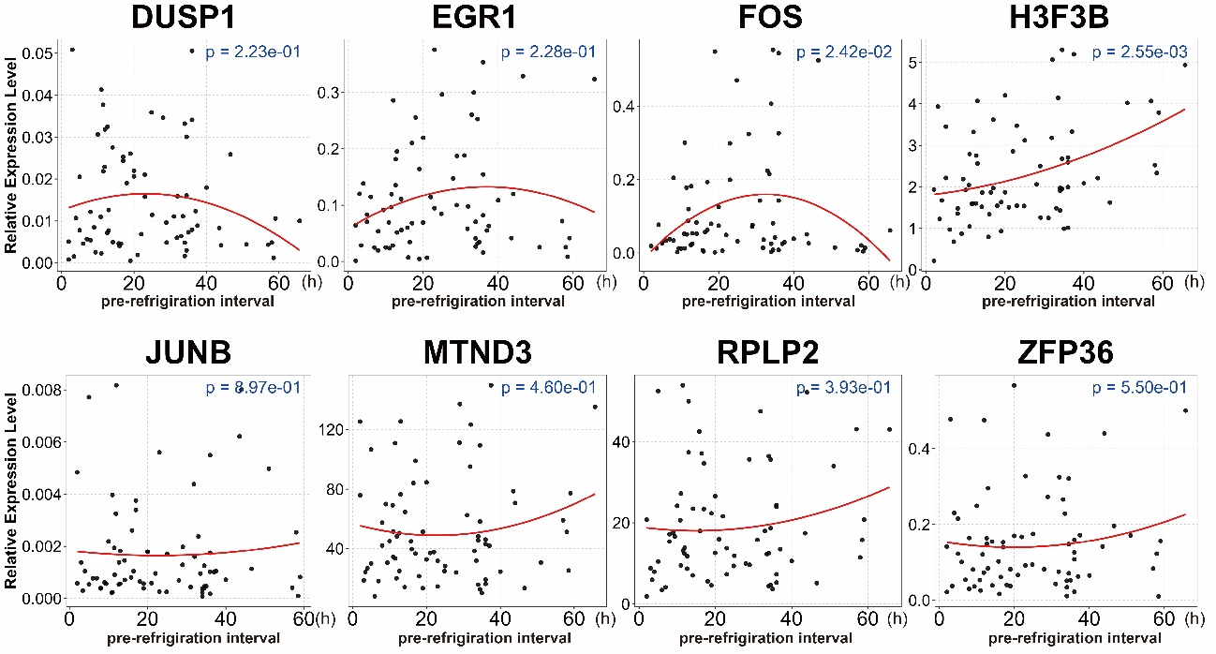
Supplementary Figure 6. RNA expression levels in human postmortem skin with RIN ≥6.5
RNA expression levels of eight human genes derived from limited individuals with RIN values ≥6.5. Horizontal axes indicate the pre-refrigeration interval, while vertical axes show relative expression levels of the genes relative to GAPDH. Each dot represents the value of each individual, and the red lines denote quadratic regression curves. P values are shown in the upper right corner of each plot.
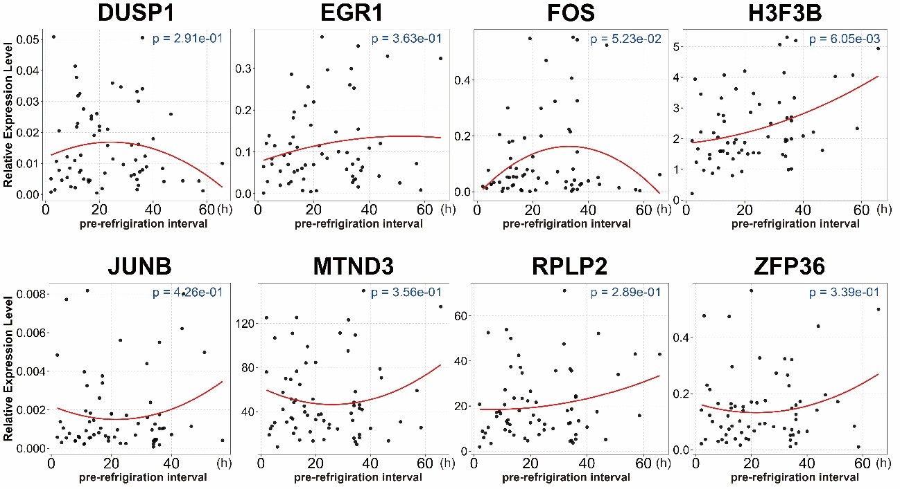
Supplementary Figure 7. RNA expression levels in human postmortem skin with RIN ≥7.0
RNA expression levels of eight human genes derived from limited individuals with RIN values ≥7.0. Horizontal axes indicate the pre-refrigeration interval, while vertical axes show relative expression levels of the genes relative to GAPDH. Each dot represents the value of each individual, and the red lines denote quadratic regression curves. P values are shown in the upper right corner of each plot.
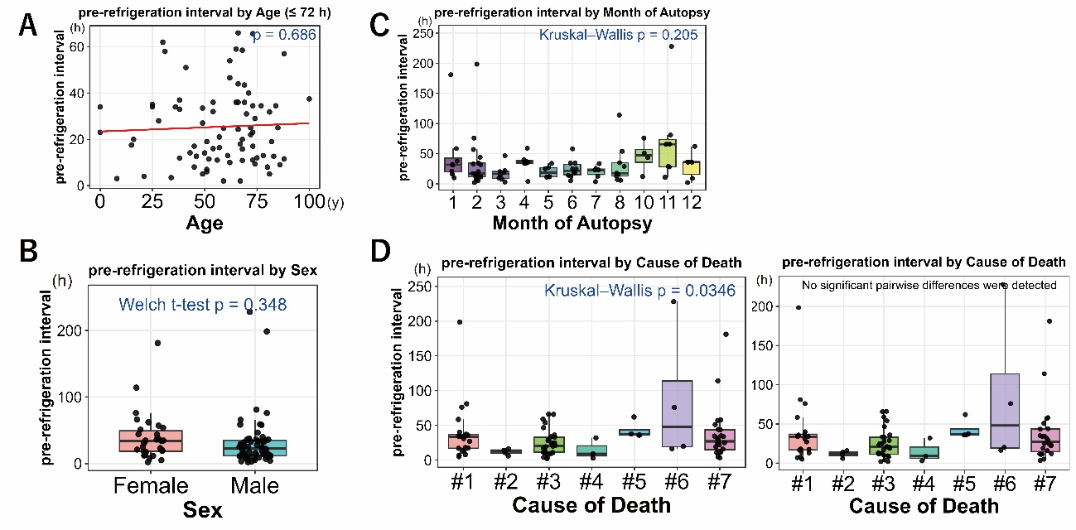
Supplementary Figure 8. Associations between pre-refrigeration interval and age, sex, autopsy month, and cause of death
A. Scatter plot of age at death versus pre-refrigeration interval. The p value shown in the upper right corner represents the result of the t-test for the regression coefficient of age in a simple linear regression model. One case with unknown age was excluded from the analysis. B. Box plot showing the relationship with sex. The p value displayed above the plot was obtained using Welch’s t-test to compare the pre-refrigeration interval between male and female cases. C. Box plot showing the relationship with the month of sample collection. Group differences were assessed using the Kruskal–Wallis test, and the resulting p value is shown in the upper right corner. D. Box plots showing the relationship with cause-of-death categories. Causes of death were classified into seven categories (#1–#7) based on information documented in autopsy reports. #1; hypoxia or asphyxia, #2; cardiovascular diseases, #3; hemorrhage or trauma, #4; infection or sepsis, #5; poisoning or metabolic disorders, #6; temperature-related disorders and #7; other or undetermined causes. Differences among groups were assessed using the Kruskal–Wallis test (left panel), and when a significant result was obtained, post hoc multiple comparisons were performed using Dunn’s test with Holm correction (right panel).
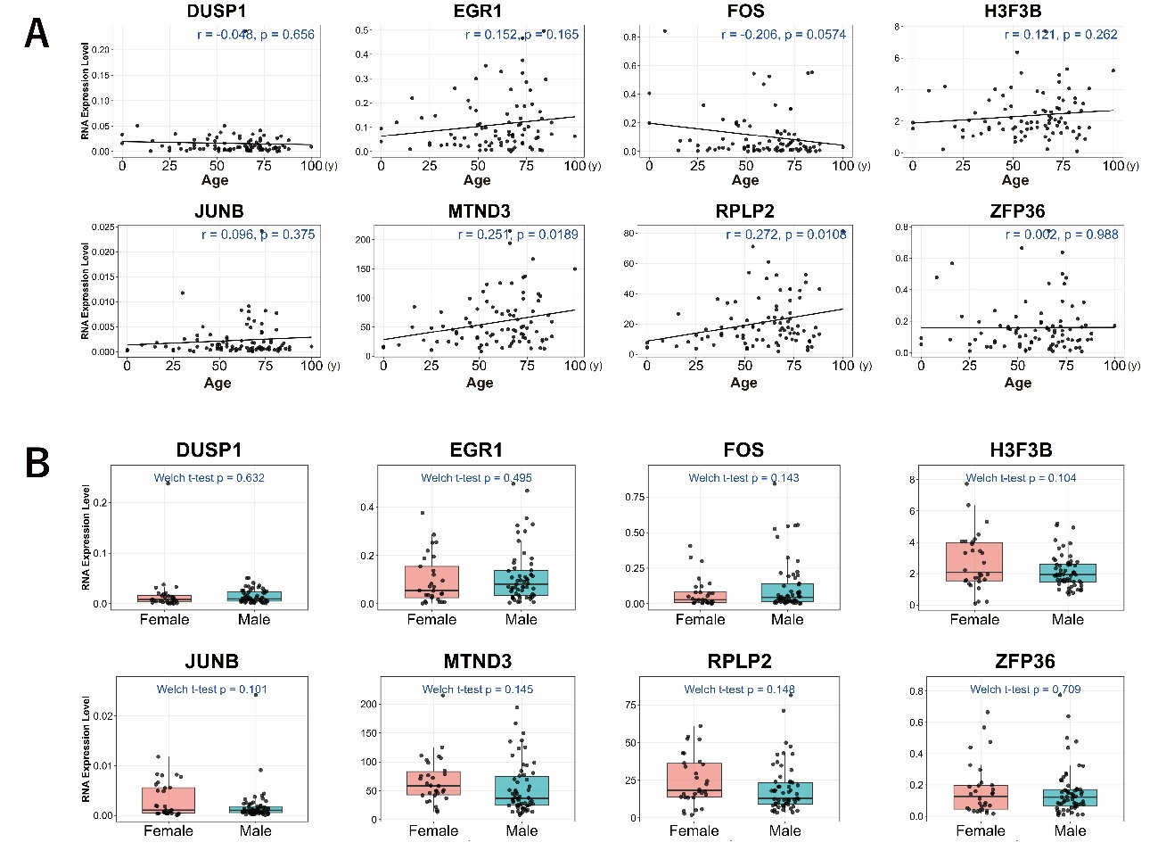
Supplementary Figure 9. Associations between individual RNA expression levels and age or sex
A. Scatter plots showing the relationship between RNA expression levels of eight human genes and age at death. Pearson’s correlation coefficient (r) and the corresponding p value, calculated under the null hypothesis that the correlation coefficient equals zero, are shown in the upper right of each panel. One case with unknown age was excluded from the analysis. B. Box plots showing the relationship between RNA expression levels of eight human genes and sex. The p value displayed on each plot was obtained using Welch’s t-test to compare RNA expression levels between male and female cases.
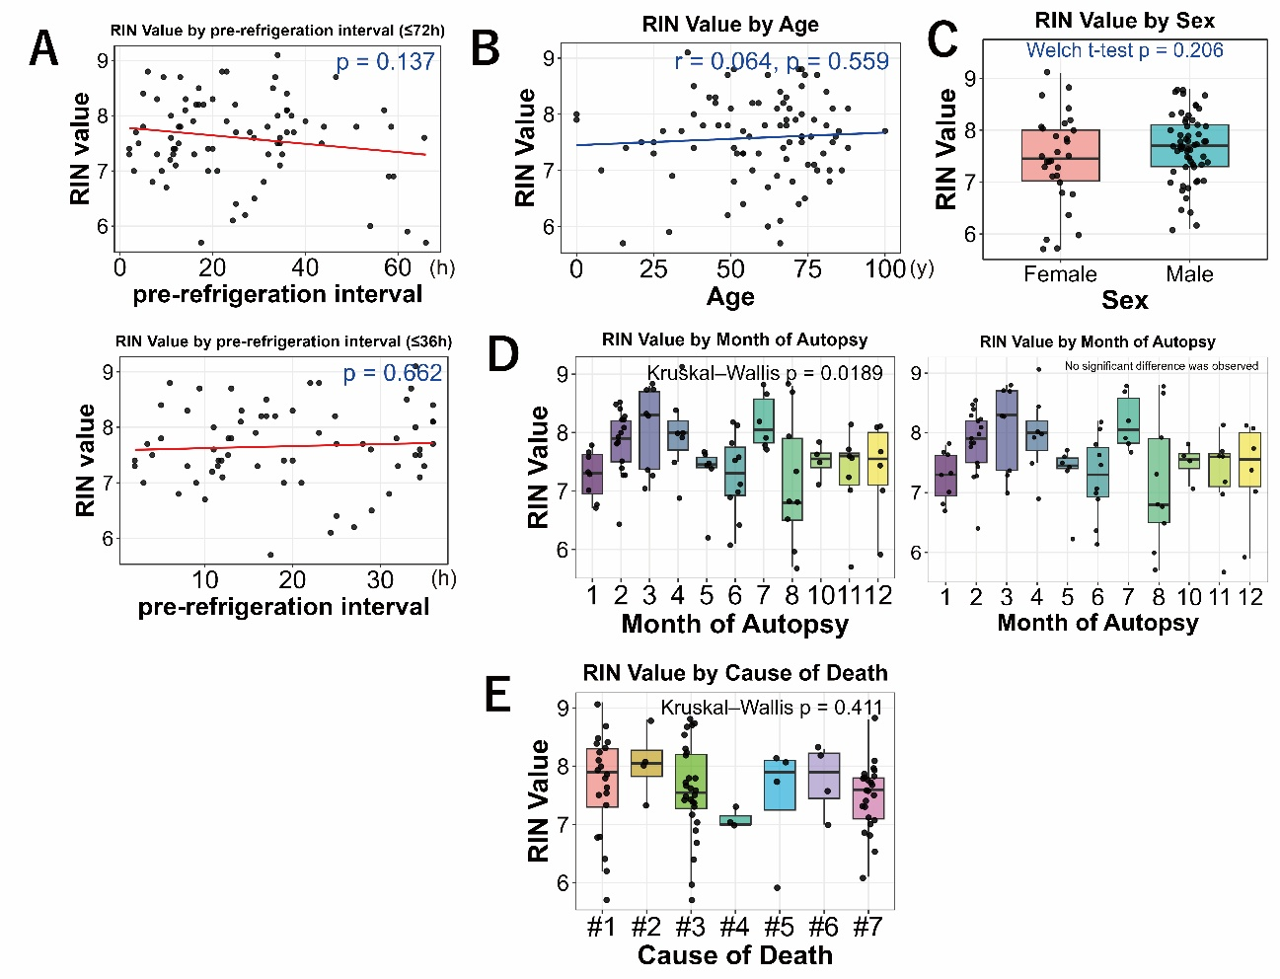
Supplementary Figure 10. Associations between RNA integrity number (RIN) and various factors
A. Scatter plot of pre-refrigeration interval versus RIN. The p value shown in the upper right corner represents the result of the t-test for the regression coefficient in a simple linear regression model with RIN as the dependent variable. The upper panel depicts samples with a pre-refrigeration interval of ≤72 h, whereas the lower panel displays the analysis restricted to ≤36 h. B. Scatter plot of age versus RIN value. The p value shown in the upper right corner represents the result of the t-test for the regression coefficient of age in a simple linear regression model with RIN as the dependent variable. One case with unknown age was excluded from the analysis. C. Box plots showing the relationship between the RIN values of eight human genes and sex. The p value displayed above each plot was obtained using Welch’s t-test to compare RNA expression levels between male and female cases. D. Differences in RIN among autopsy months were assessed using the Kruskal–Wallis test (left panel), and when a significant result was obtained, post hoc multiple comparisons were performed using Dunn’s test with Holm correction (right panel). E. Box plots showing the relationship between cause-of-death categories and RIN. Causes of death were classified into seven categories (#1–#7) based on information documented in autopsy reports. #1; hypoxia or asphyxia, #2; cardiovascular diseases, #3; hemorrhage or trauma, #4; infection or sepsis, #5; poisoning or metabolic disorders, #6; temperature-related disorders and #7; other or undetermined causes.

