Supplemental data
Burden of disease in myasthenia gravis – taking the patient’s perspective
Journal of Neurology
Sophie Lehnerer*, Jonas Jacobi, Ralph Schilling, Ulrike Grittner, Derin Marbin, Lea Gerischer, Frauke Stascheit, Maike Krause, Sarah Hoffmann, Andreas Meisel
* corresponding author^{1,2,3} (Sophie.lehnerer@charite.de)
1 Charité – Universitätsmedizin Berlin, corporate member of Freie Universität Berlin and Humboldt-Universität zu Berlin, Department of Neurology with Experimental Neurology, Charitéplatz 1, 10117 Berlin, Germany
2 NeuroCure Clinical Research Center, Charité University Medicine Berlin, Charitéplatz 1, 10117 Berlin, Germany
3 Center for Stroke Research Berlin, Charité University Medicine Berlin, Charitéplatz 1, 10117 Berlin, Germany

Supplement 1 Number of missing values with and without imputation
Subscales of the SF-36 | Number of missing values
 | without imputation | with imputation
Physical functioning | 112 | 22
Physical role functioning | 141 | 116
Bodily pain | 56 | 25
General health | 81 | 49
Vitality | 76 | 31
Social role functioning | 53 | 13
Mental health | 81 | 38
Emotional role functioning | 144 | 133

Supplement 2 Age distribution of study participants (SP), men (blue) and women (orange), 4 missings. The gender ratio of SP did not differ significantly from the entire group of DMG-members, all being invited to fill out the questionnaire (SD 0.00). Mean age of male
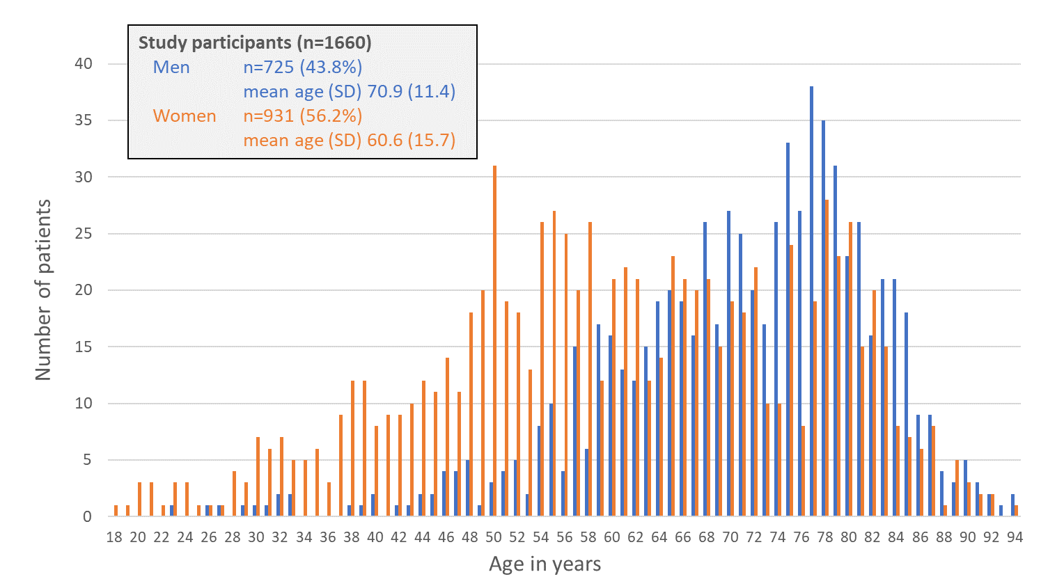

Supplement 3 Additional clinical characteristics of study participants
Age at onset of symptoms (123 missing) |  |  |  | Mean (SD)
Total (n=1537) |  |  |  | 49.3 (19.7)
Men (n=683) |  |  |  | 58.6 (15.3)
Women (n=850) |  |  |  | 41.8 (19.6)
Duration from first symptoms to diagnosis (years) (157 missing) |  |  |  | Mean (SD)
Total (n=1503) |  |  |  | 2.14 (5.8)
Men (n=670) |  |  |  | 1.28 (4.8)
Women (n=829) |  |  |  | 2.83 (6.4)
Disease Duration (since diagnosis) (45 missing) |  |  |  | Mean (SD)
Total (n=1615) |  |  |  | 13.6 (11.6)
Men (n=710) |  |  |  | 11.0 (9.4)
Women (n=905) |  |  |  | 15.6 (12.7)
Categories of disease severity (subgroups) |  | missing | n | %
Generalized MG, medium or high disease severity |  | 81 | 695 | 44.0
…and with any exacerbation medication (Rituximab, Eculizumab, IVIG, PPH) |  | 200 | 228 | 15.6
Comorbid diseases |  |  | n | %
Cardiovascular disease |  |  | 614 | 37.0
Autoimmune disease |  |  | 380 | 23.7
Neurologic disease |  |  | 381 | 23.0
Osteoporosis |  |  | 268 | 16.1
Diabetes mellitus |  |  | 248 | 14.9
Cancer |  |  | 222 | 13.4
Lung disease |  |  | 186 | 11.2
Psychiatric disorder |  |  | 121 | 7.3
Other diseases |  |  | 463 | 25.9
No comorbid disease |  |  | 354 | 21.3
At least 1 comorbid disease |  |  | 1306 | 78.7
At least 2 comorbid diseases |  |  | 704 | 42.2
3 and more comorbid diseases |  |  | 313 | 18.9
Co-medication | missing |  | n | %
Intake of antidepressants | 38 |  | 154 | 9.5
Intake of painkillers (regularly) | 38 |  | 223 | 13.7

Supplement 4 Current medication
Current Medication | missing | n | % | % in the last 6 months | Dosage/d  Mean (mg) (STD) | missing (Dosage)
Pyridostigmine | 135 | 1085 | 71.1 |  | 180 (255.2) | 621
Pyridostigmine sustained release | 136 | 644 | 42.3 |  | 180 (128.3) | 1033
Mycophenolatmofetil | 136 | 194 | 12.7 |  | 1500 (684.6) | 1469
Steroids | 136 | 391 | 25.7 |  | 5.25 (11.8) | 1280
Azathioprine | 136 | 694 | 45.5 |  | 100 (64.9) | 988
Methotrexate | 136 | 63 | 4.1 |  | 10 (18.8) | 1599
Cyclosporine A | 136 | 14 | 0.9 |  | 150 (90.6) | 1647
Rituximab | 135 | 94 | 6.2 | 53.6
Eculizumab | 136 | 10 | 0.7 | 42.9
IVIG | 134 | 243 | 15.9 | 42.2
Plasmapheresis/Immunoabsorption | 135 | 110 | 7.2 | 13.4

Supplement 5 Matching MG-patients with general population (control group, data from DEGS1 study), distribution of gender, age, education and weighted income
 | Patients with MG |  | Control group
 | n=1649 |  | n=2556
Gender | n | % | n | %
Men | 723 | 43.8 | 1004 | 39.3
Women | 926 | 56.2 | 1552 | 60.8
Age | n | % | n | % (weighted %)
18 - 24 years old | 16 | 1.0 | 32 | 1.3 (1.0)
25 - 29 years old | 13 | 0.8 | 26 | 1.0 (0.8)
30 - 39 years old | 80 | 4.9 | 160 | 6.3 (4.9)
40 - 49 years old | 144 | 8.7 | 288 | 11.3 (8.7)
50 - 59 years old | 291 | 17.6 | 582 | 22.8 (17.6)
60 - 69 years old | 363 | 22.0 | 726 | 28.4 (22.0)
70 and more years old | 742 | 45.0 | 742 | 29.0 (45.0)
Education (CASMIN) | n | % | n | %
High | 481 | 29.5 | 500 | 19.9 | p<0.001 Cohen's d=0.248
Medium | 701 | 43.0 | 1049 | 41.8 | p<0.001 Cohen's d=0.248
Low | 449 | 27.5 | 962 | 38.3 | p<0.001 Cohen's d=0.248
Income (weighted) | n | % | n | %
High | 734 | 51.1 | 592 | 42.4 | p<0.001 Cohen's d=0.446
Medium | 283 | 19.7 | 880 | 34.4 | p<0.001 Cohen's d=0.446
Low | 420 | 29.2 | 1084 | 23.2 | p<0.001 Cohen's d=0.446

Supplement 6 Multivariable analysis on emotional well-being (SF-36) (combined results after multiple imputation, n=4205). (marginal means and 95%CI, model included interaction effect for group*sex and group*age group)
Estimated marginal means (95%CI)
 | Controls | MG patients | Difference (Controls-MG)
Age group |  |  |  | 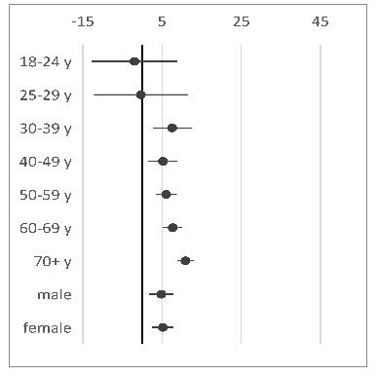
18-24y | 77 (71-83) | 79 (70-88) | -2 (-13-9)
25-29y | 71 (64-78) | 71 (62-81) | 0 (-12-11)
30-39y | 74 (71-77) | 66 (62-70) | 8 (3-12)
40-49y | 74 (72-76) | 69 (66-72) | 5 (1-9)
50-59y | 72 (70-73) | 66 (64-68) | 6 (3-9)
60-69y | 74 (73-75) | 66 (64-68) | 8 (5-10)
70+y | 76 (74-77) | 65 (63-66) | 11 (9-13)
sex
males | 76 (74-78) | 71 (69-74) | 5 (2-8)
females | 72 (70-73) | 66 (64-69) | 5 (2-8)
education |  |  |  | differences between categories (in both groups)
Low | 73 (71-75) | 68 (66-70) | 5 (2-8) | -2 (-3 - 0)
Medium | 74 (72-76) | 69 (67-71) | 5 (2-8) | -1 (-2- 1)
High | 75 (73-77) | 70 (67-72) | 5 (2-8) | reference
income
Low | 72 (70-73) | 67 (64-69) | 5 (2-8) | -4 (-6 - -3)
Medium | 74 (73-76) | 69 (67-72) | 5 (2-8) | -1 (-3 - 0)
High | 76 (74-78) | 71 (68-73) | 5 (2-8) | reference
partnership
no | 72 (70-74) | 67 (65-70) | 5 (2-8) | -3 (-5- -2)
yes | 76 (74-77) | 71 (68-73) | 5 (2-8) | reference

