Supplementary Data

Bouzigues et al. Anomia is present presymptomatically in frontotemporal dementia due to MAPT mutations

Fig. S1. Neural correlates of naming in C9orf72, MAPT and GRN mutation carriers with an additional adjustment for disease severity. Results are shown on a study-specific T1-weighted MRI template in MNI space, uncorrected p<0.001. Colour bars represent T-values.

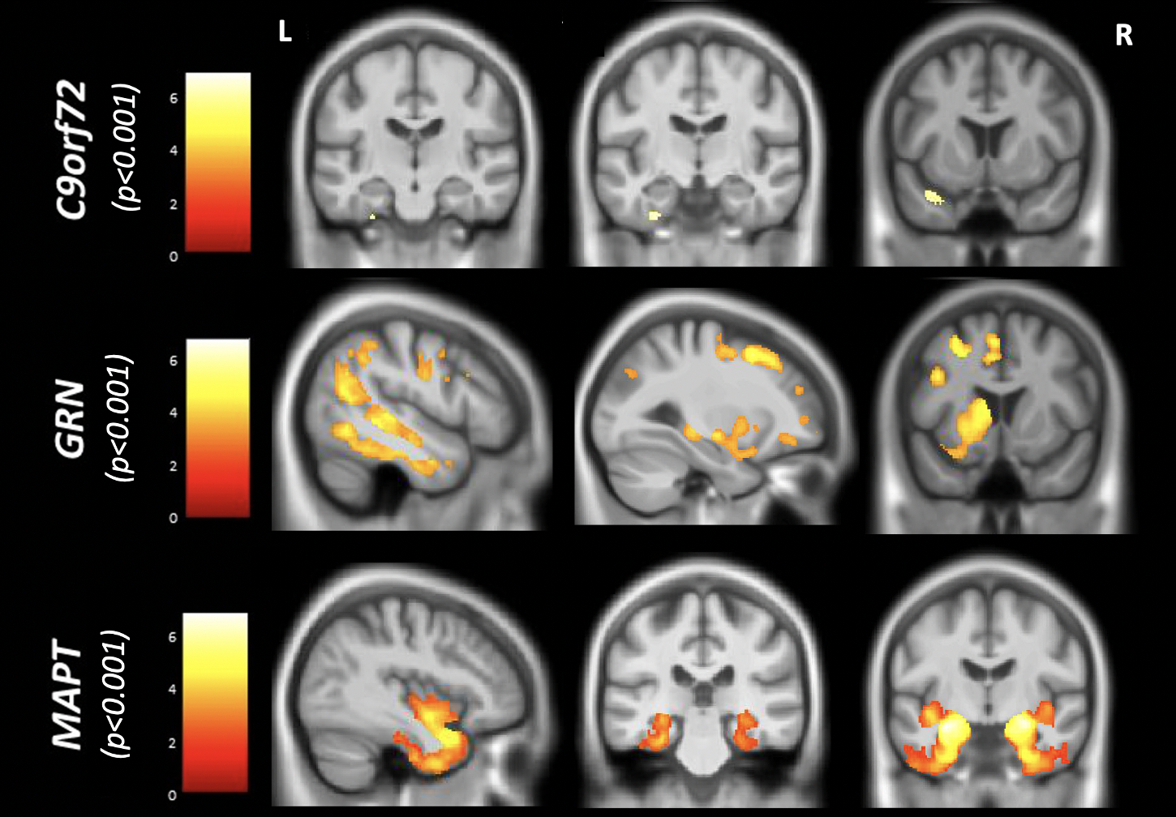
Table S1. Cumulative frequencies of BNT scores in the control group.

BNT Score | N | Cumulative Freq
21 | 3 | 1.2
22 | 2 | 2.0
23 | 6 | 4.4
24 | 3 | 5.6
25 | 14 | 11.3
26 | 21 | 19.8
27 | 44 | 37.5
28 | 54 | 59.3
29 | 54 | 81.0
30 | 47 | 100.0

Table S2. Mean control BNT performance and standard deviations according to age group and sex.

Age group | All |  | Females |  | Males
Age group | N | BNT Mean (SD) | N | BNT Mean (SD) | N | BNT Mean (SD)
Overall | 248 | 27.8 (1.9) | 141 | 27.8 (1.9) | 107 | 27.8 (1.9)
18.1-29.9 | 32 | 27.6 (1.9) | 17 | 27.9 (1.6) | 15 | 27.3 (2.2)
30.0-39.9 | 66 | 27.9 (2.0) | 40 | 27.8 (2.0) | 26 | 28.2 (2.0)
40.0-49.9 | 67 | 28.0 (1.6) | 32 | 27.7 (1.8) | 35 | 28.3 (1.4)
50.0-59.9 | 45 | 27.7 (2.0) | 29 | 27.6 (2.6) | 16 | 27.8 (1.5)
60.0-69.9 | 32 | 27.5 (2.2) | 21 | 28.1 (2.0) | 11 | 26.3 (2.1)
70.0-85.0 | 6 | 26.7 (1.9) | 2 | 27.0 (0.0) | 4 | 26.5 (2.4)

Table S3. Linear mixed model analysis comparing disease groups and controls. For each pairwise comparison, observed contrast, standard error, p values and unadjusted 95% confidence intervals are shown. Pairwise comparisons for which the difference was significant (p<0.05) are shown in bold.
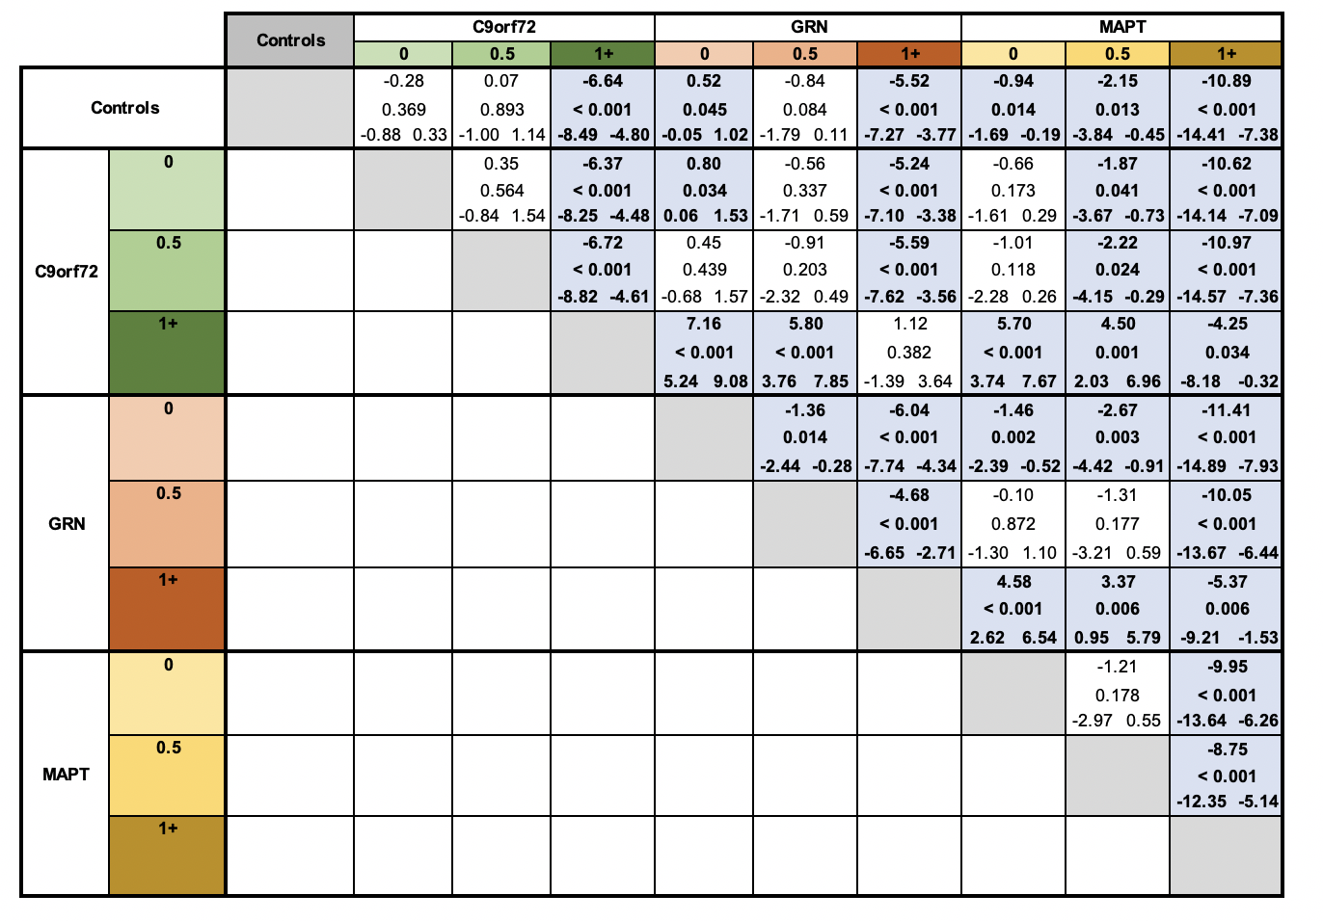

Table S4. Voxel-based morphometry analysis: grey matter regions correlating significantly with Boston Naming Test score in each genetic group.

 | Regions | cluster | peak |  |  |  | coordinates (mm)
 | Regions | equivk | p(FWE-corr) | T | p(unc) | x |  | y | z
C9orf72 | Left hippocampus, fusiform gyrus, amygdala, entorhinal cortex | 6046 | <0.001 | 7.04 | <0.001 | -32 |  | -24 | -8
C9orf72 | Left inferior frontal gyrus | 887 | <0.001 | 6.26 | <0.001 | -4 |  | 45 | -12
C9orf72 | Right frontal pole and superior frontal gyrus | 242 | <0.001 | 6.14 | <0.001 | 15 |  | 64 | 16
C9orf72 | Left middle and superior frontal gyrus | 648 | <0.001 | 5.99 | <0.001 | -24 |  | 56 | 6
C9orf72 | Right hippocampus, fusiform gyrus, amygdala, entorhinal cortex | 2437 | <0.001 | 5.87 | <0.001 | 27 |  | -8 | -15
C9orf72 | Left inferior temporal gyrus | 572 | <0.001 | 5.79 | <0.001 | -45 |  | -44 | -21
C9orf72 | Left middle frontal gyrus | 312 | 0.002 | 5.42 | <0.001 | -40 |  | 15 | 30
C9orf72 | Left anterior insula | 122 | 0.002 | 5.41 | <0.001 | -39 |  | 10 | 0
C9orf72 | Left fusiform gyrus | 60 | 0.002 | 5.34 | <0.001 | -24 |  | -54 | -10
C9orf72 | Right middle frontal gyrus | 148 | 0.003 | 5.33 | <0.001 | 27 |  | 62 | 2
C9orf72 | Right superior frontal gyrus | 55 | 0.005 | 5.18 | <0.001 | 26 |  | 58 | 12
C9orf72 | Right middle frontal gyrus | 134 | 0.006 | 5.14 | <0.001 | 28 |  | 38 | 36
C9orf72 | Left central operculum | 39 | 0.009 | 5.06 | <0.001 | -40 |  | -8 | 9
C9orf72 | Right middle frontal gyrus | 48 | 0.009 | 5.04 | <0.001 | 28 |  | 18 | 50
C9orf72 | Right temporal pole | 26 | 0.011 | 4.99 | <0.001 | 38 |  | 10 | -36
C9orf72 | Left cerebellum exterior | 39 | 0.012 | 4.99 | <0.001 | -18 |  | -74 | -40
C9orf72 | Left superior frontal gyrus | 54 | 0.012 | 4.98 | <0.001 | -12 |  | 46 | 8
C9orf72 | Left frontal pole | 48 | 0.015 | 4.93 | <0.001 | -14 |  | 62 | -9
C9orf72 | Right inferior frontal cortex | 31 | 0.021 | 4.85 | <0.001 | 9 |  | 30 | -18
C9orf72 | Left caudate | 95 | 0.022 | 4.83 | <0.001 | -12 |  | 15 | 0

GRN | Left superior temporal sulcus and inferior temporal gyrus | 3425 | <0.001 | 7.34 | <0.001 | -58 | -33 | -6
GRN | Left hippocampus | 790 | <0.001 | 6.59 | <0.001 | -21 | -33 | -2
GRN | Left middle frontal gyrus | 772 | <0.001 | 6.43 | <0.001 | -28 | 15 | 50
GRN | Left caudate, putamen and accumbens | 3173 | <0.001 | 6.40 | <0.001 | -9 | 14 | 9
GRN | Left angular gyrus | 415 | <0.001 | 5.70 | <0.001 | -50 | -60 | 18
GRN | Left supplementary motor cortex | 111 | <0.001 | 5.68 | <0.001 | -4 | 10 | 52
GRN | Left supplementary motor cortex, superior frontal gyrus | 927 | 0.001 | 5.67 | <0.001 | -4 | 16 | 39
GRN | Left supplementary motor cortex | 114 | 0.001 | 5.56 | <0.001 | -4 | -4 | 48
GRN | Left orbitofrontal cortex | 323 | 0.001 | 5.56 | <0.001 | -32 | 42 | -12
GRN | Left frontal pole | 165 | 0.002 | 5.42 | <0.001 | -20 | 60 | -9
GRN | Left middle frontal gyrus | 168 | 0.003 | 5.33 | <0.001 | -40 | 14 | 30
GRN | Left supramarginal gyrus | 173 | 0.003 | 5.33 | <0.001 | -54 | -46 | 44
GRN | Left angular gyrus | 107 | 0.003 | 5.31 | <0.001 | -39 | -56 | 48
GRN | Left superior frontal gyrus | 225 | 0.003 | 5.31 | <0.001 | -24 | -4 | 54
GRN | Left angular gyrus | 44 | 0.005 | 5.19 | <0.001 | -44 | -56 | 32
GRN | Left superior frontal gyrus | 73 | 0.006 | 5.13 | <0.001 | -22 | 58 | 6
GRN | Left anterior insula | 41 | 0.015 | 4.92 | <0.001 | -38 | 20 | -2
GRN | Left premotor cortex | 37 | 0.015 | 4.92 | <0.001 | -36 | -14 | 39
GRN | Left precuneus | 24 | 0.016 | 4.92 | <0.001 | -8 | -51 | 34
GRN | Left anterior insula | 27 | 0.027 | 4.79 | <0.001 | -42 | 2 | 4
GRN | Left middle frontal gyrus | 31 | 0.028 | 4.77 | <0.001 | -26 | 50 | 3
MAPT | Left temporal pole, amygdala, hippocampus, entorhinal cortex, inferior temporal gyrus and insula | 14502 | <0.001 | 11.32 | <0.001 | -28 | -6 | -18
MAPT | Right temporal pole, amygdala, hippocampus, entorhinal cortex, inferior temporal gyrus and insula | 13592 | <0.001 | 10.91 | <0.001 | 26 | -8 | -15
MAPT | Left fusiform gyrus | 73 | 0.010 | 5.03 | <0.001 | -44 | -44 | -16

Table S5. Voxel-based morphometry analysis: grey matter regions correlating significantly with Boston Naming Test score in each genetic group, with additional adjustment for disease severity.

 | Regions | cluster | peak |  |  | coordinates (mm)
 | Regions | equivk | p(FWE-corr) | T | p(unc) | x | y | z
C9orf72 | Left inferior temporal gyrus | 83 | 0.636 | 3.86 | <0.001 | -28 | -14 | -39
C9orf72 | Left temporal pole | 79 | 0.905 | 3.59 | <0.001 | -34 | 10 | -27
GRN | Left superior temporal sulcus and inferior temporal gyrus | 8409 | <0.001 | 6.65 | <0.001 | -58 | -33 | -6
GRN | Left middle frontal gyrus | 3782 | 0.002 | 5.47 | <0.001 | -28 | 15 | 50
GRN | Left thalamus, hippocampus, caudate, putamen | 4569 | 0.007 | 5.15 | <0.001 | -20 | -34 | -3
GRN | Left supramarginal gyrus | 881 | 0.053 | 4.66 | <0.001 | -57 | -45 | 39
GRN | Left supplementary motor cortex, middle cingulate gyrus | 296 | 0.066 | 4.61 | <0.001 | -6 | -6 | 48
GRN | Left middle frontal gyrus, inferior frontal gyrus | 507 | 0.081 | 4.55 | <0.001 | -40 | 14 | 30
GRN | Left frontal pole, orbitofrontal cortex, superior frontal gyrus | 292 | 0.201 | 4.30 | <0.001 | -20 | 60 | -9
GRN | Left orbitofrontal cortex | 273 | 0.318 | 4.15 | <0.001 | -32 | 42 | -12
GRN | Left precentral gyrus, postcentral gyrus | 503 | 0.342 | 4.12 | <0.001 | -36 | -15 | 38
GRN | Left and right anterior cingulate gyrus | 100 | 0.415 | 4.05 | <0.001 | 0 | 36 | 4
GRN | Left middle frontal gyrus, superior frontal gyrus | 226 | 0.443 | 4.03 | <0.001 | -32 | 48 | 26
GRN | Left precuneus, posterior cingulate gyrus | 110 | 0.642 | 3.86 | <0.001 | -6 | -51 | 34
GRN | Right cerebellum | 147 | 0.666 | 3.84 | <0.001 | 45 | -72 | -50
GRN | Left middle frontal gyrus, precentral gyrus | 148 | 0.67 | 3.83 | <0.001 | -44 | 6 | 51
GRN | Left superior frontal gyrus | 192 | 0.737 | 3.78 | <0.001 | -22 | 58 | 6
GRN | Right occipital pole | 70 | 0.791 | 3.73 | <0.001 | 26 | -98 | 15
GRN | Left inferior frontal gyrus | 119 | 0.804 | 3.71 | <0.001 | -39 | 42 | 4
MAPT | Left amygdala, hippocampus, entorhinal cortex, temporal pole, inferior temporal gyrus, insula and fusiform gyrus | 12258 | <0.001 | 9.39 | <0.001 | -30 | -4 | -20
MAPT | Right amygdala, hippocampus, entorhinal cortex, temporal pole, inferior temporal gyrus, insula and fusiform gyrus | 12482 | <0.001 | 8.90 | <0.001 | 26 | -8 | -15
MAPT | Left insula | 1055 | 0.006 | 5.18 | <0.001 | -3 | 6 | -2

