Supplemental Information
Supplementary Fig. 1 Sensitivity analysis HRs for treatment change relative to pre-study relapse inclusion criteria
a. Relapses counted as on-study if they started in the 30 days before study start*

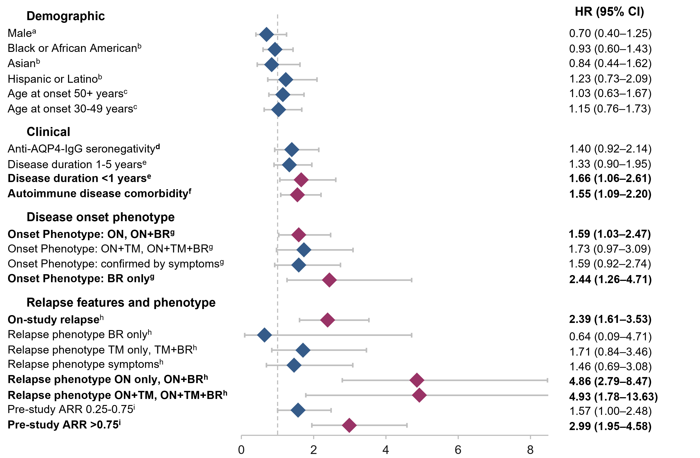

b. Relapses counted as on-study if they started within the clinician judgement window before the study start*

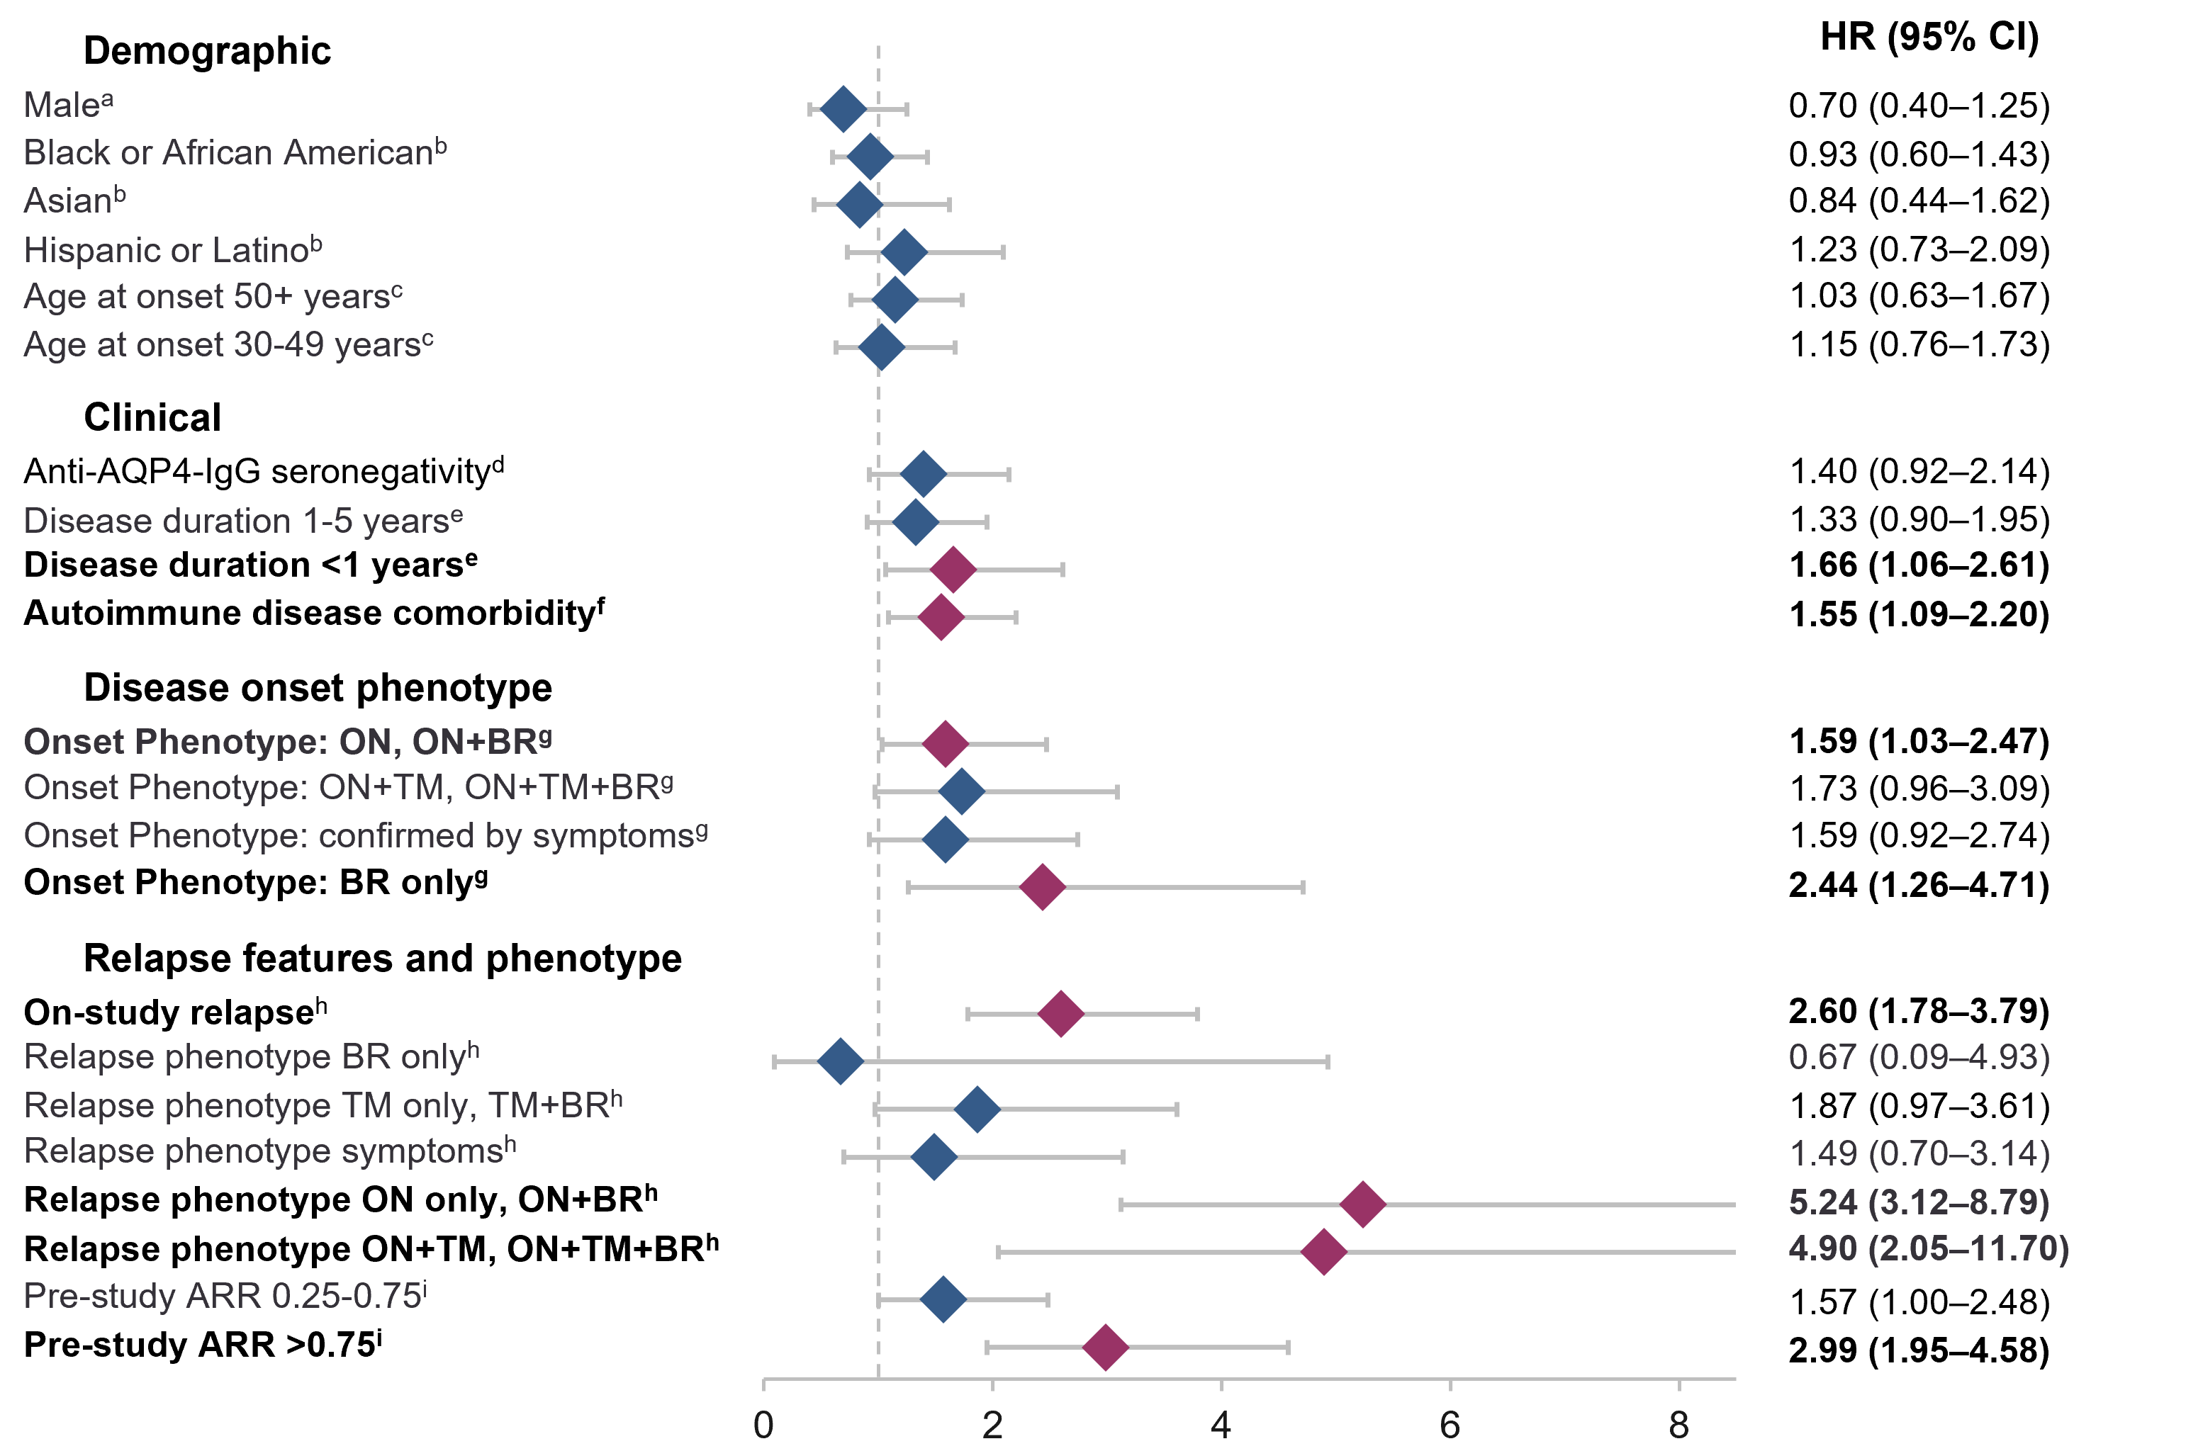
*Note: only variables related to on-study relapse/phenotype are subject to change based on the window of relapse definition. ªReference female. ^{b}Reference White. ^{c}Reference <30 years. ^{d}Reference seropositivity. ^{e}Reference >5 years. ^{f}Reference no autoimmune disease comorbidity. ^{g}Reference TM, TM + BR. ^{h}Reference no prior on-study relapse. ^{i}Reference pre-study ARR <0.25. Anti–AQP4-IgG, aquaporin 4 autoantibody; ARR, annualized relapse rate; BR, brain involvement; HR, hazard ratio; ON, optic neuritis; TM, transverse myelitis

Supplementary Fig. 2 Sensitivity analysis HRs for rituximab discontinuation among patients taking rituximab (at least two doses) relative to pre-study relapse inclusion criteria
a. Relapses counted as on-study if they started in the 30 days before the study start*

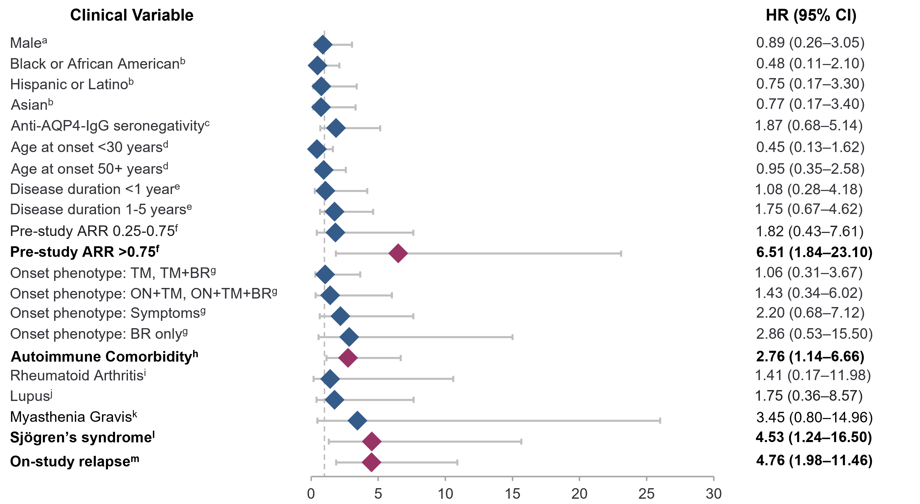

b. Relapses counted as on-study if they started within the clinician judgement window before study start*

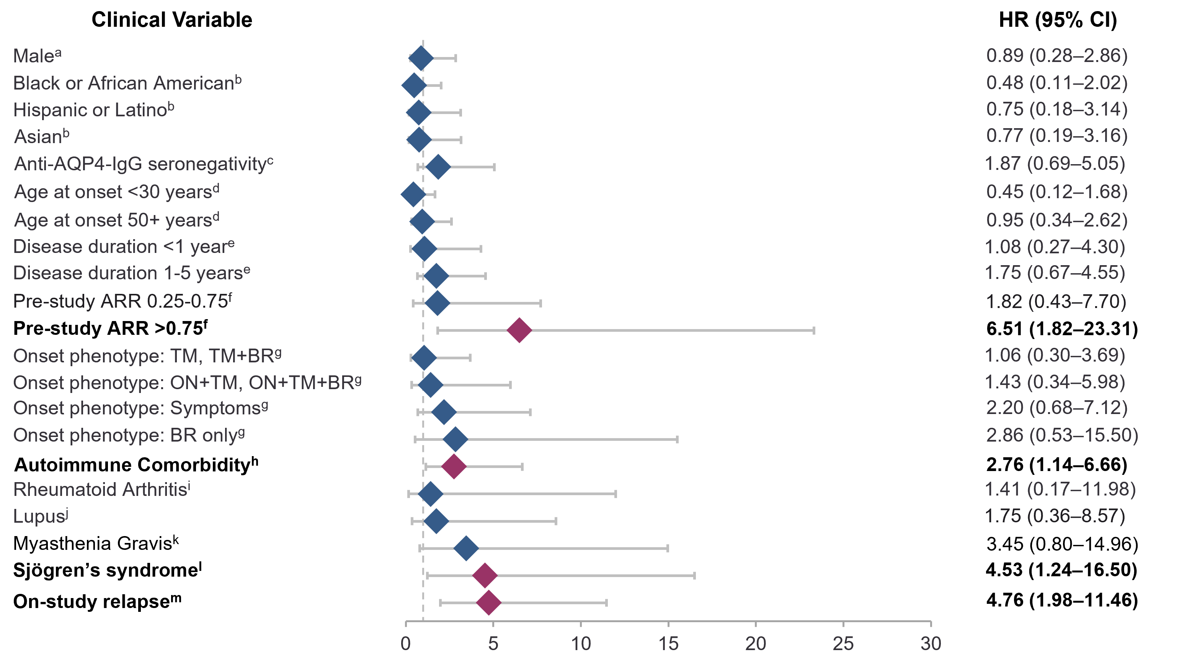
*Note: only variables related to on-study relapse/phenotype are subject to change based on the window of relapse definition. ªReference female. ^{b}Reference White. ^{c}Reference seropositivity. ^{d}Reference 30–49 years. ^{e}Reference >5 years. ^{f}Reference ARR <0.25. ^{g}Reference ON, ON + BR. ^{h}Reference no comorbidity. ^{i}Reference no rheumatoid arthritis. ^{j}Reference no lupus. ^{k}Reference no myasthenia gravis. ^{l}Reference no Sjögren syndrome. ^{m}Reference no on-study relapse. Anti–AQP4-IgG, aquaporin 4 autoantibody; ARR, annualized relapse rate; BR, brain involvement; HR, hazard ratio; ON, optic neuritis; TM, transverse myelitis

