Supplemental data to: Roos et al. Pontine Autosomal Dominant Microangiopathy with Leukoencephalopathy: Col4A1 gene variants in the original family and sporadic stroke

Supplemental figure 1: Power analysis of the COL4A1 miRNA binding site sequencing in two stroke samples
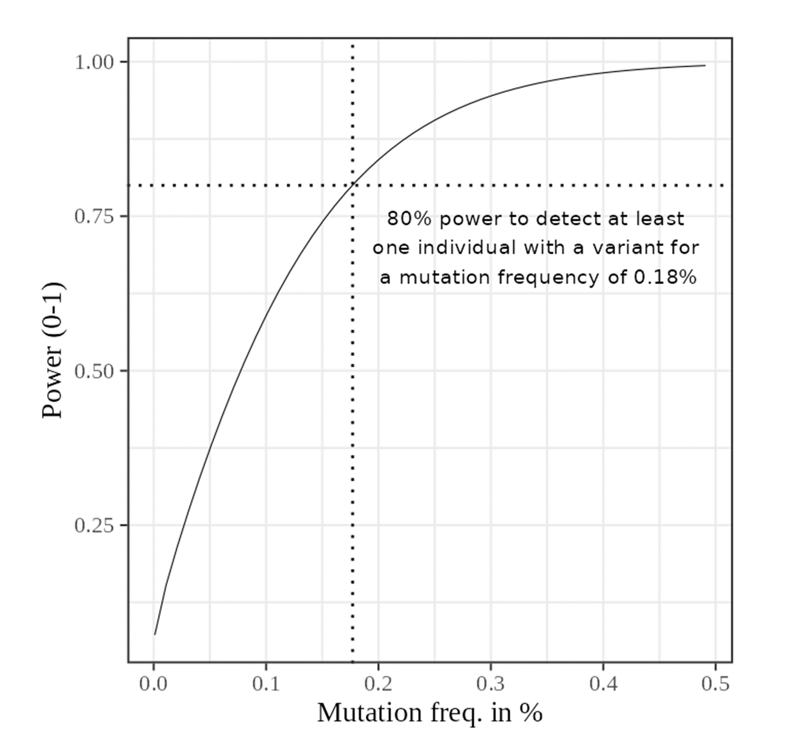
Supplemental figure 1: Statistical power (for p = 0.05) was calculated using the “pwr” package in R as detailed in the “Patients and Methods” section. Power is displayed as a function of the mutation frequency in percent. The crossing point of the dotted lines indicates 80% power for a mutation frequency of 0.18%.
Supplemental figure 2: Conservation of the COL4A1 miRNA binding site (genomic)
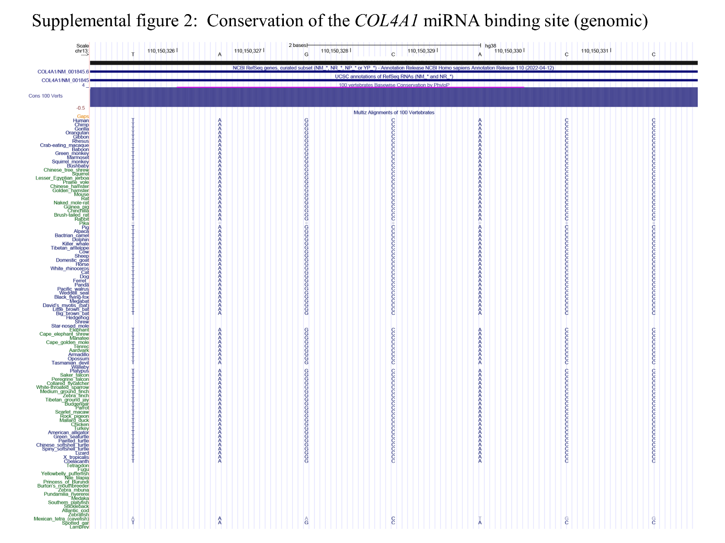
Supplemental figure 2: The conservation data are derived from the UCSC human genome browser (https://genome.ucsc.edu/). The sequence is displayed on the genomic forward strand while COL4A1 is encoded on the reverse strand.

