Supplementary material

Ravulizumab pharmacokinetics and pharmacodynamics in patients with generalized myasthenia gravis
Tuan Vu,¹ Stephan Ortiz,² Masahisa Katsuno,³ Djillali Annane,⁴ Renato Mantegazza,⁵ Kathleen N Beasley,² Rasha Aguzzi,² James F Howard, Jr⁶
¹University of South Florida Morsani College of Medicine, Tampa, FL, USA; ²Alexion, AstraZeneca Rare Disease, Boston, MA, USA; ³Nagoya University Graduate School of Medicine, Nagoya, Japan; ⁴Hôpital Raymond Poincaré, University of Versailles, Garches, France; ⁵Fondazione IRCCS Istituto Neurologico Carlo Besta, Milan, Italy; ⁶The University of North Carolina, Chapel Hill, NC, USA

Corresponding author
Stephan Ortiz; Email: Stephan.Ortiz@alexion.com

Supplementary Fig. S1 Example of impact of PLEX/PP intervention and supplemental ravulizumab doses on the concentration–time profile of ravulizumab

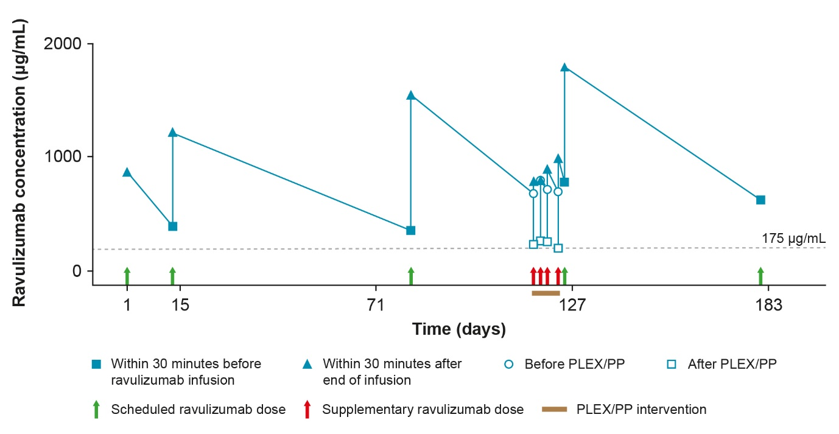
The dashed line represents the pharmacokinetic therapeutic target threshold.
PLEX/PP = plasma exchange/plasmapheresis
Supplementary Fig. S2 Example of impact of IVIg intervention and supplemental ravulizumab doses on the concentration–time profile of ravulizumab

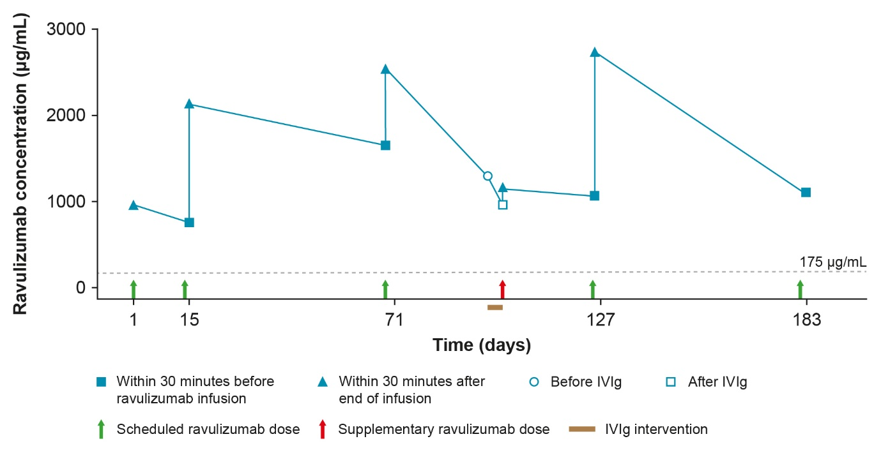
The dashed line represents the pharmacokinetic therapeutic target threshold.
IVIg = intravenous immunoglobulin

Supplementary Fig. S3 Mean (SD) serum free C5 concentrations and mean (SD) MG-ADL total scores across 26 weeks of treatment with ravulizumab
