Supplementary Materials

Title: The influence of culture and cognitive reserve on the clinical presentation of behavioural-variant frontotemporal dementia

Skeggs, A^{1,2}, Wei, G^{1,2}, Landin-Romero, R^{1,2}, Hodges, JR^{2,3}, Piguet, O^{1,2} & Kumfor, F^{1,2}

Correspondence to: Fiona Kumfor, 94 Mallett Street Camperdown, Sydney, NSW, Australia 2050, fiona.kumfor@sydney.edu.au

Supplementary Table 1
Diagnostic and neuropsychiatric features across bvFTD groups
 | Australian  n = 53 | CALD-English  n = 36 | CALD-LOTE  n = 18 | Chi square | p | Cramer’s V
Diagnostic features
Disinhibition | 30 (75.0%) | 19 (82.6%) | 13 (92.9%) | 1.94 | .369 | .17
Apathy | 34 (85.0%) | 21 (91.3%) | 11 (78.6%) | 1.28 | .560 | .12
Loss of Empathy | 35 (87.5%) | 17 (73.9%) | 10 (71.4%) | 2.85 | .254 | .18
Preservative Behaviour | 21 (52.5%) | 11 (47.8%) | 6 (42.9%) | 0.42 | .812 | .07
Hyperorality | 30 (75%) | 14 (60.9%) | 13 (92.9%) | 4.50 | .105 | .25
Neuropsychiatric features
Abnormal Motor Behaviour | 23 (50.0%) | 13 (41.9%) | 3 (21.4%) | 3.53 | .170 | .20
Agitation | 28 (59.6%) | 20 (66.7%) | 9 (64.3%) | 0.44 | .874 | .07
Anxiety | 14 (30.4%) | 17 (56.7%) | 4 (28.6%) | 5.78 | .053 | .26
Apathy | 39 (83%) | 28 (90.3%) | 12 (85.7%) | 0.85 | .716 | .10
Appetite | 40 (85.1%) | 22 (73.3%) | 12 (85.7%) | 1.78 | .377 | .14
Delusions | 12 (25%) | 8 (25.8%) | 2 (14.3%) | 0.71 | .714 | .09
Depression | 18 (39.1) | 8 (28.6%) | 4 (30.8%) | 0.93 | .676 | .11
Disinhibition | 31 (66%) | 22 (71%) | 11 (78.6%) | 0.77 | .675 | .10
Elation | 25 (53.3%) | 6 (20%) | 4 (28.6%) | 9.11 | .010* | .32
Hallucinations | 5 (10.6%) | 5 (16.1%) | 1 (7.1%) | 0.81 | .675 | .10
Irritability | 24 (52.2%) | 15 (50%) | 10 (71.4%) | 1.91 | .390 | .15
Sleep | 23 (50%) | 12 (38.7%) | 5 (38.5%) | 1.17 | .593 | .11

Note. % of cases who satisfied criteria at presentation. For diagnostic features and neuropsychiatric features data were from clinical assessments and displayed as N (%). Missing data for neuropsychiatric features: abnormal motor behaviour 16; agitation: 15; anxiety: 15; apathy: 14; appetite: 14; delusions: 14; depression: 19; disinhibition: 15; elation: 15; hallucinations: 15; irritability: 15; sleep: 15. Significant post hoc test: elation: Australia>Foreign groups.

Supplementary Figure 1 Number of diagnostic features met at initial clinical assessment
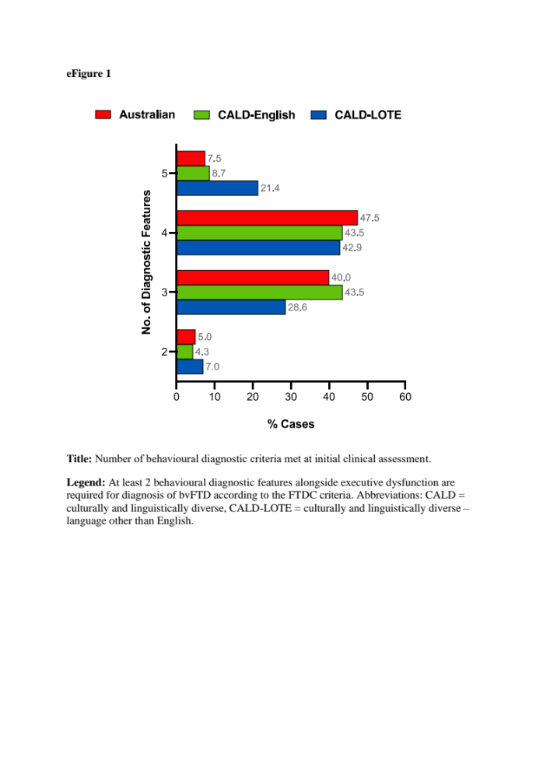

Note. A chi-square test was used to examine differences in the number of diagnostic criteria fulfilled by the bvFTD groups at clinical assessment. No significant differences were found
Supplementary Table 2 Neuropsychological test scores across groups

 | Australian | CALD-English | CALD-LOTE | Controls | F | p | Post hoc
 | n = 53 | n = 36 | n = 18 | n = 51
Cognitive Function  ACE-III | 75.33 ± 16.13 | 74.57 ± 15.54 | 74.59 ± 17.43 | 95.29 ± 3.21 | 16.10 | <.001 | All groups < Controls
Attention/Working Memory
Digit span forwards | 6.10 ± 1.31 | 6.22 ± 1.26 | 5.71 ± .77 | 7.08 ± 1.21 | 4.66 | .004 | Aus, FNE < Controls
Digit span backwards | 3.84 ± 1.32 | 4.03 ± 1.51 | 3.88 ± .86 | 5.49 ± 1.14 | 7.76 | <.001 | All groups < Controls
Trail A time (s) | 56.68 ± 43.82 | 59.15 ± 35.35 | 46.19 ± 24.19 | 32.04 ± 11.68 | 9.80 | <.001 | All groups < Controls
Visuospatial Function
RCF copy score (36) | 25.36 ± 8.14 | 27.76 ± 5.70 | 29.74 ± 4.50 | 32.79 ± 2.98 | 8.45 | <.001 | Aus, FE < Controls
Episodic Memory
RCF 3 min score (36) | 9.71 ± 8.84 | 10.05 ± 7.61 | 13.06 ± 6.22 | 18.03 ± 5.35 | 12.38 | <.001 | All groups < Controls
Language
SYDBAT
Naming (30) | 21.82 ± 5.51 | 21.39 ± 6.11 | 20.47 ± 5.81 | 27.37 ± 1.54 | 9.71 | <.001 | All groups < Controls
Semantic Association (30) | 24.19 ± 4.85 | 23.45 ± 5.69 | 25.40 ± 3.81 | 28.43 ± 1.23 | 8.64 | <.001 | All groups < Controls
Executive Function
Trail B time (s) | 131.45 ± 74.58 | 164.90 ± 118.6 | 129.93 ± 68.79 | 74.48 ± 26.67 | 9.42 | <.001 | All groups < Controls
Verbal Fluency | 22.92 ± 15.32 | 26.39 ± 16.06 | 22.44 ± 10.83 | 47.53 ± 12.10 | 14.03 | <.001 | All groups < Controls
Data were presented as mean ± standard deviation. Sidak correction for multiple comparisons: critical p = .008. Abbreviations: bvFTD = behavioral variant frontotemporal dementia, CALD = culturally and linguistically diverse, CALD-LOTE = culturally and linguistically diverse – language other than English, ACE = Addenbrooke’s Cognitive Examination, RCF = Rey Complex Figure, SYDBAT = Sydney Language Battery. Missing data: ACE-III: 4 CALD-English, Digit span forwards: 3 Australian; 4 CALD-English; 1 CALD-LOTE; 2 Controls, Digit span backwards: 3 Australian; 5 CALD-English; 2 CALD-LOTE; 5 Controls, Trail A time: 3 Australian; 5 CALD-English; 2 CALD-LOTE; 5 Controls, Trail B time: 4 Australian; 6 CALD-English; 2 CALD-LOTE; 5 Controls, RCF copy score: 4 Australian; 5 CALD-English; 1 CALD-LOTE; 5 Controls, RCF 3 min score: 4 Australian; 6 CALD-English; 2 CALD-LOTE; 5 Controls, SYDBAT naming: 3 Australian; 5 CALD-English; 3 CALD-LOTE; 5 Australians, SYDBAT semantic association: 13, Verbal fluency: 5 Australians; 5 CALD-English; 2 CALD-LOTE; 8 Controls.

Supplementary Table 3
Voxel-based morphometry results showing regions of grey matter intensity reduction in bvFTD patient groups compared to controls
Regions | Hemisphere | Number of voxels | MNI coordinates
 |  |  | X | Y | Z
bvFTD: Australian
Temporal Pole, Orbitofrontal Cortex, Medial Frontal Cortex, Frontal Pole, Parahippocampal Gyrus, Amygdala, Hippocampus, Putamen, Insular Cortex, Accumbens | B | 74520 | -28 | -4 | -52
Cerebellum (Crus I, II, VIIb) | R | 6109 | 52 | -62 | -44
bvFTD: CALD-English
Putamen, Amygdala, Hippocampus, Insular Cortex, Orbitofrontal Cortex, Planum Polare, Heschl's Gyrus (H1, H2), Parietal Operculum Cortex, Frontal Pole, Temporal Pole, Frontal Operculum Cortex | R | 58923 | 28 | 4 | -30
Cerebellum (Crus I, II, VIIb) | L | 2463 | -40 | -78 | -48
Cerebellum (Crus I, II, VIIb) | R | 564 | 46 | -56 | -56
bvFTD: CALD-LOTE
Cerebellum (Crus I, II, VI), Temporal Fusiform Cortex (posterior division), Temporal Occipital Fusiform Cortex, Lateral Occipital Cortex (inferior division), Occipital Fusiform Cortex | R | 54920 | 42 | -56 | -58
Occipital Pole, Lateral Occipital Cortex (inferior division), Occipital Fusiform Gyrus | L | 926 | -30 | -92 | -12
Occipital Fusiform Gyrus, Occipital Pole | R | 492 | 22 | -88 | -8
Note. Results are reported at p <0.05 corrected for family-wise error, with a cluster threshold of 300 contiguous voxels. CALD = culturally and linguistically diverse; CALD-LOTE = culturally and linguistically diverse – language other than English; B = bilateral; L = left; R = right; MNI = Montreal Neurological Institute.

