SUPPLEMENTARY MATERIAL (SM)

Table of content:
SM Item S1. COVID-19 long term protocol. [page 2]
SM Item S2. Study flowchart. [page 3]
SM Item S3. Distribution of initial acute hospitalizations among Long-COVID protocol respondents. [page 4]
SM Item S4. Baseline characteristics. [page 5]
SM Item S5. Period prevalence of neurological symptoms evaluated at acute hospitalization Observed prevalence by time period, month post-discharge (%) [page 6]
SM Item S6. Observed prevalence and persistence of neurological symptoms over survey follow-up post hospital discharge [page 7-13]
SM Item S7. Observed prevalence and persistence of neurological symptoms over survey follow-up post-acute illness [page 14]

Supplementary Material Item S1. COVID-19 long term protocol.
The following link refers to the COVID-19 long term protocol: https://isaric.org/research/covid-19-clinical-research-resources/covid-19-long-term-follow-up-study/#:~:text=Long%20term%20follow%2Dup%20protocol,a%20range%20of%20validated%20tools
The CRF of this survey include:
Tier 1 Initial Freestanding follow up survey– use for any person (hospitalized or not hospitalized) at the first follow up assessment
OR
Tier 1 Initial Follow up survey– use for a person with a Core or Rapid CRF completed during an acute hospital admission at the first assessment
Tier 1 Ongoing survey – for additional assessment time points

Supplementary Material Item S2: Study flowchart: Neurological signs and symptoms evaluated at acute hospitalization: Altered consciousness/confusion, Fatigue/Malaise, Lost/Altered sense of smell (Anosmia), Lost/Altered sense of taste (Ageusia), Muscle aches/joint pain, Seizures. For each survey follow-up period, the number of respondents is given along with the median and lower/upper quantiles for days since hospital discharge.
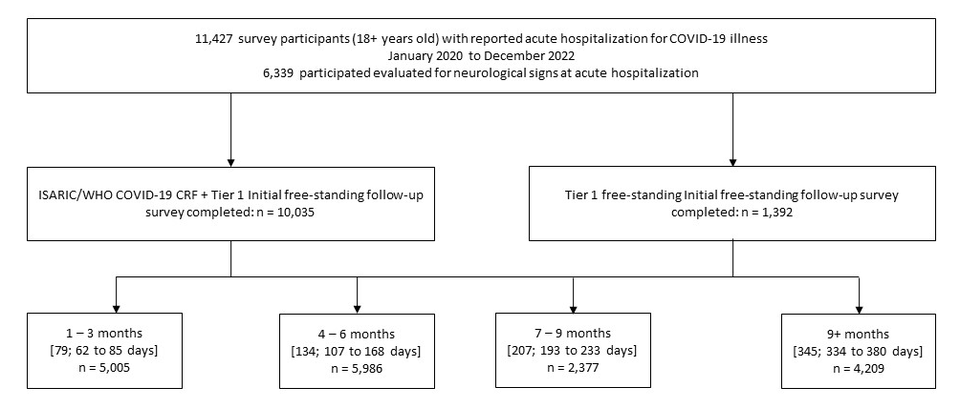
Supplementary Material Item S3: Distribution of initial acute hospitalizations among Long-COVID protocol respondents. Frequencies are stratified by the availability of neurological signs and symptoms evaluates at disease onset/hospital admission.
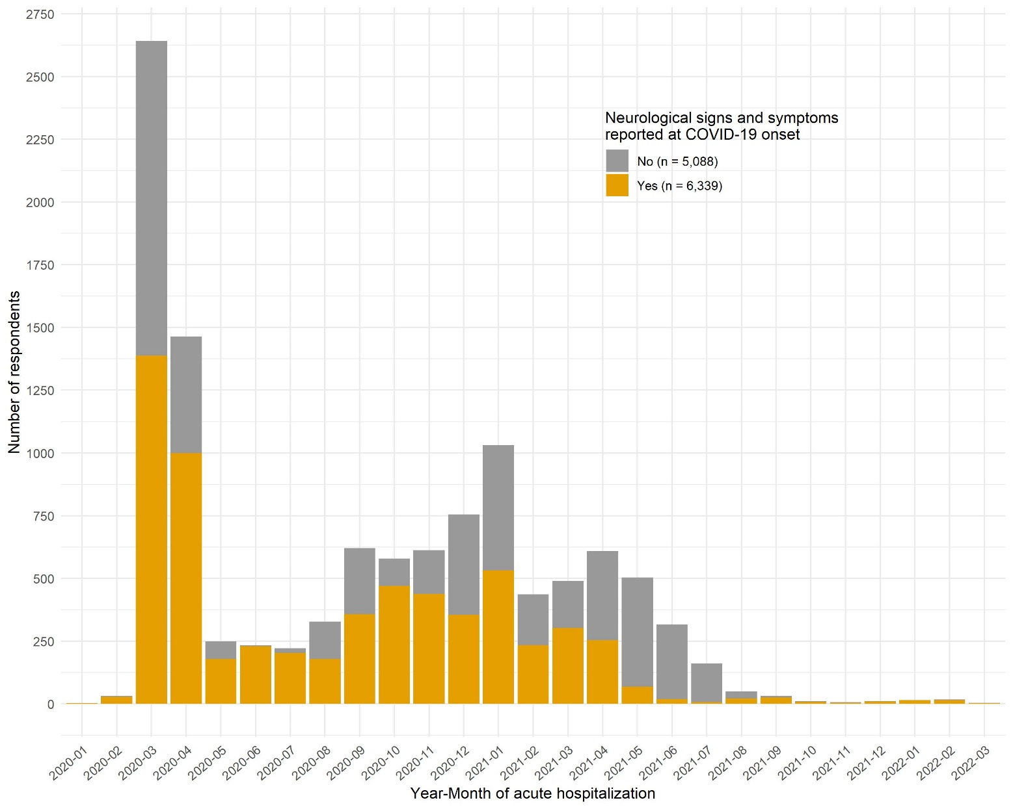

Supplementary Material Item S4: Baseline characteristics. Characteristics are summarised for the full study cohort. Continuous variables are summarised by the median and interquartile range (Q1 to Q3), and mean and standard deviation (SD). Categorical variables are summarised by the number of events/total respondents and percentage.
Characteristic | All survey respondents
Age at hospitalization, years: Median (IQR) | 56 (45 to 67)
Age at hospitalization, years: Mean (SD) | 55.8 (15.3)
Female | 4,806 (41.9%)
Admitted to ICU during acute hospitalization | 3 024 (26.8%)
Hospital length of stay, days: Median (IQR) | 9 (6 to 14)
Hospital length of stay, days: Mean (SD) | 12.6 (12.3)
Geographic region
Africa | 2,273 (19.8%)
Americas | 23 (0.2%)
Asia | 1,860 (16.2%)
Europe | 7,320 (63.8%)
Country income classification
High Income | 7,437 (64.8%)
Upper-Middle | 2,251 (19.6%)
Low-Middle | 1,785 (15.6%)
Low | 3 (<0.1%)

Supplementary Material Item S5: Period prevalence of neurological symptoms evaluated at acute hospitalization. Summary data are reported as the total number of observed cases divided by the total number of participants evaluated and as an unadjusted estimate with a 95% confidence interval (CI)
Symptom | 1-3 months | 4-6 months | 7-9 months | 9+ months
1+ neurological symptoms | 47.7% (45.8% to 49.7%)  2,381/4,992 | 51.8% (49.9% to 53.6%)  3,095/5,980 | 48.8% (46.0% to 51.6%)  1,158/2,375 | 49.4% (47.3% to 51.6%)  2,079/4,209
Altered consciousness/confusion | 14.3% (13.1% to 15.6%)  531/3,712 | 21.4% (20.1% to 22.7%)  1,004/4,695 | 21.7% (19.6% to 24.0%)  400/1,842 | 25.2% (23.7% to 26.8%)  1,049/4,156
Fatigue/malaise | 45.4% (43.2% to 47.5%)  1,728/3,810 | 45.9% (44.1% to 47.9%)  2,270/4,943 | 41.2% (38.5% to 44.1%)  868/2,105 | 38.8% (36.9% to 40.7%)  1,609/4,152
Lost/altered sense of smell | 6.2% (5.4% to 7.0%)  237/3,828 | 6.2% (5.5% to 6.9%)  306/4,944 | 6.6% (5.5% to 7.8%)  138/2,098 | 5.7% (5.0% to 6.5%)  237/4,165
Lost/altered sense of taste | 6.8% (6.0% to 7.7%)  259/3,822 | 5.8% (5.2% to 6.5%)  287/4,943 | 5.8% (4.8% to 7.0%)  122/2,095 | 5.1% (4.5% to 5.9%)  214/4,172
Muscle aches/joint pain | 23.2% (21.9% to 24.6%)  1,137/4,893 | 28.7% (27.4% to 30.1%)  1,699/5,920 | 27.9% (25.8% to 30.1%)  655/2,348 | 32.8% (31.1% to 34.5%)  1,376/4,200
Seizures | 0.2% (0.0% to 0.4%)  4/2,591 | 0.4% (0.2% to 0.7%)  15/3,704 | 0.6% (0.3% to 1.2%)  10/1,592 | 0.5% (0.3% to 0.8%)  20/4,112

Supplementary Material Item S6 Observed prevalence and persistence of neurological symptoms over survey follow-up post hospital discharge. (Not evaluated at acute hospitalization)

Symptom | Post-discharge follow-up, | Period prevalence of symptom | First assessment of symptom | Follow-up assessment of symptom
Dizziness | 1-3 months | 7.5% (6.3% to 8.8%)  141/1,890 | 7.5% (6.3% to 8.8%)  141/1,890 | --
Dizziness | 4-6 months | 8.2% (7.1% to 9.4%)  193/2,364 | 8.1% (6.8% to 9.7%)  126/1,550 | 8.2% (6.4% to 10.5%)  67/814
Dizziness | 7-9 months | 4.8% (3.5% to 6.3%)  46/968 | 3.9% (2.4% to 6.0%)  20/513 | 5.7% (3.7% to 8.4%)  26/455
Dizziness | 9+ months | 5.6% (4.7% to 6.6%)  138/2,455 | 3.7% (2.3% to 5.6%)  21/575 | 6.2% (5.1% to 7.5%)  117/1,880
Erectile dysfunction | 1-3 months | 4.6% (3.6% to 5.8%)  75/1,627 | 4.6% (3.6% to 5.8%)  75/1,627 | --
Erectile dysfunction | 4-6 months | 9.5% (8.2% to 10.9%)  200/2,112 | 10.8% (9.3% to 12.5%)  180/1,672 | 4.5% (2.8% to 7.0%)  20/440
Erectile dysfunction | 7-9 months | 8.6% (6.8% to 10.6%)  84/982 | 9.9% (7.7% to 12.5%)  70/710 | 5.1% (2.8% to 8.6%)  14/272
Erectile dysfunction | 9+ months | 11.0% (9.8% to 12.4%)  281/2,548 | 5.6% (4.0% to 7.5%)  44/791 | 13.5% (11.8% to 15.3%)  237/1,757
Fainting/blackouts | 1-3 months | 1.7% (1.1% to 2.5%)  25/1,498 | 1.7% (1.1% to 2.5%)  25/1,498 | --
Fainting/blackouts | 4-6 months | 1.7% (1.1% to 2.3%)  32/1,936 | 1.5% (1.0% to 2.2%)  26/1,741 | 3.1% (1.1% to 6.7%)  6/195
Fainting/blackouts | 7-9 months | 1.6% (0.9% to 2.5%)  18/1,130 | 1.5% (0.8% to 2.5%)  14/958 | 2.3% (0.6% to 6.0%)  4/172
Fainting/blackouts | 9+ months | 1.3% (0.9% to 1.9%)  30/2,312 | 1.2% (0.5% to 2.4%)  8/662 | 1.3% (0.8% to 2.0%)  22/1,650
Headache | 1-3 months | 15.3% (14.2% to 16.4%)  747/4,892 | 15.3% (14.2% to 16.4%)  747/4,892 | --
Headache | 4-6 months | 18.2% (17.1% to 19.3%)  1,078/5,936 | 19.3% (18.1% to 20.7%)  832/4,301 | 15.0% (13.2% to 17.0%)  246/1,635
Headache | 7-9 months | 18.4% (16.7% to 20.2%)  431/2,346 | 21.8% (19.4% to 24.4%)  302/1,386 | 13.4% (11.2% to 16.0%)  129/960
Headache | 9+ months | 18.8% (17.5% to 20.2%)  788/4,192 | 8.8% (6.8% to 11.3%)  64/724 | 20.9% (19.4% to 22.5%)  724/3,468
Loss of sensation | 1-3 months | 0.6% (0.3% to 1.1%)  12/1,872 | 0.6% (0.3% to 1.1%)  12/1,872 | --
Loss of sensation | 4-6 months | 0.7% (0.4% to 1.1%)  16/2,337 | 0.8% (0.4% to 1.4%)  12/1,521 | 0.5% (0.1% to 1.3%)  4/816
Loss of sensation | 7-9 months | 1.0% (0.5% to 1.9%)  10/962 | 1.0% (0.3% to 2.3%)  5/509 | 1.1% (0.4% to 2.6%)  5/453
Loss of sensation | 9+ months | 0.6% (0.3% to 1.0%)  15/2,454 | 0.8% (0.3% to 1.9%)  5/599 | 0.5% (0.3% to 1.0%)  10/1,855
Muscle weakness | 1-3 months | 19.5% (17.8% to 21.2%)  510/2,618 | 19.5% (17.8% to 21.2%)  510/2,618 | --
Muscle weakness | 4-6 months | 23.8% (22.2% to 25.4%)  880/3,705 | 26.6% (24.7% to 28.6%)  736/2,766 | 15.3% (12.9% to 18.1%)  144/939
Muscle weakness | 7-9 months | 23.1% (20.8% to 25.6%)  360/1,558 | 26.7% (23.7% to 30.0%)  278/1,041 | 15.9% (12.6% to 19.7%)  82/517
Muscle weakness | 9+ months | 21.5% (20.1% to 23.0%)  883/4,107 | 11.6% (9.2% to 14.5%)  80/689 | 23.5% (21.9% to 25.2%)  803/3,418
Paraesthesia | 1-3 months | 9.0% (7.9% to 10.2%)  233/2,589 | 9.0% (7.9% to 10.2%)  233/2,589 | --
Paraesthesia | 4-6 months | 16.0% (14.7% to 17.4%)  590/3,686 | 17.8% (16.3% to 19.5%)  492/2,758 | 10.6% (8.6% to 12.9%)  98/928
Paraesthesia | 7-9 months | 15.8% (13.9% to 17.9%)  246/1,554 | 19.4% (16.9% to 22.3%)  202/1,039 | 8.5% (6.2% to 11.5%)  44/515
Paraesthesia | 9+ months | 16.5% (15.2% to 17.8%)  675/4,100 | 8.8% (6.7% to 11.3%)  62/706 | 18.1% (16.7% to 19.5%)  613/3,394
Problems seeing | 1-3 months | 7.3% (6.3% to 8.4%)  188/2,581 | 7.3% (6.3% to 8.4%)  188/2,581 | --
Problems seeing | 4-6 months | 10.0% (9.0% to 11.1%)  370/3,692 | 10.3% (9.1% to 11.5%)  284/2,770 | 9.3% (7.5% to 11.5%)  86/922
Problems seeing | 7-9 months | 10.9% (9.3% to 12.7%)  169/1,553 | 11.5% (9.5% to 13.8%)  120/1,043 | 9.6% (7.1% to 12.7%)  49/510
Problems seeing | 9+ months | 9.3% (8.4% to 10.3%)  381/4,095 | 5.0% (3.5% to 6.9%)  35/705 | 10.2% (9.2% to 11.3%)  346/3,390
Problems sleeping | 1-3 months | 11.9% (10.5% to 13.4%)  259/2,184 | 11.9% (10.5% to 13.4%)  259/2,184 | --
Problems sleeping | 4-6 months | 14.8% (13.4% to 16.3%)  395/2,668 | 17.7% (15.9% to 19.7%)  328/1,851 | 8.2% (6.4% to 10.4%)  67/817
Problems sleeping | 7-9 months | 16.0% (13.8% to 18.4%)  187/1,172 | 20.5% (17.3% to 24.1%)  146/713 | 8.9% (6.4% to 12.1%)  41/459
Problems sleeping | 9+ months | 23.4% (21.9% to 25.1%)  850/3,628 | 34.8% (31.8% to 38.1%)  475/1,364 | 16.6% (14.9% to 18.3%)  375/2,264
Problems speaking or communicating | 1-3 months | 7.8% (6.7% to 8.9%)  203/2,612 | 7.8% (6.7% to 8.9%)  203/2,612 | --
Problems speaking or communicating | 4-6 months | 11.0% (9.8% to 12.3%)  319/2,893 | 10.9% (9.7% to 12.3%)  291/2,664 | 12.2% (8.1% to 17.7%)  28/229
Problems speaking or communicating | 7-9 months | 10.7% (9.1% to 12.6%)  148/1,381 | 10.9% (9.2% to 13.0%)  132/1,207 | 9.2% (5.3% to 14.9%)  16/174
Problems speaking or communicating | 9+ months | 13.9% (12.4% to 15.5%)  328/2,360 | 4.0% (2.7% to 5.8%)  28/692 | 18.0% (16.0% to 20.1%)  300/1,668
Problems swallowing or chewing | 1-3 months | 1.3% (0.9% to 2.0%)  25/1,859 | 1.3% (0.9% to 2.0%)  25/1,859 | --
Problems swallowing or chewing | 4-6 months | 0.9% (0.6% to 1.4%)  21/2,328 | 0.7% (0.4% to 1.3%)  11/1,515 | 1.2% (0.6% to 2.3%)  10/813
Problems swallowing or chewing | 7-9 months | 0.6% (0.2% to 1.3%)  6/969 | 1.0% (0.3% to 2.3%)  5/514 | 0.2% (0.0% to 1.2%)  1/455
Problems swallowing or chewing | 9+ months | 0.7% (0.4% to 1.1%)  16/2,452 | 0.8% (0.3% to 2.0%)  5/596 | 0.6% (0.3% to 1.1%)  11/1,856
Problems with balance | 1-3 months | 9.7% (8.6% to 11.0%)  251/2,583 | 9.7% (8.6% to 11.0%)  251/2,583 | --
Problems with balance | 4-6 months | 14.8% (13.5% to 16.0%)  545/3,694 | 16.4% (14.9% to 18.0%)  454/2,764 | 9.8% (7.9% to 12.0%)  91/930
Problems with balance | 7-9 months | 14.5% (12.7% to 16.5%)  226/1,557 | 17.3% (14.9% to 20.0%)  181/1,045 | 8.8% (6.4% to 11.8%)  45/512
Problems with balance | 9+ months | 14.7% (13.6% to 16.0%)  603/4,093 | 8.7% (6.7% to 11.2%)  61/699 | 16.0% (14.7% to 17.4%)  542/3,394
Tinnitus | 1-3 months | 2.2% (1.2% to 3.6%)  15/683 | 2.2% (1.2% to 3.6%)  15/683 | --
Tinnitus | 4-6 months | 3.6% (2.2% to 5.7%)  19/522 | 3.9% (2.3% to 6.1%)  18/466 | 1.8% (0.0% to 9.9%)  1/56
Tinnitus | 7-9 months | 1.8% (0.8% to 3.5%)  9/489 | 1.0% (0.3% to 2.5%)  4/413 | 6.6% (2.1% to 15.4%)  5/76
Tinnitus | 9+ months | 2.0% (1.1% to 3.5%)  13/635 | 1.5% (0.6% to 2.9%)  8/536 | 5.1% (1.6% to 11.8%)  5/99
Tremor | 1-3 months | 5.6% (4.5% to 6.9%)  83/1,485 | 5.6% (4.5% to 6.9%)  83/1,485 | --
Tremor | 4-6 months | 10.3% (8.9% to 11.9%)  198/1,917 | 10.4% (8.9% to 12.0%)  179/1,724 | 9.8% (5.9% to 15.4%)  19/193
Tremor | 7-9 months | 8.4% (6.8% to 10.2%)  95/1,137 | 8.2% (6.5% to 10.2%)  79/965 | 9.3% (5.3% to 15.1%)  16/172
Tremor | 9+ months | 10.0% (8.8% to 11.4%)  234/2,339 | 4.4% (3.0% to 6.3%)  31/704 | 12.4% (10.8% to 14.2%)  203/1,635

Supplementary Material Item S7: Observed prevalence and persistence of neurological symptoms over survey follow-up post-acute illness.
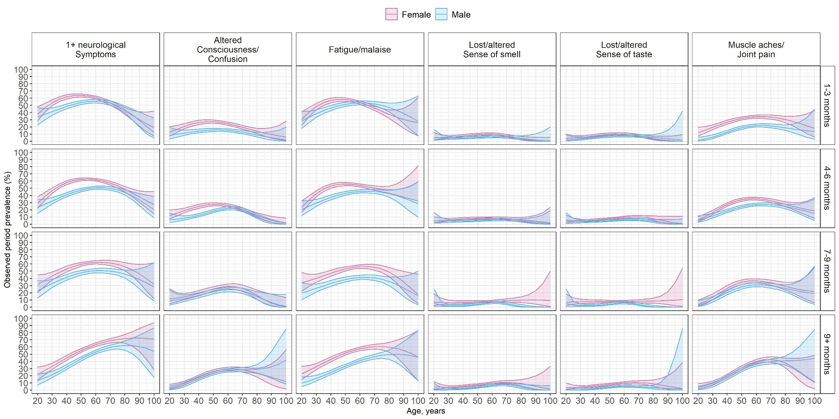
Seizures excluded due to insufficient cases reported

